Proposal
Ustaad
An AI-Powered Skilled Labor Marketplace
[Member 1 Name — Roll Number]
[Member 2 Name — Roll Number]
[Member 3 Name — Roll Number]
Team Leader: [Group Leader Name]
Advisor: [Instructor's Name]
National University of Computer & Emerging Sciences, Karachi
CS Department — Software Engineering — Spring 2026
[Submission Date]

1. Overview
Ustaad (Urdu for 'master craftsman') is a web-based, AI-augmented marketplace that connects customers in urban Pakistan with verified skilled workers — plumbers, electricians, carpenters, masons, painters, AC technicians, and similar trades. The motivation for the project is the everyday frustration that residents of Karachi (and similar cities) face when trying to find a trustworthy tradesman: word-of-mouth networks are unreliable, prices fluctuate arbitrarily, and existing foreign apps (TaskRabbit, Urban Company) are either unavailable, expensive, or unsuited to the local market.
The intended customers are two-sided: everyday urban households needing a reliable tradesman, and the tradesmen themselves who currently lack a formal reputation system. The platform will deliver a new, self-contained product (not an extension of an existing system) consisting of a React-based web application, a microservices backend with an API Gateway, three machine-learning services (matching, fair-price prediction, demand forecasting), and an admin console for KYC and dispute resolution.
Timeline: the project runs from Week 7 (proposal approval) to Week 15 (final demo & viva) of Spring 2026, a total of 9 active weeks. The project does not depend on any other parallel project; however, it leverages and demonstrates the cumulative learning of the Software Engineering, Database Systems, and Web Engineering courses.
Key deliverables: a deployed working prototype, a public GitHub repository, a complete IEEE-format SRS, a UML model suite, a test report with performance benchmarks (monolithic vs. microservices, rule-based vs. ML matching), and a viva-ready demo video.

2. Project Detail

2.1 Problem or Challenge
In Pakistani metropolitan cities — most acutely in Karachi, a city of more than 20 million — finding a reliable skilled tradesman is a daily socio-economic problem for ordinary households. A homeowner whose pipe bursts on a Sunday afternoon depends on a chain of phone calls, neighbours' suggestions, or a corner-shop notice board to locate a plumber. The plumber who eventually arrives quotes a price the customer has no way to verify, the work has no warranty, and there is no record of the encounter for either party. The same opacity affects electricians, carpenters, masons, painters, AC technicians, and appliance repairmen. Disputes are common, exploitation runs in both directions, and the absence of a verifiable reputation traps competent workers in low-wage informal networks.
On the workers' side, the problem is equally severe but less visible. A skilled mason or electrician — often a self-employed migrant from rural Sindh or Punjab — has no platform on which to advertise, no way to schedule his week, and no recourse if a customer refuses to pay after the job is done. Demand is highly seasonal (a spike before Eid, a flood of AC-repair jobs during heatwaves) but workers cannot anticipate it; they spend long hours idle and then turn customers away during peaks. International apps such as TaskRabbit do not operate locally, and existing local platforms (Mr. Right, Sahulat) suffer from limited geographic coverage, no AI-assisted matching, and architectures that buckle under regional traffic spikes. The challenge addressed by this project is therefore to build a trust-, intelligence-, and scale-aware digital infrastructure for skilled-labour intermediation in Pakistan.

2.2 Project Vision
Vision Statement: “To make hiring a trusted, fairly-priced skilled worker as simple as ordering a ride — and to give every Pakistani tradesman a portable, verifiable reputation that travels with them across cities and decades.”
The success of Ustaad will be measured against four criteria: (1) a customer can post a job and receive at least three high-quality, AI-ranked worker recommendations within sixty seconds; (2) every transaction concludes with a transparent, mutually-rated record stored on the platform; (3) the system demonstrably outperforms a rule-based baseline on match acceptance rate; and (4) the underlying microservices architecture handles 500 concurrent users with sub-second p95 latency, validating the engineering choices.
This vision motivates the team because it transforms an everyday frustration into an academic showcase of modern Software Engineering practice — microservices, design patterns, AI integration, performance benchmarking — while addressing a problem the team members themselves face every month.

2.3 Project Feasibility Study
A feasibility study was conducted prior to commencement to confirm that the project is worth pursuing in the available time, with the available skills, and with realistic resources. Three dimensions were considered: technical, operational, and economic.

2.3.1 Technical Feasibility
All required technologies are mature, open-source, and free for academic use. The frontend (React 18, Tailwind 3) and backend (Node.js 20 with Express) frameworks are familiar to the team from the Web Engineering course. The relational store (PostgreSQL 15) and document store (MongoDB 6) are covered in the Database Systems course; Redis is straightforward to operate as a cache and pub-sub bus. The machine-learning components — XGBoost for fair-price regression, a hybrid recommender for matching, and Prophet for demand forecasting — are accessible through scikit-learn / Prophet APIs and do not require GPU hardware: training and inference run in seconds on a laptop. Containerisation (Docker, Docker Compose) provides a reproducible developer and demo environment. Load testing is achievable with JMeter on a single machine. Conclusion: technically feasible.

2.3.2 Operational Feasibility
Operationally, the platform is straightforward: customers post jobs, workers bid, both parties rate. The team has consulted three local skilled workers (a plumber, an electrician, and an AC technician) about their willingness to use a smartphone-driven app — all three were enthusiastic, provided the interface supports Urdu, has audio cues, and allows a one-tap response. The admin workflow (KYC, disputes) is simple and can be performed by a single team member during the demo. Adoption beyond the academic prototype is realistic: the same pattern has succeeded in India (Urban Company) and Bangladesh (Sheba.xyz). Conclusion: operationally feasible.

2.3.3 Economic Feasibility
The project's economic feasibility was assessed in two senses — the cost of building and running the academic prototype, and the long-term commercial sustainability of the model.
Cost item | Estimate (Academic prototype) | Notes
Frameworks & libraries | PKR 0 | Open-source (React, Node, Python, PostgreSQL, MongoDB, Redis).
Development hardware | PKR 0 | Existing laptops of team members.
Cloud hosting (demo) | PKR 0–3,000 | Free tier on Render / Railway / Fly.io is sufficient for 3 weeks of demo.
Twilio SMS (sandbox) | PKR 0 | Free trial credits; production cost ≈ PKR 1.5/SMS.
Domain (optional) | PKR ~1,500 | One-year .com or .pk.
Total (academic phase) | ≈ PKR 4,500 | Well within team self-funding.

Long-term economic model: the platform can sustain itself with a 10% commission on completed transactions plus optional premium subscriptions for workers who want priority placement. At a conservative estimate of 1,000 monthly transactions in Karachi at an average ticket of PKR 3,000, the platform generates PKR 300,000/month in commission — sufficient to cover hosting, customer support, and modest reinvestment. Conclusion: economically feasible both as a student project and as a future venture.

2.4 Project Goals
The project goals are organised into the categories below.

Functional goals
- Allow customers to post jobs with category, location, budget, and photos.
- Allow workers to receive AI-ranked job leads relevant to their skill and location.
- Support a complete bid → accept → escrow → complete → review lifecycle.
- Provide multi-channel notifications and in-app chat.
- Provide an admin dashboard for KYC, disputes, and analytics.

Technological goals
- Apply a microservices architecture with an API Gateway and event-driven inter-service communication (RabbitMQ).
- Demonstrate at least five Gang-of-Four design patterns in the codebase: Singleton, Factory, Observer, Strategy, Repository, plus the structural MVC.
- Integrate three real, demonstrably-trained machine-learning models (matching, pricing, forecasting).
- Containerise the entire system with Docker for reproducible demos.

Quality goals
- ≥ 70% unit-test coverage across all services.
- p95 API latency ≤ 800 ms for un-cached reads, ≤ 300 ms for cached reads.
- Microservices version measurably outperforms a monolithic baseline at 500 concurrent users.
- Cyclomatic complexity per function ≤ 10; lint clean on every PR.

Organisational goals
- Each team member learns at least one new tool / framework not previously used in coursework.
- Use Git with feature-branch workflow, code review, and CI from day one.
- Hold weekly 15-minute retrospectives following Scrum norms.

Other goals (usability, portability, etc.)
- Usability: a first-time customer completes a job posting in ≤ 3 minutes; SUS score target ≥ 75 in informal user testing.
- Portability: the entire stack runs on any Linux host with Docker; no cloud-vendor lock-in.
- Localisation: the customer-facing UI ships in English and Urdu.
- Accessibility: WCAG 2.1 AA compliance for the four most-used screens.

Constraints
- Project must be delivered by Week 15 of Spring 2026 with a team of 2–3 students.
- All third-party APIs (Twilio, JazzCash, EasyPaisa, Maps) must remain on free / sandbox tiers.
- All sensitive data handling must respect Pakistan's PECA (Electronic Crimes Act) and standard data-minimisation practice.
- The system must run on commodity hardware (4 vCPU, 8 GB RAM) for the demo.

2.5 Project Abstract
Ustaad is a web-based, AI-augmented marketplace built to solve a chronic problem of urban Pakistani life: the difficulty of finding a trustworthy, fairly-priced skilled tradesman. The platform connects two user groups — customers who need a service performed at home (plumbing, electrical, carpentry, masonry, painting, AC repair, appliance repair, cleaning) and verified skilled workers who perform those services. A customer posts a job describing what needs to be done, where, and within what budget; the system instantly returns a ranked list of the most suitable workers based on a hybrid recommendation model that combines content features (skill match, distance, availability) with collaborative signals (similar customers' acceptance history) and an explicit explanation of why each worker is recommended. A regression model simultaneously suggests a fair-price band so that neither side enters the negotiation blind. Workers respond with bids; the customer accepts one; an escrow holds the funds until both parties confirm the job is complete; reviews are exchanged double-blind to deter retaliation, and the worker's reputation grows with each completed job.
Behind the user experience the system applies modern Software Engineering practice. The backend is decomposed into eight microservices (Auth, User, Job, Bid, Payment, Notification, Admin, plus three Python/FastAPI ML services for matching, pricing, and forecasting) sitting behind an API Gateway that handles TLS, authentication, and rate limiting. Inter-service communication is event-driven through RabbitMQ; hot-path queries are cached in Redis. The codebase deliberately exemplifies six classical design patterns — Singleton for shared resources, Factory for user-type instantiation, Observer for notification fan-out, Strategy for interchangeable payment methods and matching algorithms, Repository for data-access abstraction, and MVC at the level of each individual service. As required by the Software Engineering course rubric, the project compares a monolithic baseline against the microservices version under JMeter load testing at 100, 500, and 1,000 concurrent users, and compares a rule-based matcher against the ML model on customer-acceptance rate. The final deliverable is a deployable, containerised prototype together with a complete IEEE-format SRS, a full UML model suite, and a viva-ready demo. The project demonstrates that AI integration and distributed-systems engineering can be applied even to local everyday problems — and that the resulting system is both academically rigorous and commercially plausible.

2.6 Project Scope
This section delimits exactly what the v1.0 academic deliverable includes and excludes, in order to avoid scope creep during the eight implementation weeks.

In Scope
- Web application (responsive, mobile-first) for Customer, Worker, and Admin roles.
- Eight curated service categories (plumbing, electrical, carpentry, masonry, painting, AC repair, appliance repair, cleaning).
- Customer features: registration, login, post job, view AI recommendations, chat, accept bid, pay (sandbox), confirm completion, review.
- Worker features: registration with KYC upload, login, browse jobs, place bid, chat, mark done, withdraw earnings (mock), view demand forecast.
- Admin features: KYC approval queue, dispute resolution, anomaly review, basic KPIs.
- AI services: hybrid worker-matching, fair-price regression, time-series demand forecasting, isolation-forest anomaly detection.
- Microservices backend behind an API Gateway with Redis caching and RabbitMQ events.
- Performance comparison: monolithic baseline vs. microservices version benchmarked under JMeter.
- English + Urdu UI; PKR currency.
- Public GitHub repository, IEEE SRS, full UML suite, demo video.

Out of Scope
- Native iOS / Android apps (the responsive web app suffices for v1.0).
- Live integration with real payment rails (only sandbox / test endpoints are used; no live PKR will move).
- Automated NADRA / CNIC verification API (KYC is performed manually by the admin from uploaded photos).
- Real-time location tracking of workers en route (a stretch goal if time permits).
- Insurance, refunds beyond what the escrow model already supports, and tax reporting.
- Cities outside Karachi (the seed data and demo are Karachi-only; the architecture supports expansion).
- AI-driven background-check or fraud-history pulls from third-party services.

2.7 Project Team
The project is delivered by a team of three Computer Science undergraduates. Roles are assigned by interest and prior experience but every member contributes to design, code review, and testing.
Organization: Name & Roll # | Availability | Comment / Primary Responsibility
[Group Leader Name — Roll #] | 20 hrs / week | Group Leader. Backend microservices (Auth, User, Job, Bid). Architecture decisions. Liaison with advisor.
[Member 2 Name — Roll #] | 20 hrs / week | Frontend (React + Tailwind). UI/UX. Admin console. Localisation (Urdu).
[Member 3 Name — Roll #] | 20 hrs / week | ML services (Matching, Pricing, Forecasting). DevOps (Docker, CI). Performance testing (JMeter).
Advisor: [Instructor Name] | 1 hr / week | Course Instructor. Reviews progress and approves milestones.

2.8 Existing & Related Work
Several platforms in adjacent markets address parts of the same problem. The table below compares Ustaad against them and highlights what makes Ustaad distinct. Sources: each platform's public website and Crunchbase profile (accessed during proposal preparation).
Platform | Region | Verified Workers | AI Matching | Microservices | Local Lang. | Limitation
TaskRabbit | USA / EU | Yes | Limited (rules) | Yes | No | Not available in Pakistan; expensive.
Urban Company (UrbanClap) | India, UAE, SG | Yes | Yes (proprietary) | Yes | Hindi, EN | Premium pricing; not in Pakistan.
Mr. Right | Pakistan | Partial | No | Monolithic | EN only | Limited city coverage; no ML; small scale.
Sahulat (Sahulat.pk) | Pakistan | Partial | No | Monolithic | EN/UR | Limited categories; no analytics.
Bykea (services arm) | Pakistan | Yes | Limited | Microservices | EN/UR | Primarily ride / delivery; service catalog small.
Sheba.xyz | Bangladesh | Yes | Yes | Microservices | Bangla | Not in Pakistan.
Ustaad (this project) | Karachi (Pak.) | Yes (admin KYC) | Yes (hybrid + explainable) | Yes (event-driven) | EN/UR | Academic prototype — early-stage scale.

Uniqueness of Ustaad: the project combines four properties that no single competitor in the Pakistani market offers together — (i) explainable AI matching with confidence scores, (ii) fair-price prediction visible to both sides before negotiation, (iii) a microservices architecture proven against a monolithic baseline through measured performance comparison, and (iv) full English/Urdu localisation with KYC-verified workers. The closest competitor (Mr. Right) is monolithic, has no ML, and operates in fewer cities; the most-feature-complete competitor (Urban Company) is not available in Pakistan and is not built around the explainability or local-language constraints addressed here.

2.9 Proposed Solution & Architecture
Ustaad is structured as a six-tier layered system. Clients (web and mobile browsers) communicate exclusively through an API Gateway, which performs TLS termination, authentication, and rate limiting before routing requests to the appropriate microservice. Application-level services (Auth, User, Job, Bid, Payment, Notification, Admin) own their data and expose narrow REST APIs. A separate Intelligence tier (Matching, Pricing, Forecasting, Anomaly) runs in Python under FastAPI and is invoked synchronously where latency-critical (price prediction during posting) and asynchronously via RabbitMQ where latency-tolerant (matching, notification fan-out). A Messaging & Cache tier provides RabbitMQ for events and Redis for hot-path caching and session storage. The Data tier holds PostgreSQL (relational), MongoDB (chat, reviews), and S3-compatible object storage (images). External providers (Twilio, SendGrid, JazzCash, EasyPaisa, Stripe, Google Maps, Web Push) are accessed through anti-corruption-layer adapters so the rest of the system is insulated from their changes.
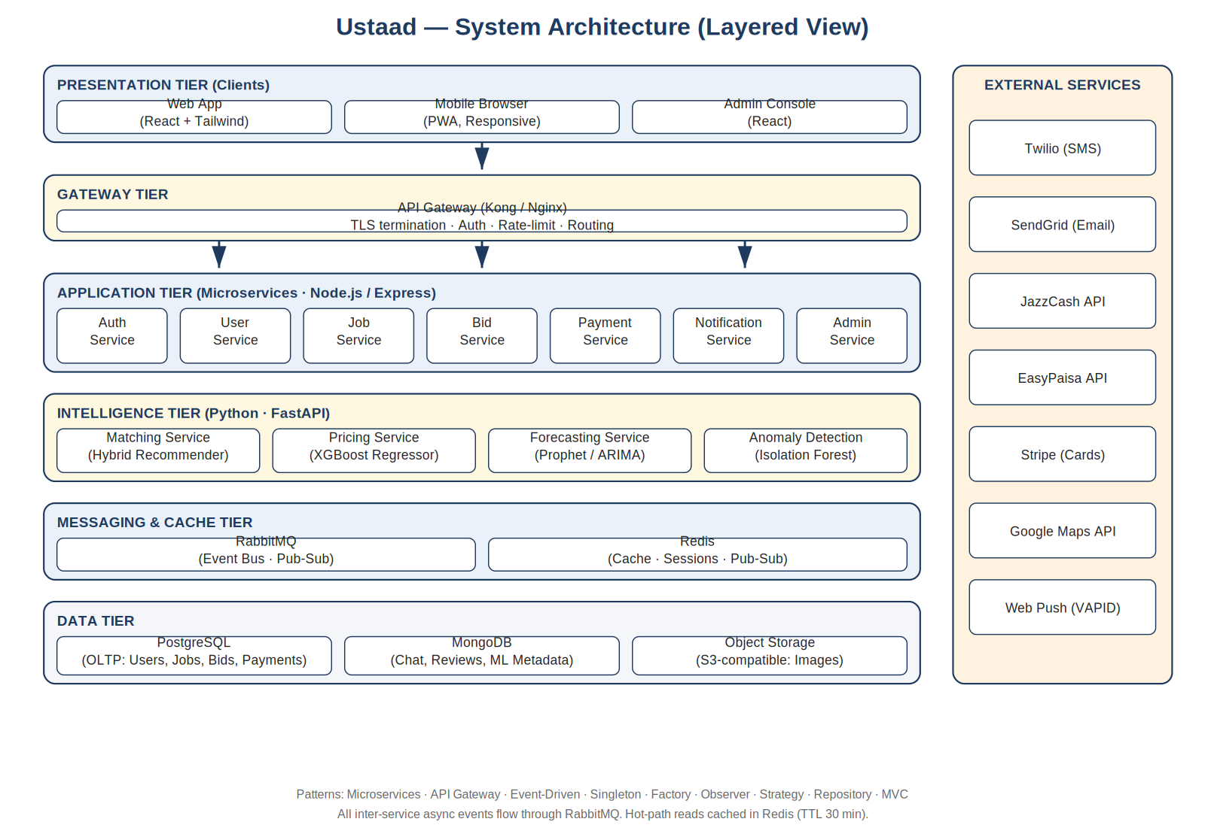
Figure: Ustaad — System Architecture (Layered View). Clients → API Gateway → Application Services → Intelligence Services → Messaging/Cache → Data. External providers shown on the right.
The architecture realises six classical Gang-of-Four design patterns — Singleton (shared connection pools and configuration), Factory (User-subclass instantiation), Observer (Notification Service fan-out), Strategy (interchangeable PaymentStrategy and MatchingStrategy), Repository (data-access abstraction), MVC (per-service code organisation) — alongside three architectural patterns: Microservices, API Gateway, and Event-Driven (publish/subscribe). The expected benefits of these choices are documented in §2.4 (Quality Goals) and validated quantitatively in the performance-comparison report deliverable.

2.10 Use Case Model
Ustaad supports six actors: Customer, Worker, Admin, Guest, and two external system actors — Payment Provider and SMS / Email Provider — together with an internal ML Engineer who retrains models. The diagram below summarises the use cases each actor participates in. Two «include» relationships are highlighted: Post Job «includes» Get Fair-Price Estimate (the price recommendation is unconditionally fetched during posting), and Accept Bid «includes» Make Payment (escrow hold is unconditionally placed on bid acceptance).
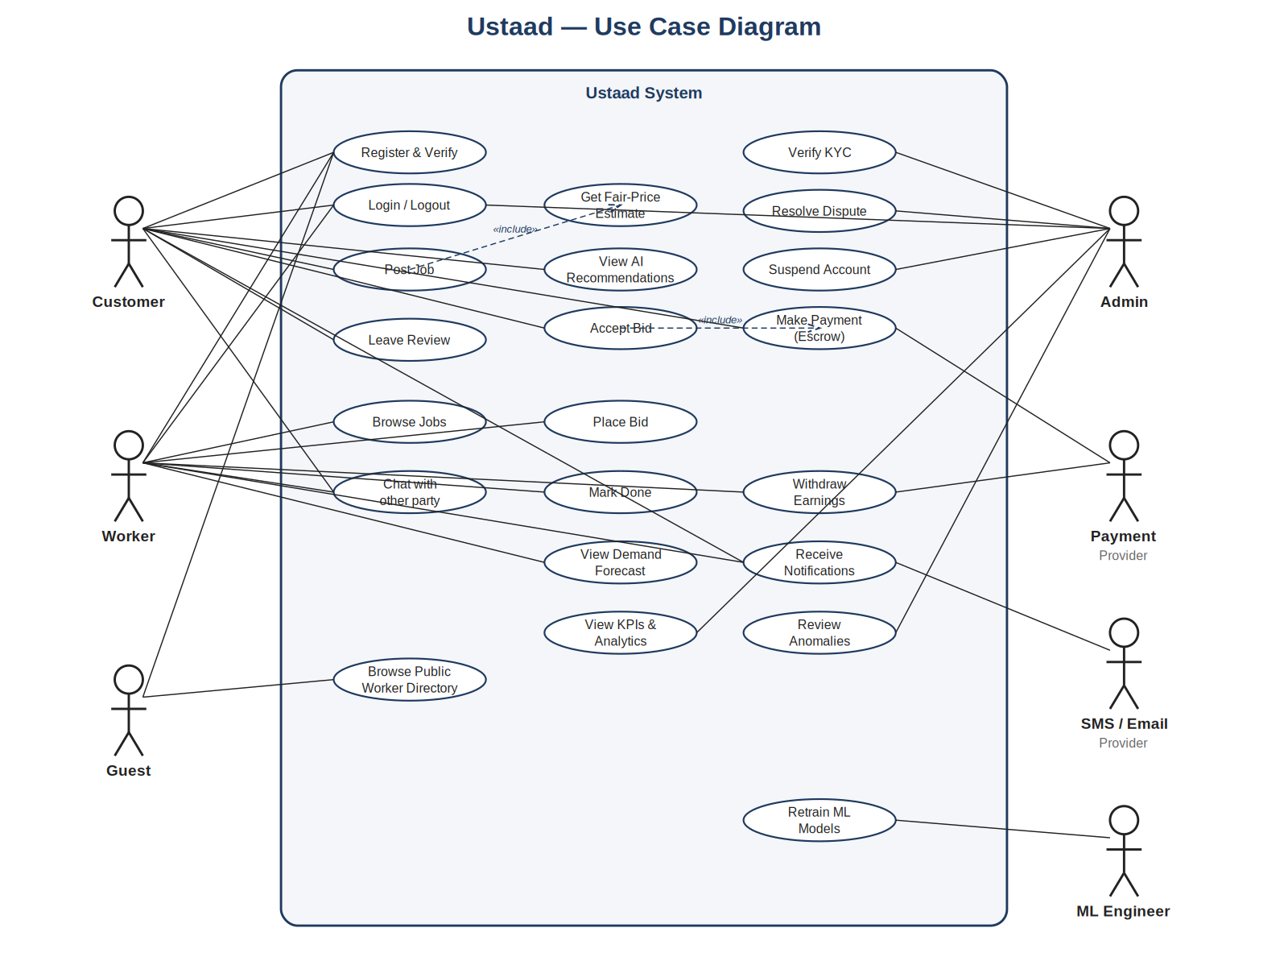
Figure: Ustaad — Use Case Diagram. Primary actors (Customer, Worker, Guest) on the left; supporting actors (Admin, Payment Provider, SMS/Email Provider, ML Engineer) on the right. Functional requirements REQ-1.x to REQ-10.x in the SRS map onto these use cases.
Each use case in the diagram is detailed in §4 of the SRS as a feature with functional requirements (REQ-1.1 through REQ-10.5).

2.11 Feature List
The 20 core domain features below are functional capabilities specific to the skilled-labour marketplace domain. Generic features (login, logout, dashboard, GUI design) and non-functional concerns (security, reliability, accessibility) are intentionally excluded; they are addressed in §5 of the SRS.
- F1. Post a job specifying category, sub-category, location (GPS-aided), description, photos, preferred date/time, and budget range.
- F2. Receive AI-ranked top-K worker recommendations with explainable scores (skill match, distance, rating, availability).
- F3. Receive a fair-price band (low / recommended / high) generated by an ML regression model before submitting the job.
- F4. Place a bid on an open job with amount, ETA, and an optional message.
- F5. Negotiate a bid with up to three counter-offers between customer and worker.
- F6. Accept a winning bid, automatically holding the agreed amount in escrow.
- F7. In-app chat between customer and assigned worker with message persistence and dispute-time replay.
- F8. Mark a job as Done (worker action) and Confirm Completion (customer action) to release escrow.
- F9. Submit a double-blind 1–5 star rating plus a written review of the other party.
- F10. Browse a worker's public profile including aggregated rating, completed-job count, and verified skills.
- F11. Upload and manage worker portfolio (before/after photos of past jobs).
- F12. Multi-channel real-time notifications (in-app, push, email, SMS) tied to per-event preferences.
- F13. View a 7-day demand-forecast heatmap by category and locality (Worker and Admin dashboards).
- F14. Worker availability scheduler — block dates, set preferred radius, set minimum bid.
- F15. Withdraw earnings to a registered bank / mobile-wallet account in daily batches.
- F16. Admin: review and approve / reject worker KYC submissions (CNIC + certificates).
- F17. Admin: open, investigate, and resolve disputes with three outcomes (release / refund / split).
- F18. Admin: view real-time KPIs (active jobs, GMV, average match time, dispute rate).
- F19. Anomaly detection on transactions and reviews — automated flagging of suspicious patterns for admin review.
- F20. Public worker directory (read-only for guests) with category and city filters to drive sign-up.

2.12 Software Development Methodology
The project follows Agile Scrum adapted to the academic calendar. Scrum is chosen over Waterfall for two specific reasons: (i) the requirements at the AI-services boundary are inherently uncertain — model quality emerges only after iterative training and feedback — and (ii) the hybrid technology stack (JS, Python, multiple databases) means risk is best discovered early through working software, not late through documentation hand-offs.
Concrete adaptations: (a) sprints are one academic week long instead of the textbook two, to fit the 8-active-week implementation window; (b) the daily stand-up is replaced by an asynchronous WhatsApp check-in plus a 15-minute in-person sync three times a week; (c) the Sprint Review is held with the course advisor every alternate week as the surrogate Product Owner; (d) the Sprint Retrospective is mandatory at the end of every sprint and produces one concrete improvement action.
Roles in this project:
- Product Owner — played jointly by the team (translating customer-empathy interviews into a backlog) under the advisor's review.
- Scrum Master — rotated weekly between team members; responsible for unblocking the team and keeping the sprint board current.
- Development Team — all three members; cross-functional, pairs on hard tasks.
Engineering practices supporting Scrum:
- Trunk-based Git workflow with short-lived feature branches and mandatory peer review on every PR.
- Continuous Integration runs lint, unit tests, and dependency-vulnerability scan on every push.
- Definition of Done: code merged + unit tests passing + integration test passing + JIRA / GitHub issue closed + at least one screen-recording or demo GIF in the PR.
- Sprint backlog and burndown maintained in GitHub Projects (Kanban view).

2.13 Proposed Infrastructure Platform and Tools
All names listed exhaustively below — to be refined as the project progresses.

Languages & Runtimes
- JavaScript (ES2022) and TypeScript 5 — Node.js 20 LTS for application services.
- Python 3.11 — for ML services.
- HTML5, CSS3, JSX — for the React frontend.

Frameworks & Libraries
- Frontend: React 18, React Router 6, TanStack Query, Tailwind CSS 3, shadcn/ui, Vite, i18next, Zod.
- Backend: Express 4, Joi for validation, Mongoose, Sequelize / Prisma, jsonwebtoken, bcrypt, helmet, pino logger.
- ML: scikit-learn 1.3, XGBoost 2, Prophet 1.1, FastAPI 0.100+, Pydantic 2, joblib, pandas, numpy.

Data Stores
- PostgreSQL 15 — primary OLTP.
- MongoDB 6 — chat, reviews, ML metadata.
- Redis 7 — cache, session store, pub/sub.
- S3-compatible object storage (MinIO locally; Cloudflare R2 in demo deployment).

Messaging, Gateway, and Networking
- RabbitMQ 3.12 — domain events.
- Kong (or Nginx) — API Gateway.
- Docker 24, Docker Compose 2 — containerisation.

External Services & APIs
- Twilio — SMS.
- SendGrid — email.
- JazzCash sandbox API — wallet payments.
- EasyPaisa sandbox API — wallet payments.
- Stripe test mode — card payments.
- Google Maps Platform — geocoding, distance matrix.
- Web Push (VAPID) — push notifications.

DevOps, CI/CD, Testing, Monitoring
- GitHub — source hosting and pull-request review.
- GitHub Actions — CI (lint, test, audit) on every push and PR.
- Jest — JS unit and integration tests.
- PyTest — Python unit tests.
- Supertest / Playwright — API and end-to-end tests.
- JMeter — load and performance testing.
- Postman / Newman — API exploration and contract tests.
- Prometheus + Grafana (optional) — metrics and dashboards in extended deployment.

Productivity, Design, and Documentation
- VS Code with team-shared settings (.vscode) and Prettier/ESLint configurations.
- Figma or Balsamiq — UI mockups.
- draw.io or Lucidchart — UML diagrams (or PlantUML in source control).
- Microsoft Word / LibreOffice — SRS, proposal, and final report (IEEE format).
- OBS Studio — demo screen recording.
- Notion / Google Drive — meeting notes and shared documentation.

2.14 Project Timeline
The Gantt chart below shows the planned schedule from Week 7 (proposal approval) to Week 15 (final submission). Tasks are colour-coded by phase: planning/documentation (dark blue), design (mid blue), implementation (green), patterns/refactor (amber), ML and caching (purple), and testing (red). Overlapping bars indicate parallel work split across team members.
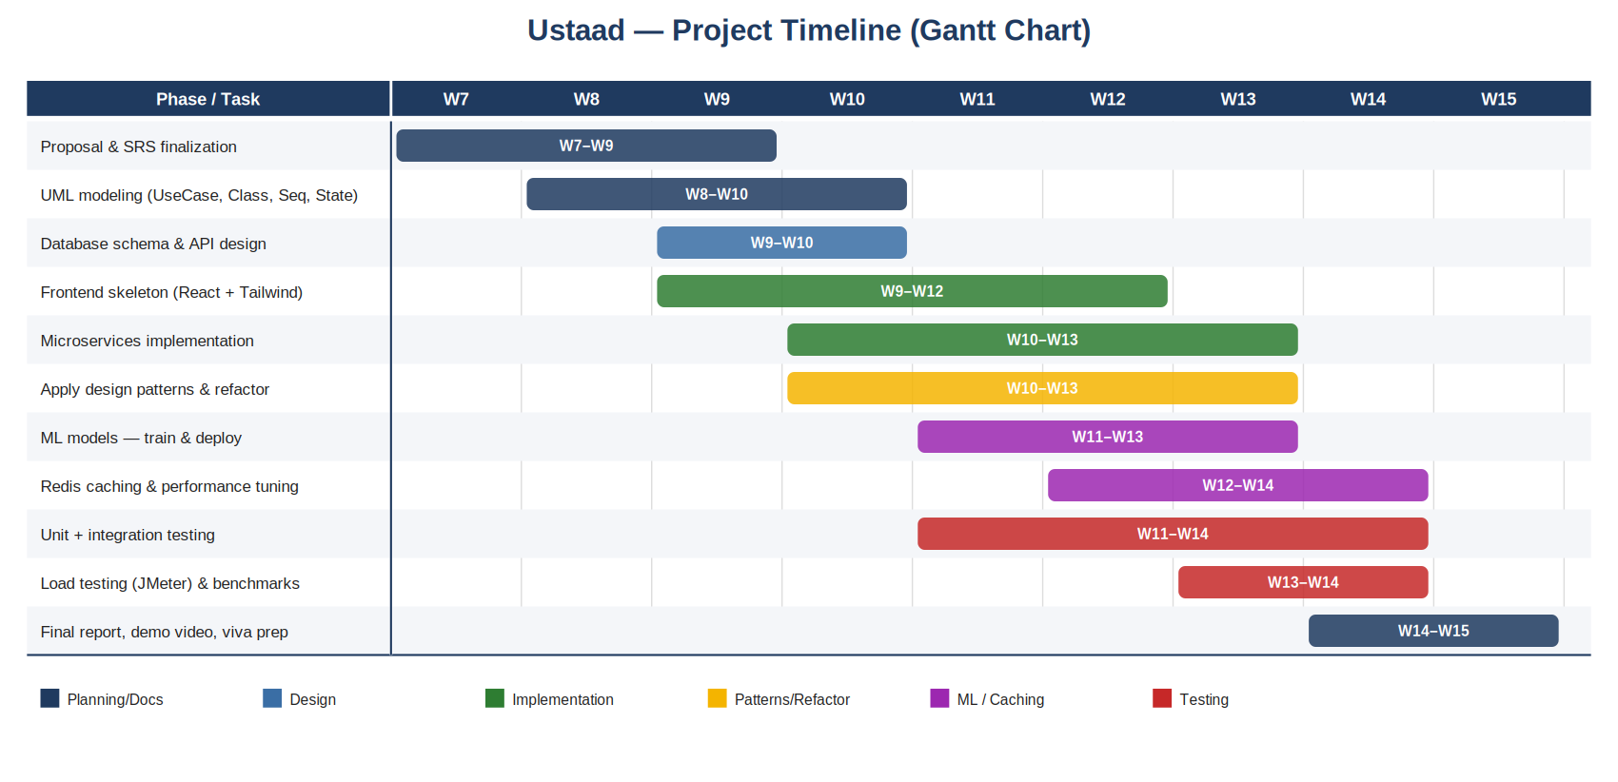
Figure: Ustaad — Project Timeline (Gantt chart). Eleven tasks distributed across nine weeks, with parallel work streams between frontend, backend, ML, and testing.

Sprint Breakdown
- Sprint 1 (Week 8): Finalise SRS, complete UML suite, set up monorepo, CI, and microservices skeleton.
- Sprint 2 (Week 9): Database schema and API contracts; auth & user services first cut.
- Sprint 3 (Week 10): Job & Bid services; frontend skeleton (signup, post-job, dashboard).
- Sprint 4 (Week 11): Apply design patterns; first ML model (pricing) deployed; integration tests begin.
- Sprint 5 (Week 12): Matching service; notification observer; chat; Redis caching.
- Sprint 6 (Week 13): Forecasting service; admin console; payment escrow flow with Strategy pattern.
- Sprint 7 (Week 14): Load testing; performance comparison; bug fixing; demo preparation.
- Sprint 8 (Week 15): Final report, demo video, viva preparation, submission.

2.15 Mockups
Detailed click-through mockups will be produced in Figma during Sprint 1 and included in the final report's Appendix. The five primary screens identified for the v1.0 prototype are: (1) Customer landing & sign-up, (2) Post-Job form with inline AI fair-price band, (3) Worker recommendation list with explainable scores, (4) Worker dashboard with active leads and demand forecast, and (5) Admin dispute-resolution screen. Each screen will follow the visual conventions (colour palette, typography, button styles) specified in §3.1 of the SRS.
In the interest of a brief proposal, mockups are listed by name here; the visual artefacts are tracked as a TBD item and will appear in the SRS Appendix and the final viva slides.

2.16 References
References are listed in IEEE citation format.
[1] IEEE, IEEE Recommended Practice for Software Requirements Specifications, IEEE Std 830-1998. New York, NY, USA: IEEE, 1998.
[2] K. E. Wiegers, Software Requirements, 3rd ed. Redmond, WA: Microsoft Press, 2013.
[3] E. Gamma, R. Helm, R. Johnson, and J. Vlissides, Design Patterns: Elements of Reusable Object-Oriented Software. Reading, MA: Addison-Wesley, 1995.
[4] S. Newman, Building Microservices, 2nd ed. Sebastopol, CA: O'Reilly Media, 2021.
[5] M. Fowler, Patterns of Enterprise Application Architecture. Boston, MA: Addison-Wesley, 2002.
[6] T. Chen and C. Guestrin, “XGBoost: A Scalable Tree Boosting System,” in Proc. 22nd ACM SIGKDD Int. Conf. Knowledge Discovery and Data Mining (KDD '16), San Francisco, CA, USA, 2016, pp. 785–794.
[7] S. J. Taylor and B. Letham, “Forecasting at scale,” The American Statistician, vol. 72, no. 1, pp. 37–45, 2018.
[8] F. M. Harper and J. A. Konstan, “The MovieLens Datasets: History and Context,” ACM Trans. Interactive Intelligent Systems, vol. 5, no. 4, art. 19, 2015. (Reference for hybrid recommender baseline.)
[9] Government of Pakistan, Prevention of Electronic Crimes Act (PECA), 2016. Islamabad: Ministry of Information Technology, 2016.
[10] OWASP Foundation, “OWASP Top Ten — 2021.” [Online]. Available: https://owasp.org/Top10/.
[11] Project repository, “Ustaad-E-Mazdoor.” [Online]. Available: https://github.com/shahmeer-irfan/Ustaad-E-Mazdoor.
[12] Urban Company, Crunchbase profile. [Online]. Available: https://www.crunchbase.com/organization/urbanclap. (Comparator in §2.8.)

