Software Requirements
Specification
for
Ustaad
An AI-Powered Skilled Labor Marketplace
Version 1.0 — Approved
Prepared by Team Ustaad
National University of Computer & Emerging Sciences, Karachi
Department of Computer Science
Software Engineering — Spring 2026

Revision History
Name | Date | Reason for Changes | Version
Team Ustaad | Week 7, 2026 | Initial draft for proposal approval | 0.1
Team Ustaad | Week 9, 2026 | Expanded functional requirements, added UML references | 0.5
Team Ustaad | Week 14, 2026 | Final approved version with NFRs and validation results | 1.0

1. Introduction

1.1 Purpose
This Software Requirements Specification (SRS) document specifies the functional and non-functional requirements for Ustaad, an AI-powered web-based marketplace that connects customers with verified skilled workers — plumbers, electricians, carpenters, masons, painters, AC technicians, and similar trades. This document covers Release 1.0, which includes the core marketplace functionality, AI-driven worker–job matching, fair-price prediction, demand forecasting, microservices backend, and administrative tooling. The SRS is intended to serve as the authoritative reference for design, implementation, testing, and validation activities throughout the project lifecycle.

1.2 Document Conventions
This document follows the IEEE 830-1998 SRS standard. The following typographic and structural conventions apply throughout:
- Bold is used for terms being defined and for requirement IDs.
- Italics are used for placeholders or emphasis on user-visible text.
- Monospace denotes code, file names, API endpoints, or commands.
- Each functional requirement is uniquely tagged in the form REQ-X.Y where X is the feature number and Y is the requirement index.
- Each requirement carries an implicit priority of High unless explicitly noted as Medium or Low.
- Priorities of higher-level features are inherited by their detailed sub-requirements.

1.3 Intended Audience and Reading Suggestions
This document is written for the following stakeholders:
- Course Instructors and Evaluators — to assess the project against rubric criteria; recommended reading order: §1.4, §2, §4, §5, Appendix B.
- Developers (project team members) — to implement the system; recommended order: full document, with focus on §3, §4, §5, Appendix B.
- Testers / QA — to derive test cases; focus on §4 (functional) and §5 (non-functional).
- End Users (customers, workers, admins) — may consult §1.4, §2.2, §2.3, and §3.1 for an overview of capabilities.
- Project Sponsors / External Reviewers — may begin with §1, §2, and Appendix B.

1.4 Product Scope
Ustaad is a self-contained web application targeted at urban Pakistani markets (initial launch: Karachi). Its primary objective is to reduce the friction, opacity, and price arbitrariness of hiring skilled labor by replacing word-of-mouth networks with a verified, ratings-driven, AI-augmented matching platform. Customers post jobs; the system recommends the top-K most suitable workers using a hybrid recommendation model (content-based + collaborative filtering + geographic proximity), and a regression model suggests a fair price band based on job category, location, and historical data. Workers benefit from prioritized job leads, transparent pricing, and a verifiable reputation. The platform is engineered on a microservices backend with an API Gateway and Redis caching to demonstrate scalable software architecture.
Business goals: (i) increase customer trust through verified profiles and reviews; (ii) increase worker income through smart matching and demand forecasting; (iii) demonstrate technical depth in AI integration and microservices architecture as required by the Software Engineering course rubric.

1.5 References
- IEEE Std 830-1998: Recommended Practice for Software Requirements Specifications. IEEE, 1998.
- Wiegers, K. E. Software Requirements Specification Template, 1999.
- Project Description, Software Engineering Course, Spring 2026, FAST-NUCES Karachi.
- Erl, T. Service-Oriented Architecture: Concepts, Technology, and Design. Prentice Hall, 2005.
- Gamma, E. et al. Design Patterns: Elements of Reusable Object-Oriented Software. Addison-Wesley, 1994.
- Newman, S. Building Microservices. O'Reilly, 2nd Edition, 2021.
- Project repository: github.com/shahmeer-irfan/Ustaad-E-Mazdoor

2. Overall Description

2.1 Product Perspective
Ustaad is a new, self-contained product. It is not a follow-on to any existing system but is conceptually similar to platforms such as TaskRabbit (USA), Urban Company (India), and Mr. Right (Pakistan). It differentiates itself through three architectural pillars: (1) an AI matching engine that explains its recommendations, (2) a microservices backend that scales independently, and (3) a demand-forecasting dashboard that helps workers plan their availability.
The system consists of the following major components, communicating through an API Gateway:
- Web frontend (React.js + Tailwind CSS) — single-page application for customers, workers, and admins.
- API Gateway (Kong or Nginx) — single entry point, request routing, authentication, rate limiting.
- Auth Service — registration, login, JWT issuance, role-based access control.
- User Service — customer and worker profile management, KYC, skills, geolocation.
- Job Service — job posting, lifecycle management, bidding.
- Matching Service — AI-driven worker recommendation (Python/FastAPI).
- Pricing Service — ML-based fair-price estimator.
- Notification Service — Observer-pattern fan-out: email, SMS, in-app.
- Payment Service — Strategy-pattern adapter for JazzCash, EasyPaisa, card.
- Forecasting Service — time-series demand prediction per locality and category.
- Data tier — PostgreSQL (relational), MongoDB (reviews/chat), Redis (cache + pub/sub).
A high-level component diagram is provided in Appendix B (Figure B-1).

2.2 Product Functions
The major functions Ustaad provides are summarized below; detailed requirements are in §4.
- F1. Account creation, KYC verification, and authentication for three user classes (Customer, Worker, Admin).
- F2. Profile and skill management, including portfolio uploads and certification verification.
- F3. Job posting with category, description, location, deadline, and budget range.
- F4. AI-based smart matching of jobs to workers with explainable ranking.
- F5. Real-time bidding, negotiation, and acceptance workflow.
- F6. Multi-channel notifications driven by domain events.
- F7. Secure payments (escrow-style hold and release on completion).
- F8. Ratings, reviews, and reputation scoring.
- F9. AI-based fair-price recommendation for both customer and worker.
- F10. Demand-forecasting dashboard for workers and admins.
- F11. Admin moderation, dispute resolution, and analytics.
- F12. Anomaly detection on transactions and reviews to flag fraud.

2.3 User Classes and Characteristics
User Class | Frequency of Use | Technical Expertise | Key Characteristics & Importance
Customer | Occasional (1–4×/month) | Low to Medium | Posts jobs, browses workers, pays, reviews. Largest class. Most important to satisfy — drives adoption. Mobile-first.
Worker | Daily | Low (often blue-collar, may be semi-literate) | Receives leads, bids, completes jobs, withdraws earnings. UI must support Urdu + low-bandwidth use.
Admin | Daily (internal staff) | High | Verifies KYC, resolves disputes, monitors analytics, manages categories. Small but critical class.
Guest / Visitor | Rare | Any | Browses public worker directory and category info before signup. Low priority.
External ML Engineer (internal) | As needed | High | Re-trains and deploys updated matching/pricing/forecasting models via the model-registry endpoint.

2.4 Operating Environment
The system shall operate in the following environment:
- Server-side: Linux (Ubuntu 22.04 LTS) hosts running Docker 24+ and Docker Compose. Each microservice runs in its own container.
- Frontend: Modern browsers — Chrome 110+, Firefox 110+, Safari 16+, Edge 110+. Responsive design for screen widths ≥ 320 px.
- Database: PostgreSQL 15+, MongoDB 6+, Redis 7+.
- ML runtime: Python 3.11+, scikit-learn 1.3+, Prophet 1.1+, FastAPI 0.100+.
- Network: Reliable internet for the server tier; clients are expected to operate on 3G/4G with degraded but functional UX.
- Coexistence: The system integrates with third-party services (Twilio for SMS, SMTP for email, JazzCash/EasyPaisa for payments, Google Maps API for geocoding) and must not interfere with their normal operation.

2.5 Design and Implementation Constraints
- DC-1 Architectural style: the backend MUST be implemented as a set of loosely-coupled microservices behind an API Gateway. A single monolithic deployment is permitted only as the baseline used in the performance-comparison rubric item.
- DC-2 Design patterns: the system MUST demonstrably apply at least five of {Singleton, Factory, Observer, Strategy, Repository, MVC}. The pattern usage and its effect on maintainability/scalability must be documented in code comments and the design report.
- DC-3 Languages and frameworks: JavaScript/TypeScript (Node.js + Express) for service code; Python for ML services; React for frontend.
- DC-4 Communication: synchronous service-to-service calls use HTTPS+JSON; asynchronous events use RabbitMQ topics.
- DC-5 Security: all traffic over TLS 1.2+; passwords hashed with bcrypt (cost ≥ 12); JWTs with 15-minute access and 7-day refresh tokens.
- DC-6 Localization: the customer-facing UI MUST support both English and Urdu (i18n via JSON resource files).
- DC-7 Source control & CI: the project MUST be hosted in the public GitHub repository at github.com/shahmeer-irfan/Ustaad-E-Mazdoor with CI checks (lint, unit tests) on every pull request.
- DC-8 Time/budget: the system must be delivered by Week 15 of the academic semester by a team of 2–3 students.

2.6 User Documentation
The following user documentation will be delivered alongside the software:
- README.md in the GitHub repository — installation, configuration, and quick-start instructions.
- User Manual (PDF) — illustrated guide for Customers and Workers, in English and Urdu.
- Admin Guide (PDF) — KYC verification workflow, dispute resolution, dashboard usage.
- API Reference (auto-generated from OpenAPI/Swagger spec, served at /api-docs).
- Demo video (10–12 minutes) — recorded walkthrough of all major features for the project viva.
- In-app contextual help — tooltips and a built-in FAQ accessible from the user menu.

2.7 Assumptions and Dependencies
The requirements in this document depend on the following assumed factors:
- A1. Customers and workers have access to a smartphone or PC with internet connectivity (3G or better).
- A2. Workers can read either English or Urdu sufficient to navigate a guided UI.
- A3. Third-party APIs (Twilio, JazzCash/EasyPaisa, Google Maps) remain available with current pricing and SLAs.
- A4. Sufficient labelled historical data (≥ 5,000 synthetic or scraped jobs) is available to train the matching, pricing, and forecasting models. If unavailable at training time, models may begin in a rule-based fallback mode.
- A5. Course-provided cloud credits (or local Docker hosting) are sufficient for demonstration and load testing up to 1,000 concurrent users.
- A6. The legal status of online labour intermediation in Pakistan permits a non-commercial student prototype; no PECA-related restrictions apply to academic demonstration.
- A7. KYC verification in the prototype is performed manually by the admin; an automated NADRA/CNIC API integration is out of scope for v1.0.

3. External Interface Requirements

3.1 User Interfaces
The Ustaad UI follows a minimal, mobile-first responsive design built with React.js and Tailwind CSS. All screens share the conventions described below.
- Color palette: primary #1F3A5F (deep blue), accent #F4B400 (warm yellow), success #2E7D32, danger #C62828, neutral grays for text.
- Typography: Inter for English, Noto Nastaliq Urdu for Urdu; minimum body size 14 px.
- Standard top navigation: logo (home), search, notifications bell, profile menu. Bottom nav on mobile for the 4 primary tasks.
- Every form field has an inline error label and an aria-describedby for accessibility.
- Standard buttons: primary (filled blue), secondary (outline), destructive (red). Minimum tap target 44×44 px.
- Loading states use skeleton screens, never indefinite spinners on full pages.
- Error pages: 401, 403, 404, 500 — each with a clear message, a retry, and a 'back home' button.
- Language toggle (EN / اردو) persists per user and is also available on the public landing page.
Wireframes for the ten primary screens (landing, signup, login, customer dashboard, post-job, worker recommendations, job detail, worker dashboard, chat, admin) are provided in Appendix B (Figure B-2).

3.2 Hardware Interfaces
The system has no direct hardware interfaces. Indirect hardware interactions occur via the user's device:
- Camera (mobile) — for capturing CNIC photos and job-site images during posting and completion. Accessed via the WebRTC getUserMedia API.
- GPS / Geolocation sensor — for capturing the customer's location when posting a job and the worker's location when bidding. Accessed via the W3C Geolocation API with explicit user consent.
- Push-notification subsystem of the OS — for delivering Web Push messages (mobile and desktop), via the W3C Push API and Notifications API.
- Local storage (IndexedDB) — for caching the last-known recommendations and offline-friendly read of recent jobs.

3.3 Software Interfaces
Component | Version | Purpose & Data Exchanged
PostgreSQL | 15.x | Primary relational store (users, jobs, bids, payments). SQL via parameterized queries through a Repository layer. Shared connection pool per service.
MongoDB | 6.x | Stores chat messages, review documents, and ML model metadata. Accessed via the official Node.js driver.
Redis | 7.x | Hot-path cache (worker search results, session tokens) and pub/sub channel for cross-service events.
Twilio API | 2010-04-01 | Outbound SMS notifications. Service receives phone number + message; returns delivery status.
SMTP (SendGrid) | v3 | Outbound email notifications using transactional templates.
JazzCash / EasyPaisa | Latest | Payment initiation and webhook callback. Strategy pattern abstracts both providers behind a PaymentGateway interface.
Google Maps API | v3 | Geocoding addresses to lat/long; calculating travel-time estimates between worker and job site.
FastAPI ML services | 0.100+ | Internal HTTP/JSON: POST /match, POST /predict-price, GET /forecast?city=&category=. Authentication by mutual API key.
RabbitMQ | 3.12 | Asynchronous message broker for domain events (JobCreated, BidPlaced, JobCompleted, PaymentReleased).

3.4 Communications Interfaces
- All client-server traffic uses HTTPS over TLS 1.2 or higher. HTTP requests are automatically redirected to HTTPS by the API Gateway.
- Service-to-service calls within the cluster use HTTP over a private Docker network with mutual API-key authentication; production deployment may upgrade to mTLS.
- Real-time chat and live notifications use WebSockets (wss://) terminated at the API Gateway and proxied to the Notification Service.
- Asynchronous events use AMQP 0.9.1 over RabbitMQ. Message format: JSON with schema versioning (e.g., {"event":"JobCreated","v":1,"payload":{...}}).
- Push notifications use the W3C Web Push protocol with VAPID keys.
- Email uses SMTP over TLS on port 587; SMS uses Twilio's HTTPS REST API.
- Minimum sustained throughput per client connection: 32 kbps; the UI degrades gracefully under lower bandwidth (skips non-essential images).
- Synchronization: idempotent retry with exponential back-off for all network calls; correlation IDs propagate through the gateway for distributed tracing.

4. System Features
Functional requirements are organized by system feature. Each feature follows the structure: description & priority, stimulus/response sequences, and itemized functional requirements (REQ-N.M).

4.1 User Registration & Authentication

4.1.1 Description and Priority
Allows guests to register as a Customer or Worker, log in securely, recover passwords, and obtain a session that scopes access by role. KYC documents (CNIC for workers) are uploaded during registration and queued for admin review.
Priority: High. (Benefit, Penalty, Cost, Risk on 1–9 scale: see table below.)

4.1.2 Stimulus / Response Sequences
- User submits the registration form: system validates fields, checks email/phone uniqueness, hashes password (bcrypt cost 12), creates an inactive user, sends an email + SMS OTP
- User submits OTP within 10 minutes: account is activated; if Worker, profile enters 'pending KYC' state
- User submits incorrect OTP three times: OTP is invalidated; user must request a new one (rate-limited to 3/hour)
- User logs in: system verifies credentials, issues 15-minute access JWT and 7-day refresh token, logs the device fingerprint
- User clicks 'forgot password': system emails a single-use reset link valid for 30 minutes

4.1.3 Functional Requirements
REQ-1.1: The system shall provide registration forms for Customer and Worker with role-specific fields (Customer: name, email, phone, password, location; Worker: + CNIC, primary skill, years of experience, service area, certification upload).
REQ-1.2: The system shall validate email uniqueness, phone-number format (Pakistani: +92 followed by 10 digits), and password strength (min 8 chars, 1 uppercase, 1 digit, 1 symbol). Invalid inputs shall produce inline, accessible error messages.
REQ-1.3: The system shall hash all passwords using bcrypt with a work factor of at least 12 before storage. Plain-text passwords shall never be logged or transmitted after hashing.
REQ-1.4: The system shall send a 6-digit OTP via SMS and email upon registration; OTPs shall expire after 10 minutes and be single-use.
REQ-1.5: The system shall issue a JWT access token (15-minute expiry) and a refresh token (7-day expiry, rotated on use) upon successful login.
REQ-1.6: The system shall enforce role-based access control: Customer-only endpoints reject Worker tokens with HTTP 403, and vice versa.
REQ-1.7: The system shall lock an account for 15 minutes after 5 consecutive failed login attempts within 10 minutes.
REQ-1.8: The system shall provide 'forgot password' flow via single-use email link valid for 30 minutes, requiring the new password to differ from the last three.
REQ-1.9: Worker accounts shall remain in 'pending KYC' state until an Admin approves the uploaded CNIC and certificates; a pending Worker may browse but not bid.

4.2 Job Posting & Lifecycle Management

4.2.1 Description and Priority
Enables Customers to create, edit, cancel, and complete jobs. Each job moves through a defined lifecycle (Draft → Open → Bidding → Assigned → InProgress → Completed → Closed | Cancelled | Disputed) and is the source of all downstream events consumed by other services.
Priority: High. (Benefit, Penalty, Cost, Risk on 1–9 scale: see table below.)

4.2.2 Stimulus / Response Sequences
- Customer clicks 'Post a Job': system displays the job-posting form with the AI-suggested fair price band based on category and location
- Customer submits the job: system creates the job in 'Open' state and emits a JobCreated event consumed by the Matching Service
- Customer cancels an Open job: system cancels with no penalty and notifies any bidders
- Customer cancels an Assigned job: system applies a small cancellation fee per the business rules and notifies the assigned worker

4.2.3 Functional Requirements
REQ-2.1: The system shall allow a Customer to create a job with: title (5–80 chars), category (from a curated list), description (20–1000 chars), location (auto-filled from GPS, editable), preferred date/time, expected duration, and budget range.
REQ-2.2: The system shall display, before submission, an AI-recommended fair price band returned by the Pricing Service (see §4.8); the customer may accept it or override with their own range.
REQ-2.3: The system shall persist a job in 'Draft' state on form-field changes (auto-save every 5 seconds) so that the customer can resume later.
REQ-2.4: The system shall transition a job to 'Open' on submission and emit a JobCreated event to RabbitMQ within 1 second.
REQ-2.5: The system shall allow attachment of up to 5 photos per job (max 5 MB each, JPEG/PNG/WEBP) and store them in S3-compatible object storage.
REQ-2.6: The system shall enforce job-state transitions strictly: only the lifecycle Draft→Open→Bidding→Assigned→InProgress→Completed→Closed (with side branches to Cancelled, Disputed) shall be permitted; invalid transitions shall return HTTP 409.
REQ-2.7: The system shall not allow a Customer to have more than 10 simultaneously Open jobs to prevent spam.
REQ-2.8: The system shall allow a Customer to mark a job 'Completed' only after the assigned worker has marked it 'Done'; payment release follows §4.6.

4.3 AI-Based Worker Matching

4.3.1 Description and Priority
When a job is posted, the Matching Service ranks the most suitable workers using a hybrid recommendation model — content features (skill match, experience, distance), collaborative signals (similar customers' acceptance history), and availability — and returns an explainable top-K list to the customer. This is the project's headline AI capability and the primary technical-depth contribution.
Priority: High. (Benefit, Penalty, Cost, Risk on 1–9 scale: see table below.)

4.3.2 Stimulus / Response Sequences
- JobCreated event arrives at the Matching Service: service computes feature vectors for all eligible workers in the city, scores them, and writes a ranked top-20 list to Redis with TTL 30 minutes
- Customer opens the job page: Job Service reads the ranked list from Redis (cache hit) or triggers re-ranking, then returns it to the UI with explanations
- Worker rejects an offer or goes offline: the list is invalidated and re-ranked excluding that worker

4.3.3 Functional Requirements
REQ-3.1: The Matching Service shall return a ranked list of at most 20 workers within 800 ms (p95) for any job whose city has fewer than 10,000 active workers.
REQ-3.2: The matching score shall be a weighted combination of: skill match (0.35), distance (0.20), worker rating (0.20), historical acceptance rate (0.15), and availability now (0.10). Weights shall be configurable in a YAML file without code changes (Strategy pattern).
REQ-3.3: The system shall present, for each recommended worker, an explanation listing the top 3 contributing factors (e.g., 'matches your plumbing skill', '2.1 km away', '4.8★ rating').
REQ-3.4: The Matching Service shall expose two algorithm strategies — RuleBased (baseline) and MLHybrid (default) — selectable per request via a query parameter for the performance-comparison evaluation.
REQ-3.5: Workers in 'pending KYC', 'suspended', or 'on leave' state shall be excluded from all recommendation lists.
REQ-3.6: The system shall log every recommendation event (job, worker IDs, score, timestamp) for offline model retraining and offline A/B analysis.
REQ-3.7: If the Matching Service is unavailable, the Job Service shall fall back to a simple distance-then-rating sort and surface a non-blocking warning to the user.

4.4 Bidding, Negotiation & Acceptance

4.4.1 Description and Priority
Workers respond to jobs by placing bids; customers may accept, counter-offer, or reject. The flow ends when both parties agree on a price, at which point the job is assigned and an escrow hold is placed.
Priority: High. (Benefit, Penalty, Cost, Risk on 1–9 scale: see table below.)

4.4.2 Stimulus / Response Sequences
- Worker places a bid: system validates the bid is within ±50% of the AI fair-price band and emits a BidPlaced event
- Customer accepts a bid: system creates a contract record, places an escrow hold, transitions the job to 'Assigned', notifies both parties
- Customer counter-offers: the worker is notified; bid status becomes 'Negotiating'

4.4.3 Functional Requirements
REQ-4.1: The system shall allow each eligible worker to place at most one active bid per job. A bid contains: amount, ETA, optional message (max 280 chars).
REQ-4.2: The system shall reject bids more than 50% above or below the AI fair-price band with a warning explaining the band, but shall allow override after explicit customer confirmation.
REQ-4.3: The system shall close bidding automatically 30 minutes after a job is assigned, or 72 hours after posting if no bid is accepted.
REQ-4.4: Acceptance of a bid shall be atomic: a single database transaction creates the contract, holds the escrow amount, transitions the job state, and emits BidAccepted; partial failure rolls back all changes.
REQ-4.5: The system shall notify the winning worker and all losing bidders within 2 seconds of bid acceptance.
REQ-4.6: Counter-offers shall be limited to 3 per pair (customer ↔ worker) per job to prevent abuse.

4.5 Real-Time Multi-Channel Notifications

4.5.1 Description and Priority
All time-sensitive domain events (new bid, job assigned, payment released, rating left) generate notifications delivered through the user's preferred channels — in-app (WebSocket), email, SMS, and Web Push. The Notification Service is the canonical demonstration of the Observer pattern in this project.
Priority: High. (Benefit, Penalty, Cost, Risk on 1–9 scale: see table below.)

4.5.2 Stimulus / Response Sequences
- Any service emits a domain event to RabbitMQ: Notification Service consumes it, looks up subscribers, and dispatches per-channel messages via the appropriate adapter
- User toggles a channel off in preferences: future events skip that channel for that user

4.5.3 Functional Requirements
REQ-5.1: The Notification Service shall subscribe to the events: JobCreated, BidPlaced, BidAccepted, JobAssigned, JobInProgress, JobCompleted, PaymentReleased, ReviewSubmitted, DisputeOpened.
REQ-5.2: Each user shall be able to enable/disable each channel (in-app, email, SMS, push) independently, with sensible defaults: in-app and push ON for all events; email ON for transactional only; SMS ON for assignment/payment events.
REQ-5.3: In-app notifications shall be delivered over WebSocket within 1 second of event emission for online users, and queued for later display for offline users.
REQ-5.4: SMS shall be sent only for high-priority events (assignment, payment, dispute) due to cost; the Notification Service shall apply a per-user daily SMS cap of 10.
REQ-5.5: All notifications shall be idempotent: re-delivery of the same event shall not produce duplicate user-visible messages (deduplication by event UUID, kept 24 hours).
REQ-5.6: Failed deliveries shall be retried with exponential back-off (1m, 5m, 30m, 2h, 12h) before being marked permanently failed and surfaced to admin.

4.6 Secure Payment Processing

4.6.1 Description and Priority
Customers fund an escrow at job assignment; the worker is paid when the job is completed and the customer confirms. Multiple payment providers are supported via the Strategy pattern.
Priority: High. (Benefit, Penalty, Cost, Risk on 1–9 scale: see table below.)

4.6.2 Stimulus / Response Sequences
- Customer accepts a bid: Payment Service initiates an escrow hold via the configured provider; on success, the job assignment is finalized
- Both parties confirm completion: Payment Service releases funds to the worker's wallet minus the platform commission (10%)
- Dispute is opened: funds remain held until admin resolution; admin may release, refund, or split

4.6.3 Functional Requirements
REQ-6.1: The system shall support at least three payment strategies: JazzCashStrategy, EasyPaisaStrategy, CardStrategy (via Stripe-test). The active strategy is chosen per transaction by the customer.
REQ-6.2: All payment intents shall be persisted with status (Pending, Held, Released, Refunded, Failed) and a provider correlation ID for reconciliation.
REQ-6.3: Webhook callbacks from providers shall be verified by HMAC signature; unverified webhooks shall be rejected and logged.
REQ-6.4: The platform commission shall default to 10% of the transaction amount, configurable via admin settings without code redeploy.
REQ-6.5: No payment endpoint shall accept or store raw card data; tokenization is delegated entirely to the provider (PCI-DSS scope reduction).
REQ-6.6: Worker withdrawals to a bank account shall be processed in a daily batch and require 2-factor confirmation by the worker.

4.7 Ratings & Reviews

4.7.1 Description and Priority
After a completed job, both parties may rate each other (1–5 stars) and leave a written review. Reviews feed into the matching algorithm and are visible on the worker's public profile.
Priority: Medium. (Benefit, Penalty, Cost, Risk on 1–9 scale: see table below.)

4.7.2 Stimulus / Response Sequences
- Job transitions to Closed: system invites both parties to leave a review within 14 days
- User submits a review: the review is published immediately, but the rating only becomes visible after both sides have rated (to discourage retaliation)

4.7.3 Functional Requirements
REQ-7.1: The system shall allow ratings on a 1–5 integer scale and reviews of 10–500 characters.
REQ-7.2: Ratings shall remain double-blind for 14 days or until both parties rate, whichever is sooner.
REQ-7.3: The aggregate worker rating shall be a weighted average favoring recent reviews (exponential decay, half-life 90 days).
REQ-7.4: Reviews containing profanity or personal contact information shall be auto-flagged and held for admin moderation.
REQ-7.5: Anomaly detection shall identify suspicious patterns (sudden 5★ bursts, repeated text from one IP) and flag the offending accounts (see §4.10).

4.8 AI-Based Fair-Price Prediction

4.8.1 Description and Priority
Given a job's category, sub-category, location, expected duration, and historical comparables, the Pricing Service returns a fair-price band [low, recommended, high] and a confidence score. Used during job posting (§4.2) and bid validation (§4.4).
Priority: High. (Benefit, Penalty, Cost, Risk on 1–9 scale: see table below.)

4.8.2 Stimulus / Response Sequences
- Customer fills the job-posting form: system POSTs the partial form to /predict-price; the response updates the recommended band in real time (debounced 300 ms)
- Worker enters a bid amount outside ±50% of band: UI surfaces a soft warning with the band and the model's confidence

4.8.3 Functional Requirements
REQ-8.1: The Pricing Service shall expose a POST /predict-price endpoint accepting {category, subcategory, lat, lng, durationMinutes, urgency} and returning {low, recommended, high, currency, confidence}.
REQ-8.2: The model shall be a gradient-boosted regressor (XGBoost or LightGBM) trained on at least 5,000 historical job records, with a target MAPE ≤ 25% on the held-out test set.
REQ-8.3: The service shall return a fallback rule-based band when model confidence is below 0.5, clearly indicating that the band is heuristic.
REQ-8.4: The model shall be retrainable via an admin-only POST /retrain endpoint that runs a background job and atomically swaps the model version on success.
REQ-8.5: All predictions shall be logged with the input features and the returned band for offline drift monitoring.

4.9 Demand-Forecasting Dashboard

4.9.1 Description and Priority
Workers and admins see predicted job volume per category and locality for the upcoming 7 days, enabling workers to plan their schedule and admins to anticipate hot zones. Implemented with a Prophet (or ARIMA) time-series model per (city, category) pair.
Priority: Medium. (Benefit, Penalty, Cost, Risk on 1–9 scale: see table below.)

4.9.2 Stimulus / Response Sequences
- Worker opens the dashboard: UI requests GET /forecast?city=Karachi&category=plumbing&horizon=7; service returns a 7-day series with confidence intervals
- Admin opens the global view: UI shows a heatmap of predicted demand across all categories

4.9.3 Functional Requirements
REQ-9.1: The Forecasting Service shall train at least one time-series model per (city, top-10 category) pair on rolling 90-day windows.
REQ-9.2: Forecasts shall be cached in Redis for 6 hours to limit re-computation; a manual 'refresh' option triggers re-computation for admins only.
REQ-9.3: The dashboard shall render forecasts as line charts with shaded 80% and 95% prediction intervals.
REQ-9.4: The mean absolute percentage error of forecasts on held-out data shall be reported on the admin page; targets MAPE ≤ 30%.

4.10 Admin Console & Anomaly Detection

4.10.1 Description and Priority
Admins moderate KYC, resolve disputes, manage categories, and monitor system health. An anomaly detector flags suspicious transactions and review patterns for human review.
Priority: High. (Benefit, Penalty, Cost, Risk on 1–9 scale: see table below.)

4.10.2 Stimulus / Response Sequences
- Admin logs in: system loads the admin dashboard with KPIs (active jobs, GMV, dispute count, flagged accounts)
- Anomaly detector flags a transaction: the transaction is moved to a review queue and notifications are sent to all admins
- Admin resolves a dispute: system applies the chosen resolution (release / refund / split) and closes the case

4.10.3 Functional Requirements
REQ-10.1: The admin console shall provide queues for: KYC pending, disputes open, anomalies flagged, refund requests.
REQ-10.2: An Isolation Forest model shall score each completed transaction for anomaly; scores above a configurable threshold (default 0.85) shall be flagged automatically.
REQ-10.3: The system shall log every admin action (actor, action, target, timestamp, before/after) to an immutable audit log retained for 7 years.
REQ-10.4: Disputes shall have a documented resolution SLA: 95% resolved within 5 business days.
REQ-10.5: The admin shall be able to suspend or reinstate any user account; suspension immediately invalidates active sessions and refresh tokens.

5. Other Nonfunctional Requirements

5.1 Performance Requirements
Performance targets are stated for the system under nominal load (100 concurrent active users) unless otherwise indicated.
- PR-1 All page loads (cold cache) shall complete within 2.5 seconds at the 95th percentile on a 4G connection.
- PR-2 API endpoints shall respond within 300 ms (p95) for cached reads and 800 ms (p95) for un-cached reads.
- PR-3 The Matching Service shall return a top-20 ranked list within 800 ms (p95) for cities with up to 10,000 active workers.
- PR-4 The Notification Service shall dispatch in-app messages within 1 second of event emission (p95).
- PR-5 The system shall support 500 concurrent active users without degraded SLAs and degrade gracefully (queuing + 503 + Retry-After) above that level.
- PR-6 Throughput target: ≥ 200 requests/second sustained on commodity hardware (4 vCPU, 8 GB RAM per service).
- PR-7 Database queries on indexed columns shall execute in under 50 ms (p99); the design shall provide indexes on user.email, user.phone, job.status, job.location, bid.jobId.
- PR-8 Redis cache hit ratio for the worker-search hot path shall be ≥ 70% in steady state.

5.2 Safety Requirements
- SR-1 The system shall warn customers prominently before sharing their address with a worker, and shall mask exact addresses until a bid is accepted (only locality + landmark are visible during bidding).
- SR-2 All in-app communication between customers and workers shall be retained for 90 days and shall be made available to the admin during dispute resolution to deter harassment.
- SR-3 An emergency 'panic' button shall be available during an active job that records GPS, captures the conversation, and notifies both the platform admin and a pre-registered emergency contact.
- SR-4 Worker profiles shall display verification status (KYC verified, certifications) prominently; un-verified workers shall not appear in primary recommendations.

5.3 Security Requirements
- SEC-1 All HTTP traffic shall be served over TLS 1.2 or higher with HSTS enabled (max-age ≥ 6 months).
- SEC-2 Authentication shall use signed JSON Web Tokens (HS256 with a 256-bit secret rotated quarterly, or RS256 with a key in an external secrets manager).
- SEC-3 Authorization decisions shall be enforced at the API Gateway and re-validated at each service (defense in depth).
- SEC-4 All user-supplied input shall be validated against a strict schema (Joi/Zod for Node services, Pydantic for Python). SQL is constructed only via parameterized queries.
- SEC-5 PII (CNIC numbers, full addresses, payment details) shall be encrypted at rest with AES-256.
- SEC-6 Rate limiting at the gateway shall apply: 60 req/min per IP for unauthenticated routes, 600 req/min per user for authenticated routes.
- SEC-7 OWASP Top-10 mitigations shall be applied; security headers (CSP, X-Frame-Options, X-Content-Type-Options, Referrer-Policy) shall be set on every response.
- SEC-8 Dependency scanning (npm audit, pip-audit) shall run in CI; high/critical findings shall block the merge.
- SEC-9 The system shall comply with applicable PECA (Pakistan Electronic Crimes Act) provisions and standard data-minimization practice.

5.4 Software Quality Attributes
Attribute | Priority | Specification
Availability | High | ≥ 99% monthly uptime for the user-facing API; planned maintenance windows announced 24h in advance.
Maintainability | High | Cyclomatic complexity ≤ 10 per function; ≥ 70% unit-test coverage; design patterns documented in code comments.
Scalability | High | Each microservice shall scale horizontally (stateless) by adding container replicas; database read replicas for the User and Job services.
Reliability | High | Mean time between failures ≥ 168 hours; idempotent operations across retries; no data loss on a single-node failure.
Usability | High | First-time customers shall complete a job posting in ≤ 3 minutes; SUS score target ≥ 75 in usability testing.
Portability | Medium | All services packaged as Docker images; deployable on any Linux host with Docker 24+. No vendor lock-in to a specific cloud.
Interoperability | Medium | Public API documented via OpenAPI 3.0; webhooks for partner integrations.
Testability | High | Each module shall expose a clear interface; integration tests shall use ephemeral database containers.
Localizability | High | Strings externalized to JSON resource bundles; date/time and currency formatted by locale.
Accessibility | Medium | WCAG 2.1 AA compliance for primary flows; keyboard-navigable forms; ARIA labels on interactive elements.

5.5 Business Rules
- BR-1 Only KYC-verified workers may bid on jobs.
- BR-2 Customers may cancel a job free of charge while it is in 'Open' or 'Bidding' state. Cancellation in 'Assigned' state incurs a 5% cancellation fee paid to the worker.
- BR-3 Platform commission is 10% of the gross job amount, deducted on payment release.
- BR-4 A worker who cancels three Assigned jobs within 30 days is automatically suspended pending admin review.
- BR-5 A customer who opens five disputes resolved against them in 90 days is rate-limited to one job posting per week.
- BR-6 Worker withdrawals require a minimum balance of PKR 500 and are processed in a daily batch.
- BR-7 Promotional discounts shall not reduce the worker's payout — they are absorbed entirely from the platform commission.

6. Other Requirements

6.1 Database Requirements
- PostgreSQL serves as the primary OLTP store with normalized schemas for users, jobs, bids, contracts, payments, reviews, and audit logs.
- MongoDB stores chat messages and unstructured review documents; chat is partitioned per conversation.
- Redis serves as cache, session store, and pub/sub bus.
- Daily encrypted backups retained for 30 days; weekly retained for 1 year.
- All schema migrations are version-controlled (Flyway/Alembic) and applied automatically in CI/CD.

6.2 Internationalization Requirements
- All user-visible strings externalized; English (en) and Urdu (ur) locales supported in v1.0.
- Currency: Pakistani Rupee (PKR) with proper grouping (e.g., 1,00,000).
- Date/time displayed in the user's local timezone (Asia/Karachi).
- Right-to-left layout support for the Urdu locale.

6.3 Legal Requirements
- Terms of Service and Privacy Policy presented at signup and accessible in-app at all times.
- Data subject rights honored within 30 days of request (export, deletion).
- PECA compliance for content moderation and harmful-content reporting.

6.4 Reuse Objectives
- Common cross-cutting concerns (logging, error handling, validation, auth middleware) implemented as a shared internal NPM/PyPI package consumed by all services.
- UI component library (Buttons, Inputs, Modals, Toasts) is reusable across customer, worker, and admin apps.

Appendix A: Glossary
Term | Definition
API Gateway | A single entry-point service that routes requests to backend microservices, terminates TLS, applies authentication, and enforces rate limits.
Bid | An offer placed by a worker on an open job, consisting of price, ETA, and an optional message.
CNIC | Computerized National Identity Card — the official identity document for Pakistani citizens, used here for KYC verification.
Customer | A user class that posts jobs and pays workers.
Escrow | A neutral hold of funds by the platform until the job is completed and confirmed by both parties.
GMV | Gross Merchandise Value — total monetary value of all transactions processed through the platform in a period.
JWT | JSON Web Token — a signed, base64-encoded token used to carry the authenticated user's identity between client and server.
KYC | Know Your Customer — identity-verification procedure required for workers before they may bid.
Microservice | A small, independently deployable service that owns its data and exposes a well-defined API.
Observer (pattern) | A behavioral design pattern where dependents (observers) are notified automatically when the subject's state changes.
p95 / p99 | The 95th / 99th percentile of a measurement distribution (e.g., response time).
Repository (pattern) | An abstraction layer between the domain and the data-access logic, exposing collection-like access to entities.
SLA | Service-Level Agreement — a commitment to a measurable level of service (e.g., 99% uptime).
Strategy (pattern) | A behavioral design pattern that defines a family of interchangeable algorithms and lets the client choose at runtime.
TLS | Transport Layer Security — the cryptographic protocol that secures HTTPS connections.
Ustaad | Urdu for 'master' / 'expert'; here, the brand name of the platform and a common honorific for skilled tradesmen.
Worker | A user class that performs jobs; in the local idiom, a 'mazdoor' or 'ustaad'.

Appendix B: Analysis Models
This appendix presents the UML and analysis models that accompany this SRS. Each diagram is also delivered as a separate file in the project repository under /docs/uml/. The narrative text accompanying each figure explains its key elements so the SRS remains self-sufficient.

B.1 Use-Case Diagram
The use-case diagram identifies the actors and the use cases they participate in.
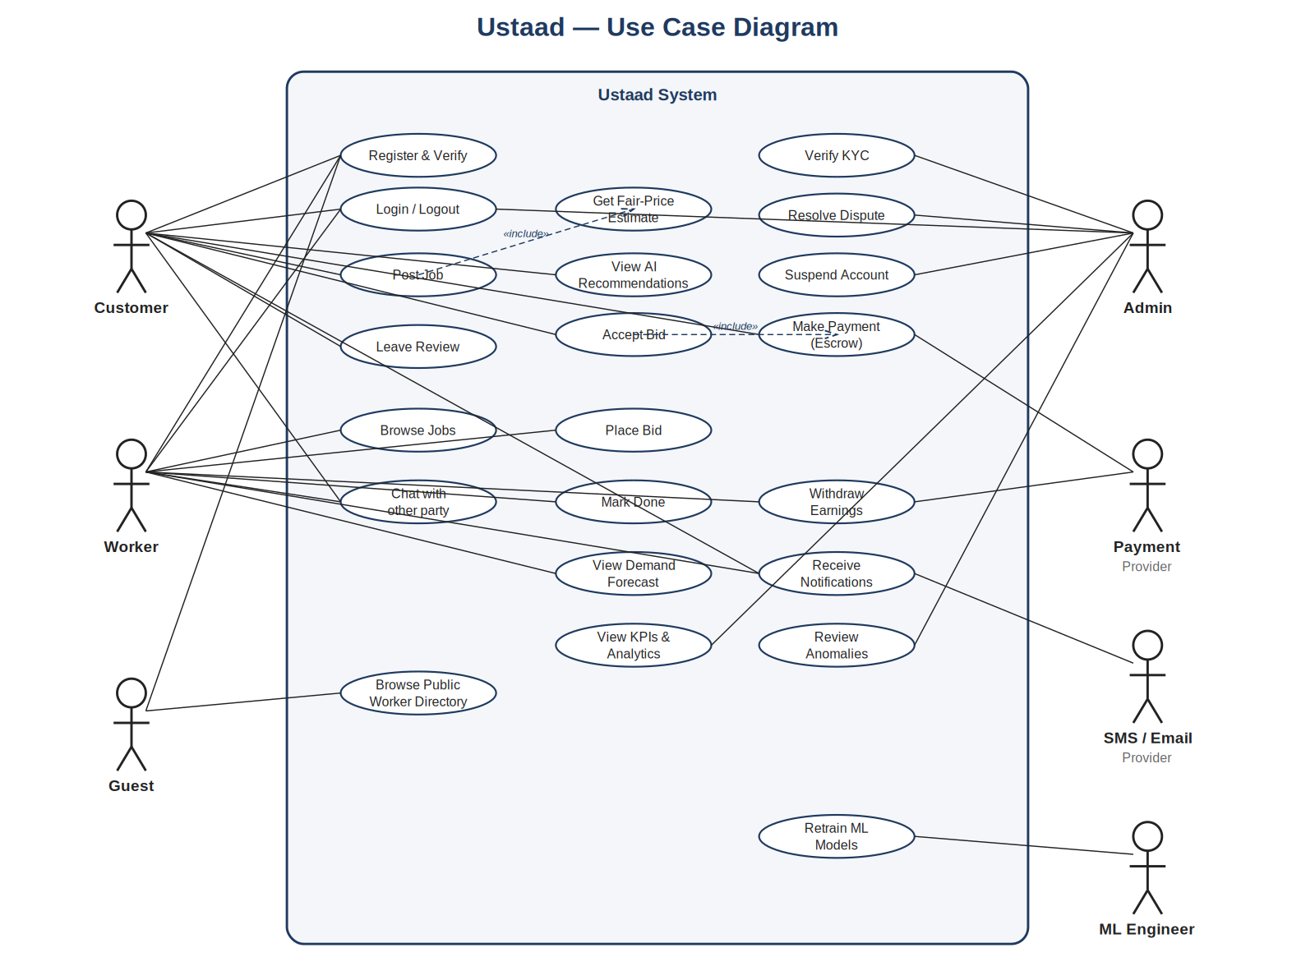
Figure: B-1: Ustaad — Use Case Diagram. Primary actors (Customer, Worker, Guest) on the left; supporting actors (Admin, Payment Provider, SMS/Email Provider, ML Engineer) on the right. Two «include» relationships are highlighted in the centre.
- Actors: Customer, Worker, Guest, Admin, External Payment Provider, External SMS/Email Provider, ML Engineer (internal).
- Includes / Extends: Post Job «includes» Get Fair-Price Estimate; Accept Bid «includes» Make Payment.

B.2 Class Diagram
The class diagram captures the core domain model and shows where four design patterns are realised: Factory (User → Customer/Worker/Admin subtypes), Strategy (PaymentStrategy with three concrete implementations), Observer (NotificationSubject and four concrete Observer subclasses), and Repository (data-access abstraction, omitted from the diagram for clarity).
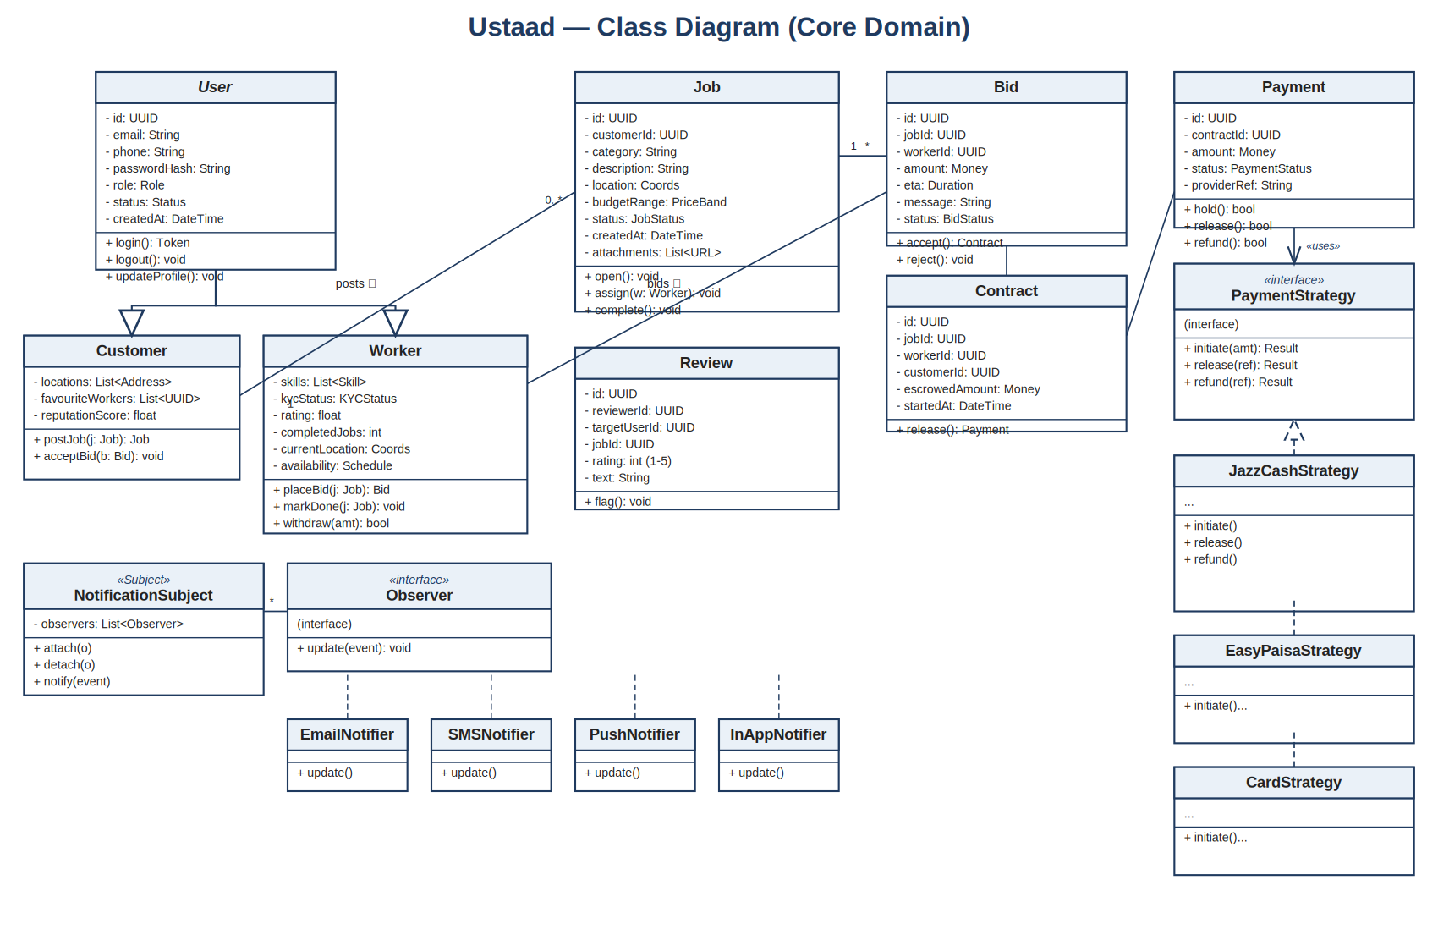
Figure: B-2: Ustaad — Class Diagram (core domain). Inheritance shown with hollow triangle arrows; aggregation shown with diamonds; «interface» realisations shown with dashed lines.

B.3 Sequence Diagram — 'Post Job → Match → Bid → Accept'
This sequence diagram traces the most important end-to-end flow in the system. It exercises seven services (the Customer's browser, API Gateway, Job Service, Pricing Service, RabbitMQ, Matching Service, Notification Service, and the Worker's browser) and demonstrates both synchronous (numbered solid arrows) and asynchronous (open arrows) interactions.
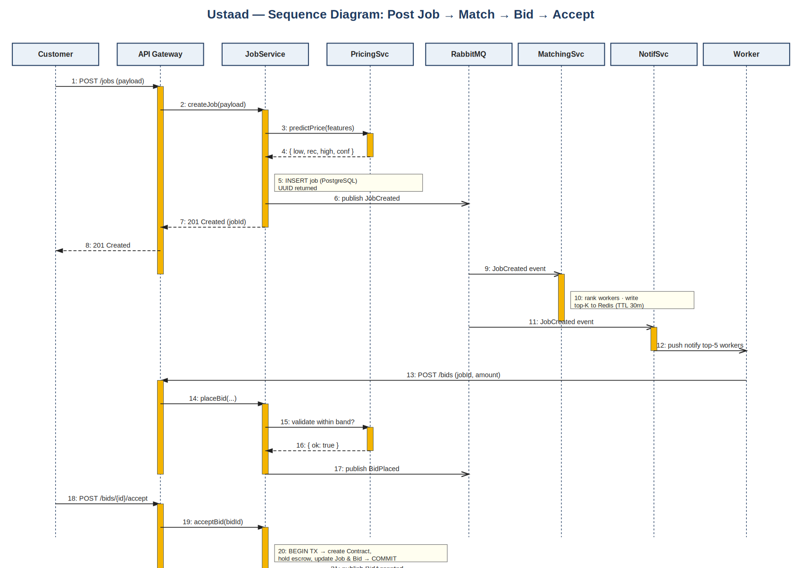
Figure: B-3: Sequence Diagram for the Post-Job → Match → Bid → Accept user flow. Activations shown as amber rectangles on each lifeline; notes (5, 10, 20) annotate non-trivial internal steps.

B.4 State Diagram — Job Lifecycle
Every Job moves through a strict lifecycle that is enforced server-side; invalid transitions return HTTP 409 (see REQ-2.6). The two side-branches from the main flow are Cancelled (any pre-Completed state) and Disputed (InProgress or Completed).
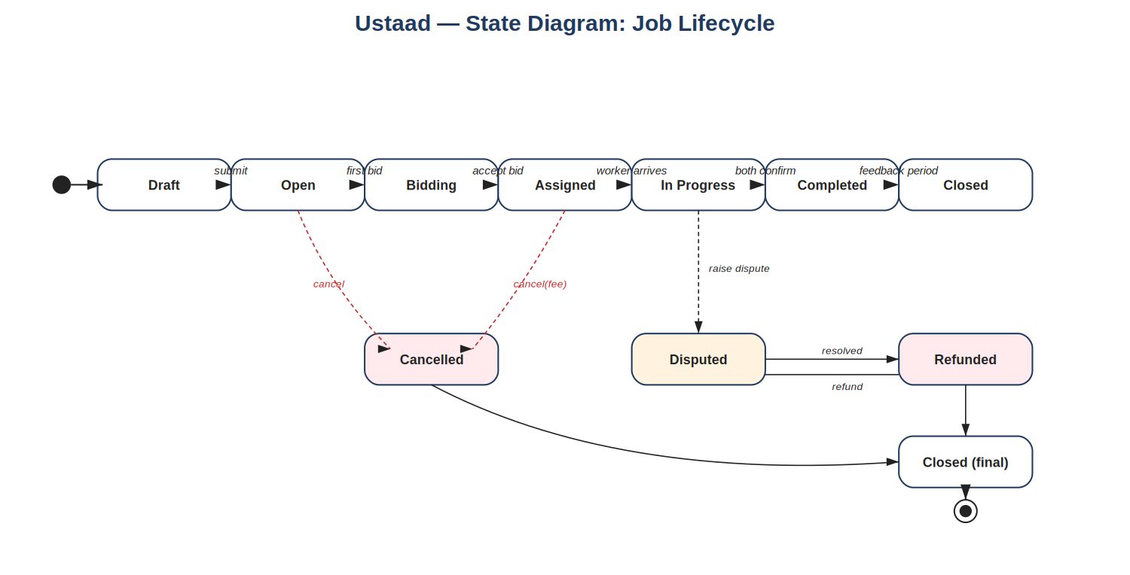
Figure: B-4: State Diagram of the Job lifecycle. The top row shows the happy-path; the bottom row shows the cancellation, dispute, and refund branches that converge on Closed (final).

B.5 Component Diagram
The architecture diagram from §2 of the proposal also serves as the SRS Component Diagram. Logical components are: WebClient, MobileBrowserClient, APIGateway (Kong), AuthService, UserService, JobService, BidService, PaymentService, NotificationService, AdminService, MatchingService, PricingService, ForecastingService, AnomalyDetectionService, PostgreSQL, MongoDB, Redis, RabbitMQ, and ObjectStorage. All client traffic enters via APIGateway; synchronous service-to-service calls flow as solid arrows; asynchronous event flows traverse RabbitMQ.
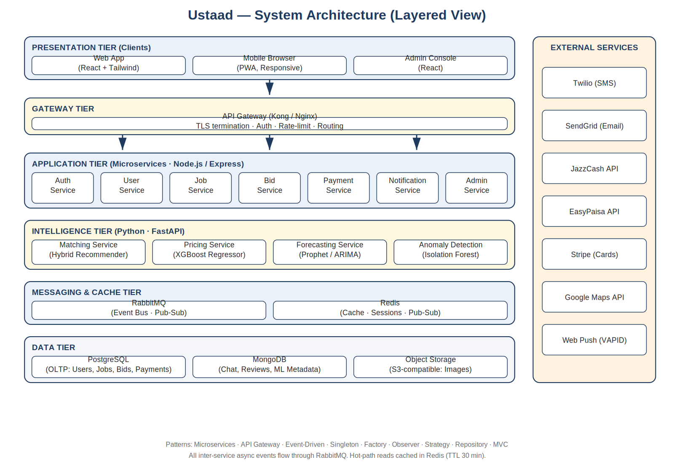
Figure: B-5: Component / Architecture Diagram. The same view doubles as the deployment topology — each labelled component is a Docker container.

B.6 Deployment Diagram
In the development and demo deployment, every component shown in B-5 runs as a Docker container on a single Linux host orchestrated by Docker Compose. The API Gateway is the only container exposing a public port (443). PostgreSQL, MongoDB, Redis, and RabbitMQ each have a mounted volume for data persistence. In a production-style deployment the same containers are scheduled on a Kubernetes cluster; the application code is unchanged.

B.7 Data-Flow Diagram, Level 0
A single high-level process 'Ustaad Platform' interacts with seven external entities (Customer, Worker, Admin, PaymentProvider, SMSProvider, EmailProvider, MapProvider) and six data stores: D1 Users, D2 Jobs, D3 Bids, D4 Payments, D5 Reviews, D6 ModelArtifacts. The DFD will be expanded into level-1 sub-diagrams in the final report.

B.8 Entity-Relationship Diagram
Key relationships in the relational schema: User (1) — (0..n) Job; Job (1) — (0..n) Bid; Worker (1) — (0..n) Bid; Job (1) — (0..1) Contract — (1) Payment; User (1) — (0..n) Review where Review has both target_user_id and reviewer_user_id. Indexes are defined on user.email (unique), user.phone (unique), job.status, job.location (GiST), and bid.jobId.

Appendix C: To-Be-Determined (TBD) List
The following items are recorded as TBD and tracked to closure before final submission.
# | Item | Owner / Target Week
TBD-1 | Final list of supported service categories (currently 8 candidates: plumbing, electrical, carpentry, masonry, painting, AC repair, appliance repair, cleaning). | Group Leader / W9
TBD-2 | Decision on synthetic vs. scraped vs. partner-supplied training data for the matching and pricing models. | ML Lead / W10
TBD-3 | Choice of WCAG 2.1 AA testing tool (axe-core vs. Lighthouse vs. manual). | Frontend Lead / W12
TBD-4 | Final commission percentage (placeholder 10%) — to be confirmed against course-instructor feedback. | Group Leader / W13
TBD-5 | Whether to ship the Urdu locale fully or as a stretch goal. | Frontend Lead / W12
TBD-6 | Production-grade logging stack (ELK vs. Loki+Grafana) — for v1.0 demonstration we use the simpler option. | Backend Lead / W11

