Optimizing Conversion Rate
Mitul Shah
03/07/2025

Goal
Optimizing conversion rate is likely the most common work of a data scientist, and rightfully so. The data revolution has a lot to do with the fact that now we are able to collect all sorts of data about people who buy something on our site as well as people who don’t. This gives us a tremendous opportunity to understand what’s working well (and potentially scale it even further) and what’s not working well (and fix it).
The goal of this challenge is to build a model that predicts conversion rate and, based on the model, come up with ideas to improve it.

Challenge Description
We have data about all users who hit our site: whether they converted or not as well as some of their characteristics such as their country, the marketing channel, their age, whether they are repeat users and the number of pages visited during that session (as a proxy for site activity/time spent on site).
Our task is to predict conversion rate and come up with recommendations for the product team and the marketing team to improve conversion rate.

Load the data into R
## Load the data
data = read.csv("/Users/mitulshah/Downloads/Downloads/Giulio Palombo Book Solutions/Optimizing Conversion Rate/conversion_project.csv", header = TRUE)
## Look at the first few rows of the data
knitr::kable(head(data))
## Warning: 'xfun::attr()' is deprecated.
## Use 'xfun::attr2()' instead.
## See help("Deprecated")
## Warning: 'xfun::attr()' is deprecated.
## Use 'xfun::attr2()' instead.
## See help("Deprecated")
country | age | new_user | source | total_pages_visited | converted
UK | 25 | 1 | Ads | 1 | 0
US | 23 | 1 | Seo | 5 | 0
US | 28 | 1 | Seo | 4 | 0
China | 39 | 1 | Seo | 5 | 0
US | 30 | 1 | Seo | 6 | 0
US | 31 | 0 | Seo | 1 | 0
country : user country based on the IP address
age : user age. Self-reported at sign-up step
new_user : whether the user created the account during this session or had already an account and simply came back to the site
source : marketing channel source Ads: came to the site by clicking on an advertisement Seo: came to the site by clicking on search results Direct: came to the site by directly typing the URL on the browser
total_pages_visited: number of total pages visited during the session. This can be seen as a proxy for time spent on site and engagement
converted: this is our label. 1 means they converted within the session, 0 means they left without buying anything. The company goal is to increase conversion rate: # conversions / total sessions

Inspecting Data Quality
Firstly, let’s inspect the data to look for weird behavior/wrong data. Data is never perfect in real life and requires to be cleaned. Identifying wrong data and dealing with it is a crucial step.
## Look at the summary of the data
knitr::kable(summary(data))
## Warning: 'xfun::attr()' is deprecated.
## Use 'xfun::attr2()' instead.
## See help("Deprecated")
## Warning: 'xfun::attr()' is deprecated.
## Use 'xfun::attr2()' instead.
## See help("Deprecated")
 | country | age | new_user | source | total_pages_visited | converted
 | Length:316200 | Min. : 17.00 | Min. :0.0000 | Length:316200 | Min. : 1.000 | Min. :0.00000
 | Class :character | 1st Qu.: 24.00 | 1st Qu.:0.0000 | Class :character | 1st Qu.: 2.000 | 1st Qu.:0.00000
 | Mode :character | Median : 30.00 | Median :1.0000 | Mode :character | Median : 4.000 | Median :0.00000
 | NA | Mean : 30.57 | Mean :0.6855 | NA | Mean : 4.873 | Mean :0.03226
 | NA | 3rd Qu.: 36.00 | 3rd Qu.:1.0000 | NA | 3rd Qu.: 7.000 | 3rd Qu.:0.00000
 | NA | Max. :123.00 | Max. :1.0000 | NA | Max. :29.000 | Max. :1.00000
## Convert country, new user and source to factor variable
data$country = as.factor(data$country)
data$new_user = as.factor(data$new_user)
data$source = as.factor(data$source)
A few quick observations:
- The site is probably a US site, although it does have a large Chinese user base as well
- User base is pretty young
- Conversion rate at around 3% is industry standard. It makes sense
- Everything seems to make sense here except for max age 123 yrs! Let’s investigate it:
## Sort all ages in descending order
sort(unique(data$age), decreasing=TRUE)
## [1] 123 111 79 77 73 72 70 69 68 67 66 65 64 63 62 61 60 59 58
## [20] 57 56 55 54 53 52 51 50 49 48 47 46 45 44 43 42 41 40 39
## [39] 38 37 36 35 34 33 32 31 30 29 28 27 26 25 24 23 22 21 20
## [58] 19 18 17
Those 123 and 111 values seem unrealistic. How many users are we talking about:
## Number of users with unrealistic age
knitr::kable(subset(data, age>79))
## Warning: 'xfun::attr()' is deprecated.
## Use 'xfun::attr2()' instead.
## See help("Deprecated")
## Warning: 'xfun::attr()' is deprecated.
## Use 'xfun::attr2()' instead.
## See help("Deprecated")
 | country | age | new_user | source | total_pages_visited | converted
90929 | Germany | 123 | 0 | Seo | 15 | 1
295582 | UK | 111 | 0 | Ads | 10 | 1
It is just 2 users! In this case, we can remove them, nothing will change.
In general, depending on the problem, you can:
- Remove the entire row saying you don’t trust the data
- Treat them as NAs
- If there is a pattern, try to figure out what went wrong.
That being said, wrong data is worrisome and can be an indicator of some bug in the logging code. Therefore, when working, you will want to talk to the software engineer who implemented the logging code to see if, perhaps, there are some bugs which affect the data significantly.
Here, let’s just get rid of those two rows:
## Remove unrealistic ages
data = subset(data, age<80)

Exploratory Data Analysis
Now, let’s quickly investigate the variables and how their distribution differs for the two classes. This will help us understand whether there is any information in our data in the first place and get a sense of the data.
Let’s look at the conversion rate for each of the variables.
## Load the required libraries
require(dplyr)
## Loading required package: dplyr
##
## Attaching package: 'dplyr'
## The following objects are masked from 'package:stats':
##
## filter, lag
## The following objects are masked from 'package:base':
##
## intersect, setdiff, setequal, union
require(ggplot2)
## Loading required package: ggplot2
## Create data country dataset showing conversion rate by country
data_country = data %>%
group_by(country) %>%
summarise(conversion_rate = mean(converted))
## Plot the conversion rate by country
ggplot(data=data_country, aes(x=country, y=conversion_rate))+
geom_bar(stat = "identity", aes(fill = country))
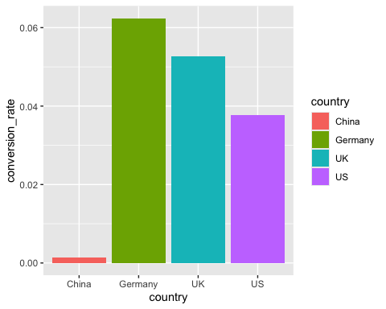
Here it clearly looks like Chinese convert at a much lower rate than other countries!
## Create data age dataset showing conversion rate by age
data_age = data %>%
group_by(age) %>%
summarise(conversion_rate = mean(converted))
## Plot the conversion rate by pages
qplot(age, conversion_rate, data=data_age, geom="line")
## Warning: `qplot()` was deprecated in ggplot2 3.4.0.
## This warning is displayed once every 8 hours.
## Call `lifecycle::last_lifecycle_warnings()` to see where this warning was
## generated.
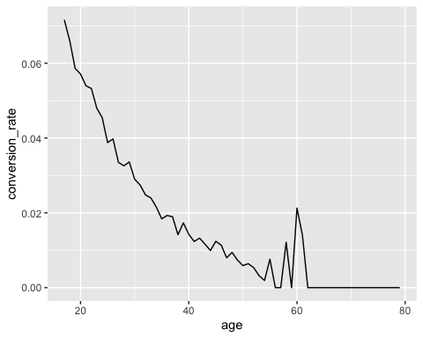
## Create data new user dataset showing conversion rate by new user
data_new_user = data %>%
group_by(new_user) %>%
summarise(conversion_rate = mean(converted))
## Plot the conversion rate by country
ggplot(data=data_new_user, aes(x=new_user, y=conversion_rate))+
geom_bar(stat = "identity", aes(fill = new_user))
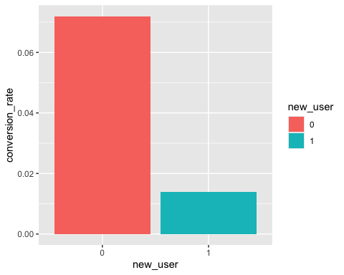
## Create data country dataset showing conversion rate by country
data_source = data %>%
group_by(source) %>%
summarise(conversion_rate = mean(converted))
## Plot the conversion rate by country
ggplot(data=data_source, aes(x=source, y=conversion_rate))+
geom_bar(stat = "identity", aes(fill = source))
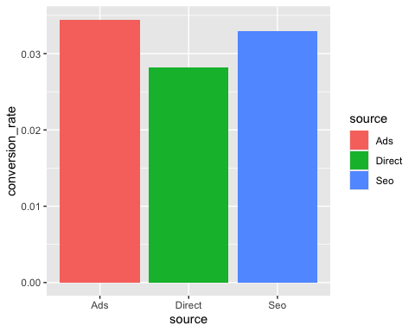
## Create data pages dataset showing conversion rate by pages
data_pages = data %>%
group_by(total_pages_visited) %>%
summarise(conversion_rate = mean(converted))
## Plot the conversion rate by pages
qplot(total_pages_visited, conversion_rate, data=data_pages, geom="line")
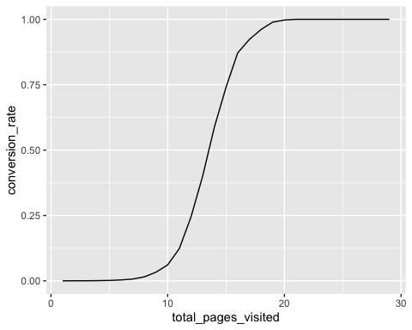

Machine Learning
Let’s now build a model to predict conversion rate. Outcome is binary and you care about insights to give product and marketing team project ideas.
I am going to pick a random forest to predict conversion rate. I picked a random forest because: it usually requires very little time to optimize it (its default params are often close to be the best ones) and it is strong with outliers, irrelevant variables, continuous and discrete variables. I will use the random forest to predict conversion, then I will use its partial dependence plots and variable importance to get insights. Also, I will build a simple tree to find the most obvious user segments.
Firstly, “converted” should really be a factor here. So let’s change it:
## Convert converted to factor variable
data$converted = as.factor(data$converted)
## Shorter name for Germany, better for the plots
levels(data$country)[levels(data$country)=="Germany"]="DE"
Create test/training set with a standard 66% split (if the data were too small, I would cross-validate). Then, I build the forest with standard values for the 3 important parameters (100 trees, trees as large as possible, 3 random variables selected at each split).
## Load the library randomforest
require(randomForest)
## Loading required package: randomForest
## Warning: package 'randomForest' was built under R version 4.3.3
## randomForest 4.7-1.2
## Type rfNews() to see new features/changes/bug fixes.
##
## Attaching package: 'randomForest'
## The following object is masked from 'package:ggplot2':
##
## margin
## The following object is masked from 'package:dplyr':
##
## combine
## Set the seed
set.seed(4321)
## Create train/test split with 66% data as training data
train_sample = sample(nrow(data), size = nrow(data)*0.66)
## Training data
train_data = data[train_sample,]
## Test data
test_data = data[-train_sample,]
## Random Forest Model
rf = randomForest(y=train_data$converted, x = train_data[, -ncol(train_data)],
ytest = test_data$converted, xtest = test_data[, -ncol(test_data)],
ntree = 100, mtry = 3, keep.forest = TRUE)
## Print the Random Forest Model
rf
##
## Call:
## randomForest(x = train_data[, -ncol(train_data)], y = train_data$converted, xtest = test_data[, -ncol(test_data)], ytest = test_data$converted, ntree = 100, mtry = 3, keep.forest = TRUE)
## Type of random forest: classification
## Number of trees: 100
## No. of variables tried at each split: 3
##
## OOB estimate of error rate: 1.44%
## Confusion matrix:
## 0 1 class.error
## 0 201075 882 0.004367266
## 1 2124 4609 0.315461161
## Test set error rate: 1.48%
## Confusion matrix:
## 0 1 class.error
## 0 103607 436 0.004190575
## 1 1152 2313 0.332467532
So, OOB error and test error are pretty similar around 1.4%. We are confident we are not overfitting.
Error is pretty low. However, we started from a 97% accuracy (that’s the case if we classified everything as a “non converted”). So, ~98.6% is good, but nothing shocking. Indeed, 30% of conversions are predicted as “non conversion”.
If we cared about the very best possible accuracy or specifically minimizing false positive/false negative, we would find the best cut-off point. Since in this case that doesn’t appear to be particularly relevant, we are fine with the default 0.5 cutoff value used internally by the random forest to make the prediction.
If you care about insights, building a model is just the first step. You need to check that the model predicts well and, if it does, you can now extract insights out of it.
Let’s start by checking variable importance:
## Variable Importance Plot
varImpPlot(rf,type=2)
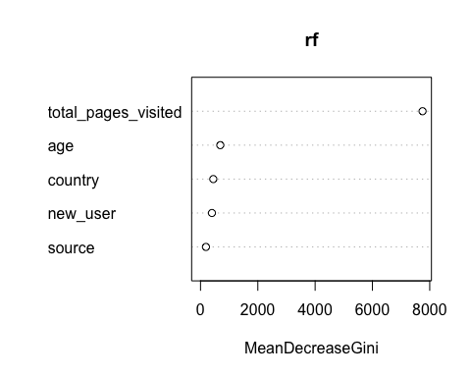
Total pages visited is the most important one, by far. Unfortunately, it is probably the least “actionable”. People visit many pages because they already want to buy. Also, in order to buy, you have to click on multiple pages. Let’s rebuild the RF without that variable. Since classes are heavily unbalanced and we don’t have that very powerful variable anymore, let’s change the weights a bit, just to make sure we will get something classified as 1.
## Random Forest Model without pages visited variable
rf = randomForest(y=train_data$converted, x = train_data[, -c(5, ncol(train_data))],
ytest = test_data$converted, xtest = test_data[, -c(5, ncol(train_data))],
ntree = 100, mtry = 3, keep.forest = TRUE, classwt = c(0.7,0.3))
## Print the output of Random Forest Model
rf
##
## Call:
## randomForest(x = train_data[, -c(5, ncol(train_data))], y = train_data$converted, xtest = test_data[, -c(5, ncol(train_data))], ytest = test_data$converted, ntree = 100, mtry = 3, classwt = c(0.7, 0.3), keep.forest = TRUE)
## Type of random forest: classification
## Number of trees: 100
## No. of variables tried at each split: 3
##
## OOB estimate of error rate: 13.87%
## Confusion matrix:
## 0 1 class.error
## 0 176143 25814 0.1278193
## 1 3129 3604 0.4647260
## Test set error rate: 13.64%
## Confusion matrix:
## 0 1 class.error
## 0 90991 13052 0.1254481
## 1 1610 1855 0.4646465
Accuracy went down, but that’s fine. The model is still good enough to give us insights.
Let’s recheck variable importance:
## Variable Importance Plot
varImpPlot(rf,type=2)
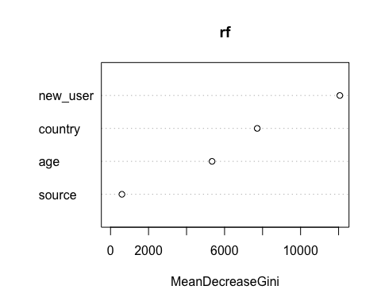
Interesting! New user is the most important one. Source doesn’t seem to matter at all.
Let’s check partial dependence plots for the 4 vars:
## Partial Dependence Plots
op <- par(mfrow=c(2, 2))
partialPlot(rf, train_data, country, 1)
partialPlot(rf, train_data, age, 1)
partialPlot(rf, train_data, new_user, 1)
partialPlot(rf, train_data, source, 1)
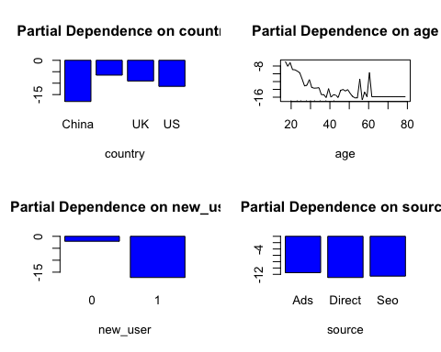
par(op)
This shows that:
- Users with an old account are much better than new users
- China is really bad, all other countries are similar with Germany being the best
- The site works very well for young people and gets worse for >30 yr old
- Source is basically irrelevant
Let’s now build a simple decision tree and check the 2 or 3 most important segments:
## Load the rpart library
require(rpart)
## Loading required package: rpart
## Build the decision tree
tree = rpart(data$converted ~ ., data[, -c(5,ncol(data))],
control = rpart.control(maxdepth = 3),
parms = list(prior = c(0.7, 0.3))
)
## Print the tree
tree
## n= 316198
##
## node), split, n, loss, yval, (yprob)
## * denotes terminal node
##
## 1) root 316198 94859.4000 0 (0.70000000 0.30000000)
## 2) new_user=1 216744 28268.0600 0 (0.84540048 0.15459952) *
## 3) new_user=0 99454 66591.3400 0 (0.50063101 0.49936899)
## 6) country=China 23094 613.9165 0 (0.96445336 0.03554664) *
## 7) country=DE,UK,US 76360 50102.8100 1 (0.43162227 0.56837773)
## 14) age>=29.5 38341 19589.5200 0 (0.57227507 0.42772493) *
## 15) age< 29.5 38019 23893.0000 1 (0.33996429 0.66003571) *
A simple small tree confirms exactly the random forest findings.

Conclusion and next step
- The site is working very well for young users. Definitely let’s tell marketing to advertise and use channels which are more likely to reach young people.
- The site is working very well for Germany in terms of conversion. But the summary showed that there are few Germans coming to the site: way less than UK, despite a larger population. Again, marketing should get more Germans. Big opportunity.
- Users with old accounts do much better. Targeted emails with offers to bring them back to the site could be a good idea to try.
- Maybe go through the UI and figure out why older users perform so poorly? From ~30 y/o conversion clearly starts dropping. A good actionable metric here is conversion rate for people >=30 yr old. Building a team whose goal is to increase that number would be interesting.
- Something is wrong with the Chinese version of the site. It is either poorly translated, doesn’t fit the local culture, or maybe some payment issue. Given how many users are based in China, fixing this should be a top priority. Huge opportunity.

