**Aim:**

To study and implement Linux commands.

**Description:**

|  |  |  |  |
| --- | --- | --- | --- |
| Sl. No. | COMMAND | DESCRIPTION | ATTRIBUTES/OPTIONS |
| 1. | ls | List all the contents in the directory | Filesystem |
| 2. | ls –a | List all the hidden files in the directory | Filesystem |
| 3. | vdir | List the contents in the directory | Filesystem |
| 4. | cd | Changes directory | Filesystem |
| 5. | mkdir | Makes/creates directory | Filesystem |
| 6. | rmdir | Removes directory | Filesystem |
| 7. | cat | Concatenate and print files | Filesystem |
| 8. | cat -T | Prints file contents without space | Filesystem |
| 9. | vim | View content | Filesystem |
| 10. | cut | Cuts out selected fields of each line of s file | Text processing |
| 11. | grep | Search text for a pattern | Misc |
| 12. | wc | Line , word and byte or character count | Text processing |
| 13. | cp | Copy content | File system |
| 14. | mv | Move content | Filesystem |
| 15. | cal | Extract current calendar | Misc |
| 16. | cal -j | Extract Julian calendar | Misc |
| 17. | netstat | Extract network statistics | Network troubleshoot |
| 18. | netstat –i | Obtain interface configurations | Network troubleshoot |
| 19. | netstat –s | Obtain port configurations | Network troubleshoot |
| 20. | netstat –listen | Obtain listening ports | Network troubleshoot |
| 21. | netstst –a | Obtain all the IP information | Network troubleshoot |
| 22. | netstat –all | Obtail all the IP information | Network troubleshoot |
| 23. | head | Copy the first part of files | Test processing |
| 24. | tail | Copy the last part of file | Test processing |
| 25. | sort | Sort in an order | Text processing |
| 26. | w | Obtain user information | System administration |
| 27. | who | Obtain current user information | System administration |
| 28. | chmod | Change mode | System administration |
| 29. | cmp | Compare file contents | Filesystem |
| 30. | diff | Differentiate file contents | Filesystem |
| 31. | comm | Extract common/unique features of files | Filesystem |
| 32. | id | Obtain user id | System administration |

1.List the contents of user's home directory including the hidden files

OUTPUT:

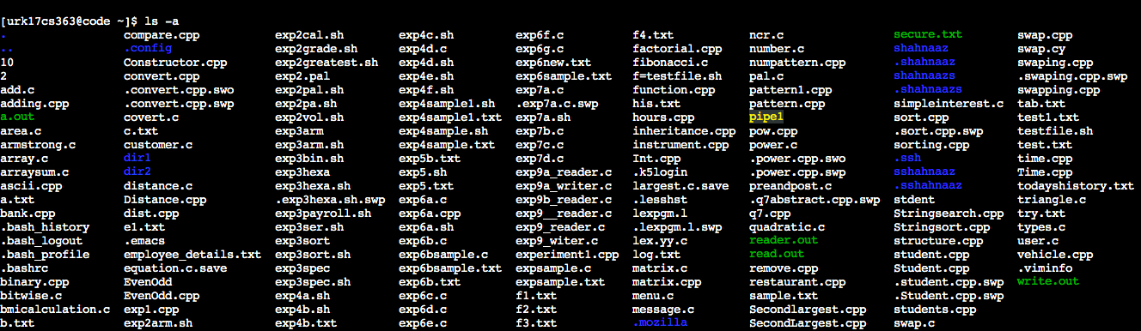

2. List the content of /var directory?

OUTPUT:



3. Create two directories named dir1 & dir2

OUTPUT:

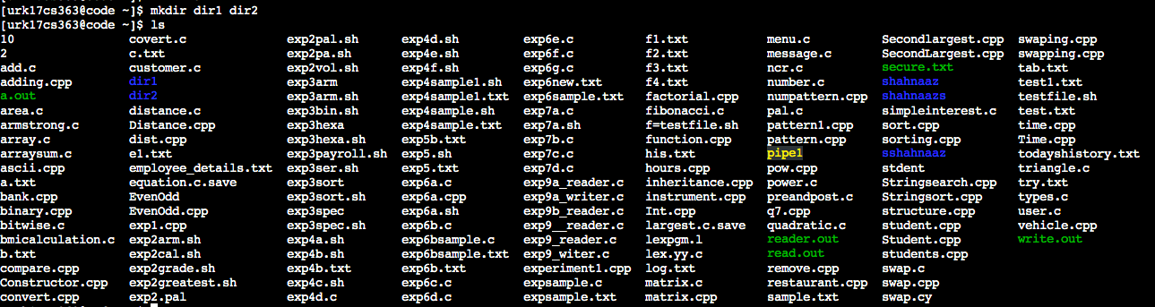

4. Create a hidden directory with your name?

OUTPUT:

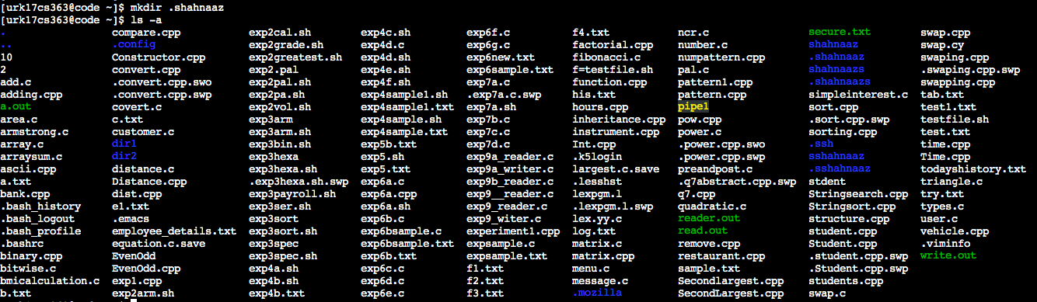

5. Display the content of a hidden directory.



6. Display the calendar of 2020.

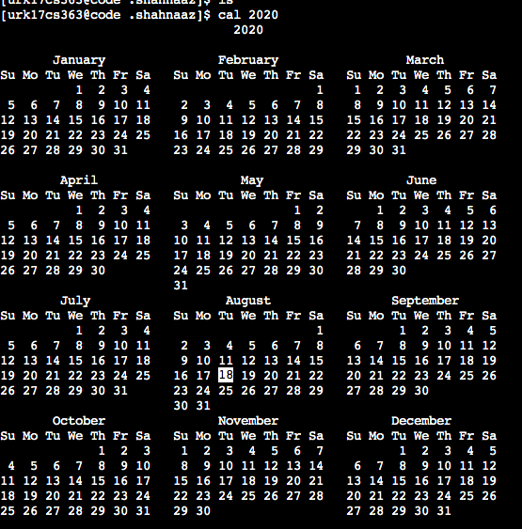

7. Copy the file /etc/passwd file to current directory with sample.txt as the filename

OUTPUT:

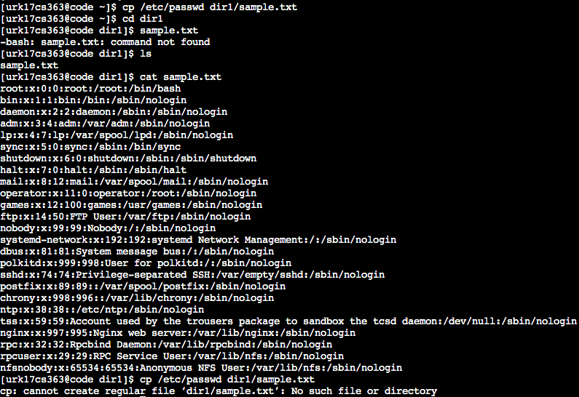

8. Create a file test1.txt using Vim editor with the following contents to it

Name Register Number Research Interest

OUTPUT:

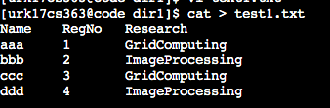

a. Display the student names who are having Research Interest as Grid Computing

OUTPUT:

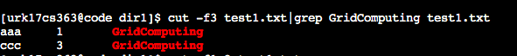

b. List all the student names & RegNo in the class

OUTPUT:

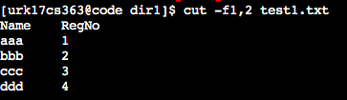

c. List the count of students who have interest as Image Processing and store the

result in another file.

OUTPUT:

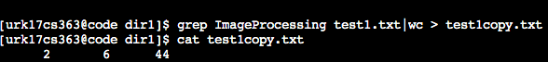

d. Display the first two rows and last two and store into another file

OUTPUT:

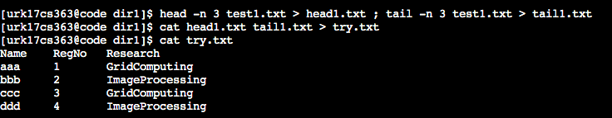

9. Display the contents of the file test1.txt without any blank lines

OUTPUT:

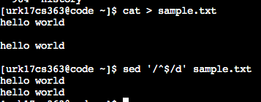

10. Move the file sample.txt from dir1 directory to dir2 directory

OUTPUT:

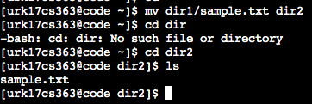

11. Change directory into dir2 directory

OUTPUT:



12. Check whether the file sample.txt is present their

OUTPUT:



13. Rename the file sample.txt to new.txt and check whether sample.txt is there or not?

OUTPUT:



14. Remove the directory dir1

OUTPUT:

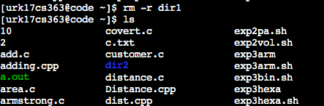

15. Display last 3 lines of the file test1.txt

OUTPUT:

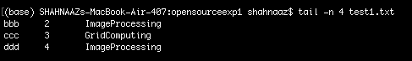

16. Display all the commands you have executed so far and save the list into a file named

todayshistory.txt

OUTPUT:

17. How many files are present under your home directory?

OUTPUT:

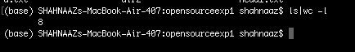

18. Perform sorting of three files and store the sorted file in the fourth file

OUTPUT:

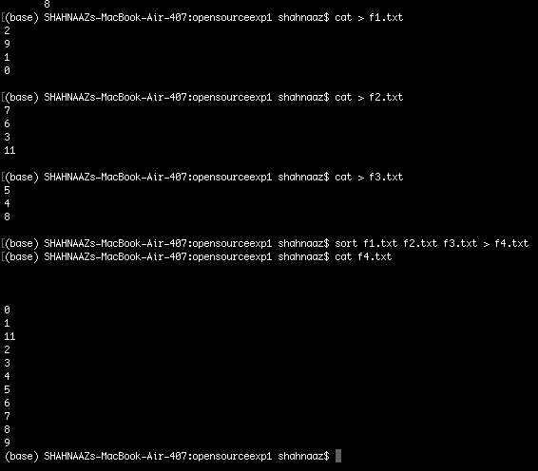

19. Change the permission of your newly created file such that the group users and others don’t access any type of access.

OUTPUT: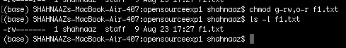

20. Display the network status on the shell.

OUTPUT:

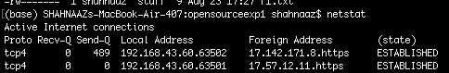

21. Compare any two files and search for both common and exclusive features

OUTPUT:

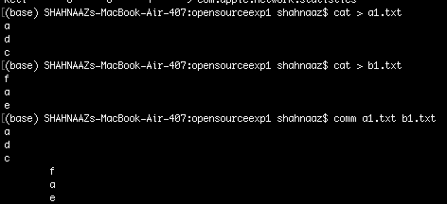

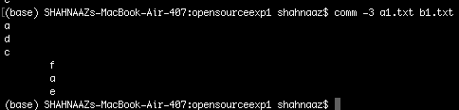

22. Display the user ID, process ID and parent process ID.

OUTPUT:





23. Report disk usages of file system.

OUTPUT:

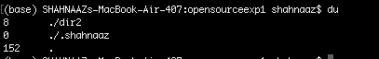

24. Display the statistics of all ports connected to a network.

OUTPUT:

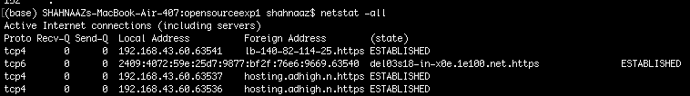

25. Display the uptime of the system and show the statistics of memory usage. Check if

there is any malicious packets intrude the network.

OUTPUT:



26.Display the date in Julian format

OUTPUT:

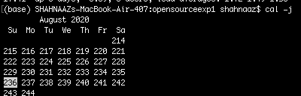

27.Find out if the Linux platform is infected or not.

OUTPUT:

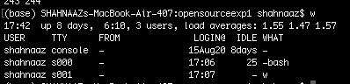

28.Display only the free space available in the memory.

OUTPUT:

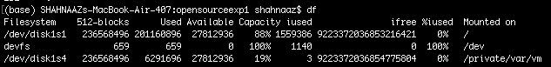

29.Display the configuration information of your network

OUTPUT:



30.Display the IP information under the command netstat

OUTPUT:c

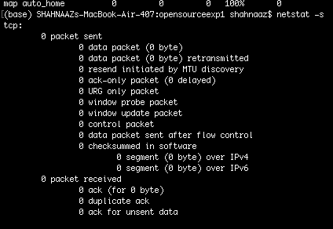

**Video Link:**

https://drive.google.com/file/d/1nUl_hmRTc6o7qi7pesuc-YWTBpYE021r/view?usp=sharing

**Result:**

The Linux commands to the given tasks were run successfully.