**Aim:**

To install the latest version of the Linux kernel.

**Description:**

KERNEL CONFIGURATION:

* kernel is the main component of most computer operating systems; it is a bridge between applications and the actual data processing done at the hardware level.
* The kernel's responsibilities include managing the system's resources (the communication between hardware and software components).
* Kernel usually provide methods for synchronization and communication between processes called inter-process communication (IPC).

KERNEL ARCHITECTURE:

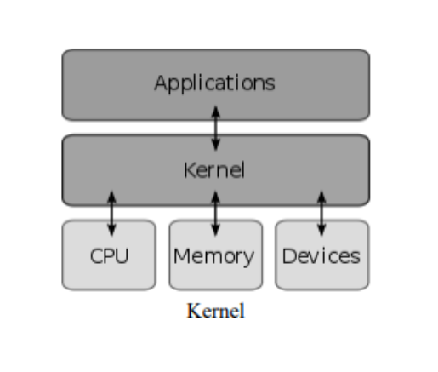

* The Linux kernel is the operating system kernel used by the Linux family of Unix-like operating systems. It is one of the most prominent examples of free and open source software.
* The Linux kernel is released under the GNU General Public License version 2 (GPLv2), and is developed by contributors worldwide.

COMMANDS:

|  |  |  |
| --- | --- | --- |
| Sl. No. | COMMAND | DESCRIPTION |
| 1. | rpm -qa kernel-devel | Version of the kernel |
| 2. | uname –r | Name of the kernel |
| 3. | uname -a | Prints all system information |
| 4. | uname -n | Hostname of network node |
| 5. | cd | Changes directory |
| 6. | mv | Move content |
| 7. | tar | Used to unzip files |
| 8. | tar -xf | Unzip xz files |
| 9. | tar -xjvf | Unzip bz files |
| 10. | sudo | Run programs with security privilege |
| 11. | ln | Used to create hard link or soft link |
| 12. | ln -f | Force existing destination pathnames to be removed to allow the link |
| 13. | ln -s | Create soft link |
| 14. | make | Build executable programs and libraries from source code |
| 15. | mrproper | command cleans up any leftover files |

**Configuration:**

1. Download the latest kernel version from [www.kernel.org](http://www.kernel.org).
2. Move the downloaded file to /usr/src using mv command
3. Navigate to the /usr/scr file using cd command
4. Unzip the Linux file using tar command
5. Create symlink for the Linux file using ln command

**Outputs:**

1. Download latest kernel source code from [www.kernel.org](http://www.kernel.org).



1. Printing version of the kernel



1. Printing name of the kernel



1. Moving kernel source to /usr/src

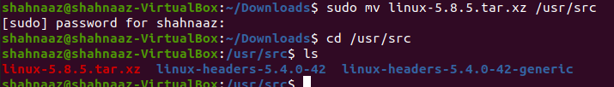

1. Unzip the kernel file

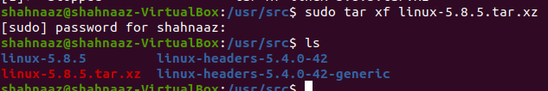

1. Navigate to the kernel file

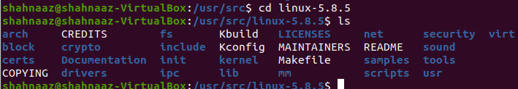

1. Creating symlink



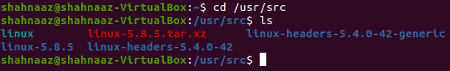

**Video Link:**

<https://drive.google.com/file/d/1Yw42gV4w6pKFcZx-9l8RLW1NtbXx6hmC/view?usp=sharing>

**Result:**

The Linux kernel has been installed successfully.