**Aim:**

Creating a repository in GitHub.

**Description:**

**GitHub** is a Git repository hosting service, but it adds many of its own features. While Git is a command line tool, **GitHub** provides a Web-based graphical interface. It also provides access control and several collaboration features, such as a wikis and basic task management tools for every project.

**GitHub** is a website for developers and programmers to collaboratively work on code. The primary benefit of **GitHub** is its version control system, which allows for seamless collaboration without compromising the integrity of the original project.

COMMANDS:

|  |  |  |
| --- | --- | --- |
| Sl. No. | COMMAND | DESCRIPTION |
| 1. | git init | Initialize git repository |
| 2. | git add filename | To add individual files |
| 3. | git add * | To add all files |
| 4. | git status | To see the added files status |
| 5. | git commit -m “text” | Added text note with added file |
| 6. | git remote add origin path | To link the files to the github repository |
| 7. | git push -u origin master | To push files into the repository |

**PROCEDURE:**

1. Installing git
2. Initialize git
3. Adding the files that has to be uploaded
4. Commit the files
5. Link the files to the GitHub repository
6. Push the files into the repository
7. Check uploaded files

**Outputs:**

1. Installing git

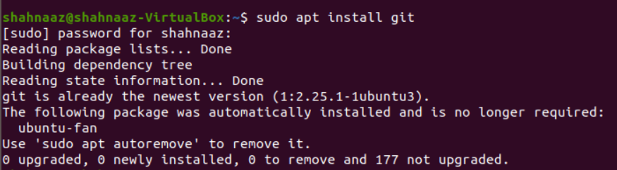

1. Check version

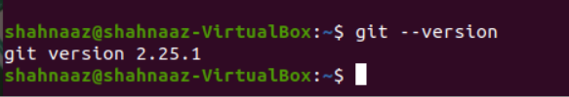

1. Initializing git



1. Adding files and checking status

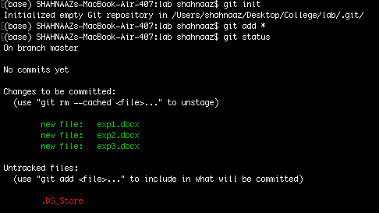

1. Uploading the files

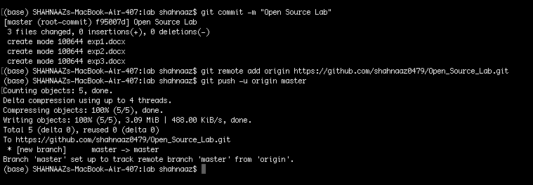

1. Checking repository

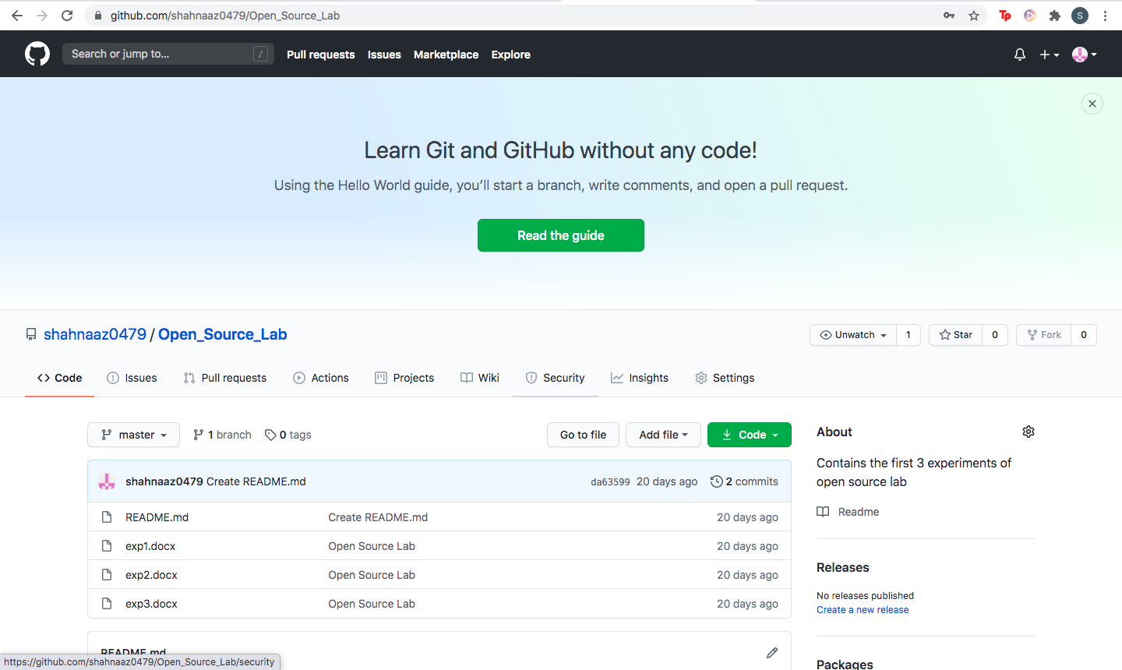

GitHub Link:

<https://github.com/shahnaaz0479/Open_Source_Lab>

Video Link:

RESULT:

Files have been uploaded to GitHub.