

**Green University of Bangladesh**

**Department of Computer Science and Engineering (CSE)**

**Faculty of Sciences and Engineering**

**Semester: (Spring, Year:2022), B.Sc. in CSE (Day/Eve)**

**Course Title: DATA STRUCTURE**

**Course Code:CSE 106 Section:DA**

**Student Details**

|  |  |  |
| --- | --- | --- |
| **Name** | | **ID** |
| **1.** | Mst.Shahnaj Akter Smrity | 212902027 |
| **2.** |  |  |
| **3.** |  |  |

**Lab Date : _8/03/2022 _ _ _ _ _ _ _ _ _ _ _ _ _ _ _ _ _**

**Submission Date : _15/03/2022 _ _ _ _ _ _ _ _ _ _ _ _ _ _ _ _ _**

**Course Teacher’s Name : _Rusmita Halim Chaity _ _ _ _ _ _ _**

**[For Teachers use only: Don’t Write Anything inside this box]**

|  |
| --- |
| **Project Proposal Status**  **Marks: ………………………………… Signature: .....................**  **Comments: .............................................. Date: ..............................** |

1. **TITLE OF THE EXPERIMENT :**

Linear search algorithm using recursion.

1. **OBJECTIVE :**

In this program by using array and recursive function the position of an element will be detected.

1. **PROBLEM A NALYSIS :**

Here I am going to write a C program which would find the position of an element in an array using Linear Search Algorithm. I have to take an array and a value to be searched in the array as input from the user, and then find the position of that element in array by using linear search algorithm. In order to look for an element in an array, it’ll go sequentially in increasing index values. If it encounter the element requested by the user i will return the position of that element in array, but if it is not there it will return -1 which indicates the absence of element which was searched.

.

1. **ALGORITHM:**

* At first I have to declare an array and required variable.
* Then the index value and position value need to be initiated
* In order to search the array sequentially I have to use ‘if else’ condition and the position is returned if the key element is available in the array, otherwise “Element is missing” is printed.
* Need to use recursive function called **RecurLS()**, which takes in 4 input parameters and returns the position of element in a array which is searched by the user.
* When the search element is in the first position the program will return to the index.
* But if it is not the first element of array, then the size of array would be decrease by 1, by eliminating the first element of the array, which means when the RecurLS() is called second time the array size will be (n-1). This will go on until the element is found.

1. **IMPLEMENTATION:**

/*212902027*/

#include <stdio.h>

int RecurLS(int arr[], int value, int index, int n)

{

int position = 0;

if(index >= n)

{

return 0;

}

else if (arr[index] == value)

{

position = index + 1;

return position;

}

else

{

return RecurLS(arr, value, index+1, n);

}

return position;

}

int main()

{

int n, value, position, m = 0, arr[100];

printf("Enter the total elements in the array ");

scanf("%d", &n);

printf("Enter the array elements\n");

for (int i = 0; i < n; i++)

{

scanf("%d", &arr[i]);

}

printf("Enter the element to search ");

scanf("%d", &value);

position = RecurLS(arr, value, 0, n);

if (position != 0)

{

printf("Element found at position %d ", position);

}

else

{

printf("Element is missing");

}

return 0;

}

1. **OUTPUT:**

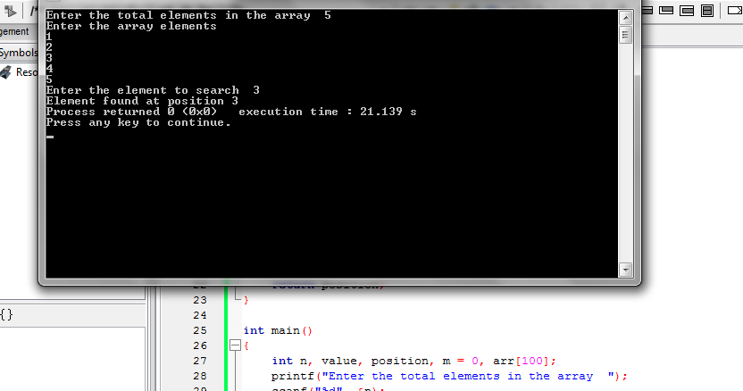

1. **DISCUSSION AND CONCLUSION :**

The experiment was so interesting. I enjoyed it a lot.I actually did not interact with major problem while doing the experiment. I had to counteract with some minor issues which had been eliminated through discussion along with my friends.