

**Green University of Bangladesh**

**Department of Computer Science and Engineering (CSE)**

**Faculty of Sciences and Engineering**

**Semester: (Spring, Year:2022), B.Sc. in CSE (Day/Eve)**

**Course Title: DATA STRUCTURE**

**Course Code:CSE 106 Section:DA**

**Student Details**

|  |  |  |
| --- | --- | --- |
| **Name** | | **ID** |
| **1.** | Mst.Shahnaj Akter Smrity | 212902027 |
| **2.** |  |  |
| **3.** |  |  |

**Lab Date : _8/03/2022 _ _ _ _ _ _ _ _ _ _ _ _ _ _ _ _ _**

**Submission Date : _15/03/2022 _ _ _ _ _ _ _ _ _ _ _ _ _ _ _ _ _**

**Course Teacher’s Name : _Rusmita Halim Chaity _ _ _ _ _ _ _**

**[For Teachers use only: Don’t Write Anything inside this box]**

|  |
| --- |
| **Project Proposal Status**  **Marks: ………………………………… Signature: .....................**  **Comments: .............................................. Date: ..............................** |

1. **TITLE OF THE EXPERIMENT :**

Implementation of doubly linked list.

1. **OBJECTIVE :**

In this program by using doubly linked lilts an element would be positioned specifically and the modification would also be shown for that particular element list. .

1. **ALGORITHM:**

* At first create a node for the doubly linked list.
* Then Check if the next node is NULL or not. If it’s NULL, return from the function because any new node cannot be added before a NULL
* Allocate memory for the new node
* Generate a for loop for every new node.
* Set new_node->data=data

new_node->prev=end

new_node->next=NULL

end->next=new_node

end=new_node

* When

head =NULL, list is empty

but head =temp means data exist

* If temp!=NULL and temp->next!=NULL

Then, temp->next->prev=new_node and temp->next=new_node

* Insertion complete
* End

1. **IMPLEMENTATION:**

/**212902027*/

#include<stdio.h>

#include<stdlib.h>

struct node

{

int data;

struct node*prev;

struct node*next;

}*head,*end;

void createlist(int n);

void displaylist();

void insertion(int data,int pos);

int main()

{

int n,data,choice=1;

head=NULL;

end=NULL;

while(choice!=0)

{

printf("Program of doubly link list\n");

printf("1.create list \n");

printf("2.insert node \n");

printf("3.display list \n");

printf("0.exit\n");

printf("Enter your choice:");

scanf("%d",&choice);

switch(choice)

{

case 1:

printf("All nodes in the list");

scanf("%d",&n);

createlist(n);

break;

case 2:

printf("position of inserting new node");

scanf("%d",&n);

printf("enter data of %d node:",n);

scanf("%d",&data);

insertion(data,n);

break;

case 0:

break;

default:

printf("Error!!");

}

printf("\n\n\n\n\n");

}

return 0;

}

void createlist(int n)

{

int i,data;

struct node*new_node;

if(n>=1)

{

head=(struct node*)malloc(sizeof(struct node));

printf("Enter data of 1st node");

scanf("%d",&data);

head->data=data;

head->prev=NULL;

head->next=NULL;

end=head;

for(i=2;i<=n;i++)

{

new_node=(struct node*)malloc(sizeof(struct node));

printf("Enter data of %d node:",i);

scanf("%d",&data);

new_node->data=data;

new_node->prev=end;

new_node->data=NULL;

end->next=new_node;

end=new_node;

}

printf("\n Doubly linked list is created");

}

}

void displaylist()

{

struct node*temp;

int n=1;

if(head==NULL)

{

printf("list is empty\n");

}

else

{

temp = head;

printf("Data \n");

while(temp!=NULL)

{

printf("Data of %d node =%d\n",n,temp->data);

n++;

temp=temp->next;

}

}

}

void insertion(int data,int pos)

{

int i;

struct node*new_node,*temp;

if(head==NULL)

{

printf("Error,list is empty \n");

}

else

{

temp=head;

i=1;

while(i<pos-1 && temp!=NULL)

{

temp=temp->next;

i++;

}

if(temp!=NULL)

{

new_node=(struct node*)malloc(sizeof(struct node));

new_node->data=data;

new_node->next=temp->next;

new_node->prev=temp;

if(temp->next!=NULL)

{

temp->next->prev=new_node;

}

temp->next=new_node;

printf("Node inserted at %d position\n",pos);

}

else

{

printf("wrong position\n");

}

}

}

1. **OUTPUT:**

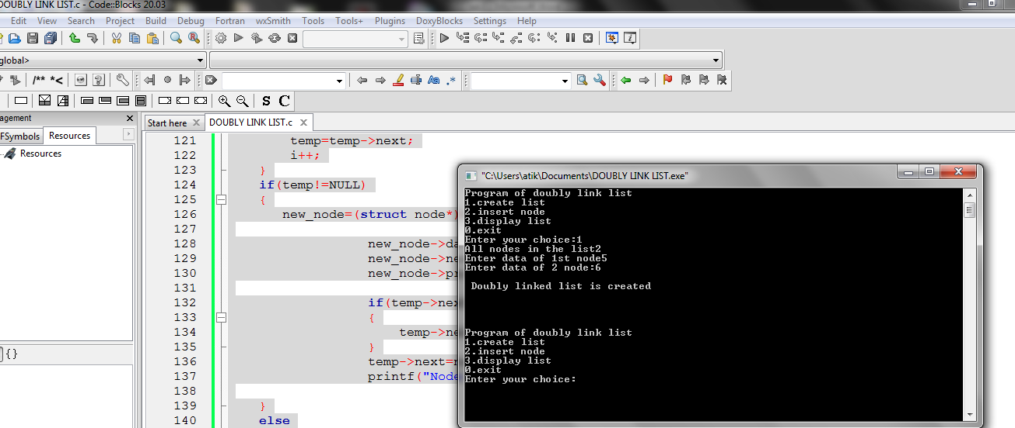

1. **DISCUSSION:**

I found this program very helpful to add any value in the list. In this program I learn about the insertion technique and I am looking forward to learn the deleting method.