What is Excel?
It is a spreadsheet program developed by Microsoft. Excel organizes data in columns and rows and allows you to do mathematical functions. It runs on Windows, macOS, Android and iOS.
The first version was released in 1985 and has gone through several changes over the years. However, the main functionality mostly remains the same.
Excel is typically used for:
- Analysis
- Data entry
- Data management
- Accounting
- Budgeting
- Data analysis
- Visuals and graphs
- Programming
- Financial modelling
- And much, much more!

Why Use Excel?
- It is the most popular spreadsheet program in the world
- It is easy to learn and to get started.
- The skill ceiling is high, which means that you can do more advanced things as you become better
- It can be used with both work and in everyday life, such as to create a family budget
- It has a huge community support
- It is continuously supported by Microsoft
- Templates and frameworks can be reused by yourself and others, lowering creation costs

The Ribbon explained

- The Ribbon provides shortcuts to Excel commands. A command is an action that allows you to make something happen. This can for example be to: insert a table, change the font size, or to change the color of a cell.
- The Ribbon may look crowded and hard to understand at first. Don't be scared, It will become easier to navigate and use as you learn more. Most of the time we tend to use the same functionalities over again.
- The Ribbon is made up by the App launcher, Tabs, Groups and Commands. In this section we will explain the different parts of the Ribbon.
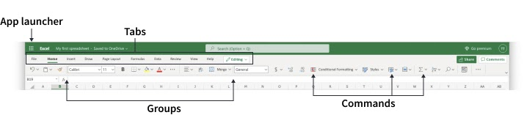
App launcher
The App launcher icon has nine dots and is called the Office 365 navigation bar. It allows you to access the different parts of the Office 365 suite, such as Word, PowerPoint and Outlook. App launcher can be used to switch seamlessly between the Office 365 applications.
Tabs
The tab is a menu with sub divisions sorted into groups. The tabs allow users to quickly navigate between options of menus which display different groups of functionality.
Groups
The groups are sets of related commands. The groups are separated by the thin vertical line break.
Commands
The commands are the buttons that you use to do actions.
Now, let's have a look at the Sheet. Soon you will be able to understand the relationship between the Ribbon and the Sheet, and you can make things happen.

The Sheet explained
The Sheet is a set of rows and columns. It forms the same pattern as we have in math exercise books, the rectangle boxes formed by the pattern are called cells.
Values can be typed to cells.
Values can be both numbers and letters:
