You are given a pandas dataframe df, containing information on year wise expense on health by different countries.
Below are it's first five rows.
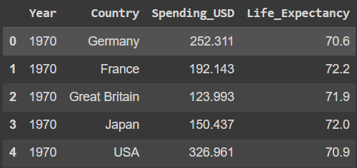
Split the columns Year into the following bins - (1969, 1980], (1980, 1990], (1990, 2000], (2000, 2010], (2010, 2021]
Find the average expenditure for each of these year ranges.
Return a dataframe with year ranges as index and a column named avg_expenditure.
Round off the expenditure values to three decimal places.
Sample Input-
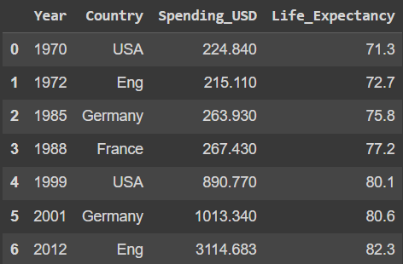
Sample Output-
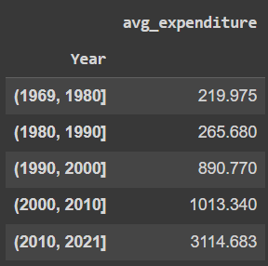
Sample Explanation-
A dataframe with year ranges in the index and average expense for each year range under the column avg_expenditure is returned.

