You are given a dataframe df containing information about taxi rides.
First 5 rows of df-
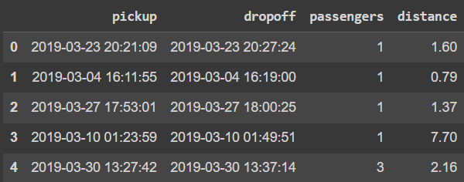
Create a new column time_of_day containing the labels for pickup time based on the following rules-
[0 am to 6 am) - morning
[6 am to 12 pm) - day
[12 pm to 6 pm) - afternoon
[6 pm to 0 am) - night
For all the intervals above, left limit is included but right limit is not included in the range.
Return a pandas series containing the number of pickups for each time_of_day. Sort the counts in descending order.
See sample output to understand the output format better.
Sample Input-
Sample Output-
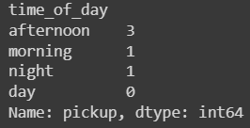
Sample Explanation-
There are 3 pickups between 12 pm and 6 pm. 1 pickup between 0 am and 6 am. 1 pickup between 6 pm and 0 am. 0 pickups between 6 am and 12 pm.
Note:
The counts are sorted in descending order.

