Which of the given option(s) are the right method and syntax for pivoting the below-mentioned dataframe such that each customer would have a value that is the total quantity of a particular type of accessories he holds?
Input:
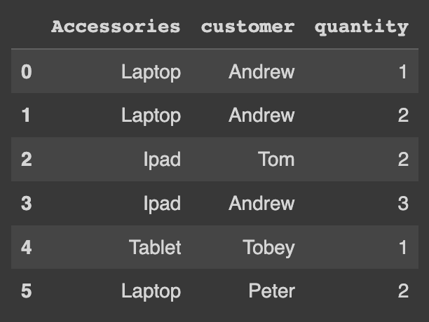
The output for the same, after the required operation, will look something like this:
Output:
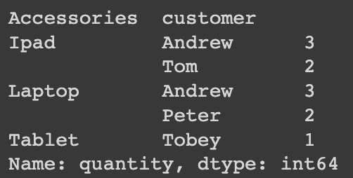
Use the code below in order to create the given dataframe:
import pandas as pd

df = pd.DataFrame({
"Accessories": ["Laptop", "Laptop", "Ipad", "Ipad", "Tablet", "Laptop"],
"customer": ["Andrew", "Andrew", "Tom", "Andrew", "Tobey", "Peter"],
"quantity": [1, 2, 2, 3, 1, 2],
})

