Consider a dataset containing information about products' sales in various regions, structured as follows:
| Region | Product | Sales |
|---------------- |---------------------|----------------|
| North | A | 100 |
| North | B | 150 |
| North | C | 200 |
| South | A | 120 |
| South | B | 180 |
| South | C | 220 |
| East | A | 90 |
| East | B | 160 |
| East | C | 190 |
| West | A | 110 |
| West | B | 140 |
| West | C | 210 |
If we pivot this dataset with "Region" as index, "Product" as columns, and "Sales" as values, what would be the resulting DataFrame?
A.
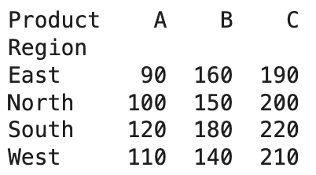
B.
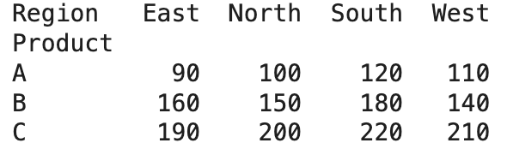
C.
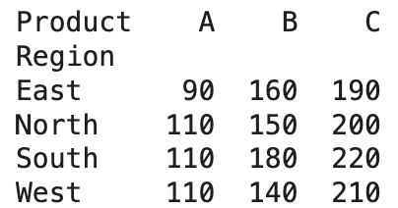
D. None of the above

