In the titanic dataset, to understand the impact of age and gender on the chances of survival, which of these option(s) would be a suitable choice?
dataset:
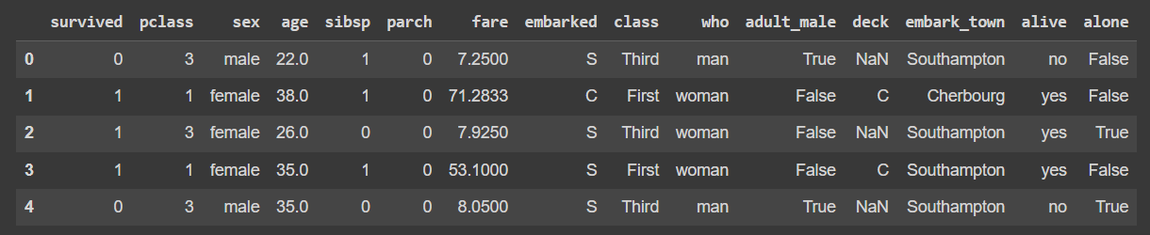
You can load the titanic dataset using
1)
import pandas as pd
titanic = pd.read_csv(“https://raw.githubusercontent.com/mwaskom/seaborn-data/master/titanic.csv”)
2)
import seaborn as sns
- Boxplot can be used here. It shows that the median age of survivors in males is higher than in non-survivors.
- Boxplot can be used here. It shows that the median age of survivors in females is higher than in non-survivors.
- Barplot can be used here. It shows that the mean age of survivors is lesser than non-survivors in males.
- Histogram can be used here. It shows that the median age of survivors is higher than non-survivors in females.
To understand the impact of age and gender on survival in the Titanic dataset, we need a plot that:
- Compares age distribution
- Across survival status
- And separated by gender
Let’s evaluate each option:

❌ 1. Boxplot can be used here. It shows that the median age of survivors in males is higher than in non-survivors.
❌ Suitable choice
- Boxplots are ideal for comparing age distributions
- They clearly show median, quartiles, spread
- You can compare:
  - Male survivors vs Male non-survivors
So yes, this is appropriate.

✅ 2. Boxplot can be used here. It shows that the median age of survivors in females is higher than in non-survivors.
✅ Not generally correct for Titanic dataset.
- In most analyses of the Titanic dataset:
  - Female survivors tend to be younger, not older
- So the statement about median being higher is usually incorrect.
Even though boxplot is suitable, the conclusion stated is incorrect.

✅ 3. Barplot can be used here. It shows that the mean age of survivors is lesser than non-survivors in males.
✅ best choice.
- Barplots are mainly used for:
  - Categorical comparisons
  - Or mean values
- But age distribution comparison is better shown using boxplot or violin plot
- Also, barplots don’t show distribution/spread clearly.
So not a suitable primary choice.

❌ 4. Histogram can be used here. It shows that the median age of survivors is higher than non-survivors in females.
❌ Incorrect.
- Histogram shows distribution, not median directly.
- Median comparison is not easily visible in histograms.
- Also, the statement about median being higher is likely incorrect.

✅ Final Answer:
✔ Only Option 2 is a suitable and correct choice.
✔ Only Option 3 is a suitable and correct choice.

• Boxplot → best for distribution + median comparison
• Barplot → good for mean comparison
• Histogram → good for distribution only, not median comparison

