Problem Description:
Given a dataframe containing a single column "City\tState".
Our objective is to process and return this dataframe with names of City and State separated into two different columns.
Input Format: (NOTE: No need to take the input explicitly — the input-handling code is already in place.)
First line of the input contains the dataframe, in the form of a dictionary.
Output Format:
The new dataframe
Sample Input:
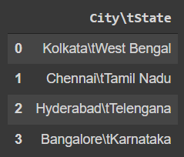
Sample Output:
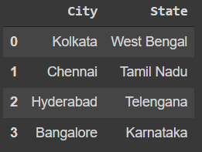
Sample Explanation:
The respective City and State are separated into two different columns as shown in the sample output.
Note: Recall the string methods in Pandas.

