You are given a dataframe df containing life expectancies of different countries for different years.
It's first five rows are-
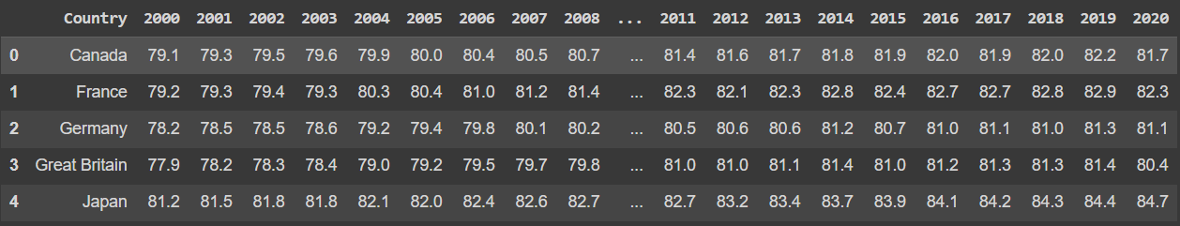
Melt all the year columns into a single column. Set variable name as 'Year' and value name as 'Life_Expectancy'.
Find 5 years with the maximum average life expectancy.
Return a dataframe containing 5 rows with Year as index and Life Expectancy as a column, sorted in descending order of average life expectancy.
Note that the Life Expectancy column in the output represents the avarage life expectencies for different years.
Check sample output for better understanding.
Sample Input-
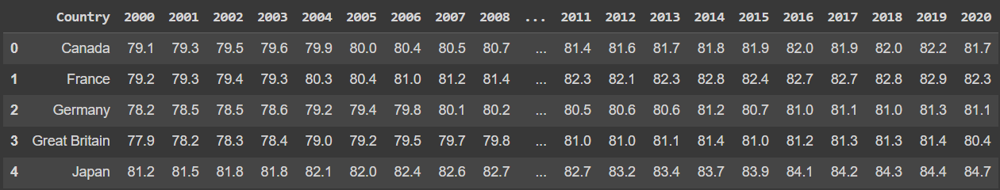
Sample Output-
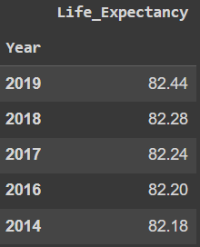
Sample Explanation-
The year 2019 has the highest average life expectancy of 82.44.
The year 2018 has the second highest average life expectancy of 82.28 and so on..

