A certain company is going to present its data to its new Chief of Management.
The data scientists compiled the data into 4 columns: month, mean of the sales, demo product sales in the last 12 months, and major product sales in the last 12 months.
Help the data scientists plot this data visually into 3 subplots:
- The first subplot should be a line plot, with x-axis as month_number, y-axis as the mean_sales column, title as "trend graph", x label as "month" and y label as "sales"
- The second subplot should be a bar plot, with x-axis as month_number, y-axis as the demo_prod column, title as "demo prod sales", x label as "month" and y label as "sales"
- The third subplot should be a scatter plot, with x-axis as month_number, y-axis as the major_prod column, title as "distribution of major prod sales", x label as "month" and y label as "scattered points"
Also, the figure size should be set to [20, 5]
The output will be verified with the above attributes. This will be taken care of in the backend.
Input Format: (NOTE: No need to take the input explicitly — the input-handling code is already in place.)
A dataframe
Output Format:
Strings of data
Sample Input:
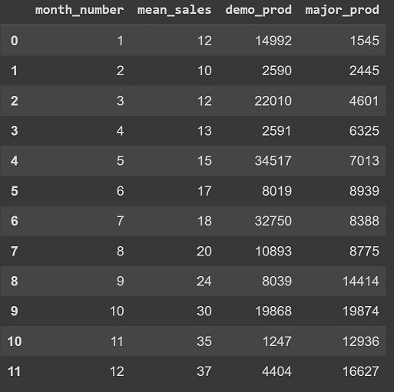
Sample Output:
The plot generated will look something like this
