Problem Description:
You are provided with a DataFrame sales_data containing information about sales transactions. Each row represents a single transaction with the following columns:
- Date: The date of the transaction.
- Region: The region where the transaction occurred.
- Product: The product that was sold.
- Sales: The amount of sales for that transaction.
Your task is to create a pivot table from sales_data that shows the total sales amount for each region. You need to write a function generate_pivot_table(data) that takes the DataFrame sales_data as input and returns the pivot table.
Your function should:
- Create a pivot table with 'Region' as the index and the sum of 'Sales' as the values.
- Handle missing values, filling them with zeros.
- Sort the resulting pivot table rows and columns alphabetically.
Your function should return the pivot table as a DataFrame.
- Refer to sample input and output for better understanding.
Input Format: (NOTE: No need to take the input explicitly — the input-handling code is already in place.)
The first line of the input contains the dataframe, in the form of a dictionary.
Output Format:
The new dataframe
Sample Input:
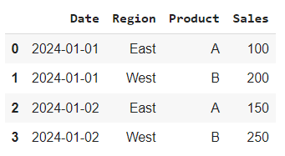
Sample Output:
