GOOGLE ADS – PRACTICAL TASKS
Completed Assignment

1. Google Ads Account Setup
Account dashboard screenshot: The screenshot below shows the Google Ads account dashboard after setup.
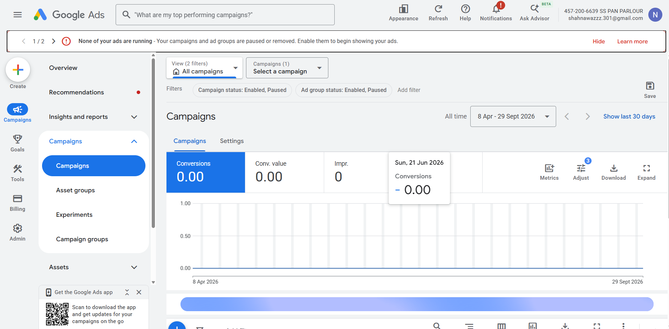
Google Ads dashboard – SS PAN PARLOUR account

2. Google Ads Campaign Types + Real-World Examples
Campaign Type | What It Is Used For | Real-World Example
Search Campaign | Text ads that can appear when people search for relevant products or services on Google. | Zomato promoting a food-delivery offer to people searching for food delivery or restaurant-related terms.
Display Campaign | Visual ads shown across websites and apps that are part of Google's Display Network. | Flipkart promoting a major sale with banner ads to users who may be interested in online shopping.
Video Campaign | Video advertising, commonly used on YouTube, to build awareness, consideration or action. | Spotify promoting its music app or a new feature through a YouTube video advertisement.
App Campaign | Promotes mobile-app installations or in-app actions across Google's available surfaces. | A music-streaming app running ads to encourage users to install its Android app.
Shopping Campaign | Shows product-focused ads containing information such as product images, names and prices. | An e-commerce brand promoting headphones, smartphones or other products to shoppers searching for those items.

3. Google Ads Campaign Objective
Selected objective: Website Traffic
Explanation: The Website Traffic objective is useful when a brand wants to bring relevant users to a specific website or landing page. For Myntra, it could drive shoppers to a sale or new-collection page. For BookMyShow, it could direct users to movie listings, showtimes or a booking page. Traffic can then be measured through website visits and related conversion actions.

4. Keyword Match Types – “online food delivery”
Match Type | Google Ads Keyword Syntax | Example
Broad Match | online food delivery | online food delivery
Phrase Match | "online food delivery" | "online food delivery"
Exact Match | [online food delivery] | [online food delivery]
Syntax reminder: Broad Match uses the keyword without special symbols; Phrase Match uses quotation marks; Exact Match uses square brackets.

5. Ten Keywords for a Cricket Score App During IPL Season
# | Keyword | Match Type
1 | IPL live score | Broad
2 | "IPL live score" | Phrase
3 | [IPL live score] | Exact
4 | IPL today match score | Broad
5 | "IPL today match score" | Phrase
6 | [IPL today match score] | Exact
7 | live cricket score | Broad
8 | "live cricket score" | Phrase
9 | IPL scorecard | Broad
10 | [IPL scorecard] | Exact
Practical note: These are assignment examples. Actual keyword selection should be validated with Google Keyword Planner using the campaign's target location, language, budget and current search demand.

