Domain Registration & Web Hosting Assignment
Food Blog Website • Hosting Comparison • Website Concepts

Task 1 — Domain Name Search
Suggested food-blog domain name: ZestyBiteGuide.com. The domain is suitable for a food discovery/review blog similar in concept to a restaurant-discovery platform.
GoDaddy domain availability result:
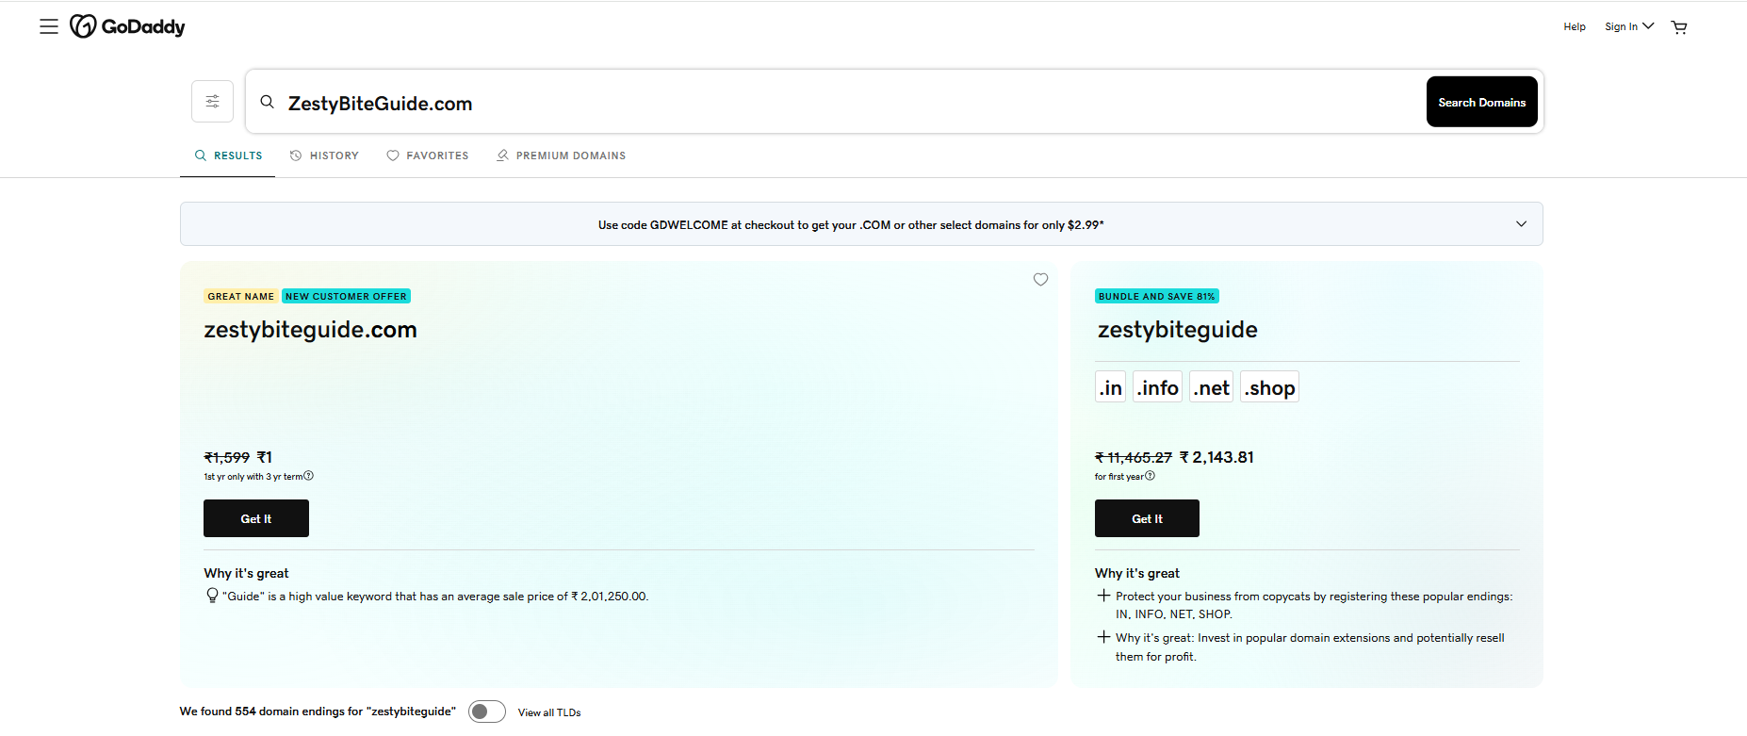
Figure 1: GoDaddy search result for ZestyBiteGuide.com
The screenshot shows ZestyBiteGuide.com in the GoDaddy results and displays the available-domain purchase option.

Task 2 — Shared Hosting Plan Comparison
Comparison of two shared-hosting options relevant to a small ecommerce or food-blog website: Hostinger Premium and Bluehost Basic/Starter. Prices and plan limits can change by region, term, and promotion.
Feature | Hostinger Premium | Bluehost Basic / Starter
Introductory pricing | Promotional pricing varies by term and region | Promotional pricing varies by term and region
Websites | Multiple websites on eligible Premium offers | Designed for small websites; verify current allowance
Storage | SSD/NVMe storage allocation; exact quota varies by offer | SSD storage; exact quota varies by current plan
Free SSL | Yes | Yes
Free domain | Included on eligible plans/offers | Included on eligible plans/offers
Email | Email features available depending on package | Email availability depends on current package
Control panel | hPanel | Bluehost dashboard / cPanel-related tools depending on plan
Backups | Backup features depend on plan | Backup features depend on current plan
Support | 24/7 support | 24/7 support
Suitable for | Beginners and small websites seeking an easy dashboard | Beginners and small WordPress-oriented websites
Comparison summary: Both providers can be used for a small website. When selecting a plan, compare the current promotional price, renewal price, storage, website allowance, SSL, backups, email, and support.

Task 3 — Domain Registration vs Web Hosting
A domain name is like your Instagram username: it is the unique name people use to find you. Web hosting is like Instagram's photo storage: it is the space where your website's pages, images, and files are stored. The domain acts as the website address, while hosting provides the server space that delivers the website to visitors.

Task 4 — Basic Website Launch Checklist
- Define the website goal — Decide the purpose, target audience, important pages, and main call-to-action.
- Choose a domain name — Select a short, memorable, relevant domain and check availability.
- Register the domain — Register the chosen domain and keep account and renewal details secure.
- Choose web hosting — Compare storage, SSL, backups, support, website limits, bandwidth, email, and renewal price.
- Connect domain and hosting — Point the domain's DNS/nameservers to the hosting provider.
- Enable HTTPS — Activate an SSL certificate and confirm the site loads securely.
- Build the website — Install a CMS such as WordPress or upload HTML/CSS/JS files.
- Create essential pages — Prepare Home, About, Contact, Privacy Policy, and relevant content/product pages.
- Make it mobile-friendly — Test navigation, buttons, text, images, and layout on mobile and desktop.
- Optimize basic SEO — Add titles, meta descriptions, headings, alt text, clean URLs, and internal links.
- Test the website — Check links, forms, images, speed, spelling, HTTPS, and browser compatibility.
- Set up analytics — Connect analytics/search tools to measure traffic and performance.
- Create a backup — Back up the website before launch and understand the recovery process.
- Launch and monitor — Publish the website and monitor traffic, errors, uptime, and search visibility.
Submission note: The GoDaddy screenshot you provided has been inserted under Task 1. The InfinityFree/free-subdomain task has been removed as requested.

