Website Structure & Planning Tasks
Digital Marketing / Web Development Assignment

Task 1 – Food Delivery Website Sitemap
The sitemap below shows the main pages of a food delivery website similar to Zomato and how users can move between the key sections.

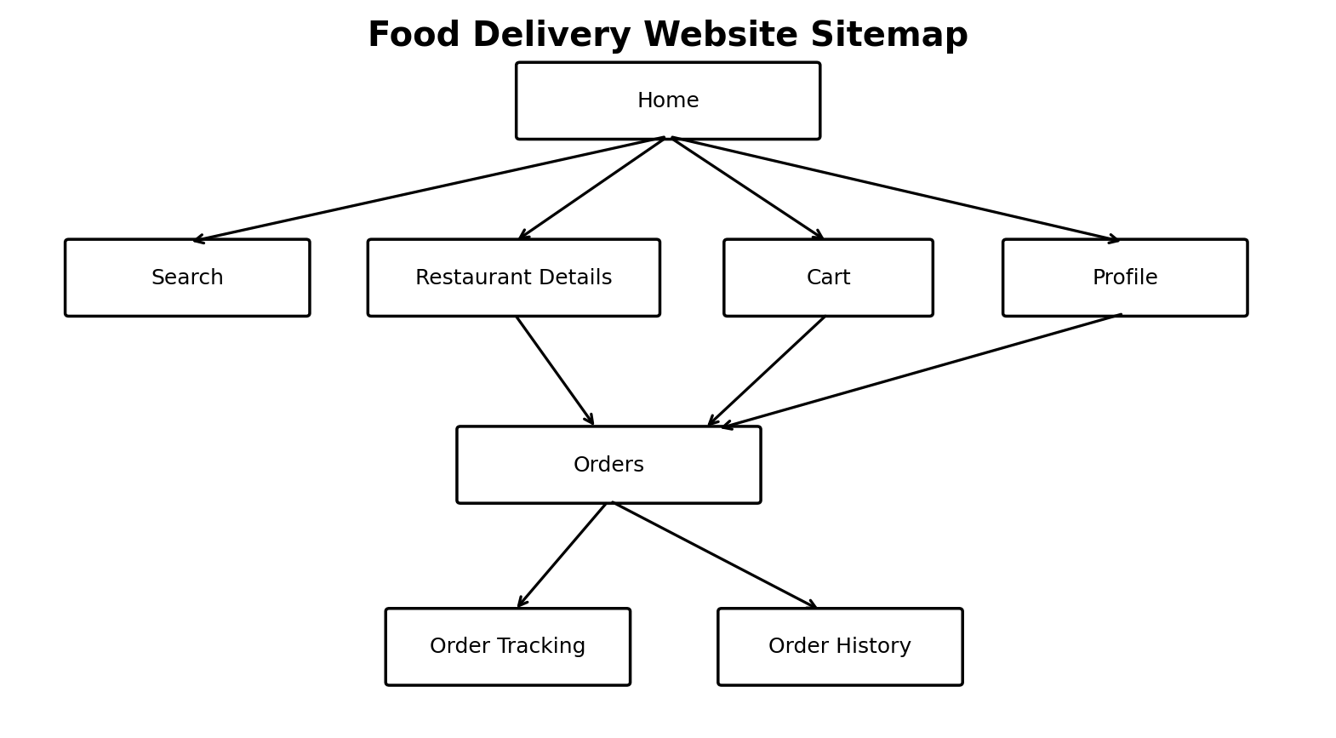
Main flow: Home → Search → Restaurant Details → Cart → Orders. Profile provides account-related features, while Orders connects to order tracking and order history.

Task 2 – Movie Review Website Folder Structure
Example folder structure for a basic movie review website called MovieReview:
MovieReview/
├── index.html
├── pages/
│ ├── home.html
│ ├── movies.html
│ ├── movie-details.html
│ ├── reviews.html
│ ├── about.html
│ └── contact.html
├── images/
│ ├── logo.png
│ ├── banners/
│ │ ├── banner-1.jpg
│ │ └── banner-2.jpg
│ ├── movies/
│ │ ├── movie-1.jpg
│ │ ├── movie-2.jpg
│ │ └── movie-3.jpg
│ └── icons/
│ ├── search.png
│ └── star.png
├── css/
│ ├── style.css
│ └── responsive.css
└── scripts/
├── main.js
├── search.js
└── reviews.js

Folder Purpose
- pages/ – Stores separate HTML pages.
- images/ – Stores logos, banners, movie posters and icons.
- css/ – Contains main and responsive stylesheet files.
- scripts/ – Contains JavaScript for search, reviews and interactions.
- index.html – Main/home page of the website.

Task 3 – Why Website Structure Is Important for E-commerce
A clear website structure helps e-commerce users find products quickly and move through the buying process with less confusion. Pages can be organized into categories, product details, cart, checkout and account sections.
Good structure also helps search engines understand relationships between pages. Logical navigation, descriptive URLs, internal links and organized categories can make important pages easier to discover and crawl.
A well-planned structure also supports mobile usability. For an e-commerce site, the path from product discovery to checkout should be simple, consistent and easy to understand.

Task 4 – Website Version of Instagram
App selected: Instagram. If Instagram were designed primarily as a website, these main sections could be included:
Section / Page | Purpose
Home / Feed | Displays posts and reels from followed accounts, with likes, comments and shares.
Explore | Helps users discover new photos, videos, creators, hashtags and topics.
Reels | Provides a dedicated area for short-form vertical videos.
Search | Lets users search for accounts, hashtags, places and content.
Messages | Provides direct messages, group conversations and shared media.
Notifications | Shows likes, comments, follows, mentions and other activity.
Profile | Displays bio, profile picture, posts, reels, tagged content and account information.
Create | Allows users to upload or create posts, stories and reels.
Settings | Contains privacy, security, account and notification preferences.

