AI CONTENT CREATION TASKS
Completed Assignment
Task 1: Instagram Captions for a New Zomato Restaurant Launch
1. 🍽️ New place. New flavours. Same old craving! Meet your next favourite restaurant on Zomato. ❤️‍🔥 Order. Bite. Repeat. #Zomato #NewRestaurant #Foodie
2. 🚨 Your food plans just got an upgrade! Our newest restaurant is serving flavours worth talking about. 🍕🔥 Find us on Zomato! #FoodLaunch #ZomatoFood
3. One bite and you’ll know why everyone is talking about us. 🤤✨ Fresh flavours, delicious plates and a whole lot of happiness — now live on Zomato! #FoodLovers
4. Your next food obsession has officially arrived. 😍🍴 Grab your friends, pick your favourite dish and let the feast begin! Available on Zomato. #FoodieLife
5. 🎉 GRAND LAUNCH ALERT! New menu. Fresh vibes. Big flavours. Your table is waiting — order our launch specials on Zomato today! 🔥 #GrandLaunch #Zomato
Task 2: Myntra Trending Sneaker Description + AI Rewrite
Product: UrbanFlex Street Runner Sneakers
Original version: The UrbanFlex Street Runner is a casual sneaker designed for everyday use. It has a lightweight upper, cushioned sole and lace-up closure. The simple design works well with jeans, joggers and casual outfits. It is suitable for college, travel, shopping and regular daily wear.
AI-enhanced version: Step into effortless street style with the UrbanFlex Street Runner. Its lightweight feel and cushioned sole keep you comfortable from morning classes to evening plans, while the clean sneaker design instantly upgrades your everyday look. Pair it with jeans, cargos or joggers and make every step feel easy. Whether you’re heading to college, exploring the city or meeting friends, these sneakers are built to keep up with your day.
Aspect | Original | AI-Enhanced
Tone | Straightforward | Energetic and lifestyle-focused
Language | Simple specifications | Vivid, conversational wording
Emotional appeal | Low | Higher through lifestyle imagery
Audience | General buyer | College/casual/lifestyle users
Readability | Clear | More engaging and scannable
Task 3: Spotify Artist Recommendation Blog Post
Artist: Arijit Singh
If you’re looking for an artist who can fit almost every mood, give Arijit Singh a spot on your Spotify playlist. His music moves effortlessly between romantic melodies, emotional ballads and energetic film tracks, making it easy to find a song for whatever kind of day you’re having. Whether you’re travelling, studying late at night or simply relaxing with headphones on, his expressive vocals bring a distinct feeling to each track. Start with a few of his popular songs, save the ones that match your mood and let Spotify build your next listening session around them. If you love Hindi music, he’s an artist worth exploring.
Word count: 106 words.
Task 4: Flipkart Big Billion Days Promotional Banner
AI-generated promotional banner created according to the task requirements. It contains a catchy headline and multiple product visuals.
Headline: “INDIA’S BIGGEST SALE IS BACK!”
Sale identity: “Flipkart BIG BILLION DAYS”
Offer: “UP TO 80% OFF”
Products shown: Smartphone, laptop and headphones.
Additional elements: Free delivery, easy returns, no-cost EMI, shopping bags, gift boxes, brand/product labels and a prominent “SHOP NOW” call-to-action.
Promotional Banner
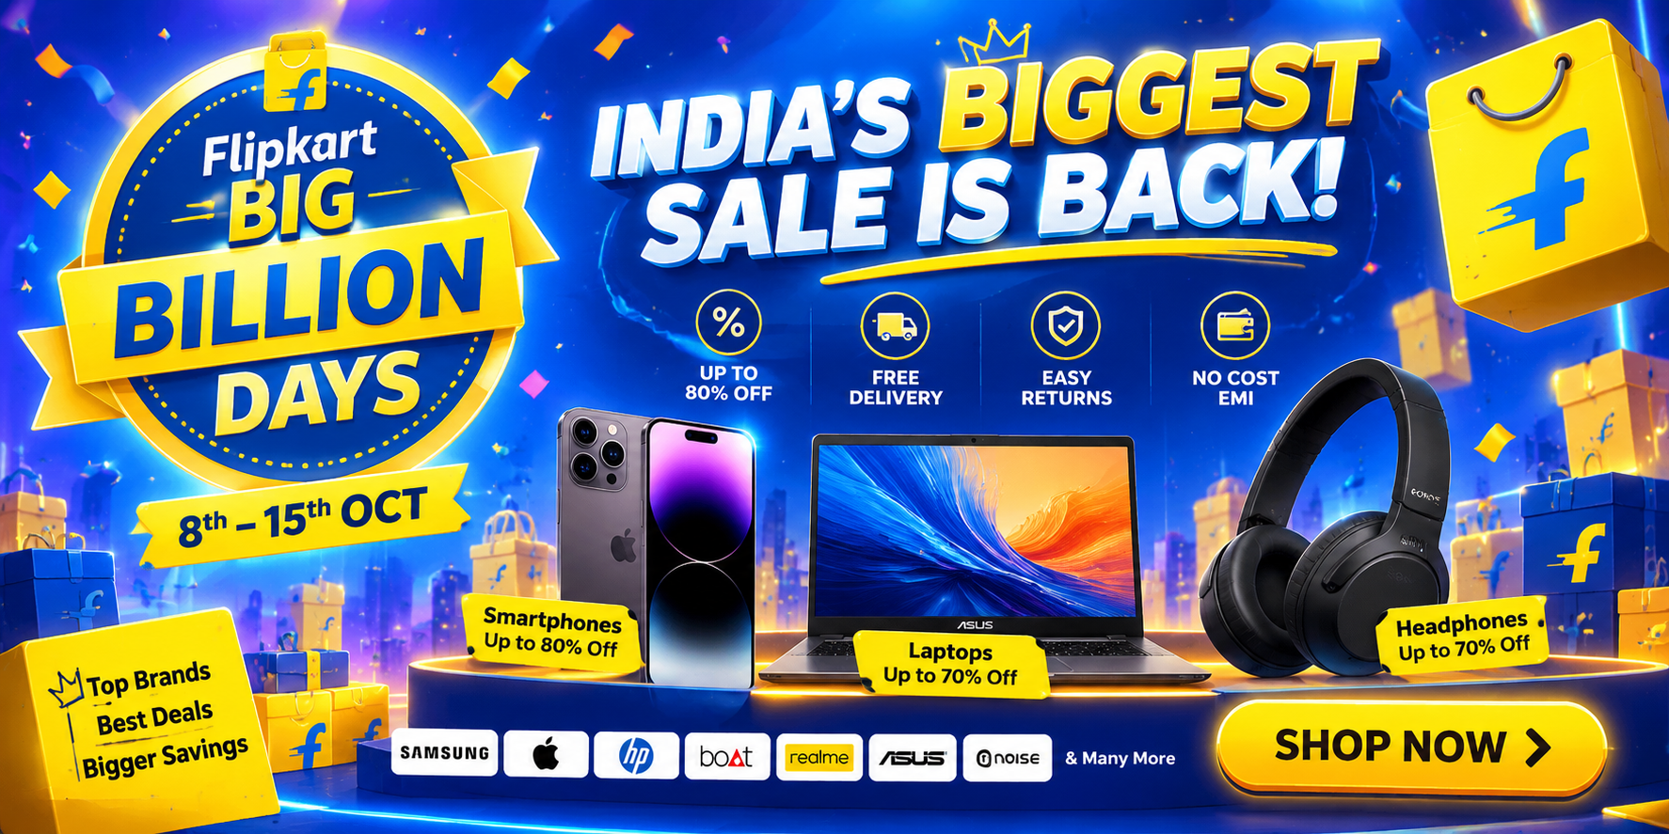
Assignment Completed

