Synopsis

A lexical analyzer is that part of the compiler which reads the source file and generates as its output a stream of tokens. A token is the smallest component of a program.

The output of the lexical analyzer is fed to the parser which subsequently uses them for syntax analysis.
For example, consider the statement:

a = b + 5;

This is converted by the lexical analyzer into the token stream

< a,id > < =,assign-op > < b, id > < +, add_op> < 5, dec>

Input to the program
The input to the program is a C – file, input.c

Output of the program
The output of the program is a stream of tokens which would be fed to a parser for semantic error-checking. However, the output in this program is directly displayed on the monitor. The output is a set of tuples, along with line numbers in source file, in which the first entry indicates the token type and the second entry gives us the token itself
< token , token_type >

Process

This process of converting our input C – source file to a stream of tokens forms the bulk of our project work. This is how it is achieved:

- List the set of token types to be returned by lexical analyzer
- Design a single N.F.A. from the regular expressions that accepts all tokens in C
- Simulate the N.F.A. in a C-program using nested if-else statements

Limitation of the program - Length of the token that in input file must be less than or equal to 256 characters.

The token types can be one of the following:
- Identifiers (e.g. my_name , _iden , printf)
- Keywords (e.g. int ,for ,do , struct)
- Operators (e.g. +=, << , ==)
- Strings (e.g. “ xyz “, “OUR PROJECT”)
- Constants
- Integer constants (e.g. 5, 0x10 , 50L)
- Float constants (e.g. 5.03 , 5.03e7 , 5.03e-15)
- Character constants (e.g. ‘H’ , ‘i’ ,’\a’)

White-spaces and comments are ignored, Separators like ; , { - do not have a token class as according to C-language grammar specifications, they are treated as terminal symbols.

The errors detected in the lexer phase are:
- Decimal errors (e.g. 27qwe , 20a)
- Float errors (e.g. 1.2qwe , 1.2e , 1.2eabc)
- Character errors (e.g. ‘abc’ , ‘12de’)
- Hex errors (e.g. 0x1zw , 0x2y)
- Octal errors (e.g. 098 , 0a6)
- EOF errors

The approach to the project has been to construct an ’nfa’ that accepts all tokens in ‘c’. The nfa is to be implemented in a ‘c’ program. The lexical analyzer program is implemented as an implementation of nfa comprising of a sequence of nested if-else statements.
The choice of data structures also has been a conscious one. The entire code after stripping comments, blanks (preprocessing) will be stored in a file. Keywords are stored as an array in a lexicographic order to enable binary search.
This lexical analyzer displays all the tokens that ‘c’ language permits. User friendliness can be improved by using n-curses.
System Design

Identifiers:

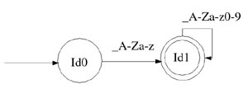

String constants:

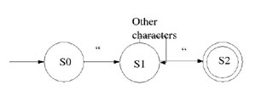

Character constants:

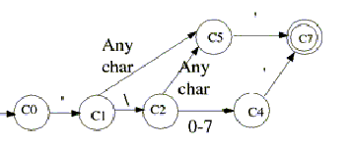

Integer constants:
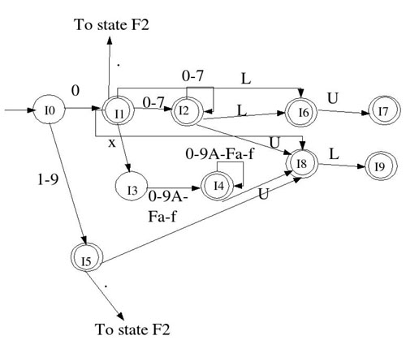

Float Constants

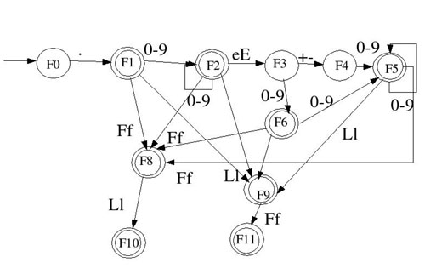

Operators:
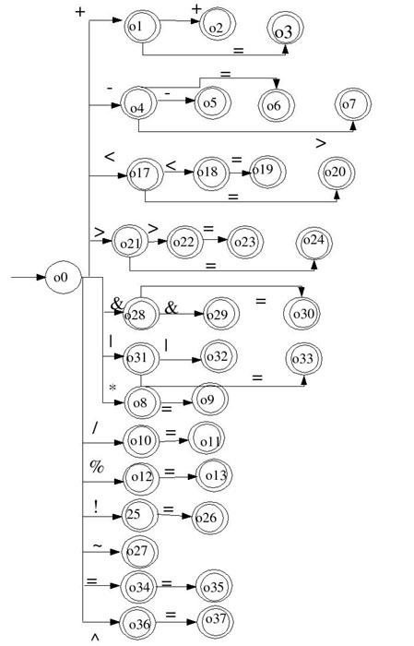
, ? ;
o38

{ } ( ) [ ]
Token Classes

The token classes defined according to us, (following the C-language grammar) are:

The different token classes are:

ID – Identifiers

STOR_SPEC - Storage specifier keywords:auto,register,static,extern,typedef

TYPE_SPEC - Type specifier keywords:void,char,short,int,long,float,double,signed,unsigned,struct,union,enum

TYPE_QUAL - Type qualifier keywords:const,volatile

LAB_KEY - Label keywords:case,default

SEL_KEY: Selection statement keywords:if,else,switch

ITER_KEY: Iteration statement keywords:while,do,for

JMP_KEY: Jump statement keywords:goto,continue,break,return

SIZEOF: Sizeof keyword:sizeof

CHAR_C: Character constants
STR_C: String constants
OCT_C: Octal number constants
INT_C: Integer number constants
HEX_C: Hexadecimal number constants
FLOAT_C: Float number constants

ASS_OP: Assignment operators: = *= /= %= += -= <<= >>= &= |= ^=
OR_OP: Logical OR operator: ||
AND_OP: Logical AND operator: &&
IN_OR: Inclusive Or: |
IN_AND: Inclusive AND: &
EXOR_OP: Exclusive Or operator: ^
EQ_OP: Equality operators: == !=
REL_OP: Relational operators: < > <= >=
SH_OP: Shift operators: << >>
ADD_OP: Additive operators: + -
MUL_OP: Multiplicative operators: * / %
UN_OP: Unary operators: ++ -- ~ !
DEREF_OP: Deference operator: ->
DOT_OP: Dot operator: .

ERR_CH: Errors in characters
ERR_IN: Errors in integers
ERR_FL: Errors in floats
ERR_INV: Errors due to invalid characters in file
ERR_EOF: Errors due to eof

Input/Output Screen Shot

Input screenshot:

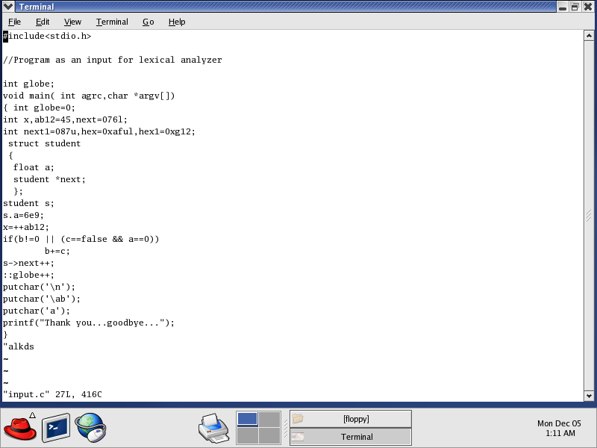

Output screenshot:

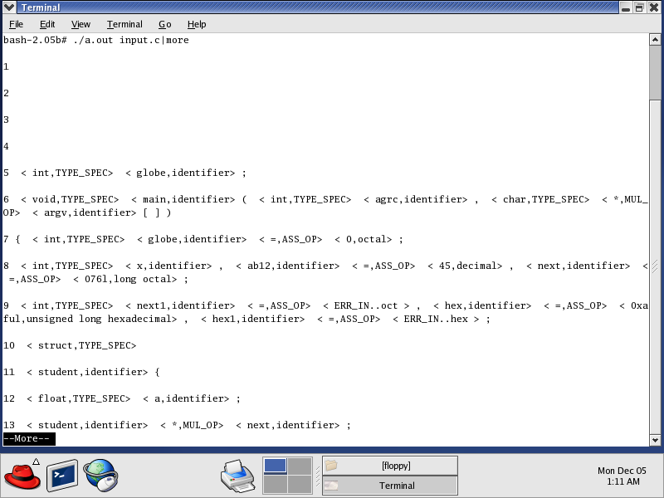

Output screenshot continued:

