**Neil Shah- Subnets**

**Network 1**

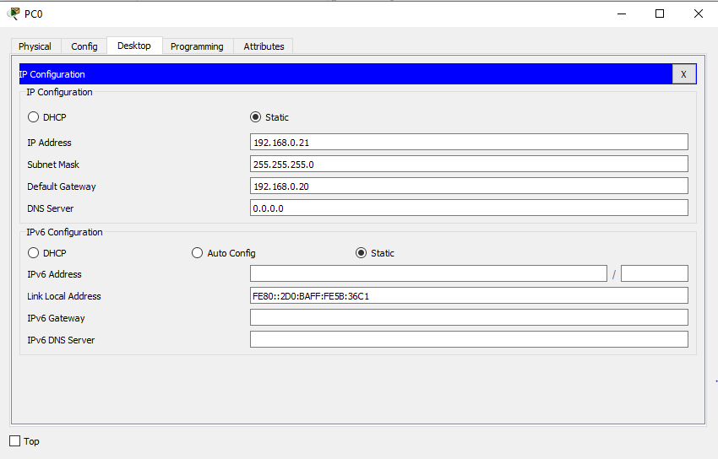

**Network 2**

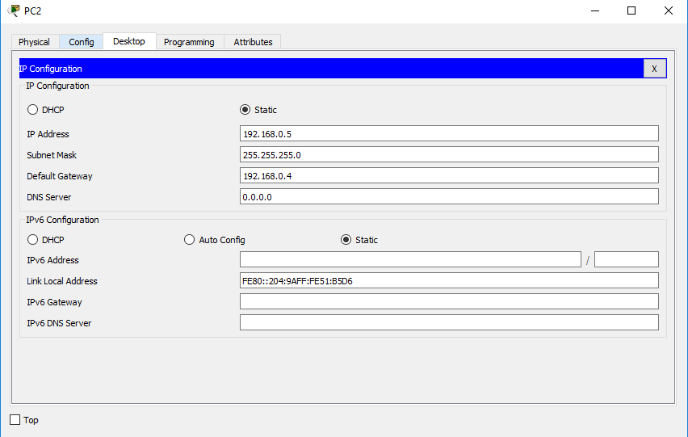

**Network 3**