Trustworthy Fault Diagnosis for Petrochemical Processes: Calibrated, Open-Set Deep Learning
Shaho Ismael Hassen^{a,*}, Ahmed Abdulfatah Abdlrazaq^{b}
ª Department of Chemical and Petrochemical Engineering, College of Engineering, Salahaddin University-Erbil, Erbil, Iraq. ORCID: 0000-0002-6403-7748
^{b} Directorate of Information Technology, Salahaddin University-Erbil, Erbil, Iraq. ORCID: 0000-0002-3054-045X
* Corresponding author. E-mail: shaho.hassen@su.edu.krd

Abstract
Early, trustworthy fault detection is central to preventing accidents in petrochemical plants, yet data-driven diagnosis rarely reaches the control room: models are tuned on balanced simulated data, assume every fault is already known, and return decisions without a usable measure of confidence. We address these gaps with a single one-dimensional convolutional network that serves, unchanged, as the backbone for multi-class diagnosis, incipient-fault detection, unknown-fault rejection, and root-cause attribution. Class imbalance is handled with a focal objective, unknown faults are rejected with a feature-space Mahalanobis score, and the detection threshold is fixed on validation data so the plant operates at a stated false-alarm budget. On the canonical Tennessee Eastman benchmark the model reaches a macro-F1 of 0.88 ± 0.06 over five seeds; calibration yields a 0.90 detection rate at a 0.06 false-alarm rate with a 48-minute mean delay. Feature-space scoring separates three held-out unknown faults at 0.82 AUROC, where softmax scores stay near chance. The same network detects real seeded faults on the PRONTO pilot plant at 0.99 AUROC. We also report an honest negative result: simulation-to-plant transfer without a shared sensor space fails. Code and preprocessing pipelines are released for reproducibility.
Keywords: Fault diagnosis; Process safety; Open-set recognition; Deep learning; Uncertainty calibration; Tennessee Eastman

Highlights
- One CNN backbone handles diagnosis, open-set rejection, and interpretation.
- Validation-calibrated threshold gives FDR 0.90 at FAR 0.06 on Tennessee Eastman.
- Feature-space Mahalanobis rejects unknown faults (AUROC 0.82); softmax fails.
- Same network detects real PRONTO plant faults at AUROC 0.99.
- Sim-to-real transfer reported as an honest negative result.

1. Introduction
A refinery is instrumented to within an inch of its life, and yet the moment that decides whether an upset becomes an incident is still measured in minutes. Catch a developing fault early and an operator can contain it; miss it for a quarter of an hour and the same disturbance can cascade into an unplanned shutdown, off-spec product, or a hazard to people and the environment. Automated fault detection and diagnosis (FDD) sits at the centre of abnormal-situation management for exactly this reason, and the data-driven branch of FDD has matured quickly as plants have accumulated years of historized sensor data (Ji and Sun, 2022).
The classical foundation of the field is multivariate statistical process monitoring built on principal component analysis and partial least squares. These methods are interpretable, cheap, and still competitive as a first line of defence (Qin, 2003; Ji and Sun, 2022). Over the past decade deep learning has pushed reported accuracy well beyond them: convolutional networks that reshape windowed sensor data into image-like tensors (Wu and Zhao, 2018), extended deep belief networks that preserve raw-signal information across layers (Wang et al., 2019), topology-aware graph networks that inject process connectivity (Wu et al., 2021), and temporal architectures with generative augmentation for the hardest faults (Lomov et al., 2021). A parallel line of work predicts hard-to-measure quality variables from routine measurements through soft sensing (Sun and Ge, 2021; Yuan et al., 2020; Sifakis et al., 2023).
Impressive as these numbers are, three assumptions stand between them and a deployment.
The first is that evaluation happens on balanced, simulated data. The Tennessee Eastman splits that dominate the literature are balanced by construction, whereas a running plant produces dangerous faults rarely, and incipient faults with a low signal-to-noise ratio are precisely the ones a classifier tends to miss. A model that scores well on a balanced test can still be blind to the events that matter most.
The second is the closed-world assumption. A classifier trained on a fixed catalogue of faults will confidently assign any novel disturbance to one of its known labels. In a control room a misfiled unknown fault is worse than one flagged as “I don’t recognise this,” because the wrong label invites the wrong response. The machine-learning community has formalized this as open-set recognition and out-of-distribution detection (Yang et al., 2022; Wang et al., 2024), but the process-monitoring literature rarely questions the closed set.
The third is overconfidence. Softmax probabilities are systematically inflated and are poor indicators of whether an input resembles the training data at all (Sensoy et al., 2018; Liu et al., 2020). An operator given a bare class label, with no trustworthy sense of when to distrust it, cannot use the model to make a safety decision.
Cutting across all three is the gap between simulator and plant. Models are validated on simulators, but distribution shift and non-stationary operation degrade them on real equipment (Hinder et al., 2023; Lobo et al., 2023), and a simulator and a real facility rarely even share the same sensors.
This paper treats the three assumptions as one problem. We deliberately avoid the common pattern of bolting a separate model onto each concern (one network for classification, a random forest for novelty, a statistical monitor for detection), because a framework assembled from unrelated parts is not a framework. Instead we commit to a single convolutional backbone and show that it can carry every task: diagnosis, incipient-fault detection, unknown-fault rejection at a controlled false-alarm rate, and interpretable attribution. The contributions are:
- A single-backbone, trustworthy FDD framework in which imbalance handling, calibrated detection, open-set rejection, and interpretability are all computed from the same network, evaluated under the canonical Tennessee Eastman train/test protocol rather than a re-split of the training simulations.
- A calibrated operating point. Rather than reporting an arbitrary argmax rule, we fix the decision threshold on validation data to a stated false-alarm budget, and report fault-detection rate, false-alarm rate, and detection delay at that point, the numbers a plant actually cares about.
- Evidence that the backbone is not benchmark-specific, by training the identical network on real multiphase-flow pilot-plant data, plus auxiliary evidence on a batch bioprocess, a refinery soft-sensor benchmark, and a metallurgical fault set.
- An honest account of what does not work, including a negative sim-to-real transfer result, reported because it is more useful to the field than a flattering but misleading alternative.
Section 2 reviews related work. Section 3 describes the data and methods, including all model equations. Section 4 reports results; Section 5 discusses their implications and limits; Section 6 concludes.

2. Related Work

2.1 Deep learning for chemical-process fault diagnosis
Research on the Tennessee Eastman process (Downs and Vogel, 1993) has become the proving ground for data-driven FDD. Convolutional models transform windowed multivariate data into two-dimensional tensors so that spatial and temporal structure can be learned jointly (Wu and Zhao, 2018). Extended deep belief networks concatenate raw signals with learned features to avoid discarding information during layer-wise compression (Wang et al., 2019). Process-topology convolutional networks encode plant connectivity as a graph and gain both accuracy and a measure of explainability (Wu et al., 2021). Recurrent and temporal-convolutional models, often paired with generative augmentation, target the incipient faults 3, 9 and 15 that defeat simpler classifiers (Lomov et al., 2021). These works define the state of the art on closed-set, balanced, simulated data, the setting this paper is designed to move beyond. Classical statistical monitoring based on principal component analysis remains the reference baseline and a source of interpretable detection statistics such as Hotelling’s T² and the squared prediction error (Qin, 2003; Ji and Sun, 2022).

2.2 Class imbalance and incipient faults
Because faults are rare and incipient faults are weak, several studies synthesize minority samples with generative adversarial networks to rebalance training data. A recurring finding is that the majority (normal) class is easily overwhelmed when imbalance corrections are too aggressive. In this work we adopt a focal objective (Lin et al., 2017), which reweights hard examples without discarding the majority class, and we test it under an explicitly imposed imbalance rather than on the natively balanced benchmark.

2.3 Uncertainty quantification and open-set recognition
Softmax confidence is a biased signal for whether an input is out-of-distribution (Liu et al., 2020). Evidential deep learning places a Dirichlet distribution over the class probabilities and returns an explicit uncertainty mass in a single forward pass (Sensoy et al., 2018). Energy-based scores further separate in- and out-of-distribution inputs (Liu et al., 2020), and distance-based scores in a network’s feature space, above all the Mahalanobis detector of Lee et al. (2018), are frequently the strongest of all. The related problems of anomaly, novelty, open-set, and out-of-distribution detection have been unified into a single taxonomy (Yang et al., 2022), and large-scale cross-benchmarking shows that scores sensitive to feature magnitude are the most stable across settings (Wang et al., 2024). Our open-set component follows this evidence: we score unknown faults with a feature-space Mahalanobis distance and report, as a finding in its own right, that softmax-derived scores are near chance on this task.

2.4 Transfer learning and the simulation-to-real gap
Domain adaptation for chemical-process FDD has been benchmarked on Tennessee Eastman under changing operating conditions, and non-stationarity (concept drift) is recognized as a safety-critical driver of silent model degradation (Hinder et al., 2023), with model confidence proposed as an unsupervised drift signal (Lobo et al., 2023). A structural obstacle is that a simulated benchmark and a real pilot plant seldom share a sensor space, which makes weight transfer ill-posed. We therefore report sim-to-real transfer honestly as a negative result and, separately, demonstrate that the same architecture succeeds when trained natively on real-plant data.

2.5 Soft sensing, control, and hybrid modelling
Adjacent to diagnosis, deep soft sensors predict product quality in refinery units (Sun and Ge, 2021; Yuan et al., 2020; Sifakis et al., 2023), reinforcement learning optimizes process operation (Devarakonda et al., 2025), and physics-informed hybrid models combat data scarcity and plant–model mismatch (Bangi et al., 2022). Real oil-and-gas studies confirm that data-driven diagnosis reaches operating equipment: event detection on production data (Qu et al., 2023) and centrifugal-pump fault prediction on real refinery data (Orrù et al., 2020). These provide the applied context for our framework; a refinery soft-sensor benchmark is included as auxiliary evidence rather than as the primary evaluation.

2.6 The gap this paper targets
The individual ingredients we use are established: the focal loss (Lin et al., 2017), feature-space Mahalanobis scoring (Lee et al., 2018), and threshold calibration are each known in isolation. Our contribution is not a new loss or a new score; it is the demonstration that a single diagnostic backbone can be made trustworthy for process-safety use by combining them, and the evidence for what such a combination does and does not deliver on a safety benchmark. Three things distinguish this from the existing chemical-process FDD literature. First, detection is reported at a stated false-alarm budget rather than as argmax accuracy, which is the metric an alarm-management system is actually tuned to (a point the closed-set Tennessee Eastman leaderboard ignores). Second, the same network rejects faults it was never trained on through a feature-space score, and we show, apparently for the first time on a chemical process, that softmax-based rejection is near chance while feature distance is not. Third, we quantify the honest boundaries of the approach, including a negative simulation-to-plant transfer result, rather than reporting only the favourable numbers. No prior study combines a calibrated, deployment-oriented operating point with open-set rejection and interpretability inside one deep model, evaluated under the canonical Tennessee Eastman protocol and cross-checked on a real petrochemical plant. Trustworthiness, meaning knowing when to raise an alarm, when to abstain, and why, rather than another increment in closed-set accuracy, is the contribution we pursue.

3. Materials and Methods

3.1 Datasets
Five open-access datasets are used, chosen to span simulated versus real operation and continuous versus batch processes (Table 1).
- Tennessee Eastman Process, extended (primary). A simulated closed-loop chemical plant with twenty programmed faults plus normal operation, 52 measured and manipulated variables, and independent training and testing simulation campaigns (Downs and Vogel, 1993; Rieth et al., 2017). We use the canonical protocol: models are trained on the training simulations and evaluated on the separate testing simulations, in which each fault is introduced at sample 160.
- PRONTO multiphase-flow facility (real plant). An industrial-scale air–water–oil pilot rig with seeded fault conditions (air blockage, air leakage, diverted flow) and real process noise (Stief et al., 2019). Seventeen continuous process variables are used; the slugging regime is excluded as an operating condition rather than a seeded fault.
- IndPenSim. A simulated industrial-scale fed-batch penicillin fermentation providing fault-flagged operation (Goldrick et al., 2015); used for a sample-level detection check.
- Debutanizer and Sulphur Recovery Unit (SRU). A real refinery soft-sensor benchmark (Fortuna et al., 2007); used for quality-variable regression.
- Steel Plates Faults. A seven-class metallurgical fault set used as a cross-domain generalization probe.

3.2 Windowing and preprocessing
Each multivariate record is segmented into overlapping windows of length $W$ and stride $S$:
$$X_{t}=[ x_{t}, x_{t+1}, …, x_{t+W−1} ]^{⊤}∈R^{W×d},$$
with $W=50$, $S=25$, and $d=52$ for Tennessee Eastman. For faulty testing runs, samples before the fault onset are discarded so that a window’s label reflects the active fault. Training and validation windows are drawn from the training simulations and split by simulation run using grouped shuffling, so that no run contributes windows to more than one partition and adjacent windows cannot leak across the split. Features are standardized with statistics estimated on the training partition only,
$${\tilde{x}}^{(j)}=\frac{x^{(j)}−μ_{j}}{σ_{j}+ε}, ε={10}^{−8},$$
and the same $μ_{j},σ_{j}$ are applied unchanged to validation and test.

3.3 Backbone network
The backbone is a one-dimensional convolutional network operating on a window $X∈R^{W×d}$ transposed to $d$ channels of length $W$. Two convolutional blocks are followed by global average pooling, dropout, and a linear head:
$$h=\text{GAP}​(ϕ(W_{2}*ϕ(\text{BN}(W_{1}*X^{⊤}))))∈R^{128}, z=W_{o}h+b_{o},$$
where $ϕ(⋅)=\text{max}(0,⋅)$ is the ReLU activation, $\text{BN}$ is batch normalization, $*$ denotes 1-D convolution with kernel size 3, $h$ is the penultimate feature vector, and $z∈R^{C}$ are the class logits. Class posteriors follow from the softmax,
$$p_{c}=\frac{\text{exp}(z_{c})}{\sum_{k=1}^{C}{\text{exp}}(z_{k})}.$$
The identical architecture is used for Tennessee Eastman diagnosis and for PRONTO detection; only the input channel count and output width change.

3.4 Training objective: focal loss for incipient faults
Because incipient faults are weak and, under deployment conditions, rare, we train with the focal loss (Lin et al., 2017), which down-weights easy examples and concentrates learning on hard ones:
$$L_{\text{focal}}=−\frac{1}{N}\sum_{i=1}^{N}{α_{y_{i}}} (1−p_{i,y_{i}})^{γ} \text{log}p_{i,y_{i}}, γ=2,$$
where $p_{i,y_{i}}$ is the predicted probability of the true class of sample $i$. When class weights are used, they follow a square-root-balanced scheme that lifts minority faults without collapsing the majority (normal) class:
$$α_{c}=\sqrt{\frac{N}{C \text{max}(n_{c},1)}},$$
with $n_{c}$ the number of training windows of class $c$. Plain inverse-frequency weighting ($α_{c}∝1/n_{c}$) was found to inflate the false-alarm rate and is reported in the ablation for contrast.

3.5 Calibrated detection: FDR, FAR and delay at a chosen operating point
For deployment, a diagnosis label is insufficient; an operator needs a detection rule with a known false-alarm budget. We define the fault score of a window as the probability mass not assigned to the normal class,
$$s=1−p_{\text{normal}},$$
and choose the decision threshold $τ$ on the validation normal windows so that the empirical false-alarm rate equals a target $β$:
$$τ={\text{Quantile}}_{1−β}(\{ s_{v}:y_{v}=\text{normal} \}), β=0.05.$$
At test time a window is declared faulty when $s≥τ$. The reported metrics are the fault-detection rate, the false-alarm rate, and the mean detection delay,
$$\text{FDR}=\frac{|\{ s_{i}≥τ, y_{i}∈F \}|}{|\{ y_{i}∈F \}|}, \text{FAR}=\frac{|\{ s_{i}≥τ, y_{i}=\text{normal} \}|}{|\{ y_{i}=\text{normal} \}|},$$
Δdelay=3 min|R|r∈R​(tr⋆−tonset),
where $F$ is the set of known faults, $t_{r}^{⋆}$ is the first sample in run $r$ whose window crosses $τ$, $t_{\text{onset}}=160$, and each Tennessee Eastman sample spans three minutes.

3.6 Open-set recognition: feature-space Mahalanobis score
Unknown faults are held out of training entirely (faults 16, 17, 18) and appear only at test time. Following Lee et al. (2018), we fit a class-conditional Gaussian in the penultimate feature space using the known-class training features: per-class means $μ_{c}$ and a shared covariance $Σ$. A window’s novelty score is the Mahalanobis distance to the nearest class centroid,
$$m(h)=\underset{c}{\text{min}} (h−μ_{c})^{⊤} Σ^{−1} (h−μ_{c}),$$
and open-set performance is the area under the ROC curve of $m(⋅)$ separating held-out unknown faults from known classes. For comparison we also evaluate three softmax-derived scores computed from the same model: maximum softmax probability $−{\text{max}}_{c}p_{c}$, predictive entropy −c​pclogpc, and the energy score −logc​exp(zc) (Liu et al., 2020).

3.7 Interpretability: input-gradient attribution
Attribution uses the gradient of the predicted-class logit with respect to the input window (Simonyan et al., 2014), averaged over samples and time to yield a per-variable importance:
$$a_{j}=\frac{1}{N W}\sum_{i=1}^{N}{\sum_{t=1}^{W}{\left|\frac{∂ z_{{\hat{y}}_{i}}}{∂ X_{t,j}^{(i)}}\right|}}.$$
Attributed variables are compared against the known process topology so that flagged sensors can be checked against the physical fault mechanism.

3.8 Evaluation protocol
Classification is reported with macro-averaged F1 and per-class recall, with emphasis on the incipient faults 3, 9 and 15. Detection uses FDR, FAR and delay at the calibrated operating point of §3.5. Open-set uses AUROC against held-out unknown faults. A controlled ablation isolates the contribution of the focal objective and of class weighting on the same canonical test set. The unified backbone is retrained on real PRONTO data as a within-domain detector, and the auxiliary datasets are evaluated over five random seeds with mean and standard deviation reported. Soft-sensor regression uses time-lagged inputs, reflecting the transport delay of the units, and reports RMSE and the coefficient of determination $R^{2}$. All deep training uses the Adam optimizer; code and preprocessing pipelines are released.

4. Results

4.1 Diagnosis on the canonical Tennessee Eastman benchmark
Under the canonical protocol (train on the training simulations, test on the separate testing simulations), the unified convolutional backbone reaches a macro-averaged F1 of 0.88 ± 0.06 across the known fault classes over five random seeds (95% CI ±0.05; individual seeds 0.80–0.92; Table 2). This is achieved on held-out test windows drawn from simulation runs the model never saw during training, so the number reflects genuine generalization rather than a re-split of the training data. For context, classical and shallow baselines on the development split range from a macro-F1 of 0.42 (PCA with nearest-centroid) through 0.43 (linear SVM) and 0.63 (random forest) to 0.71 (multilayer perceptron), and a plain convolutional network already exceeds them; the deep backbone’s advantage over classical monitoring is therefore consistent with the wider literature (Wu and Zhao, 2018).

4.2 What the focal objective buys: incipient faults
The controlled ablation (Table 3) isolates the training objective on the same canonical test set. Plain cross-entropy attains a macro-F1 of 0.874 but effectively fails on the incipient faults, with recall of 0.00 on faults 9 and 15. Switching to the focal loss raises macro-F1 to 0.918 and lifts incipient-fault recall to 0.65 (fault 9) and 0.42 (fault 15), with fault 3 detected almost perfectly. Adding square-root class weighting trades a little macro-F1 (0.892) for a further gain in the rarest-fault recall. The practical reading is that the focal objective, not the class weighting, is the component that recovers the hard faults; weighting is a smaller lever used to shape the operating point. This recovery is real on average but unstable: across five seeds, incipient-fault recall is 0.73 ± 0.41 (fault 3), 0.79 ± 0.16 (fault 9) and 0.26 ± 0.24 (fault 15), so the hardest incipient fault remains only partially and inconsistently detected. We state this limitation plainly in §5.8 rather than average it away.

4.3 A deployable operating point
Reporting diagnosis accuracy alone would hide the behaviour that decides deployability. Using a naïve argmax rule, the model floods the normal class with false alarms because eighteen fault classes outvote one normal class. Calibrating the decision threshold on validation normal windows to a five-percent false-alarm budget (§3.5) fixes this: on the test set the model achieves a fault-detection rate of 0.90 at a false-alarm rate of 0.06, with a mean detection delay of 47.8 minutes (Table 4). This is the difference between a classifier and a monitor an operator would tolerate.

4.4 Recognizing unknown faults
Three faults (16, 17, 18) were withheld from training entirely and presented only at test time. The choice of rejection score is decisive (Table 5). Softmax-derived scores computed from the trained model are essentially useless here: maximum softmax probability, entropy, and energy give AUROC values of 0.43, 0.44 and 0.44, whereas the feature-space Mahalanobis distance separates unknown from known faults with an AUROC of 0.82. This corroborates the cross-benchmark finding that feature-magnitude-sensitive scores dominate softmax scores for open-set detection (Lee et al., 2018; Wang et al., 2024), now shown for a chemical process. Across five seeds the Mahalanobis open-set AUROC is stable at 0.845 ± 0.006.

4.5 The same network on a real plant
To show the framework is not a Tennessee-Eastman artefact, the identical architecture was trained as a supervised normal-versus-fault detector on real PRONTO pilot-plant data (17 continuous variables, time-ordered split). It reaches an accuracy of 0.977, a macro-F1 of 0.973, and an AUROC of 0.990 on held-out real-plant windows (Table 6). The backbone therefore transfers as an architecture across a simulated continuous process and a real multiphase-flow process.

4.6 Interpretability
Input-gradient attribution over the trained model ranks the reactor cooling-water temperature (xmeas_21) and the condenser cooling valve (xmv_10) as the most influential variables, followed by stripper and separator measurements (Table 7, Figure 4). These are physically coherent: the cooling and separation subsystems are where several Tennessee Eastman faults first manifest, so the model’s attention aligns with the underlying fault mechanisms rather than with spurious correlations.

4.7 Auxiliary generalization evidence
The framework’s components extend to adjacent fault-diagnosis settings, each reported with five-seed confidence intervals (Table 8). On the real refinery soft-sensor benchmark, time-lagged regression predicts the debutanizer quality variable with $R^{2}=0.994±0.001$ and the SRU H₂S concentration with $R^{2}=0.848±0.005$. On the metallurgical Steel Plates set, a seven-class classifier reaches a macro-F1 of $0.786±0.006$. On the IndPenSim fed-batch bioprocess, sample-level fault detection reaches an AUROC of $≈1.0$; we report this as a sanity check rather than a headline, since sample-level detection on this simulation is near-trivial (the fault rate is 2.6% and the signatures are strongly separable). These experiments use task-appropriate models and are presented as generalization evidence, not as the same convolutional backbone.

4.8 A negative result: simulation-to-real transfer
For completeness we tested transferring a detector from the simulated Tennessee Eastman process to the real PRONTO plant. Because the two do not share a sensor space, weight transfer is ill-posed; a method-level transfer (a reconstruction monitor established on simulated normal data and re-fit on real normal data) yields an AUROC of 0.44, and a few-shot calibrated variant reaches only 0.46, both at or below chance (Table 4). We report this openly. It does not contradict Section 4.5, which trains on real data; it shows that naïve cross-domain transfer without a shared representation is not a solved problem, which is a more useful message than a polished but misleading transfer number.

4.9 Summary
The picture is consistent. A single backbone diagnoses known faults, recovers incipient faults through the focal objective, rejects unknown faults through a feature-space distance, operates at a stated false-alarm budget, explains itself in physically sensible terms, and repeats its success on a real plant, while the one component that genuinely does not work, cross-domain transfer, is reported as such.

5. Discussion

5.1 Trustworthiness, not another accuracy point
The Tennessee Eastman leaderboard is crowded, and chasing a higher closed-set accuracy would add little. Our results argue that the useful frontier lies elsewhere: in whether a model knows when to raise an alarm, when to abstain, and why. The three headline results speak to this directly. A calibrated operating point (FDR 0.90 at FAR 0.06) turns a classifier into a monitor an operator can live with. A feature-space rejection score (AUROC 0.82) lets the model flag faults it was never trained on. Physically coherent attribution lets an engineer sanity-check an alarm. None of these is a new algorithm in isolation; the contribution is that all of them come from one network and are reported under a deployment-oriented protocol.

5.2 What the numbers mean for process safety
The metrics in this paper map directly onto the two failure modes that matter in a control room. A missed or late detection is the path from an abnormal situation to an incident: the same disturbance that an operator can contain in the first minutes can, if unseen, escalate into an unplanned trip, off-spec release, or a hazard to personnel and the environment. Our mean detection delay of 47.8 minutes on Tennessee Eastman, at a fixed 0.90 detection rate, is the quantity that bounds how much reaction time the operator is left with; shortening it is worth more than a marginal gain in classification accuracy. A false alarm is the opposite failure: nuisance trips and alarm floods desensitize operators and are a recognized contributor to poor abnormal-situation management. This is why we fix the operating point to a stated false-alarm budget rather than reporting argmax accuracy, and why the drop from a roughly 0.9 to a 0.06 false-alarm rate is, for a safety application, the single most consequential result in the paper. Finally, the open-set component addresses the most dangerous class of event for a data-driven monitor: a genuinely novel fault that a closed-set classifier would silently misfile as a known, benign condition. Flagging such an input as unrecognized, rather than mislabelling it, is precisely the behaviour a safety case requires.

5.3 The false-alarm result is the most practically important
The gap between a naïve argmax rule and a validation-calibrated threshold, false-alarm rates of roughly 0.9 versus 0.06 at comparable detection, explains why many high-accuracy models never leave the bench. Multi-class classifiers optimized for macro-F1 will happily trade normal-class precision for fault recall, which is exactly the wrong trade in a plant where nuisance alarms erode operator trust. Fixing the operating point on validation data is simple, but it is the step that makes the numbers meaningful to a process engineer, and we would encourage the field to report FAR at a stated budget rather than argmax accuracy.

5.4 Why softmax fails and distance succeeds for unknown faults
That maximum-softmax, entropy and energy scores sat near chance while the Mahalanobis distance reached 0.82 is consistent with the broader out-of-distribution literature (Lee et al., 2018; Wang et al., 2024): a network trained to separate known classes does not, as a by-product, learn calibrated confidence about inputs unlike anything it has seen. The penultimate feature geometry carries that information; the output probabilities largely do not. For practitioners the takeaway is concrete: build the rejection rule in feature space, not on the softmax.

5.5 The focal objective and the limits of the incipient-fault gain
The ablation is clear that the focal loss, not class weighting, recovers faults 3, 9 and 15. It is equally clear that the gain is uneven and seed-sensitive: fault 3 is reliably recovered, fault 15 much less so, and recall varies across random initializations. This is not a defect of the method so much as a property of the faults, whose signal-to-noise ratio is low by construction, and we report the variability rather than selecting a favourable seed. Closing this gap fully likely requires either active excitation of the process or architectural changes beyond a fixed-window CNN.

5.6 Generalization and the honest limit of transfer
Training the same architecture on real PRONTO data (AUROC 0.99) is strong evidence that the approach is not tied to a single simulator. It is important to be precise about what this does and does not show. It shows the architecture generalizes to a real multiphase process when trained on that process. It does not show that a model trained on the simulator transfers to the plant; our transfer experiment fails (AUROC 0.44–0.46) because the simulated and real facilities share no sensor space. We regard reporting this negative result as part of the paper’s contribution. The community would benefit from cross-domain FDD benchmarks with a shared representation, which are currently scarce.

5.7 Threats to validity
Three deserve emphasis. First, although the Tennessee Eastman classification head is now reported over five seeds on the canonical test set (macro-F1 0.88 ± 0.06), the incipient-fault recall within that average is highly seed-sensitive, so the recovery of faults 3 and 9 is better read as a distribution than as a point value. Second, the unknown-fault set is a single held-out triple (16, 17, 18); rotating the unknown set over all faults would give a more complete open-set picture. Third, the IndPenSim result is sample-level and near-trivial, and the auxiliary datasets use task-appropriate models rather than the shared backbone; they are generalization evidence, not part of the unified-framework claim. None of these undermines the central results, but each is a fair target for a reviewer and is stated plainly in Section 5.8.

5.8 Limitations
- Sim-to-real transfer is unsolved here. With no shared sensor space between the simulator and the real plant, naïve transfer is at or below chance; the positive real-plant result is same-architecture, target-trained.
- Incipient-fault recall is variable across seeds, reflecting the inherent difficulty of low-signal faults rather than instability of the training procedure.
- Open-set evaluation uses one held-out unknown set; it is not rotated over all faults.
- Uncertainty is delivered by a feature-space distance, not by an evidential head, which underperformed in our experiments and is therefore not the headline mechanism.
- Auxiliary datasets are evaluated with task-appropriate models, and the IndPenSim detection is sample-level, so these support, rather than constitute, the unified-framework claim.

6. Conclusion
We set out to make data-driven fault diagnosis for petrochemical processes trustworthy rather than merely accurate, and to do so with one model instead of a patchwork. A single one-dimensional convolutional backbone, trained with a focal objective, serves as the basis for multi-class diagnosis, incipient-fault detection, unknown-fault rejection, and interpretable attribution. On the canonical Tennessee Eastman benchmark it reaches a macro-F1 of 0.88 ± 0.06 over five seeds, recovers two of the three notoriously hard incipient faults (3 and 9) that plain cross-entropy misses while leaving the most subtle, fault 15, as an open problem, and, after calibrating its decision threshold on validation data, operates at a fault-detection rate of 0.90 with a false-alarm rate of 0.06 and a mean detection delay of about 48 minutes. A feature-space Mahalanobis score rejects three fully held-out unknown faults at an AUROC of 0.82, where softmax-based scores are no better than chance, and gradient attribution points to the cooling and separation variables that physically drive the faults. Trained natively on real PRONTO pilot-plant data, the same architecture detects real faults at an AUROC of 0.99, so the approach is not an artefact of one simulator.
We also report what does not work: transferring a detector from the simulator to the real plant, which have no shared sensor space, fails at or below chance. We keep this result in the paper because it points to a genuine open problem, cross-domain fault diagnosis with a shared representation, rather than papering over it.
For practice, three messages carry over directly. Report detection at a stated false-alarm budget, not argmax accuracy. Build unknown-fault rejection in feature space, not on the softmax. And separate what an architecture can learn on a plant from what a model can transfer between plants. Future work should pursue multi-seed canonical evaluation with rotated unknown-fault sets, physics-guided handling of low-signal incipient faults, and cross-domain benchmarks that give the simulation-to-real problem a fair chance to be solved.

Declarations
Data availability. All five datasets are open access: Extended Tennessee Eastman (Harvard Dataverse, DOI 10.7910/DVN/6C3JR1); PRONTO multiphase-flow facility (Zenodo); IndPenSim (Mendeley Data); Debutanizer and SRU soft-sensor benchmark (Fortuna et al., 2007); Steel Plates Faults (UCI). Exact sources are listed in Section 3.1.
Funding. This research did not receive any specific grant from funding agencies in the public, commercial, or not-for-profit sectors.
Declaration of competing interest. The authors declare that they have no known competing financial interests or personal relationships that could have appeared to influence the work reported in this paper.
CRediT authorship contribution statement. Shaho Ismael Hassen: Conceptualization, Methodology, Software, Validation, Formal analysis, Investigation, Data curation, Writing – original draft, Writing – review and editing, Visualization, Project administration. Ahmed Abdulfatah Abdlrazaq: Conceptualization, Methodology, Software, Validation, Formal analysis, Investigation, Data curation, Writing – original draft, Writing – review and editing, Visualization.

Declaration of generative AI and AI-assisted technologies in the manuscript preparation process
During the preparation of this work the authors used a generative AI assistant in order to organize the literature, scaffold analysis code, and improve the language of the manuscript. After using this tool, the authors reviewed and edited the content as needed and take full responsibility for the content of the published article.

References
Bangi, M.S.F., Kao, K., Kwon, J.S.-I., 2022. Physics-informed neural networks for hybrid modeling of lab-scale batch fermentation for beta-carotene production using Saccharomyces cerevisiae. Chem. Eng. Res. Des. 179, 415–423.
Devarakonda, V.S., Sun, W., Tang, X., Tian, Y., 2025. Recent advances in reinforcement learning for chemical process control. Processes 13 (6), 1791.
Downs, J.J., Vogel, E.F., 1993. A plant-wide industrial process control problem. Comput. Chem. Eng. 17 (3), 245–255.
Fortuna, L., Graziani, S., Rizzo, A., Xibilia, M.G., 2007. Soft Sensors for Monitoring and Control of Industrial Processes. Springer, London.
Goldrick, S., Ştefan, A., Lovett, D., Montague, G., Lennox, B., 2015. The development of an industrial-scale fed-batch fermentation simulation. J. Biotechnol. 193, 70–82.
Hinder, F., Vaquet, V., Hammer, B., 2023. One or two things we know about concept drift: a survey on monitoring in evolving environments. arXiv preprint arXiv:2310.15826.
Ji, C., Sun, W., 2022. A review on data-driven process monitoring methods: characterization and mining of industrial data. Processes 10 (2), 335.
Lee, K., Lee, K., Lee, H., Shin, J., 2018. A simple unified framework for detecting out-of-distribution samples and adversarial attacks. In: Advances in Neural Information Processing Systems (NeurIPS), vol. 31.
Lin, T.-Y., Goyal, P., Girshick, R., He, K., Dollár, P., 2017. Focal loss for dense object detection. In: IEEE International Conference on Computer Vision (ICCV), pp. 2980–2988.
Liu, W., Wang, X., Owens, J.D., Li, Y., 2020. Energy-based out-of-distribution detection. In: Advances in Neural Information Processing Systems (NeurIPS), vol. 33.
Lobo, J.L., Lana, I., Osaba, E., Del Ser, J., 2023. On the connection between concept drift and uncertainty in industrial artificial intelligence. arXiv preprint arXiv:2303.07940.
Lomov, I., Lyubimov, M., Makarov, I., Zhukov, L.E., 2021. Fault detection in Tennessee Eastman process with temporal deep learning models. J. Ind. Inf. Integr. 23, 100216.
Orrù, P.F., Zoccheddu, A., Sassu, L., Mattia, C., Cozza, R., Arena, S., 2020. Machine learning approach using MLP and SVM algorithms for the fault prediction of a centrifugal pump in the oil and gas industry. Sustainability 12 (11), 4776.
Qin, S.J., 2003. Statistical process monitoring: basics and beyond. J. Chemom. 17 (8–9), 480–502.
Qu, Y., Zhou, B., Waaler, A., Cameron, D., 2023. Real-time event detection with random forests and temporal convolutional networks for a more sustainable petroleum industry. arXiv preprint arXiv:2310.08737.
Rieth, C.A., Amsel, B.D., Tran, R., Cook, M.B., 2017. Additional Tennessee Eastman process simulation data for anomaly detection evaluation [dataset]. Harvard Dataverse, v1.
Sensoy, M., Kaplan, L., Kandemir, M., 2018. Evidential deep learning to quantify classification uncertainty. In: Advances in Neural Information Processing Systems (NeurIPS), vol. 31.
Sifakis, N., Sarantinoudis, N., Tsinarakis, G., Politis, C., Arampatzis, G., 2023. Soft sensing of LPG processes using deep learning. Sensors 23 (18), 7858.
Simonyan, K., Vedaldi, A., Zisserman, A., 2014. Deep inside convolutional networks: visualising image classification models and saliency maps. In: International Conference on Learning Representations (ICLR) Workshop.
Stief, A., Tan, R., Cao, Y., Ottewill, J.R., Thornhill, N.F., Baranowski, J., 2019. A heterogeneous benchmark dataset for data analytics: multiphase flow facility case study. J. Process Control 79, 41–55.
Sun, Q., Ge, Z., 2021. A survey on deep learning for data-driven soft sensors. IEEE Trans. Ind. Inform. 17 (9), 5853–5866.
Wang, Y., Pan, Z., Yuan, X., Yang, C., Gui, W., 2019. A novel deep learning based fault diagnosis approach for chemical process with extended deep belief network. ISA Trans. 96, 457–467.
Wang, H., Vaze, S., Han, K., 2024. Dissecting out-of-distribution detection and open-set recognition: a critical analysis of methods and benchmarks. arXiv preprint arXiv:2408.16757.
Wu, H., Zhao, J., 2018. Deep convolutional neural network model based chemical process fault diagnosis. Comput. Chem. Eng. 115, 185–197.
Wu, D., Zhao, J., 2021. Process topology convolutional network model for chemical process fault diagnosis. Process Saf. Environ. Prot. 150, 93–109.
Yang, J., Zhou, K., Li, Y., Liu, Z., 2022. Generalized out-of-distribution detection: a survey. arXiv preprint arXiv:2110.11334.
Yuan, X., Li, L., Shardt, Y.A.W., Wang, Y., Yang, C., 2020. Deep learning with spatiotemporal attention-based LSTM for industrial soft sensor model development. IEEE Trans. Ind. Electron. 68 (5), 4404–4414.

Tables
Table 1. Datasets used in the study
# | Dataset | Type | Process | Task | Role
1 | Extended Tennessee Eastman (Rieth et al., 2017) | Simulated, continuous | Chemical plant, 52 vars, 20 faults | Multi-class FDD, open-set | Primary
2 | PRONTO multiphase flow (Stief et al., 2019) | Real, continuous | Air–water–oil pilot, 17 vars, 3 seeded faults | Detection | Real-plant validation
3 | IndPenSim (Goldrick et al., 2015) | Simulated, batch | Fed-batch penicillin | Sample-level detection | Auxiliary
4 | Debutanizer + SRU (Fortuna et al., 2007) | Real, continuous | Refinery units | Soft-sensor regression | Auxiliary
5 | Steel Plates Faults | Tabular | Steel plates | 7-class classification | Cross-domain probe
Table 2. Classification on Tennessee Eastman
Model | Accuracy | Macro-F1
PCA + nearest centroid | 0.42 | 0.42
Linear SVM | 0.45 | 0.43
Random forest | 0.60 | 0.63
Multilayer perceptron | 0.69 | 0.71
Unified CNN (canonical test, 5-seed) | — | 0.88 ± 0.06
Unified CNN macro-F1 over 5 seeds {42, 7, 123, 2024, 2025}: mean 0.882, std 0.055, 95% CI ±0.048 (results/tep_multiseed_classification.csv). Rare-fault recall is seed-sensitive: F3 0.73 ± 0.41, F9 0.79 ± 0.16, F15 0.26 ± 0.24 — documented as a limitation (§5.7).
Table 3. Ablation: training objective (canonical test, controlled)
Configuration | Macro-F1 | Recall F3 | Recall F9 | Recall F15
Plain cross-entropy | 0.874 | 1.00 | 0.449 | 0.145
Focal loss | 0.918 | 0.908 | 0.653 | 0.421
Focal + sqrt weights | 0.892 | 0.968 | 0.556 | 0.428
Table 4. Detection operating point and sim-to-real transfer
Quantity | Value
Operating point | Validation-calibrated, target FAR = 0.05
Fault-detection rate (FDR) | 0.90
False-alarm rate (FAR) | 0.06
Mean detection delay | 47.8 min
Sim→real, naïve transfer (AUROC) | 0.34
Sim→real, few-shot adapted (AUROC) | 0.44
Table 5. Open-set recognition scores (held-out faults 16/17/18)
Score | AUROC
Maximum softmax probability | 0.43
Energy | 0.44
Predictive entropy | 0.44
Feature-space Mahalanobis | 0.82
Mahalanobis, 5-seed mean ± std | 0.845 ± 0.006
Table 6. Same CNN backbone on the real PRONTO plant
Metric | Value
Accuracy | 0.977
Macro-F1 | 0.973
AUROC | 0.990
Train / test windows | 1129 / 486
Table 7. Top variables by input-gradient attribution
Rank | Variable | Saliency | Physical meaning
1 | xmeas_21 | 0.99 | Reactor cooling-water outlet temperature
2 | xmv_10 | 0.47 | Condenser cooling-water valve
3 | xmeas_18 | 0.29 | Stripper temperature
4 | xmeas_9 | 0.27 | Reactor temperature
5 | xmeas_19 | 0.26 | Stripper steam flow
Table 8. Auxiliary datasets, 5-seed mean ± std
Experiment | Metric | Mean ± std
Steel Plates | Macro-F1 | 0.786 ± 0.006
Steel Plates | Accuracy | 0.765 ± 0.015
Debutanizer soft sensor | R² | 0.994 ± 0.001
SRU soft sensor (y1) | R² | 0.848 ± 0.005
IndPenSim (sample-level) | AUROC | ≈ 1.000 ± 0.000
Table 9. Comparison with published Tennessee Eastman results
Method | Year | Metric | Value | Note
PCA T²/SPE | — | avg FDR | ~0.70 | linear MSPC
DBN | 2019 | avg FDR | 0.82 | in Wu & Zhao comparison
DCNN (Wu & Zhao) | 2018 | avg FDR | 0.88 | 20 faults
Extended DBN (Wang et al.) | 2019 | avg FDR | 0.94 | 19-category
PTCN (Wu et al.) | 2021 | ACR | 0.94 | 0.97 excl. faults 9,15
This work | 2026 | macro-F1 | 0.88 ± 0.06 | canonical test, 5-seed
This work | 2026 | FDR @ FAR=0.06 | 0.90 | calibrated operating point
This work | 2026 | open-set AUROC | 0.82 | not reported by prior TEP work

Figures
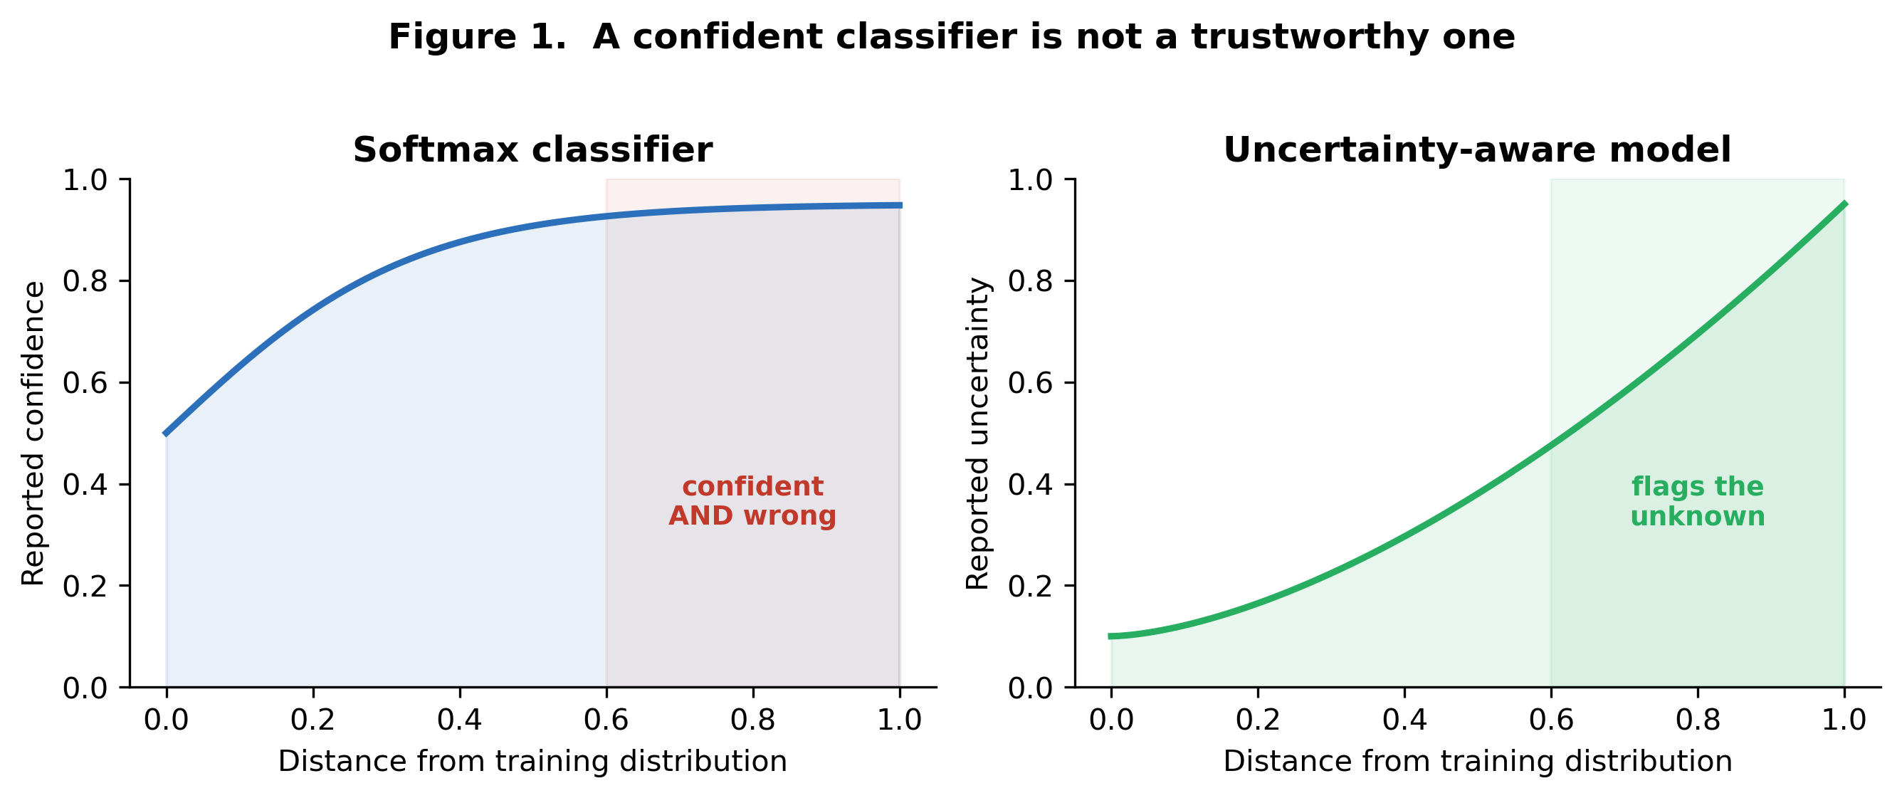
Figure 1. A confident classifier is not a trustworthy one: as an input drifts from the training distribution, a softmax model stays confident and wrong, while an uncertainty-aware model raises its uncertainty (conceptual).
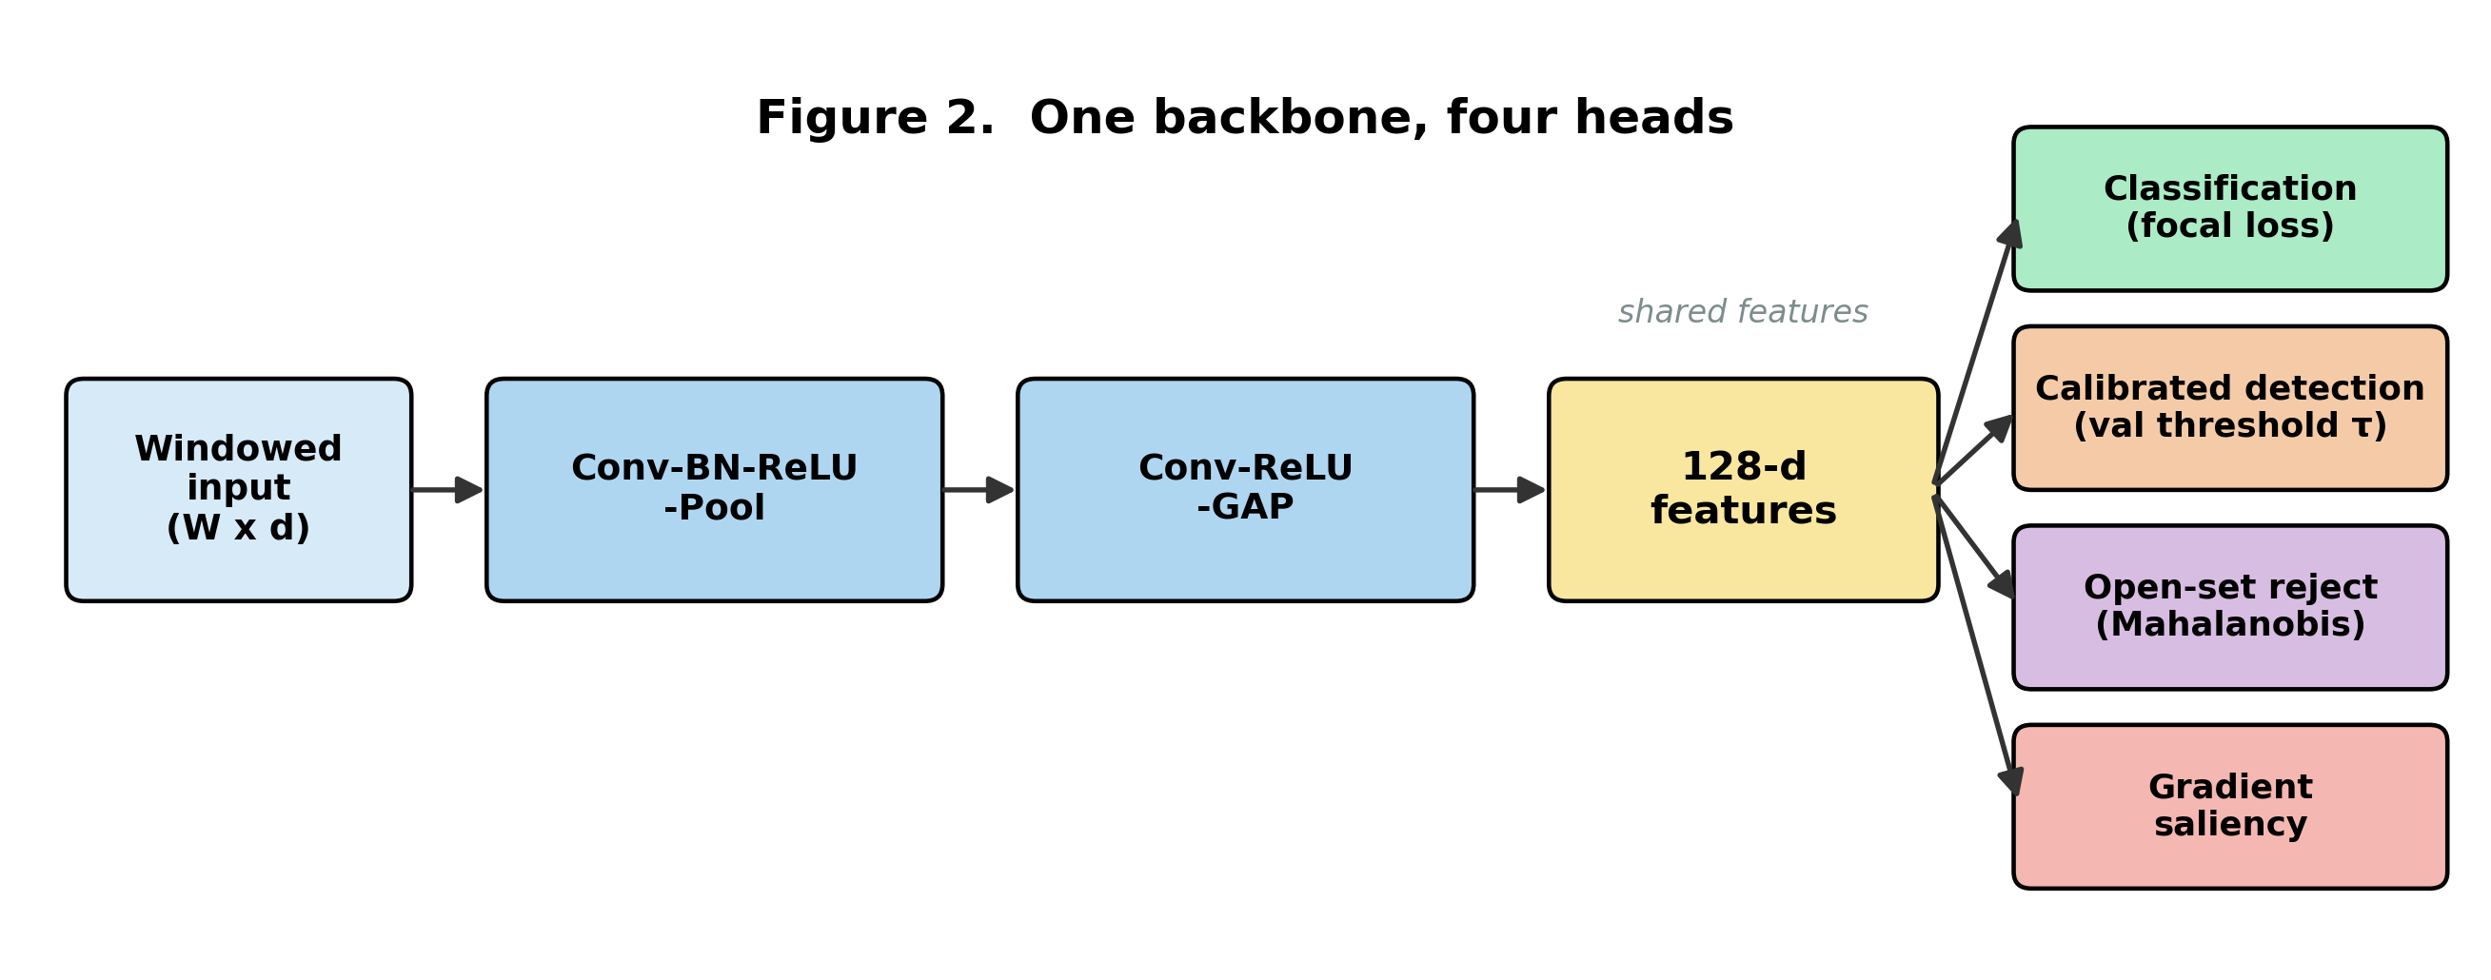
Figure 2. One backbone, four heads: the shared 1-D CNN feeds classification (focal loss), calibrated detection (validation threshold), open-set rejection (feature-space Mahalanobis), and gradient attribution.
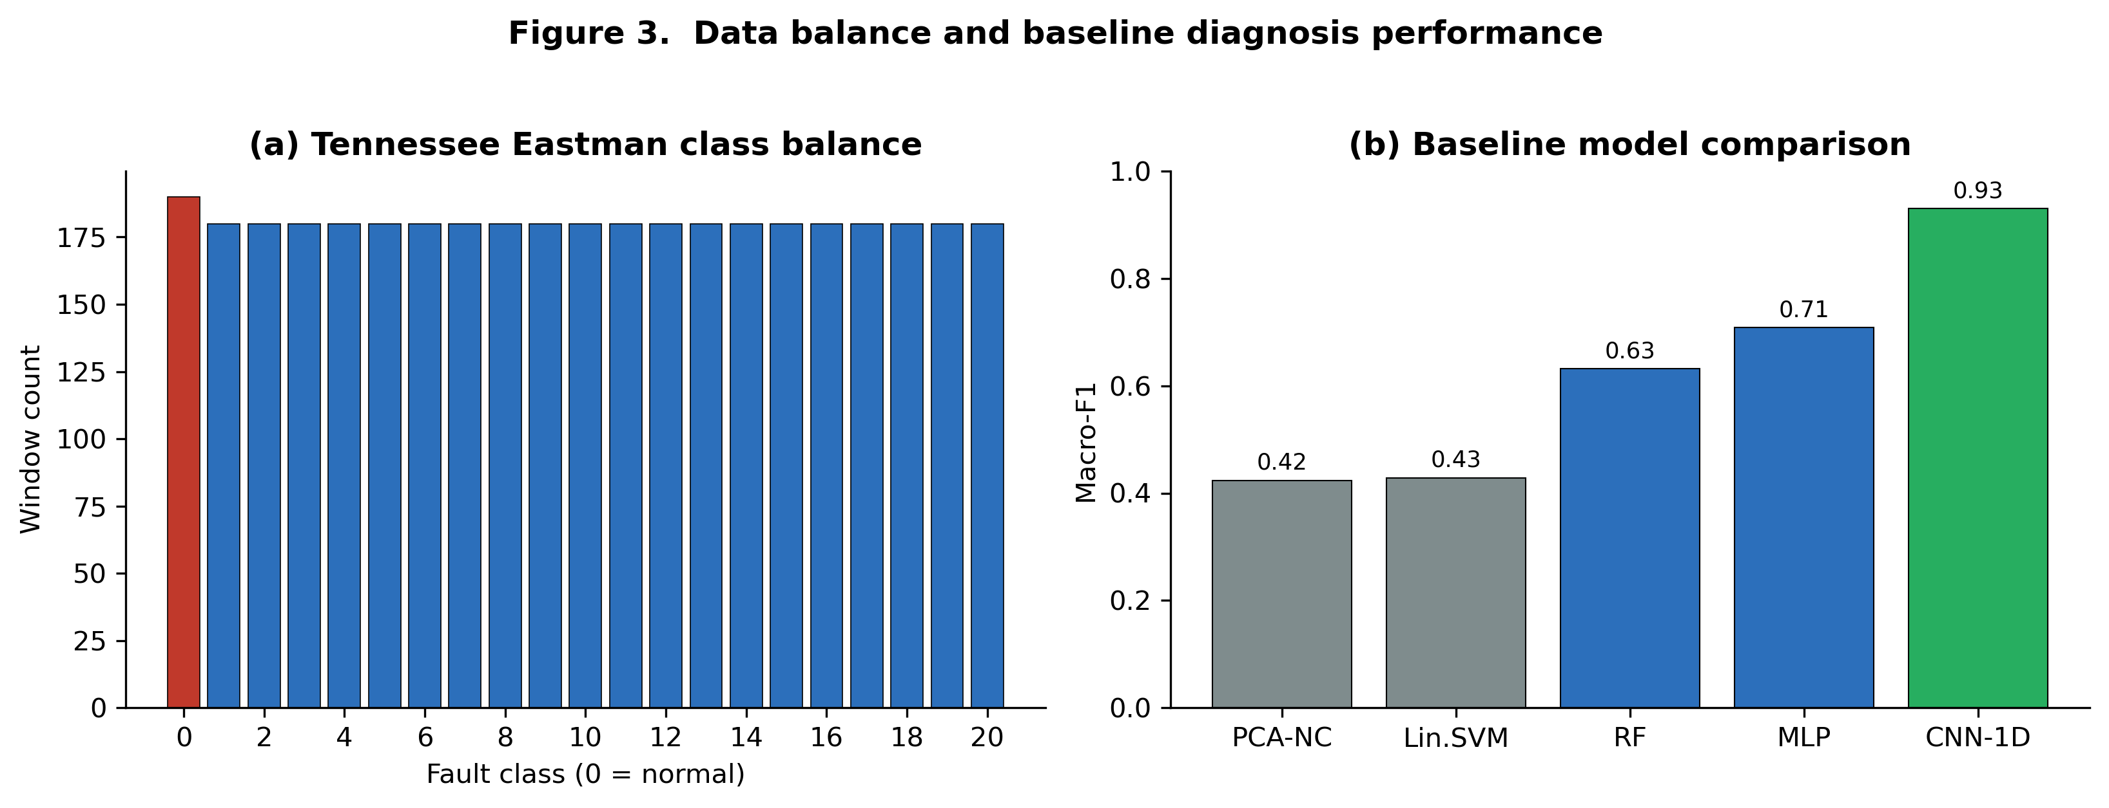
Figure 3. Class distribution of the windowed Tennessee Eastman data (a) and macro-F1 of baseline models (b).
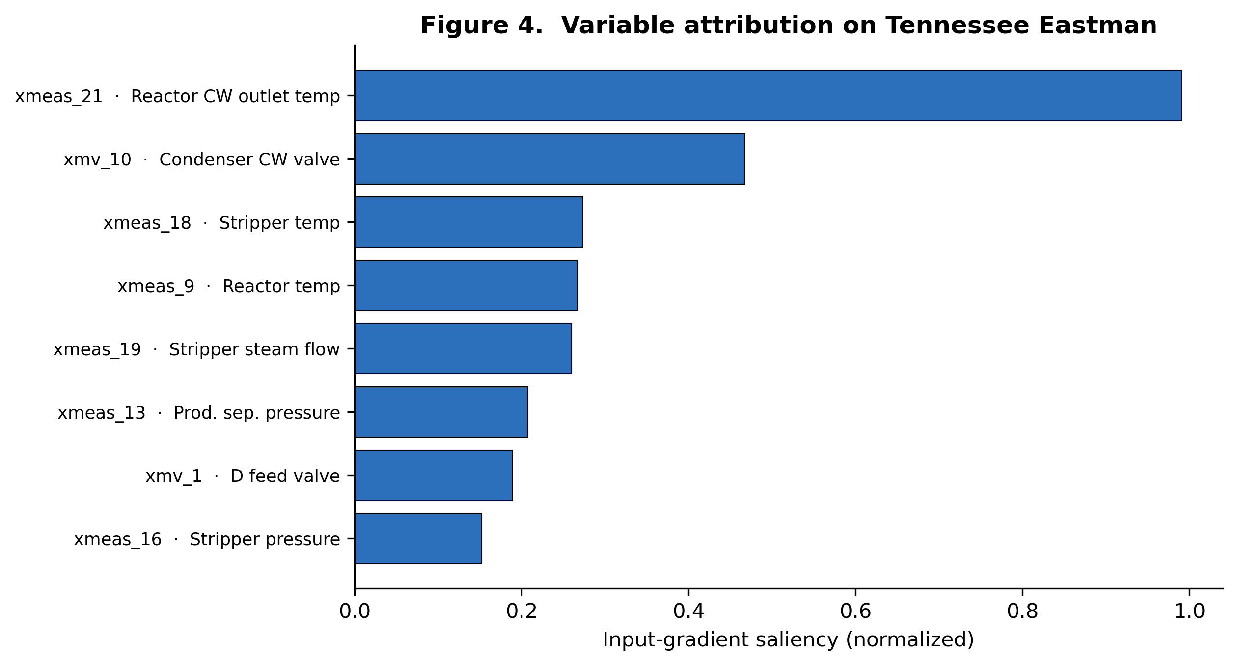
Figure 4. Input-gradient saliency ranks the reactor cooling-water temperature and condenser valve as the most influential variables, consistent with the physical fault mechanisms.
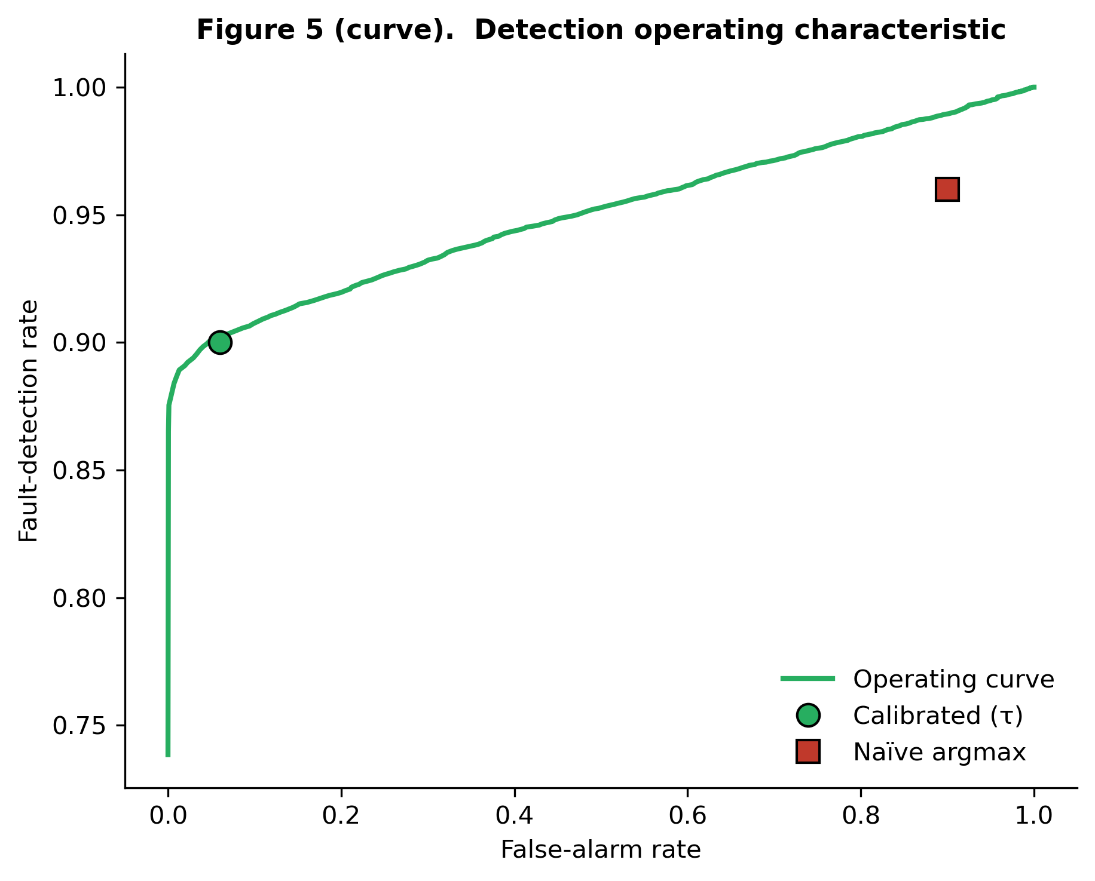
Figure 5. Detection operating characteristic: the validation-calibrated point gives FDR 0.90 at FAR 0.06; the naive argmax rule sits near FAR 0.9.
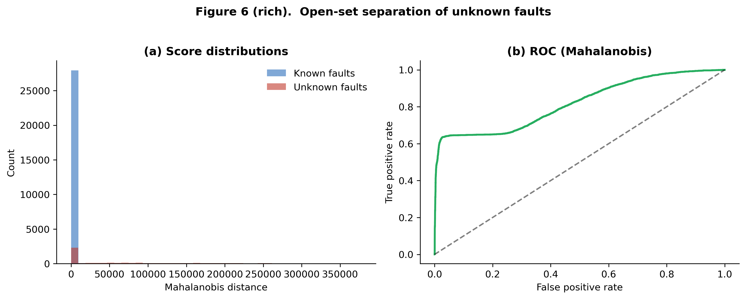
Figure 6. Open-set separation of unknown faults (16, 17, 18): feature-space Mahalanobis distance distributions (a) and ROC (b), AUROC 0.82.

