

**Project Report**

|  |  |  |  |  |  |  |
| --- | --- | --- | --- | --- | --- | --- |
| **Only for Course Teacher** | | | | | | |
|  | | **Needs Improvement** | **Developing** | **Sufficient** | **Above Average** | **Total Marks** |
| **Allocate Marks & Percentage** | | **25%** | **50%** | **75%** | **100%** | **25** |
| **Problem understanding & Analysis** | **7** |  |  |  |  |  |
| **Implementation** | **8** |  |  |  |  |  |
| **Report Writing** | **10** |  |  |  |  |  |
| **Total obtained marks** | | | | | |  |
| **Comments** |  | | | | | |
|  |
|  |

Semester: **Spring 24**

Student Name: **Md. Imtiaz Hossain**

Student ID: **221-35-953**

Batch: **37th**                              Section: **C2**

Course Code: **SE231**               Course Name: **Software Analysis and Design Project**

Course Teacher Name: **Khalid Been Md. Badruzzaman Biplob**

Designation: **Lecturer**

**Department of Software Engineering**

**Daffodil International University**

Submission Date: **23 May 2024**

**Table of Contents**

[**Introduction 4**](https://docs.google.com/document/d/18bhZ61RsXprsXbYbl-FViJBEEXnmxkFv/edit#heading=h.30j0zll)

[Objective 4](https://docs.google.com/document/d/18bhZ61RsXprsXbYbl-FViJBEEXnmxkFv/edit#heading=h.1fob9te)

[Key Features 4](https://docs.google.com/document/d/18bhZ61RsXprsXbYbl-FViJBEEXnmxkFv/edit#heading=h.3znysh7)

[**Scenario Writing 5**](https://docs.google.com/document/d/18bhZ61RsXprsXbYbl-FViJBEEXnmxkFv/edit#heading=h.2et92p0)

Scenario 1: User Profile Management 5 Scenario 2: Self Enrollment Student 5 Scenario 3: Student Assessment Participation 6 Scenario 4: View Grades 6 Scenario 5: View Course Material 6 Scenario 6: View Notifications 6

[**Stakeholder 7**](https://docs.google.com/document/d/18bhZ61RsXprsXbYbl-FViJBEEXnmxkFv/edit#heading=h.17dp8vu)

[**User Profile 7**](https://docs.google.com/document/d/18bhZ61RsXprsXbYbl-FViJBEEXnmxkFv/edit#heading=h.lnxbz9)

[User Profile-01: Admin 7](https://docs.google.com/document/d/18bhZ61RsXprsXbYbl-FViJBEEXnmxkFv/edit#heading=h.35nkun2)

[User Profile-02: Teacher 8](https://docs.google.com/document/d/18bhZ61RsXprsXbYbl-FViJBEEXnmxkFv/edit#heading=h.1ksv4uv)

[User Profile-03: Student 9](https://docs.google.com/document/d/18bhZ61RsXprsXbYbl-FViJBEEXnmxkFv/edit#heading=h.44sinio)

[**Scope 10**](https://docs.google.com/document/d/18bhZ61RsXprsXbYbl-FViJBEEXnmxkFv/edit#heading=h.z337ya)

[Enrollment Control: 10](https://docs.google.com/document/d/18bhZ61RsXprsXbYbl-FViJBEEXnmxkFv/edit" \l "heading=h.3j2qqm3)

[Class Administration: 10](https://docs.google.com/document/d/18bhZ61RsXprsXbYbl-FViJBEEXnmxkFv/edit#heading=h.1y810tw)

[Assessment Management: 10](https://docs.google.com/document/d/18bhZ61RsXprsXbYbl-FViJBEEXnmxkFv/edit#heading=h.4i7ojhp)

[Academic Tracking: 11](https://docs.google.com/document/d/18bhZ61RsXprsXbYbl-FViJBEEXnmxkFv/edit#heading=h.2xcytpi)

[Communication Hub: 11](https://docs.google.com/document/d/18bhZ61RsXprsXbYbl-FViJBEEXnmxkFv/edit#heading=h.1ci93xb)

[User Profile Management: 11](https://docs.google.com/document/d/18bhZ61RsXprsXbYbl-FViJBEEXnmxkFv/edit#heading=h.3whwml4)

[Material Repository: 11](https://docs.google.com/document/d/18bhZ61RsXprsXbYbl-FViJBEEXnmxkFv/edit#heading=h.2bn6wsx)

[Self-Enrollment for Students: 11](https://docs.google.com/document/d/18bhZ61RsXprsXbYbl-FViJBEEXnmxkFv/edit#heading=h.qsh70q)

Student Assessment Participation: 11

View Grades: 11

View Course Material: 11

[**Feasibility Study 11**](https://docs.google.com/document/d/18bhZ61RsXprsXbYbl-FViJBEEXnmxkFv/edit#heading=h.1pxezwc)

[1. Technical Feasibility: 11](https://docs.google.com/document/d/18bhZ61RsXprsXbYbl-FViJBEEXnmxkFv/edit#heading=h.49x2ik5)

[2. Operational Feasibility: 12](https://docs.google.com/document/d/18bhZ61RsXprsXbYbl-FViJBEEXnmxkFv/edit#heading=h.2p2csry)

[3.Financial Feasibility: 12](https://docs.google.com/document/d/18bhZ61RsXprsXbYbl-FViJBEEXnmxkFv/edit#heading=h.147n2zr)

[4. Legal and Compliance Feasibility: 12](https://docs.google.com/document/d/18bhZ61RsXprsXbYbl-FViJBEEXnmxkFv/edit#heading=h.3o7alnk)

[5.Schedule Feasibility: 12](https://docs.google.com/document/d/18bhZ61RsXprsXbYbl-FViJBEEXnmxkFv/edit#heading=h.23ckvvd)

6.Scalability and Growth Feasibility: 12

7. User Experience and Satisfaction Feasibility: 12

[**Project Block Diagram 14**](https://docs.google.com/document/d/18bhZ61RsXprsXbYbl-FViJBEEXnmxkFv/edit#heading=h.ihv636)

[Block Diagram-1: Admin 14](https://docs.google.com/document/d/18bhZ61RsXprsXbYbl-FViJBEEXnmxkFv/edit#heading=h.32hioqz)

[Block Diagram-2: Teacher 15](https://docs.google.com/document/d/18bhZ61RsXprsXbYbl-FViJBEEXnmxkFv/edit#heading=h.1hmsyys)

[Block Diagram-3: Student 16](https://docs.google.com/document/d/18bhZ61RsXprsXbYbl-FViJBEEXnmxkFv/edit#heading=h.2grqrue)

[**Software Requirement Specification 17**](https://docs.google.com/document/d/18bhZ61RsXprsXbYbl-FViJBEEXnmxkFv/edit#heading=h.3fwokq0)

[**SRS 17**](https://docs.google.com/document/d/18bhZ61RsXprsXbYbl-FViJBEEXnmxkFv/edit#heading=h.1v1yuxt)

[**User Case Diagram 21**](https://docs.google.com/document/d/18bhZ61RsXprsXbYbl-FViJBEEXnmxkFv/edit#heading=h.4f1mdlm)

[**User Case Description 22**](https://docs.google.com/document/d/18bhZ61RsXprsXbYbl-FViJBEEXnmxkFv/edit#heading=h.2u6wntf)

[Case Description-01: Request Login Credential 22](https://docs.google.com/document/d/18bhZ61RsXprsXbYbl-FViJBEEXnmxkFv/edit#heading=h.19c6y18)

[Case Description-02: Login 23](https://docs.google.com/document/d/18bhZ61RsXprsXbYbl-FViJBEEXnmxkFv/edit#heading=h.28h4qwu)

[Case Description-03: Forgot Password 24](https://docs.google.com/document/d/18bhZ61RsXprsXbYbl-FViJBEEXnmxkFv/edit#heading=h.37m2jsg)

[Case Description-04: View Grades 25](https://docs.google.com/document/d/18bhZ61RsXprsXbYbl-FViJBEEXnmxkFv/edit#heading=h.46r0co2)

[Case Description-05: View Course Material. 26](https://docs.google.com/document/d/18bhZ61RsXprsXbYbl-FViJBEEXnmxkFv/edit#heading=h.111kx3o)

[Case Description-06: Enrollment Control 27](https://docs.google.com/document/d/18bhZ61RsXprsXbYbl-FViJBEEXnmxkFv/edit#heading=h.206ipza)

[Case Description-07: Assessment Management 28](https://docs.google.com/document/d/18bhZ61RsXprsXbYbl-FViJBEEXnmxkFv/edit#heading=h.2zbgiuw)

[Case Description-08: Class Administration 30](https://docs.google.com/document/d/18bhZ61RsXprsXbYbl-FViJBEEXnmxkFv/edit#heading=h.1egqt2p)

[Case Description-09: Communication Hub 31](https://docs.google.com/document/d/18bhZ61RsXprsXbYbl-FViJBEEXnmxkFv/edit#heading=h.2dlolyb)

[Case Description-10: Academic Tracking 33](https://docs.google.com/document/d/18bhZ61RsXprsXbYbl-FViJBEEXnmxkFv/edit#heading=h.3cqmetx)

Case Description-11: User profile Management 34

Case Description-12: Upload Material 36

Case Description-13: Self-Enrollment Student 38

Case Description-14: Student Assessment Participation 39

Case Description-15: View Notifications 41

Case Description-16: Logout 42

[**Activity Diagram 43**](https://docs.google.com/document/d/18bhZ61RsXprsXbYbl-FViJBEEXnmxkFv/edit#heading=h.3q5sasy)

[Activity Diagram-1: User Profile Management 43](https://docs.google.com/document/d/18bhZ61RsXprsXbYbl-FViJBEEXnmxkFv/edit#heading=h.25b2l0r)

Activity Diagram-2: Self Enrollment Student 44

[Activity Diagram-3: View Grades 45](https://docs.google.com/document/d/18bhZ61RsXprsXbYbl-FViJBEEXnmxkFv/edit#heading=h.34g0dwd)

[Activity Diagram-4: Assessment Management 46](https://docs.google.com/document/d/18bhZ61RsXprsXbYbl-FViJBEEXnmxkFv/edit#heading=h.1jlao46)

[Activity Diagram-5: View Course Material 47](https://docs.google.com/document/d/18bhZ61RsXprsXbYbl-FViJBEEXnmxkFv/edit#heading=h.43ky6rz)

Activity Diagram-6: View Notifications 48

Activity Diagram-7: Assessment Management 49

Activity Diagram-8: Upload Material 50

Activity Diagram-9: Academic Tracking 51

Activity Diagram-10: Communication Hub 52

Activity Diagram-11: Class Administration 53

Activity Diagram-12: Enrollment Control 54

**Sequence Diagram 55**

[Sequence Diagram-1: User Profile Management 55](https://docs.google.com/document/d/18bhZ61RsXprsXbYbl-FViJBEEXnmxkFv/edit#heading=h.3vac5uf)

[Sequence diagram 2: Self-Enrollment Student](https://docs.google.com/document/d/18bhZ61RsXprsXbYbl-FViJBEEXnmxkFv/edit#heading=h.2afmg28)  56

Sequence diagram 3: View grades 57

[Sequence diagram 4: Student Assessments Participation 58](https://docs.google.com/document/d/18bhZ61RsXprsXbYbl-FViJBEEXnmxkFv/edit#heading=h.1opuj5n)

[Sequence diagram 5: View Course Materials 59](https://docs.google.com/document/d/18bhZ61RsXprsXbYbl-FViJBEEXnmxkFv/edit#heading=h.2nusc19)

Sequence diagram 6: View Notifications 60

Sequence diagram 7: Assessment Management 61

Sequence diagram 8: Upload Material 62

Sequence diagram 9: Academic Tracking 63

Sequence diagram-10: Communication Hub 64

Sequence diagram-11: Class Administration 65

Sequence diagram-12: Enrollment Control 66

[**Class Diagram 67**](https://docs.google.com/document/d/18bhZ61RsXprsXbYbl-FViJBEEXnmxkFv/edit#heading=h.1302m92)

[**Er Diagram 68**](https://docs.google.com/document/d/18bhZ61RsXprsXbYbl-FViJBEEXnmxkFv/edit#heading=h.2250f4o)

**Introduction to the Class Management System**

The Class Management System is a comprehensive platform designed to streamline administrative tasks, enhance communication, and facilitate academic activities within an educational institution. It caters to the needs of students, teachers, and administrators by providing intuitive features and efficient workflows. From managing enrollments to conducting assessments and facilitating communication, the system offers a range of functionalities to support the academic process.

**Objective:**

The primary objective of the Class Management System is to streamline administrative tasks, enhance communication, and improve the academic experience within educational institutions. By automating routine processes such as class management, enrollment, assessment, and communication, the system aims to reduce manual effort and administrative overhead. It facilitates transparent information sharing among students, teachers, and administrators, ensuring timely dissemination of class updates, assignments, and announcements. Furthermore, the system provides personalized user experiences, allowing users to customize profiles and access relevant information based on their roles. Efficient data management and analysis capabilities enable educators and administrators to make informed decisions and enhance the overall efficiency and effectiveness of academic operations. Designed to be scalable and flexible, the system can adapt to the evolving needs of educational institutions, supporting continuous improvement and innovation in teaching and learning practices.

**Key Features:**

* **User Authentication:** Students, teachers, and administrators can securely log in to the system using their credentials.
* **Enrollment Control:** Administrators have the authority to manage student enrollment, including viewing enrollment status, enrolling new students, and removing enrolled students.
* **Assessment Management:** Teachers can create, edit, and review various types of assessments such as quizzes, assignments, presentations, midterms, and final exams. Students can participate in these assessments and view their results.
* **Class Administration:** Administrators and teachers can manage classes, including selecting courses, setting class capacity, and assigning teachers to classes. Students can view class schedules, enroll in classes, and access course materials.
* **Communication Hub:** Users can send and receive notifications about class updates, assignments, and events. They can customize notification content and track communication history. Students can receive important announcements and updates from teachers and administrators.
* **Academic Tracking:** Teachers can track academic progress by managing attendance, entering records, and calculating grades for students. Students can view their attendance records and grades for assessments.
* **User Profile Management:** Users have the flexibility to manage their profiles, change passwords, update contact information, and upload profile pictures. Students can personalize their profiles and keep their information up to date.
* **Material Repository:** Teachers can upload course materials, organize them by class, add descriptions, and review upload history. Students can view, download, and access course materials uploaded by teachers.

Overall, the Class Management System aims to enhance efficiency, improve communication, and streamline administrative tasks to create a seamless academic experience for all users, with a specific focus on student engagement and interaction.

**Scenario Writing:**

**Scenario 1: User Profile Management:**

* User navigates to "Profile Management."
* User selects "Update Contact Info."
* System displays contact form.
* User enters new contact details.
* User reviews the info.
* User clicks "Save."
* System validates and updates info.
* Notification: "Contact info updated successfully."

**Scenario 2: Self Enrollment Student**

* User navigates to "Self-Enrollment."
* System displays available courses.
* User selects desired course.
* User confirms enrollment.
* System checks course availability.
* System enrolls users in course.
* Notification: "Enrollment successful."

**Scenario 3: Student Assessment Participation**

* User navigates to "Assessments."
* System lists available assessments.
* User selects desired assessment.
* System displays assessment details.
* User starts the assessment.
* User completes and submits the assessment.
* System confirms submission.
* Notification: "Assessment submitted successfully."

**Scenario 4: View Grades:**

* User navigates to "Grades."
* System lists available courses.
* User selects desired course.
* System displays grades for completed assessments.
* User reviews the grades.
* Users can choose to print or export the grades if needed.
* Notification: "Grades viewed successfully."

**Scenario 5: View Course Material:**

* User navigates to "Course Material."
* System lists available courses.
* User selects desired course.
* System displays a list of course materials (e.g., documents, videos, links).
* User selects a material to view or download.
* System presents the selected material.
* User views or downloads the material.
* Notification: "Course material accessed successfully."

**Scenario 6: View Notifications:**

* User navigates to "Notifications."
* System displays a list of recent notifications.
* User selects a notification to read.
* System presents the full content of the selected notification.
* User reads the notification.
* Notification: "Notification read successfully."

**Stakeholders:**

* **Students:** They interact with the system to access course materials, view grades, participate in assessments, and receive notifications about class updates and events.
* **Teachers:** They use the system to manage classes, create assessments, mark attendance, assign grades, upload course materials, and communicate with students and administrators.
* **Admin:** They oversee the system's functionality, including enrollment control, class administration, user profile management, and communication hub activities. Administrators ensure the system operates smoothly and efficiently.

**User Profile for Admin:**

|  |  |  |
| --- | --- | --- |
| **User Class** | **Notes on characteristics** | **Requirement implied** |
| Type of user | Internal | User interface, verification |
| Age range | 30-60 | verification |
| Mandatory | Yes |  |
| Frequency of use | Several times a day | Performance, operation and acceptance, safety. |
| Computer Experience | High | User interface, documentation |
| Education | Masters |  |
| Goals | efficiently manage the class management system | Performance, resource, security, maintenance. |
| Language skills | Bangla, English |  |
| Number of users | One | Performance, operation and acceptance. |
| Training | Several training sessions needed. | Documentation. |
| Other system used | No |  |
| Ways of working | configuration, user accounts, course scheduling, updates, and collaboration for effective class management system operation. | Performance, operation and acceptance, security. |

**User Profile for Teacher:**

|  |  |  |
| --- | --- | --- |
| **User Class** | **Notes on characteristics** | **Requirement implied** |
| Type of user | External | User interface, verification |
| Age range | 30-60 | verification |
| Mandatory | Yes |  |
| Frequency of use | Several times a day | Performance, operation and acceptance, safety. |
| Computer Experience | Moderate | User interface, documentation |
| Education | Masters |  |
| Goals | facilitate effective teaching, assessment, and communication within the class | Performance, resource, security,  maintenance. |
| Language skills | Bangla, English |  |
| Number of users | Many | Performance, operation and acceptance. |
| Training | Several training sessions needed. | Documentation. |
| Other system used | No |  |
| Ways of working | engaging course content, assess student performance, provide feedback, and communicate with students within the class | performance, operation and acceptance, security. |

**User Profile for students**

|  |  |  |
| --- | --- | --- |
| **User Class** | **Notes on characteristics** | **Requirement implied** |
| Type of user | External | User interface, verification |
| Age range | 18-30 | verification |
| Mandatory | Yes |  |
| Frequency of use | Several times a day | Performance, operation and acceptance, safety. |
| Computer Experience | Low to High | User interface, documentation |
| Education | HSC |  |
| Goals | engage with course materials, complete assignments, communicate with peers and instructors | Performance, resource  , security, maintenance. |
| Language skills | Bangla, English |  |
| Number of users | Many | Performance, operation and acceptance. |
| Training | One quick presentation is enough | Documentation. |
| Other system used | No |  |
| Ways of working | engaging course content, assess student performance, provide feedback, and communicate with students within the class | Performance, operation and acceptance, security. |

**Scope:**

The scope of the Class Management System encompasses various functionalities aimed at facilitating the administration, teaching, and learning processes within educational institutions. Key components of the system include:

* **Enrollment Control:** Admins can manage student enrollment by viewing enrollment status, enrolling new students, and removing enrolled students.

* **Class Administration:** Admins and teachers can handle class-related tasks such as validating class information, setting class capacity, assigning teachers, and adding, updating, or removing classes.
* **Assessment Management:** Teachers can create, edit, and review assessments (quizzes, assignments, exams) and track students' performance.
* **Academic Tracking:** Teachers can manage attendance records, track academic progress, and calculate grades for students.
* **Communication Hub:** Admins and teachers can send and receive notifications about class updates, assignments, and events, and customize notification content.
* **User Profile Management:** Users (students, teachers) can manage their profiles by updating contact information, changing passwords, and uploading profile pictures.
* **Material Repository:** Teachers can upload and organize course materials, such as lecture notes, presentations, and readings, for easy access by students.
* **Self-Enrollment for Students:** Students can request login credentials from administrators by providing authentication IDs issued by the institution.
* **Student Assessment Participation:** Students can participate in assessments created by teachers, such as taking quizzes and submitting assignments.
* **View Grades:** Students can view their grades for completed assessments.
* **View Course Material:** Students and teachers can access course materials uploaded for their classes.

# **Feasibility Study:**

A feasibility study of a class management system typically assesses various aspects to determine the viability and potential success of implementing such a system within an educational institution. Here are the key components typically included in a feasibility studyThe outcome of a feasibility study for a class management system, considering all aspects in detail, can provide valuable insights and recommendations to guide decision-making and project planning. Here are potential outcomes based on each aspect:

1. **Technical Feasibility:**
   1. Identification of technical requirements and capabilities needed for system development and implementation.
   2. Assessment of technical constraints, compatibility issues, and integration challenges.
   3. Recommendation for the adoption of appropriate technologies, infrastructure upgrades, or development approaches to ensure technical feasibility.
2. **Operational Feasibility:**
   1. Evaluation of stakeholders' readiness and willingness to adopt and use the system effectively.
   2. Identification of operational risks, challenges, and opportunities for process improvement.
   3. Recommendations for change management strategies, training programs, and communication plans to enhance operational feasibility.
3. **Financial Feasibility:**
   1. Estimation of the total project costs and potential return on investment (ROI) associated with the class management system.
   2. Assessment of funding sources, budgetary constraints, and financial sustainability considerations.
   3. Recommendation for funding allocation, cost-saving measures, or alternative financing options to ensure financial feasibility.
4. **Legal and Compliance Feasibility:**
   1. Assessment of legal and regulatory requirements related to data privacy, security, accessibility, and intellectual property rights.
   2. Identification of compliance risks, liabilities, and mitigation strategies.
   3. Recommendation for policies, procedures, and contractual agreements to ensure legal and compliance feasibility.
5. **Schedule Feasibility:**
   1. Development of a realistic project timeline and schedule for system implementation.
   2. Identification of critical path tasks, dependencies, and potential schedule risks.
   3. Recommendation for schedule management strategies, resource allocation, and milestone tracking to ensure timely completion of the project.
6. **Scalability and Growth Feasibility:**
   1. Evaluation of the system's scalability, flexibility, and adaptability to accommodate future growth and changes.
   2. Identification of scalability constraints, performance bottlenecks, and strategies for scaling the system.
   3. Recommendation for architectural design, technology selection, and capacity planning to ensure scalability and growth feasibility.
7. **User Experience and Satisfaction Feasibility:**
   1. Assessment of user preferences, needs, and satisfaction with the proposed system through feedback mechanisms.
   2. Identification of usability issues, accessibility barriers, and user experience challenges.
   3. Recommendation for user interface design improvements, accessibility enhancements, and user support mechanisms to optimize user experience and satisfaction.

Overall, the outcome of the feasibility study provides a comprehensive analysis of the viability, risks, and opportunities associated with implementing a class management system, along with actionable recommendations to address key findings and ensure the success of the project.

**Conclusion:**

Based on the findings of the feasibility study, a determination will be made regarding the viability of proceeding with the proposed system. Recommendations may be provided to address any identified challenges or constraints.

**Project Block Diagram:**

**Block Diagram 1: Admin**

**Figure-1: Block Diagram for Admin**

**Block Diagram 2: Teacher**

**Figure-2: Block Diagram for Teacher**

**Block Diagram 2: Student**

**Figure-3: Block Diagram for Student**

**Software Requirement Specification**

**SRS**

|  |  |
| --- | --- |
| **FR-01** | **Request Login Credentials:** |
| **Description** | Users (typically teachers or students) can request login credentials (username and password) from the admin. The user must provide an authentication ID given by the institution. |
| **Stakeholders** | Teachers, Students |

|  |  |
| --- | --- |
| **FR-02** | **Login:** |
| **Description** | Users can securely log in to the system using their credentials provided by the admin. |
| **Stakeholders** | Admin, Teachers, Students |

|  |  |
| --- | --- |
| **FR-03** | **Forgot Password:** |
| **Description** | Users who forget their passwords can request a password reset through a secure process |
| **Stakeholders** | Admin, Teachers, Students |

|  |  |
| --- | --- |
| **FR-04** | **View grades:** |
| **Description** | Students can view their grades for completed assessments. |
| **Stakeholders** | Teachers, Students |

|  |  |
| --- | --- |
| **FR-05** | **View Course Material:** |
| **Description** | Students and teachers can access course materials uploaded for their classes. |
| **Stakeholders** | Teachers, Students |

|  |  |
| --- | --- |
| **FR-06** | **Enrollment Control:** |
| **Description** | Admins can control student enrollment, including viewing enrollment status, enrolling new students, and removing enrolled students. |
| **Stakeholders** | Admin |

|  |  |
| --- | --- |
| **FR-07** | **Assessment Management:** |
| **Description** | Teachers can manage assessments, including quizzes, assignments, presentations, midterms, and final exams. They can create, edit, and review assessment details and results |
| **Stakeholders** | Teachers |

|  |  |
| --- | --- |
| **FR-08** | **Class Administration:** |
| **Description** | Admins and teachers can administrate classes, validating class information, setting, or removing classes. capacity, assigning teachers, adding, updating |
| **Stakeholders** | Admin, Teachers |

|  |  |
| --- | --- |
| **FR-09** | **Communication Hub:** |
| **Description** | Admins and teachers can manage communication by sending and receiving notifications about class updates, assignments, and events. They can customize notification content and track history. |
| **Stakeholders** | Admin,Teachers |

|  |  |
| --- | --- |
| **FR-10** | **Academic Tracking:** |
| **Description** | Teachers can track academic progress by managing attendance, entering records, and calculating grades for students. |
| **Stakeholders** | Teacher |

|  |  |
| --- | --- |
| **FR-11** | **User Profile Management:** |
| **Description** | Users can manage profiles, changing passwords, updating contact information, and uploading profile pictures |
| **Stakeholders** | Teachers |

|  |  |
| --- | --- |
| **FR-12** | **Upload Material:** |
| **Description** | Teachers can upload course materials, organizing them by class, adding descriptions, and reviewing upload history. |
| **Stakeholders** | Teachers |

\

|  |  |
| --- | --- |
| **FR-13** | **Self-Enrollment Student:** |
| **Description** | students to independently enroll themselves in classes within the system. |
| **Stakeholders** | Students |

|  |  |
| --- | --- |
| **FR-14** | **Student Assessment Participation:** |
| **Description** | enables students to engage with assessments created by teachers within the system. |
| **Stakeholders** | Students |

|  |  |
| --- | --- |
| **FR-15** | **View Notifications:** |
| **Description** | Student, teacher can receive notifications send by admin or teachers |
| **Stakeholders** | Students, teachers |

|  |  |
| --- | --- |
| **FR-16** | **Logout:** |
| **Description** | can log out of the system to end their session securely. |
| **Stakeholders** | Admin, Teachers, Students |

**Use Case Diagram**

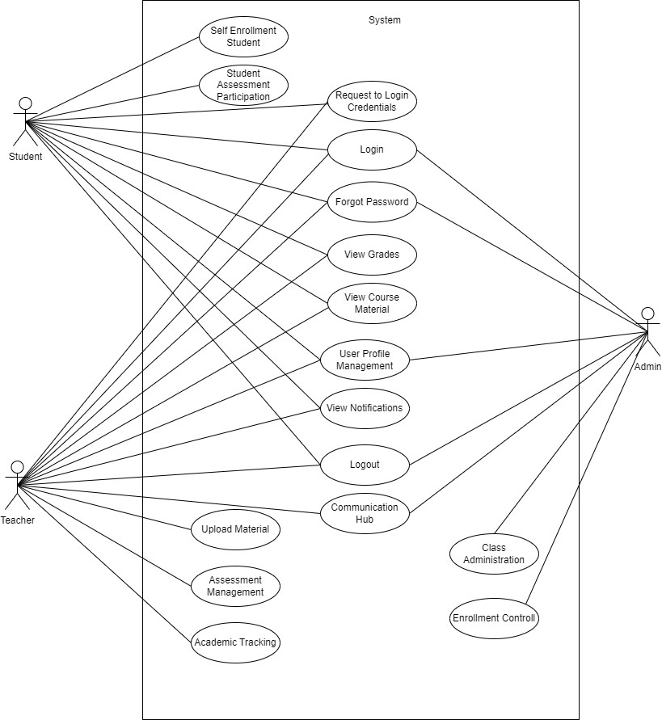

**Figure-4: User Case Diagram for Class Management System**

### **User Case Description**

### **Case Description-01: Request Login Credential**

|  |  |  |
| --- | --- | --- |
| **Use Case** | **Request Login Credential** | |
| **Goal** | Users (typically teachers or students) can request login credentials (username and password) from the adminTop of Form**.** | |
| **Preconditions** | Users must be registered in the system. | |
| **Success End Condition** | Login Credentials Sent Successfully. | |
| **Failed End Condition** | Failed to Send Login Credentials | |
| **Primary Actors:**  **Secondary Actors:** | Users (Teachers, Students)  Admin | |
| **Trigger** | The user requests login credentials from the admin. | |
| **Description / Main Success Scenario** | **Step** | **Action** |
| 1 | User contacts the admin to request login credentials. |
| 2 | User-provided authentication ID |
| 3 | Admin verifies the user's identity using an authentication ID provided by the institution. |
| 4 | Admin generates new login credentials (username and password) for the user. |
| 5 | Admin sends the login credentials to the user. |
| 6 | Notification: "Login Credentials Sent Successfully" |
| **Alternative Flows** | |  |  | | --- | --- | | 1 | **Invalid Authentication ID:** | |  | 1.1 Admin requests additional verification or denies the request. | | 2.1 | **Failed to Send Email:** | |  | 2.1 Admin notifies the user about the issue and may attempt to resend the email. | | |
| **Quality Requirements** | Admin responds to login credential requests within 24 hours. | |

### Case Description-02: Login

|  |  |
| --- | --- |
| Use Case | Login |
| Goal | Users can access the system by logging in. |
| Precondition | Users must be registered. |
| Success End Condition | Login Successful |
| Failed End Condition | Login Failed |
| Primary Actors:  Secondary Actors: | Student, Teacher |
| Trigger | The user requests login to enter the system |
| Description / Main  Success  Scenario | |  |  | | --- | --- | | 1. | User selects the "Login" option. | | 2. | System presents the login interface. | | 3. | User enters their user ID and password. | | 4. | User clicks the "Login" button. | | 5. | System verifies the credentials and logs in the user. | | 6. | Notification: "Login Successful" | |
| Alternative Flows | |  |  | | --- | --- | | 1.1 | System Error | |  | 1.1.a. User retries login. | | 2.1 | Server not found | |  | 2.1.a. User retries login later. | | 3.1 | System Did not respond | |  | 3.1.a. System displays an error message. | | 4.1 | Information Error | |  | 4.1.a. Notification: "Enter the right User ID and Password." | |
| Quality Requirements | Users can complete the login process within 10 seconds. |

### Case Description-03: Forgot Password

|  |  |
| --- | --- |
| Use Case | Forgot Password |
| Goal | Users who forget their passwords can reset them through a secure process. |
| Precondition | User must have a registered account in the system |
| Success End Condition | Notification: "Password Reset Successful" |
| Failed End Condition | Notification: "Failed to Reset Password" |
| Primary Actors:  Secondary Actors: | Teacher, Student. |
| Trigger | User initiates the forgot password process. |
| Description / Main  Success  Scenario | |  |  | | --- | --- | | 1. | User selects the "Forgot Password" option on the login page. | | 2. | System prompts the user to enter their email address associated with their account. | | 3. | User enters their email address and submits the request. | | 4. | System verifies the email address and sends a password reset link to the user's email. | | 5. | User receives the email and clicks on the password reset link. | | 6. | System prompts the user to enter a new password. | | 7 | User enters a new password and confirms it. | | 8 | System updates the password in the database. | | 9 | Notification: "Password Reset Successful" | |
| Alternative Flows | |  |  | | --- | --- | | 1.1 | Invalid Email Address | |  | 1.1.a. System notifies the user that the email address is invalid and prompts them to enter a valid one. | | 2.1 | Email Not Received | |  | 2.1.a. User checks spam or junk folder. If not found, user requests a resend of the password reset email. | |
| Quality Requirements | Password reset process should be completed within 5 minutes. |

### Case Description-04: View Grades

|  |  |
| --- | --- |
| Use Case | View Grades |
| Goal | Students can view their grades for completed assessments. |
| Precondition | Student must be logged into the system. |
| Success End Condition | Notification: "Grades Displayed Successfully" |
| Failed End Condition | Notification: "Failed to Retrieve Grades" |
| Primary Actors:  Secondary Actors: | Students |
| Trigger | Student initiates the request to view grades |
| Description / Main  Success  Scenario | |  |  | | --- | --- | | 1. | Student selects the "View Grades" option from the menu. | | 2. | System retrieves and displays the student's grades for completed assessments. | | 3. | Student reviews the grades. | | 4. | Notification: "Grades Displayed Successfully" | |
| Alternative Flows | System notifies the student that there are no grades available to display. |
| Quality Requirements | Grades should be displayed to the student within 3 seconds of initiating the request. |

### Case Description-05: View Course Material.

|  |  |
| --- | --- |
| Use Case | View course Material |
| Goal | Users (students and teachers) can access course materials uploaded for their classes. |
| Precondition | User must be logged into the system. |
| Success End Condition | Course material is successfully accessed. |
| Failed End Condition | Unable to access course material. |
| Primary Actors:  Secondary Actors: | Student, Teacher |
| Trigger | User initiates the request to view course material |
| Description / Main  Success  Scenario | |  |  | | --- | --- | | 1. | User selects the "View Course Material" option from the menu. | | 2. | System verifies the user's credentials and grants access to the course material functionality. | | 3. | System displays the available course materials | | 4. | User selects the desired course. | | 5. | System displays the selected course material. | | 6. | User successfully views the course material. | |
| Alternative Flows | |  |  | | --- | --- | | 1.1 | No Course Material Available | | 2.1 | System Doesn't work. | |  | 2.1.a.Try Again Later! | | 3.1 | Server Down | |  | 4.1.a. Try again leter | |
| Quality Requirements | Course material retrieval and display should occur within 5 seconds of initiating the request. |

### Case Description-06: Enrollment Control

|  |  |
| --- | --- |
| Use Case | Enrollment Control |
| Goal | Users can register to sign in to the system. Admins can control student enrollment, including viewing enrollment status, enrolling new students, and removing enrolled students. |
| Precondition | Admin must be logged into the system. |
| Success End Condition | Enrollment is successfully managed. |
| Failed End Condition | Unable to manage enrollment. |
| Primary Actors:  Secondary Actors: | Admin |
| Trigger | Admin initiates the request to manage enrollment |
| Description / Main  Success  Scenario | |  |  | | --- | --- | | 1. | Admin selects the "Enrollment Control" option from the menu. | | 2. | System verifies the admin's credentials and grants access to the enrollment control functionality. | | 3. | displays information about enrolled students and available slots in classes. | | 4. | Admin selects the desired action (e.g., enroll new students, remove enrolled students). | | 5. | System performs the selected action (e.g., enrolls new students, removes enrolled students) and updates the enrollment status accordingly. | | 6. | Notification: "Enrollment Control Successful" | |
| Alternative Flows | |  |  | | --- | --- | | 1.1 | System Error | |  | 1.1.a. Try Again!! | | 2.1 | System Doesn't work. | |  | 2.1.a.Try Again Later! | | 3.1 | . No Enrollment Information Available | |  | 31.a. "Retry" | | 4.1 | Enroll New Students Error | |  | 4.1.a. "Retry Enrollment" | | 5.1 | Class Capacity Exceeded | |  | 5.1.a. "Adjust Capacity" | |
| Quality Requirements | Enrollment control actions should be completed within 10 seconds of initiating the request. |

### Case Description-07: Assessment Management

|  |  |
| --- | --- |
| Use Case | Assessment Management |
| Goal | Teachers can manage assessments for their classes. |
| Precondition | The user must be logged in as a teacher. |
| Success End Condition | The assessment management task is completed successfully. |
| Failed End Condition | The assessment management task is unsuccessful. |
| Primary Actors:  Secondary Actors: | Teacher |
| Trigger | The teacher initiates the assessment management process. |
| Description / Main  Success  Scenario | |  |  | | --- | --- | | 1. | Teacher selects "Assessment Management" option. | | 2. | System presents options: create, edit, or review assessments. | | 3. | Teacher creates assessment with details. | | 4. | System validates and adds assessment. | | 5. | Teacher edits assessment details if needed. | | 6. | System updates assessment. | | 7 | Teacher reviews assessment details. | | 8 | Teacher reviews assessment details. | |
| Alternative Flows | |  |  | | --- | --- | | 1.1 | System Error | |  | 1.1.a. Try Again!! | | 2.1 | System Doesn't work. | |  | 2.1.a.Try Again Later! | | 3.1 | Teacher cancels operation: | |  | 3.1.a. System returns to main menu without changes | | 4.1 | Assessment ID does not match: | |  | 4.1.a. Prompt teacher to enter correct ID. | |
| Quality Requirements | Usability: Intuitive interface for easy assessment management.  Reliability: System should handle tasks accurately and gracefully handle errors. |

### Case Description-08: Class Administration

|  |  |
| --- | --- |
| Use Case | Registration |
| Goal | Admins can administer classes. |
| Precondition | The user must be logged in as an admin or teacher. |
| Success End Condition | The class administration task is completed successfully. |
| Failed End Condition | The class administration task is unsuccessful. |
| Primary Actors:  Secondary Actors: | Admin |
| Trigger | The user initiates the class administration process. |
| Description / Main  Success  Scenario | |  |  | | --- | --- | | 1. | User selects "Class Administration." | | 2. | System presents options: validate class info, set capacity, assign teacher, add/update/remove class. | | 3. | User validates class information. | | 4. | System validates information. | | 5. | User sets class capacity. | | 6. | System updates class capacity. | | 7 | User assigns teacher to class. | | 8 | System updates class with assigned teacher. | | 9 | User adds, updates, or removes class. | | 10 | System completes class administration task. | |
| Alternative Flows | |  |  | | --- | --- | | 1.1 | If errors occur: | |  | 1.1.a. System displays error messages. | | 2.1 | user cancels: | |  | 2.1.a. System returns to main menu. | | 3.1 | system unresponsive: | |  | 3.1.a. Prompt user to retry later. | | 4.1 | server error | |  | 4.1.a. • Prompt user to retry later. | |
| Quality Requirements | Usability: Intuitive interface for easy class administration.  Reliability: System should handle tasks accurately and gracefully handle errors. |

### Case Description-09: Communication Hub

|  |  |
| --- | --- |
| Use Case | Communication Hub |
| Goal | Admins and teachers can manage communication by sending notifications. |
| Precondition | The user must be logged in as an admin or teacher. |
| Success End Condition | The communication task is completed successfully. |
| Failed End Condition | The communication task is unsuccessful. |
| Primary Actors:  Secondary Actors: | Admin, Teacher |
| Trigger | The user initiates the communication management process. |
| Description / Main  Success  Scenario | |  |  | | --- | --- | | 1. | User selects "Communication Hub." | | 2. | System presents options: send notification, receive notification, track history. | | 3. | User sends notification with customized content. | | 4. | System sends notification. | | 5. | User receives notification. | | 6. | System tracks notification history. | | 7 | Communication task is completed successfully. | |
| Alternative Flows | |  |  | | --- | --- | | 1.1 | System Error | |  | 1.1.a. Try Again!! | | 2.1 | user cancelation: | |  | 2.1.a. System returns to main menu. | | 3.1 | server error: | |  | 3.1.a. Prompt user to retry later”. | | 4.1 | The system did not respond | |  | 4.1.a. Show Error Message. | |
| Quality Requirements | Usability: Intuitive interface for easy communication management.  Reliability: System should handle tasks accurately and gracefully handle errors. |

### Case Description-10: Academic Tracking

|  |  |
| --- | --- |
| Use Case | Academic Tracking |
| Goal | Teachers can track academic progress by managing attendance, entering records, and calculating grades for students. |
| Precondition | The user must be logged in as a teacher. |
| Success End Condition | The academic tracking task is completed successfully. |
| Failed End Condition | The academic tracking task is unsuccessful. |
| Primary Actors:  Secondary Actors: | Teacher |
| Trigger | The teacher initiates the academic tracking process. |
| Description / Main  Success  Scenario | |  |  | | --- | --- | | 1. | Teacher selects "Academic Tracking." | | 2. | System presents options: manage attendance, enter records, calculate grades. | | 3. | Teacher manages attendance for a class session. | | 4. | System updates attendance records. | | 5. | Teacher enters academic records (e.g., assignments, quiz scores). | | 6. | System updates academic records. | | 7 | Teacher calculates grades for assessments. | | 8 | System updates gradebook. | | 9 | Academic tracking task is completed successfully. | |
| Alternative Flows | |  |  | | --- | --- | | 1.1 | System Error | |  | 1.1.a. Try Again!! | | 2.1 | System Doesn't work. | |  | 2.1.a.Try Again Later! | | 4.1 | The user Did not fill up the details! | |  | 4.1.a. Checked By the system & Notify by “Please! Fill Up the Box”. | | 5.1 | The system Doesn’t save the details. | |  | 5.1.a. Notification: “Details did not Save” | |
| Quality Requirements | Usability: Intuitive interface for easy academic tracking.  Reliability: System should handle tasks accurately and gracefully handle errors. |

### Case Description-11: User profile Management

|  |  |
| --- | --- |
| Use Case | User profile Management |
| Goal | Users can manage their profiles |
| Precondition | The user must be logged into their account. |
| Success End Condition | The user's profile is updated successfully. |
| Failed End Condition | The profile update is unsuccessful. |
| Primary Actors:  Secondary Actors: | Teacher, Student |
| Trigger | The user initiates the profile management process. |
| Description / Main  Success  Scenario | |  |  | | --- | --- | | 1. | User selects "User Profile Management." | | 2. | System presents options: change password, update contact information, upload profile picture. | | 3. | User selects to change password. | | 4. | User enters new password and confirms. | | 5. | System updates password. | | 6. | User selects to update contact information. | | 7 | User enters new contact information. | | 8 | System updates contact information. | | 9 | User selects to upload profile picture. | | 10 | User uploads picture. | | 11 | System updates profile picture. | | 12 | Profile management task is completed successfully. | |
| Alternative Flows | |  |  | | --- | --- | | 1.1 | System Error | |  | 1.1.a. Try Again!! | | 2.1 | System Doesn't work. | |  | 2.1.a.Try Again Later! | | 3.1 | user cancels operation: | |  | 3.1.a. System returns to main menu. | | 4.1 | The system did not respond | |  | 4.1.a. Show Error Message. | | 5.1 | The system Doesn’t save the details. | |  | 5.1.a. Notification: “Details did not Save” | |
| Quality Requirements | Usability: Intuitive interface for easy profile management.  Reliability: System should handle profile updates accurately and securely. |

### Case Description-12: Upload Material

|  |  |
| --- | --- |
| Use Case | Upload Material |
| Goal | Teachers can upload course materials, organize them by class, add descriptions, and review upload history. |
| Precondition | The user must be logged in as a teacher. |
| Success End Condition | The course material is successfully uploaded and organized. |
| Failed End Condition | The upload or organization of course material is unsuccessful. |
| Primary Actors:  Secondary Actors: | Teacher |
| Trigger | The teacher initiates the material upload and organization process. |
| Description / Main  Success  Scenario | |  |  | | --- | --- | | 1. | Teacher selects "Material Repository." | | 2. | System presents options: upload course material, organize material, view upload history. | | 3. | Teacher selects to upload course material. | | 4. | Teacher selects the class for which the material is intended. | | 5. | Teacher uploads the material and adds a description. | | 6. | System organizes the material by class. | | 7 | Teacher reviews the upload history to confirm successful upload. | | 8 | Material repository task is completed successfully. | |
| Alternative Flows | |  |  | | --- | --- | | 1.1 | System Error | |  | 1.1.a. Try Again!! | | 2.1 | System Doesn't work. | |  | 2.1.a.Try Again Later! | | 3.1 | teacher cancels operation: | |  | 3.1.a. System returns to main menu. | | 4.1 | If server error: | |  | 4.1.a Prompt teacher to retry later. | | 5.1 | The system Doesn’t save the details. | |  | 5.1.a. Notification: “Details did not Save” | |
| Quality Requirements | Usability: Intuitive interface for easy material upload and organization.  Reliability: System should handle uploads accurately and securely. |

### Case Description-13: Self-Enrollment Student

|  |  |
| --- | --- |
| Use Case | Self-Enrollment Student |
| Goal | Students can enroll themselves into classes. |
| Precondition | The student must be logged into their account. |
| Success End Condition | The student successfully enrolls in the desired class. |
| Failed End Condition | The student's enrollment process is unsuccessful. |
| Primary Actors:  Secondary Actors: | Student |
| Trigger | The student initiates the self-enrollment process. |
| Description / Main  Success  Scenario | |  |  | | --- | --- | | 1. | Student selects "Self-Enrollment." | | 2. | System presents available classes for enrollment. | | 3. | Student browses and selects desired class. | | 4. | Student confirms enrollment. | | 5. | System updates enrollment status. | | 6. | Student receives confirmation of successful enrollment. | | 7 | Self-enrollment process is completed successfully. | |
| Alternative Flows | |  |  | | --- | --- | | 1.1 | System Error | |  | 1.1.a. Try Again!! | | 2.1 | class capacity is full: | |  | 2.1.a System notifies student and enrollment is not processed. | | 3.1 | student cancels operation: | |  | 3.1.a System returns to main menu. | | 5.1 | The system did not respond | |  | 5.1.a. Show Error Message. | | 6.1 | The system Doesn’t save the details. | |  | 6.1.a. Notification: “Details did not Save” | |
| Quality Requirements | Usability: Intuitive interface for easy self-enrollment.  Reliability: System should handle enrollment accurately and securely. |

### Case Description-14: Student Assessment Participation

|  |  |
| --- | --- |
| Use Case | Student Assessment Participation |
| Goal | Students can participate in assessments, such as quizzes, assignments, presentations, midterms, and final exams. |
| Precondition | The student must be logged into their account. |
| Success End Condition | The student successfully completes the assessment. |
| Failed End Condition | The student's participation in the assessment is unsuccessful. |
| Primary Actors:  Secondary Actors: | Student |
| Trigger | The student initiates participation in the assessment. |
| Description / Main  Success  Scenario | |  |  | | --- | --- | | 1. | Student selects the assessment they want to participate in. | | 2. | System presents the assessment details | | 3. | Student completes the assessment within the given timeframe. | | 4. | Student submits the assessment. | | 5. | System records the student's participation and updates assessment results. | | 6. | Student receives confirmation of successful participation. | |
| Alternative Flows | |  |  | | --- | --- | | 1.1 | System Error | |  | 1.1.a. Try Again!! | | 2.1 | If student cancels participation: | |  | 2.1.a System returns to the assessment selection. | | 3.1 | assessment submission fails: | |  | 3.1.a System prompts student to retry submission. | | 4.1 | The system did not respond | |  | 4.1.a. Show Error Message. | | 5.1 | The system Doesn’t save the details. | |  | 5.1.a. Notification: “Details did not Save” | |
| Quality Requirements | Usability: Intuitive interface for easy assessment participation.  Reliability: System should accurately record student participation and assessment results. |

### Case Description-15: View Notifications

|  |  |
| --- | --- |
| Use Case | View Notifications |
| Goal | Users (both teachers and students) can view notifications |
| Precondition | User must be logged into the system. |
| Success End Condition | User successfully views notifications. |
| Failed End Condition |  |
| Primary Actors:  Secondary Actors: | Teacher, Student |
| Trigger | User selects the option to view notifications. |
| Description / Main  Success  Scenario | |  |  | | --- | --- | | 1. | User navigates to the "View Notifications" option in the system. | | 2. | System retrieves and displays a list of notifications. | | 3. | User reads the notifications. | | 4. | Notification list is displayed successfully. | |
| Alternative Flows | |  |  | | --- | --- | | 1.1 | If there are no notifications available: | |  | 1.1.a System displays a message indicating no notifications are available. | | 2.1 | System Doesn't work. | |  | 2.1.a.Try Again Later! | | 5.1 | The system did not respond | |  | 5.1.a. Show Error Message. | |
| Quality Requirements | Usability: Notification viewing should be user-friendly and easy to navigate.  Accessibility: Notifications should be accessible to both teachers and students. |

### Case Description-16: Logout

|  |  |
| --- | --- |
| Use Case | Logout |
| Goal | Users can securely end their session in the system. |
| Precondition | User must be logged into the system. |
| Success End Condition | User successfully logs out of the system. |
| Failed End Condition | None |
| Primary Actors:  Secondary Actors: | Students, Teachers, Admin |
| Trigger | User initiates the logout process. |
| Description / Main  Success  Scenario | |  |  | | --- | --- | | 1. | User navigates to the logout option in the system. | | 2. | User confirms their intention to logout. | | 3. | System securely ends the user's session. | | 4. | Notification: "Logout Successful" is displayed. | |
| Alternative Flows | |  |  | | --- | --- | | 1.1 | If user cancels logout: | |  | System returns to the previous state. | |
| Quality Requirements | Usability: Logout option should be easily accessible and intuitive.  Security: User's session should be securely ended to prevent unauthorized access. |

**Activity Diagram**

**Activity Diagram-1: User Profile Management**

**Activity Diagram-2:** **Self Enrollment Student**

**Activity Diagram-3: View Grades**

**Activity Diagram-4: Student Assessment Participation**

**Activity Diagram-5:** **View Course Material**

**Activity Diagram-6: View Notifications**

**Activity Diagram-7:** **Assessment Management**

**Activity Diagram-8: Upload Material**

**Activity Diagram-9: Academic Tracking**

**Activity Diagram-10: Communication Hub**

**Activity Diagram-11: Class Administration**

**Activity Diagram-12: Enrollment Controll**

**Sequence Diagram**

**Sequence Diagram 1:** **User Profile Management**

**Sequence Diagram 2:** **Self-Enrollment Student**

**Sequence Diagram 3:** **View grades**

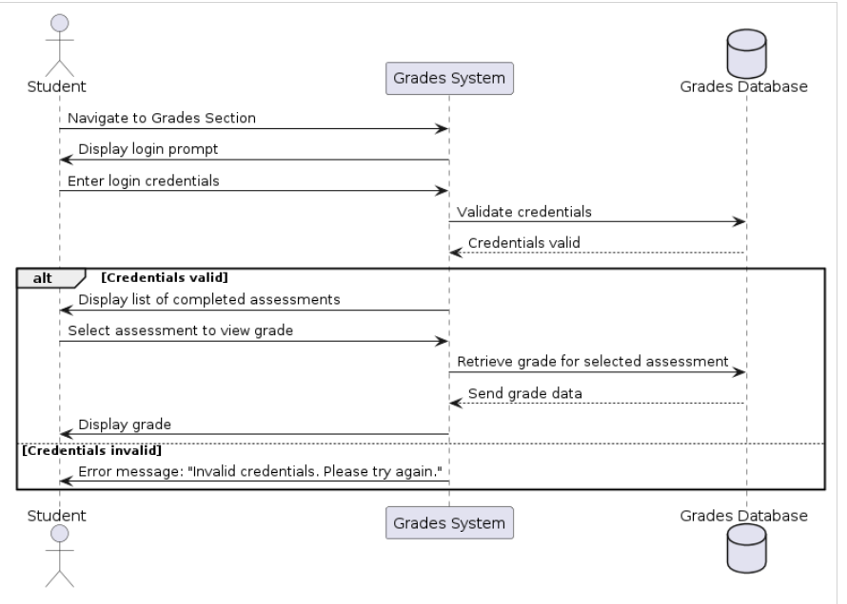

**Sequence Diagram 4:** **Student Asssessment Participation**

**Sequence Diagram 5:** **View Course Materials**

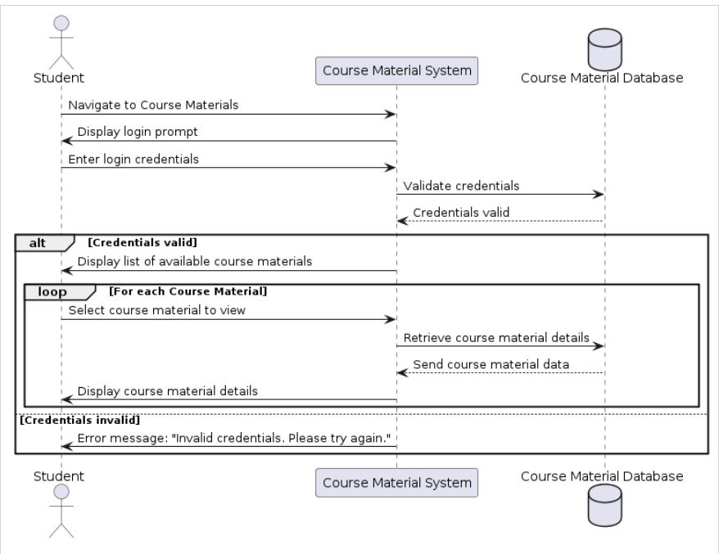

**Sequence Diagram 6:** **View Notifications**

**Sequence Diagram 7:** **Assessment Management**

**Sequence Diagram 8: Upload Material**

**Sequence Diagram 9: Academic Tracking**

**Sequence Diagram 9: Academic Tracking**

**Sequence Diagram 10: Communication Hub**

**Sequence Diagram 11: Class Administration**

**Sequence Diagram 12:** **Enrollment Controll**

**Class Diagram**

**E R Diagram**

