**PUNE VIDYARTHI GRIHA’S**

**COLLEGE OF ENGINEERING AND TECHNOLOGY**



**T.E. MINI PROJECT ON**

**“INTENSITY CONTROL OF STREET LIGHTS FOR POWER SAVING.”**

**(ELECTRONICS AND TELECOMMUNICATION)**

**UNDER THE GUIDANCE OF**

**PROF. Y.B.THAKARE**

**PROF.N.P.DESHPANDE**

**SUBMITTED BY**

**ASMITA THAKARE Exam no: T120073140**

**PRANAV SHAH Exam no: T120073119**

**ACADEMIC YEAR: 2014-15**

**DEPARTMENT OF ELECTRONICS AND TELECOMMUNICATION**

**PVG’S COET**

**PUNE VIDYARTHI GRIHA’S**

**COLLEGE OF ENGINEERING AND TECHNOLOGY**

**CERTIFICATE**

THIS IS TO CERTIFY THAT

**NAME ROLL NO EXAM SEAT NO.**

**1. ASMITA THAKARE 38 T120073140**

**2. PRANAV SHAH 19 T120073119**

**“INTENSITY CONTROL OF STREET LIGHTS FOR POWER SAVING.”**

FOR TE E&TC (2012) COURSE Academic year (2014-2015) as Prescribed in the syllabus of

**UNIVERSITY OF PUNE.**

Prof. N.P.DESHPANDE Prof. Y.B.THAKARE HOD

**ACKNOWLEDGEMENT**

We take this opportunity to express our heartfelt gratitude towards our Senior Lecturer, Prof. N.P.Deshpande and Prof. Y.B.Thakare whose skillfull guidance helped us in materializing our ideas. We would also like to thank Head of Department, Prof.P.G.Shete and other staff members for their valuable guidance and support at every stage of work. An enormous share of gratitude to the teaching and non-teaching staff of our Department for extending their help, support and guidance whenever required. Lastly, a thank you to all our fellow classmates and seniors for rending their help.

Submitted by:

ASMITA THAKARE T120073140

PRANAV SHAH T120073119

/

**INDEX**

1. **Introduction…………………………………………………………………………..( 5 )**
2. **Block Diagram ………………….……………………………………………………( 7 )**
3. **Specifications and Methodology ……………………………………………………( 8 )**
4. **Circuit diagram and Description……………………………………………………( 9 )**
5. **PCB layout…………………………………………………………………………...( 17 )**
6. **PWM concept………………………………………………………………………...( 18 )**
7. **Bill of Materials……………………………………………………………………...( 20 )**
8. **Conclusion and future scope…………………..……………………………………( 21 )**
9. **References …………………………………………………………………………...( 21 )**

**INTRODUCTION:**

White Light Emitting Diodes (LED) replaces HID lamps in street lighting system to include dimming feature. A microcontroller of the PIC18F family is used to control the intensity by developing pulse width modulated signals that drives a MOSFET to switch the LEDs accordingly to achieve desired operation.

In the present system, mostly the lightning up of highways is done through High Intensity Discharge lamps (HID), whose energy consumption is high. Its intensity cannot be controlled according to the requirement, so there is a need to switch on to an alternative method of lightning system, i.e., to use LEDs. This system is built to overcome the present day drawbacks of HID lamps. This system demonstrates the usage of LEDs (light emitting diodes) as the light source and its variable intensity control, according to the requirement. LEDs consume less power and its life time is more, as compared to the conventional HID lamps. The most important and interesting feature is that its intensity can be controlled according to the requirement during non peak hours which is not feasible in HID lamps.

A cluster of LEDs are used to form a street light. The microcontroller contains programmable instructions which controls the intensity of lights based on the PWM (Pulse width modulation) signals generated.

INTENSITY CONTROL OF STREET LIGHTS USING VEHICLE DETECTION

This type is designed to detect vehicle movement on highways to save energy. This proposed system provides a solution for energy saving achieved by sensing an approaching vehicle, the lights remain on with only 25% of intensity when there no vehicle is detected. As a vehicle approaches, the block of street lights switch to 90% intensity, and then, as the vehicle passes by, the trailing lights revert back to 25% intensity again. High intensity discharge lamp (HID) presently used for urban street lighting are based on the principle of gas discharge wherein the light intensity which is not controllable by any voltage reduction. White light emitting diode (LED) based lamps are soon replacing the HID lamps in street light. Intensity control is also possible by pulse width modulation (PWM) generated by the microcontroller.

A sensor is used on side of the road that senses a vehicle movement and sends logic commands to the microcontroller to switch on/off the LEDs. Thus, this way of dynamically changing intensity helps in saving lot of energy.

**BLOCK DIAGRAM**

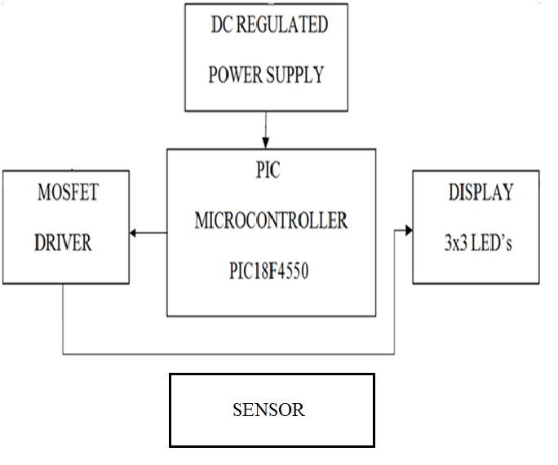

**SPECIFICATIONS**

* Estimated supply current : 350mA
* Controller: 25mA(sink and source)
* Power supply :+5V and +12V
* PIC18F series Microcontroller (8bit, 4Kb RAM and 2MB ROM).
* White LEDs(8mm thickness )

**METHODOLOGY:**

1. Paper work and feasibility.
2. Coding of the algorithm in C language to control light intensity as per required conditions
3. Simulation of the designed circuit using Multisim & Proteus.
4. Development of prototype.
5. PCB design using PCB design software and fabrication.
6. Mounting of components and testing.

**TYPE 1: DIMMING OF STREET LIGHTS**

**Circuit Diagram**



**DESCRIPTION**

A controller from PIC18F family is selected which provides pwm signals to the gate of the Mosfet and it acts as a switch which has sufficient frequency such that leds appear to be continuously on. Supply of 12 Volts is provided to the anode of the leds and their cathode is given to the Drain of the Mosfet. As per the code the duty cycle varies and thus the intensity of High brightness leds is controlled. PIC18F requires supply of 5 Volts with current sinking and sourcing capability of 25 mili-Ampere.The duty cycle of the pwm signal is varied using timers.

RESULT :

75% duty cycle

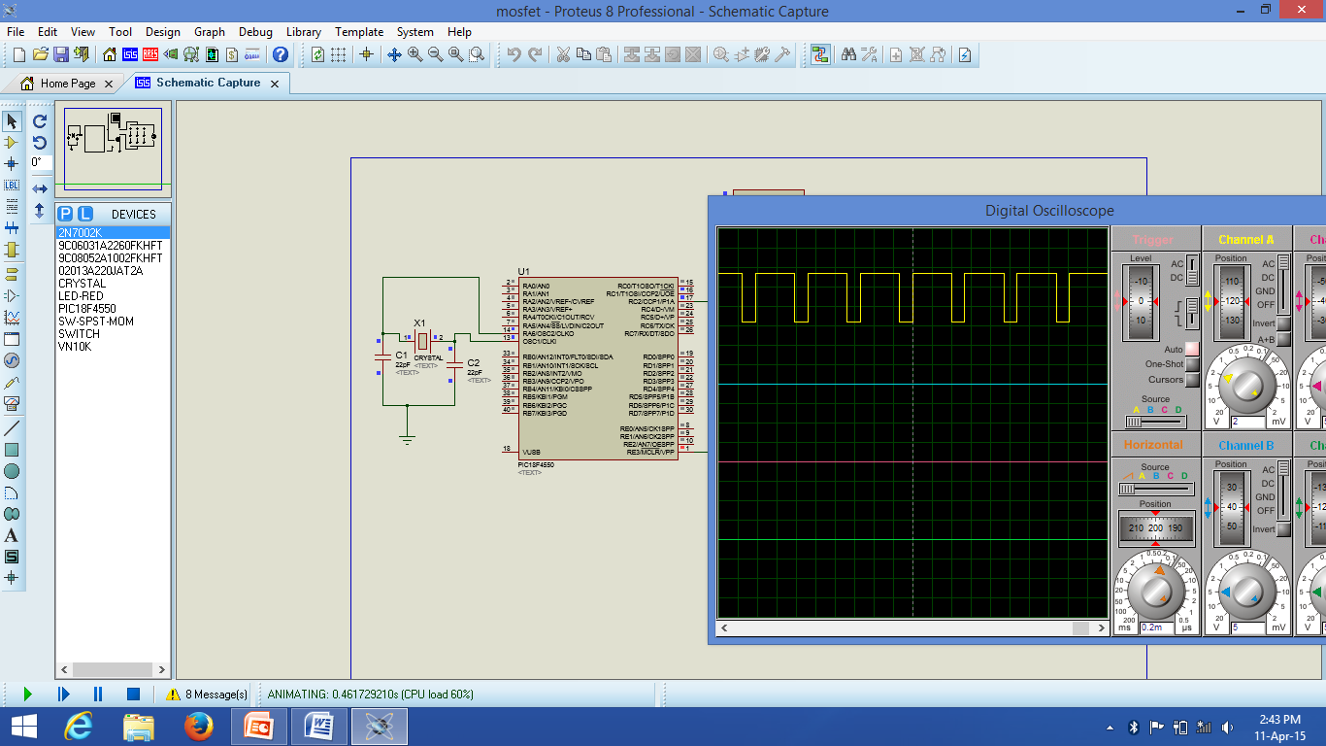

50% duty cycle

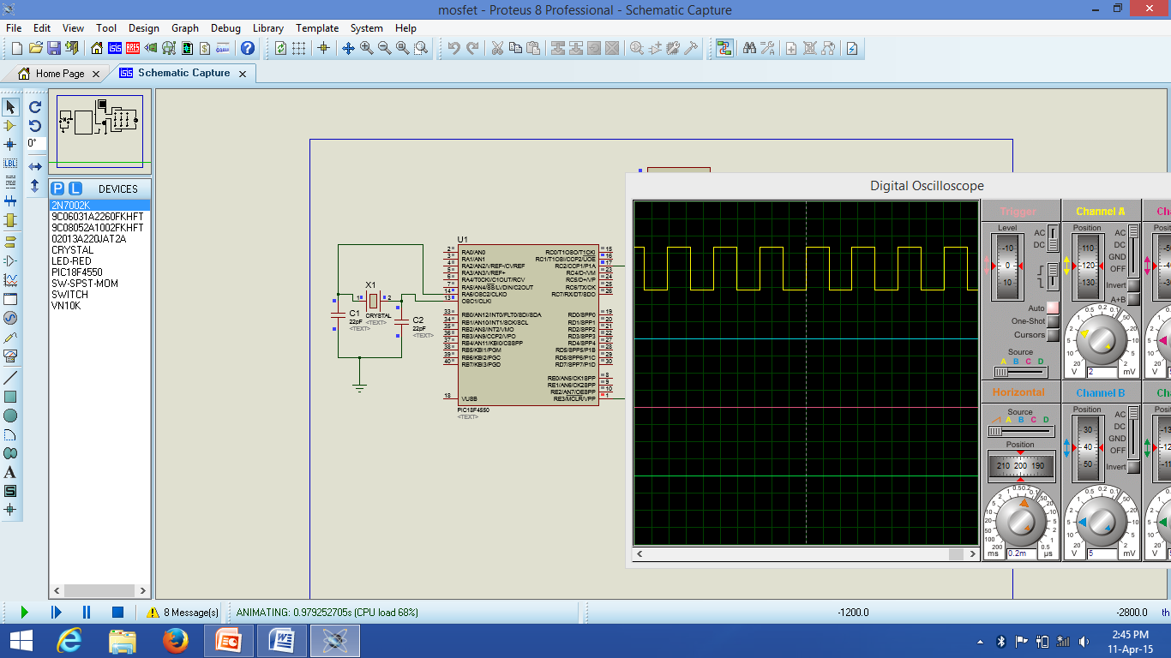

**ALGORITHM:**

1. Start
2. Configure the required pins as output.
3. Set PWM period using Pr2 register
4. Configure Timer 2 control register as per requirement.
5. Set the PWM duty cycle using proper configuration of CCPR1L register.
6. Provide sufficient delay.
7. End.

**FLOWCHART**

**TYPE 2: INTENSITY CONTROL OF STREET LIGHTS USING VEHICLE DETECTION**

**Circuit Diagram**

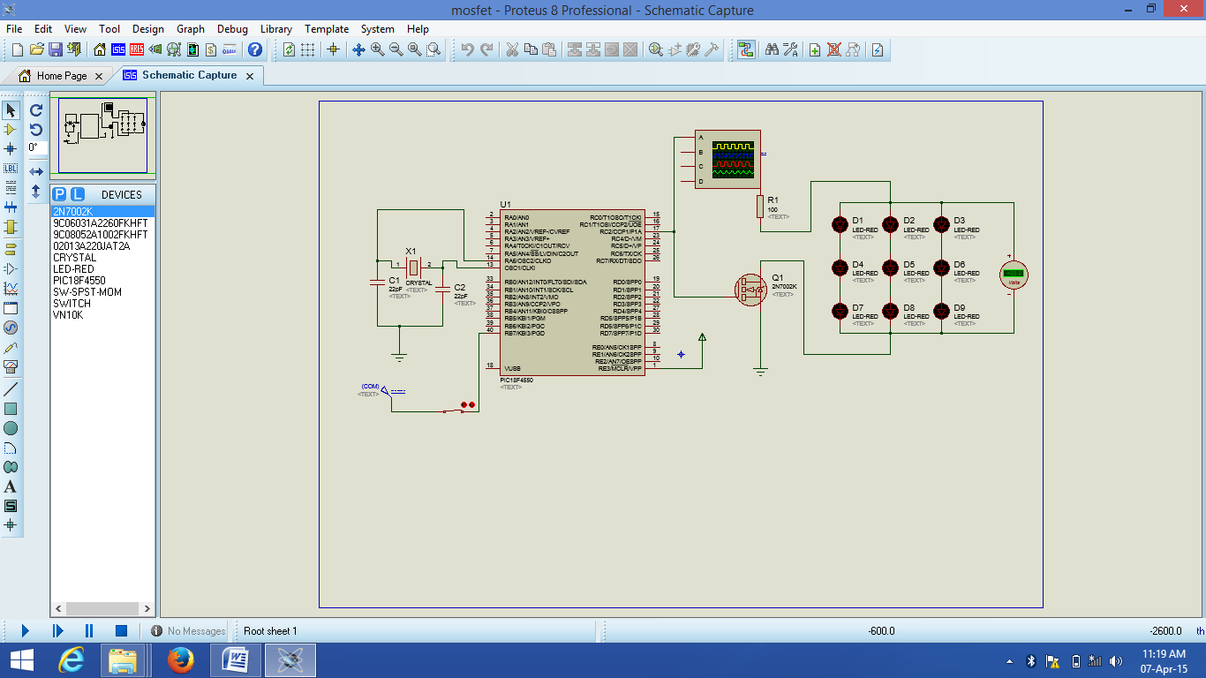

**DESCRIPTION:**

PIR sensor is used to detect crossing of Vehicles. As soon as the vehicle crosses the sensor, the intensity of leds is increased for few seconds till the vehicle crosses the light. Coding is done in such a way that when there is no vehicle detection the output of sensor is low and the intensity of leds is 25% of its full intensity and when vehicle is detected the output of sensor goes high and then intensity of leds goes upto 90% of its original value.

RESULT:

When input is HIGH

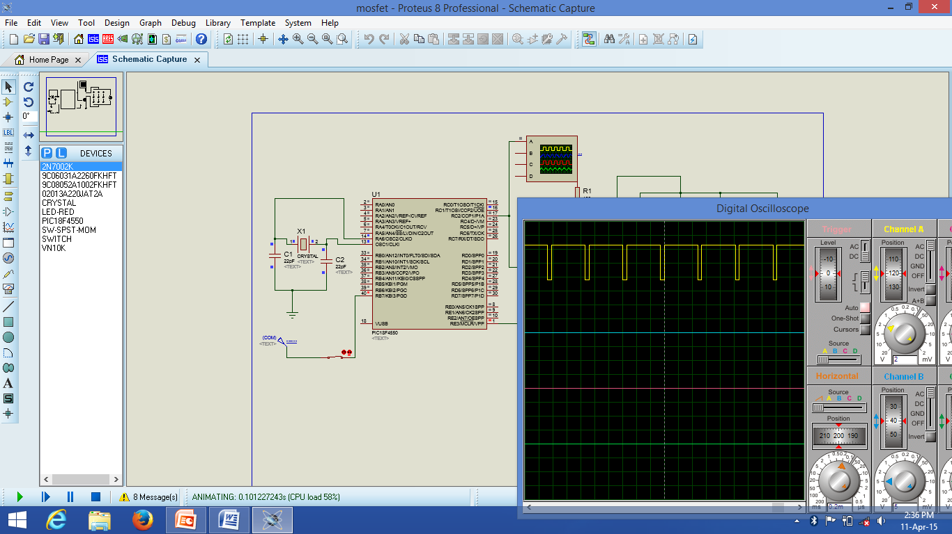

When input is LOW

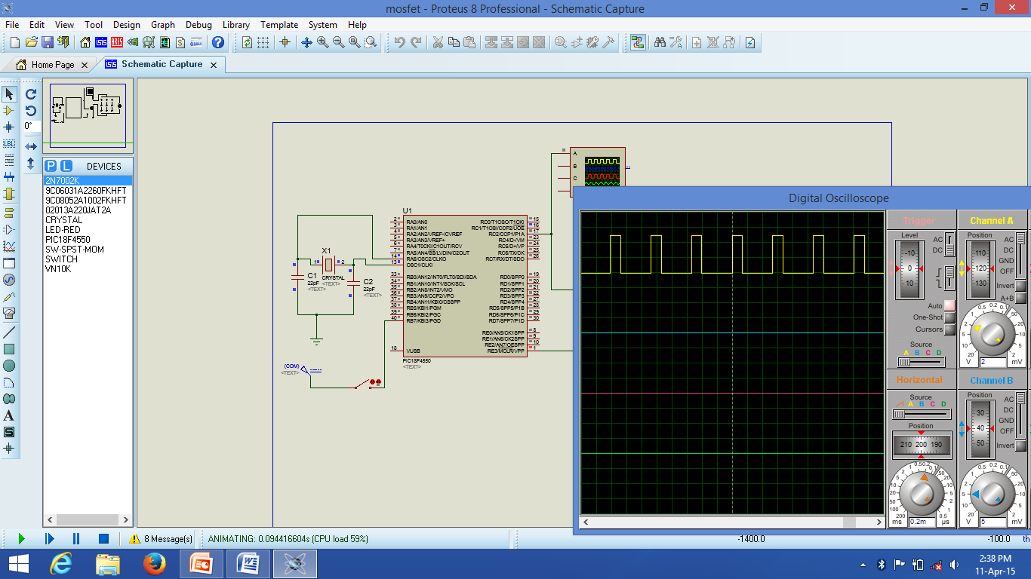

**ALGORITHM:**

1. Start
2. Configure the required pins as output
3. Set PWM period using PR2 register
4. Configure Timer 2 control register as per requirement
5. If input is high set duty cycle to 90% using CCPR1L register
6. Else set duty cycle to 25% is input is low
7. Go to step 5.

**FLOWCHART**

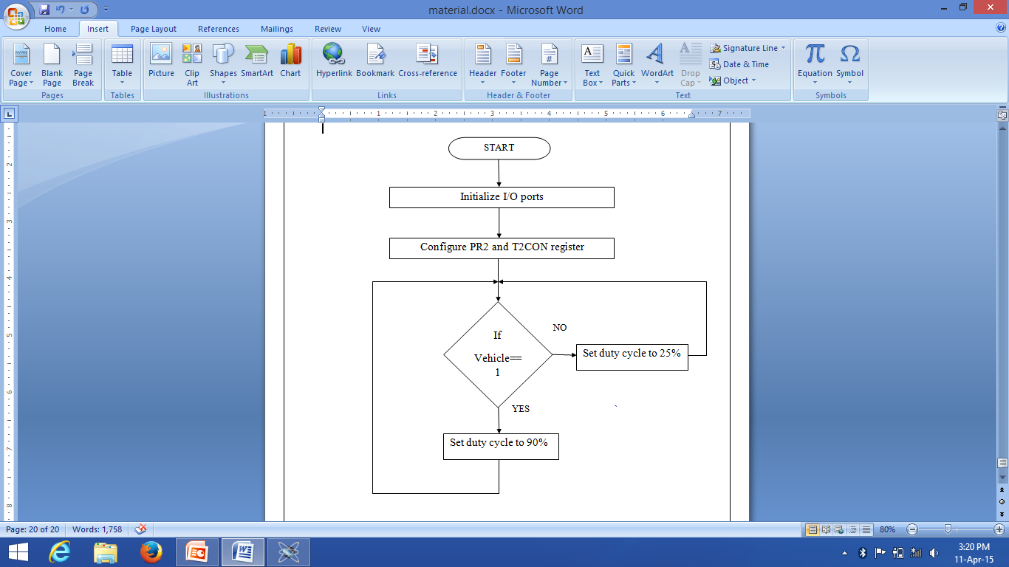

**PCB LAYOUTS**

**Main Layout.**

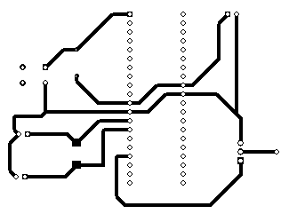

**Power supply**

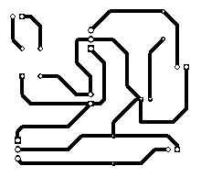

**PWM**

To control the brightness of an LED you can vary the power which is sent to the LED, for example using a potentiometer (variable resistor), the more power the LED receives the brighter it is, the less power it receives the dimmer it is. Microcontrollers are digital, meaning they only have two ‘power’ states, on and off. Although it is possible to supply a varying power from a microcontroller (using a Digital to Analogue Convertor (DAC)) this usually requires an additional chip. PWM provides the ability to ‘simulate’ varying levels of power by oscillating the output from the microcontroller.

If, over a short duration of time, we turn the LED on for 50% and off for 50%, the LED will appear half as bright since the total light output over the time duration is only half as much as 100% on. The important factor here is the ‘duration’, if we turn the light on and off too slowly the viewer will see the flashing of the LED not a constant light output which appears dimmer. The pulsing width (in this case 50%) is the important factor here. By varying (or ‘modulating’) the pulsing width we can effectively control the light output from the LED, hence the term PWM or Pulse Width Modulation.

[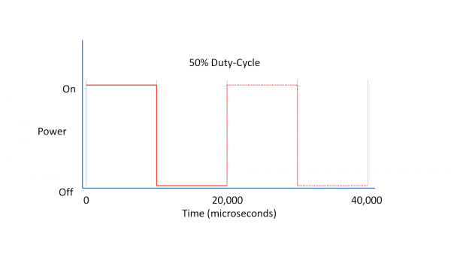](http://www.waitingforfriday.com/index.php/File:PWMSlide5.PNG)

When using PWM it’s important to consider how slowly we can ‘flash’ the LED so that the viewer does not perceive the oscillation. The eye’s inability to see rapid oscillations of light is caused by our ‘persistence of vision’ which means, in very simple terms, we see the light as on even after it has turned off. This technique is how televisions display a seemingly moving picture which is actually made up of a number of different still frames displayed one after the other very rapidly. The minimum speed of an LED oscillating which can be seen by the human eye varies from person to person. However, for the purposes of this article, we will use a minimum speed of 50Hz, or 50 times per second (the same speed as used by European televisions).

**Duty-Cycle**

When using PWM there are certain terms which you will come across again and again. The most important term is ‘duty-cycle’. The duty-cycle refers to the total amount of time a pulse is ‘on’ over the duration of the cycle, so at 50% brightness the duty-cycle of the LED is 50%. The ‘cycle’ itself is measured (usually) in Hertz which gives us the cycles-per-second. So at 50Hz our cycle is 1 second divided by 50 cycles, which is 0.02 seconds. Since we are using such small time measurements it’s more useful to use microseconds (there are 1,000,000 microseconds in a second), this gives us a cycle duration of 20,000 microseconds which is 50 cycles per second or 50Hz.

During the 20,000 microseconds we have to turn the LED either on or off depending on the required duty-cycle so, for example, a 75% duty-cycle requires the pulse to be on for 15,000 microseconds and then off for 5,000 microseconds.

[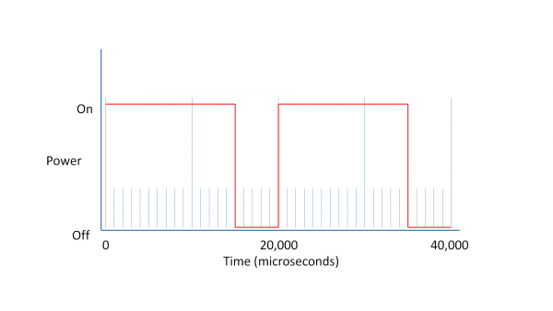](http://www.waitingforfriday.com/index.php/File:PWMSlide24.PNG)

**BILL OF MATERIALS.**

|  |  |  |  |  |
| --- | --- | --- | --- | --- |
| **SR.NO** | **NAME OF COMPONENT** | **QUANTITY** | **RATE per piece(₹)** | **TOTAL(₹)** |
| 1 | PIC 18F4550 | 1 | 250 | 250 |
| 2 | MOSFET IRF 540 | 2 | 30 | 60 |
| 3 | IC 7805 | 2 | 10 | 20 |
| 4 | IC 7812 | 2 | 10 | 20 |
| 5 | HB LED’s(1 Watt) | 9 | 6 | 54 |
| 6 | HB LED’s(0.5 Watt) | 9 | 4 | 36 |
| 7 | Transformer | 2 | 50 | 100 |
| 8 | Capacitor | 5 | 10 | 50 |
| 9 | Copper clad board | 1 | 110 | 110 |
| 10 | Etching Solution | 1 | 50 | 50 |
| 11 | Diode Bridge | 2 | 10 | 20 |
| 12 | Led | 5 | 2 | 10 |
| 13 | Wires | 20 | 4 | 80 |
| 14 | Soldering metal | 1 | 50 | 50 |
| 15 | Crystal | 2 | 15 | 30 |
| 16 | Switch | 2 | 5 | 10 |
| 17 | Enclosure | 2 | 100 | 200 |
| 18 | PIR sensor | 1 | 250 | 250 |

NET TOTAL Rs.1,355/-

**CONCLUSION and FUTURE SCOPE:**

This system is more efficient as compared to other lighting systems. Reduction in power as well as reduction in cost for maintenance is achieved.

In future this system can be made more automated using Real time clock instead of timer and the intensity can also be controlled depending on the density of the vehicles.

**REFERENCES.**

[1] Long, X.; Liao, R.; Zhou, J.;"Development of street lighting system-based novel high-brightness LED modules," Optoelectronics, IET , vol.3, no.1, pp.40-46, February 2009 doi: 10.1049/ietopt:20070076.

[2] Po-Yen Chen; Yi-Hua Liu; Yeu-Torng Yau; Hung-Chun Lee; , "Development of an energy efficient street light driving system," Sustainable Energy Technologies, 2008. ICSET 2008. IEEE International Conference on , vol., no., pp.761-764, 24-27 Nov. 2008 doi:10.1109/ICSET.2008.4747108.