Social Media Sentiment Analysis Report

Intern Name: Shah Pranjal Pankajkumar

Company: Brainwave Matrix Solutions

Project Title: Social Media Sentiment Dashboard

Toolset: Power BI | DAX | Python | VADER

Date: May 24, 2025

# Introduction

This report presents a comprehensive Power BI dashboard designed to analyze sentiment data from various social media platforms. The primary objective of the project is to visualize user sentiments—positive, neutral, and negative—across platforms, hashtags, and time periods. The analysis incorporates metrics such as likes, shares, sentiment counts, and trending hashtags, offering a detailed view of public opinion dynamics.

# Key Metrics Visualized

Total Likes: 141K

Total Shares: 58K

Total Hashtags Analyzed: 5

**VIZUALIZATION**: Cards Insights

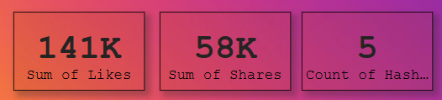

# Quarterly Sentiment Overview

The sentiment data is analyzed over the four quarters of 2024. The third quarter exhibits the highest volume of sentiment-related activity. A decline is observed in Quarter 4 across all sentiment categories. Visualizations show a clear trend where positive sentiment slightly outweighs others, with neutral and negative sentiments closely following.

**VIZUALIZATION:** Stacked Area Chart

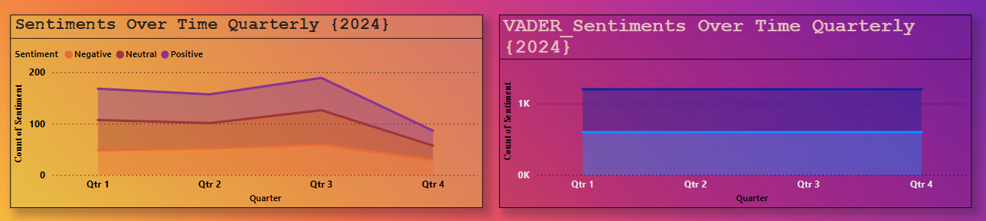

# Top Hashtag Sentiment Distribution

Popular hashtags such as #Python, #AI, #Data Science, and #Machine Learning were analyzed. All hashtags reflect a mix of sentiments, providing insights into how topics are perceived across social platforms.

# VADER Sentiment Analysis

**Positive Sentiment:** 482 posts

**Neutral Sentiment:** 118 posts

**Negative Sentiment:** Not classified in this version.

**Hashtag Performance:**

All five hashtags (e.g., #AI, #Python) show significantly more positive sentiment compared to neutral.

**VIZUALIZATION**: Stacked Bar Chart

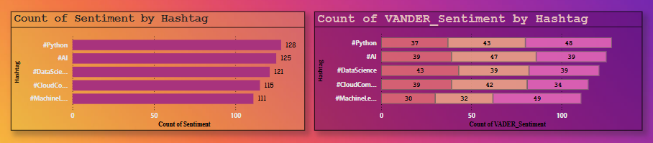

# Platform Sentiment Analysis

The dashboard includes a breakdown of sentiment counts by social media platforms (Instagram, Reedit, Twitter). Twitter emerged as the platform with the highest activity. The analysis allows platform-specific filtering for targeted insights.

**Instagram:** 27%

**Reddit:** 28%

**Twitter:** 26%

Positive sentiment dominates across all platforms, especially on Instagram and Reddit.

**VIZUALIZATION**: Pie Chart Insights

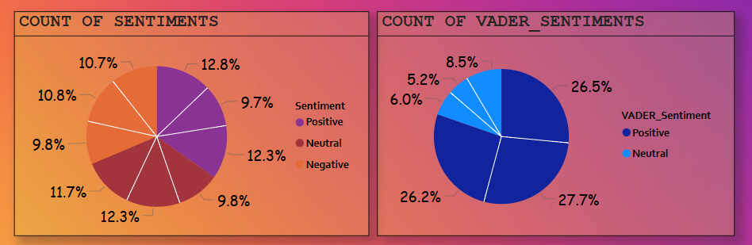Sentiment Distribution: Positive (34.8%), Neutral (33.8%), Negative (31.3%)

# Power BI Dashboard & Visualizations

Below are key snapshots from the interactive Power BI dashboard:

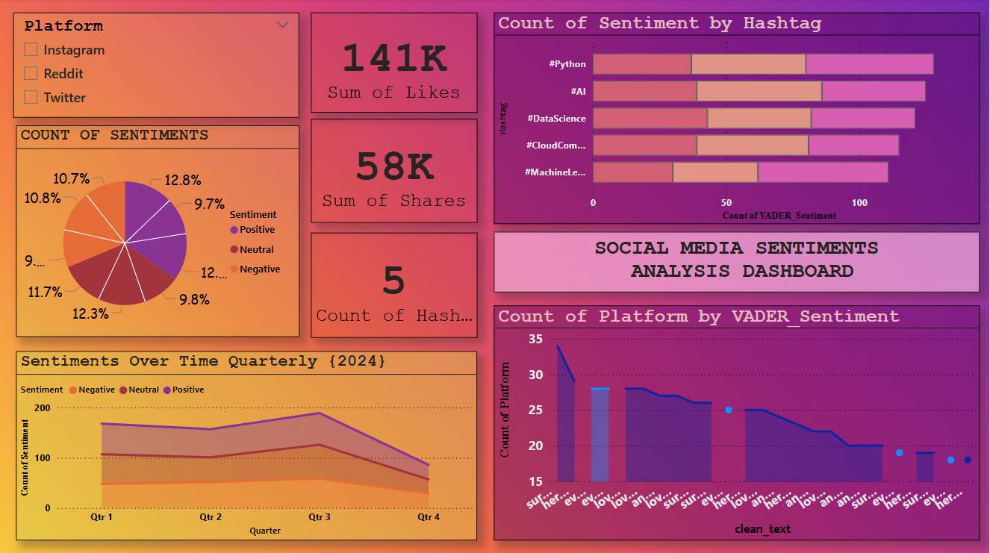

# Interactivity Features

- Platform filter (Instagram, Reddit, Twitter)

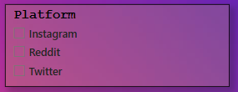

- Hashtag-based sentiment analysis

- Time-based sentiment trend

- VADER sentiment breakdown

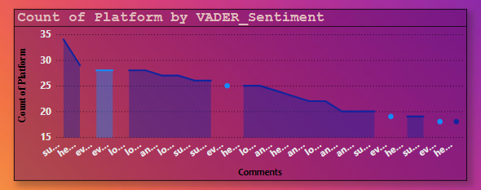

# Insights & Recommendations

- Positive sentiments slightly lead over neutral and negative sentiments.

- Quarter 3 of 2024 saw the highest sentiment activity.

- Sentiment trends can guide marketing efforts and content strategy.

- Hashtag-specific sentiment analysis can inform campaign effectiveness.

**Methodology**

**a. Data Preprocessing**

Lower-cased text

Removed punctuation, URLs, and emojis

Removed stopwords using NLTK

**b. Sentiment Classification**

Manual Labels: Based on a predefined column in the data-set

VADER Analysis: Used compound score to classify:  
  
Positive: ≥ 0.05

Neutral: Between -0.05 and 0.05

Negative: ≤ -0.05

**c. Visualization in Power BI**

1. KPIs: Total Likes, Shares

2. Bar Charts: Sentiment distribution, hashtag performance

3. Pie Charts: Platform-wise sentiment breakdown

4. Line Charts: Sentiment trend over time

# Tools Used

**Python (Pandas, VADER, NLTK)** – Data Cleaning and Sentiment Analysis

**Power BI** – Dashboard Development

**Google Collab** – Notebook Execution

**Microsoft Word** – Report Preparation

### ****Conclusion**** 1. Overall Sentiment is positive, but differs by analysis method: 2. VADER detects higher positivity than manual classification.

### 3. #Machine Learning and #Python are highly favored.

### 4. Platform-wise, Reedit and Instagram contribute the most to positive sentiment, while Twitter appears more neutral.

### 5. Spikes in engagement correlate with major dates or trends