**INTERNET OF THINGS**

2019

DCS

NITTE Meenakshi Institute of Technology

11/4/2019

Smart Vehicle Analysis

Centre of Excellence

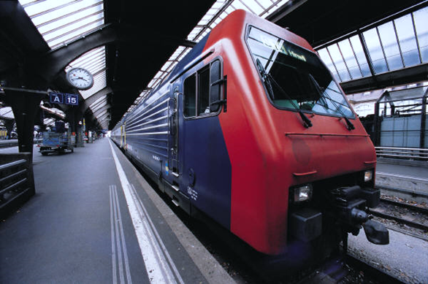

**Submitted by:**

1. **Prashant Shah**
2. **Mohammed Firaaz Farook**
3. **Ankit Prasad Gupta**
4. **Thathva Sri Sai Reddy**
5. **Smriti P Manay**
6. **Sreehari S**

**SMART VEHICLE ANALYSIS**

**INTRODUCTION**

Analysis on data is important to gather future insights and thus help in determining various facts about the data and develop algorithms to work on this data. The following analysis is on Smart Transport with its various factors like Speed, Time etc when taken into consideration provide some information through different visualizations.

**TOOLS USED**

* Python
* Python Libraries: Pandas, Matplotlib, Plotly, Cufflinks

**Pandas:**

Pandas is an open source, BSD-licensed library providing high-performance, easy-to-use data structures and data analysis tools for the Python programming language.

Pandas is a NumFOCUS sponsored project. This will help ensure the success of development of pandas as a world-class open-source project and makes it possible to donate to the project.

**Matplotlib:**

Matplotlib is a Python 2D plotting library which produces publication quality figures in a variety of hardcopy formats and interactive environments across platforms. Matplotlib can be used in Python scripts, the Python and IPython shells, the Jupyter notebook, web application servers, and four graphical user interface toolkits.

Matplotlib tries to make easy things easy and hard things possible. You can generate plots, histograms, power spectra, bar charts, error charts, scatterplots, etc., with just a few lines of code. For examples, see the sample plots and thumbnail gallery.

For simple plotting the pyplot module provides a MATLAB-like interface, particularly when combined with IPython. For the power user, you have full control of line styles, font properties, axes properties, etc, via an object-oriented interface or via a set of functions familiar to MATLAB users.

**Plotly:**

Plotly is a technical computing company headquartered in Montreal, Quebec, that develops online data analytics and visualization tools. Plotly provides online and offline graphing, analytics, and statistics tools for individuals and collaboration, as well as scientific graphing libraries for Python, R, MATLAB, Perl, Julia, Arduino, and REST.

Plotly at its core is a data visualization toolbox. Under every plotly graph is a JSON object, which is a dictionary like data structure. Simply by changing the values of some keywords in this object, we can get vastly different and ever more detailed plots.

**Cufflinks:**

Plotly is a Python library which is used to design graphs, especially interactive graphs. It can plot various graphs and charts like histogram, bar plot, boxplot, spread plot and many more. It is mainly used in data analysis as well as financial analysis. plotly is an interactive visualization library.

Cufflink connects plotly with pandas to create graphs and charts of dataframes directly. choropleth is used to describe geographical plotting of USA. choropleth is used in the plotting of world maps and many more.

The following shows the data that is analysed on. It contains different columns and analysis is done on this.

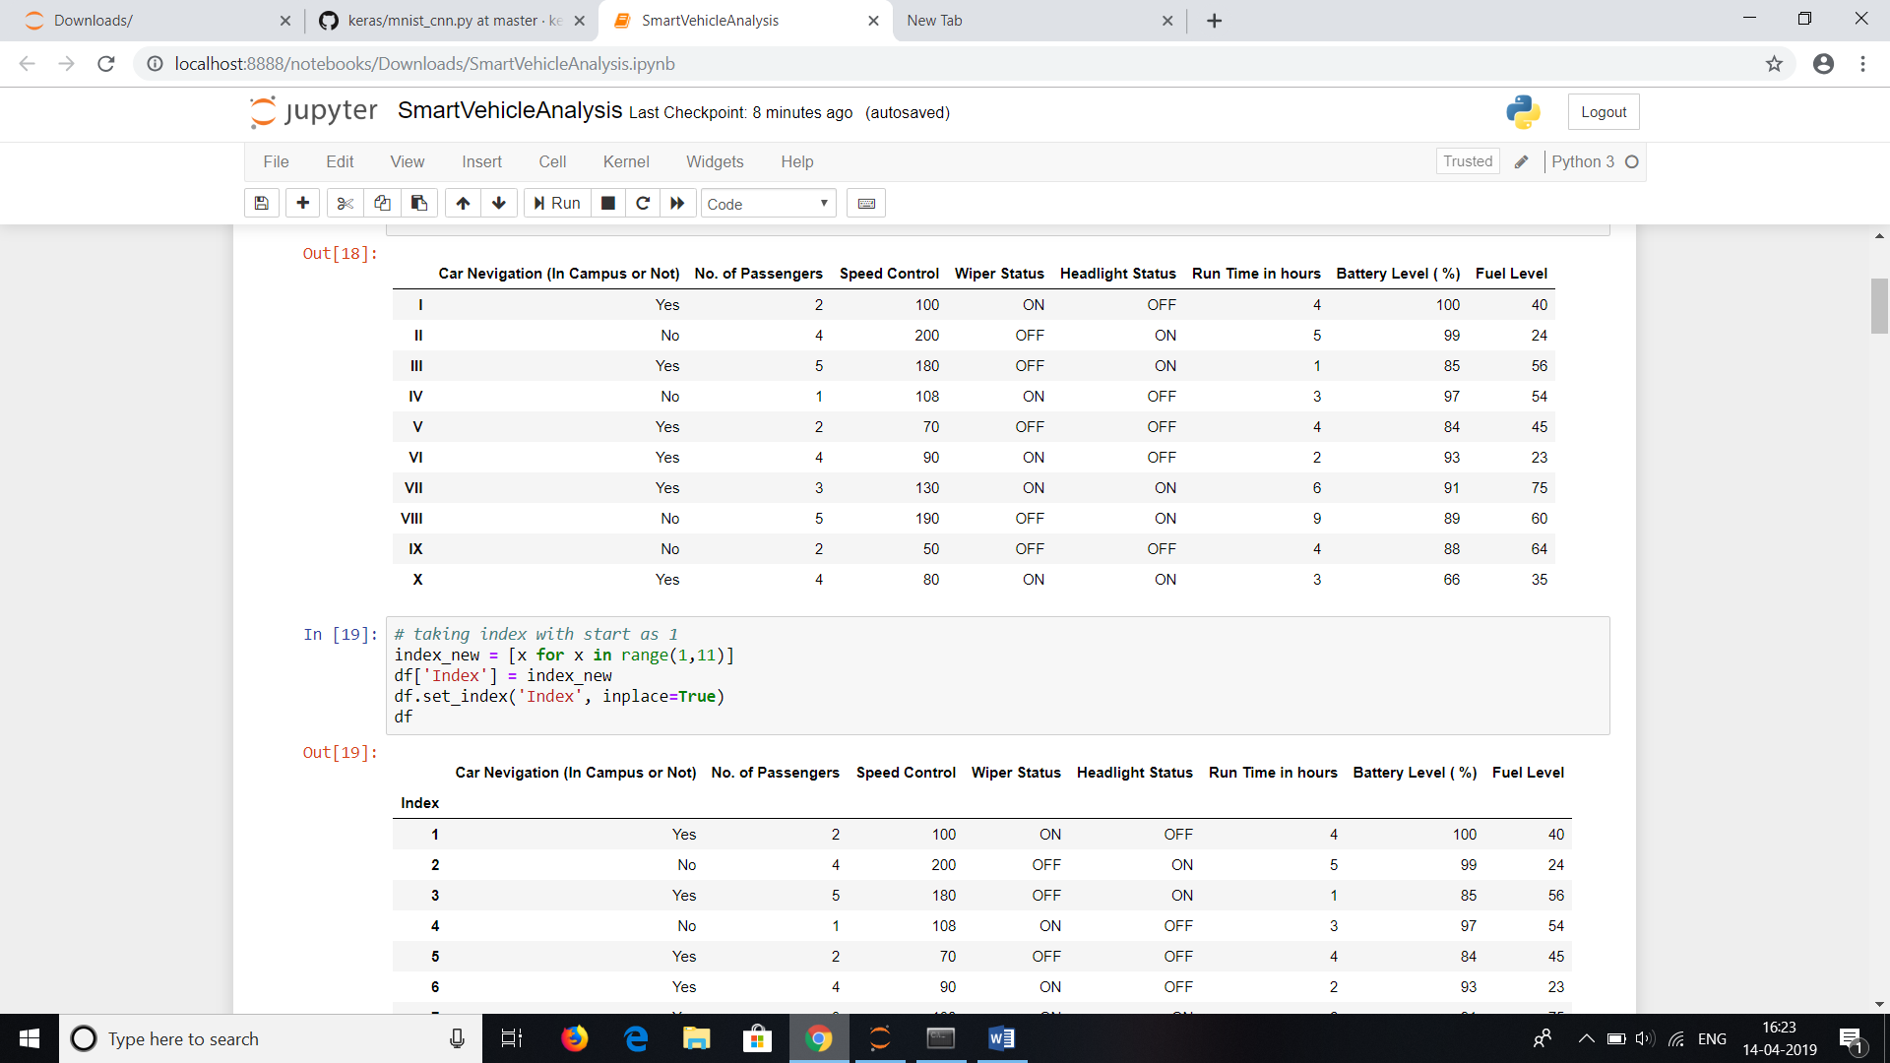

The following bar chart shows the number of passengers that sit in the vehicle on different days of the week represented with different colours. Maximum passengers sit during the midweek.

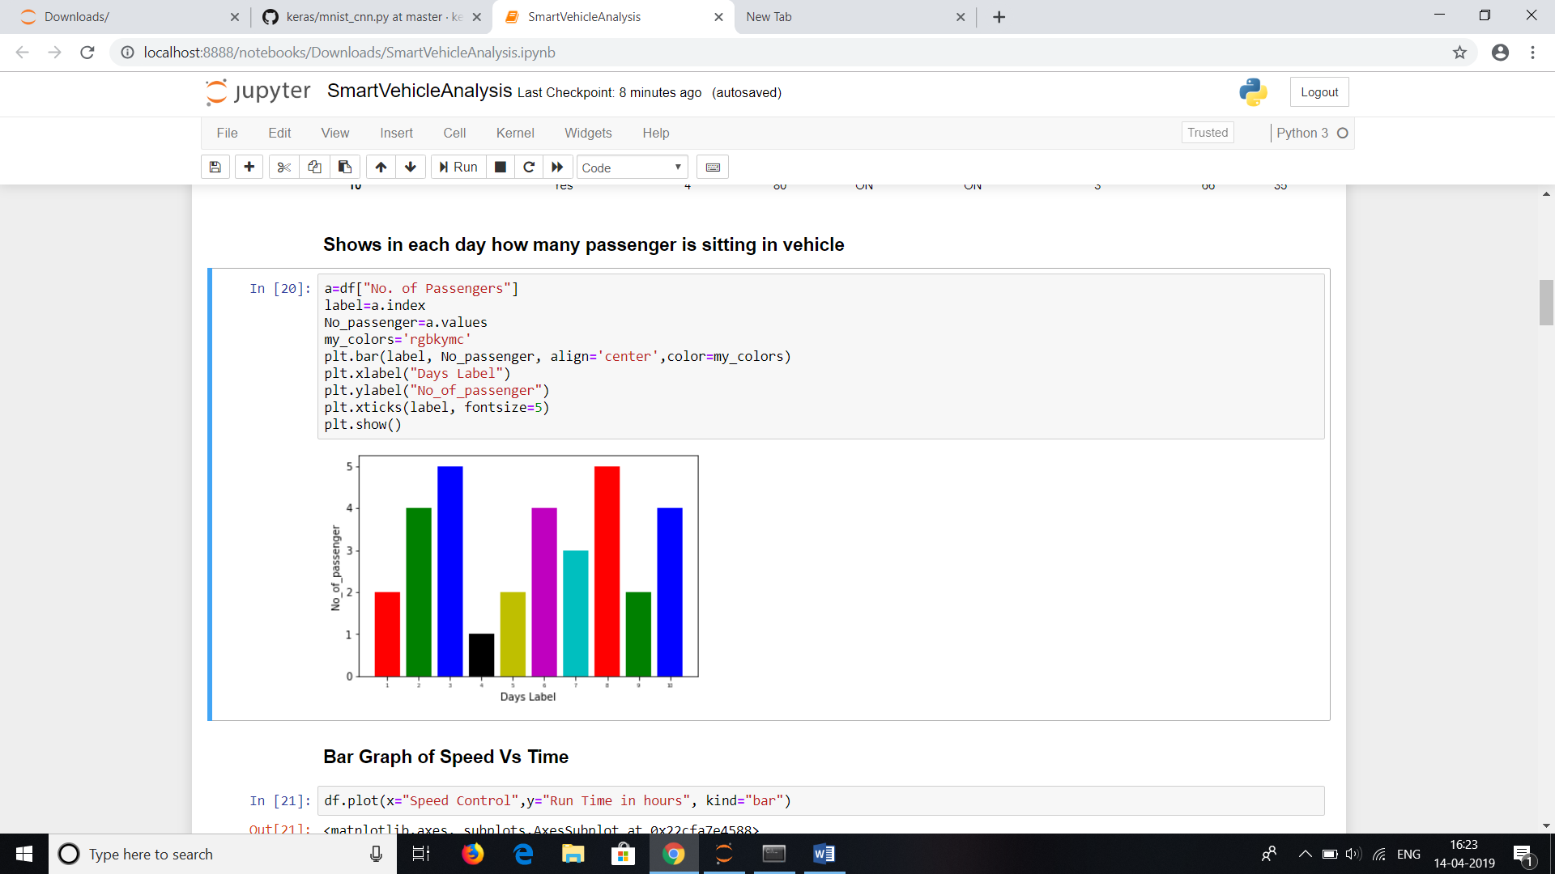

The bar graph shows the Speed the vehicle is controlled during the runtime in hours.

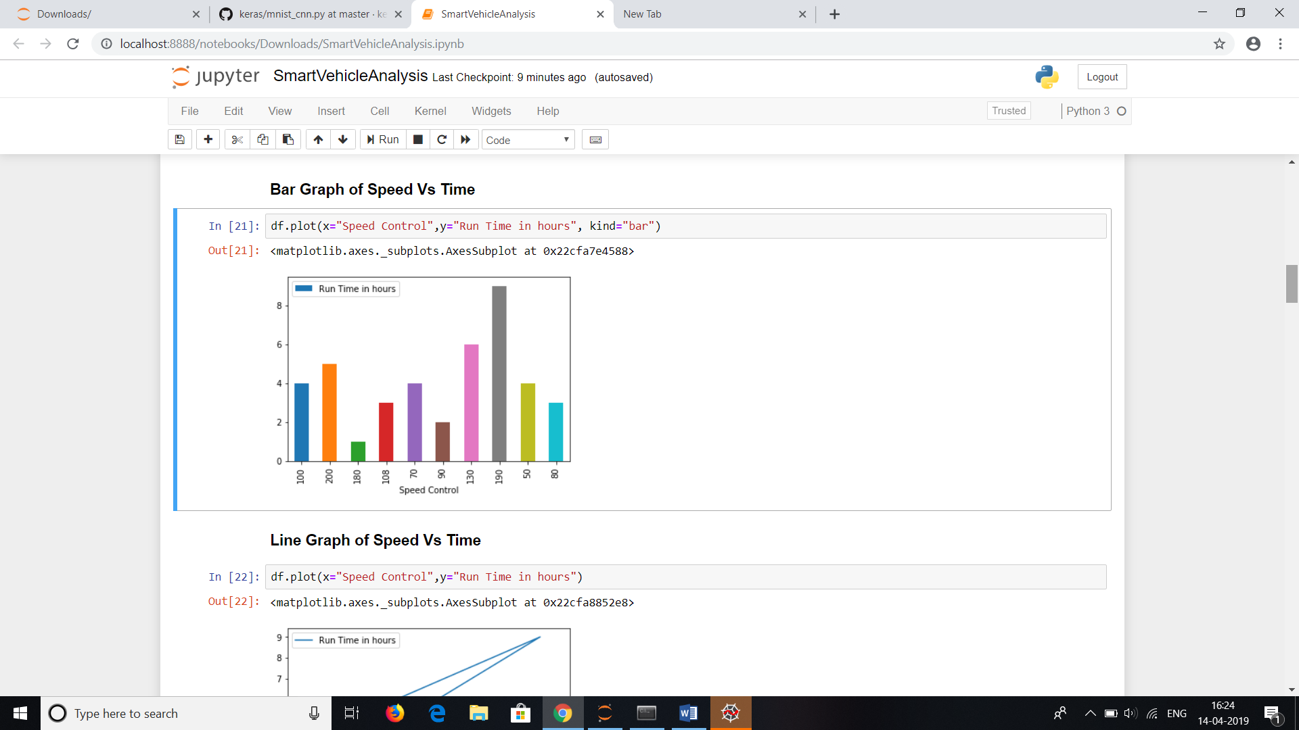

The line graph shows the speed travelled vs run time

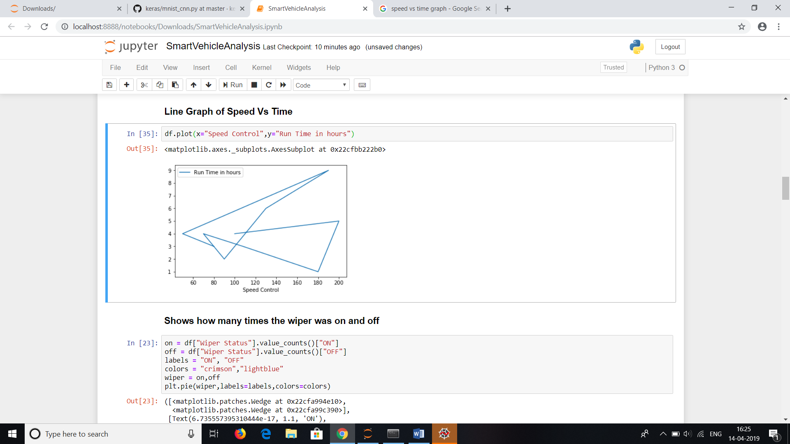

Depicting the number of times, the wiper was on and off

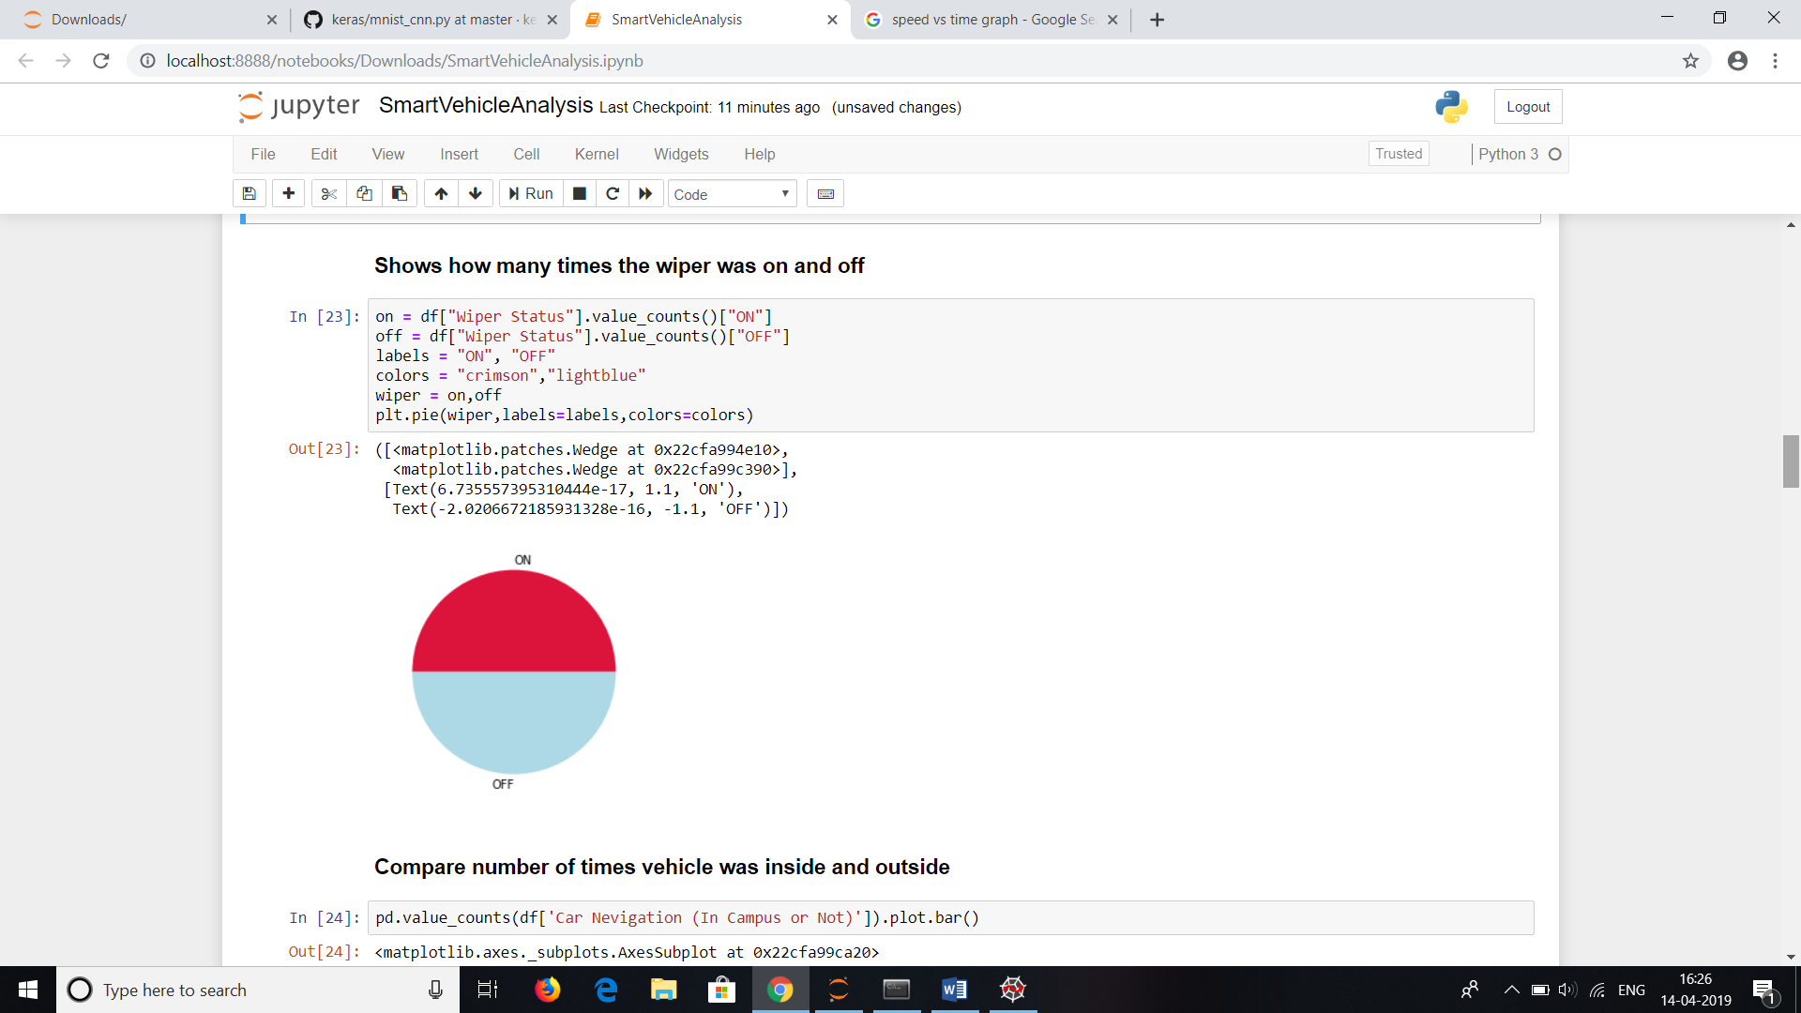

The bar graph shows how long the vehicle spent inside the campus and outside.

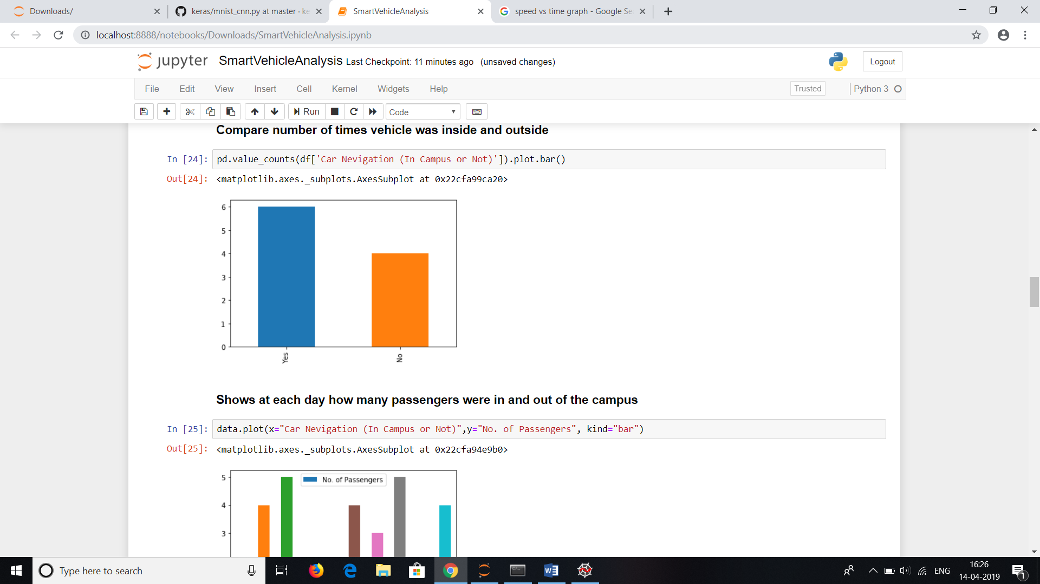

The graph shows the number of passengers when the vehicle was inside the campus or outside during all days of the week.

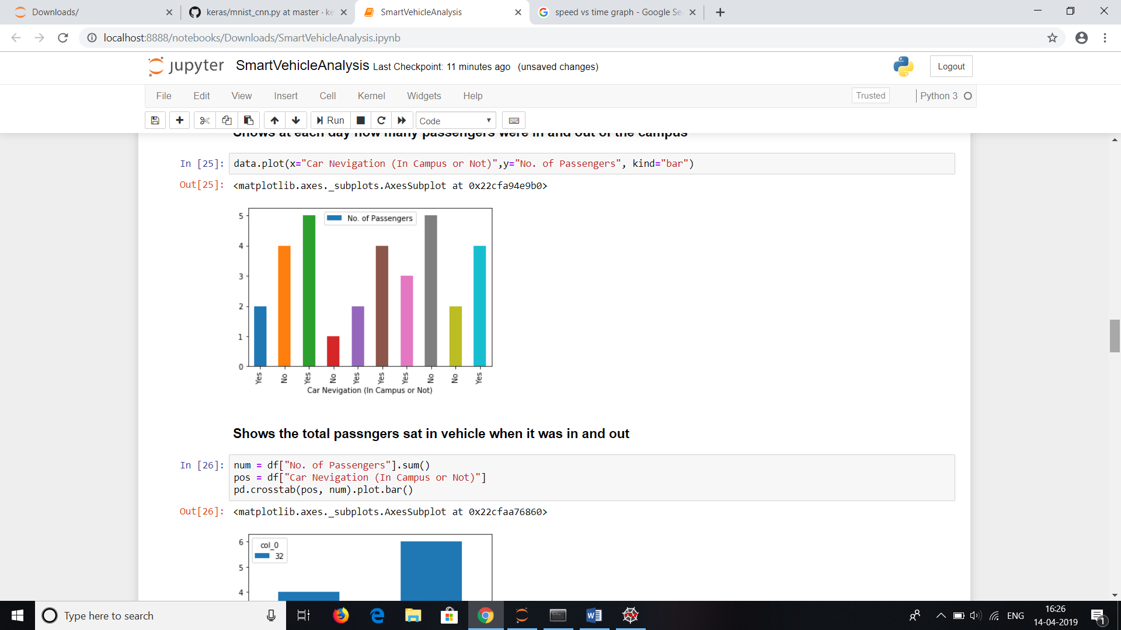

Like the previous graph except it’s an overall count.

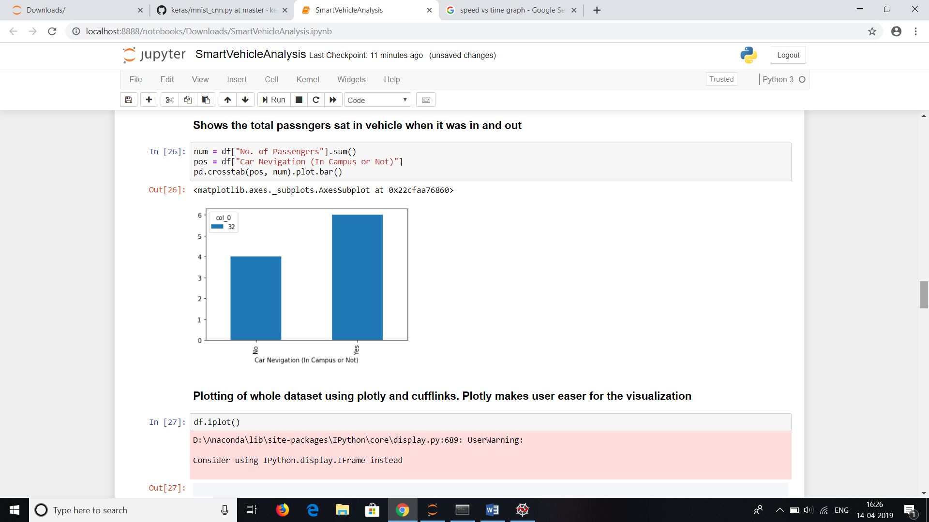

A line graph showing all the variations of the data over all columns of the dataset

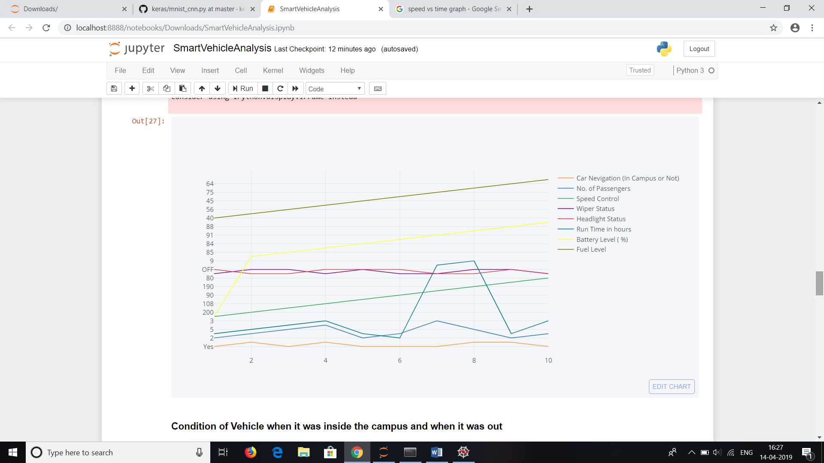

Showing the condition of the vehicle when it was outside or inside.

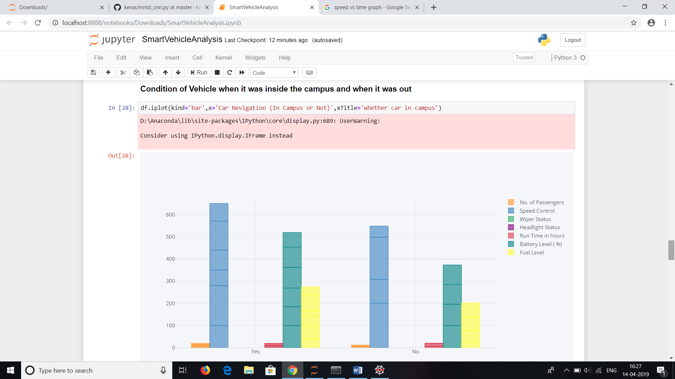

Run time in hours vs all attributes and its variations

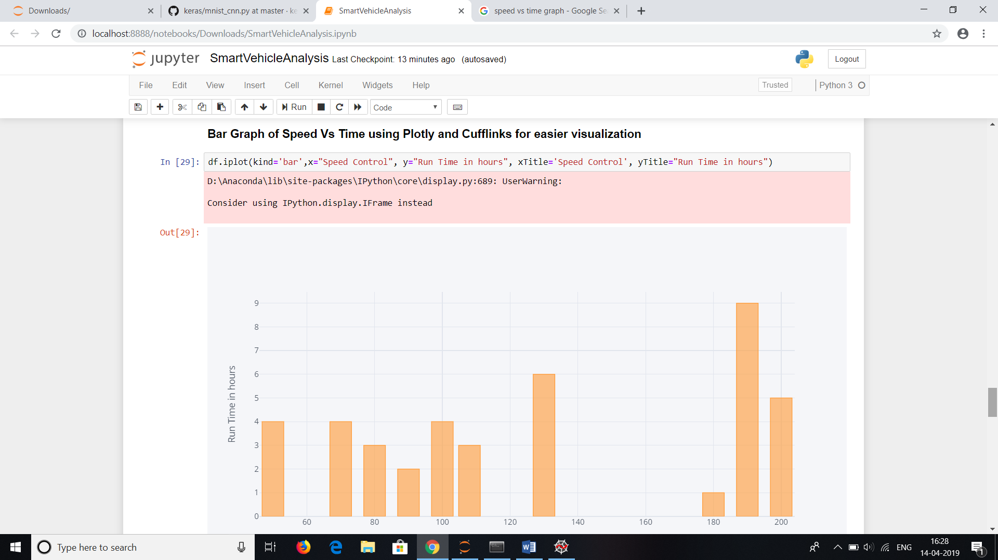

The run time of the vehicle when it was inside and outside the campus.

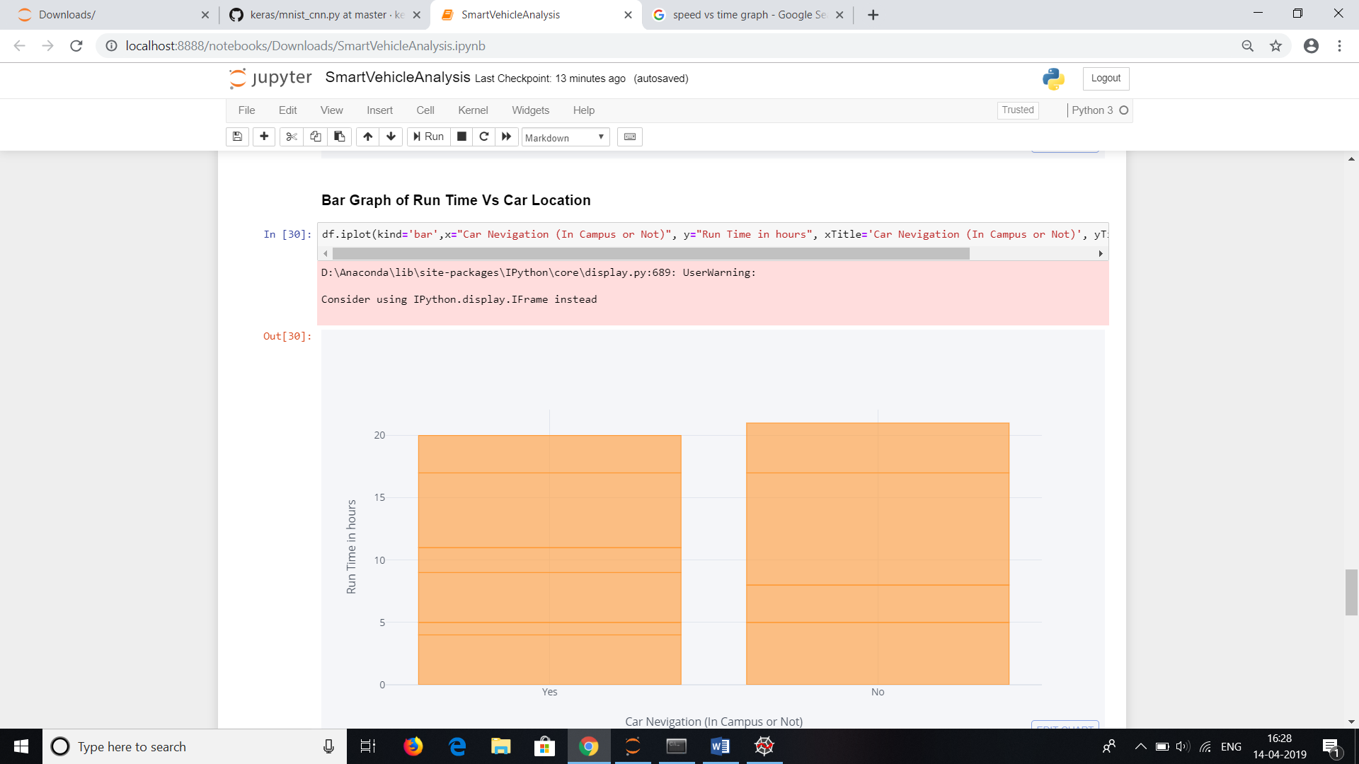

A heatmap showing all attributes

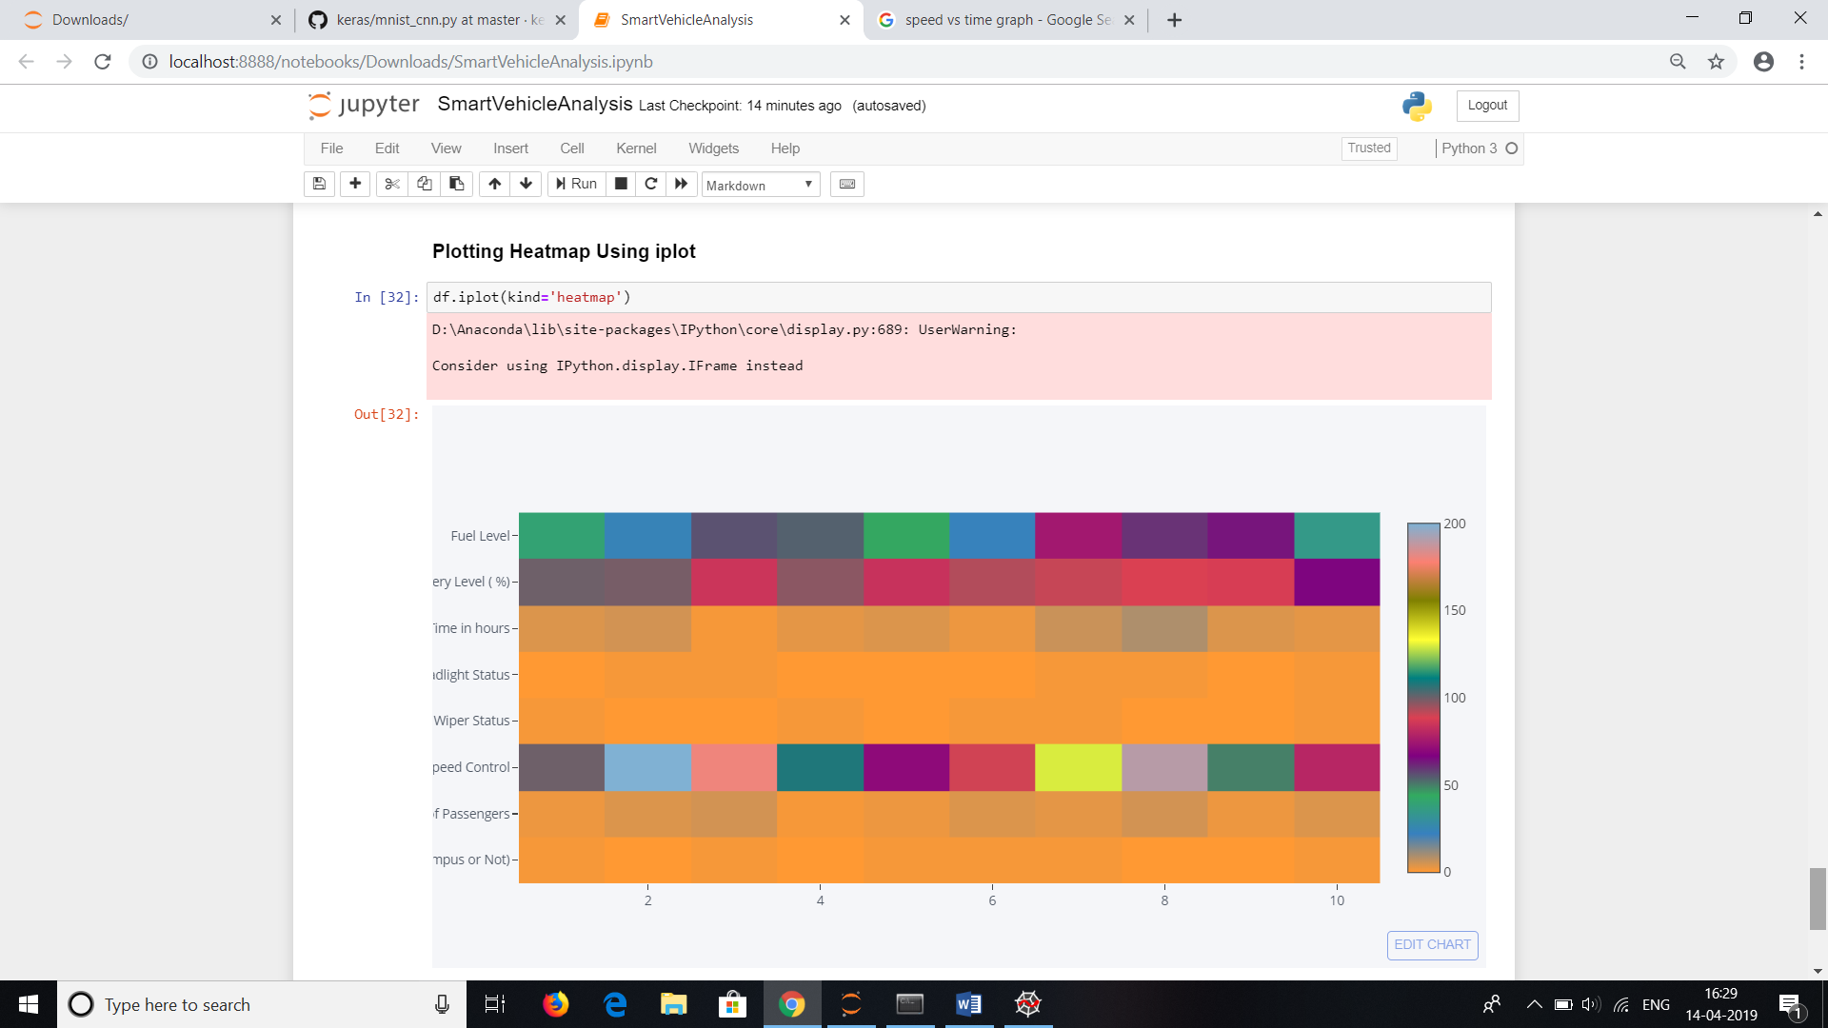

**Bibliography:**

1. [https://plot.ly](https://plot.ly/ipython-notebooks/cu)
2. [https://www.geeksforgeeks.org](https://www.geeksforgeeks.org/)
3. [https://medium.com](https://medium.com/)
4. [https://cloudxlab.com](https://cloudxlab.com/)
5. [https://www.hackerearth.com](https://www.hackerearth.com/)