1. **Introduction**

MongoDB is a free and open-source cross-platform document-oriented database program. Classified as a NoSQL database program, MongoDB uses JSON-like documents with schemata. MongoDB is developed by MongoDB Inc. and is published under a combination of the Server-Side Public License and the Apache License.

MongoDB supports field, range query, and regular expression searches. Queries can return specific fields of documents and also include user-defined JavaScript functions. Queries can also be configured to return a random sample of results of a given size.

As of October 2018, MongoDB is released under the Server-Side Public License, a license developed by the project. It replaces the GNU Affero General Public License, and is nearly identical to the GNU General Public License version 3, but requires that those using the software as part of a service available to third-parties must make the service's source code available under this license. The language drivers are available under an Apache License. In addition, MongoDB Inc. offers proprietary licenses for MongoDB.

* 1. **Objective**

The main objective of this project is to,

* To insertstudent, booksdetails.
* To update student, books details.
* To remove student, books, details.
* To show student, books, details.
  1. **Description**

MongoDB stores data in flexible, JSON-like documents, meaning fields can vary from document to document and data structure can be changed over time.

“Student Library Management” mainly focuses on inserting, deleting, updating and displaying book and students’ details.

This project front end is developed using python tkinterand backend is developed using “MongoDB”.

1. **System Analysis**

Our Project MongoDB for Student Library Database consists of four collections named as, student, membership, book, issrec. Each collection has operations insertion, read, update, delete. Library is place where all kind of books are available. This system contains list of all the books and can be accessed by remote user concurrently from anywhere in the campus. This system provides interface for students. Librarian can modify the database. User can update students, books, membership. They can recommend for new books by just sending messages to the librarian from anywhere in the college. They can view the issue and return dates of any book. This project it works on python as frontend and MongoDB as backend.

1. **System Requirements**

Our Project Student Library Database requires following software and hardware:

* 1. **Software Requirements:**

Our Project requires following Software:

* MongoDB (Backend)
* Python (Frontend)
  1. **Hardware Requirements:**

Our Project requires following Software:

* System with Windows OS

1. **System Implementation**

Student Library Database Project can be implemented in any library. It is an easier way to store the data of each student with their identification as well as library linked identifications. This project is very important in education sectors. This reduces paper works and is very user friendly. This project can be imported in any fields. It has a major role to reduce time efficiency.

1. **Results**

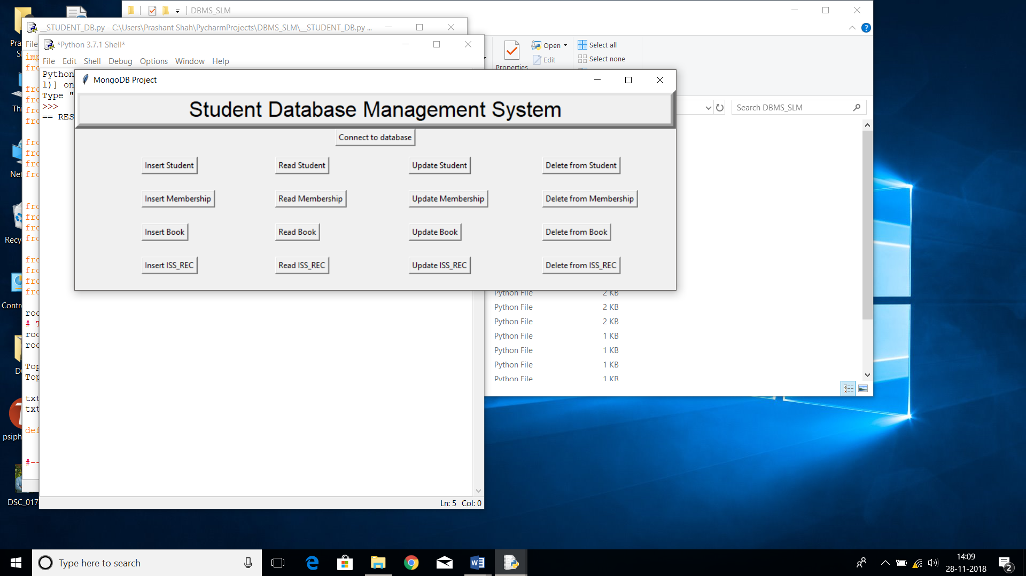

Fig1: Front page

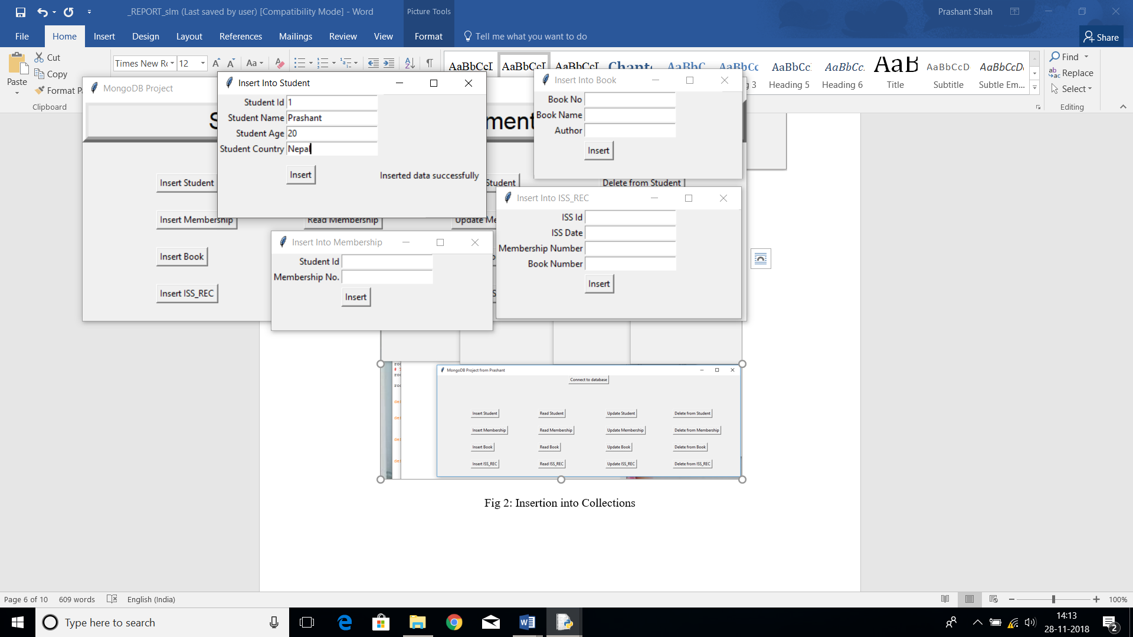

Fig 2: Insertion into Collections

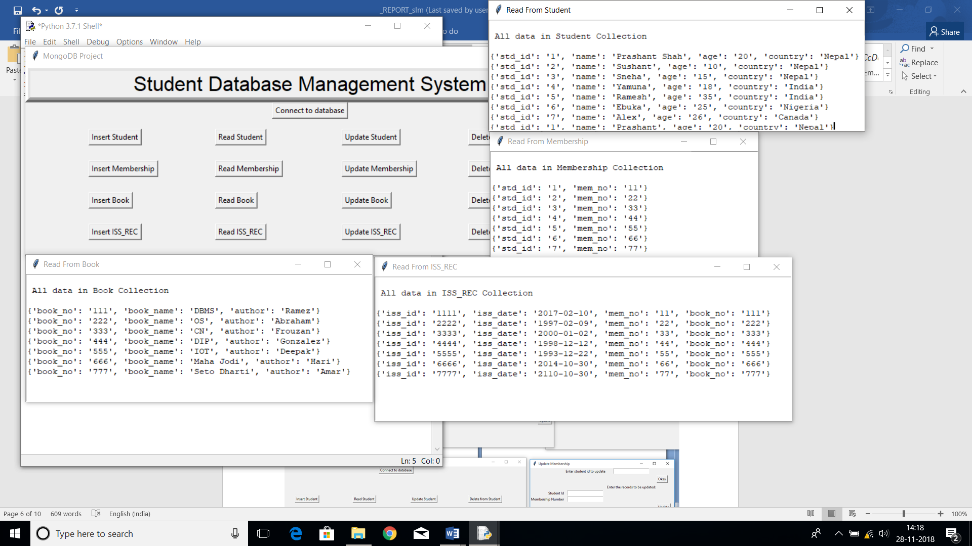

Fig 3: Reading Records from Collections

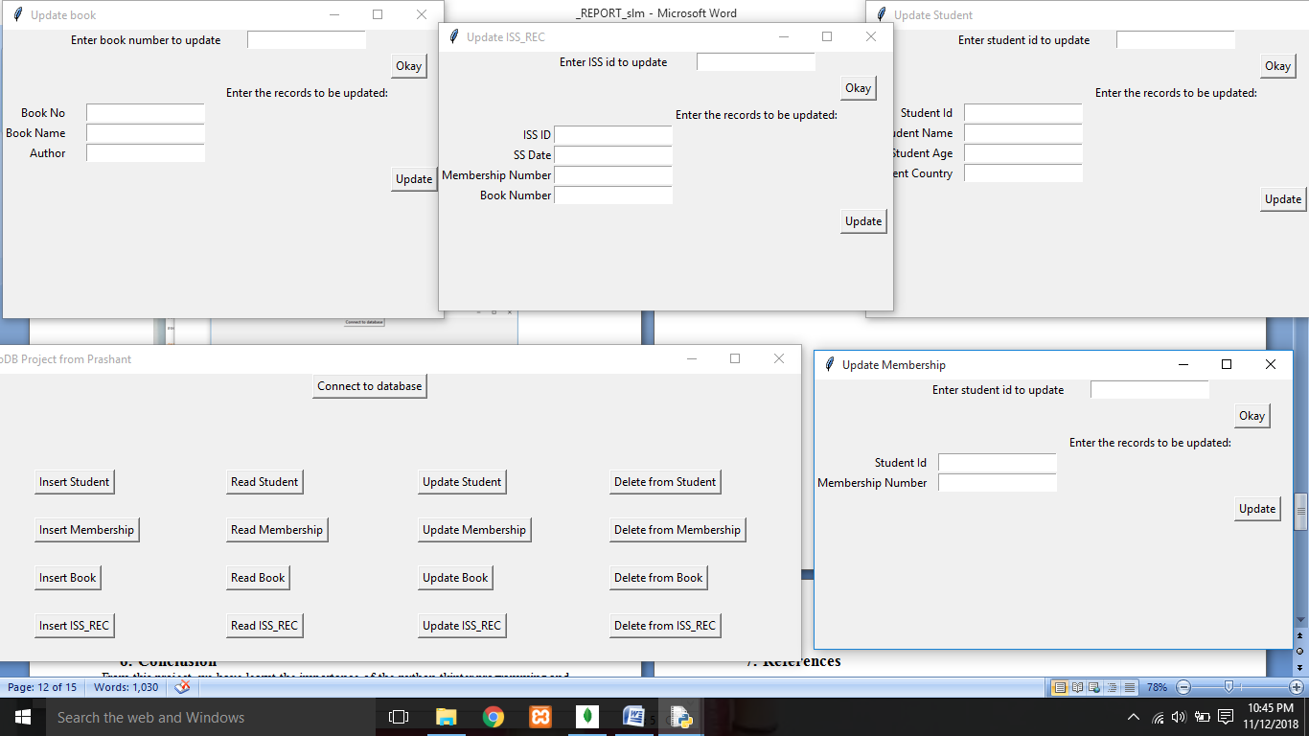

Fig 4: Updating the records in Collections

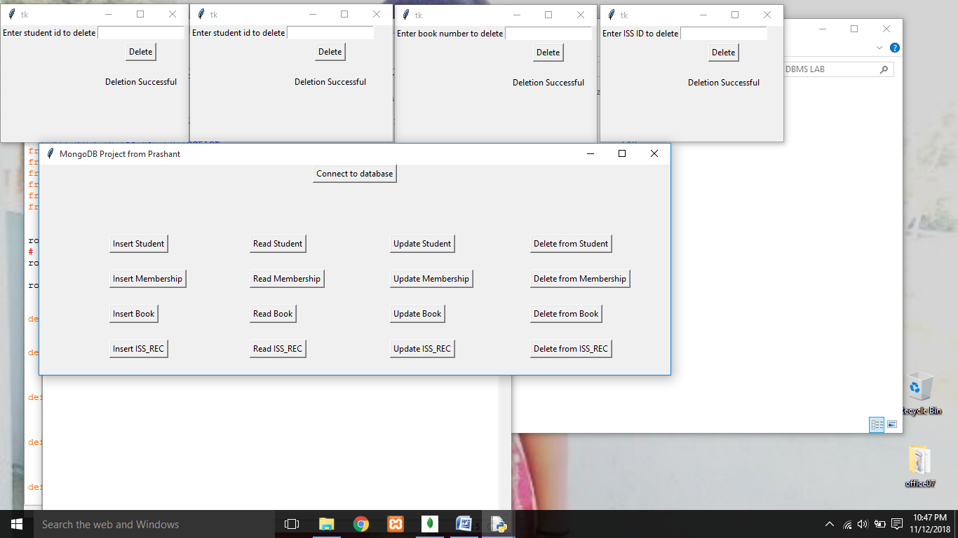

Fig 5: Deleting the records from Collections

1. **Conclusion**

From this project, we have learnt the importance of the python tkinter programming and Database platforms. There are numerous benefits from learning this; however, the most important benefit is that being in a century where people are heading towards ‘Digital World’, this project helps people in simplifying their lives and understanding how the world is entering Industry 4.0.

We have also, through this project understood the working of the above-mentioned concepts to a thorough extent. We have learnt different tip and tricks in coding and using the multiple languages as a powerful tool in making the understanding of Tkinters programming.

1. **References**

* <https://www.youtube.com>
* <https://cloud.mongodb.com>
* <https://www.tutorialspoint.com>
* <https://beginnersbook.com>
* <https://realpython.com>
* <https://docs.mongodb.com>
* <https://stackoverflow.com>