1. **Plagiarism:**

After every success we came to know that our project is containing 6% plagiarism.

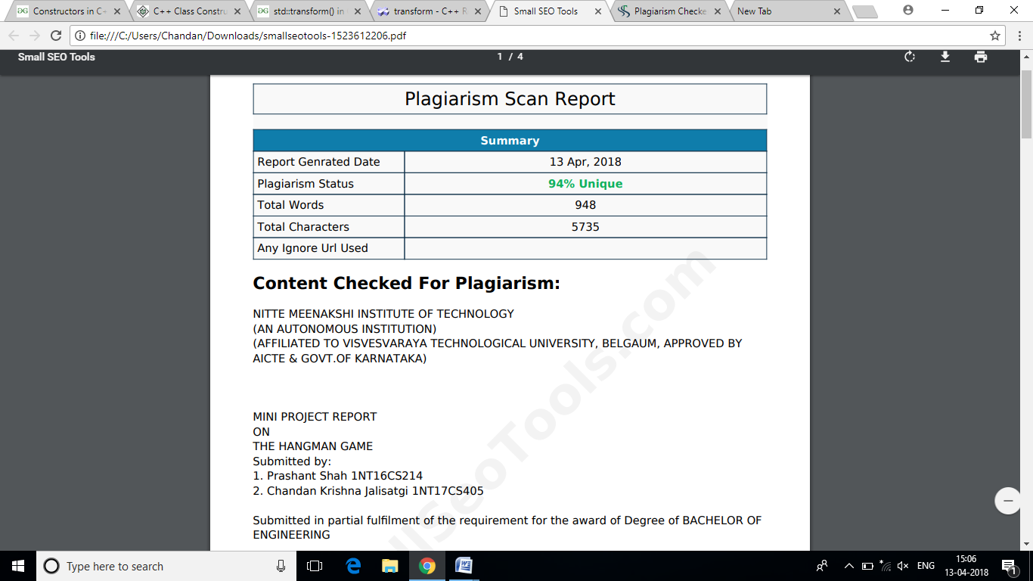

Fig. 9: Plagiarism Certificate