1. **Result with Snapshot:**

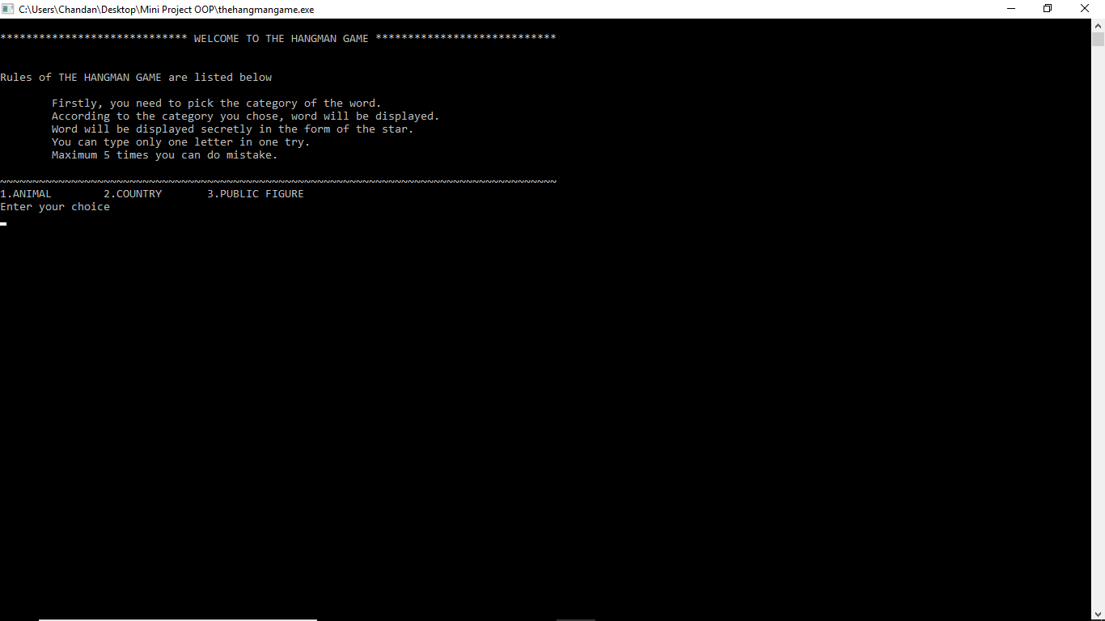

Fig. 1: Screenshot 1

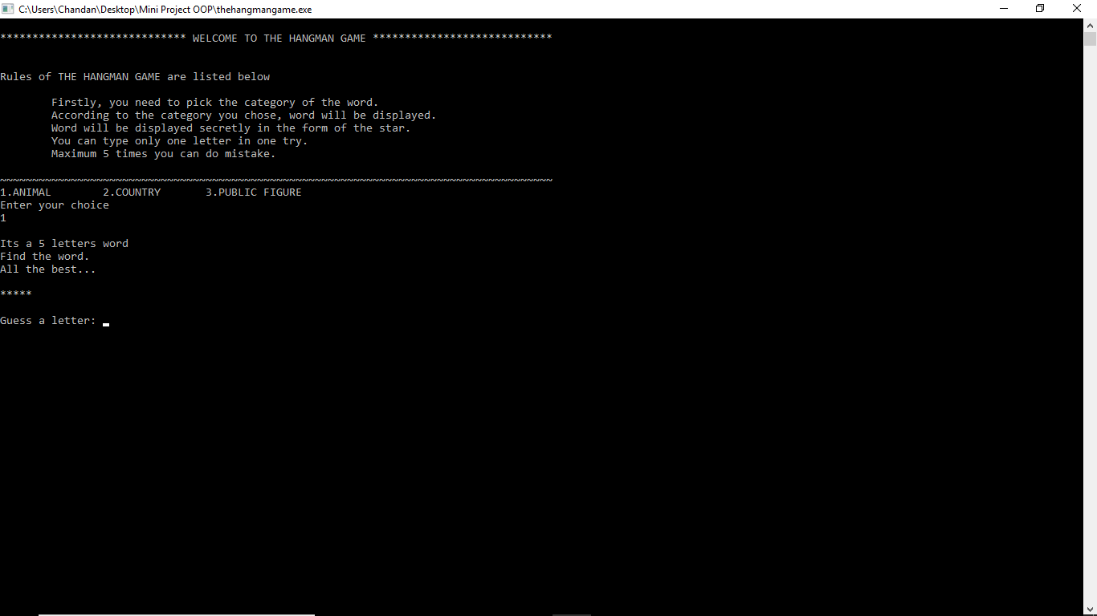

Fig. 2: Screenshot 2

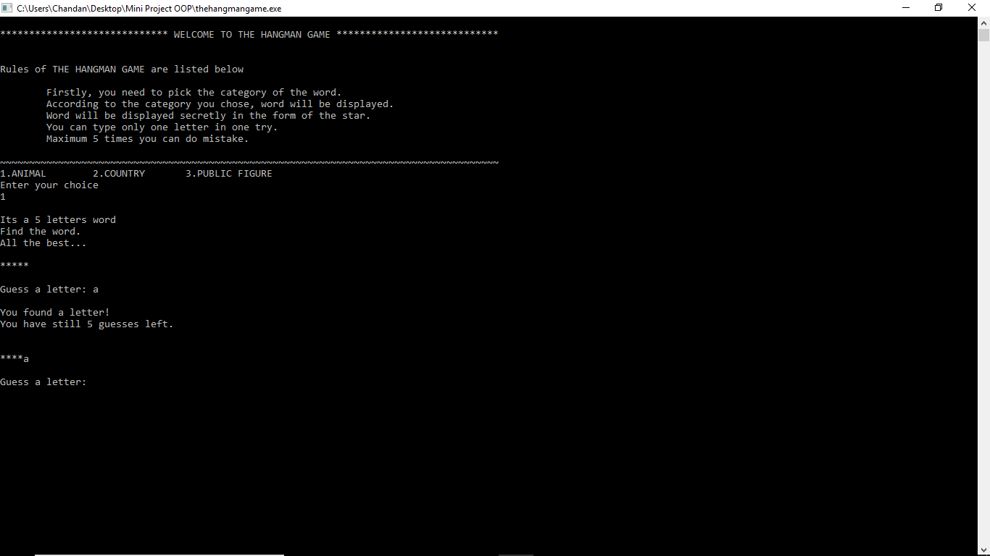

Fig. 3: Screenshot 3

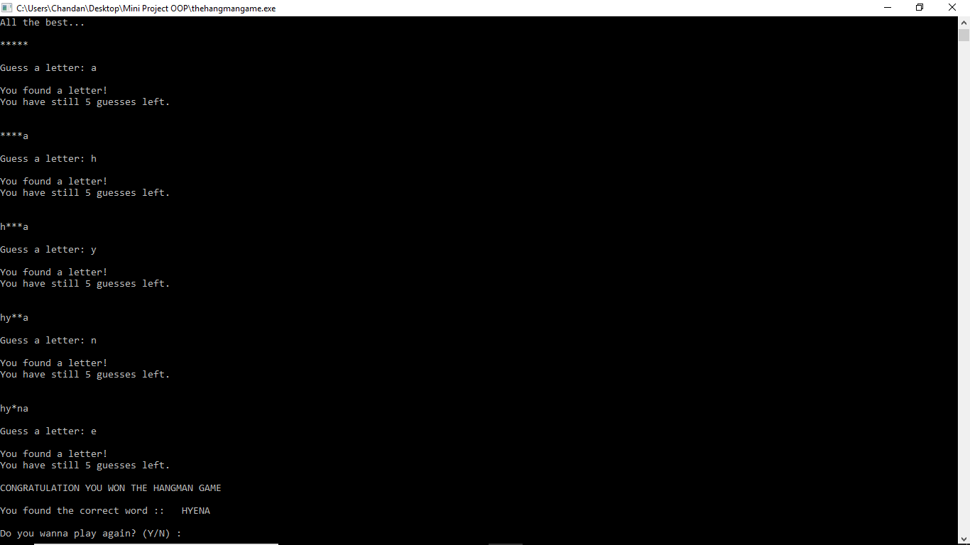

Fig. 4: Screenshot 4

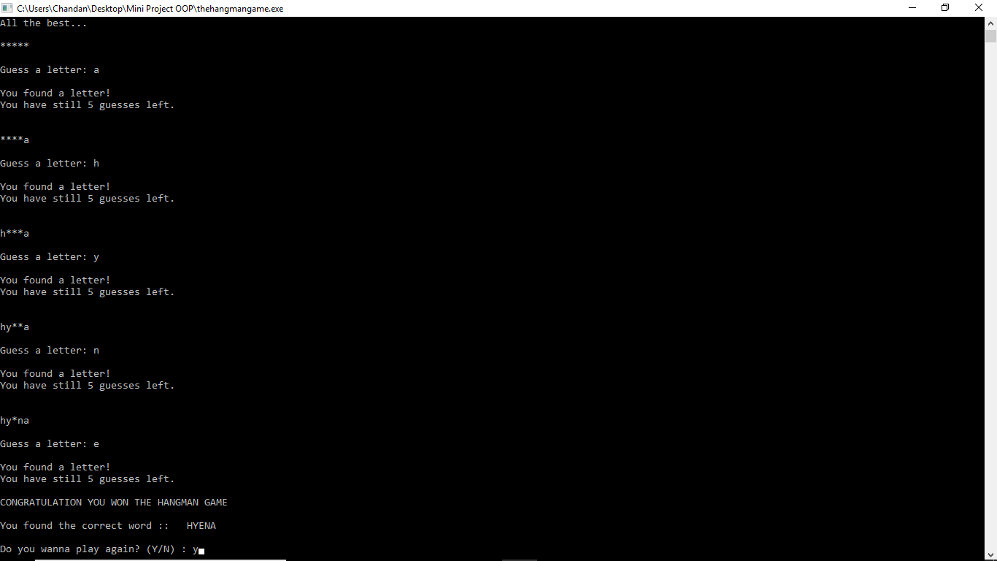

Fig. 5: Screenshot 5

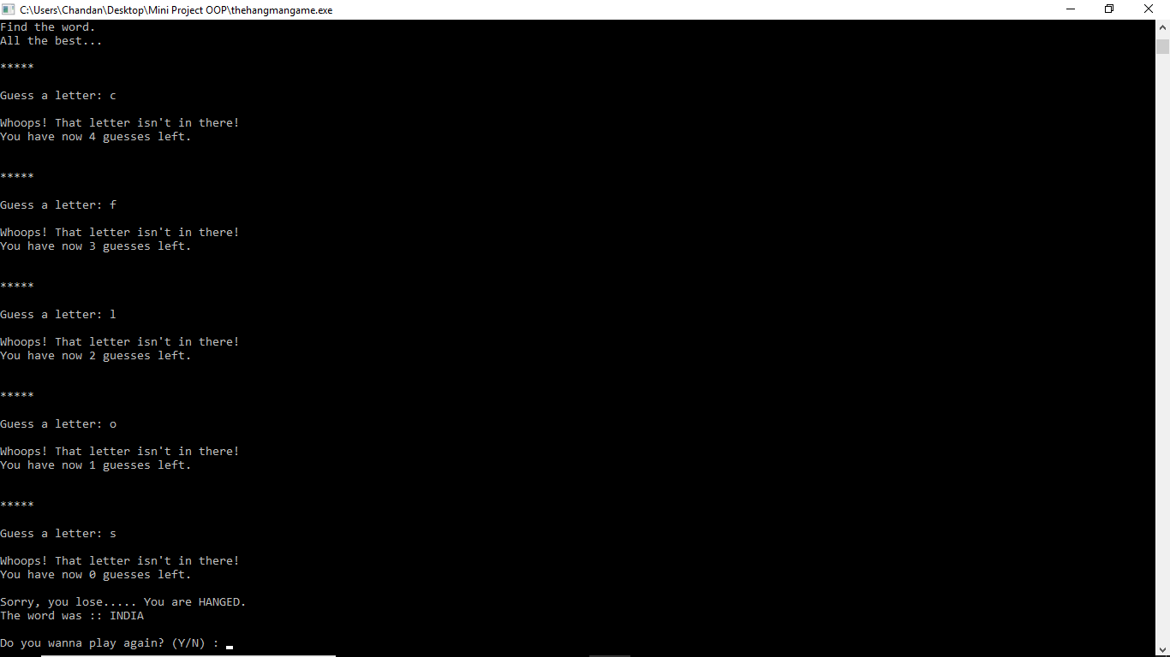

Fig. 6: Screenshot 6

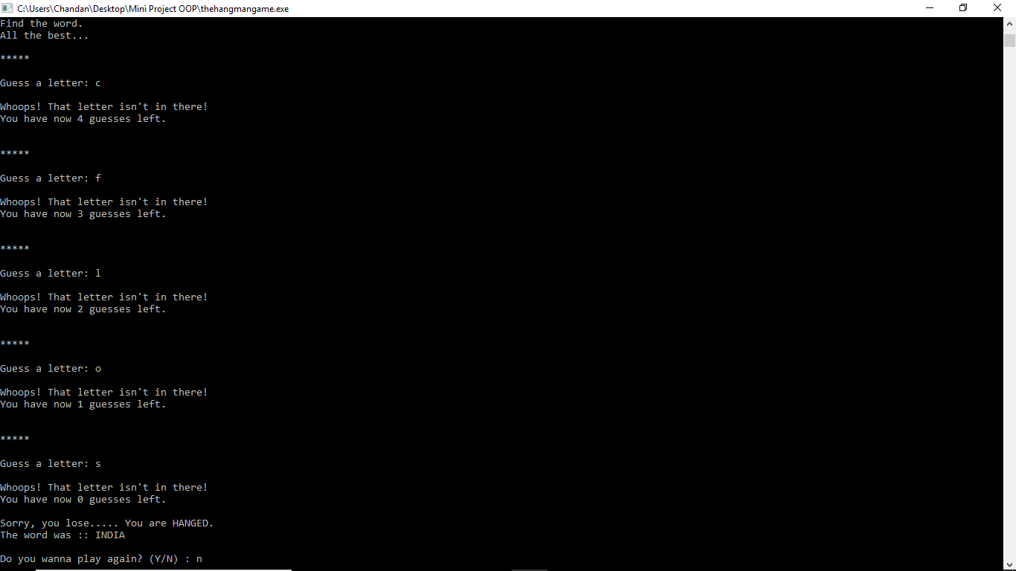

Fig. 7: Screenshot 7

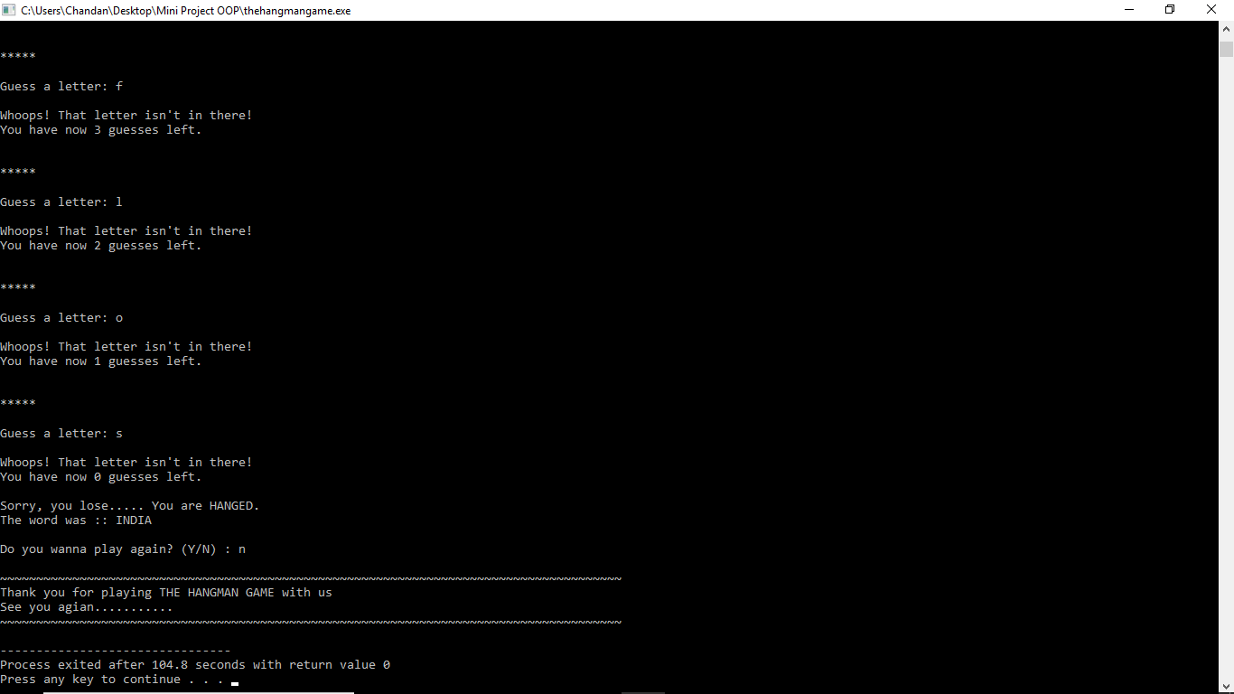

Fig. 8: Screenshot 8