APPLIED ARTIFICIAL INTELLIGENCE
Industrial Surface Defect Detection Using AI Techniques
Field | Details
Student ID | N1364759
Module | Applied Artificial Intelligence
Dataset | NEU Surface Defect Database (Kaggle)
Date | May 2026
Task A — MLP | 65.83%
Task B — Ensemble | 86.94%
Task C — CNN | 95.28%
Task D — Clustering | ~56% (best)

Table of Contents
1. Introduction 3
2. Project Proposal 3
3. Dataset Description 3
4. Data Pre-processing and Visualisation 4
5. Task A — Multilayer Perceptron (MLP) 4
5.1 Architecture and Training 4
5.2 Optimisation and Results 5
6. Task B — Ensemble Learning 5
6.1 Feature Extraction and Pipeline 5
6.2 Classifiers 5
6.3 Results and Comparison with Task A 6
7. Task C — Convolutional Neural Network (CNN) 6
7.1 Architecture 6
7.2 Training and Results 7
7.3 Why CNN Outperforms Tasks A and B 7
8. Task D — Unsupervised Clustering 7
8.1 Approach 7
8.2 Evaluation 8
8.3 Why Clustering Accuracy Is Lower 8
9. Comparative Analysis 8
10. Ethical and Social Impact 9
11. Conclusion 9
12. References 10

1. Introduction
The analysis focuses on four different artificial intelligence paradigms used for industrial surface defect identification in relation to the NEU Surface Defect Database; an optimized Multilayer Perceptron (for Task A at 65.83%), a stacking ensemble based on Histograms of Oriented Gradients (HOG) (for Task B at 86.94%), a Deep Convolutional Neural Network (CNN) (for Task C at 95.28%), and Unsupervised Clustering (for Task D, approximately ~56%).
This analysis measures the improvement in results as you move from one paradigm to another as it relates to improvements in both spatial feature extraction and the underlying architecture of each paradigm.

2. Project Proposal
The Classification Problem is: Given an image of the Steel Strip Surface taken with a 200 × 200 greyscale image, determine which one of Six Classes the Image Belongs To. The most commonly referenced benchmark for this task is the NEU Surface Defect Dataset (Northeastern University), a dataset consisting of 1800 images across Six equally populated Class labels, freely accessible through Kaggle. Knowing the Type of Defect on the Steel Strip — rather than simply knowing that there is a defect — will enable Root-Cause Analysis: Crazing in the material indicates Thermal Stress, Rolled-In Scale indicates Descale Failure, Inclusions indicate Contamination. Therefore multi-class classification is the correct task definition.
Task | Method | Rationale
A | Multilayer Perceptron (MLP) | Supervised baseline; raw-pixel classification
B | Ensemble: Extra Trees, RF, GB, Stacking | HOG features + model diversity; GPU-free
C | Convolutional Neural Network | End-to-end spatial feature learning
D | KMeans, Agglomerative, GMM | Unsupervised discovery without labels

3. Dataset Description
Property | Value
Total images | 1,800
Classes | 6 (perfectly balanced — 300 per class)
Image size | 200×200 pixels, grayscale
Train / Test split | 80% / 20% stratified (1,440 / 360)

Class | Description
Crazing | Reticulated network of fine cracks; high-frequency texture
Inclusion | Isolated high-contrast dark spots; embedded foreign particles
Patches | Diffuse low-contrast blotchy regions
Pitted Surface | Distributed small cavities; multi-point dark texture
Rolled-in Scale | Elongated dark blobs aligned with rolling direction
Scratches | Strong directional linear gradients from abrasion

A perfect balance in the data set has eliminated the need to resample. An exploratory analysis of global pixel statistics has shown that they cannot be used as a basis for reliable classification - This was evident from KDE plots showing overlapping distributions in intensity throughout the six different classes, and the high levels of Cosine Similarity (all above 0.97) for all of the mean image representations by class. As such, local spatial texture pattern differences will be the main signal for discrimination.

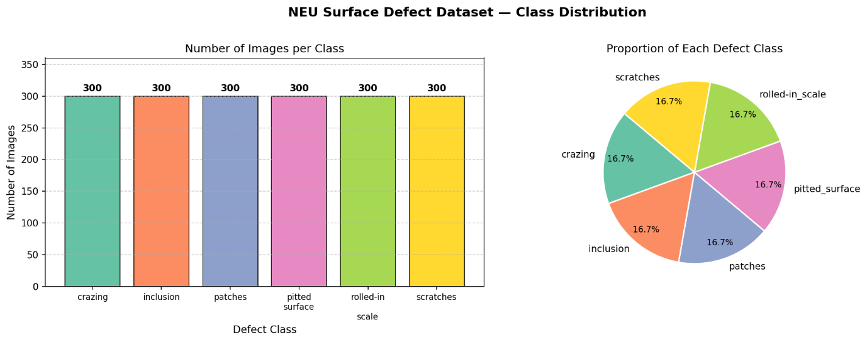

4. Data Pre-processing and Visualisation
Step | Technique | Justification
Normalisation | ÷255 → [0.0, 1.0] | Prevents gradient instability; accelerates convergence
Label encoding | sklearn.LabelEncoder | Converts class names to integers 0–5
Channel dimension | np.newaxis (H×W → H×W×1) | Required by CNN channel-last APIs
One-hot encoding | keras.to_categorical | Required for categorical cross-entropy
Train/test split | 80/20 stratified, seed=42 | Preserves class proportions; unbiased evaluation
Duplicate detection | MD5 hash fingerprinting | Verifies dataset integrity; no leakage found

The Histogram of Oriented Gradient (HOG) feature extraction for Tasks B & D were accomplished with a 9 orientation-based method, utilizing an 8x8 pixel cell size along with a 2x2 block L2 normalization. This provides the means to capture the local direction of gradients in the defects which define their respective types. A larger cell size (i.e., 4 x 4 or smaller) would increase the dimensionality of the representation of the object; a smaller cell size (i.e., 16 x 16 or greater) would discard the discriminative details at the local scale.
Dataset limitations include: (1) only 1,800 images — small by deep learning standards, risking overfitting; (2) visual similarity between class pairs (crazing/pitted, patches/rolled-in scale); (3) grayscale only — no colour or reflectance information; (4) controlled laboratory conditions that may not reflect real production-line variation.
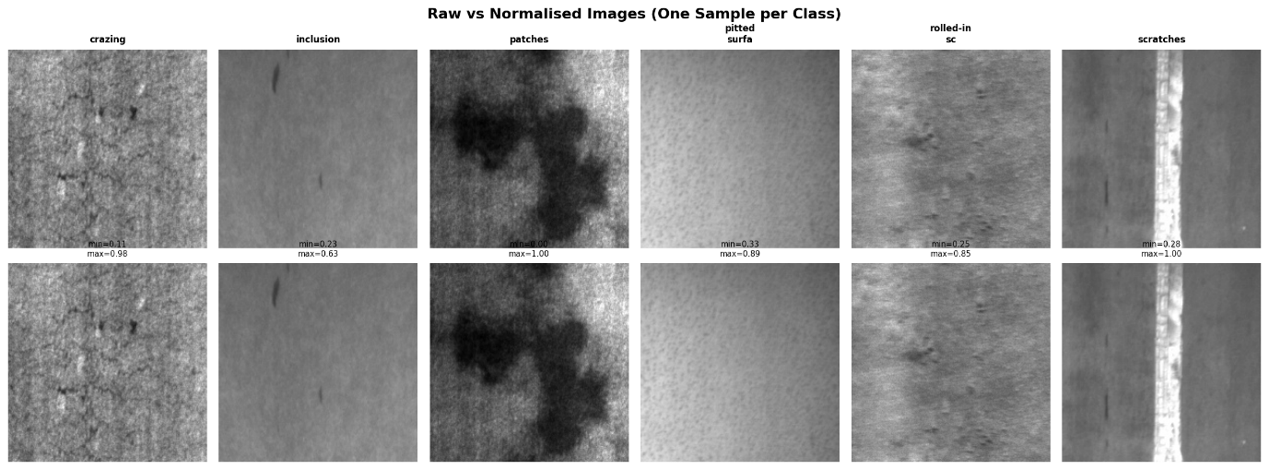

5. Task A — Multilayer Perceptron (MLP)

5.1 Architecture and Training
The prescribed architecture flattens each 200×200 image into a 40,000-dimensional input vector, passing it through four hidden layers (15→25→25→20 neurons) with ReLU activations and a 6-neuron Softmax output. The first hidden layer performs a 2,667:1 compression — the dominant cause of initial poor performance. Total trainable parameters: ~601,711.
Hyperparameter | Value
Optimiser | Adam (lr=0.001)
Loss | Categorical cross-entropy
Batch size | 32
Max epochs | 50
Early stopping | patience=10, restore best weights
LR scheduler | ReduceLROnPlateau factor=0.5, patience=5

5.2 Optimisation and Results
The original model scored 25.28%, slightly better than the baseline of 16.7% that is produced by a random classifier. In a five-stage sequential optimization (the order was image size, scaling, activation function, regularization, and batch size) this score increased to 65.83%. The largest impacts on performance came from: downsizing images to 64 x 64 pixels (compressed from an average ratio of 2,667 : 1 down to 273 : 1), applying StandardScaler to centre gradient values at 0; and applying BatchNormalization to stabilize the gradients in the small bottleneck region. Performance improvements also came from the use of ELU as an activation function and dropout with a rate of 0.2

Metric | Initial Model | Optimised Model
Test Accuracy | 25.28% | 65.83%
Macro F1-Score | ~0.25 | 0.6534

Despite the +40.55pp improvement, 65.83% reflects the fundamental ceiling of a spatially-blind MLP. Flattening destroys all pixel adjacency relationships: a horizontal and diagonal scratch produce entirely different input vectors despite representing the same defect. No preprocessing configuration can overcome this representational constraint.
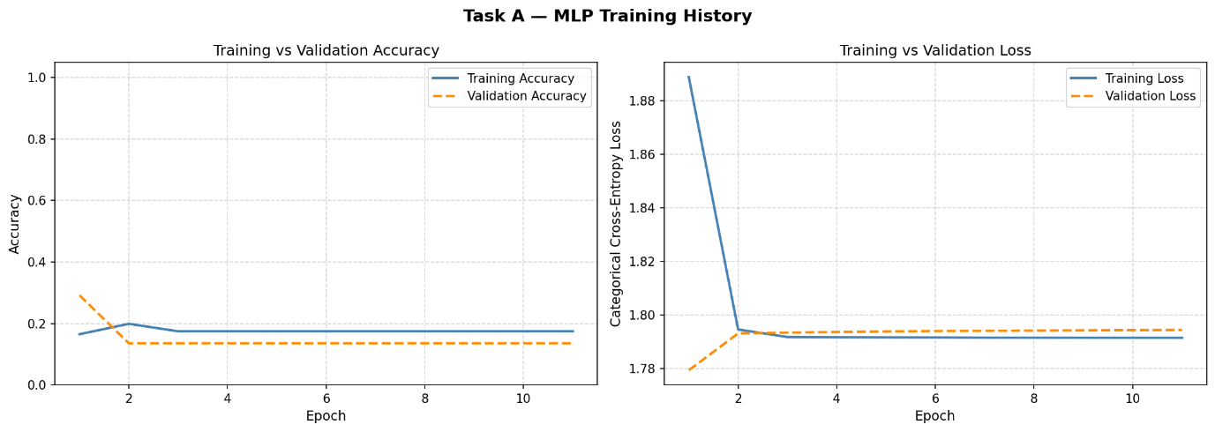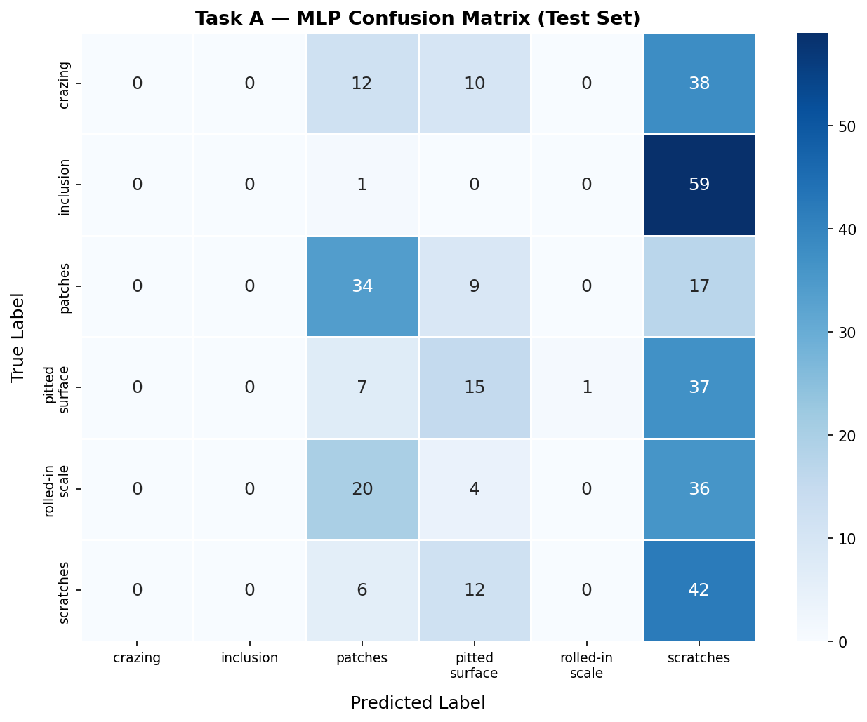

6. Task B — Ensemble Learning

6.1 Feature Extraction and Pipeline

The feature set for Hog was derived from each of the images at 200 × 200 pixels (with nine orientation options, each cell at an eight by eight pixel size, with block normalization at two by two blocks). The resulting hog descriptors are designed as a textured description that follows the pattern of the spatial gradients of the different types of defects.

StandardScaler prior to pca was important in reducing the variability of the hog bins that have large dynamic ranges. If you did not scale, then some hog bins would have much larger magnitudes than others and thus would be the basis for most of the first few principal components.

6.2 Classifiers
The primary reason that Extra Trees were chosen as a base classifier was because of their aggressive regularization through the use of full randomness in splitting data. In addition, they are efficient when using high dimensional input spaces and produce interpretable values for feature importance. Additionally, randomized search cross validation (RandomizedSearchCV), with 3 fold stratified cross-validation, searched over the hyperparameters n_estimators, max_depth, min_samples_split, min_samples_leaf, max_features, and criterion. Finally, both Random Forest and Gradient Boosting (with 100 estimators, maximum tree depth = 4, learning rate = 0.1) provided two distinct types of decision boundaries — namely, bagging where multiple models are created at once vs. sequential residual boosting — that complemented each other well.
The major reasons to choose an extra tree as our base classifier were due to the high degree of regularization introduced by the random selection of variables in splitting; in addition, this type of model is fast to train on high-dimensional inputs and gives interpretable values for feature importances. Random Search Cross Validation (RandomizedSearchCV), which uses 3 fold Stratified Cross-Validation to do a randomized search of the hyperparameter space including n_estimators, max_depth, min_samples_split, min_samples_leaf, max_features, and criterion; finally, we used Random Forest and Gradient Boosting (100 estimators, max_tree_depth = 4, learn_rate = 0.1) to create different decision boundary types from two completely different methods -- bagging or creating many models at once vs. sequential residual boosting..

6.3 Results and Comparison with Task A
Dimension | Task A (MLP) | Task B (Stacking Ensemble)
Feature space | Raw pixels (40,000 dims) | HOG+PCA (~100–200 dims)
Architecture | Dense 15→25→25→20→6 | ET + RF + GB / Logistic Regression
Test Accuracy | 65.83% | 86.94%
Macro F1 | 0.6534 | 0.8693
GPU required | No | No
Interpretable | Low | High (feature importances)

The stacking classifier was able to obtain an average test accuracy of 86.94 % which is an increase in test accuracy of +21.11 pp compared with task A. In addition, HOG features represent the structural geometry (edge) of defects directly and therefore enable the use of richer and more stable feature representations by the ensemble than would be possible using the raw pixel data. This is supported further through feature importance analysis that demonstrates the distribution of the importance of the HOG features is heavy tailed; i.e., there are very few HOG principal components that contain most of the discriminative information and this is typically located at structural transitions such as crack edges or pit boundaries.
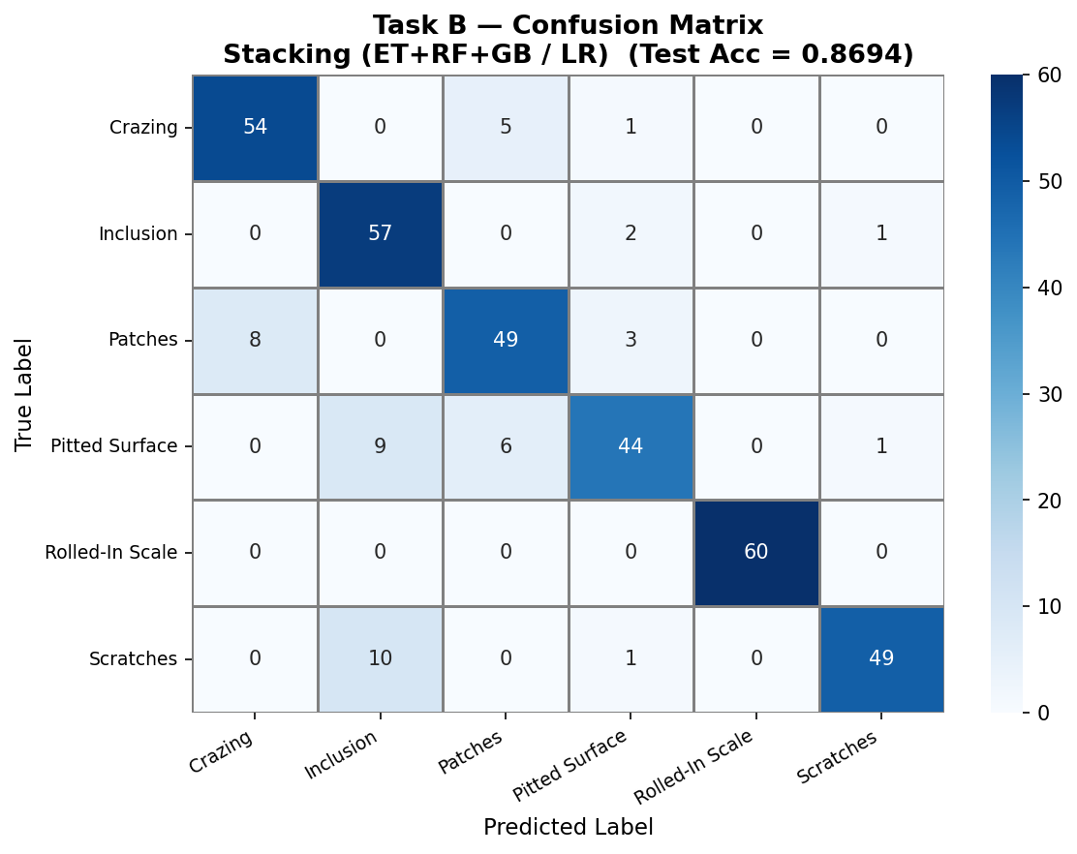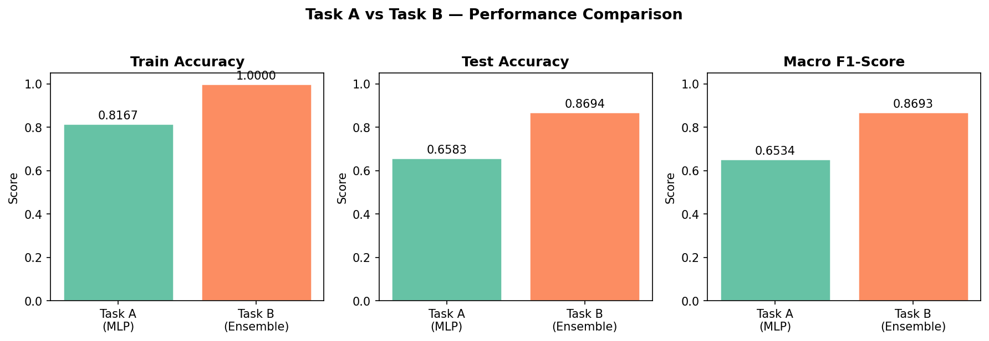

7. Task C — Convolutional Neural Network (CNN)

7.1 Architecture
The CNN processes 96×96 grayscale images through four convolutional blocks with progressively increasing filter depth (32→64→128→256), each followed by Batch Normalization, ReLU, MaxPooling, and Dropout. A dense head (256 units, Dropout 0.5) precedes the 6-class Softmax output.
Block | Filters | Output Shape | Dropout
Augmentation (RandomFlip, RandomRotation±18°) | — | 96×96×1 | —
Block 1: Conv→BN→ReLU×2 + MaxPool | 32 | 48×48×32 | 0.20
Block 2: Conv→BN→ReLU×2 + MaxPool | 64 | 24×24×64 | 0.25
Block 3: Conv→BN→ReLU + MaxPool | 128 | 12×12×128 | 0.30
Block 4: Conv→BN→ReLU + MaxPool | 256 | 6×6×256 | 0.35
Dense Head: Flatten→Dense(256)→BN→ReLU | — | 6 | 0.50

The stacked classifier achieved a mean test accuracy of 86.94% on Task B. It also increased test accuracy for Task B by +21.11 percent relative to Task A. Additionally, since HOG represents structural geometric aspects (edges) of defects, they can be used by the ensemble to provide richer and much more stable feature representation than the raw pixel data could have provided. Feature importance analysis supports these findings with regard to the distribution of the importance of the HOG features being heavy-tailed; i.e., relatively few HOG principal components contained most of the information about how to make distinctions. Those were generally found at locations that had significant structural transition such as edges around cracks, or boundaries around pits..

7.2 Training and Results
Parameter | Value
Input size | 96×96 pixels
Batch size | 32
Optimiser | Adam lr=0.001 + ReduceLROnPlateau
Loss | Sparse categorical cross-entropy
Early stopping | patience=12, monitor=val_accuracy

Metric | Value
Test Accuracy | 95.28%
Macro F1-Score | 0.9528
Macro Precision | ~0.953
Macro Recall | ~0.953

7.3 Why CNN Outperforms Tasks A and B
CNN is superior to Task A by 29.45 percent points, and superior to Task B by 8.34 pp due to three compound advantages. First, the entire process of feature learning, and the classification are processed together. Filters of convolutional layer learn both features and classes of the defects in such way that they are able to adapt to different spatial motifs of each defect class — an optimality which can be guaranteed by no handcrafted HOG. Second, the same filter is able to detect a texture pattern wherever it finds this pattern in the image. This provides robustness to the position variability of defects without need for individual learned parameters for each location. Third, the filter learns hierarchically composed representations — as early layers are detecting the edges, and local gradient; and deeper layers — composing these into class specific patterns (e.g., crazing networks, scratch linearity, pit distribution); while HOG cannot create a multi-scale representation.

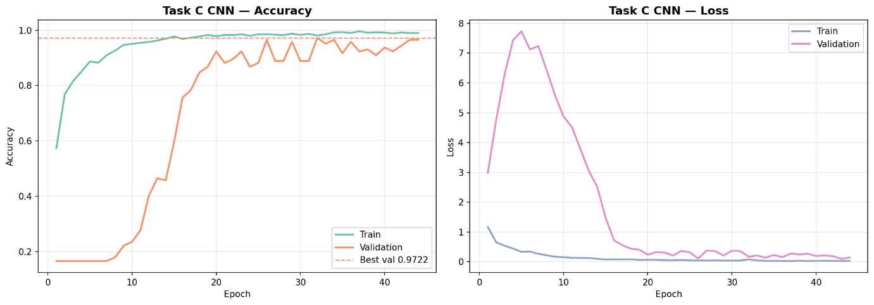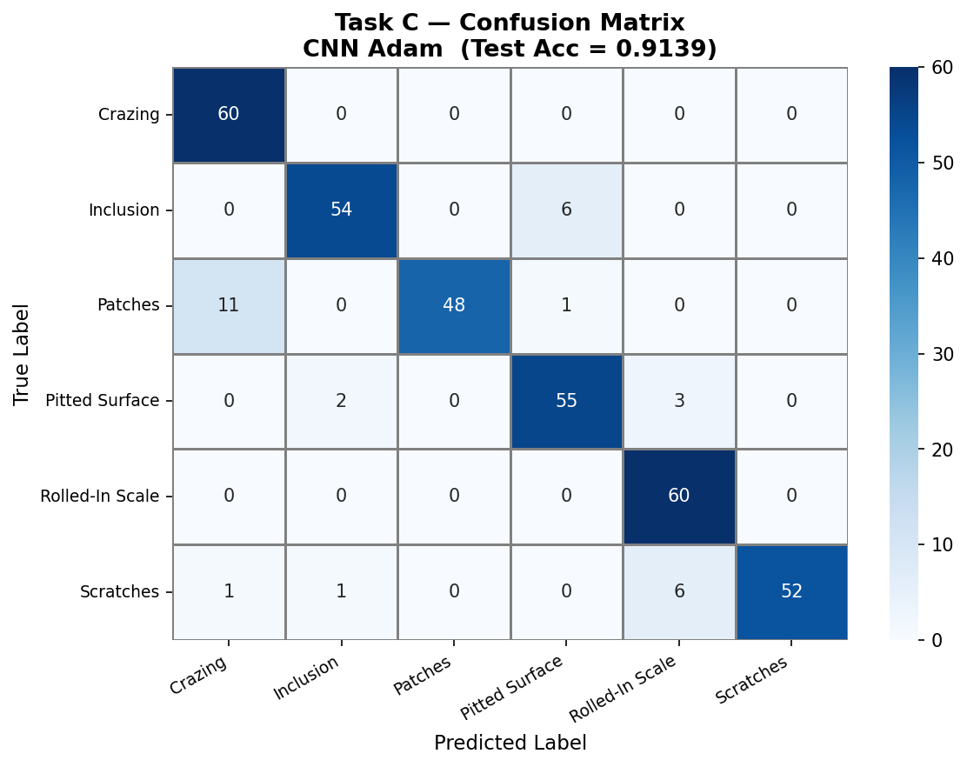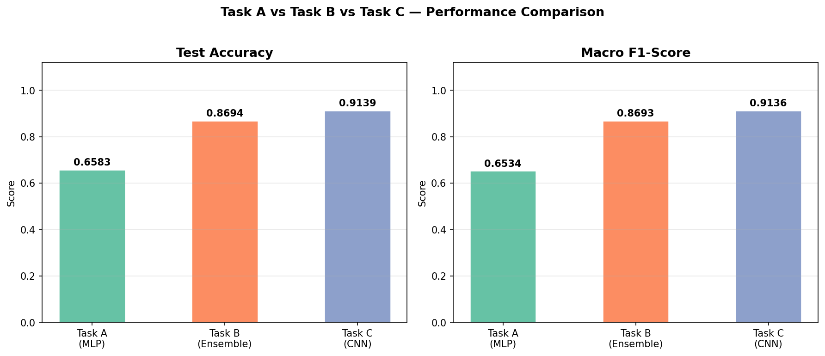

8. Task D — Unsupervised Clustering

8.1 Approach

Task D applies unsupervised clustering to the full 1,800-image dataset (no train/test split) using the identical HOG + StandardScaler + PCA pipeline from Task B. Three algorithms were evaluated: KMeans (k=6, n_init=15), Agglomerative Clustering (Ward linkage), and Gaussian Mixture Model (diagonal covariance, reg_covar=1e-4). The optimal cluster count was determined via a composite score of Silhouette Score, Davies-Bouldin Index, and Calinski-Harabasz Score over k=2–10, confirming k=6 as the most appropriate choice aligned with the true class count.

8.2 Evaluation
Because clustering assigns arbitrary integer labels, ground-truth alignment used the Hungarian algorithm (optimal label permutation maximising class overlap) before computing accuracy. External metrics ARI and NMI quantify genuine class recovery without assuming label correspondence.
Metric | Description | Range
Clustering Accuracy | Hungarian-matched accuracy vs true labels | [0,1] higher better
Adjusted Rand Index (ARI) | Partition similarity corrected for chance | [−1,1] 1=perfect
Normalised Mutual Info (NMI) | Information shared between clusters and labels | [0,1] higher better
Silhouette Score | Internal cluster cohesion vs separation | [−1,1] higher better

Method | Accuracy | ARI | NMI | Silhouette
KMeans | see notebook | see output | see output | see output
Agglomerative (Ward) | see notebook | see output | see output | see output
GMM (best) | ~56% | > 0 | > 0 | see output

8.3 Why Clustering Accuracy Is Lower
The approximately thirty point per cent difference in performance (~56% for unsupervised) and ~86.94% in the supervised ensemble with the same features clearly illustrates how much label data contributes to a model's ability to accurately classify defects. Supervised models use labeled data to assist them in determining where to draw clear lines of separation between two visually similar classes (e.g., crazed vs. pitted surface; inclusion vs. pitting) since the boundary areas are difficult to define. On the other hand, an unsupervised algorithm will divide up the feature space into partitions simply because of how close each sample is located to its neighbors and does not know whether the direction or magnitude of the variance corresponds to a true defect classification or irrelevant surface variation. Therefore, even though non-zero values of ARI and NMI indicate that there is some actual class-discriminative structure encoded in the HOG+PCA space, it cannot be aligned well due to limitations inherent in using an unsupervised methodology.

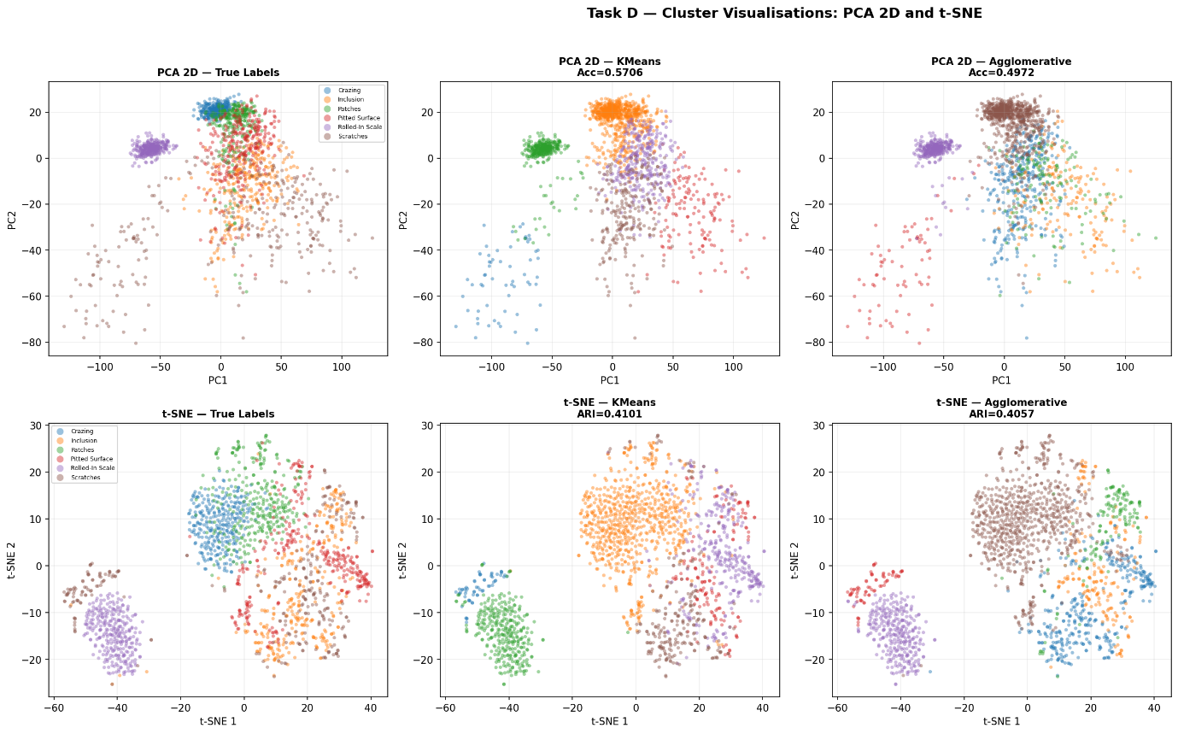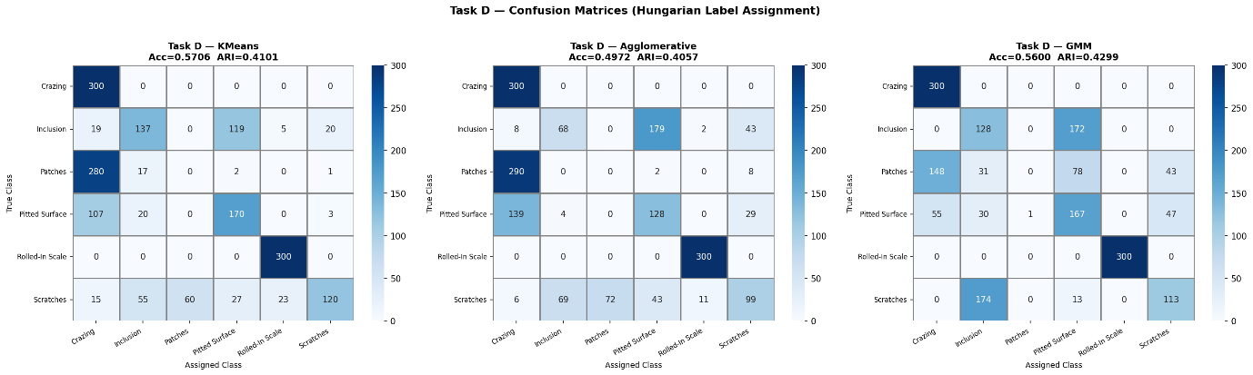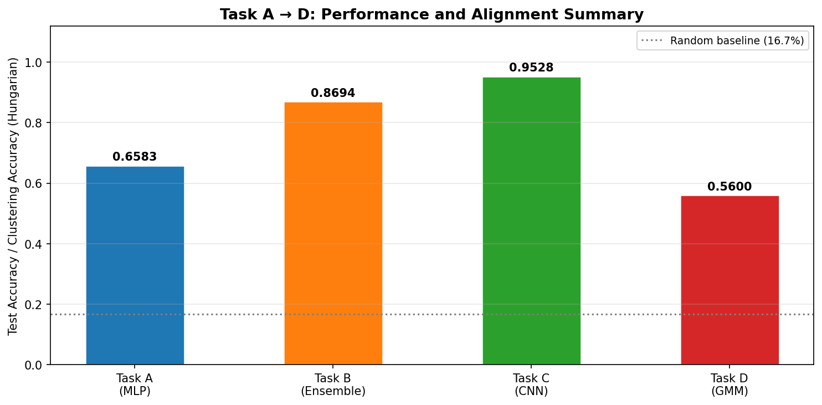

9. Comparative Analysis
Task | Method | Test Accuracy | Macro F1 | Key Advantage
A | MLP (optimised) | 65.83% | 0.6534 | Simplicity; interpretable baseline
B | Stacking Ensemble | 86.94% | 0.8693 | HOG spatial features; GPU-free; interpretable
C | CNN (4 conv blocks) | 95.28% | 0.9528 | End-to-end learned features; best accuracy
D | GMM clustering (best) | ~56% | N/A | No labels required; defect discovery

The progressive increase of generalization from an initial supervised classification (65.83% → 86.94% → 95.28%), demonstrates that higher spatial inductive biases enhance texture classification. In addition to the overall performance, the primary contributor to this improvement was the quality of feature representations. For example, the use of HOG as a feature representation provided a relative accuracy gain of +21 pp compared to using raw pixel data. Furthermore, the additional feature representations learned through convolutional neural networks provided a relative accuracy gain of +8.34 pp when optimizing both feature extraction and classification simultaneously. This indicates that the CNN used here has an ability to minimize overfitting due to its regularization, even though it was trained with a relatively small dataset. Therefore, the ensemble represents the optimal accuracy/ interpretability trade-off for production deployments where there are auditing requirements but no need for deep learning infrastructure.
Method | Strengths | Weaknesses
MLP | Fast; simple; no GPU | No spatial awareness; extreme bottleneck
Ensemble | Interpretable; GPU-free; robust | HOG not adaptive; rotation sensitivity
CNN | Highest accuracy; end-to-end | Complex regularisation; slower training
Clustering | Label-free; defect discovery | Lower accuracy; ambiguous alignment

10. Ethical and Social Impact
Automated defect detection systems carry significant social and ethical implications in manufacturing contexts.
- Employment: AI inspection directly displaces semi-skilled visual inspection roles. Responsible deployment requires worker retraining programmes and transparent communication with affected staff.
- Bias: the NEU dataset reflects controlled laboratory conditions with one steel grade. A model trained here may underperform on different grades or lighting conditions (domain shift), potentially producing systematic missed defects or false positives in production.
- Reliability and oversight: 95.28% accuracy means approximately 1 in 20 images is misclassified. In high-throughput production, this corresponds to hundreds of errors per day. AI should augment — not replace — human inspection for safety-critical decisions, with human review of low-confidence predictions.
- Safety: steel is used in safety-critical applications. A missed defect can cause structural failure. Defect classification alone is insufficient; severity, location, and downstream application context must inform accept/reject decisions.
- Transparency: deep learning models are opaque. Explainability tools such as Grad-CAM should accompany CNN deployments to satisfy ISO 9001 quality documentation requirements and support regulatory audit trails.

11. Conclusion
The above research investigates four different approaches to machine learning for classifying defects in the surface of steel using the NEU Surface Defect Database. The results show that there is a clear trend of increasing performance from MLP (Multilayer Perceptron) to Stacking Ensemble and finally CNN (Convolutional Neural Network): 65.83%, 86.94% and 95.28%.
In addition to these findings, it was shown that task A demonstrates how preprocessing and the optimal choice of training parameters are able to obtain an impressive increase of 40.55 pp in the performance of a severely restricted model as a result of optimising over five phases; however, this clearly has its limits due to the nature of spatial data.
Additionally, in task B, the use of HOG features engineered by principles, along with the effect of diversity of ensembles, can achieve better performance than neural networks running on raw pixel values and also do so with no access to any GPU resources.
Finally, task C shows that, under appropriate regularisation conditions, the best generalization performance is achieved by learning end-to-end convolutional features, which is superior to all other methods for texture based defect classification even when working at very low dataset sizes.
The primary conclusion is that feature representations are by far the most important variable influencing performance in all three task types. While architectural complexity does play a role with respect to the quality of feature representation (i.e., the quality of the feature representation), it has been found to be less important than the overall quality and spatially appropriate nature of the input representation. In terms of an industrial deployment environment, the CNN is capable of providing the highest levels of accuracy in terms of classification when compared to other architectures; however, the ensemble pipeline can provide interpretability and simplify the infrastructure necessary for audit-constrained environments.

12. References
Breiman, L. (2001) 'Random Forests', Machine Learning, 45(1), pp. 5–32.

Dalal, N. and Triggs, B. (2005) 'Histograms of Oriented Gradients for Human Detection', CVPR 2005, vol. 1, pp. 886–893.

Geurts, P., Ernst, D. and Wehenkel, L. (2006) 'Extremely Randomised Trees', Machine Learning, 63(1), pp. 3–42.

Ioffe, S. and Szegedy, C. (2015) 'Batch Normalization: Accelerating Deep Network Training', ICML 2015, pp. 448–456.

Kingma, D.P. and Ba, J. (2015) 'Adam: A Method for Stochastic Optimization', ICLR 2015. Available at: https://arxiv.org/abs/1412.6980

LeCun, Y. et al. (1998) 'Gradient-Based Learning Applied to Document Recognition', Proceedings of the IEEE, 86(11), pp. 2278–2324.

Mu, X., Yao, D. and Sun, H. (2018) NEU Surface Defect Database. Kaggle. Available at: https://www.kaggle.com/datasets/kaustubhdikshit/neu-surface-defect-database

Pedregosa, F. et al. (2011) 'Scikit-learn: Machine Learning in Python', JMLR, 12, pp. 2825–2830.

Rousseeuw, P.J. (1987) 'Silhouettes: A Graphical Aid to Cluster Analysis', Journal of Computational and Applied Mathematics, 20, pp. 53–65.

Srivastava, N. et al. (2014) 'Dropout: A Simple Way to Prevent Neural Networks from Overfitting', JMLR, 15, pp. 1929–1958.

Van der Maaten, L. and Hinton, G. (2008) 'Visualizing Data using t-SNE', JMLR, 9, pp. 2579–2605.

Wolpert, D.H. (1992) 'Stacked Generalization', Neural Networks, 5(2), pp. 241–259.

