NLG Change Impact
Automated review of every merge request into nlg-dev
GitLab MR pipeline · stage: change_impact
Purpose | Tell a developer what their branch affects, and what it may have forgotten
Runs as | A stage in the merge-request pipeline, from the branch's own code
Trigger | Opening or updating an MR into nlg-dev
Output | XLSX report, emailed to the developer; the job fails so it gets read
Owner | STAAT Data Science

1. Purpose
A merge request answers “what did I change?”. It does not answer the two questions that decide whether the change is safe: what does this affect downstream, and did I finish it?
The NLG codebase makes both hard to answer by eye. A method can be reached by ninety tasks across several DAGs through dynamic dispatch, so a small edit can have wide reach. And a change in one file frequently implies the same change elsewhere — a key added to one config but not its sibling, three of four call sites updated. Neither shows up in the diff: the evidence for an omission is in the files nobody touched.
This check runs automatically on every merge request into nlg-dev, works both questions out, and emails the developer a report before the merge goes ahead.
Why every run fails, even a clean one
A passing job with a note attached is not read. Failing puts the report in front of the developer at the one moment the fix is cheap — while the change is still their active work. It is a prompt to look, not a gate: once they have looked, they override the job and carry on. That is one click, and it is the whole cost of making sure the report was seen.

2. How it runs
The task sits in the merge-request pipeline and calls one script from the branch itself.
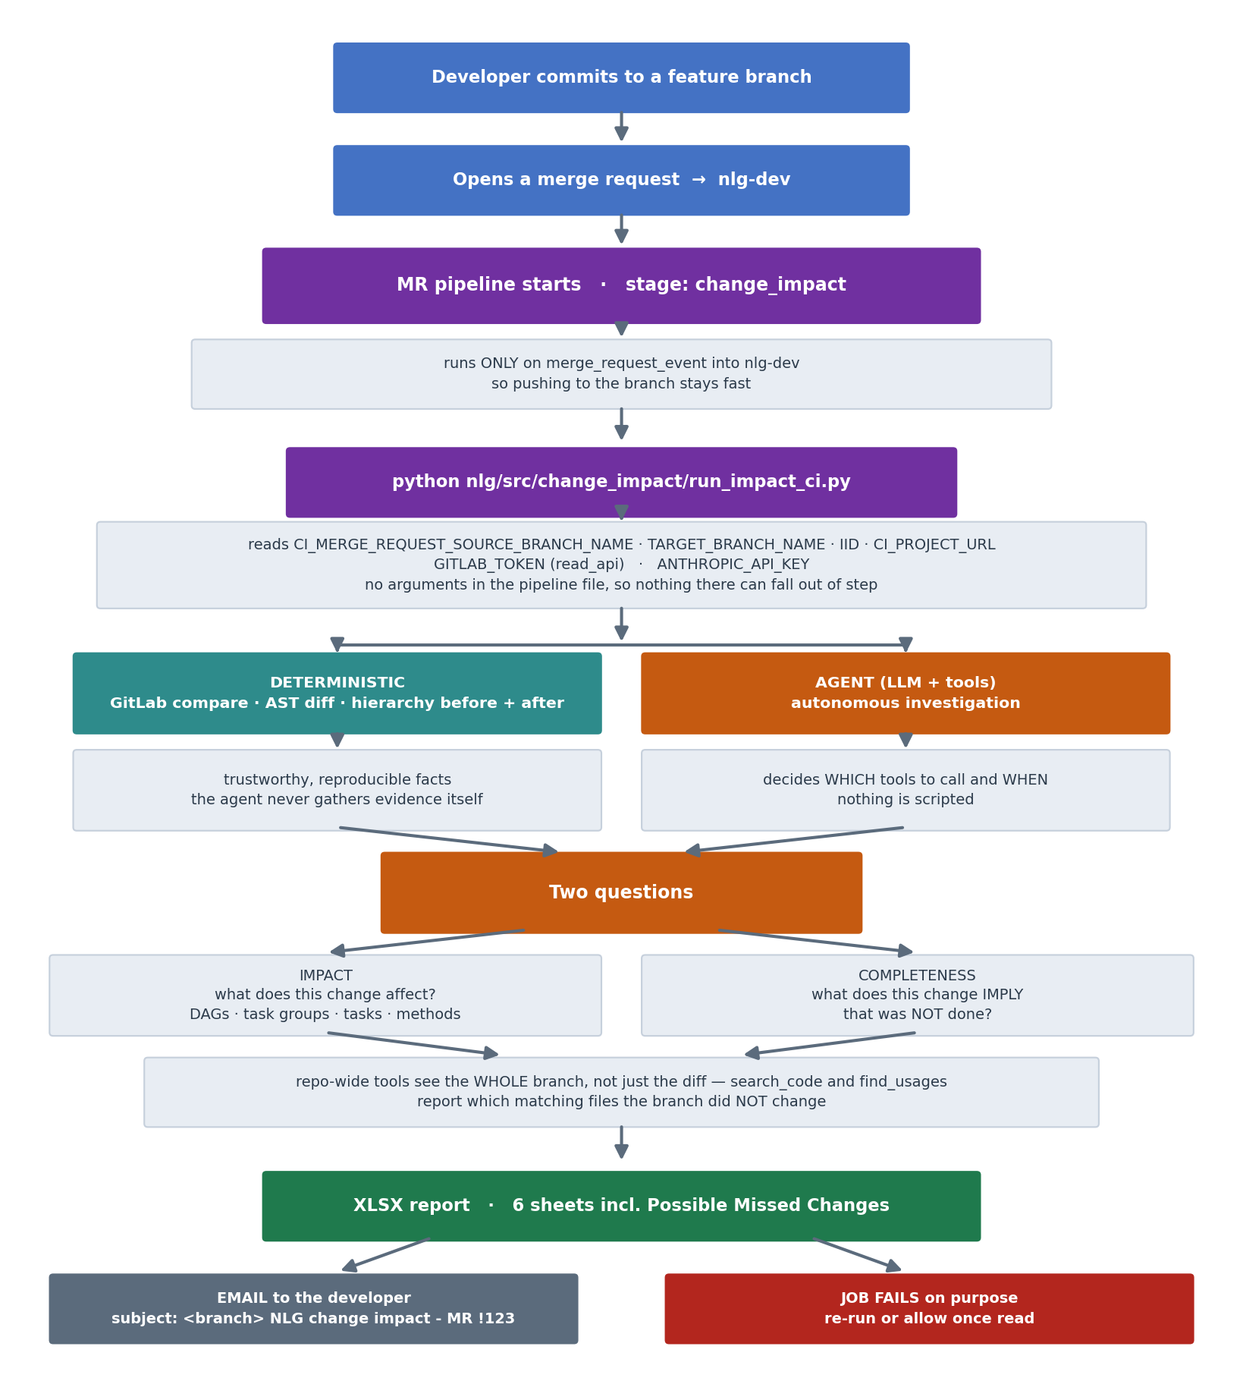

3. Wiring it into the pipeline

The stage
nlg_change_impact:
stage: change_impact
image: python:3.8
rules:
- if: '$CI_PIPELINE_SOURCE == "merge_request_event" &&
$CI_MERGE_REQUEST_TARGET_BRANCH_NAME == "nlg-dev"'
before_script:
- pip install --quiet requests openpyxl anthropic
script:
- python nlg/src/change_impact/run_impact_ci.py
artifacts:
when: always
paths: ["nlg_change_impact_*.xlsx"]
allow_failure: true
One command, no arguments. Everything comes from the CI environment, so there are no branch names or MR numbers in the pipeline file that can fall out of step with reality.

What the script reads
Variable | Used for
CI_MERGE_REQUEST_SOURCE_BRANCH_NAME | the feature branch — the one input the program needs
CI_MERGE_REQUEST_TARGET_BRANCH_NAME | the base to compare against (nlg-dev)
CI_MERGE_REQUEST_IID · CI_PROJECT_URL | the subject line and the MR link
CI_JOB_TOKEN | issued by GitLab to every job — no token to provision
ANTHROPIC_API_KEY or the ini | the model key
All of the CI_* values are set automatically in a merge-request pipeline. No GitLab token is created, stored or rotated: the job authenticates with its own CI_JOB_TOKEN.

The config file
change_impact_config.ini <- beside the scripts
[email]
to = pratik.shah.2@ubs.com
[llm]
api_key = <- prefer the masked CI/CD variable
Precedence for every value: environment variable → ini → built-in default. The pipeline supplies the key as a masked variable; the ini carries the recipients, so changing who gets the report is an edit to one line in the branch.

Where the files live
nlg/src/change_impact/
run_impact_ci.py <- the pipeline calls this
change_impact_config.ini
ci_config.py · ci_email.py
nlg_impact_agent/ <- the analyser
nlg_dag_agent/ <- bundled dependency
All in the feature branch. The script puts its own folder on sys.path, so there is no packaging or install step — and a branch that changes the checker tests the new version on itself.

Every run fails, every run emails
The job ends non-zero on every outcome — clean, findings, or the check itself breaking — and the report is emailed every time. A green job is not read.
Code | Meaning
1 | there is something to read
2 | the check itself could not run
3 | clean — no impact and no gaps; still fails so the report is seen
All three are overridable. With allow_failure the job shows as failed-with-warning and the pipeline carries on; the developer reads the report and, if nothing needs action, proceeds. The codes stay distinct so the log says why it stopped.

4. What the developer receives
 | Detail
To | pratik.shah.2@ubs.com (override with CHANGE_IMPACT_EMAIL_TO)
Subject | <branch> NLG change impact - MR !123
Body | the MR link, a summary table, and any possible missed changes inline
Attachment | the full XLSX report
The body leads with the merge-request link so the developer can go straight from the mail to the change without hunting for it.

The report
Sheet | Contents
Summary | what the branch does, counts, per-change verdicts
Change Impact Detail | each change → DAGs, task groups, tasks and methods affected
Possible Missed Changes | where the branch looks incomplete
Changes (no task match) | changes with no reachable task
CID Masking Compliance | deterministic CID check, no LLM involved
Tool Call Transcript | every tool call and result — the audit trail

5. How the analysis works
Step | How
Find changed files | GitLab Compare API — deterministic
Find changed functions and calls | AST diff — deterministic
Build the DAG hierarchy, before and after | reuses the existing hierarchy builder
Decide what matters, and what is missing | the LLM agent, via autonomous tool use
Keeping the first three deterministic means every fact the agent receives is reproducible. Its job is interpreting evidence, not gathering it.

Question one — impact
What does this change affect? The agent investigates as it sees fit — there is no scripted sequence of tool calls. It decides which changes warrant a closer look, whether to re-check a surprising result, and when it has enough evidence. A comment edit, a brand-new function nothing calls yet, and a change to a method ninety tasks reach are not treated alike just because all three are “changes”.

Question two — completeness
What does this change imply that was not done? This needs the whole branch rather than the diff, because the evidence for an omission is in files nobody touched. Five repo-wide tools:
Tool | Answers
search_code | every line matching a pattern, and which matching files the branch did NOT change
find_usages | every call site of a symbol repo-wide, and which of those files went untouched
find_definition | where a function or class is defined
read_file | any file, changed or not — to confirm a suspicion before reporting it
list_repo_files | the siblings of a changed file
Typical findings: an insight_type wired into the SQL mapping but never into the dummy config; a signature change applied to three of four call sites; a key added to one environment section but not the other.
Every gap carries evidence — file paths and line numbers the agent actually looked at — plus files to check, a confidence level and a recommendation.
Low-confidence gaps are reported on purpose
The agent is told to raise a doubtful gap rather than stay silent. A developer dismisses a wrong suggestion in seconds; nobody ever finds an omission that was never mentioned. Equally, it does not invent gaps — an empty sheet is the right answer when the branch is consistent, and it says so explicitly rather than just being blank.

