NLG Branch Change-Impact Agent
Purpose, architecture, and how the agent reasons about impact

1. Executive Summary
This project answers a question every developer and tester faces before merging a branch: "what, exactly, do I need to test?" Rather than re-testing the entire NLG pipeline for every change, or trusting a manual read of the diff, this system automatically determines the precise set of DAGs, task groups, tasks, and methods a branch's changes actually affect -- and just as importantly, which parts of the diff have no current effect at all.
It combines deterministic code analysis (git diffing, AST parsing, DAG hierarchy construction) with a genuinely autonomous LLM agent that investigates each change the way an experienced engineer would: by asking targeted questions, following up on surprising answers, and only concluding once it has real evidence.

2. Purpose and Problem Statement
The NLG codebase drives narrative generation across dozens of DAGs and hundreds of tasks. A single shared function, such as the dispatcher that generates rule narratives, can be called by 90 or more tasks across many DAGs. A single file, such as the database utility module, can be imported throughout the codebase. In a system this interconnected, two problems recur:
- Under-testing: a change looks small (one function, one file) but is actually load-bearing for dozens of tasks -- and that's easy to miss on a manual diff review.
- Over-testing: a change looks risky (it touches a "core" file) but is actually an unreachable new function or a cosmetic edit -- and blanket "test everything" policies waste time on it.
This project exists to replace both guesses with an evidence-based answer: for this specific branch, here is exactly what changed, here is exactly what it does and doesn't affect, and here is why.

3. Business Benefits
Benefit | Why it matters
Faster, scoped regression testing | Testers get a specific list of impacted DAGs/tasks instead of re-testing the whole pipeline for every branch.
Catches non-obvious risk | A file rename with 68 dependent tasks is exactly the kind of change a human reviewer skimming a diff can miss.
Avoids false alarms | New, not-yet-wired-up code and cosmetic changes are correctly excluded from the impact list, so testing effort isn't wasted.
Auditable reasoning | Every conclusion cites the specific evidence (task counts, caller files) the agent found -- reviewable, not a black box.
No maintenance when logic changes | Because the agent reasons over the branch's actual current code and hierarchy, it doesn't need to be updated when the underlying query-building or dispatch logic changes.

4. Architecture Overview
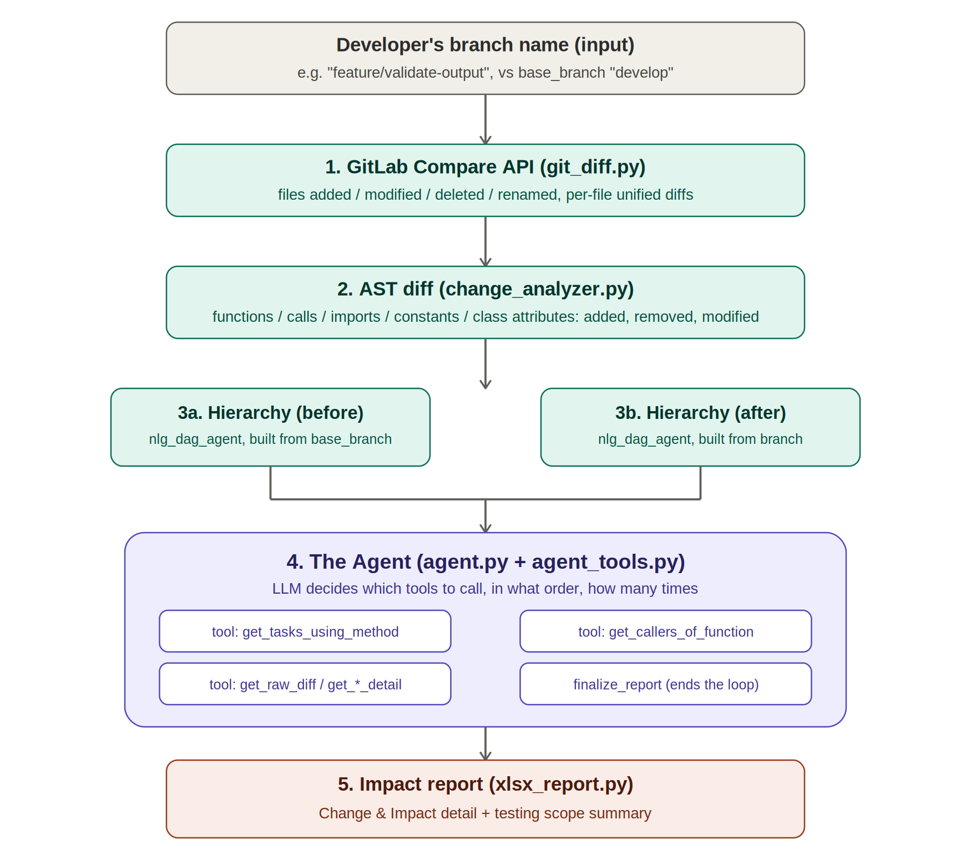
Figure 1. End-to-end pipeline: from a branch name to a ranked, evidence-based impact report.
A developer supplies a branch name (and, optionally, which branch to compare it against -- develop by default). From there, the system runs five stages, the first three of which are pure, deterministic static analysis with no judgment involved, and the last of which is where the actual thinking happens.

5. Understanding the AST: what static analysis can and can't tell you
An Abstract Syntax Tree, or AST, is what you get when you parse source code the way a compiler does: not as lines of text, but as a tree of structured elements -- this is a function definition, this is a call to another function, this is an argument list, and so on. Comparing two files' ASTs, rather than their raw text, is what lets this system tell the difference between a change that matters (a different function is now being called) and one that doesn't (a comment was added, or code was merely reformatted).
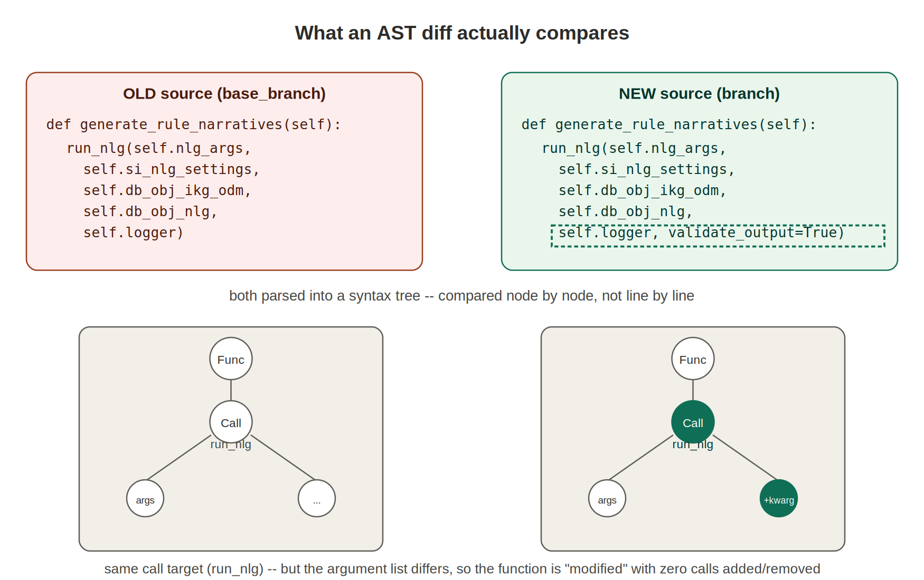
Figure 2. The same call target (run_nlg) with a different argument list -- structurally a "modified function," not a "new call."
This distinction matters in practice. Early in this project's development, a real change was found where a function's argument list changed but the function it called did not. A naive text-diff tool would just say "this line changed." The AST-aware analysis instead reports precisely what changed structurally, and flags it for the agent to inspect further -- rather than either over-simplifying it as "nothing changed" or under-explaining it as an opaque line edit.
Static analysis alone, however, cannot answer the question that actually matters for testing: does this specific change matter? An AST diff can tell you a function's calls changed; it cannot tell you whether that function is reachable from anything real, or whether a changed constant is ever read by code that runs today. That judgment is what the agent is for.

6. What's Deterministic vs. What's Agentic
Step | How | Kind
Find changed files (added/modified/deleted/renamed) | GitLab Compare API | Deterministic
Find changed functions/methods, and calls within them | AST diff | Deterministic
Find changed imports, module constants, class attributes, whole classes | AST diff | Deterministic
Build the DAG/TaskGroup/Task hierarchy (before AND after) | Reuses Project 1's engine verbatim | Deterministic
Decide whether a specific change has real impact, and on what | LLM agent, autonomous tool use | Judgment (agentic)

7. What "Agent" Means Here, and How It Decides
The word "agent" is used precisely, not loosely. This is not a script that runs a fixed checklist of checks in a fixed order. It is a large language model given a set of tools -- functions it can call to ask specific questions about the codebase -- and told to investigate a set of code changes however it judges necessary, then report its conclusions.
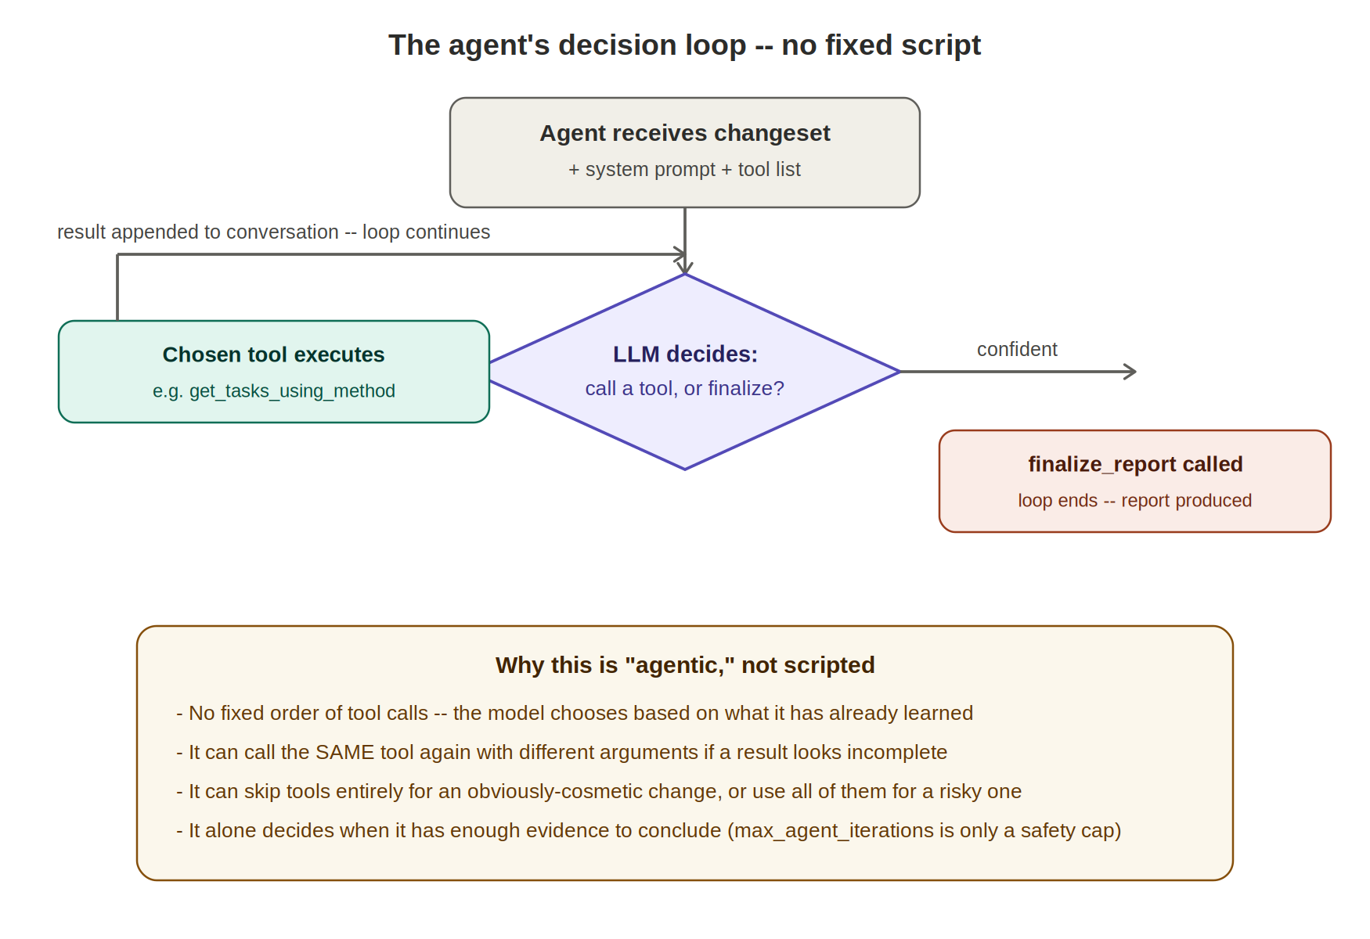
Figure 3. The agent's own control loop: it, not a script, decides what to do next at every step.
Concretely, the agent has access to nine tools: it can list every changed file, pull the exact before/after code for any specific function or module-level change, read raw diffs, and -- most importantly -- ask the DAG hierarchy which tasks actually execute a given piece of code today, both in the branch's new state and in the state before the change (needed to correctly assess something that was removed). The model decides which of these to call, with what arguments, and in what order. It can call the same tool twice with different inputs if a first answer is ambiguous. It calls a final tool, finalize_report, only when it judges it has enough evidence -- there is no point at which the surrounding code tells it what to conclude.

8. How the Agent Assesses Changes and Impact
The system prompt driving the agent lays out one governing principle: a code change does not automatically mean everything downstream is impacted, and not every changed line is even reachable from a running task. The agent is instructed to treat several categories of change differently -- a brand-new function nothing calls yet, a comment or cosmetic edit, a change to a function used by dozens of tasks, a renamed file, a removed function, and a changed configuration value -- each with guidance on which tool answers that specific question.
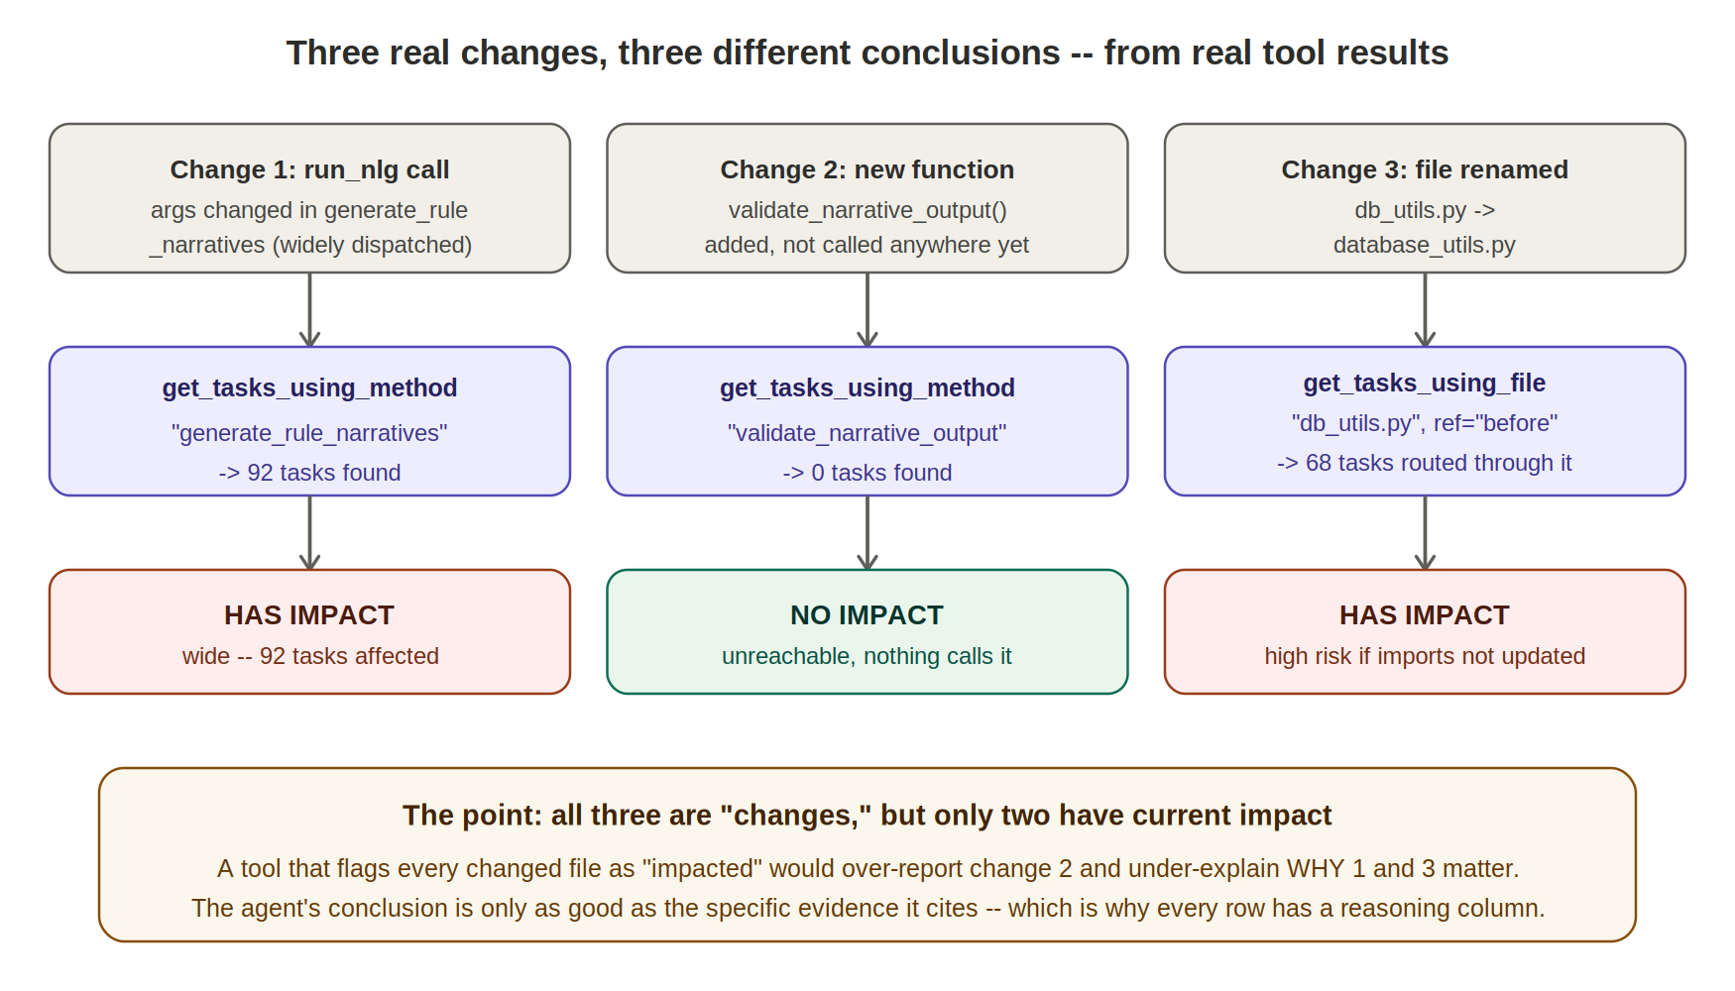
Figure 4. Three real changes from the same branch, three different, evidence-backed conclusions.
The three cases in Figure 4 are real results from validating this system against an actual, controlled set of changes made to the live NLG codebase. In each case, the agent's tool of choice returned a concrete number -- tasks found, or callers found -- and that number, not an assumption, is what determined the final verdict. A modified call inside a widely-used dispatcher was correctly identified as high impact by finding 92 dependent tasks. A brand-new, not-yet-wired-up function was correctly identified as having no current impact by finding zero. A file rename was correctly flagged as high-risk specifically because 68 tasks depended on its old path -- a fact a manual reviewer glancing at a rename in a diff could easily overlook.
A subtler case validated during development: a change to a comment above an existing function produced zero function-level or module-level changes at all, because the AST of the function was byte-for-byte identical before and after. It never reached the agent as a "change" to reason about in the first place -- filtered out at the deterministic layer, before any judgment call was needed.

9. The Impact Report
The system produces a four-sheet workbook. The primary sheet, Change Impact Detail, lists one row per (change, impacted task) pair, in the same DAG / sub-DAG / TaskGroup / task / method / file shape used elsewhere in this project family, plus a Change & Impact column describing exactly what changed and an Impact Reasoning column citing the evidence behind the conclusion. Changes the agent found no task-level match for move to a separate Changes (no task match) sheet, so they remain visible for audit rather than disappearing. A Testing Scope Summary sheet rolls everything up into the unique set of impacted DAGs, TaskGroups, tasks, methods, and files, plus the agent's own narrative summary of the branch as a whole -- the single artifact a test lead needs to scope a regression pass.

10. Known Limitations
- Reachability is name-based, not type-resolved -- the same convention used throughout this project family. A function name shared by two unrelated classes could, in principle, be conflated; the agent is instructed to cross-check surprising results, but this is a structural limitation of static analysis in a dynamically-typed language, not something any tool can fully eliminate.
- The agent requires a working LLM connection; unlike the other tools in this project family, there is no meaningful fallback, because the central task -- judging whether a change matters -- is the one thing static analysis cannot do on its own.
- Cost and runtime scale with the size of the changeset: each distinct change may need several tool calls, and building both the before and after hierarchy roughly doubles the non-agent portion of the runtime.
- Every run re-investigates from scratch by design, since a branch's code and the surrounding hierarchy can both change between runs -- there is no caching of prior conclusions.

11. Conclusion
This project turns "what does this branch actually change?" from a manual, error-prone diff review into a structured, evidence-backed report -- built on deterministic code analysis where deterministic analysis suffices, and handed to an autonomous agent only for the one part of the problem that genuinely requires judgment: deciding whether a specific change matters, and to whom.

