CID Analysis
Client-Identifying Data check for the NLG dummy pipeline
nlg_dummy · nlg_dummy2
Purpose | Stop client-identifying data reaching the narrative output unmasked
Runs as | A task in the existing nlg_dummy and nlg_dummy2 DAGs, after start_nlg
Outcome | XLSX + HTML report, emailed on every run; the task fails when a person must look
Owner | STAAT Data Science

1. Purpose
The NLG pipeline turns rows from profile tables into narrative text that a client or an adviser reads. Some of those columns hold client-identifying data — names, addresses, account identifiers. Where such a value is written into narrative text, or selected into the dummy configuration without being hashed, it is exposed.
This check reads the code deployed on the worker — the code about to run — works out exactly where each CID column's value would reach the output, and stops the pipeline when it finds one that is not masked. It also reports every column newly added to a profile table, because until somebody decides whether a new column is client-identifying, nobody can say the pipeline is safe.
Why it fails the task rather than just warning
A warning in a log is read after the fact. Failing the task stops the run at the point the problem was introduced, while the change is still someone's active work — which is the only moment the fix is cheap.

What it protects against
Risk | How the check catches it
A CID column written into narrative text | Step 3 — any exposed use in sql_column_mapping
A CID column selected without hashing | Step 4 — any exposed use in input_data_config_dummy without MD5
A new column nobody has classified | Step 5 — every column present in the schema under test but not in production
A CID column added upstream and used immediately | Step 5 re-runs steps 3 and 4 on each new CID column

2. Process flow
The task sits immediately after start_nlg. Everything below happens inside it.
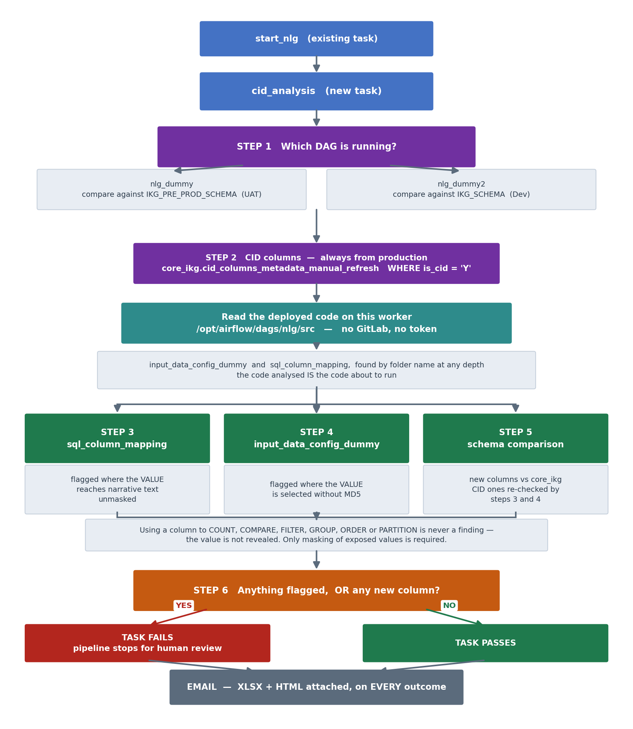

3. The six steps

Step 1 — which DAG, and therefore which schema
The task reads its own DAG id from the Airflow context. That decides which schema the profile tables are compared against in step 5.
DAG | Schema compared against production core_ikg
nlg_dummy | IKG_PRE_PROD_SCHEMA (UAT)
nlg_dummy2 | IKG_SCHEMA (Dev)
Nothing else has to be supplied. The code being analysed is the deployment on the worker, so there is nothing to select and no source-control credential to manage.

Step 2 — the CID column list
SELECT * FROM core_ikg.cid_columns_metadata_manual_refresh
WHERE upper(trim(is_cid)) = 'Y'
Always from production core_ikg, whichever DAG is running. A development copy of “which columns are client-identifying” would make the whole check meaningless.

Steps 3 and 4 — where the columns are used
Folder | What is flagged | Why the rule differs
sql_column_mapping | the value reaches narrative text unmasked | these expressions build the text a person reads
input_data_config_dummy | the value is selected without MD5 | this layer may carry CID columns provided they are hashed

Step 5 — new columns
Profile tables behind each dummy config are compared between the schema under test and production. A column present in one and not the other is new. Each new CID column then goes through steps 3 and 4; every new column is reported either way, with its data type and each place the deployed code uses it.
Views are excluded from the comparison: a view's columns are a projection of a table's, so counting them would report the same new column several times over.

Step 6 — the verdict
Situation | Task | Email
Nothing flagged, no new columns | passes | report sent
Anything flagged | FAILS | report sent
No flags but any new column | FAILS | report sent
Analysis could not run | FAILS | error sent
Why a new column alone fails the task
A new column is not a violation. But nobody has yet decided whether it is client-identifying, and a silent pass would let that decision be skipped entirely — the column would reach production unreviewed. This holds whether or not it is marked CID, and whether or not the deployed code uses it yet.

4. Where masking is actually required
A CID column leaks only when its value reaches the output. Using it to filter, count, group, compare or order reveals nothing, so those uses are not findings. Consider:
case when b.x > 0 then b.x else b.y end
The column appears twice and the two are judged separately:
Occurrence | Context | Verdict
when b.x > 0 | a test — the reader sees only whether it passed | no masking needed
then b.x | the returned value | must be hashed
So the fix is case when b.x > 0 then MD5(b.x) else b.y end — not masking the comparison, which would change what the test does.

Contexts that need no masking
Context | Example
COUNT, LENGTH, ARRAY_LENGTH, POSITION | count(b.acc_i)
PARTITION BY | OVER (PARTITION BY b.acc_mhh_n)
ORDER BY / GROUP BY | order by b.ip_frst_x
WHERE / HAVING / FILTER / join ON | filter (where b.ip_cli_i = '1')
A CASE WHEN condition | when b.x is not null
Either operand of a comparison | b.x > 0, b.x in (…), b.x is null
Contexts that DO expose the value: a bare selection, a THEN or ELSE result, STRING_AGG, MAX/MIN, COALESCE, SUBSTRING, UPPER/TRIM/INITCAP, string concatenation — anything whose output carries the value itself.

Masking is parsed, not pattern-matched
Expression | Masked?
substring(MD5(b.ip_frst_x),1,8) | yes
b.ip_frst_x | no
MD5(b.a) || b.ip_frst_x | no — the second use is bare
The third case is why searching the text for “md5” is not enough: the expression contains MD5, but one of the two uses is bare, and one bare use is enough to leak the value. Masking counts only when every occurrence sits inside a hashing call.
Output aliases are not uses
An alias usually repeats the column it came from — substring(MD5(b.lead_acc_title),1,8) as lead_acc_title. Counting the alias as a second occurrence would make a correctly hashed expression look like a leak, so the trailing alias is removed before anything is examined.

5. How it runs
Aspect | Detail
Source of the code | the deployment on this worker — /opt/airflow/dags/nlg/src
Folders read | input_data_config_dummy and sql_column_mapping, located by folder name at any depth
Network calls | Greenplum only — no source-control access, no token
Position | immediately after start_nlg
Why it reads from disk
The code the task analyses is the deployment that is about to run. Fetching the source from anywhere else could analyse a different revision from the one on the worker — the one thing this check must never do. Reading from disk removes that gap entirely, and is faster besides.

Wiring it into the DAG — two lines
from nlg.src.cid import build_task

cid_analysis = build_task()
chain(start_nlg, cid_analysis, nlg_latest_odm_insights, ...)
One task does the whole job: it analyses, writes both reports, emails them, and only then raises. Sending before raising is what makes a single task work — the attachment exists whether the run passed, found something, or errored.

Configuration
Setting | Purpose
IKG_SCHEMA | Dev schema — used by nlg_dummy2
IKG_PRE_PROD_SCHEMA | UAT schema — used by nlg_dummy
IKG_GP_GPRDSP | Greenplum connection
CID_EXCLUDE_KEYS | YAML keys exempt from the masking check; defaults to input_db_join_col
CID_EMAIL_RECIPIENTS | comma-separated; defaults to the STAAT DS list
input_db_join_col is excluded by default because it names the join key, which is never displayed — masking it would break the join without protecting anything.

6. What the report contains
XLSX and HTML, produced on every run and attached to the notification email. A clean report is the evidence the check ran, and is as much a part of the audit trail as a failing one.
Sheet | Contents
Summary | outcome, DAG, source scanned, schemas, counts, and the flagged tally by rule
Flagged | only the findings that fail the task
All findings | including the acceptable masked uses, so the report shows everything examined
New columns | every new column, one row per place it is used — see below

The New columns sheet
Self-contained, so the CID decision can be made without opening another sheet. One row per new column per place it is used, or a single row where it is not used yet.
Column | Contents
Profile Table · Target Type | where the column appeared
New Column · Data Type | e.g. character varying(50) — a text field and a numeric flag call for very different judgements
Is CID · Status | as recorded today, and whether this row needs action
Used In · File Path · YAML Key | exactly where
Masked · Exposure · Why | whether the value reaches the output, and the reason
Logic | the expression, verbatim
Action | what to do about this row

