Agile Dev Assist and Knowledge Packs – Why, For Whom, What Changes
Oct 24, 2026 · @Pratik

Summary
We built two things that work together: a Knowledge Pack – a context pack that contains everything about how our IKG / ODM / NLG code and tables are organised – and a Dev Assistant that uses it to turn a user story into finished, checked code in minutes instead of days. A person still reviews and approves every change.
 | In one line
The problem | Most of the time on a story goes into finding out how our code wants things done (which folder, which file to copy, where to register, which grant to add) – not into the logic itself. Misses show up late, in review or production
Who it is for | The developers who build IKG, ODM and NLG; then reviewers, new joiners, story writers and the people responsible for standards
What we built | Knowledge Pack: a context pack with the folders, files, tables, rules and conventions of each system.; Dev Assistant: a tool where you attach a story, press Run, and get the plan, the files, a check report and a review – then push it to GitLab under your own name
What changes | A routine story goes from 2–4 days to the same day. Mechanical mistakes are caught before the code is sent for review. Standards are checked on every file, every time. The knowledge stays current and does not leave with people
Proof so far | Two real stories: code files generated in few minutes, for under USD 2 each for token usage, with the mechanical parts right and only business questions left open
Guardrails | It never merges anything itself; it never rewrites your existing files blindly; it shows exactly which files, tables and rules it used; every branch and commit carries the developer’s name, no secrets stored on disk
What we ask | Write stories that name the tables and columns; keep the knowledge file current; review the result the way you review any merge request

The problem
Writing the logic is the small part of a story. The big part is finding out how our code base wants it done.
A simple example. A story says: “Add a new weekly profile table that shows each household’s credit-card interests.” The logic is a few joins and sums. But before a developer can write it, they have to answer, by searching the code and asking colleagues:
- Which of the 128 folders does a profile table go in, and what is the file called?
- Which existing file should I copy so mine looks the same (header, parameters, grants, distribution key)?
- Where is this file “switched on”? (There is a 260,000-character scheduling file that lists every script – forget the entry and the script never runs.)
- Which other files must change at the same time? (A history copy of the table, a config entry for archiving, a duplicate-key check, a validation query.)
- What does acc_mhh_n actually mean – statement household or marketing household?
Each answer lives in a different place: the code, a few markdown notes, and the heads of two or three senior people. So the same questions are answered again for every story, and a wrong answer is usually found late:
Where it hurts | What happens today
Review | The reviewer finds the missing registration or the missing history file after the merge request is opened – another round, another day
Production | A script nobody registered never runs; a missing grant breaks a downstream report
New joiners | Weeks before the first clean merge request
Consistency | Everyone writes the “same” file a little differently
Knowledge | When a senior person leaves, the reasons leave with them
Generic AI coding tools do not fix this. They do not know our folders, our scheduler, our Greenplum rules or our table meanings, so they produce plausible code that fails on exactly these points.

Who it is for
First for the developers who build IKG, ODM and NLG. But everyone around a story benefits.
Who | Today | With the tools
Developer | Hours of searching before the first line; something forgotten in review | A plan, the files, the registrations and a review in about 7 minutes; pushes to GitLab in their own name
New or rotating developer | Weeks to learn how the code is organised | The pack carries the conventions; the first merge request looks like a senior’s
Reviewer / tech lead | Spends review time on mechanical misses | Mechanical checks are done before the merge request; review time goes to the business logic
Story writer / product owner | Vague stories bounce back and forth | The assistant lists its open questions up front; a precise story runs in one pass
Standards / governance | Rules are documents nobody checks | 18 Greenplum rules checked on every file, every time; every change traceable to a story and a person

What we built
Two parts. One is the context pack that holds what the assistant needs to know; the other uses it to do the routine work of a story. People stay in charge of the result.
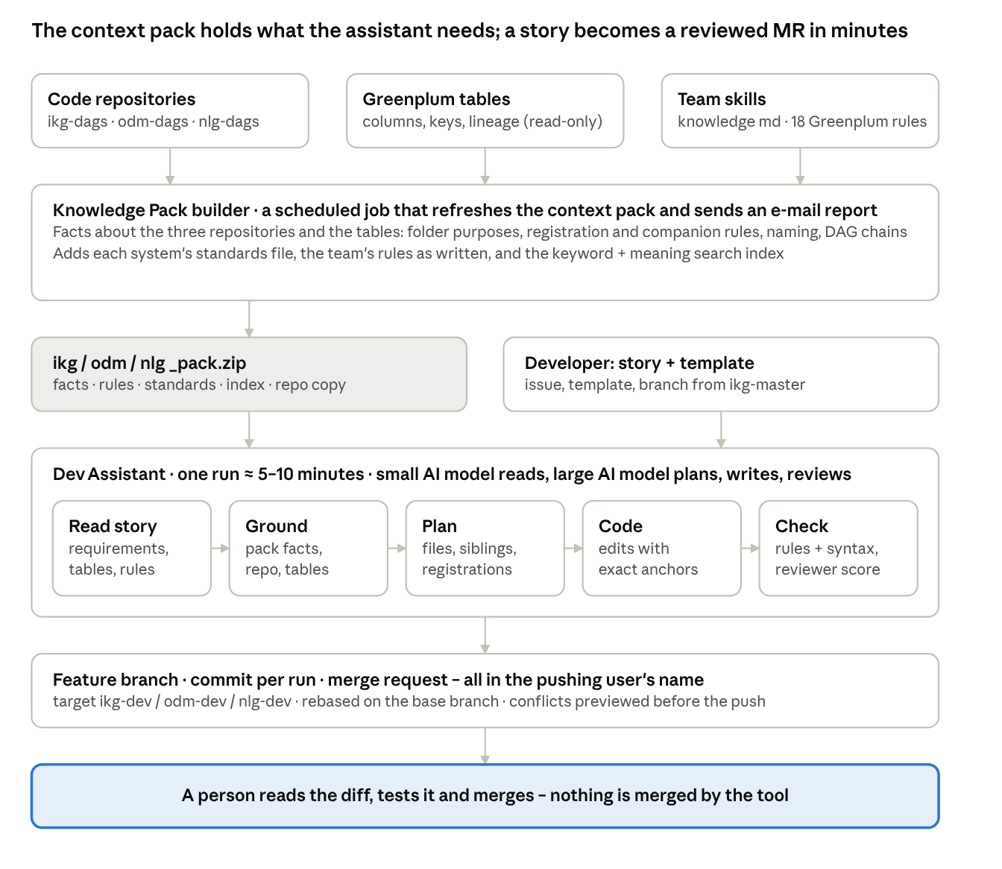
how the two parts fit · the context pack, the assistant per story, a person merges
Read it top to bottom: the code, the tables and the team’s notes go in; the Knowledge Pack comes out; the Dev Assistant combines the pack with a story; the result lands on a branch in GitLab under the developer’s name; a person reviews and merges.
The Knowledge Pack – the context pack. One pack per system (IKG, ODM, NLG), refreshed by a scheduled job that also e-mails what changed. A pack contains: what each folder is for and what a typical file in it looks like; which file switches a script on; which files change together; how tables and columns are named and what they mean; the team’s rules and standards; the team’s short notes; a search index; and a copy of the code. It answers every question from the example above, exactly and the same way for everyone, and nobody has to maintain it by hand. A refresh costs cents.
The Dev Assistant – a senior colleague who has read the context pack. A web page where a developer attaches the story, picks IKG / ODM / NLG and presses Run. Behind the button a team of AI helpers works in sequence: one reads the story and turns it into a checklist; one looks up the relevant facts in the pack; one plans which files to create and change; one writes each file; one checks every file against the rules; one reviews the result against the story. The developer sees the plan, the files, the check report, the review and exactly which sources were used – and can ask for changes in plain language before pushing.
Why both are needed. Without the pack, the assistant would have to re-read 1,100 files for every story (slow, expensive) or guess (wrong). Without the assistant, the pack is a reference nobody reads.

A story from start to finish
Take the example story: “Add a weekly profile table of each household’s credit-card interests, built from the smart-insights data.”
- Attach the story and pick IKG. The developer pastes the GitLab issue number. The assistant loads the IKG pack and shows the git conventions for IKG (branch from ikg-master, merge into ikg-dev).
- Create a feature branch. One form, three fields; the branch is created on the server. Nothing is in GitLab yet.
- Press Run (about 7 minutes). The assistant reports as it goes: story understood – 8 requirements, 3 code blocks, 8 tables → knowledge selected – 31 conventions, 40 definitions → plan: 9 files → writing → checking → review.
- Read the plan. It says, in plain words: put the heavy parsing in a new intermediate file, make the profile file a thin query over it, register both in the scheduling file, add the archive config entry, the duplicate-key check and a validation query. It also asks two questions it could not settle from the story (the exact table name, the schema parameter).
- Read the files and the review. Each file opens in the Files tab with a diff against the repository. The Review tab lists what was fixed automatically, what is still open and what is only advice, most serious first. A confidence score (0–100) says how carefully to read.
- Ask for changes in the chat. “Rename the table to …”, “add the history script” – only the affected files are regenerated.
- Push and MR. The developer types their personal GitLab token; the assistant pushes the branch and opens the merge request, both in the developer’s name, with the story, the file list and the scores in the description.
- Normal review and merge. A colleague reviews the merge request as always; the tool never merges.
Total developer time: the reading in steps 4–6 and the usual test in the dev environment – an hour or two, not days.

What changes
 | Before | After
Time from story to merge request | 2–4 days | Same day (about 7 minutes of generation, 1–2 hours of reading and testing)
Review rounds on mechanical issues (registration, grants, companion files) | 1–2 per merge request | 0 – caught before the merge request exists
Developer hours per routine story | 8–16 | 1–2
Cost of AI calls per story | – | under USD 2 (measured USD 0.64 and 1.76)
Files that follow all 18 Greenplum rules | not measured | checked on every file, every run
Age of the “how our code works” knowledge | months, or in someone’s head | always current, refreshed by a scheduled job
Who did what | sometimes unclear | every branch, commit and merge request in the developer’s name, with the story attached
What we measured on two real IKG stories (October 2026): a table-adjustment story produced 6 files (3 new, 3 changed) in 7 minutes for USD 0.64; a new-profile story produced 9 files in 13 minutes for USD 1.76. In both, the mechanical parts (folders, naming, grants, registrations, companions) were right; what was left open were business questions the story had not answered (“which exact filter set?”, “which table name?”). The same stories used to take 1–2 developer days each plus review rounds.
To keep the numbers honest, we keep a fixed set of real stories with the files we expect for each; after every change to the tools or the context pack all of them are re-run and compared, so quality is measured rather than claimed.

Why you can trust it
The worry | The answer
“It will make up how our code works” | It does not guess: the conventions come from the context pack. Every run shows a Sources used table – which file, table or rule was used, by which helper, and what was taken from it
“It will break my existing files” | Existing files are changed by small, exact find-and-replace edits, never rewritten from scratch. An edit that does not match the file exactly is refused. A change that would delete existing lines is refused unless the story explicitly replaces that file
“It will forget to register something” | A rule in code, not in the AI: every new script in a registered folder must be registered; every companion file (history copy, config entry) must be created or explicitly declined with a reason
“Standards are only words” | 18 Greenplum rules plus syntax checks run on every file. Findings are listed as Open, Fixed or Pre-existing, most serious first. The confidence score stays capped while a serious finding is open
“Nobody will know who did what” | The branch, every commit and the merge request are created with the developer’s own GitLab token and name. The tool never merges
“Passwords and keys will leak” | Keys, passwords and tokens are typed in at run time and kept in memory only – never saved to files, logs, chat history or git settings. The database is opened read-only
“It is a black box” | Every step, every look-up and every token is in the Log tab; the plan, the open questions and the sources are in the Plan tab; every helper’s output can be downloaded
“It will be expensive” | A small, cheap AI model does the reading; the large model does only the planning, writing and reviewing. Repeated inputs are reused for free. Measured: under USD 2 per story

What it does not do, and what we ask of you
Think of it as a senior colleague who writes the first draft and gets the boring parts right – not as a replacement for a developer.
- It does not run the SQL or the scheduler. It produces files; a person tests them in the dev environment.
- It is as good as the story. A story that names the tables, columns, filters and expected output runs in one pass; “adjust the eligibility logic” without saying how gives open questions and a medium score.
- It knows what the code does, not why. Business reasons (why a filter exists, what a household key means) must be written once by a person in the short team knowledge file.
What we ask:
- Write stories with the target folder, table names and expected columns; answer the assistant’s open questions in the story itself.
- Keep the team knowledge file current (definitions, abbreviations, business reasons). Everything else is generated.
- Review the generated merge request like any other: read the diff, run it in dev, merge or send back.
- Tell us about wrong findings or wrong plans. The tool does not learn on its own; we fix the cause (a checking rule, a fact in the context pack, a team note) and add that story to the fixed set of test stories we re-run after every change, so it cannot happen again unnoticed.

