NLG DAG hierarchy & impact-analysis agent
Architecture, agent design, and LLM usage

1. Overview
nlg_dag_agent is a static-analysis agent that reads the NLG Airflow codebase (nlg-dags and nlg-src) and reconstructs the full hierarchy -- DAG, sub-DAG / TaskGroup, nested TaskGroups, task, method or function, and the file each one lives in -- without being told the shape of that hierarchy in advance. It also answers impact-analysis questions ("what breaks if I change file/method/target_type X?") and exports everything to JSON and a formatted Excel workbook.
The exact same code runs in two contexts with zero changes: interactively in a Jupyter notebook (prompts for secrets), and unattended inside an Airflow DAG (reads secrets from an Airflow Variable).

2. System architecture
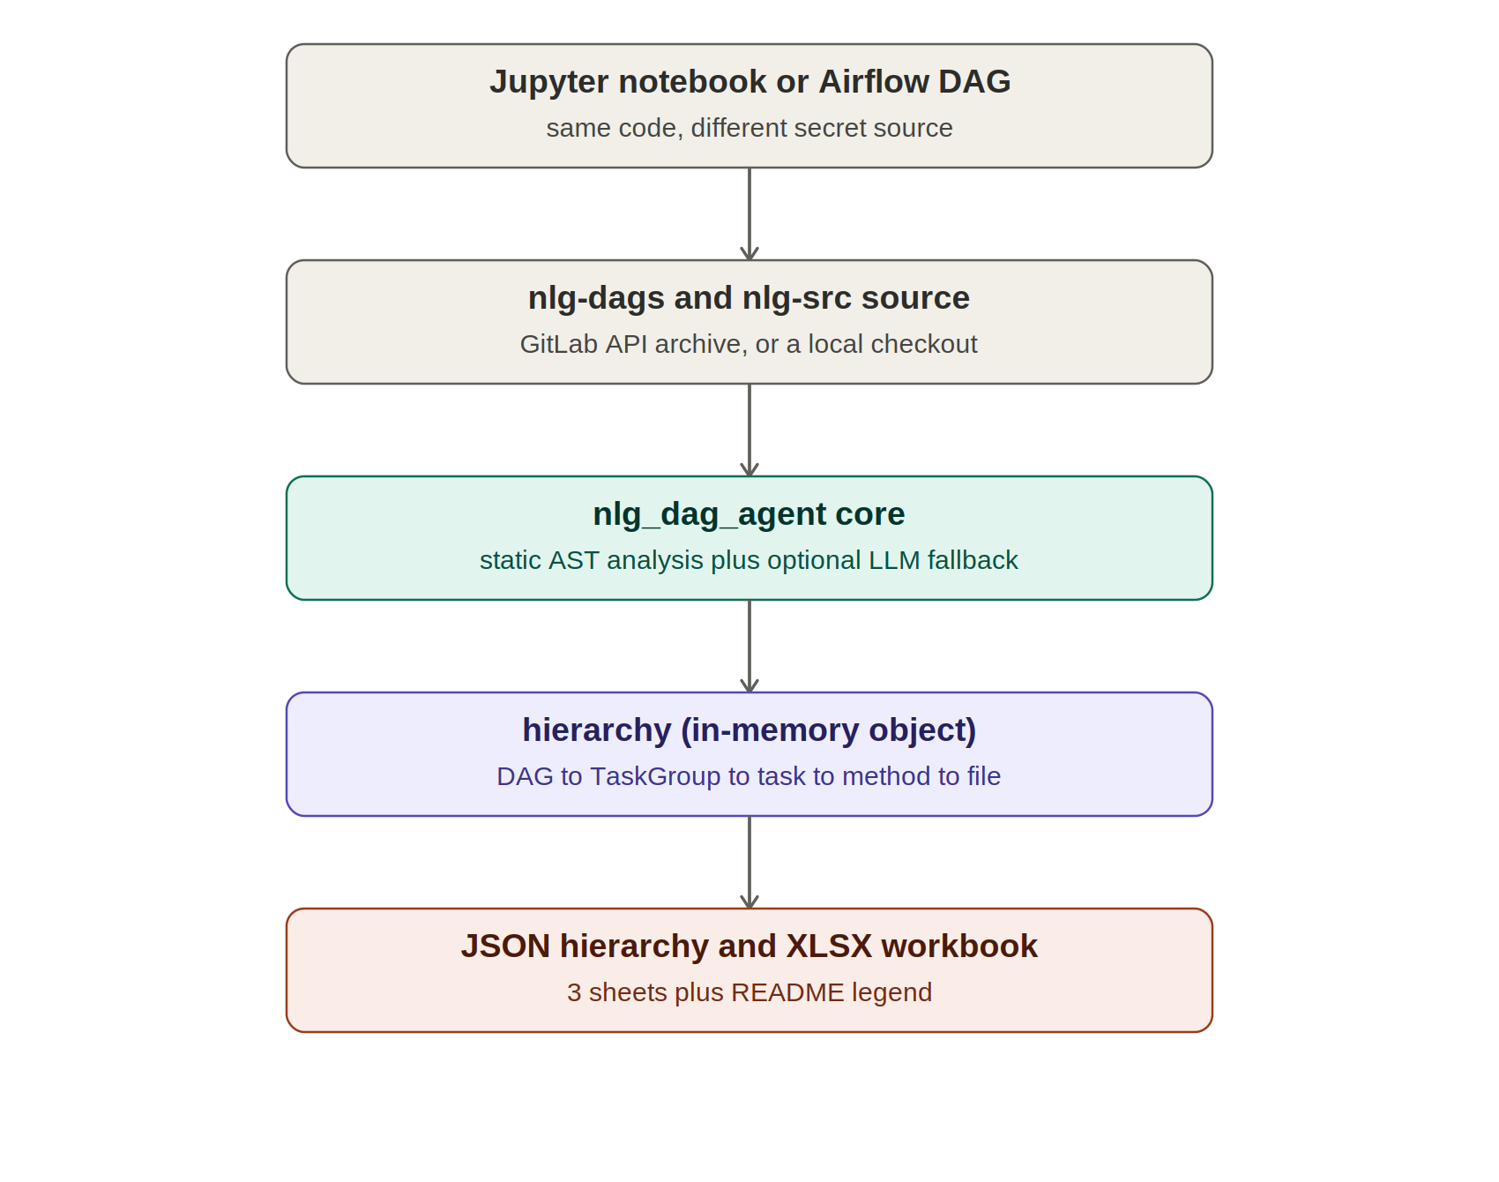
Figure 1. System context: runtime callers, source input, the core engine, the in-memory result, and the exported artifacts.
Both runtime callers (notebook and Airflow) invoke the identical build_hierarchy() entry point. Source is read either from a local checkout or directly from GitLab via a single bulk archive download (previously this fetched one file per HTTP request; it now downloads the whole subtree in one call, with a parallel-fetch and on-disk cache as fallbacks). The core engine returns an in-memory Hierarchy object, which is then serialized to a JSON file and/or a multi-sheet XLSX workbook.

3. Why is this called an "agent"?
For the large majority of what it does, this is plain deterministic code -- a Python ast parser, not a model. What earns it the "agent" label is its control flow and its role in a larger system, not the presence of an LLM:
- It perceives and reasons over an environment it wasn't told the shape of in advance. There is no hardcoded map of nlg_master's structure -- it reads arbitrary Python, figures out which functions are TaskGroups, which are dynamic-dispatch wrappers, and which classes own which methods, then reconstructs the hierarchy from scratch. A differently organized DAG file still works.
- It makes a sequence of resolution decisions per task, escalating strategies until one succeeds -- direct match, then the dispatch idiom, then LLM inference, then flag as unresolved -- rather than following one fixed code path. That escalating decision cascade is the agentic part of its control flow, independent of whether the LLM ever actually fires.
- It can act autonomously inside a larger system. Wired into Airflow, it runs unattended on a schedule, pulls fresh source, rebuilds the hierarchy, and can answer an on-demand impact-analysis question passed in via dag_run.conf -- no human in the loop for any of it.
- The optional LLM step is used as a tool the agent reaches for, not as the engine driving everything. That keeps the system deterministic and cheap to run over thousands of files, while still giving it a way to handle cases its static strategies can't -- closer to how "agent" is used for systems that plan and use tools than for a wrapper around a chat model.

4. Core pipeline: how a task gets resolved
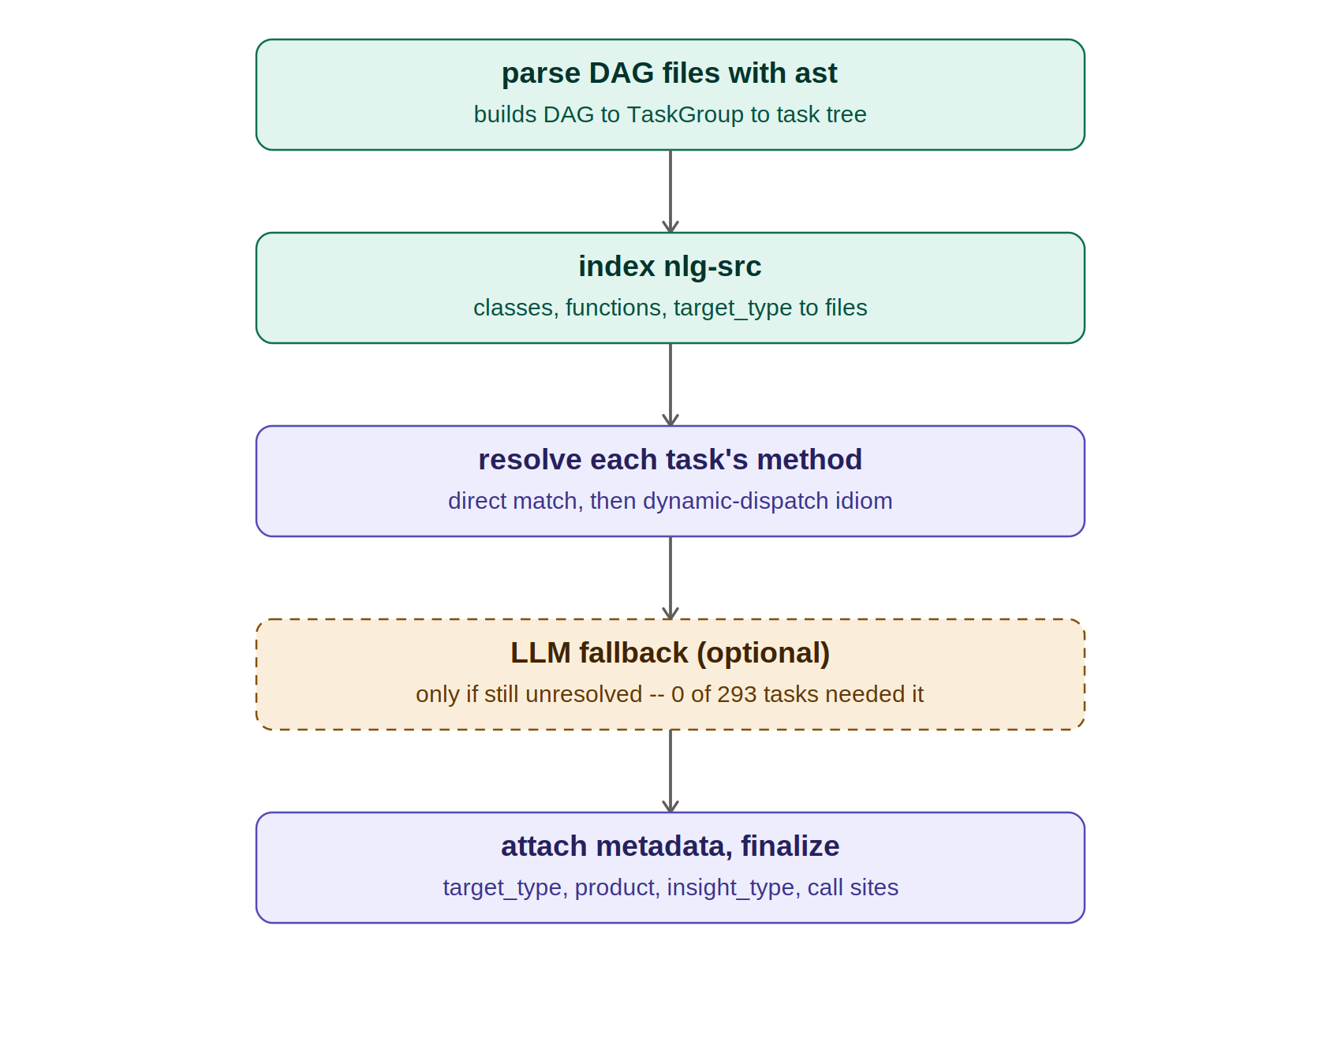
Figure 2. The five steps inside build_hierarchy(). The dashed box is conditional, not a fixed stage.
Steps 1 and 2 build two independent indexes: the DAG/TaskGroup/task tree from the DAG files, and a class/function/resource index from nlg-src. Step 3 tries to resolve each task's method with pure static analysis -- first a direct name match, then the dynamic-dispatch idiom. Step 4 (the dashed box) only runs if step 3 failed; on the actual nlg-dags / nlg-src codebase it never fired -- all 293 resolved methods came from step 3. Step 5 attaches target_type, product, insight_type, and reverse call-site metadata, and returns the finished Hierarchy object.

Resolution values, explained
Value | Meaning
static | Direct, unambiguous match -- the task's python_callable name was found as a real function or method definition in the code (module-level function in the DAG files, or a function/class method in nlg-src). No guessing involved.
dispatch | Resolved via the dynamic-dispatch idiom used throughout this codebase (eval(f"{obj}.{kwargs['action']}()")). The agent detected the pattern, read the task's actual op_kwargs, and resolved it to the real class method -- e.g. NLG.generate_rule_narratives.
llm | Neither of the above worked, so the LLM was asked to read the function body and op_kwargs and infer the real target. Flagged with a confidence level in the Notes column -- should be spot-checked manually.
unresolved | Nothing worked (no static match, no dispatch pattern, LLM disabled or also failed). Method/Function shows the raw python_callable name with file UNKNOWN -- needs a manual look.

5. How the LLM is actually used
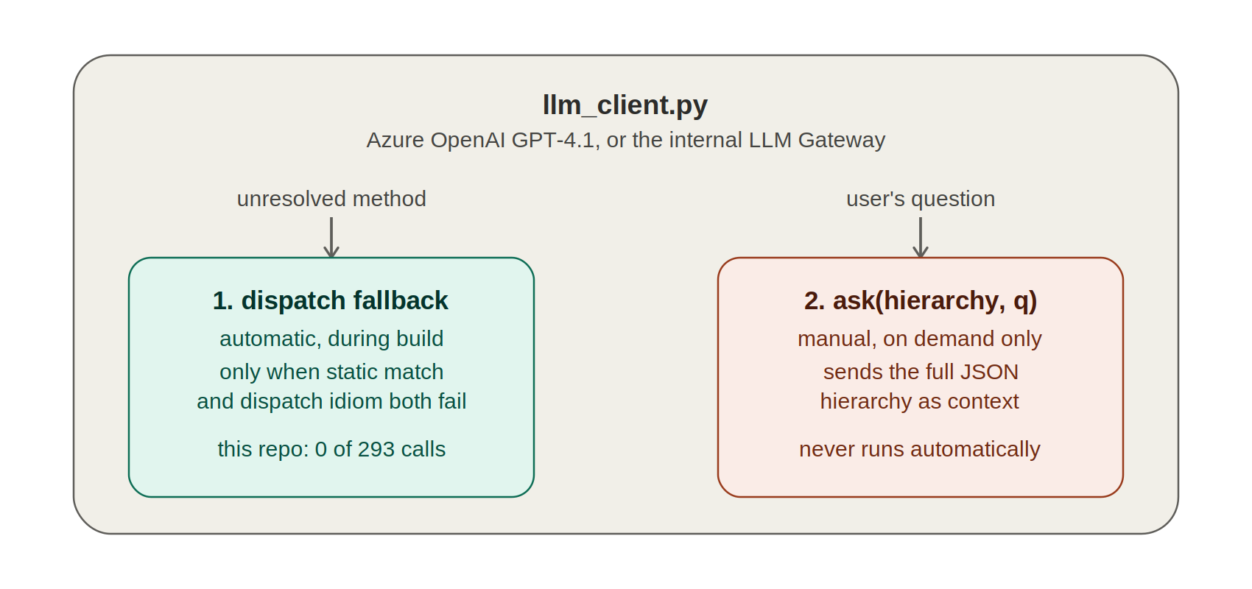
Figure 3. The two isolated, optional entry points into the LLM. Nothing else in the pipeline touches it.
1. Dispatch-resolution fallback -- automatic, inside build_hierarchy(), only reached if a task's python_callable matched neither a direct function/method nor the eval(f"{obj}.{action}()") dispatch pattern. It is sent the function's source and the task's op_kwargs, asked to return strict JSON ({"method", "confidence", "reasoning"}), and the result is tagged resolution: "llm" with the confidence and reasoning kept in the Notes column -- flagged for manual review, never silently trusted.
2. ask(hierarchy, question) -- a separate, manually invoked function. It serializes the already-built hierarchy to JSON and asks the LLM to answer a free-text question grounded only in that JSON. This never runs as part of build_hierarchy() -- it only runs when explicitly called.
Both are strictly optional. With llm_provider = "none" or no key configured, the tool still fully works -- it just can't answer entry point 1 for anything static analysis couldn't resolve (zero tasks, on the actual codebase), and ask() returns a message pointing to the structured impact_of_*() queries instead.

6. Module reference
Module | Purpose
config.py | All settings (LLM + GitLab), env-var overridable. Secret resolution: env var -> Airflow Variable -> interactive prompt.
source_loader.py | LocalSourceRepo and GitLabSourceRepo. GitLab mode downloads the whole subtree in one archive request, parallel fallback, on-disk cache.
dag_ast_parser.py | Core static extractor: DAG -> TaskGroup -> Task, via Python ast analysis, for both authoring styles found in this repo.
src_scanner.py | Indexes nlg-src: class -> methods, function -> file, and target_type -> resource files (yaml/sql/ini).
dispatch_resolver.py | Detects the eval(f"{obj}.{kwargs['action']}()") dynamic-dispatch idiom.
llm_client.py | Azure OpenAI / internal LLM Gateway REST client -- used only as fallback and for ask().
pipeline.py | Orchestrates everything: build_hierarchy(), run_impact_analysis(), ask(), tree printing, JSON export, call-site indexing.
xlsx_export.py | Exports a built Hierarchy to the 3-sheet .xlsx workbook (DAG Hierarchy, Product Hierarchy, YAML Insight Types).
__main__.py | CLI: python -m nlg_dag_agent build / impact.

