NLG Change Impact Agent
Functional and technical description
Automated impact and completeness review of every merge request into nlg-dev
What it is | An LLM agent that reads a feature branch, works out what it affects and what it may have forgotten, and tells the developer before the merge
Where it runs | A stage in the GitLab merge-request pipeline; also from a notebook for local testing
Inputs | The feature branch (from the pipeline), the repository, an Azure OpenAI deployment
Outputs | A 7-sheet XLSX report, emailed; a deliberately failing job the developer overrides once read
Owner | STAAT Data Science
Version | September 2026

Contents

1. Purpose and the problem it solves
A merge request shows what a developer changed. It does not answer the two questions that decide whether the change is safe to merge:
- What does this change reach? Which DAGs, task groups and tasks will behave differently, and therefore what must be tested?
- Is the change finished? A change in one place often implies the same change elsewhere. Was every implied edit made?
The NLG codebase makes both hard to answer by eye. Methods are reached through dynamic dispatch — a rule task calls a method by name from configuration — so a small edit to a shared method can be reached by ninety tasks across several DAGs, and nothing in the diff says so. And the pipeline is configuration-heavy: an insight type is wired into a SQL mapping, a dummy config, a DAG task list and a target-type map. Adding it to three of the four is a common, silent failure.
This project answers both questions automatically on every merge request into nlg-dev, and puts the answer in front of the developer while the change is still their active work.
Why an agent rather than a script
The first question — reachability — can in principle be scripted. The second cannot: judging whether a change is complete requires understanding what the change was trying to do, and then searching the rest of the codebase for places that share the same pattern and were left alone. That is an open-ended investigation whose next step depends on what the previous step found. A fixed script cannot do it; a language model with tools can. Section 4 explains how.

2. Functional overview

The developer's experience
Step | What happens
1 | The developer opens a merge request from a feature branch into nlg-dev
2 | The pipeline runs the change_impact stage automatically — no manual trigger
3 | Within a few minutes an email arrives: subject <branch> NLG change impact - MR !n, the MR link in the body, the XLSX attached
4 | The job shows as failed. The developer opens the report
5 | If it names something to fix, they fix it and push. If nothing needs action, they override the job and continue

What the report tells them
Sheet | Answers
Summary | What does the branch do, in plain language? How many changes, how many with impact, how many possible gaps?
Change Impact Detail | For each change: which DAGs, task groups, tasks and methods it reaches, why, and what a tester should verify
Possible Missed Changes | Where the branch looks incomplete — the change that implies more, what appears missing, the evidence, files to open, a confidence level
Changes (no task match) | Changes that reach no task — usually new code not yet wired in, or dead code
CID Masking Compliance | Client-identifying columns used without masking; deterministic, no model involved
Tool Call Transcript | Every tool the agent called and what came back — the audit trail behind every conclusion
README | How to read the report

Process flow
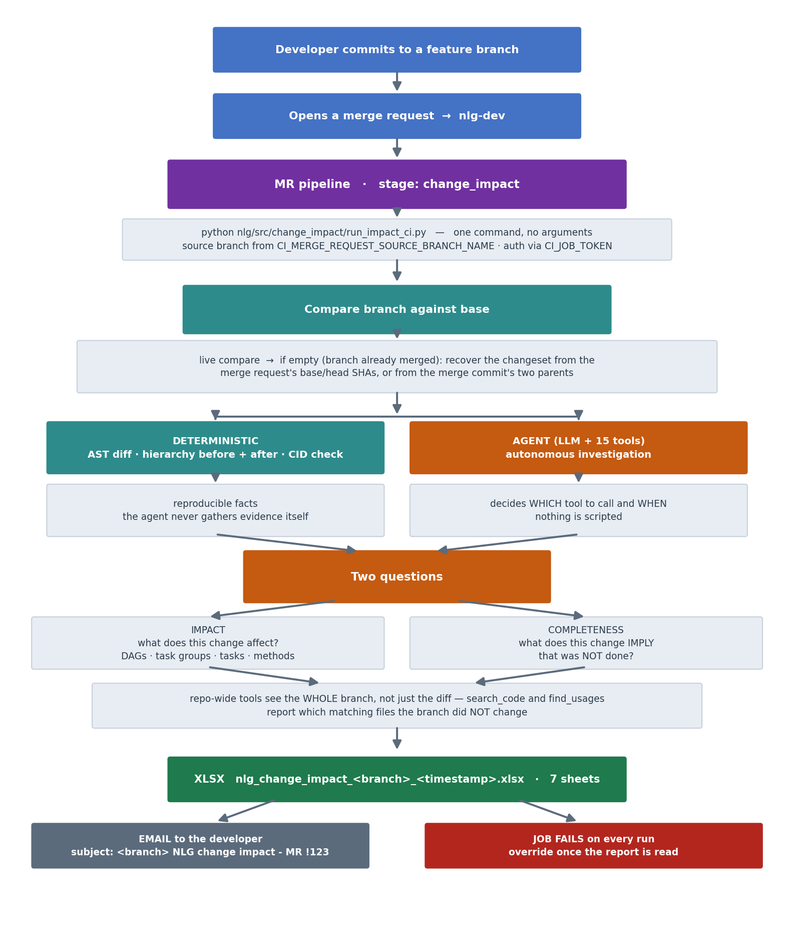

3. Technical architecture
Two packages, one principle: everything that can be computed deterministically is, and the model only ever interprets evidence that was gathered for it.
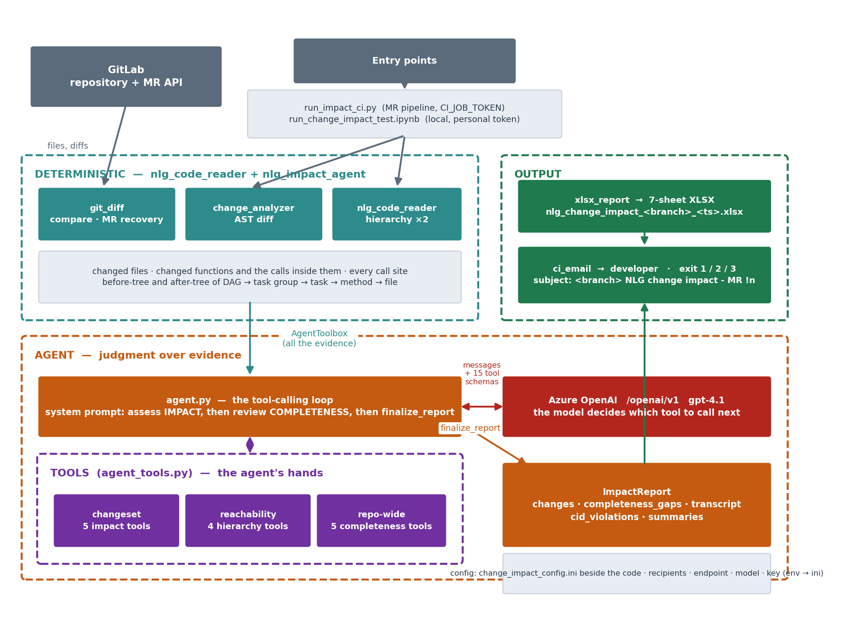

The deterministic layer
Module | Responsibility | Why deterministic
git_diff.py | Fetches the compare between branch and base. When the branch is already merged and the compare is empty, recovers the changeset from the merge request's diff refs, or from the merge commit's parents | Which files changed is a fact, not a judgment
change_analyzer.py | AST-diffs each changed Python file: functions added, removed or changed, and the calls each makes; also module-level changes (imports, constants, classes) | A function's body either changed or it did not
nlg_code_reader | Parses the repository's DAG and source files as text and builds the hierarchy DAG → task group → task → method → file, resolving the dynamic dispatch. Built twice: before and after | Reachability follows from the code as written
cid_check.py | Compares input_data_config, input_data_config_dummy and sql_column_mapping for CID columns exposed unmasked | A column is masked or it is not
The name nlg_code_reader is deliberate: it reads code. It never imports Airflow and never executes a DAG. The hierarchy it produces is the map the agent navigates.

The agent layer
Module | Responsibility
agent.py | Orchestrates a run: compare → hierarchies → AST diff → CID check → agent loop → ImpactReport. Holds the system prompt
agent_tools.py | The AgentToolbox: 15 tools the model can call, bound to the changeset and the two hierarchies. Also the finalize_report schema
agent_llm_client.py | The tool-calling loop: sends messages and tool schemas, executes each tool_call the model makes, feeds results back, until finalize_report
nlg_code_reader/azure_v1.py | Calls the Azure OpenAI v1 endpoint: base URL + /chat/completions, Bearer auth, adapts the payload when the model rejects a parameter
xlsx_report.py | Builds the 7-sheet workbook from the ImpactReport
verification.py | Independently re-checks the agent's reachability claims against the hierarchy

Entry points and configuration
File | Role
run_impact_ci.py | What the pipeline calls. Reads the source branch and MR number from CI_* variables, authenticates with CI_JOB_TOKEN, runs the analysis, emails, exits non-zero
ci_email.py | SMTP delivery: subject <branch> NLG change impact - MR !n, MR link first in the body, XLSX attached
ci_config.py + change_impact_config.ini | Recipients, SMTP, LLM endpoint, model and key. Precedence: environment variable → ini → default
run_change_impact_test.ipynb | The same analysis from a notebook, for testing a branch before wiring the stage in

Data flow
branch name ─► git_diff.get_compare() ─► CompareResult (files, commits, refs)
refs ─► build_hierarchy() ×2 ─► Hierarchy before, Hierarchy after
files + trees ─► change_analyzer.diff_*() ─► FileChange[] (functions, calls, top-level)
all of it ─► AgentToolbox ─► the agent's evidence
agent loop ─► finalize_report ─► ImpactReport
ImpactReport ─► export_xlsx() + send_impact_email() ─► XLSX, email, exit code

4. Why an agent, and how it is used

Why it is required
Three kinds of change look identical to a diff tool and should be treated completely differently:
The change | A diff tool says | The right answer
A comment or docstring edited | 1 function changed | No impact. Nothing to test
A brand-new function nothing calls yet | 1 function added | No impact yet. Note that it is unwired
One line changed in a method 90 tasks reach | 1 function changed | Wide impact. Name the 90 tasks and what to verify
Telling these apart is a judgment about what the change means, made against evidence about where the code is reached from. And the completeness question is harder still: it asks what the change implies, then searches for whether the implication was acted on. Neither can be reduced to a rule.

What makes it agentic
There is no scripted sequence of steps. The model is given the changeset, the tools, and two questions, and it investigates as it sees fit:
- It decides which changes warrant a closer look and which are trivial
- It decides which tool answers the question it currently has
- It decides whether a surprising result needs re-checking with a second tool
- It decides when it has enough evidence to finalize, or when a doubt is worth reporting at low confidence
The loop in agent_llm_client.py sends the conversation and the 15 tool schemas to the model. The model replies with tool_calls; each is executed against the AgentToolbox and the result appended; the model reads it and decides its next call. This repeats until the model calls finalize_report. Every step is recorded in the transcript.
The design rule: judgment over evidence, never judgment instead of evidence
The model never gathers facts itself. Which files changed, which functions, which tasks reach them — all of that is computed deterministically and handed over through tools. The model's only job is to interpret. That is what makes the report reproducible: two runs on the same branch see identical evidence, and the transcript shows exactly what the model looked at before each conclusion.

The two questions, in order
 | Impact | Completeness
The question | What does this change affect? | What does this change imply that was not done?
The evidence | The changeset and the two hierarchies | The WHOLE branch, changed files and unchanged alike
Typical tool | get_tasks_using_method | search_code, find_usages
The output | impacted DAGs / task groups / tasks, a testing note | a gap: what changed, what looks missing, evidence, files to check, confidence
The failure mode avoided | Testing everything, or missing the 90-task method | Merging three of four edits
The system prompt instructs the model to finish the impact assessment first, then run the completeness review, then finalize once. It is told to confirm any suspected gap with read_file before reporting it, and to report a low-confidence gap rather than stay silent — a developer dismisses a wrong suggestion in seconds, but nobody finds an omission that was never mentioned.

5. The tools
Fifteen tools in three groups. Each is a method on AgentToolbox, described to the model by a schema; the descriptions below are the ones the model itself reads.

Changeset tools — what changed
Tool | What it tells the model
list_changed_files | Get the full list of changed files in this branch, with change_type (added/deleted/renamed/modified), a one-line function-level change summary, AND a one-line top-level change summary (module imports/constants, class attributes, whole classes added/removed) fo
get_top_level_change_detail | Get the full old/new source for one specific MODULE-level or CLASS-ATTRIBUTE change (from top_level_changes) -- e.g. a changed import, a module constant/config dict, or a class attribute that isn't a method.
get_function_change_detail | Get the full old/new source and calls_added/calls_removed for one specific function/method change. If calls_added/calls_removed are both empty but the function is still marked 'modified', the change is something other than a call (e.g. a changed literal, condi
get_raw_diff | Get the raw unified diff for a changed file -- required for non-Python (yaml/sql/ini) files, optional for deeper line-level detail on Python files.
get_callers_of_function | Find every file that calls a given function/method name anywhere in the indexed codebase. Use ref='before' for a REMOVED function/call (to see who used to depend on it); ref='after' (default) for added/modified ones.

Reachability tools — what the change reaches
Tool | What it tells the model
get_tasks_using_method | Find every DAG task that actually executes a given function/method name today (directly or via its call-chain). This is the primary structural-reachability check. Use ref='before' for a REMOVED function.
get_tasks_using_file | Find every DAG task wired to a given file path (substring match). Use ref='before' with the OLD path for a deleted/renamed file.
get_tasks_using_target_type | Find every DAG task that uses a given target_type -- use for yaml/config changes.
get_dag_hierarchy_summary | Get a compact overview of every DAG and its top-level TaskGroups/tasks, for orientation.

Repo-wide tools — what the change implies
These see the entire branch, not the diff. The evidence for an omission is in files nobody touched, and search_code and find_usages say explicitly which matching files the branch did not change — those are the candidates.
Tool | What it tells the model
search_code | Search EVERY file in the branch for a pattern. Returns matching lines and, importantly, which matching files were NOT changed by this branch -- those are the candidates for a missed change. Use this whenever a change looks like it should have siblings: a key a
read_file | Read any file in the branch, changed or not, with line numbers. Use it to confirm a suspected omission before reporting it.
list_repo_files | List files in the branch, optionally filtered by substring or glob. Use it to find the siblings of a file that was changed.
find_definition | Find where a function, method or class is defined anywhere in the branch.
find_usages | Find every call site of a symbol across the WHOLE branch, and which of those files the branch did not change. Broader than get_callers_of_function, which only sees the changeset.

The finishing tool
Tool | What it tells the model
finalize_report | Call this EXACTLY ONCE, when you have gathered enough evidence to make a final, confident impact determination for every change. This ends the analysis.

Where and how tools are used
A representative investigation, as it appears in the Tool Call Transcript sheet:
# | Call | Why the model made it
1 | list_changed_files | Orientation: what is in this branch
2 | get_function_change_detail(build_payload) | The signature changed — what exactly?
3 | get_callers_of_function(build_payload) | Who in the changeset calls it?
4 | get_tasks_using_method(build_payload) | Which tasks does it reach — the impact
5 | find_usages(build_payload) | Completeness: who calls it in the WHOLE branch, and which of those files were not changed?
6 | read_file(nlg_rules_client.py, 200, 230) | Confirm the untouched caller still passes the old arguments
7 | finalize_report | One entry per change, plus the gap: 'three of four call sites updated', medium confidence, with line numbers
Step 5 is the one a diff tool cannot make. It required knowing that a signature change implies callers must change, then looking in files the diff never mentions.

6. Running it

The pipeline stage
nlg_change_impact:
stage: change_impact
image: python:3.8
rules:
- if: '$CI_PIPELINE_SOURCE == "merge_request_event" && $CI_MERGE_REQUEST_TARGET_BRANCH_NAME == "nlg-dev"'
before_script:
- pip install --quiet requests openpyxl
script:
- python nlg/src/change_impact/run_impact_ci.py
artifacts:
when: always
paths: ["nlg_change_impact_*.xlsx"]
allow_failure: true
One command, no arguments, no token to provision. The source branch comes from CI_MERGE_REQUEST_SOURCE_BRANCH_NAME and the job authenticates with its own CI_JOB_TOKEN. The only variable to add is the model key, ANTHROPIC_API_KEY, masked.

Every run fails, every run emails
Exit | Meaning
1 | there is something to read
2 | the check itself could not run — fix, do not override
3 | clean — still fails so the report is seen
A green job is not read. Making every run a moment of attention costs the developer a glance. With allow_failure the pipeline continues once they have looked.

A branch that is already merged
A live compare of a merged branch returns nothing — every commit is already in the base. The work still needs analysing, so the checker recovers the changeset from the merge request's base and head SHAs, or failing that from the merge commit on the base whose message names the branch, and builds both hierarchies from those SHAs. The log says which source it used.

Configuration
change_impact_config.ini <- beside the code, so a branch carries its own
[email] to, from, smtp_host, smtp_port
[llm] provider, endpoint, model, api_version, api_key
[gitlab] token (notebook only), url
[analysis] base_branch
Precedence for every value: environment variable → ini → built-in default. That lets the pipeline supply the key as a masked variable while the ini holds everything else.

The notebook
run_change_impact_test.ipynb calls the same analyze_branch_impact() and export_xlsx() as the pipeline, so what it produces is what the pipeline will produce. It takes the feature branch, a personal GitLab token (there is no CI_JOB_TOKEN outside a pipeline) and the model key, previews the email without sending it, and can replay the agent's transcript step by step.

7. Benefits
Benefit | How this project delivers it
Evidence-based test scope | Instead of 'test everything downstream' or a guess, each change names the DAGs and tasks it reaches and what a tester should verify
Incomplete changes caught before merge | The completeness review finds edits implied by the change but not made — the class of defect that passes every test because the untouched code was never exercised
No dependence on individual memory | Reachability through dynamic dispatch is computed from the code, not recalled by whoever has been on the team longest
Reviewer time spent where it matters | A comment edit and a change to a 90-task method are no longer presented identically
Automatic, at the right moment | Runs on every MR into nlg-dev with no manual step, while the change is still the developer's active work and the fix is cheap
Nothing to provision | The job uses its own CI_JOB_TOKEN; the branch carries its own copy of the checker and its config
Auditable, not a black box | The Tool Call Transcript shows every tool the agent called and every result; verification.py re-checks its reachability claims independently
Reproducible | All evidence is deterministic; the model only interprets. Two runs on the same branch see identical facts
Honest about uncertainty | Gaps carry a confidence level and the agent is told to raise doubts rather than stay silent; an empty result says so explicitly
Works on merged branches too | A branch already in nlg-dev is analysed for what it contributed, recovered from its merge request
Safe by default | CID masking compliance is checked deterministically on every run, independent of the model
Cheap to change | Recipients, endpoint, model and key live in one ini beside the code; the pipeline stage is one line

Limits worth knowing
- The completeness review is a judgment. It can miss an omission and it can raise a false one; that is why every gap carries evidence and a confidence level, and why the job is a prompt to look rather than a gate
- Reachability follows the code as written. A method invoked only through means the reader cannot see — a string built at runtime, an external caller — will not appear
- The model sees file contents. Do not point it at a repository that holds secrets in code

