“Main_file.py”

* This file takes Author’s profile URL as the input and gives output as Author’s profile information and list of research papers and their details:

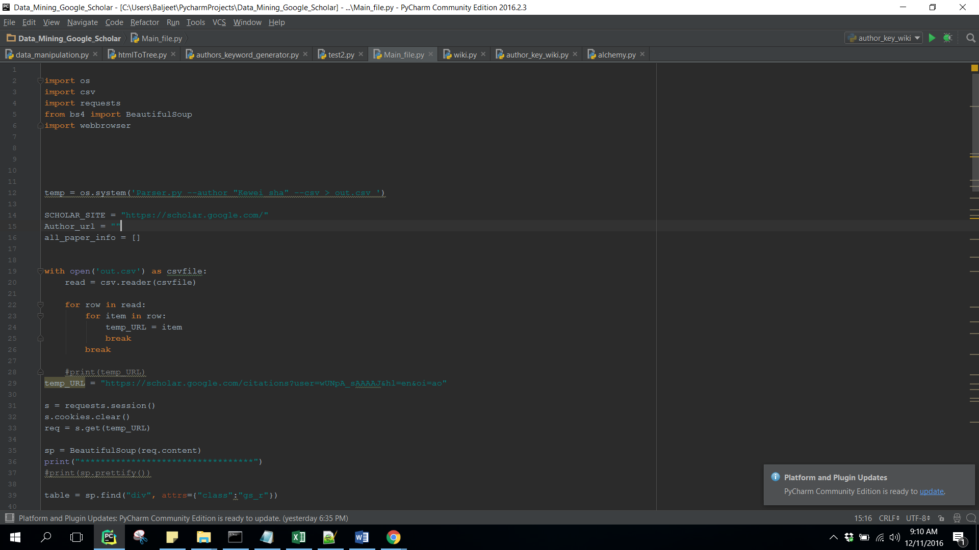

Give your URL in “temp_URL”

“Final_ACM_taxonomy.py”

This file parses the whole ACM taxonomy file and converts into tree data structure

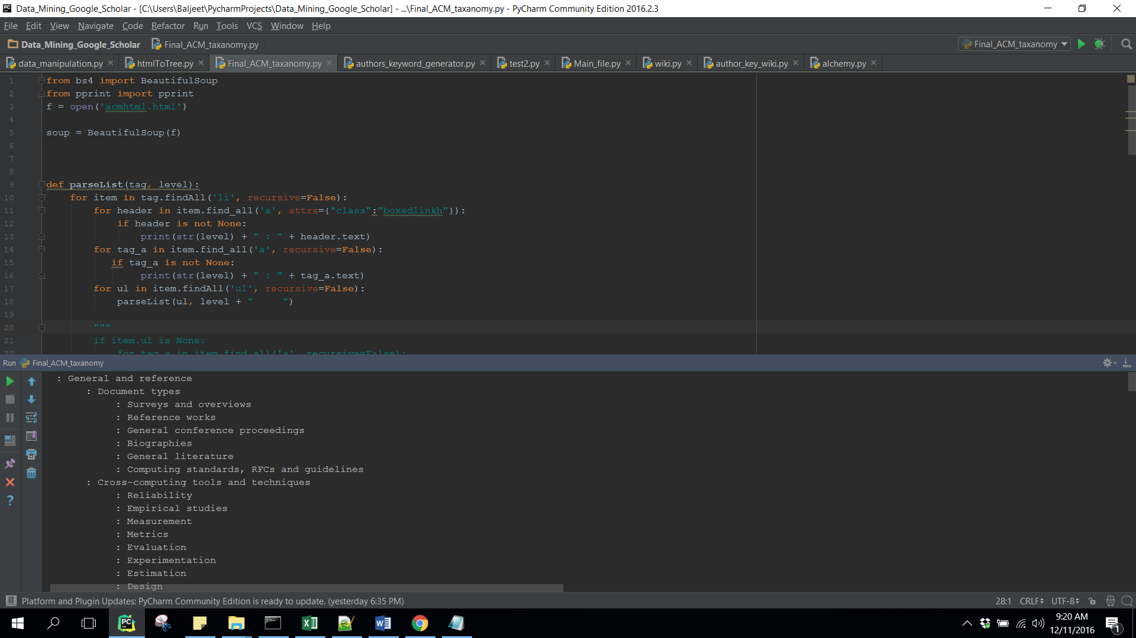

“Profile_info.py”

This takes Author’s profile URL as input and generates all research interest and h-index and i-10 index of authors.

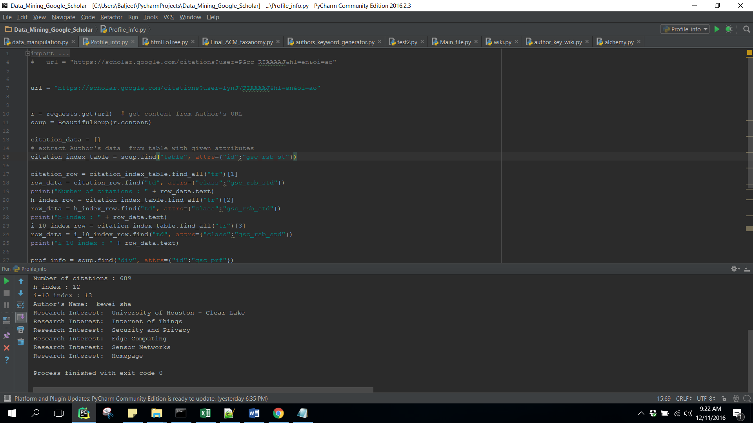

“k-means.py”

This takes input whole of the CSV file generated by previous programs and generate clusters based on k-means algorithm.

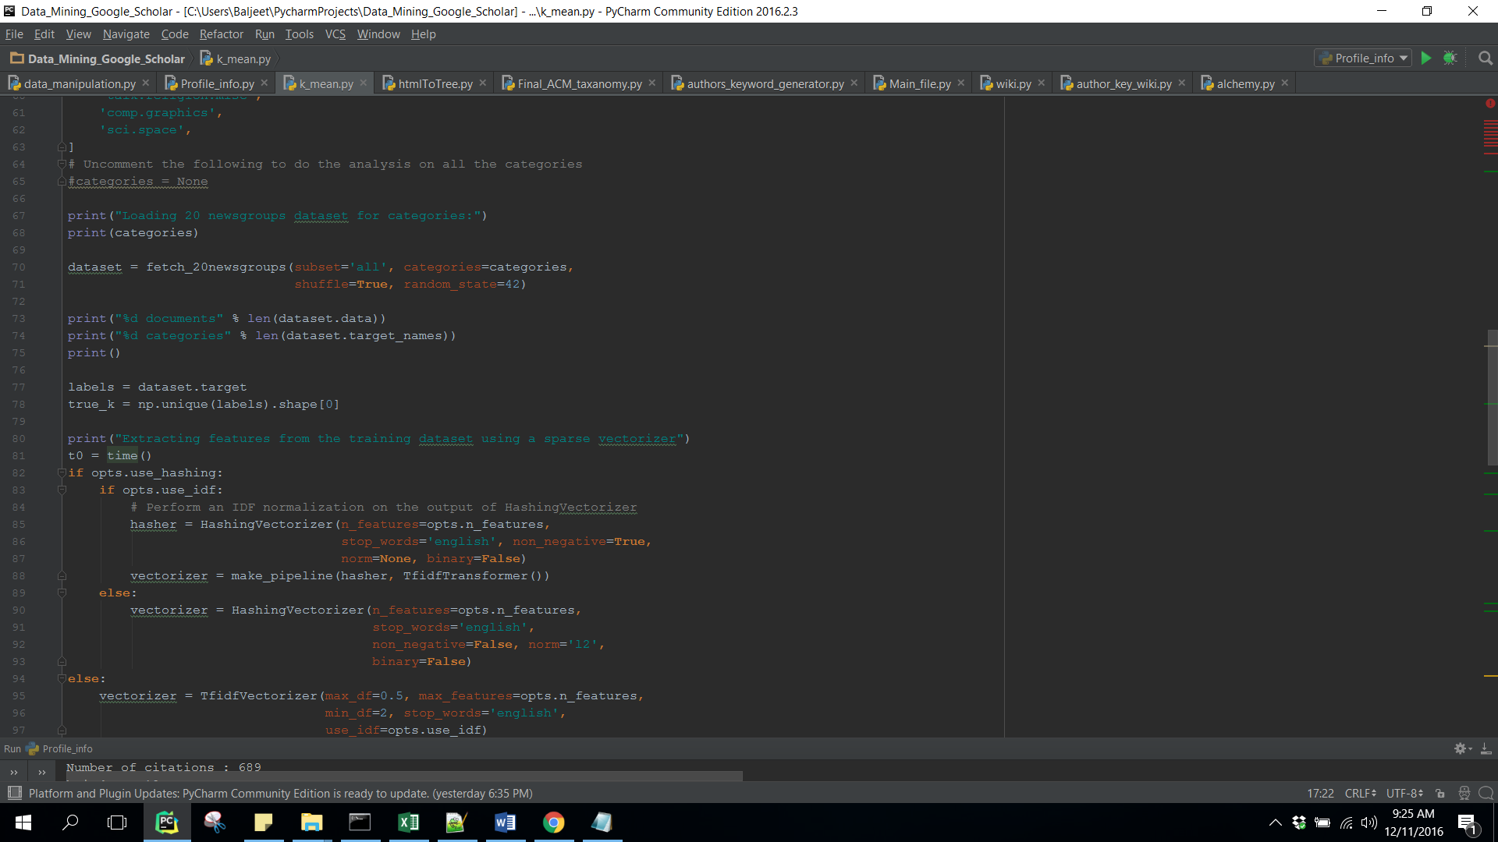

“Paper_sites_parser.py”

This takes URL from popular journal websites and extract keywords from their pages.

Following websites has been taken into consideration:

* IEEE
* Link.springer
* Ingentaconnect
* IOS press

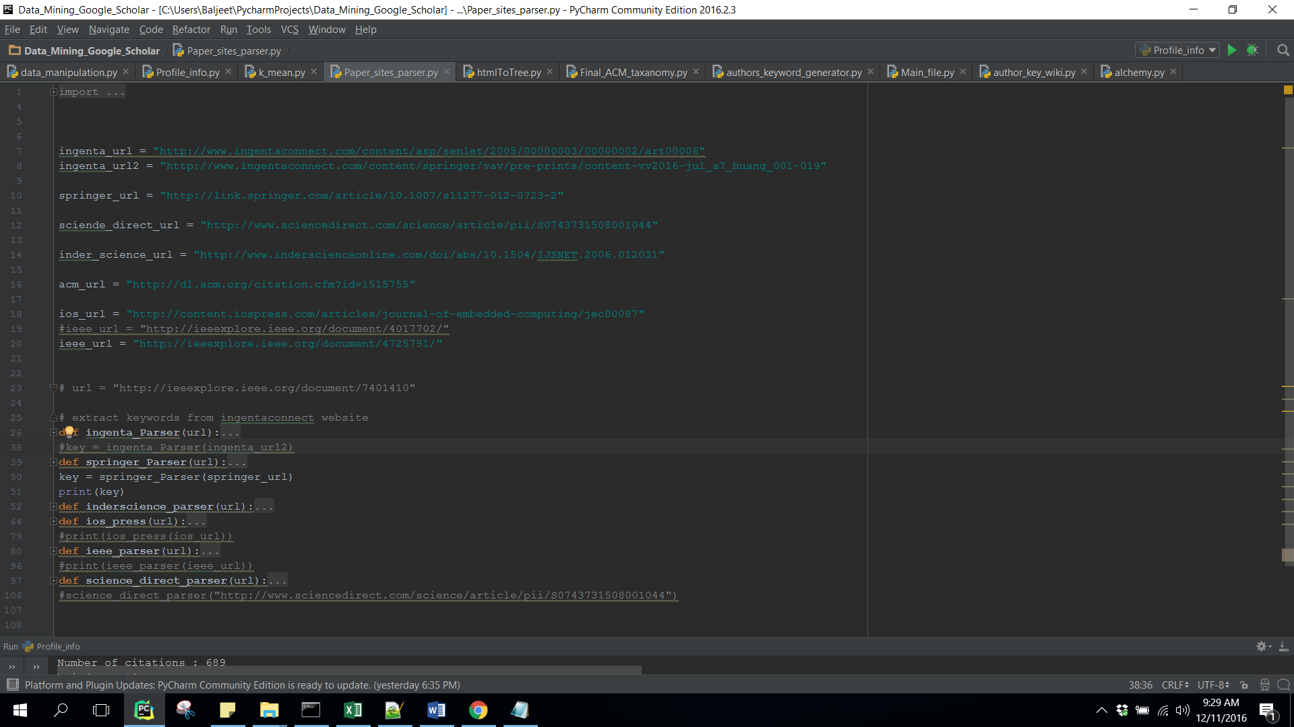

“wiki.py”

This file takes input as the keywords for which we were not able to generate keywords. This generate similar keywords.

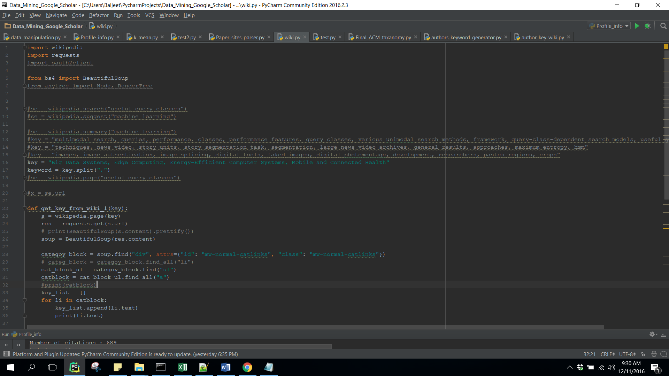

“data_manipulation.py”

This file takes those research papers as input for which we don’t have keywords. This generates keywords from these papers.

