**Attirbutes that have been removed**

verification_status_joint,

acc_open_past_24mths,

avg_cur_bal,

bc_open_to_buy,

bc_util,

chargeoff_within_12_mths,

dti_joint,

acc_now_delinq,

delinq_amnt,

mo_sin_old_il_acct,

mo_sin_old_rev_tl_op,

mo_sin_rcnt_rev_tl_op,

mo_sin_rcnt_tl,

mort_acc,

mths_since_recent_bc,

mths_since_recent_bc_dlq,

mths_since_recent_inq,

mths_since_recent_revol_delinq,

emp_title,

num_accts_ever_120_pd,

num_actv_bc_tl,

num_actv_rev_tl,

num_bc_sats,

num_bc_tl,

num_il_tl,

num_op_rev_tl,

num_rev_accts,

num_rev_tl_bal_gt_0,

num_sats,

num_tl_120dpd_2m,

num_tl_30dpd,

num_tl_90g_dpd_24m,

num_tl_op_past_12m,

pct_tl_nvr_dlq,

total_bal_ex_mort,

total_bc_limit,

total_il_high_credit_limit.

**Code used**

LoanDataSet <- read.csv("E:/study/Data Mining/project/LoanDataSet.csv")

View(LoanDataSet)

LoanDataSet <- subset(LoanDataSet, , -c(verification_status_joint, acc_open_past_24mths, avg_cur_bal, bc_open_to_buy, bc_util, chargeoff_within_12_mths))

LoanDataSet <- subset(LoanDataSet, , -c(dti_joint, acc_now_delinq, delinq_amnt, mo_sin_old_il_acct, mo_sin_old_rev_tl_op, mo_sin_rcnt_rev_tl_op))

LoanDataSet <- subset(LoanDataSet, , -c(mo_sin_rcnt_tl, mort_acc, mths_since_recent_bc, mths_since_recent_bc_dlq, mths_since_recent_inq, mths_since_recent_revol_delinq))

LoanDataSet <- subset(LoanDataSet, , -c(emp_title, num_accts_ever_120_pd, num_actv_bc_tl, num_actv_rev_tl, num_bc_sats, num_bc_tl, num_il_tl, num_op_rev_tl, num_rev_accts, num_rev_tl_bal_gt_0, num_sats, num_tl_120dpd_2m, num_tl_30dpd, num_tl_90g_dpd_24m, num_tl_op_past_12m, pct_tl_nvr_dlq, total_bal_ex_mort, total_bc_limit, total_il_high_credit_limit))

LoanDataSet <- subset(LoanDataSet, , -c(emp_length, url, desc, title))

library(sqldf)

sqldf("select count(*) from LoanDataSet")

PPlanLoanDataSet <- sqldf("select * from LoanDataSet where pymnt_plan='y'")

View(PPlanLoanDataSet)

VerifiedLDS <- sqldf("select * from LoanDataSet where verification_status != 'Not Verified'")

View(VerifiedLDS)

VerifiedLDS <-

VerifiedLDS <- sqldf("select * from VerifiedLDS where member_id > 0")

VerifiedLDS <- subset(VerifiedLDS, , -c(pymnt_plan, verification_status))

sqldf("select count(*) from VerifiedLDS as v1, verifiedLDS as v2 where v1.id = v2.id and v1.member_id!=v2.member_id")

sqldf("select * from VerifiedLDS as v1, verifiedLDS as v2 where v1.id = v2.id and v1.member_id!=v2.member_id")

sqldf("select count(*) from VerifiedLDS as v1, verifiedLDS as v2 where v1.id != v2.id and v1.member_id==v2.member_id")

sqldf("select count(*) from VerifiedLDS group by id having count(*)>1")

sqldf("select count(*) from VerifiedLDS group by member_id having count(*)>1")

savehistory("F:/notes/Data_Mining_Tools_and_Techniques/Project/Final dataset/Cleaning.Rhistory")

**LDSPP to LDSPP2**

LDSPostProcessing2 <- sqldf("select * from LDSPostProcessing where delinq_2yrs > -1")

LDSPostProcessing2 <- sqldf("select * from LDSPostProcessing2 where dti > 0")

LDSPostProcessing2$loan_status_scale[LDSPostProcessing2_intRate_12$interest_rate<12] <- 0

LDSPostProcessing2$loan_status_scale[LDSPostProcessing2_intRate_12$interest_rate>=12] <- 1

round(LDSPostProcessing2$LTI, digitis = 4)

**Correlation Analysis:**

loan_amnt <- LDSPostProcessing2 $loan_amnt

funded_amnt <- LDSPostProcessing2 $funded_amnt

cor(loan_amnt, funded_amnt)

cor.test(loan_amnt, funded_amnt)

funded_amnt_inv <- LDSPostProcessing2$funded_amnt_inv

cor.test(loan_amnt, funded_amnt_inv)

**Visualization Techniques:**

1) gradeA <- loan[loan[, "grade"] == "A",]

gradeB <- loan[loan[, "grade"] == "B",]

gradeC <- loan[loan[, "grade"] == "C",]

gradeD <- loan[loan[, "grade"] == "D",]

gradeE <- loan[loan[, "grade"] == "E",]

gradeF <- loan[loan[, "grade"] == "F",]

gradeG <- loan[loan[, "grade"] == "G",]

barplot(matrix(c(mean(gradeA[["int_rate"]]),mean(gradeB[["int_rate"]]),mean(gradeC[["int_rate"]]),mean(gradeD[["int_rate"]]),mean(gradeE[["int_rate"]]),mean(gradeF[["int_rate"]]),mean(gradeG[["int_rate"]])),nr=1),

col=c("aquamarine3"),

names.arg=LETTERS[1:7],main = "HISTORICAL INTEREST RATE BY GRADE",ylab="interest rate avg",xlab="Grade")

2) *******************************************************************

int_rate_2007 <- loan[loan[, "issue_d"] == "2007",]

int_rate_2008 <- loan[loan[, "issue_d"] == "2008",]

int_rate_2009 <- loan[loan[, "issue_d"] == "2009",]

int_rate_2010 <- loan[loan[, "issue_d"] == "2010",]

int_rate_2011 <- loan[loan[, "issue_d"] == "2011",]

int_rate_2012 <- loan[loan[, "issue_d"] == "2012",]

int_rate_2013 <- loan[loan[, "issue_d"] == "2013",]

int_rate_2014 <- loan[loan[, "issue_d"] == "2014",]

int_rate_2015 <- loan[loan[, "issue_d"] == "2015",]

avg_int_rate <- matrix(c(mean(int_rate_2007[["int_rate"]]),mean(int_rate_2008[["int_rate"]]),mean(int_rate_2009[["int_rate"]]),mean(int_rate_2010[["int_rate"]]),mean(int_rate_2011[["int_rate"]]),mean(int_rate_2012[["int_rate"]]),mean(int_rate_2013[["int_rate"]]),mean(int_rate_2014[["int_rate"]]),mean(int_rate_2015[["int_rate"]])),ncol=9,byrow=TRUE)

colnames(avg_int_rate) <- c("2007","2008","2009","2010","2011","2012","2013","2014","2015")

rownames(avg_int_rate) <- c("int_rate")

avg_int_rate <- as.table(avg_int_rate)

barplot(avg_int_rate, main = "AVERAGE INTEREST RATE",xlab="Year",ylab="avg of interest rate")

3) a2007 <- nrow(int_rate_2007[int_rate_2007[, "grade"] == "A",]) * 100/ nrow(int_rate_2007)

b2007 <- nrow(int_rate_2007[int_rate_2007[, "grade"] == "B",]) * 100/ nrow(int_rate_2007)

c2007 <- nrow(int_rate_2007[int_rate_2007[, "grade"] == "C",]) * 100/ nrow(int_rate_2007)

d2007 <- nrow(int_rate_2007[int_rate_2007[, "grade"] == "D",]) * 100/ nrow(int_rate_2007)

e2007 <- nrow(int_rate_2007[int_rate_2007[, "grade"] == "E",]) * 100/ nrow(int_rate_2007)

f2007 <- nrow(int_rate_2007[int_rate_2007[, "grade"] == "F",]) * 100/ nrow(int_rate_2007)

g2007 <- nrow(int_rate_2007[int_rate_2007[, "grade"] == "G",]) * 100/ nrow(int_rate_2007)

a2008 <- nrow(int_rate_2008[int_rate_2008[, "grade"] == "A",]) * 100/ nrow(int_rate_2008)

b2008 <- nrow(int_rate_2008[int_rate_2008[, "grade"] == "B",]) * 100/ nrow(int_rate_2008)

c2008 <- nrow(int_rate_2008[int_rate_2008[, "grade"] == "C",]) * 100/ nrow(int_rate_2008)

d2008 <- nrow(int_rate_2008[int_rate_2008[, "grade"] == "D",]) * 100/ nrow(int_rate_2008)

e2008 <- nrow(int_rate_2008[int_rate_2008[, "grade"] == "E",]) * 100/ nrow(int_rate_2008)

f2008 <- nrow(int_rate_2008[int_rate_2008[, "grade"] == "F",]) * 100/ nrow(int_rate_2008)

g2008 <- nrow(int_rate_2008[int_rate_2008[, "grade"] == "G",]) * 100/ nrow(int_rate_2008)

a2009 <- nrow(int_rate_2009[int_rate_2009[, "grade"] == "A",]) * 100/ nrow(int_rate_2009)

b2009 <- nrow(int_rate_2009[int_rate_2009[, "grade"] == "B",]) * 100/ nrow(int_rate_2009)

c2009 <- nrow(int_rate_2009[int_rate_2009[, "grade"] == "C",]) * 100/ nrow(int_rate_2009)

d2009 <- nrow(int_rate_2009[int_rate_2009[, "grade"] == "D",]) * 100/ nrow(int_rate_2009)

e2009 <- nrow(int_rate_2009[int_rate_2009[, "grade"] == "E",]) * 100/ nrow(int_rate_2009)

f2009 <- nrow(int_rate_2009[int_rate_2009[, "grade"] == "F",]) * 100/ nrow(int_rate_2009)

g2009 <- nrow(int_rate_2009[int_rate_2009[, "grade"] == "G",]) * 100/ nrow(int_rate_2009)

a2010 <- nrow(int_rate_2010[int_rate_2010[, "grade"] == "A",]) * 100/ nrow(int_rate_2010)

b2010 <- nrow(int_rate_2010[int_rate_2010[, "grade"] == "B",]) * 100/ nrow(int_rate_2010)

c2010 <- nrow(int_rate_2010[int_rate_2010[, "grade"] == "C",]) * 100/ nrow(int_rate_2010)

d2010 <- nrow(int_rate_2010[int_rate_2010[, "grade"] == "D",]) * 100/ nrow(int_rate_2010)

e2010 <- nrow(int_rate_2010[int_rate_2010[, "grade"] == "E",]) * 100/ nrow(int_rate_2010)

f2010 <- nrow(int_rate_2010[int_rate_2010[, "grade"] == "F",]) * 100/ nrow(int_rate_2010)

g2010 <- nrow(int_rate_2010[int_rate_2010[, "grade"] == "G",]) * 100/ nrow(int_rate_2010)

a2011 <- nrow(int_rate_2011[int_rate_2011[, "grade"] == "A",]) * 100/ nrow(int_rate_2011)

b2011 <- nrow(int_rate_2011[int_rate_2011[, "grade"] == "B",]) * 100/ nrow(int_rate_2011)

c2011 <- nrow(int_rate_2011[int_rate_2011[, "grade"] == "C",]) * 100/ nrow(int_rate_2011)

d2011 <- nrow(int_rate_2011[int_rate_2011[, "grade"] == "D",]) * 100/ nrow(int_rate_2011)

e2011 <- nrow(int_rate_2011[int_rate_2011[, "grade"] == "E",]) * 100/ nrow(int_rate_2011)

f2011 <- nrow(int_rate_2011[int_rate_2011[, "grade"] == "F",]) * 100/ nrow(int_rate_2011)

g2011 <- nrow(int_rate_2011[int_rate_2011[, "grade"] == "G",]) * 100/ nrow(int_rate_2011)

a2012 <- nrow(int_rate_2012[int_rate_2012[, "grade"] == "A",]) * 100/ nrow(int_rate_2012)

b2012 <- nrow(int_rate_2012[int_rate_2012[, "grade"] == "B",]) * 100/ nrow(int_rate_2012)

c2012 <- nrow(int_rate_2012[int_rate_2012[, "grade"] == "C",]) * 100/ nrow(int_rate_2012)

d2012 <- nrow(int_rate_2012[int_rate_2012[, "grade"] == "D",]) * 100/ nrow(int_rate_2012)

e2012 <- nrow(int_rate_2012[int_rate_2012[, "grade"] == "E",]) * 100/ nrow(int_rate_2012)

f2012 <- nrow(int_rate_2012[int_rate_2012[, "grade"] == "F",]) * 100/ nrow(int_rate_2012)

g2012 <- nrow(int_rate_2012[int_rate_2012[, "grade"] == "G",]) * 100/ nrow(int_rate_2012)

a2013 <- nrow(int_rate_2013[int_rate_2013[, "grade"] == "A",]) * 100/ nrow(int_rate_2013)

b2013 <- nrow(int_rate_2013[int_rate_2013[, "grade"] == "B",]) * 100/ nrow(int_rate_2013)

c2013 <- nrow(int_rate_2013[int_rate_2013[, "grade"] == "C",]) * 100/ nrow(int_rate_2013)

d2013 <- nrow(int_rate_2013[int_rate_2013[, "grade"] == "D",]) * 100/ nrow(int_rate_2013)

e2013 <- nrow(int_rate_2013[int_rate_2013[, "grade"] == "E",]) * 100/ nrow(int_rate_2013)

f2013 <- nrow(int_rate_2013[int_rate_2013[, "grade"] == "F",]) * 100/ nrow(int_rate_2013)

g2013 <- nrow(int_rate_2013[int_rate_2013[, "grade"] == "G",]) * 100/ nrow(int_rate_2013)

a2014 <- nrow(int_rate_2014[int_rate_2014[, "grade"] == "A",]) * 100/ nrow(int_rate_2014)

b2014 <- nrow(int_rate_2014[int_rate_2014[, "grade"] == "B",]) * 100/ nrow(int_rate_2014)

c2014 <- nrow(int_rate_2014[int_rate_2014[, "grade"] == "C",]) * 100/ nrow(int_rate_2014)

d2014 <- nrow(int_rate_2014[int_rate_2014[, "grade"] == "D",]) * 100/ nrow(int_rate_2014)

e2014 <- nrow(int_rate_2014[int_rate_2014[, "grade"] == "E",]) * 100/ nrow(int_rate_2014)

f2014 <- nrow(int_rate_2014[int_rate_2014[, "grade"] == "F",]) * 100/ nrow(int_rate_2014)

g2014 <- nrow(int_rate_2014[int_rate_2014[, "grade"] == "G",]) * 100/ nrow(int_rate_2014)

a2015 <- nrow(int_rate_2015[int_rate_2015[, "grade"] == "A",]) * 100/ nrow(int_rate_2015)

b2015 <- nrow(int_rate_2015[int_rate_2015[, "grade"] == "B",]) * 100/ nrow(int_rate_2015)

c2015 <- nrow(int_rate_2015[int_rate_2015[, "grade"] == "C",]) * 100/ nrow(int_rate_2015)

d2015 <- nrow(int_rate_2015[int_rate_2015[, "grade"] == "D",]) * 100/ nrow(int_rate_2015)

e2015 <- nrow(int_rate_2015[int_rate_2015[, "grade"] == "E",]) * 100/ nrow(int_rate_2015)

f2015 <- nrow(int_rate_2015[int_rate_2015[, "grade"] == "F",]) * 100/ nrow(int_rate_2015)

g2015 <- nrow(int_rate_2015[int_rate_2015[, "grade"] == "G",]) * 100/ nrow(int_rate_2015)

grade_mix_year <- matrix(c(a2007,a2008,a2009,a2010,a2011,a2012,a2013,a2014,a2015,

b2007,b2008,b2009,b2010,b2011,b2012,b2013,b2014,b2015,

c2007,c2008,c2009,c2010,c2011,c2012,c2013,c2014,c2015,

d2007,d2008,d2009,d2010,d2011,d2012,d2013,d2014,d2015,

e2007,e2008,e2009,e2010,e2011,e2012,e2013,e2014,e2015,

f2007,f2008,f2009,f2010,f2011,f2012,f2013,f2014,f2015,

g2007,g2008,g2009,g2010,g2011,g2012,g2013,g2014,g2015),ncol=9,byrow=TRUE)

colnames(grade_mix_year) <- c("2007","2008","2009","2010","2011","2012","2013","2014",2015)

rownames(grade_mix_year) <- c("A","B","C","D","E","F","G")

grade_mix_year_table <- as.table(grade_mix_year)

barplot(grade_mix_year_table,main='GRADE MIX OVER TIME',ylab="Percentages for Grades A-G",xlab = "Years")

**Decision Tree:**

library(rattle)

rattle()

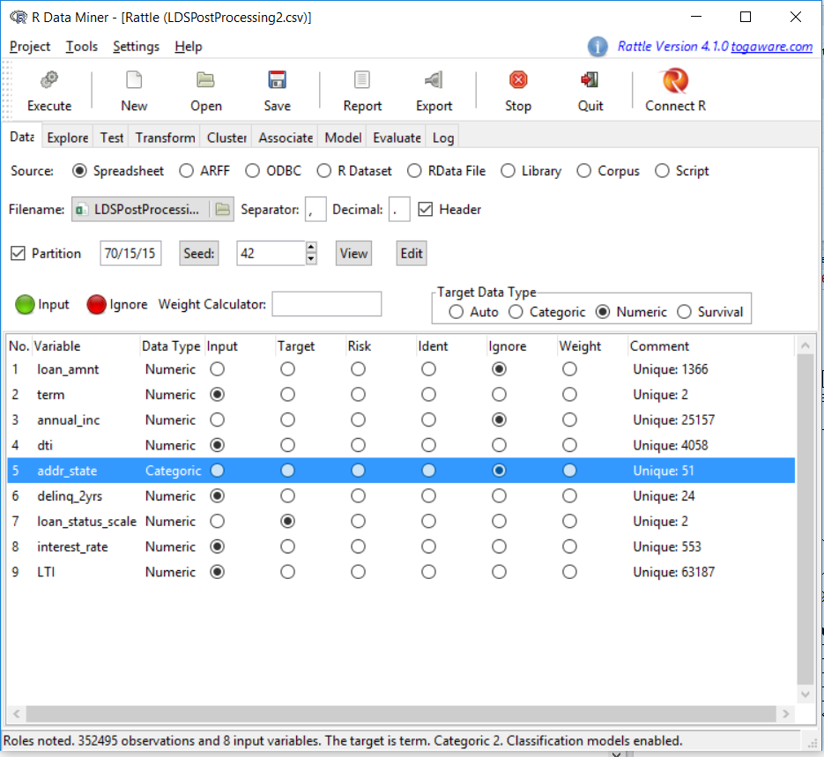

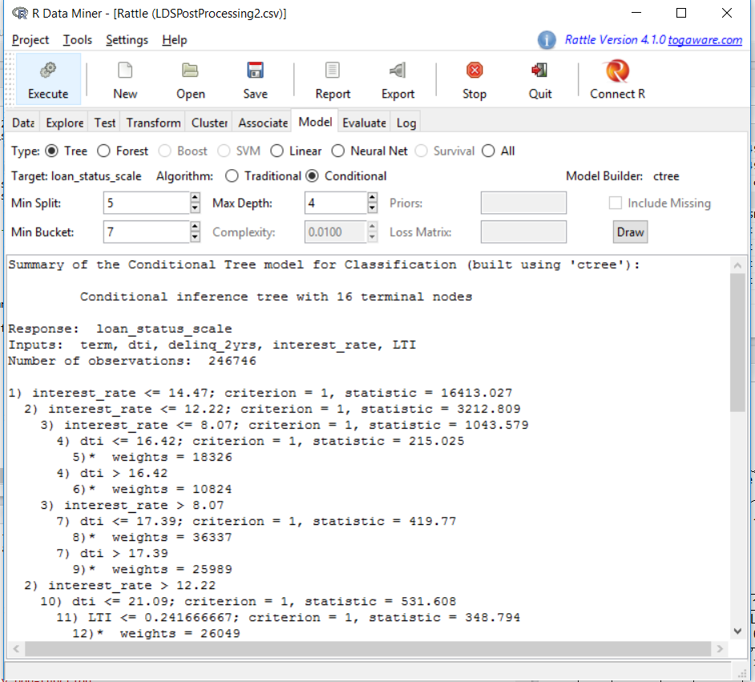

**Neural Network:**

library(grid)

library(MASS)

library(neuralnet)

temp1 = sample(352495, 200000)

temp_data = LDSPostProcessing2[temp1, ]

nn <- neuralnet(formula = loan_status_scale ~ interest_rate + dti + LTI + delinq_2yrs + term, data = temp_data, hidden = 3, stepmax = 1e6, linear.output = FALSE, algorithm = "backprop", learningrate = 0.01)

nn$net.result

nn

plot(nn)

nn$result.matrix

**Testing of Neural Network:**

temp = sample(352495, 100000)

test_data = LDSPostProcessing2[temp, ]

temp_test <- subset(test_data, select = c("interest_rate", "dti", "LTI", "delinq_2yrs","term"))

nn.results <- compute(nn, temp_test)

results <- data.frame(actual = test_data$loan_status_scale, prediction = nn59.results$net.result)

results

results$prediction <- round(results$prediction)

results

**Evaluating the Results:**

install.packages("minqa")

install.packages("caret")

library(lattice)

library(ggplot2)

library(minqa)

library(caret)

install.packages("e1071")

library(e1071)

confusionMatrix(test_data$loan_status_scale, results$prediction)