**Continuous Assessment for Laboratory**

Academic Year: 2023-2024

Name: _ {name}____________________________________ SAP ID: _{sapid}______________________

Course: Web Programming Laboratory Course Code: **DJS22ITL307**

Year: S.Y Sem: III Batch:

Department: Information Technology

|  |  |  |  |  |  |  |  |  |  |  |  |  |  |  |
| --- | --- | --- | --- | --- | --- | --- | --- | --- | --- | --- | --- | --- | --- | --- |
| Performance Indicators  (Minimum 3 Indicators) | 1 | | 2 | 3 | 4 | 5 | 6 | | 7 | | 8 | 9 | 10 | 11 |
| Course Outcome | **1** | | **1** | **1** | **1** | **1** | **1** | | **1** | | **1** | **1** | **1,2** | **1,2** |
| 1. Knowledge   (Factual/Conceptual/Procedural/ Metacognitive) (5) |  | |  |  |  |  |  | |  | |  |  |  | /5 |
| 1. Describe (Factual/Conceptual/Procedural/ Metacognitive) (5) |  | |  |  |  |  |  | |  | |  |  |  | /4 |
| 1. Demonstration   (Factual/Conceptual/Procedural/ Metacognitive) (5) |  | |  |  |  |  |  | |  | |  |  |  | /5 |
| 1. Strategy (Analyse & / or Evaluate)   (Factual/Conceptual/  Procedural/Metacognitive) | - | | - | - | - | - | - | | - | | - | - | - | - |
| 1. Interpret/ Develop   (Factual/Conceptual/  Procedural/Metacognitive)(5) |  | |  |  |  |  |  | |  | |  |  |  | /6 |
| 1. Attitude towards learning   (receiving, attending, responding, valuing, organizing, characterization by value) (5) |  | |  |  |  |  |  | |  | |  |  | - | - |
| 1. Non-verbal communication skills/ Behaviour or Behavioural skills   (motor skills, hand-eye coordination, gross body movements, finely coordinated body movements speech behaviours) | - | | - | - | - | - | - | | - | | - | - | - | /5 |
| Total (Out of 25) |  | |  |  |  |  |  | |  | |  |  |  |  |
| Signature of the faculty member |  | |  |  |  |  |  | |  | |  |  |  |  |
| Sign of the Student: | |  | | | | | | | |
| Signature of the Faculty member: | | | | | | | |  | | | | | | | |
| Name of the Faculty member: Ms. Savyasaachi Pandit | | | | | | | |  | | | | | | | |

Bloom’s (Revised) Taxonomy

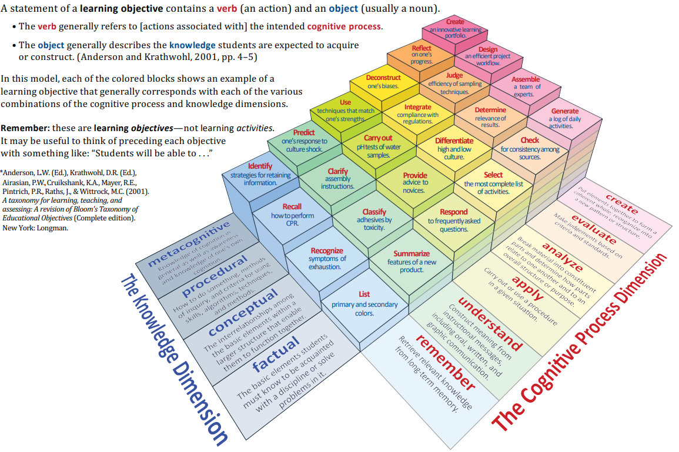

*Source:* \**Anderson, L.W. (Ed.), Krathwohl, D.R. (Ed.), Airasian, P.W., Cruikshank, K.A., Mayer, R.E., Pintrich, P.R., Raths, J., & Wittrock, M.C. (2001). A taxonomy for learning, teaching, and assessing: A revision of Bloom’s Taxonomy of Educational Objectives (Complete edition). New York: Longman.*

Course:

|  |  |  |
| --- | --- | --- |
| Code | Course Outcome | Bloom’s Level |
| **DJS22ITL307**.1 | Develop web applications. | Apply |
| **DJS22ITL307**.2 | Work effectively as a member of a team | Apply |