**Continuous Assessment for Laboratory**

Academic Year: 2023-2024

Name: _ {name}____________________________________ SAP ID: _{sapid}______________________

Course: {course} Course Code: **{course_code}**

Year: {year} Sem:{sem} Batch: {batch}

Department: Information Technology

|  |  |  |  |  |  |  |  |  |  |  |  |  |  |  |
| --- | --- | --- | --- | --- | --- | --- | --- | --- | --- | --- | --- | --- | --- | --- |
| Performance Indicators  (Minimum 3 Indicators) | 1 | | 2 | 3 | 4 | 5 | 6 | | 7 | | 8 | 9 | 10 | 11 |
| Course Outcome | **1** | | **1** | **1** | **1** | **1** | **1** | | **1** | | **1** | **1** | **1,2** | **1,2** |
| 1. Knowledge   (Factual/Conceptual/Procedural/ Metacognitive) (5) | {11} | | {12} | {13} | {14} | {15} | {16} | | {17} | | {18} | {19} | {110} | /5 |
| 1. Describe (Factual/Conceptual/Procedural/ Metacognitive) (5) | {21} | | {22} | {23} | {24} | {25} | {26} | | {27} | | {28} | {29} | {210} | /4 |
| 1. Demonstration   (Factual/Conceptual/Procedural/ Metacognitive) (5) | {31} | | {32} | {33} | {34} | {35} | {36} | | {37} | | {38} | {39} | {310} | /5 |
| 1. Strategy (Analyse & / or Evaluate)   (Factual/Conceptual/  Procedural/Metacognitive) | {41} | | {42} | {43} | {44} | {45} | {46} | | {47} | | {48} | {49} | {410} | - |
| 1. Interpret/ Develop   (Factual/Conceptual/  Procedural/Metacognitive)(5) | {51} | | {52} | {53} | {54} | {55} | {56} | | {57} | | {58} | {59} | {510} | /6 |
| 1. Attitude towards learning   (receiving, attending, responding, valuing, organizing, characterization by value) (5) | {61} | | {62} | {63} | {64} | {65} | {66} | | {67} | | {68} | {69} | {610} | - |
| 1. Non-verbal communication skills/ Behaviour or Behavioural skills   (motor skills, hand-eye coordination, gross body movements, finely coordinated body movements speech behaviours) | {71} | | {72} | {73} | {74} | {75} | {76} | | {77} | | {78} | {79} | {710} | /5 |
| Total (Out of 25) | {t1} | | {t2} | {t3} | {t4} | {t5} | {t6} | | {t7} | | {t8} | {t9} | {t10} |  |
| Signature of the faculty member |  | |  |  |  |  |  | |  | |  |  |  |  |
| Sign of the Student: | |  | | | | | | | |
| Signature of the Faculty member: | | | | | | | |  | | | | | | | |
| Name of the Faculty member: {teacher_name} | | | | | | | |  | | | | | | | |

Bloom’s (Revised) Taxonomy

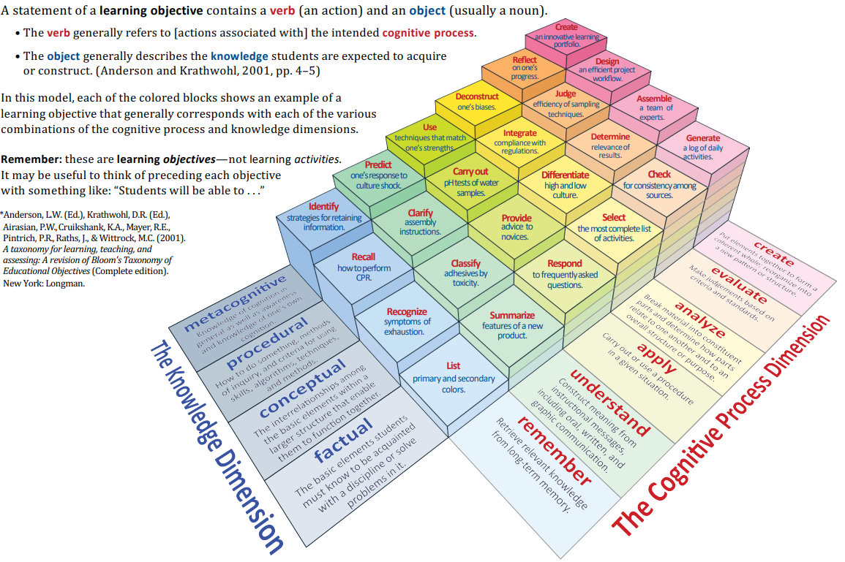

*Source:* \**Anderson, L.W. (Ed.), Krathwohl, D.R. (Ed.), Airasian, P.W., Cruikshank, K.A., Mayer, R.E., Pintrich, P.R., Raths, J., & Wittrock, M.C. (2001). A taxonomy for learning, teaching, and assessing: A revision of Bloom’s Taxonomy of Educational Objectives (Complete edition). New York: Longman.*

Course:

|  |  |  |
| --- | --- | --- |
| Code | Course Outcome | Bloom’s Level |
| {#courses}{code} | {outcome} | {level}{/courses} |