Appendix D: Mineral Precipitation, Dissolution and the Evolving Pore Space
CompLaB3D models pore-scale mineral precipitation and dissolution with a Volume-of-Pixel (VOP) approach, following the pore-scale reactive-transport work of Kang et al. (2006) and the review by Yoon, Kang and Valocchi (2015). It builds on the immobile-solid machinery already in CompLaB (Jung et al. 2023). Both directions run once per simulation time step, immediately after the chemical reactions have updated the local mineral inventory, and either may be enabled without the other.
The precipitation half reproduces heterogeneous nucleation: a mineral does not appear uniformly throughout the fluid, it forms on solid surfaces, grows inward, and gradually closes the pore. It proceeds in three stages. First, a surface-controlled reaction makes mineral only in the pore voxels that sit against a solid surface. Second, once a voxel is full of mineral, a node-conversion step turns it into solid, so the growth front steps one voxel inward. Third, because the pore shape has changed, the steady-state flow field is recomputed and the flow reroutes. Repeating these three stages advances the mineral front from the walls until, in a clogging case, the last open path seals and the flow stops.
The dissolution half runs the same machinery in reverse: a declared mineral phase is consumed by the water touching it, and a voxel whose inventory has fallen far enough is returned to open pore, after which the flow is again re-solved. Because a dissolving channel widens, and a wider channel delivers more reactant, the feedback runs the opposite way from precipitation, which is why dissolution fronts finger rather than advance as a flat face (Steefel and Lasaga 1994; Noiriel and Soulaine 2021).
Sections D.3 to D.5 describe precipitation and D.6 to D.9 dissolution, step for step and figure for figure, because the two are the same three stages run in opposite directions and are best read side by side. D.10 is the case in which both act on one mineral. D.11 gives the chemistry and the equations step by step, D.12 the checks that decide whether a run conserved mass, and D.13 the three worked examples that ship with the code.
Each stage below is written first in plain steps (an algorithm box that can be read on its own, without looking at the source code) and is then paired with a figure and a short explanation of what the figure shows. The settings that control the two features are listed next; all are read from the CompLaB.xml configuration file, and all are optional, so a run with neither block behaves exactly as a run of the solver before either feature existed.
- Clogging species (solid_substrate). The immobile mineral that fills the pore. In example 13 this is FeS. It must already be flagged immobile in the chemistry block so that it stays in place and changes only by reaction.
- Fill value (max_precipRho). The mineral density at which a voxel is treated as full. When the mineral in a voxel reaches this value, the voxel is converted to solid.
- Surface control (surface_only). Set to 1, the reaction is restricted to interface voxels, so the mineral nucleates on the walls and grows inward rather than in the open pore.
- Permeability of a converted voxel (perm_ratio). How much flow can still pass through a voxel that has turned to solid. A value of 0 blocks it completely; a small value between 0 and 1 lets a little flow leak through.
- Update interval (update_interval). How many time steps pass between one conversion-and-flow-resolve pass and the next. A larger value recomputes the flow less often and runs faster.
- Declared phase (phase0, phase1, …). What is allowed to dissolve. Each block names the material number it occupies in the geometry, the substrate that carries its inventory, its density when full, and how full it starts.
- Reopen threshold (reopen_fraction). The fraction of the full density below which a voxel is returned to open pore. It is deliberately below 1, which is what stops a marginal voxel flickering between solid and pore; see D.8.
- Precipitate linkage (is_precipitate). Set true on a phase to make the voxels that precipitation sealed eligible for dissolution later. Without it, a sealed voxel is permanent.
D.1 XML configuration
The feature is enabled and controlled by a single <precipitation> block placed directly inside <parameters> in CompLaB.xml. The block used by example 13 is:
<precipitation>
<enabled>true</enabled>
<solid_substrate>2</solid_substrate> <!-- FeS, the third substrate -->
<max_precipRho>48.9</max_precipRho> <!-- mol/L: 1000 / 20.44 cm3 per mol -->
<surface_only>1</surface_only>
<perm_ratio>0.0</perm_ratio>
<update_interval>100</update_interval>
</precipitation>

Tag | What it sets
enabled | Master switch. If false, the solver runs unchanged.
solid_substrate | Index of the immobile mineral that clogs the pore (2 = FeS).
max_precipRho | Mineral density at which a voxel is full and turns to solid, in mol/L. 48.9 is mackinawite; see the arithmetic below.
surface_only | Set to 1 to restrict the reaction to interface voxels.
perm_ratio | Flow allowed through a converted voxel (0 = fully sealed).
update_interval | Time steps between one conversion and flow re-solve and the next.
A <dissolution> block is written the same way, and adds one <phaseN> block per mineral that is allowed to dissolve. The block used by the worked example of D.13 is:
<dissolution>
<enabled>true</enabled>
<reopen_fraction>0.9</reopen_fraction> <!-- reopen below 0.9 x full -->
<surface_only>1</surface_only> <!-- only wetted voxels dissolve -->
<update_interval>100</update_interval>

<phase0>
<name>calcite_grain</name>
<material_number>0</material_number> <!-- the solid grains in geometry.dat -->
<substrate>2</substrate> <!-- which substrate holds its inventory -->
<full_density>27.1</full_density> <!-- mol/L: 1000 / 36.9 cm3 per mol -->
<initial_fill>27.1</initial_fill> <!-- starts completely solid -->
</phase0>
</dissolution>

Tag | What it sets
enabled | Master switch. If false, the solver runs unchanged.
reopen_fraction | Fraction of full_density below which a voxel returns to open pore.
surface_only | Set to 1 to dissolve only voxels that water actually touches.
update_interval | Time steps between one reopening and flow re-solve and the next.
phaseN/material_number | Which material number in geometry.dat this phase occupies.
phaseN/substrate | Which immobile substrate carries this phase's inventory.
phaseN/full_density | Inventory of a completely full voxel, mol/L.
phaseN/initial_fill | Inventory a voxel of this phase starts with. Set it to full_density for grains that are solid at the start; set it to 0 for a phase that only appears by precipitation.
phaseN/is_precipitate | True to make the voxels precipitation sealed part of this phase, so they can later reopen.

Both densities in these blocks come from the mineral, not from the model. A voxel that is completely full holds one voxel volume of solid, so
full density = 1000 / Vₘ mol/L, with Vₘ in cm³/mol
For mackinawite, 87.91 g/mol over 4.30 g/cm³ is 20.44 cm³/mol, hence 48.9 mol/L; for calcite, 100.09 g/mol over 2.71 g/cm³ is 36.9 cm³/mol, hence 27.1 mol/L. Changing minerals means recomputing this number, and a value taken from the wrong molar volume is the usual reason a pore does not clog when it should.
D.2 The header files precipitationVOP.hh and dissolutionVOP.hh
All of the new logic is contained in one drop-in header, precipitationVOP.hh, which adds two small steps to the solver and leaves every existing file unchanged apart from a few lines in the main program. The first step, surfaceAbioticKinetics3D, runs the chemical reactions but only in interface voxels; it uses the same reaction rates and the same update as the standard reaction step, so the chemistry is identical and only the location changes. The second step, precipNodeConversion3D, checks the mineral density in each pore voxel and turns a voxel into solid once it is full. A converted voxel then counts as a wall for its neighbors, so the interface, and therefore the mineral growth, advances one voxel inward. The flow update itself reuses the routine that CompLaB already applies when biofilm growth changes the pore shape.
Each CompLaB3D time step advances in a fixed order: advection-diffusion transport of the dissolved species, then the kinetic reactions (biotic and abiotic), then the equilibrium reactions, then the biofilm growth and redistribution step, and finally a flow recomputation whenever the pore geometry has changed. Precipitation is carried out inside two of these steps. During the abiotic reaction step, the surface-controlled reaction (surfaceAbioticKinetics3D) replaces the standard abiotic reaction, so the mineral forms together with the rest of the chemistry but only in the interface voxels. Then, after the biofilm growth step and once every update_interval steps, the node conversion (precipNodeConversion3D) turns any voxel that has filled with mineral into solid; this changes the pore geometry, which triggers the flow recomputation, and the updated velocity is coupled back into the transport before the next step begins.
The reverse path lives in a second drop-in header, dissolutionVOP.hh, built the same way. It reads the declared phases at start-up, seeds each phase's voxels with its initial_fill, applies the dissolution rate to the voxels water can reach, and returns a voxel to open pore once its inventory falls below the reopen threshold. It reuses the same flow-update routine, so a reopening and a sealing are the same event as far as the flow solver is concerned.
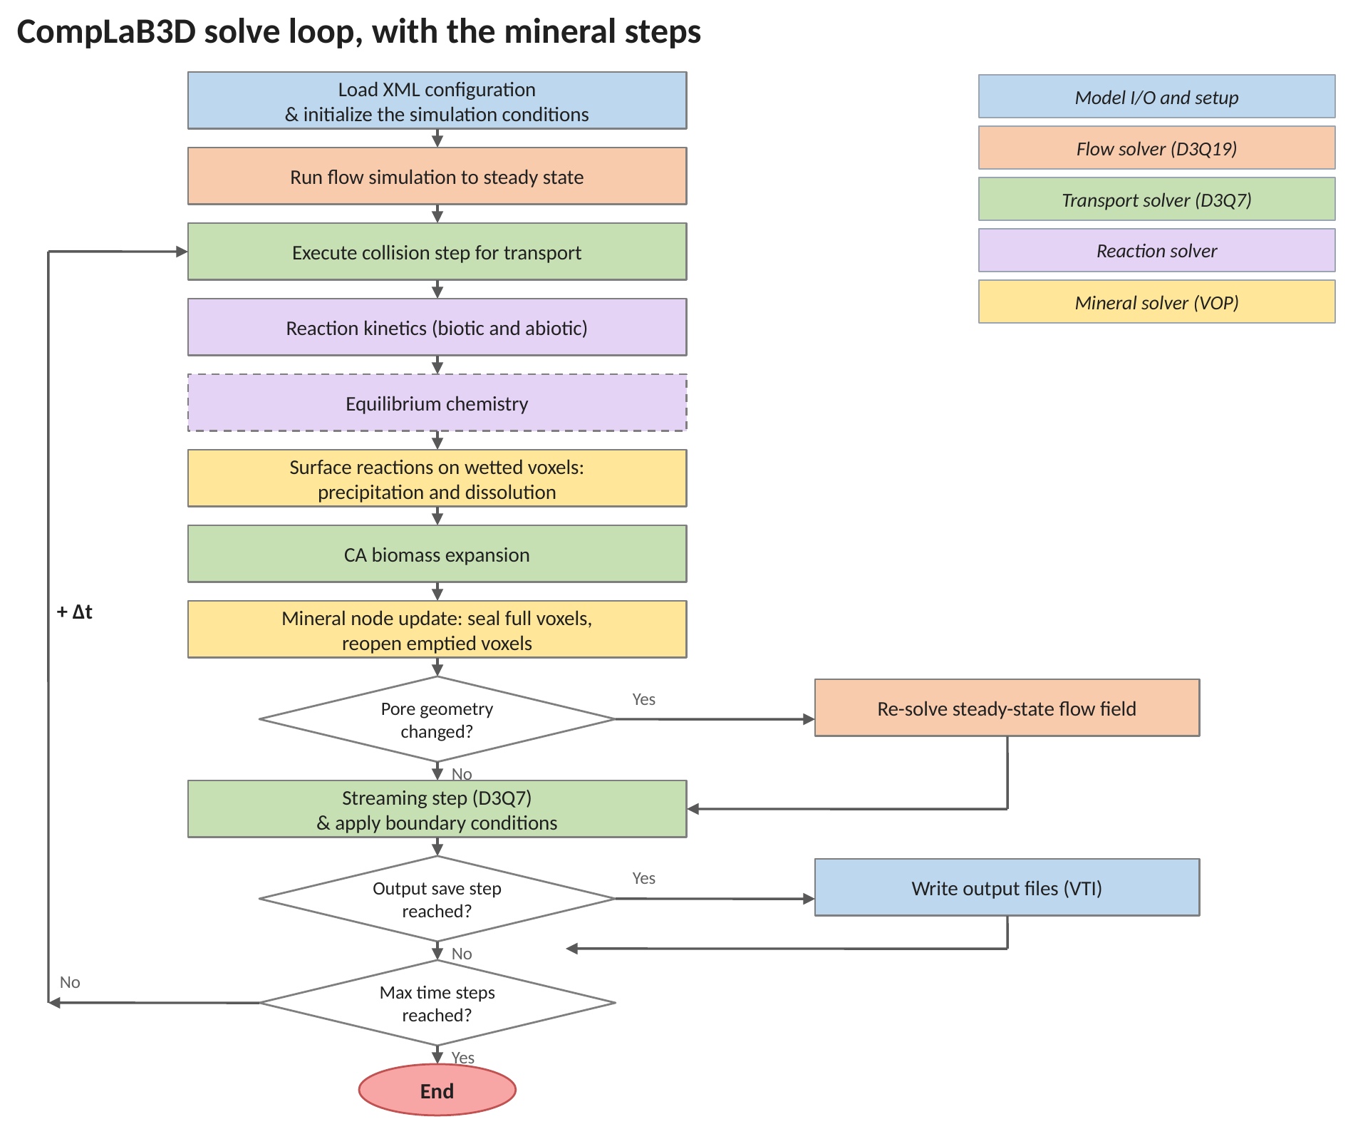
Figure 1 (updated). The CompLaB3D solve loop with the mineral steps in place. The two gold boxes are the additions: the surface reaction runs inside the reaction stage, with the rest of the chemistry, and the node update runs after biomass growth, immediately before the geometry test that decides whether the flow has to be re-solved. This replaces Figure 1 of the main text.
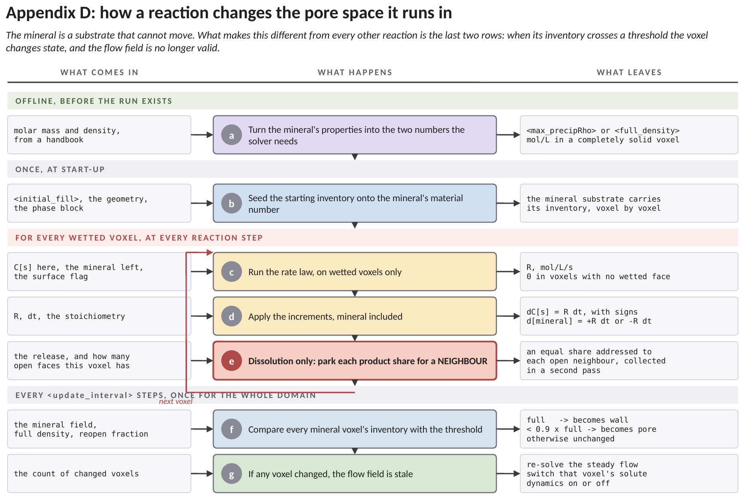
Figure D1. How these two reactions work, end to end, and where each number enters. The green band is a handbook calculation done before any simulation exists, the grey band is work the solver does once at start-up, the red band is the chemistry that runs in every wetted voxel at every reaction step, and the grey band beneath it is the intermittent check that makes this different from every other reaction in the code. Each row names what arrives, what is done to it, and what leaves. (a) The mineral's molar mass and density give the one number the solver needs: how many moles a completely solid voxel holds. For calcite, 100.09 grams per mole over 2.71 grams per cubic centimetre is 36.9 cubic centimetres per mole, so a litre holds 27.1 moles. (b) At start-up that inventory is seeded onto the material number the mineral occupies, so the mineral becomes an ordinary substrate field that happens not to move. (c) The loop begins. The rate law runs, but only on wetted voxels, meaning voxels with at least one open face. A grain's interior is unreachable by solute and does not react, which is a crude but honest stand-in for reactive surface area. (d) The increments are applied with the signs the reaction dictates, the mineral included. The mineral is the one that accumulates in place, because it cannot be transported away. (e) For dissolution only, the released product cannot be left where it was made: that voxel is solid and nothing there can carry it. It is shared equally among the voxel's open neighbours, parked in one pass and collected in a second, which is what makes the deposit exact on any number of processors. (f) Every update interval, and not every step, each mineral voxel's inventory is compared with two thresholds. A voxel that has filled becomes wall; a voxel that has fallen below the reopen fraction of full becomes pore. The two thresholds differ deliberately: a voxel that reopened at the threshold it sealed at would cross back and forth every interval. (g) If any voxel changed state, the flow field computed for the old pore space is no longer valid and is solved again, and the solute dynamics of the changed voxels are switched on or off to match. This is the row that has no counterpart anywhere else in the code: the reaction has edited the domain the solver is running on.
Both mineral steps sit inside the loop the solver already ran, and neither adds a stage of its own. That is what makes them safe to leave switched off: with no <precipitation> and no <dissolution> block the two gold boxes are skipped and the sequence is the one the solver has always followed.
D.3 Surface-controlled reaction
A pore voxel is called an interface voxel when at least one of its six touching neighbors is a wall, or a voxel that has already turned to mineral. The reaction runs only in interface voxels. This matches the physics of the system: iron is released at the Geobacter wall and sulfide is produced at the SRB wall, so the two reactants meet at the walls, and that is where the mineral forms.
Algorithm D.1 Where the reaction is allowed to happen
Given: the current chemistry everywhere, and a map showing which voxels
are open pore, wall, or mineral.
Goal: let the reaction run only on the pore surfaces, not in open water.

1. Look at every open-pore voxel, one at a time.
2. Check its six touching neighbors (left, right, front, back, top, bottom).
3. If none of those neighbors is a wall or mineral, the voxel sits in open
water, so do nothing here. // no reaction away from surfaces
4. If at least one neighbor is a wall or mineral, the voxel is on a surface,
so run the FeS-forming reaction here and add the mineral it produces.
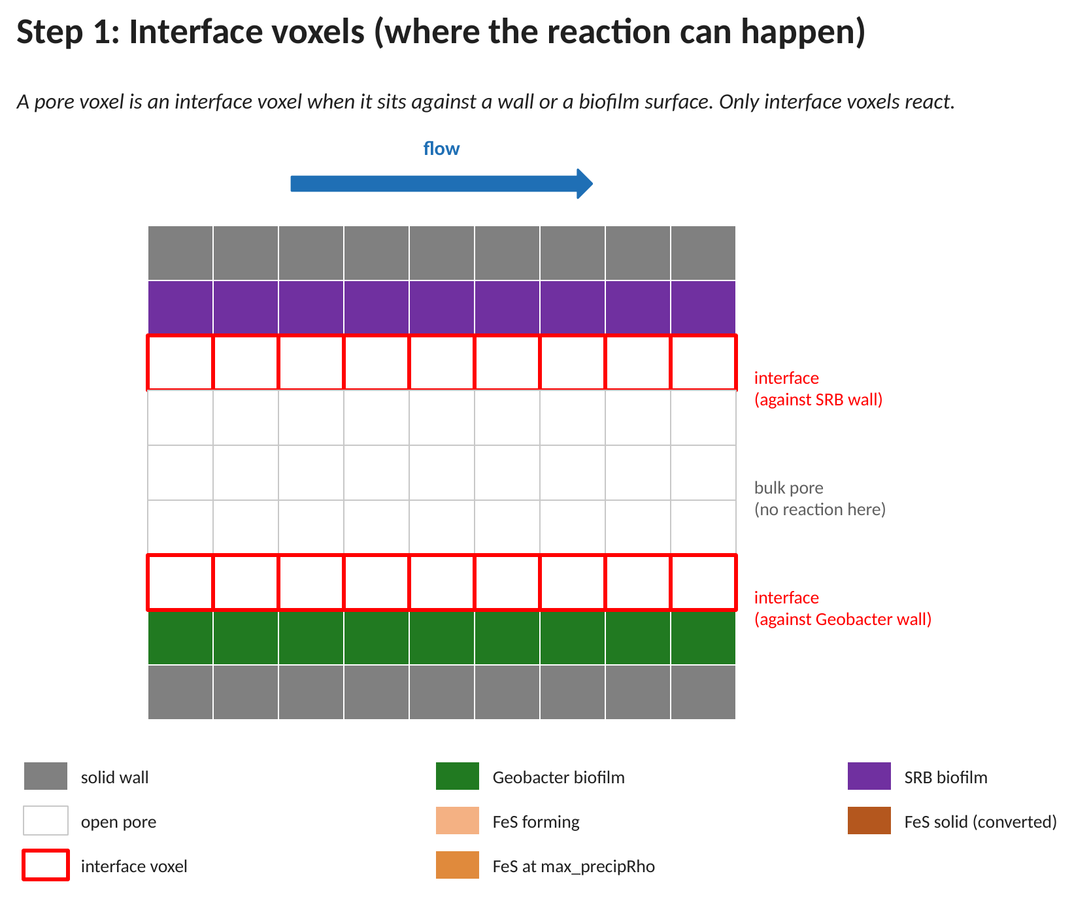
Figure D2. A cross-section of the pore before any mineral has formed, showing the walls, the two biofilms, the open pore, and the interface voxels (red outline) where the reaction is allowed.
In this first panel the pore is still clean. The grey rows at the very top and bottom are the solid grain wall. Just inside them, the purple and green rows are the two biofilms that coat the walls (SRB on top, Geobacter on the bottom). The five white rows in between are the open pore that carries the flow, shown by the blue arrow. The pore rows outlined in red, sitting directly against the biofilm walls, are the interface voxels: they touch a surface, so they are the only places allowed to react. The plain white rows in the middle are open water, far from any surface, and stay switched off. This one rule, react on the walls and nowhere else, is what the rest of the method is built on.
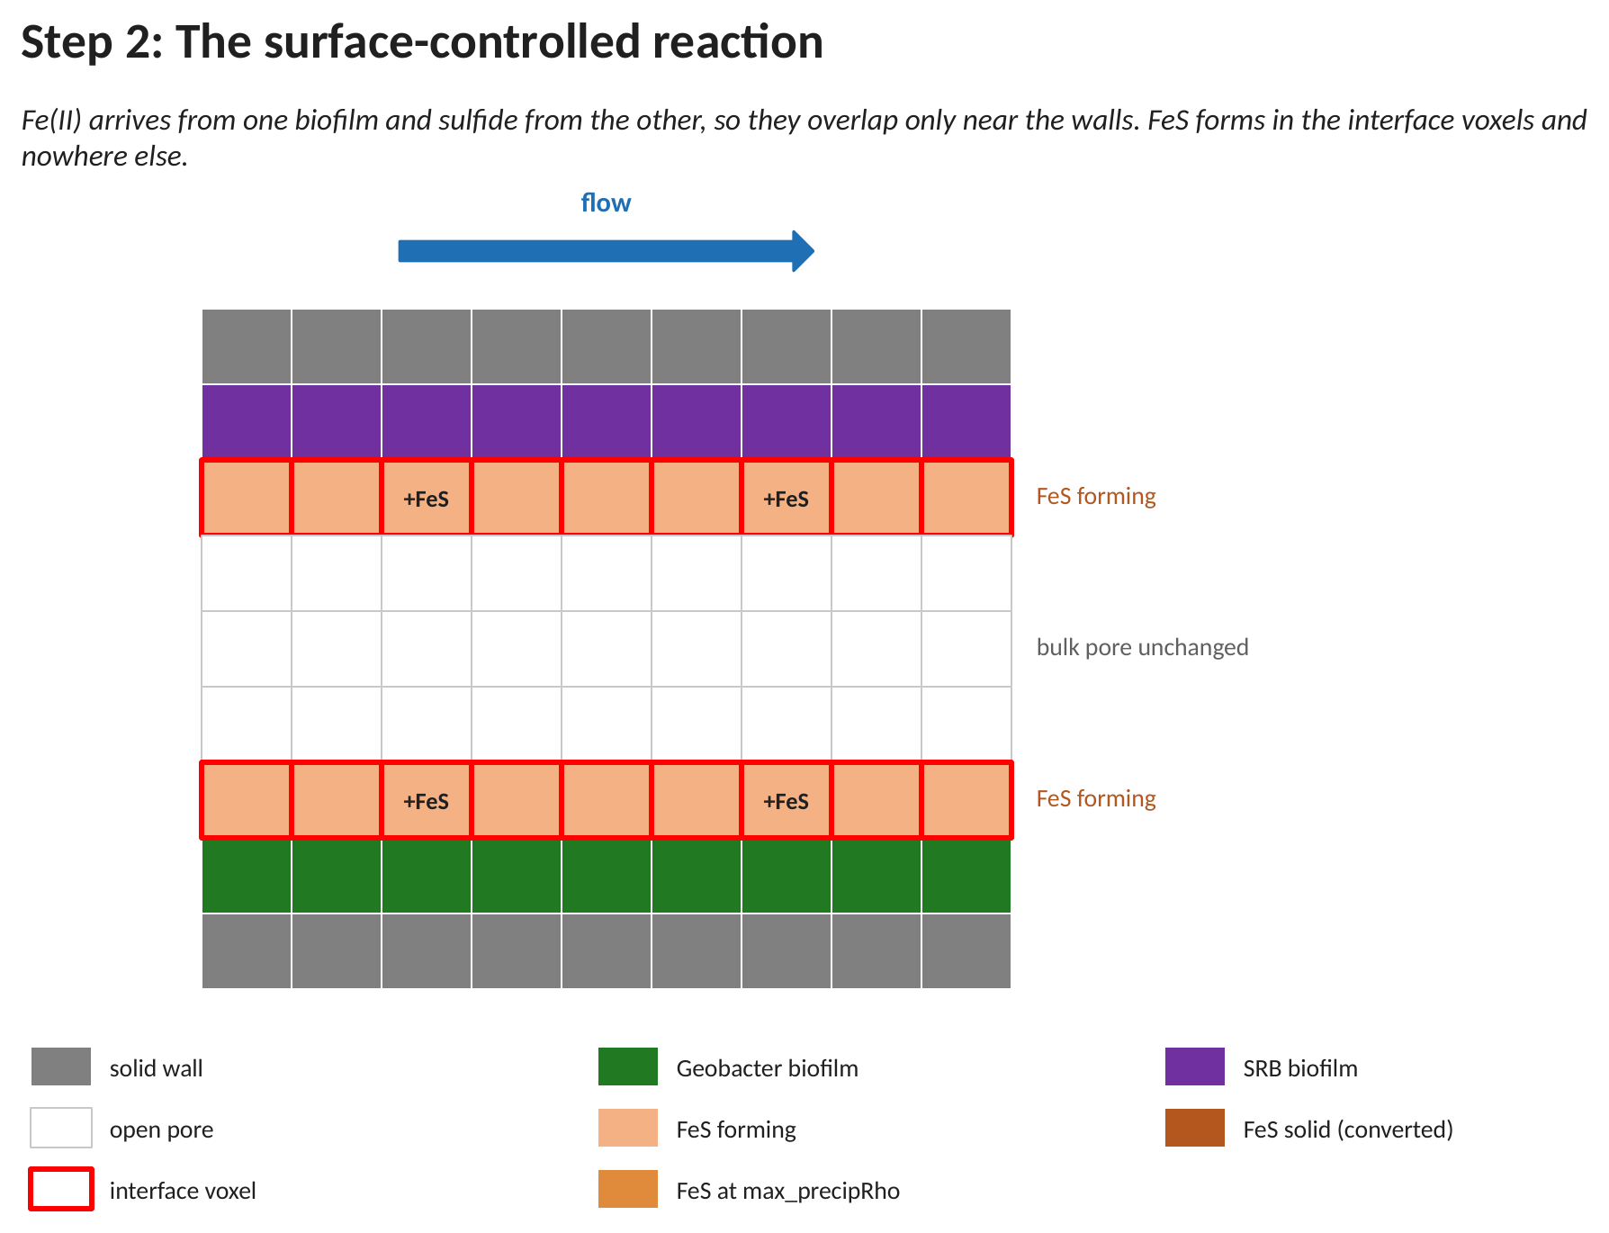
Figure D3. The surface-controlled reaction. FeS (orange) forms only in the interface voxels next to the walls, while the bulk pore stays clear.
Here the reaction has been switched on and a little time has passed. In the two interface rows the mineral FeS has begun to form (orange, marked +FeS), built from iron arriving from the Geobacter side and sulfide arriving from the SRB side. The middle rows have not changed: because they are not interface voxels. The visible result is a thin mineral coating on both walls, which is the pattern seen in real pore-scale experiments and the starting point for clogging.
The figures in this section and the next are drawn for a two-biofilm geometry, in which the iron is released at one biofilm wall and the sulfide at the other, so the two reactants overlap only near the surfaces. Example 13 produces the same overlap a different way: iron enters through one face of the domain and sulfide through the opposite face, and the mineral forms in the band where the two profiles meet. In both cases the rule that governs where mineral may form is the one stated above — a voxel reacts only if it touches a solid surface — and everything from D.4 onward follows from it unchanged.
D.4 Node conversion and inward growth
Each interface voxel keeps gathering mineral over successive time steps. Once the mineral in a voxel reaches the fill value max_precipRho, the solver freezes that voxel into solid. Because the newly solid voxel now acts as a wall, the pore voxels next to it become the new interface and start to react on the following passes. In this way the mineral front moves one voxel at a time from each wall toward the middle of the channel.
Algorithm D.2 Turning a full voxel into solid
Given: how much mineral each pore voxel now holds, and the fill value.
Goal: freeze a full voxel into solid so the mineral wall grows inward.

1. Look at every open-pore voxel, one at a time.
2. Compare the mineral in the voxel with the fill value (max_precipRho).
3. If the voxel has reached the fill value, mark it as solid. // it is now a wall
4. Its pore neighbors now touch this new wall, so on the next pass they
become interface voxels and begin to react. // the front steps in by one voxel
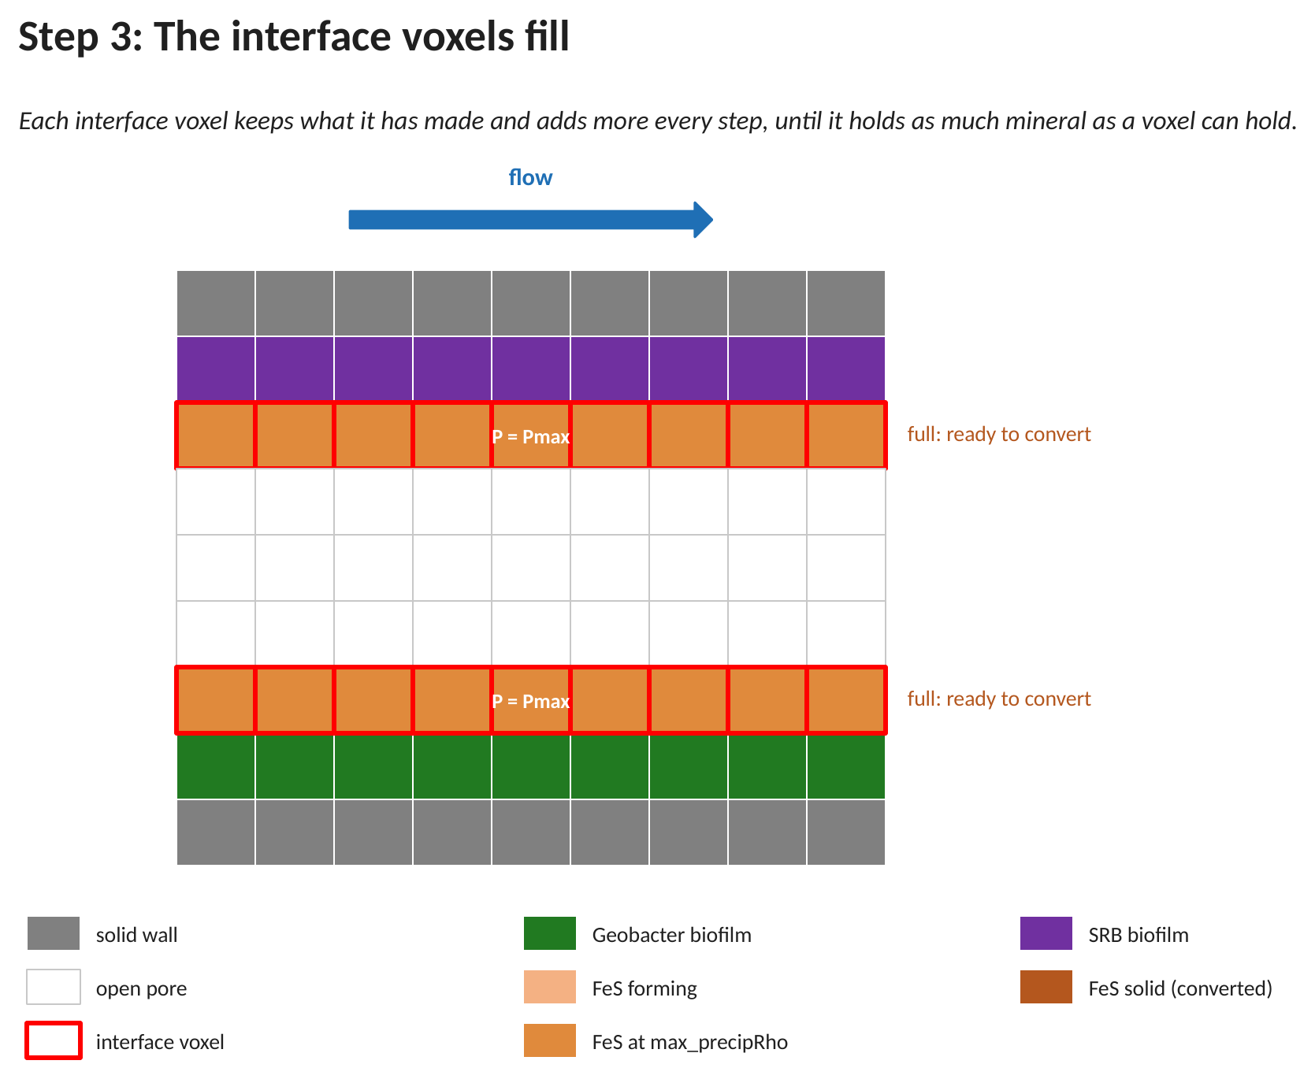
Figure D4. The wall voxels reach the fill value (labeled P = Pmax) and are full, ready to be converted to solid.
This panel captures the moment just before conversion. The mineral that was building up on the walls in Figure D3 has now reached the fill value, shown by the darker orange rows and the label P = Pmax. These voxels are packed with as much mineral as a voxel can hold. Nothing has moved yet; they are simply full and about to be turned into solid in the next step.
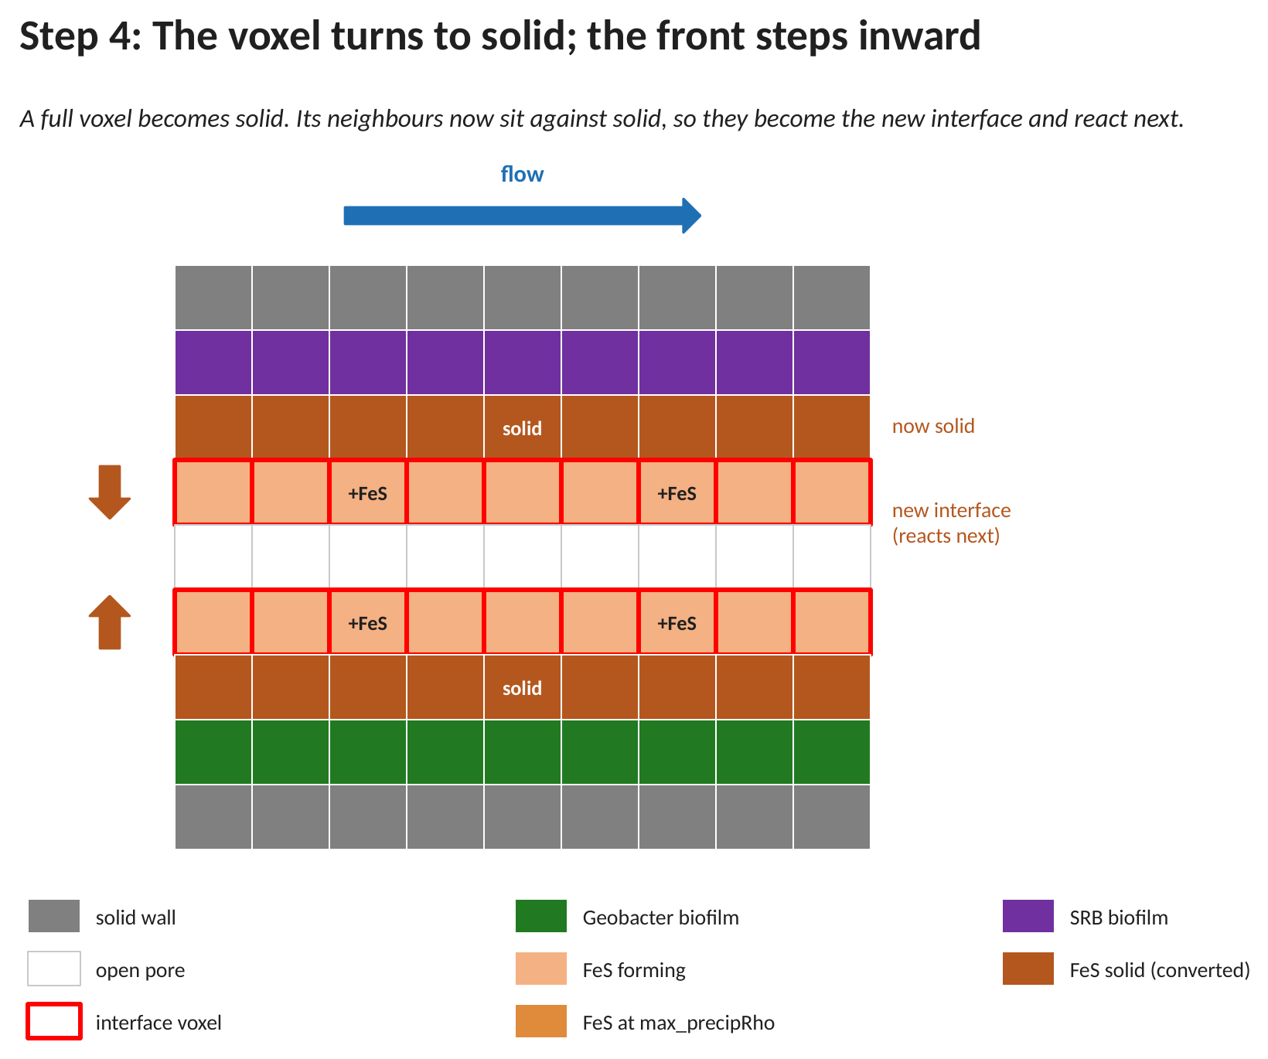
Figure D5. A full voxel becomes solid (dark orange) and the pore voxel behind it becomes the new interface (light orange), so the mineral front steps one voxel inward.
Now the full voxels have been frozen into solid (dark orange, labeled 'solid'); from this point they behave exactly like the grey wall. The key change is one row deeper: the pore voxels that were open a moment ago now sit against this fresh solid, so they have become the new interface and have started to make mineral themselves (light orange, +FeS). The small arrows on the left mark the direction of growth. Repeating this, the mineral wall thickens from both sides, step by step, toward the center of the channel.
D.5 Flow feedback and clogging
Every conversion changes the pore shape, so the flow has to be brought up to date. Every update_interval steps the solver checks whether any voxels became solid; if so, it closes those voxels to flow (or leaves them slightly open when perm_ratio is above 0) and recomputes the flow until it settles into the new shape. It then watches the flow leaving the outlet: when that flow falls to zero, no open path remains and the run reports clogging.
Algorithm D.3 Updating the flow after the shape changes
Given: the pore shape may have changed because some voxels became solid.
Goal: keep the flow consistent with the new shape, and detect a full clog.

Every few steps (set by update_interval):
1. Count how many solid voxels there are.
2. Turn any full voxels into solid (Algorithm D.2).
3. Count the solid voxels again.
4. If the count went up (the shape changed) and water is still moving:
a. Close each new solid voxel to flow
(or leave it slightly open if perm_ratio > 0).
b. Recompute the water flow until it settles. // the flow reroutes
c. Check the flow leaving the outlet:
if it has dropped to zero, the pore is blocked: report clogging.
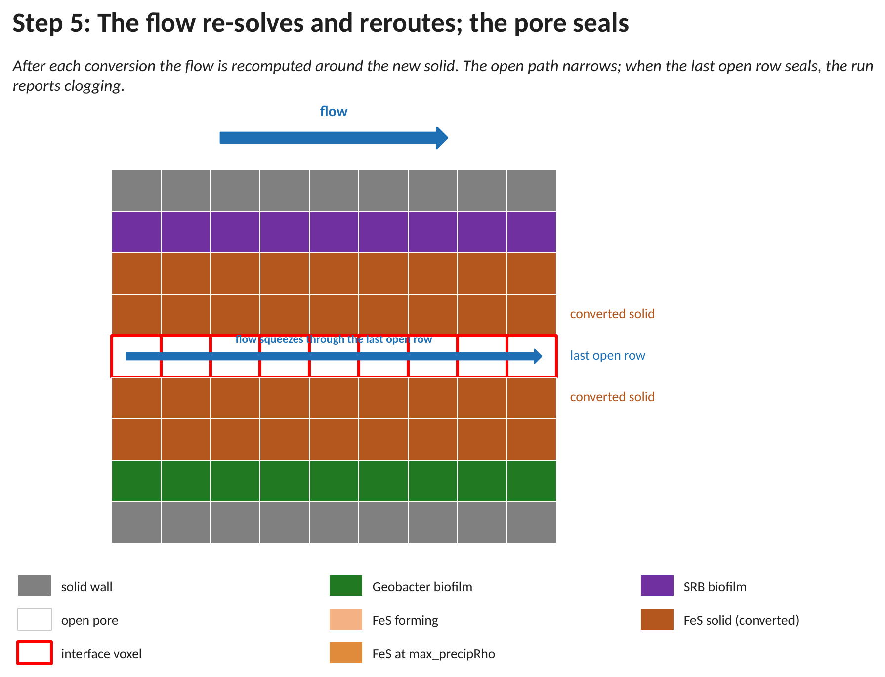
Figure D6. The pore near the point of clogging: the flow is forced through the last open row and drops to zero once that row seals.
By this stage most of the channel has turned to solid and only the middle row is still open. The flow, shown by the blue arrow, is squeezed through this last narrow gap, so it is fastest there while dropping to almost nothing everywhere else. When this final row also fills and converts, there is no open path left from the inlet to the outlet: the flow leaving the outlet falls to zero and the solver records that the pore has clogged. This is the end state of a clogging run and the point at which the simulation reports the clog.
D.6 What is allowed to dissolve, and why it has to be declared
Dissolution runs the same three stages as precipitation, in reverse. A declared mineral phase is consumed by the water in contact with it; a voxel whose inventory has fallen far enough is returned to open pore; and the flow is re-solved through the wider channel. The mineral need not have precipitated first: a phase can start completely solid and be eaten away, which is the ordinary case of an acid entering a carbonate pore space.
Before any of that, one thing has to be settled that precipitation never has to settle. Precipitation makes mineral where there was none, so the voxels it may act on are simply the pore voxels. Dissolution removes mineral that is already there, so something must say which solid may be removed. Only material inside a <phaseN> block can dissolve.
That restriction is deliberate, and the reason is worth stating because the obvious alternative fails immediately. Consider the rule a solid voxel with no mineral left becomes pore. An inert quartz grain has never held any mineral: it is already below any threshold that could be written. On the first step the entire grain pack would dissolve. Declaring phases makes inert material safe by construction rather than by a guard somebody has to remember to write.
A phase names four things: the material number it occupies in the geometry file, the immobile substrate that carries its inventory, the inventory of a completely full voxel, and the inventory a voxel starts with. The last of these is what lets a phase begin solid (initial_fill = full_density) or begin empty and appear only where precipitation puts it (initial_fill = 0, the case of D.10).
In the solve sequence: the phases are read once at start-up, before the first step, and each phase's voxels are seeded with its initial_fill. A material number that no phase claims is inert for the whole run.
D.7 Surface-controlled dissolution
A mineral voxel is called a wetted voxel when at least one of its six touching neighbours is open pore. Only wetted voxels dissolve. This is the same restriction as the interface rule of D.3 and it has the same physical content: a reaction between a solid and a solute can only happen where the two are in contact, and mineral buried inside a grain is in contact with nothing.
Which water the rate is given follows from that, and it is the one place where the dissolution path differs mechanically from the precipitation path. A solid voxel holds no water of its own that moves: the transport solver does not stream inside it, so there is no local concentration to hand the rate law. The composition is therefore taken as the average over the voxel's open neighbours — the water actually touching the mineral — and the products the reaction releases are pushed back into those same neighbours, divided evenly among them.
Algorithm D.4 Dissolving a voxel that water can reach
Given: the mineral inventory of every declared voxel, and a map showing
which voxels are open pore, wall, or mineral.
Goal: consume mineral only on the wetted faces, and put the products into
the water that is touching them.

1. Look at every declared mineral voxel, one at a time.
2. Find its open face neighbours (left, right, front, back, top, bottom).
3. If there are none, the voxel is buried and cannot be reached by water,
so do nothing here. // no reaction inside a grain
4. Average the dissolved concentrations over those open neighbours.
// the water on the surface
5. Work out the dissolution rate from that average and from how much
mineral the voxel still holds.
6. Subtract what dissolved from the voxel's inventory.
7. Divide the released products evenly among the same open neighbours,
and add them there. // mass moves into the water

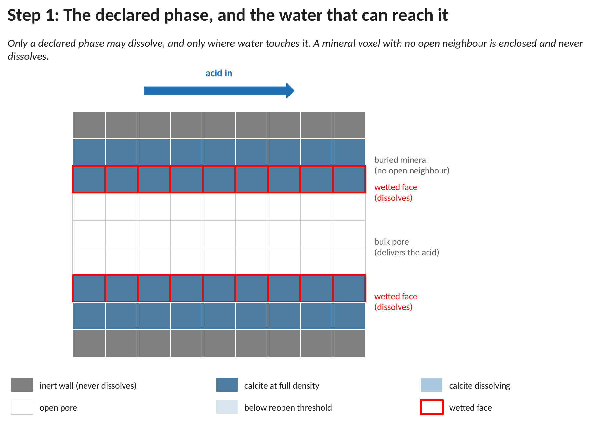
Figure D7. A cross-section of a calcite-lined pore before anything has dissolved, showing the inert wall, the declared mineral phase, the open channel, and the wetted faces (red outline) where dissolution is allowed.
In this first panel nothing has dissolved yet. The grey rows at the very top and bottom are inert wall: they are not a declared phase, so no amount of acid will remove them. The two blue bands are the calcite. Only the inner row of each band is outlined in red, because only those voxels have an open neighbour; the blue row behind each of them is buried, every one of its neighbours is solid, and it will not change until the row in front of it has gone. The white rows in the middle are the open channel, which is what delivers the acid.
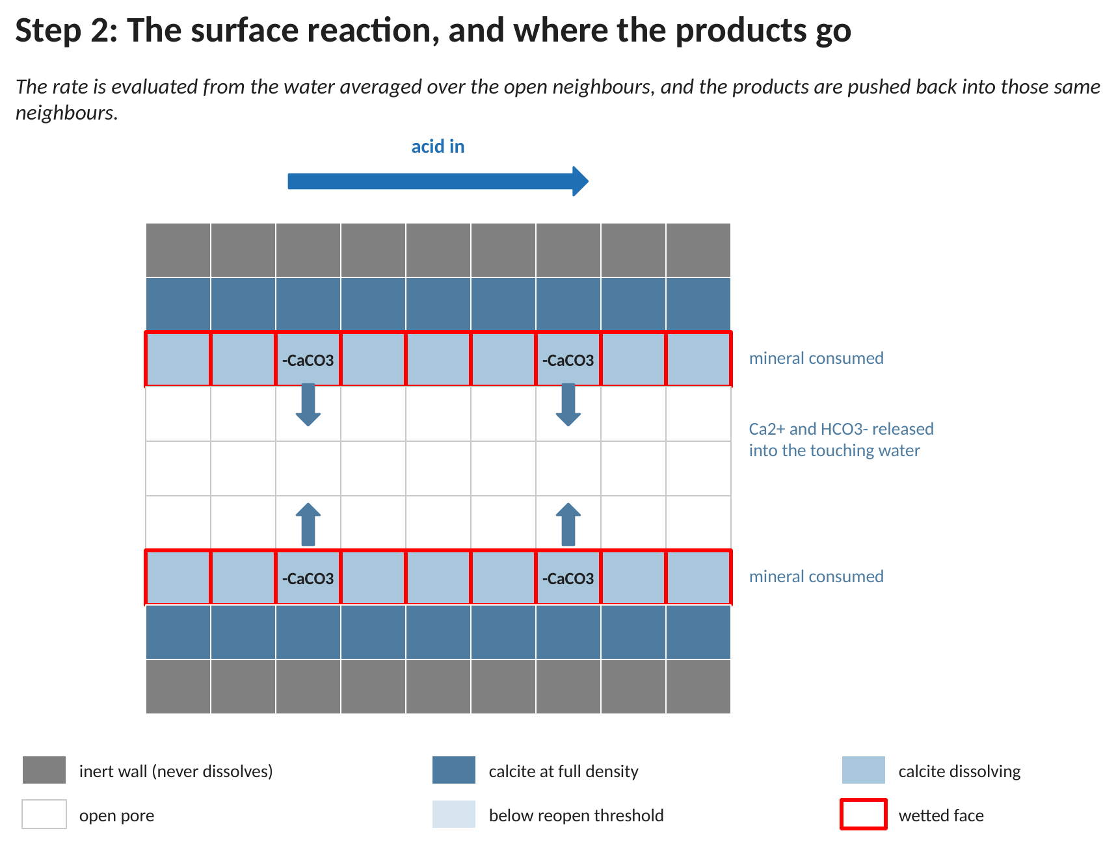
Figure D8. The surface reaction. Mineral is consumed in the wetted rows only, and the dissolved products are pushed into the open pore voxels touching them.
Here the reaction has been switched on and a little time has passed. The two wetted rows have lost mineral, shown by the lighter blue and the -CaCO3 label. The arrows show where the products went: not into the mineral voxel, which has no water that moves, but into the open pore voxels against it, split evenly among them. The buried rows behind are unchanged, and the middle of the channel is unchanged too, because nothing there is in contact with mineral. The visible result is a mineral surface being etched back one layer at a time, which is the mirror image of the coating that grew in Figure D3.
D.8 Node reopening and the retreating front
Each wetted voxel keeps losing mineral over successive time steps. Because the rate carries a factor of the mineral remaining, it slows as the voxel empties rather than running at full speed and stopping abruptly. Once the inventory falls below a set fraction of the full density, the solver returns that voxel to open pore. The mineral behind it then has an open neighbour, becomes wetted in its turn, and starts to dissolve on the following passes. In this way the mineral front moves one voxel at a time away from the channel and into the grain.
The threshold is deliberately below the full density, and the gap between the two is not a rounding allowance. On a single threshold a voxel sitting near the boundary would flip between solid and pore on the arithmetic noise of one step, and every flip costs a flow re-solve. With reopen_fraction at 0.9 a voxel has to have genuinely lost a tenth of its inventory before the geometry changes, so a marginal voxel settles instead of chattering. The symptom of getting this wrong is a porosity that oscillates with a period of exactly update_interval.
seal at P ≥ P_full reopen at P < φ · P_full (φ = 0.9)
Algorithm D.5 Returning an emptied voxel to the pore
Given: how much mineral each declared voxel now holds, and the reopen fraction.
Goal: return an emptied voxel to the pore so the mineral face steps outward.

1. Look at every declared mineral voxel, one at a time.
2. Compare its inventory with reopen_fraction x full_density.
3. If it has fallen below, mark it as open pore. // it is now water
4. Its mineral neighbours now touch open pore, so on the next pass they
become wetted and begin to dissolve. // the front steps out

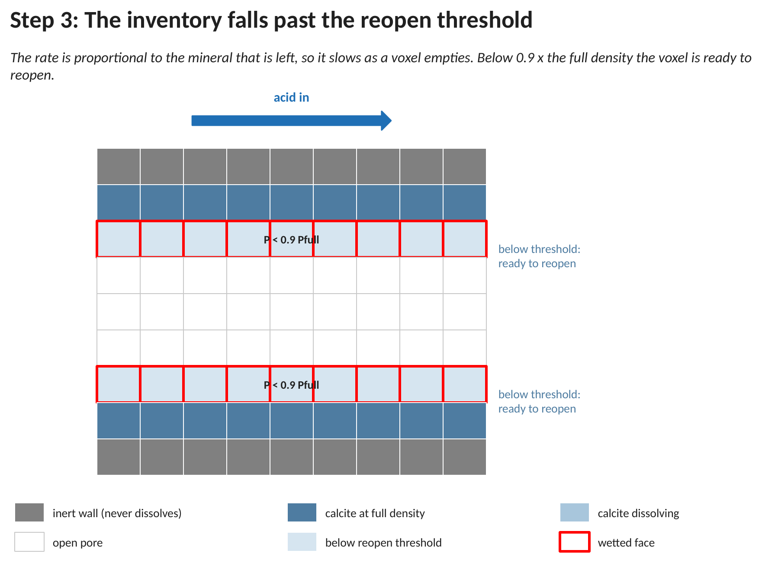
Figure D9. The wetted voxels are eaten down past the reopen threshold (labelled P < 0.9 Pfull) and are ready to be returned to the pore.
This panel captures the moment just before reopening. The mineral that was being consumed in Figure D8 has now been eaten down to a small fraction of what it held, shown by the palest blue and the label P < 0.9 Pfull. Because the rate is proportional to the mineral that is left, the last of the inventory went slowly: these rows have faded rather than emptied abruptly. Nothing has moved yet; they are simply below the threshold and about to be converted to pore in the next step.
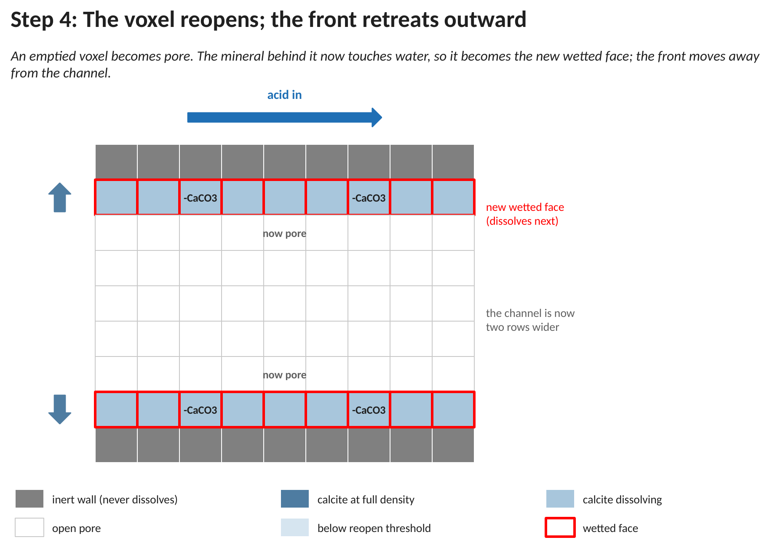
Figure D10. An emptied voxel becomes open pore and the mineral behind it becomes the new wetted face, so the front steps one voxel outward and the channel widens.
Now the emptied voxels have been returned to the pore, and from this point they behave exactly like the water that was already there. The key change is one row deeper on each side: the calcite that was buried in Figure D7 now has an open neighbour, so it has become the new wetted face and has begun to dissolve itself. The small arrows on the left mark the direction of retreat. Repeating this, the mineral coating is stripped outward from the channel, one layer at a time, which is the same stepping mechanism as Figure D5 running the other way.
D.9 Flow feedback and the widening channel
Every reopening changes the pore shape, so the flow has to be brought up to date, and the machinery is the one D.5 already described: every update_interval steps the solver checks whether any voxels became pore and, if so, opens them to flow and recomputes the field until it settles. What differs is the direction the feedback runs.
As more voxels open, the channel widens and more water gets through, so the sample becomes easier to push flow through: its permeability rises. That is the opposite of the clogging case, and it is unstable rather than self-limiting. A wider channel delivers more acid to the faces along it, which widens it faster still, while a narrow channel that started slightly behind falls further behind. A dissolution front therefore fingers along the best-supplied paths instead of advancing as a flat face (Steefel and Lasaga 1994; Noiriel and Soulaine 2021), and it is exactly this that a pore-scale model resolves and a continuum one cannot.
Algorithm D.6 Updating the flow after the pore reopens
Given: the pore shape may have changed because some voxels became pore.
Goal: keep the flow consistent with the new shape, and carry the feedback.

Every few steps (set by update_interval):

1. Count how many open voxels there are.
2. Return any emptied voxels to the pore (Algorithm D.5).
3. Count the open voxels again.
4. If the count went up (the shape changed):
a. Open each new pore voxel to flow.
b. Recompute the water flow until it settles. // the flow redistributes
c. More water now follows the widened path, so the next pass delivers
more acid to the faces along it. // the front runs ahead

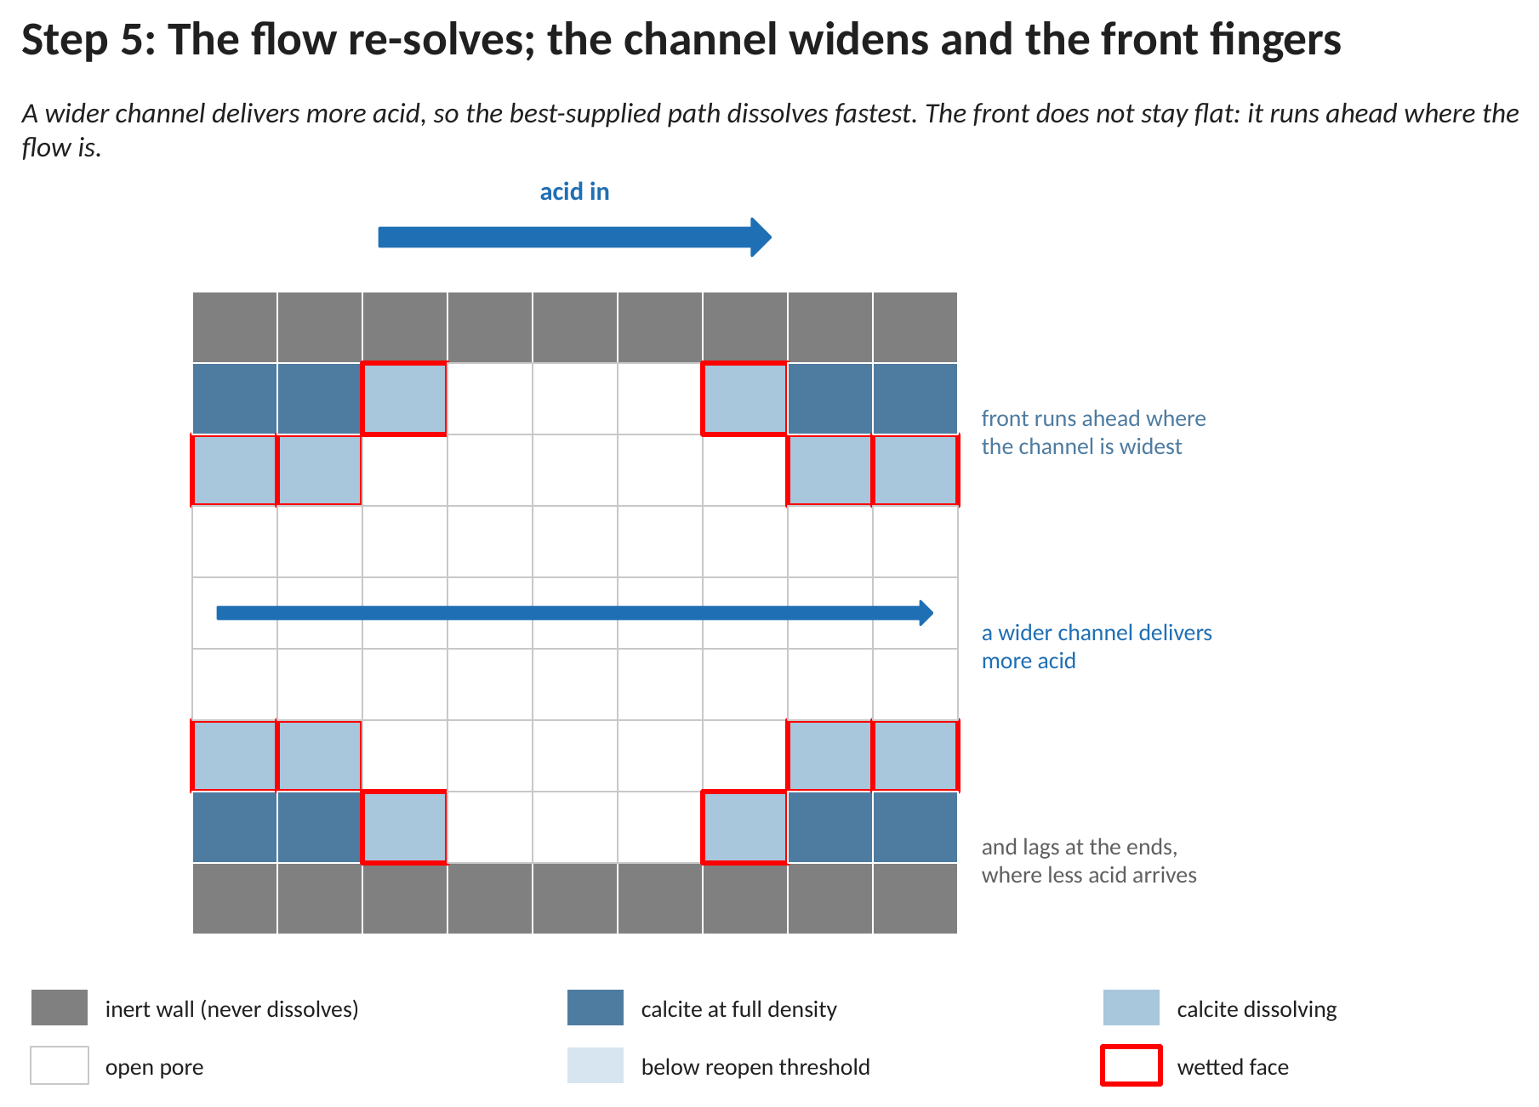
Figure D11. The pore after several reopenings: the channel has widened unevenly, and the front runs ahead where the flow is and lags where it is not.
By this stage the front is no longer flat. The middle columns, where the channel opened first, have received the most acid and have been dissolved through both calcite rows down to the inert wall behind; the columns at either end still hold mineral. That unevenness is the feedback made visible: widening the channel increases the flow through it, which delivers more acid, which widens it further. Precipitation does the reverse, closing its best-supplied paths first, which is why a clogging front tends to flatten itself while a dissolution front does not. A run in this state has not finished: it continues until the declared phase is exhausted or the acid supply is.
D.10 Both directions acting on one mineral
The two configuration blocks are independent, which is why both may be enabled at once. What connects them is a single flag on the phase:
<phase0>
<name>FeS_precipitate</name>
<material_number>0</material_number>
<substrate>3</substrate>
<full_density>48.9</full_density>
<initial_fill>0</initial_fill> <!-- nothing there at the start -->
<is_precipitate>true</is_precipitate> <!-- voxels sealed by precipitation -->
</phase0>

With is_precipitate set, a voxel that the precipitation path sealed is stamped as belonging to this phase, which is what makes it eligible for the dissolution path later. Without the stamp the two halves would not know they were operating on the same mineral, and a sealed voxel would be permanent, as it is in D.5. Note also that max_precipRho and full_density are the same physical quantity — the density of the solid mineral — and must carry the same value in both blocks.
One point of interpretation matters more than any setting here. The forward and reverse laws are not inverses of one another. Precipitation as written in D.11.2 is second order in the dissolved ions; dissolution as written in D.11.6 is first order in acid and in the mineral remaining. They are two separate rate laws that happen to move the same mineral. That is how the code is intended to be used: there is no solubility product anywhere in it, and therefore no saturation state to drive a single reversible rate. A mineral under both laws has no well-defined equilibrium — it has whichever steady state the two rate constants and the transport happen to produce. If detailed balance is needed, it has to be imposed by the two laws the user writes, for example by giving each a saturation-state term in the form R = k A (Ω − 1)ⁿ with Ω the saturation index and A the reactive surface area (Steefel and Lasaga 1994).
A voxel in this case can therefore seal, sit sealed while the flow reroutes around it, and later be reopened by acid arriving down a different path. Porosity is no longer a one-way trend, and the thing to watch in the output is not its direction but its shape: it should move in steps and then hold, not oscillate at the update interval. That is the failure D.8 exists to prevent.
D.11 The chemistry and mathematics, step by step
Where precipitation enters the time loop. Each CompLaB3D iteration runs a fixed sequence of stages: (i) transport of the dissolved species by advection and diffusion; (ii) the kinetic reactions, biotic and abiotic; (iii) the equilibrium speciation; (iv) biomass growth and redistribution; and (v) a flow re-solve, done only when the pore geometry has changed, whose new velocity field feeds stage (i) on the next iteration. Precipitation acts at two points: the surface reaction runs inside stage (ii), and the node conversion and flow feedback run after stage (iv).
D.11.1 The precipitation reaction
Precipitation moves a dissolved species into an immobile solid. In general form, two dissolved reactants A and B combine into a solid mineral P:
A(aq) + B(aq) → P(s) (1)
In this system the mineral is mackinawite (FeS). Dissolved Fe(II), produced by the iron-reducing bacteria, and sulfide, produced by the sulfate-reducing bacteria, react to form solid FeS:
Fe²⁺ + HS⁻ → FeS(s) + H⁺ (2)
The two reactants are made at different walls (Fe(II) at the Geobacter wall, sulfide at the sulfate-reducer wall), so they only overlap in quantity near the surfaces. The mineral therefore forms on the grain surfaces, not in the open water, which is why the reaction is limited to interface voxels (Section D.3).
In the solve sequence: this reaction is defined in defineAbioticKinetics.hh and runs in stage (ii). It uses the dissolved concentrations that stage (i) has just delivered to each voxel.
D.11.2 The reaction rate
The rate follows the law of mass action: it is proportional to how much of each reactant is present, so it is fast when both are abundant and zero when either one is missing. Writing R for the rate and square brackets for concentration,
R = k · [Fe²⁺] · [HS⁻] (3)
In equation (3), [Fe²⁺] and [HS⁻] are the concentrations of iron and sulfide (mol/L); k is a fixed rate constant measured in the laboratory (the code constant k_FeS, Rickard 1989); and R is the amount of FeS formed per litre each second. A general reaction obeys the same law, R = k·[A]·[B].
In the solve sequence: the rate is computed by defineAbioticRxnKinetics from the local reactant concentrations. The routine surfaceAbioticKinetics3D first reads the geometry map to check that the voxel touches a surface, and applies the rate only there.
D.11.3 Build-up of the solid
Each reacting voxel keeps the FeS it has already made and adds more on every step. Calling the solid FeS in a voxel P, it grows at the rate R:
dP/dt = R (4)
The solver advances this one fixed time step Δt at a time, keeping a running total:
P(new) = P(old) + R · Δt (5)
Equation (5) says the new solid equals the old solid plus what formed during the step (rate times step length). Here P is the density of the clogging mineral (the immobile solid_substrate, FeS) and Δt is the reaction step ade_dt.
In the solve sequence: still in stage (ii), the amount R·Δt is added to the FeS field and the dissolved reactants are reduced by the matching amounts, so mass is conserved.
D.11.4 Turning a full voxel into solid
A voxel can hold only so much mineral. Once its FeS reaches a set maximum, P_max, the voxel is switched from open pore to solid:
if P ≥ P_max, the voxel becomes solid (6)
P_max is the setting max_precipRho. A voxel that has turned solid does three things: it stops reacting, because it is full; it acts as a wall for its neighbours, so the pore voxels behind it now touch a surface and start to form FeS on the next step; and it blocks the flow. Because the neighbours start reacting, the mineral wall grows one voxel deeper each time a layer fills, moving inward from the walls toward the centre of the pore.
In the solve sequence: precipNodeConversion3D runs after stage (iv), once every update_interval steps. It reads the FeS field and the geometry map, and writes the geometry map, changing full pore voxels to solid. The rise in the solid count tells the flow stage that the geometry has changed.
D.11.5 Updating the flow, and detecting clogging
When a voxel becomes solid, the shape of the open pore changes, so the flow has to be worked out again. Two rules set the new flow.
Rule 1. The water is incompressible, so the amount of water entering any region equals the amount leaving it:
flow in = flow out ( ∇ · u = 0 ) (7)
where u is the velocity.
Rule 2. A solid voxel lets no water pass through it (the setting perm_ratio = 0; a value between 0 and 1 would let a little through).
With the new solid voxels closed off, the flow solver runs again until the flow settles, and the water finds a new path around them. As more voxels close, the open paths narrow and less water gets through, so the sample becomes harder to push flow through (its permeability falls). The solver keeps watching the water leaving the outlet. When the last open path closes, that outflow drops to zero, and the run reports that the pore has clogged:
outflow = 0 means the pore is fully clogged (8)
In the solve sequence: if the geometry map changed, updateNsLatticesDynamics3D closes the new solid voxels to flow, the Navier-Stokes solver re-runs until the flow settles, and the new velocity field is copied back into the transport step (latticeToPassiveAdvDiff) so the next iteration moves the chemicals along the new flow.
D.11.6 Dissolution: the reverse path
Dissolution moves an immobile solid back into the dissolved phase. In general form, a solid P is attacked by a dissolved reactant A:
P(s) + A(aq) → dissolved products (9)
In the worked example of D.13 the mineral is calcite and the attacking species is the proton:
CaCO₃(s) + H⁺ → Ca²⁺ + HCO₃⁻ (10)
The rate is first order in the attacking species and first order in the mineral that is left:
R = k · [H⁺] · P (11)
In equation (11), [H⁺] is the concentration in the water touching the mineral — the neighbour average of D.7, not a concentration stored in the solid voxel — P is the inventory still in that voxel, and k is the rate constant (the code constant k_calcite). The factor P is what makes the rate fall away as a voxel empties, instead of running at full speed until the inventory reaches zero and stopping in a single step. The inventory is then advanced exactly as in equation (5), with the sign reversed:
P(new) = P(old) − R · Δt (12)
In the solve sequence: the rate is returned by defineDissolutionRate in stage (ii). The mineral decrement is written to the immobile substrate that carries the phase; the dissolved products are added to the open face neighbours. The reopening test and the flow re-solve run after stage (iv), once every update_interval steps.
D.11.7 Mass across a change of geometry
Every conversion, in either direction, moves mass between two accounts — the dissolved lattices and the mineral inventory — and never creates or destroys it. For a species released only by dissolution and consumed by nothing, the whole run therefore satisfies one identity:
Σ dissolved in the domain = mineral removed from the declared phase (13)
with no source and no sink to explain any discrepancy. That makes it the tightest available check on the transport step, and D.12 is how the solver tests it.
D.11.8 Why precipitation matters for the uranium
The FeS that forms does two jobs. It fills the pore, as above, and it also coats the grain surface, and that coating decides how the uranium is reduced.
The reactive surface carries two materials: leftover Fe(III) oxide, where the bacteria reduce uranium, and the new FeS coating, where the chemistry reduces uranium. The more of the surface the FeS covers, the more of the uranium the chemistry handles. The fraction of the surface covered by FeS is its amount divided by the total reactive solid:
f_ab = FeS / (FeS + Fe(III)) (14)
and the fraction left for the bacteria is the rest, f_bio = 1 - f_ab. (A tiny number is added to the bottom so the code never divides by zero.) The abiotic reduction rate is multiplied by f_ab, and the biotic rate by f_bio.
For example, if FeS covers three quarters of the surface, then about three quarters of the uranium is reduced by the chemistry and one quarter by the bacteria. As precipitation continues, f_ab grows and the chemistry gradually takes over. This handover from bacteria to chemistry is Zhao's Eqs. 1 and 2, and it is the reason precipitation had to be added to the model.
In the solve sequence: f_ab and f_bio (frac_ab and frac_bio in the code) are computed in stage (ii) from the local FeS and Fe(III) amounts, and they scale the two uranium-reduction rates, so the split updates every step as FeS builds up.
D.12 Checking that a run conserved mass
A geometry that changes during a run puts pressure on the parts of the solver that are easiest to get wrong, and three of them were wrong. Each is described here because each produced results that looked entirely reasonable.
D.12.1 What an immobile species inside a solid voxel reports
The transport solver stores populations as a deviation from equilibrium, so the density of a voxel is the sum of its populations plus one. The dynamics assigned to a solid voxel, however, return their own stored density and ignore the populations altogether. Every mineral inventory therefore read back as exactly 1.0 mol/L, whatever had been seeded into it.
The consequence was not subtle. A calcite phase seeded at 27.1 mol/L read as 1.0; the reopening test of Algorithm D.5 found every grain below its threshold; and the entire grain pack converted to pore on iteration zero, after which the case dissolved nothing at all for the rest of the run and reported a perfectly steady porosity. Solid voxels on an immobile substrate now report their own contents.
D.12.2 A no-flux face has to be a wall, not a zero-gradient
A boundary that copies the interior value outward is a zero-gradient condition, and a zero-gradient condition is an open outflow: material leaves through it freely. Used where a wall was intended, it silently supplies whatever the interior has, and a species produced inside the domain will appear to be produced faster than the reaction makes it. In the dissolution example this manufactured close to a third of the calcium.
The configuration therefore distinguishes three boundary types per substrate: a held value, a zero-gradient outflow, and closed — a bounce-back plane, which is exactly no-flux. A species that is created inside the domain and must not leave it takes closed on both faces.
D.12.3 Mass sitting where the density query cannot see it
A bounce-back voxel holds populations but reports its own stored density, so a sum over reported densities misses whatever has accumulated at the walls. The diagnostics therefore carry a second column per field, the mass held in such voxels, and the conservation test is applied to the sum of the two. On a fully closed box with every reaction switched off, the solver now conserves solutes to within about 4 parts in 10¹³, where it previously lost several per cent.
D.12.4 What the run reports
For a dissolution run the closing report gives the mineral removed and, separately, the amount released per dissolved species. The separation matters: a single released total summed over every substrate double-counts a reaction that releases two species, which is why an earlier version reported twice the mineral it had actually consumed. The identity of equation (13) is checked every diagnostic interval and the residual is printed, so a run that failed it is visible in the log rather than in the figures.
D.13 The three shipped cases
Three cases ship with the code, one per direction and one for both. Each is self-contained: the geometry generator, the configuration, the rate-law header and the post-processing checks are all in the case folder, and each carries its own README describing what it simulates and what a correct run looks like.
Example | Reaction | What it shows
13_precipitation | Fe²⁺ + HS⁻ → FeS(s) | Sections D.3 to D.5 running: a mineral forming in a band where two supplies overlap, filling its voxels and sealing them. Porosity can only fall, and nothing reopens a sealed voxel.
14_dissolution | CaCO₃(s) + H⁺ → Ca²⁺ + HCO₃⁻ | Sections D.6 to D.9 running: acid entering from one face, etching back the mineral coating on the grain surfaces, and the voxels it empties returning to pore. Porosity can only rise. This is the case that carries the calcium balance of equation (13).
15_precip_and_dissolution | both, on one mineral | Section D.10 running: both directions on the same FeS phase, linked by is_precipitate. Porosity moves in both directions; the thing to watch is that it moves in steps and then holds, rather than oscillating at the update interval.

All three run on the same staggered slot, small enough to finish in seconds. Between them they exercise every setting in the two configuration blocks of D.1, and their post-processing scripts apply the checks of D.12.
D.14 A worked example: one voxel through each direction
Section D.13 lists the three cases. This section takes one voxel out of two of them and puts real numbers through the equations of D.11, once for a voxel that is filling with mineral and once for a voxel that is being eaten away. The arithmetic is short enough to check on paper, which is the point: the two directions are not symmetric, and the asymmetry is easier to see in numbers than in prose.
D.14.1 Where every number in this example comes from
Some of the numbers below describe the mineral and are properties of the substance. Some are the modeller's choices about how the pore space is allowed to change. The rest are the state of the simulation at the instant the reaction step begins.
the number | what it is | where it comes from
1.0 L mol⁻¹ s⁻¹ | the rate constant for iron sulfide precipitation | k_FeS in examples/13_precipitation/kinetics/defineAbioticKinetics.hh
48.9 mol L⁻¹ | how much iron sulfide a completely full voxel holds | <max_precipRho> in that case's CompLaB.xml. It is the molar density of mackinawite: 87.91 g per mole over 4.30 g per cubic centimetre gives 20.44 cubic centimetres per mole, and a litre holds 48.9 of those
1.0×10⁻² L mol⁻¹ s⁻¹ | the rate constant for calcite dissolution, per mole of mineral left | k_calcite in examples/14_dissolution/kinetics/defineAbioticKinetics.hh
27.1 mol L⁻¹ | how much calcite a completely solid voxel holds | <full_density> in that case's CompLaB.xml: 100.09 g per mole over 2.71 g per cubic centimetre is 36.9 cubic centimetres per mole
0.9 | the fraction of full below which a mineral voxel is handed back to the pore space | <reopen_fraction>. A choice, not a measurement, and D.9 explains why it is not 1.0
100 steps | how often the solver re-examines which voxels are solid | <update_interval> in both cases. The chemistry runs every step; only the geometry check is intermittent
0.0149760 s | how long one reaction step lasts in these two cases | the solver prints it as [ADE] dt at start-up. Both cases set <Peclet>1</Peclet>, so the step follows the MEASURED mean pore velocity and is an output of the flow solve rather than something typed in. That is why it is not the round 0.015 s of the diffusion-only cases
the concentrations | what the voxel holds at this instant | the transport solver, one step earlier. These are the only numbers that differ from voxel to voxel

D.14.2 A voxel that is filling: precipitation
Take a voxel in the band where the two supplies meet. Iron enters from one face at 5 mol per litre and sulfide from the other, so somewhere between them both are present; say this voxel holds 0.80 mol per litre of iron and 0.60 of sulfide. The rate law is second order, one of each:
R = k_{FeS} × [Fe²⁺] × [HS⁻] = 1.0 × 0.80 × 0.60 = 0.48 mol L⁻¹ s⁻¹
That is a rate. What the solver applies is an amount, so multiply by the length of the step:
ΔC = R × Δt = 0.48 × 0.0149760 = 7.18848×10⁻³ mol L⁻¹
and that one number is applied three times, with the signs the reaction dictates: iron falls by it, sulfide falls by it, and the mineral rises by it.
d[Fe2+] = -7.18848e-3 mol/L one iron consumed
d[HS-] = -7.18848e-3 mol/L one sulfide consumed
d[FeS] = +7.18848e-3 mol/L one mineral made
The three are equal in magnitude because the reaction is one for one for one. That is the check to make on your own rate law before anything else: if the three increments are not in the ratio the reaction says, the stoichiometry in the header is wrong, and no amount of correct transport will fix it.
D.14.3 What it takes to seal that voxel
The mineral is a substrate like any other, except that it does not move, so its value accumulates in place. Sealing happens when it reaches the density of the solid, and at the rate above that is:
48.9 / 7.18848×10⁻³ = 6803 steps
roughly 102 seconds of simulated time. Two things about that number are worth saying. First, it is an upper bound in one sense and a lower bound in another: the rate falls as the two reactants are consumed, which makes it slower, but fresh supply keeps arriving from both faces, which makes it faster, and which of those wins is exactly what the transport solver is there to decide. Second, the geometry is only re-examined every 100 steps, so the voxel is not converted the instant it fills. It is converted at the next check, and D.9 explains why that lag is preferable to checking every step.
When the conversion does happen, one voxel of the 4992 in this domain leaves the pore space, so the porosity the run reports falls by 1/4992, about 2.0×10⁻⁴. A porosity curve that falls in visible steps rather than smoothly is not a defect: it is the update interval, and the step height is the number of voxels that crossed the threshold since the last check.
D.14.4 A voxel that is being eaten: dissolution
Now the other direction, in the calcite case. This voxel starts completely solid, so its mineral inventory is the full 27.1 mol per litre, and it sits at the wetted face of a grain where acid has reached it. Acid enters the domain at 1.0×10⁻² mol per litre and the water started at 1.0×10⁻⁴, so take a face value between the two, 5.0×10⁻³. The rate law is first order in acid and first order in the mineral remaining:
R = k_{calcite} × [H⁺] × [calcite] = 1.0×10⁻² × 5.0×10⁻³ × 27.1 = 1.355×10⁻³ mol L⁻¹ s⁻¹
The second factor is what makes this different from precipitation, and it is worth dwelling on. The mineral appears in its own rate law, so a voxel that is nearly empty dissolves slowly. That is a crude stand-in for reactive surface area, which falls as a grain is consumed, and it is the reason the last of a grain takes far longer to go than the first of it. Over one step:
Δ[calcite] = − 1.355×10⁻³ × 0.0149760 = − 2.0292×10⁻⁵ mol L⁻¹
d[calcite] = -2.0292e-5 mol/L mineral removed from the inventory
d[Ca2+] = +2.0292e-5 mol/L one calcium released per formula unit
d[H+] = -2.0292e-5 mol/L one proton consumed per formula unit
D.14.5 What it takes to reopen that voxel
A dissolving voxel is handed back to the pore space when its inventory falls below <reopen_fraction> of full, which is 0.9 × 27.1 = 24.39 mol per litre. So 2.71 mol per litre has to go, and at the rate above:
2.71 / 2.0292×10⁻⁵ = 133 547 steps
which is about 2000 seconds of simulated time, and far longer than the 2000 steps the shipped case runs. That is not a flaw in the case and it is the most useful number in this section: dissolution here is slow, the shipped run is a demonstration of the mechanism rather than a simulation run to completion, and a reader who expected to watch grains disappear will otherwise conclude something is broken. Raise the acid concentration, raise the rate constant, or run longer; the arithmetic above says by how much before any of it is tried.
The asymmetry with precipitation is now visible in the two numbers rather than in words. Sealing a voxel needs the mineral to reach the density of the solid, 48.9, from nothing. Reopening one needs only the top ten per cent of its inventory to go, 2.71 out of 27.1. The thresholds differ deliberately, and D.9 gives the reason: a voxel that reopened at the same threshold it sealed at would chatter across the boundary every update interval.
D.14.6 Where the released product actually lands
One detail of the arithmetic above is quietly wrong as stated, and correcting it is the whole of D.8. The calcium is released by a voxel that is solid. Solid voxels do not carry solute and nothing there can transport it away, so putting the calcium in the voxel that made it would be putting it inside the rock. It is instead shared out among that voxel's open neighbours, and the share is equal:
share = released / n_{open}
A voxel with four open faces gives each of them a quarter. The bookkeeping that makes this exact is the pass-and-gather of D.8: the releasing voxel parks each share, and a second pass has each open neighbour collect exactly the shares addressed to it. The reason it is done in two passes rather than one is that a single pass writing into neighbours crosses processor boundaries, and mass written across a boundary by one rank is not seen by the rank that owns the destination.
The run reports whether it worked, and the shipped 2000-step run of example 14 reports this:
[DISSOL-VOP] 816000 product shares parked, 816000 collected by the water
[DISSOL-VOP] mineral removed from inventory: -4.68855 mol/L
[DISSOL-VOP] substrate 0: -4.68855 mol/L the proton, consumed
[DISSOL-VOP] substrate 1: +4.68855 mol/L the calcium, released
Two invariants are being asserted there, and both are worth checking in any run of your own. Parked equals collected, exactly, which says no share fell between the two passes and would still say so on any number of processors. And the calcium released equals the mineral removed, while the proton consumed is its negative, which is the stoichiometry of the rate law reappearing in the totals after transport has moved everything around. Neither is enforced anywhere; they are consequences, which is what makes them worth reporting.
The 4.68855 mol per litre is a total over all 72 mineral voxels in the case, so it is about 0.065 per voxel, against the 0.0406 that 2000 steps at the single fixed acid concentration of D.14.4 would give. The difference is the acid at the grain faces being higher than the 5.0×10⁻³ assumed there, which is what the transport solver is for: the arithmetic in this section is one voxel at one instant, and a run is that arithmetic in every voxel, coupled.
References
Jung, H., Song, H.-S., Meile, C.: CompLaB v1.0: a scalable pore-scale model for flow, biogeochemistry, microbial metabolism, and biofilm dynamics. Geoscientific Model Development. 16, 1683 to 1696 (2023). doi:10.5194/gmd-16-1683-2023
Kang, Q., Lichtner, P. C., Zhang, D.: Lattice Boltzmann pore-scale model for multicomponent reactive transport in porous media. Journal of Geophysical Research: Solid Earth. 111, B05203 (2006). doi:10.1029/2005JB003951
Noiriel, C., Soulaine, C.: Pore-scale imaging and modelling of reactive flow in evolving porous media: tracking the dynamics of the fluid-rock interface. Transport in Porous Media. 140, 181 to 213 (2021). doi:10.1007/s11242-021-01613-2
Steefel, C. I., Lasaga, A. C.: A coupled model for transport of multiple chemical species and kinetic precipitation/dissolution reactions with application to reactive flow in single phase hydrothermal systems. American Journal of Science. 294, 529 to 592 (1994). doi:10.2475/ajs.294.5.529
Yoon, H., Kang, Q., Valocchi, A. J.: Lattice Boltzmann-based approaches for pore-scale reactive transport. Reviews in Mineralogy and Geochemistry. 80, 393 to 431 (2015). doi:10.2138/rmg.2015.80.12
Zhao, J., Scheibe, T. D., Mahadevan, R.: Model-based analysis of mixed uranium(VI) reduction by biotic and abiotic pathways during in situ bioremediation. Chemical Geology. 357, 215 to 222 (2013). doi:10.1016/j.chemgeo.2013.08.031

