In-line Flux Balance Analysis: a reader's guide
what it is, how each solver runs it, and what each pipeline does
1. The idea, for someone who models reactive transport
In a classical reactive-transport model you write the reaction rate yourself. A Monod expression turns the local concentrations into one rate, and fixed yield coefficients turn that rate into a source term for every species. The stoichiometry is baked into those coefficients, and it does not move.
Flux balance analysis replaces that expression with a question put to the organism's whole metabolic network. The network is a list of every reaction the organism can run — hundreds for a core model, thousands for a genome-scale one. The question is: given how much of each substrate is available in this voxel right now, what is the fastest this organism can grow, and what does it consume and release while doing so?
The answer is not looked up and not fitted. It is the solution of a linear program, solved fresh in every voxel that holds biomass, at every time step.
 | a Monod rate law | flux balance analysis
what you supply | a maximum rate, a half-saturation, and a yield per species | the organism's reaction list
what is fixed | the stoichiometry, in the yields | only the reaction list
what can change with conditions | the rate | the rate AND the stoichiometry
cost per voxel per step | a few floating-point operations | one linear program, about 0.1 ms
valid where | wherever the law was calibrated | everywhere: nothing was calibrated

The last row is why this path exists. There is no fitted box outside which the answer stops meaning anything, so it is the reference every cheaper path is checked against. The fourth row is why the other paths exist at all.
2. How flux balance analysis works
2.1 The metabolic model is a matrix
A metabolic model is a list of reactions. Write the metabolites as rows and the reactions as columns, and put each reaction's stoichiometric coefficients down its column, and that list becomes a matrix S.
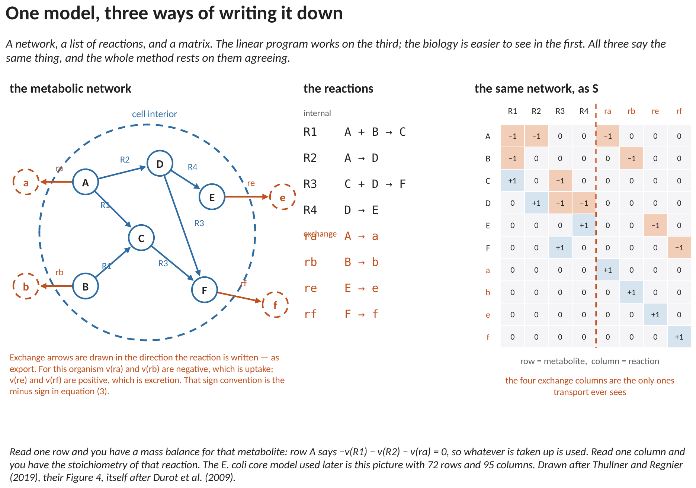
Figure 1. A six-metabolite example, written three ways. The network, the reactions, and the same information as the matrix S. Read one row and you have a mass balance for that metabolite; read one column and you have the stoichiometry of that reaction.
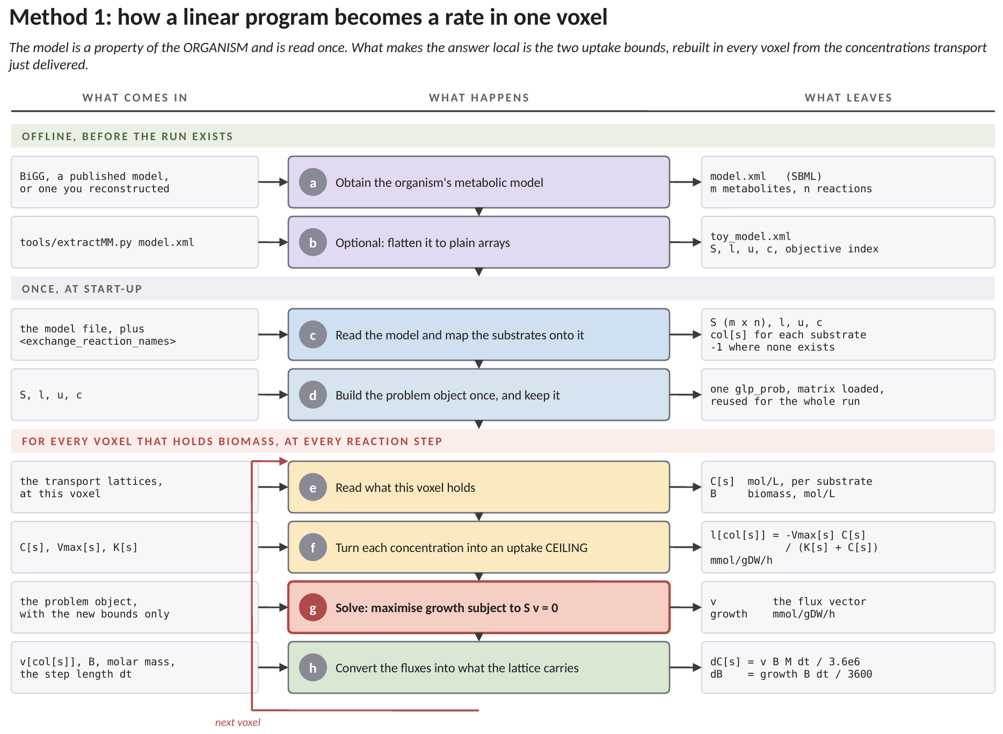
Figure 2. How this method works, end to end, and where each number enters. The three bands are the whole point: the green band is work a person does before any simulation exists, the grey band is work the solver does once at start-up, and the red band is the loop that runs in every voxel at every reaction step. Each row names what arrives, what is done to it, and what leaves. (a) The metabolic model is a property of the organism, not of the simulation: it is a list of the reactions the cell can run, taken from a database or reconstructed, and it is written once. (b) Optionally it is flattened to plain arrays, which removes the need to parse chemical markup at start-up but changes nothing about the model. (c) At start-up the solver reads that model and matches each of its exchange reactions to one of the substrates the simulation transports, by name. A substrate the organism does not exchange is marked absent rather than silently paired with the wrong reaction. (d) The problem object is built once and reused for the whole run, which is what makes solving a linear program in every voxel affordable at all. (e) The loop begins. The solver reads what this voxel holds: one concentration per substrate, and the biomass present. (f) Each concentration becomes an uptake CEILING through the Michaelis-Menten expression, in millimoles per gram of dry cells per hour. This is the only row that differs between one voxel and the next, and therefore the only place the local condition enters. (g) The program is solved: make growth as large as possible subject to nothing accumulating inside the cell, and subject to those ceilings. What comes back is a flux for every reaction, growth included. Note that the stoichiometry is an output here, not an input: the ratio in which the substrates are consumed is whatever the optimum required, and it can change from voxel to voxel. (h) The fluxes are converted into the units the transport solver works in, using the biomass present, its molar mass and the length of the step. Those increments are what the next transport step carries away.
Two kinds of reaction matter differently. INTERNAL reactions happen inside the cell and the transport model never sees them. EXCHANGE reactions cross the cell boundary, and they are the only ones that do: they are where the transport model delivers concentrations and where it collects source terms.
2.2 Three statements and one that is local
The program has four parts. Three are fixed for the whole run; one is rebuilt in every voxel, and that one is the entire coupling between the metabolic model and the transport model.
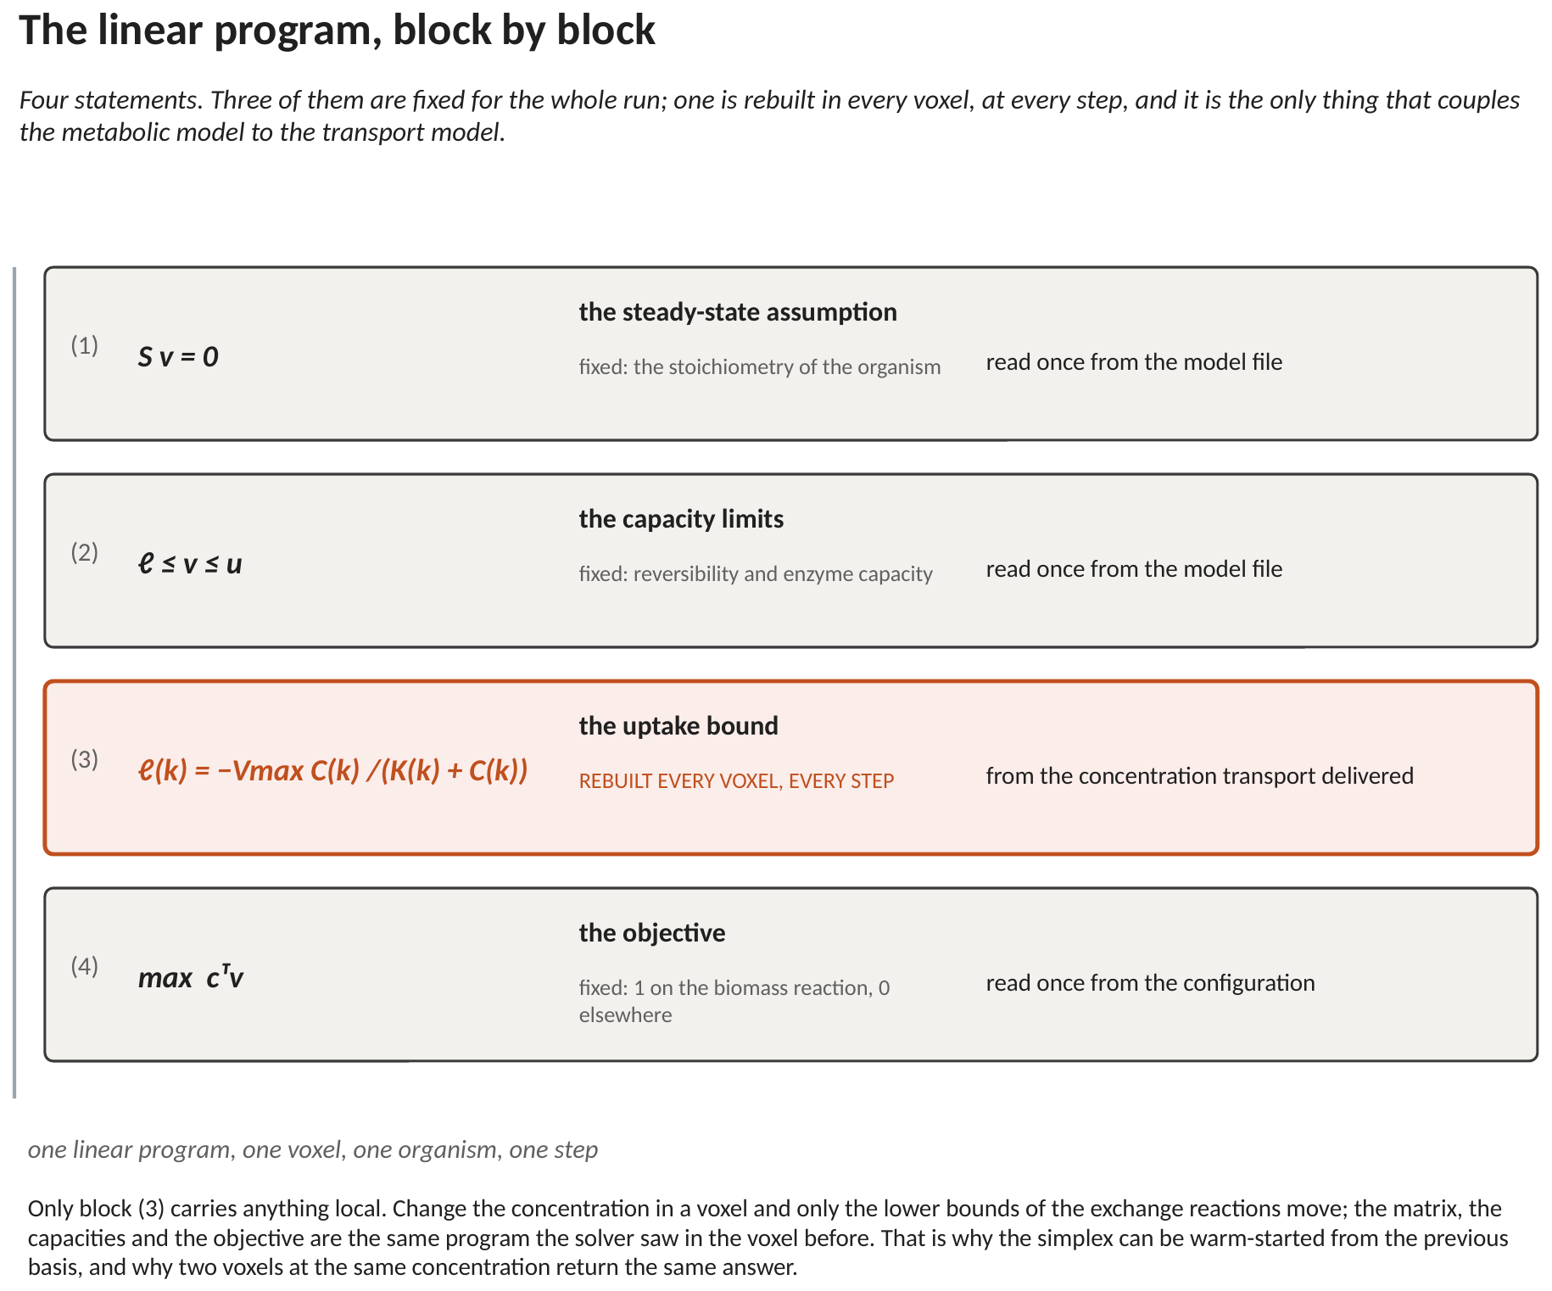
Figure 3. The program, block by block. Only the third block carries anything that changes from one voxel to the next.
The first says every internal metabolite is at steady state:
S v = 0 (1)
Nothing accumulates inside the cell. This is the assumption that makes the problem linear, and it holds because internal pools turn over in seconds while the transport step is minutes or hours.
The second says no reaction may run faster than it can:
ℓ ≤ v ≤ u (2)
The third is the one that carries the local condition. For each substrate the organism can take up, its exchange reaction gets a lower bound built from the concentration transport just delivered:
ℓ_{k} = − V_{max,k} C_{k} / ( K_{k} + C_{k} ) (3)
That is an ordinary Michaelis–Menten expression, and it is doing an ordinary job: it says how fast this substrate CAN enter the cell. The minus sign is a convention — exchange reactions are written as export, so uptake is a negative flux. Nothing else in the program changes from voxel to voxel.
The fourth is what the organism is assumed to be doing:
max cᵀ v (4)
with c one on the biomass reaction and zero elsewhere. The organism grows as fast as its network and its supply allow.
2.3 What comes back
The solver returns one flux for every reaction. Two things are read out of that vector, and nothing else is used:
- The flux on the biomass reaction is the growth rate, which drives the biomass increment.
- The flux on each exchange reaction, scaled by biomass and the time step, is the source term for that species — negative where it was consumed, positive where it was released.
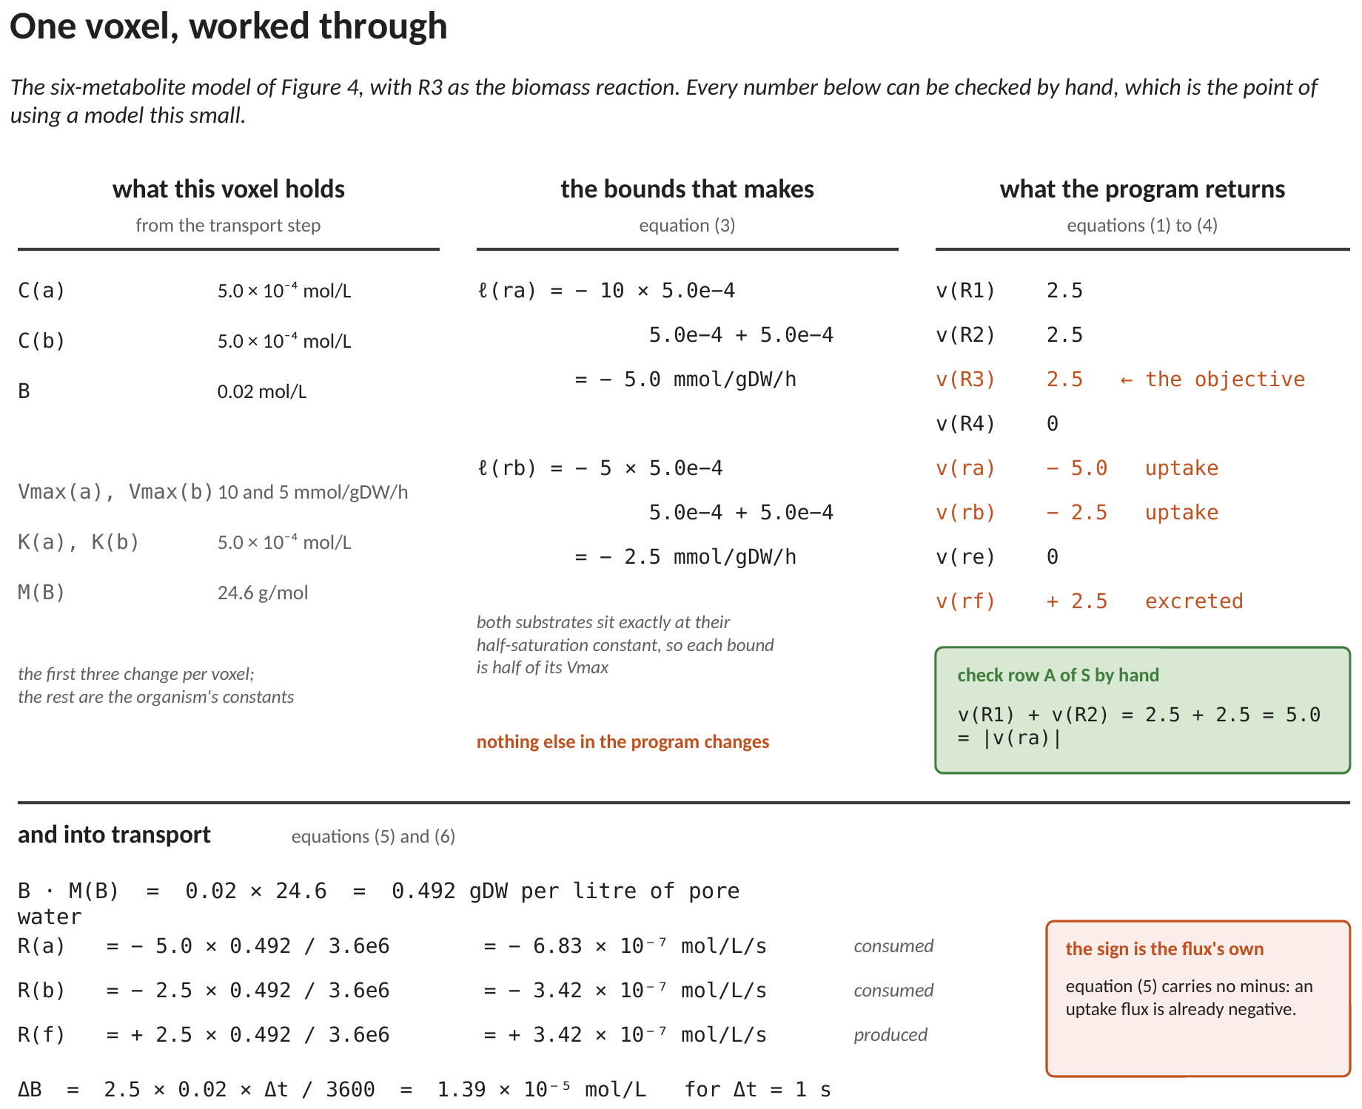
Figure 4. One voxel, end to end: what transport delivered, the bounds that built, what the solver returned, and what went back to transport.
The internal reactions — the several thousand in a real model — are machinery the transport step never sees. It hands concentrations to the cell boundary and receives fluxes back across it.
3. Where it sits in the solve loop
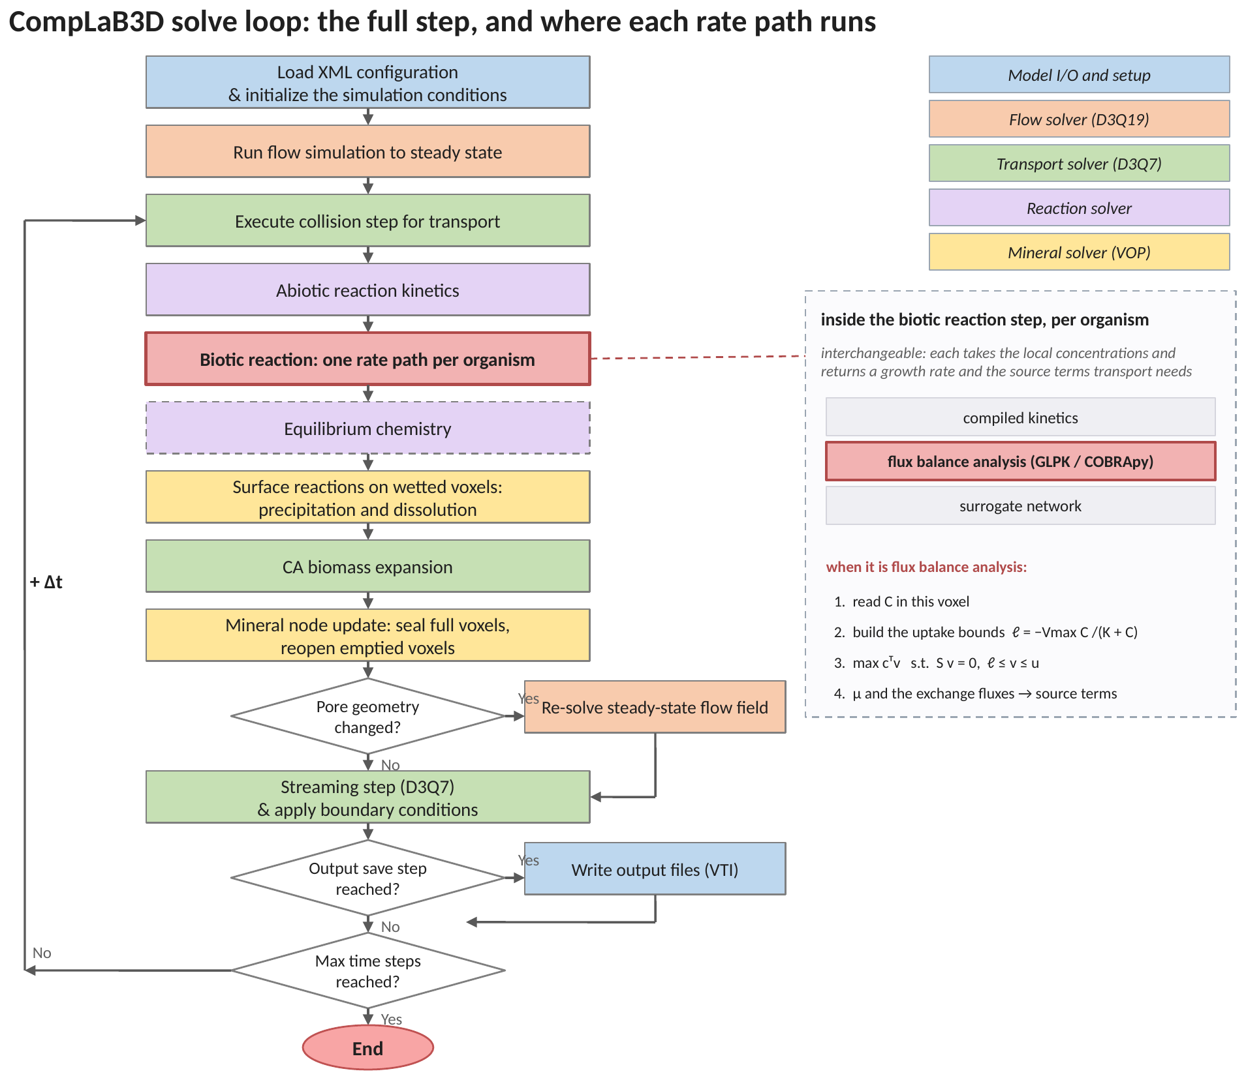
Figure 5. The solve loop. The biotic reaction step is highlighted; flux balance analysis is one of the interchangeable things that step can be.
Nothing above or below the reaction step knows which rate path is running. That is what makes the paths comparable: two runs differing only in the reaction step differ only because of the rate law.
4. How GLPK runs it
GLPK is a linear-programming library linked directly into the executable. Everything stays in one process.
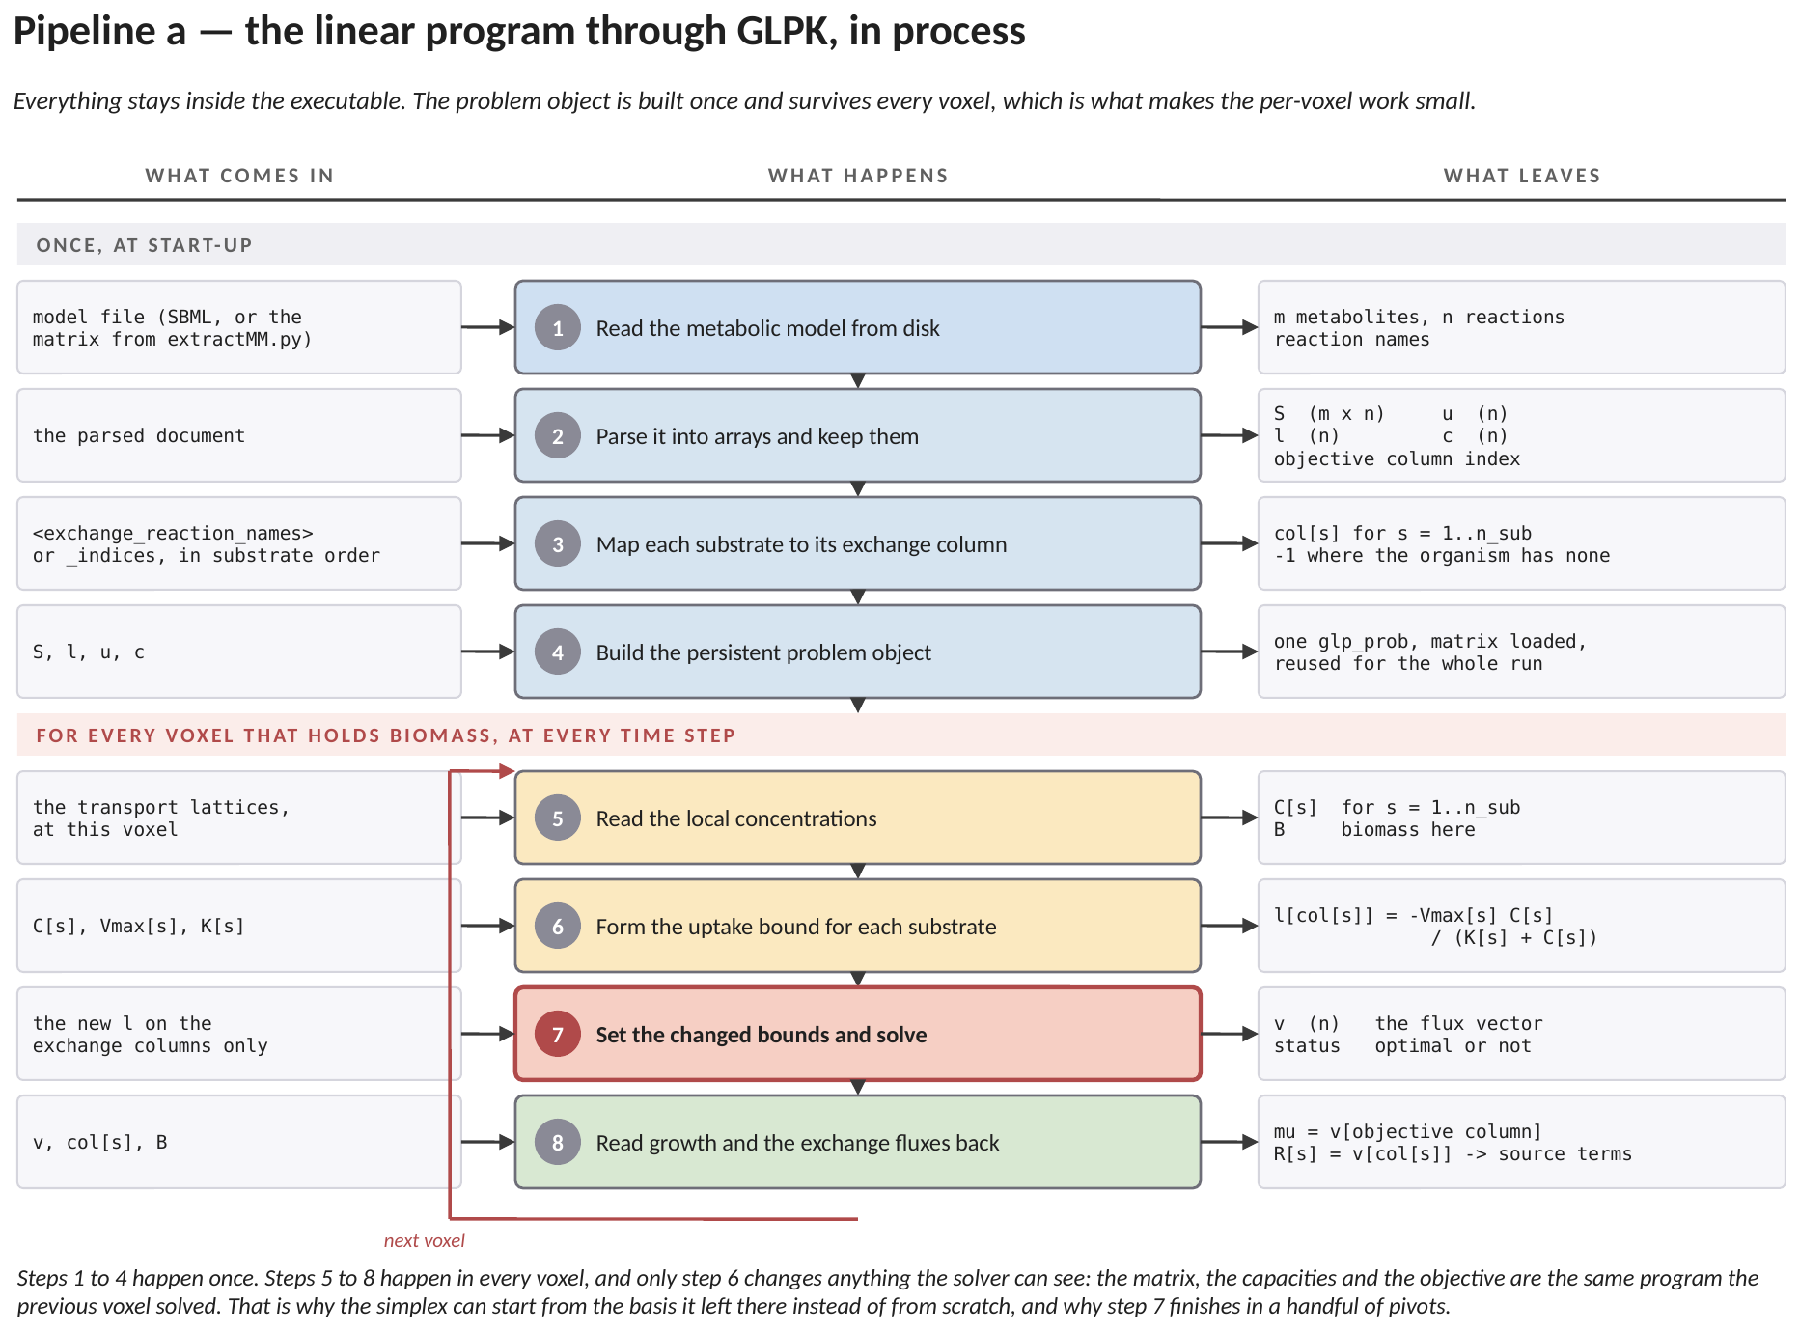
Figure 6. Pipeline a — GLPK, step by step. What each stage receives, what it does, and what it leaves. Steps 1 to 4 happen once; steps 5 to 8 happen in every voxel that holds biomass, at every step.
The four start-up steps read the model, turn it into arrays, work out which reaction exchanges which substrate, and build ONE problem object that survives the whole run. That object is the reason the per-voxel work is small.
Per voxel there are only three things to do: read the concentrations, form the uptake bounds from equation (3), and solve. The matrix, the capacities and the objective are the same program the previous voxel solved, so the simplex restarts from the basis it left there and finishes in a handful of pivots — about 0.1 ms.
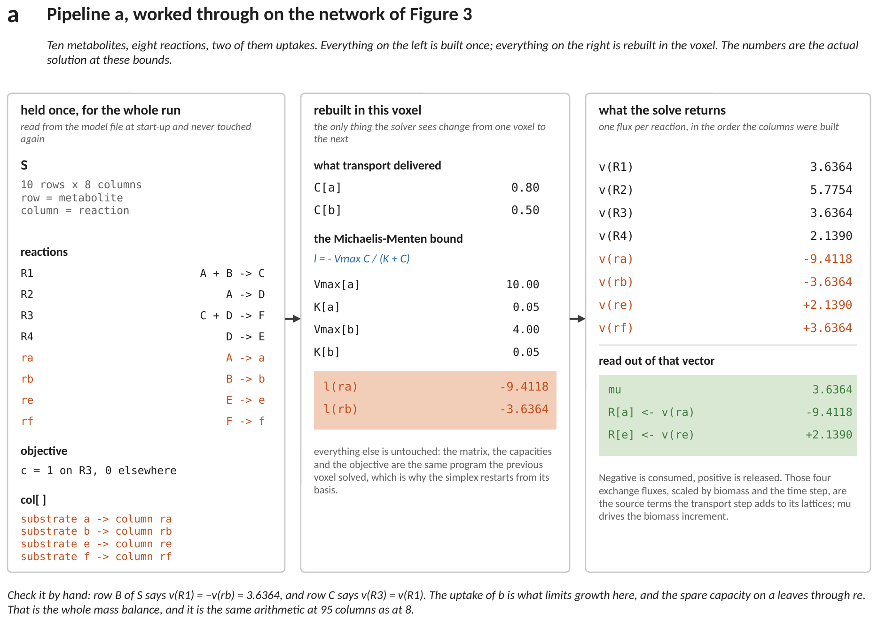
Figure 7. The same pipeline with numbers in it, on the network of Figure 1. Left: what is built once. Middle: the two numbers this voxel changes. Right: what the solve returns. These are the actual solutions at those bounds.
Figure 7 is small enough to check by hand. Row B of the matrix says the first internal reaction runs at exactly the rate substrate b is taken up; row C carries that into the objective. So growth is set by whichever uptake bound binds first, and the spare capacity on the other substrate leaves through an exchange.
5. How COBRApy runs it
COBRApy is the standard Python toolbox for metabolic models. CompLaB3D can run the same program through it, in an interpreter embedded in the executable.
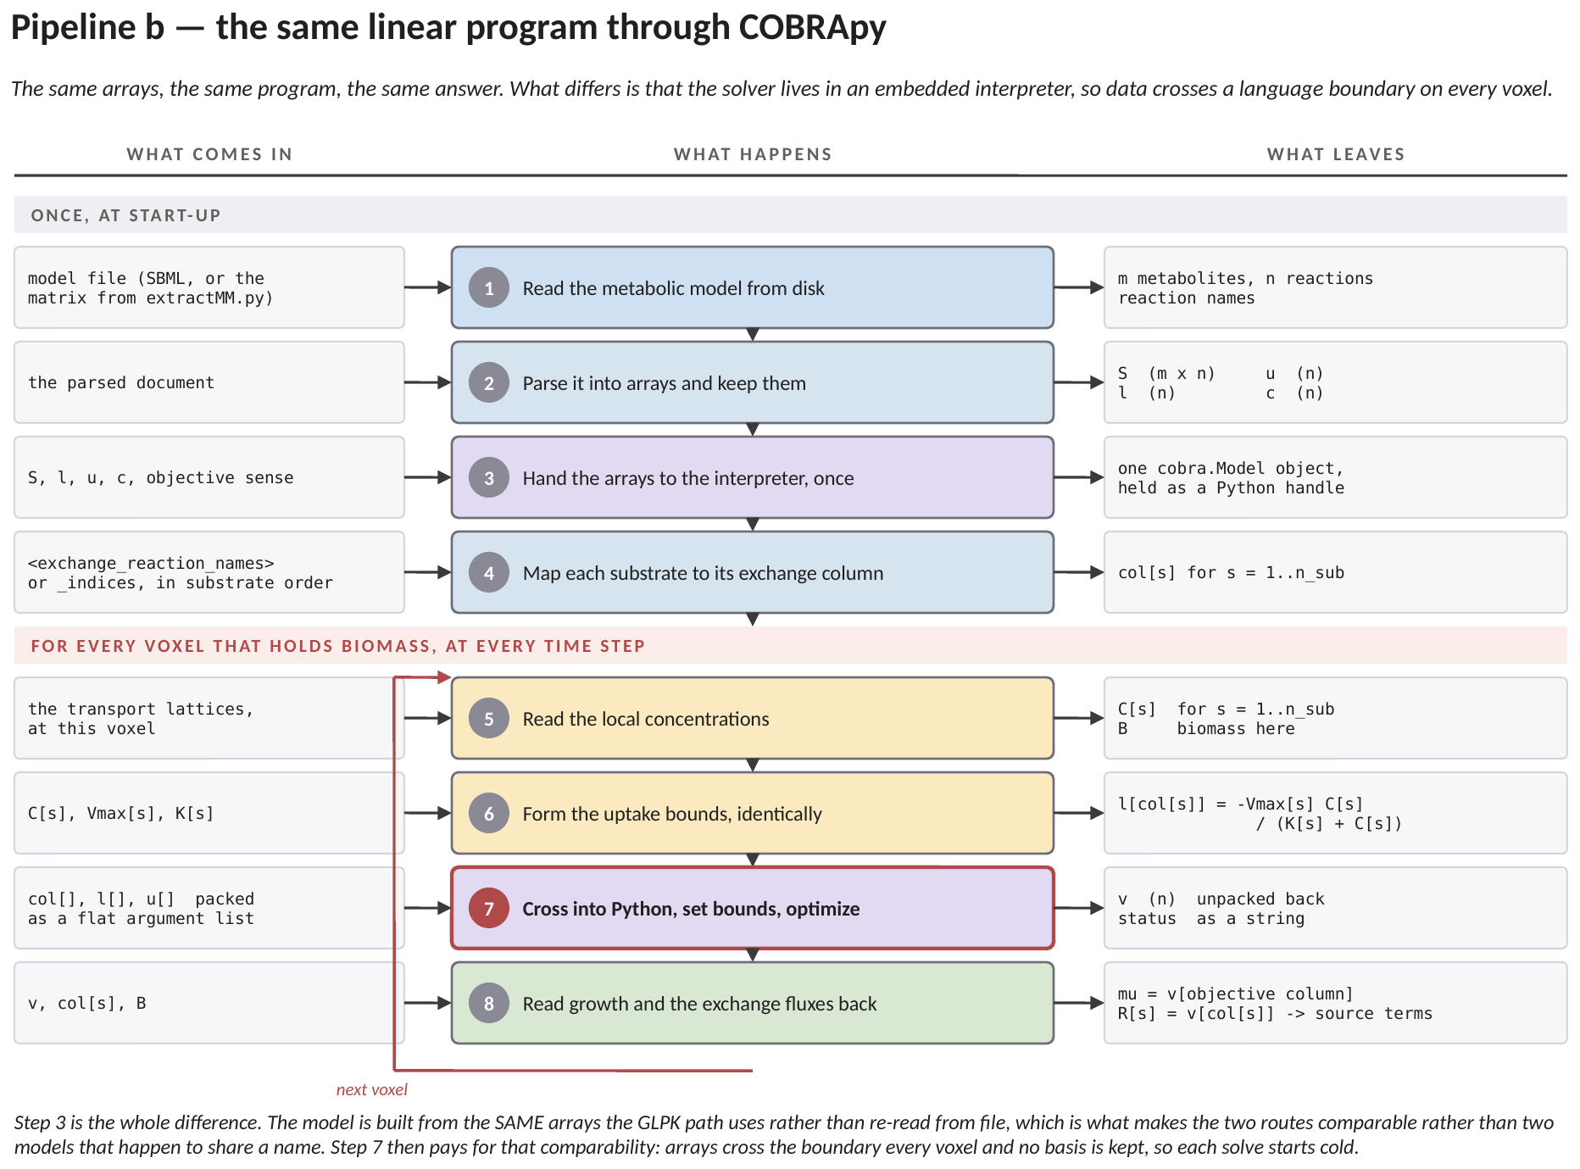
Figure 8. Pipeline b — COBRApy, step by step. The same eight stages, with one difference that changes the cost of all of them: stage 7 crosses into a Python interpreter and back on every voxel.
The model is built from the SAME arrays the GLPK path uses, not re-read from the file. That is deliberate: it is what makes the two routes comparable rather than two models that happen to share a name.
Per voxel the bounds are packed into a list, sent across the language boundary, solved, and the fluxes unpacked on the way back. No basis is kept between calls, so each solve starts cold: about 1 ms, an order of magnitude more than GLPK.
 | GLPK | COBRApy
per call | about 0.1 ms | about 1 ms
warm start | yes, the previous basis | no
what crosses per voxel | nothing | the bound and flux arrays
XML tag | <reaction_type>glpk</reaction_type> | <reaction_type>cobrapy</reaction_type>
use it for | production runs, MPI domains | model development, checking a GLPK result

Both are exact and neither approximates the other, so a disagreement between them is a defect in one of the two couplings rather than a property of either solver. Running one case through both is the strongest check available on this path, and the only independent one either has.
6. When one program is not enough: the chain
The growth rate a single program returns is almost always unique. The individual exchange fluxes very often are not.
Ask, at that fixed optimal growth, how large the release of one by-product may be, and the answer is usually a RANGE rather than a number: anywhere in it the organism grows exactly as fast, and the products simply trade against one another. The solver returns whichever end its pivoting rule reached. Nothing about that is wrong — it is one member of an optimal set — but it is arbitrary, it need not survive a change of solver, and it cannot be compared against a measured yield.
The fix is to solve a SEQUENCE of programs, each optimising the next quantity while holding every earlier one at the optimum it reached:
LP 1: max v[growth] -> f1
LP 2: max v[product 1], subject to v[growth] >= a1 f1 -> f2
LP 3: max v[product 2], subject to v[growth] >= a1 f1
v[product 1] >= a2 f2

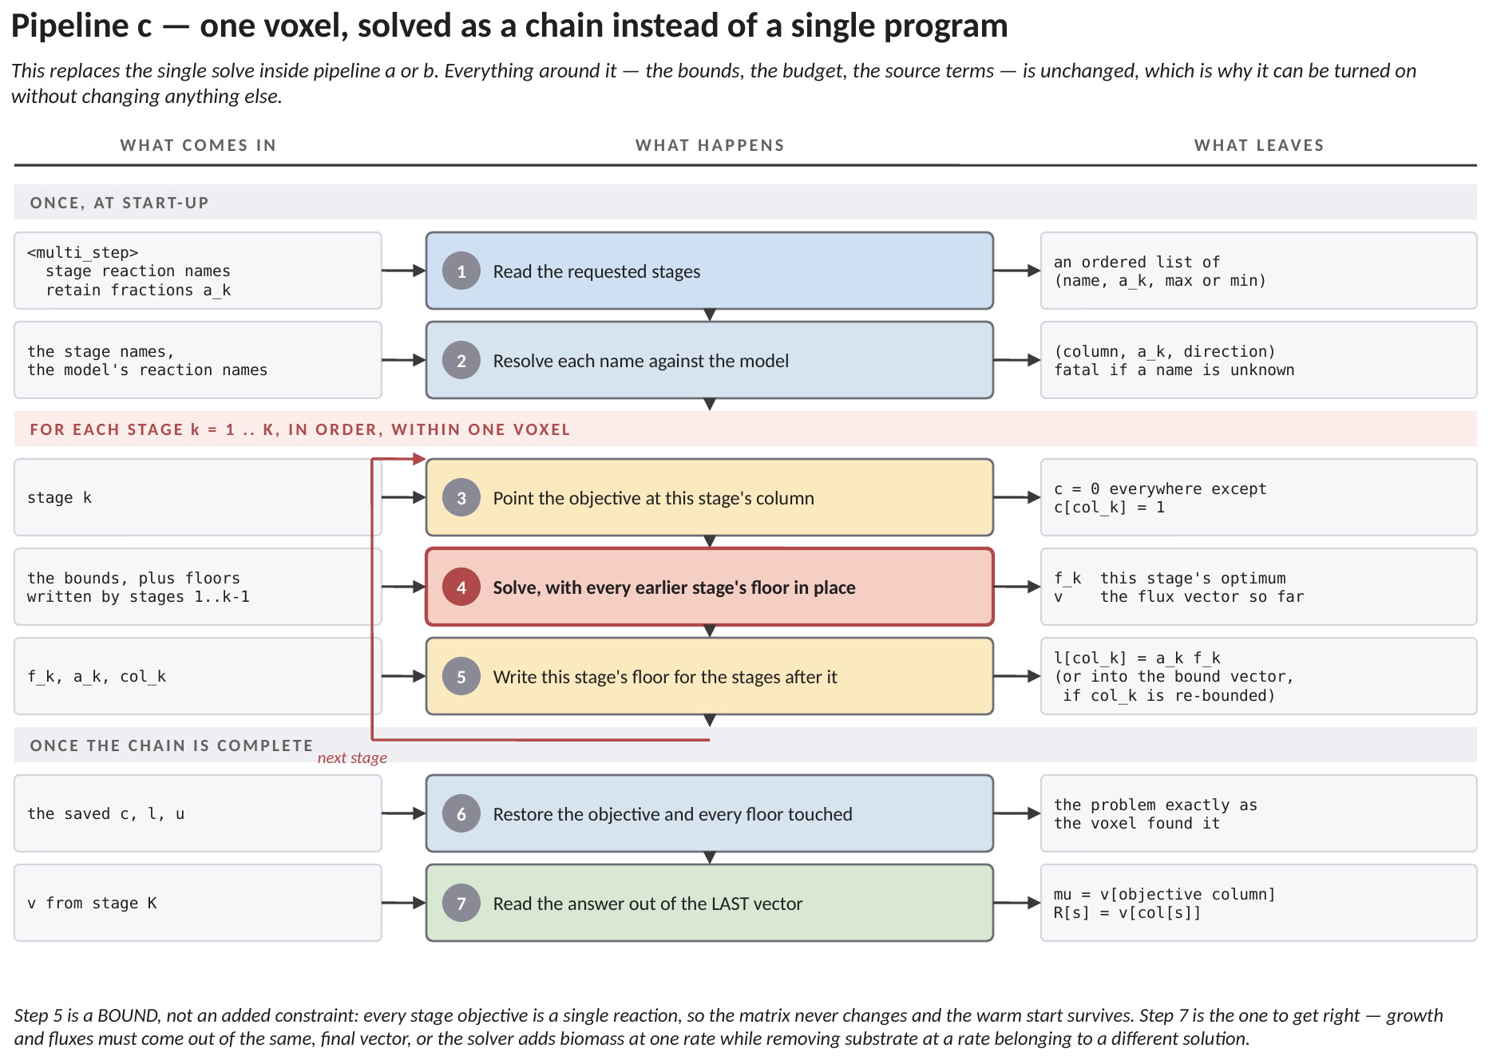
Figure 9. Pipeline c — the chain, step by step. It replaces the single solve inside pipeline a or b; everything around it is unchanged.
Each stage pins one more quantity, so after the last one nothing is free: the same model at the same bounds returns the same numbers, on any solver, every time.
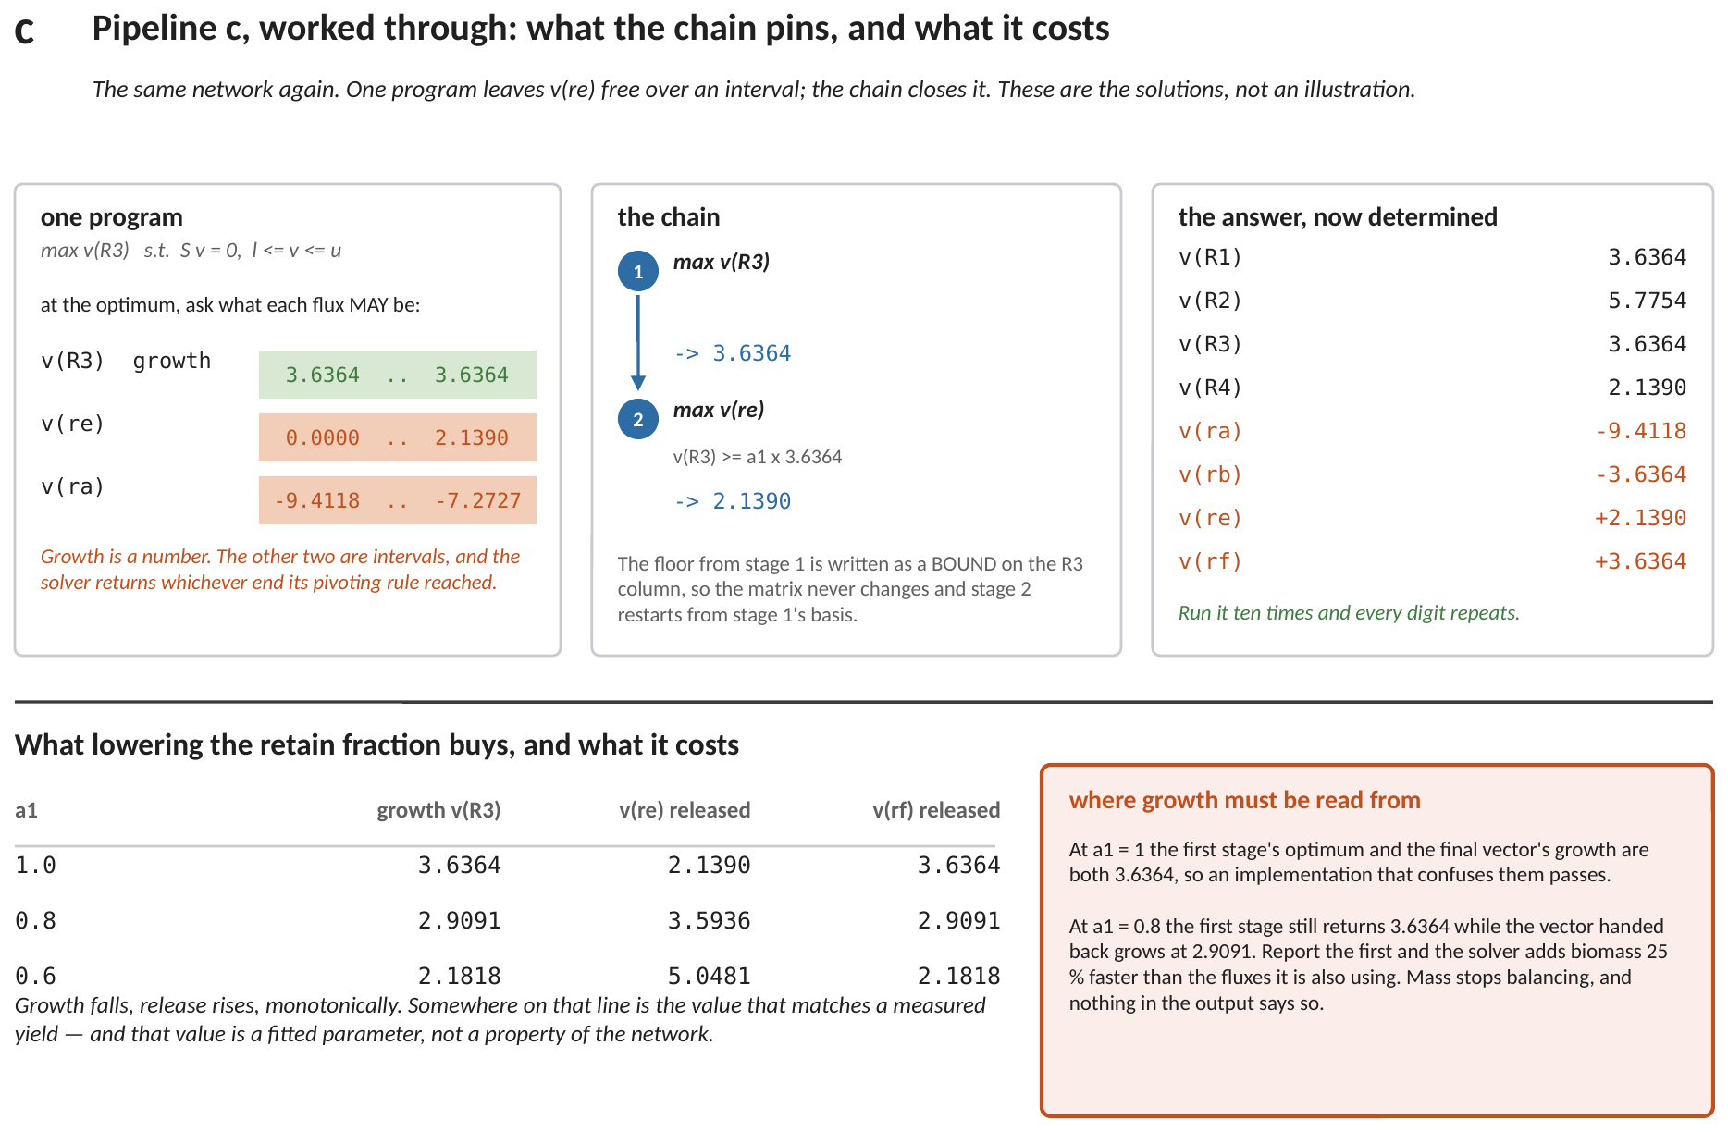
Figure 10. The chain on the network of Figure 1. Top left: what one program leaves free. Top middle: the two stages. Top right: the determined answer. Below: what lowering the retain fraction buys, and where growth must be read from.
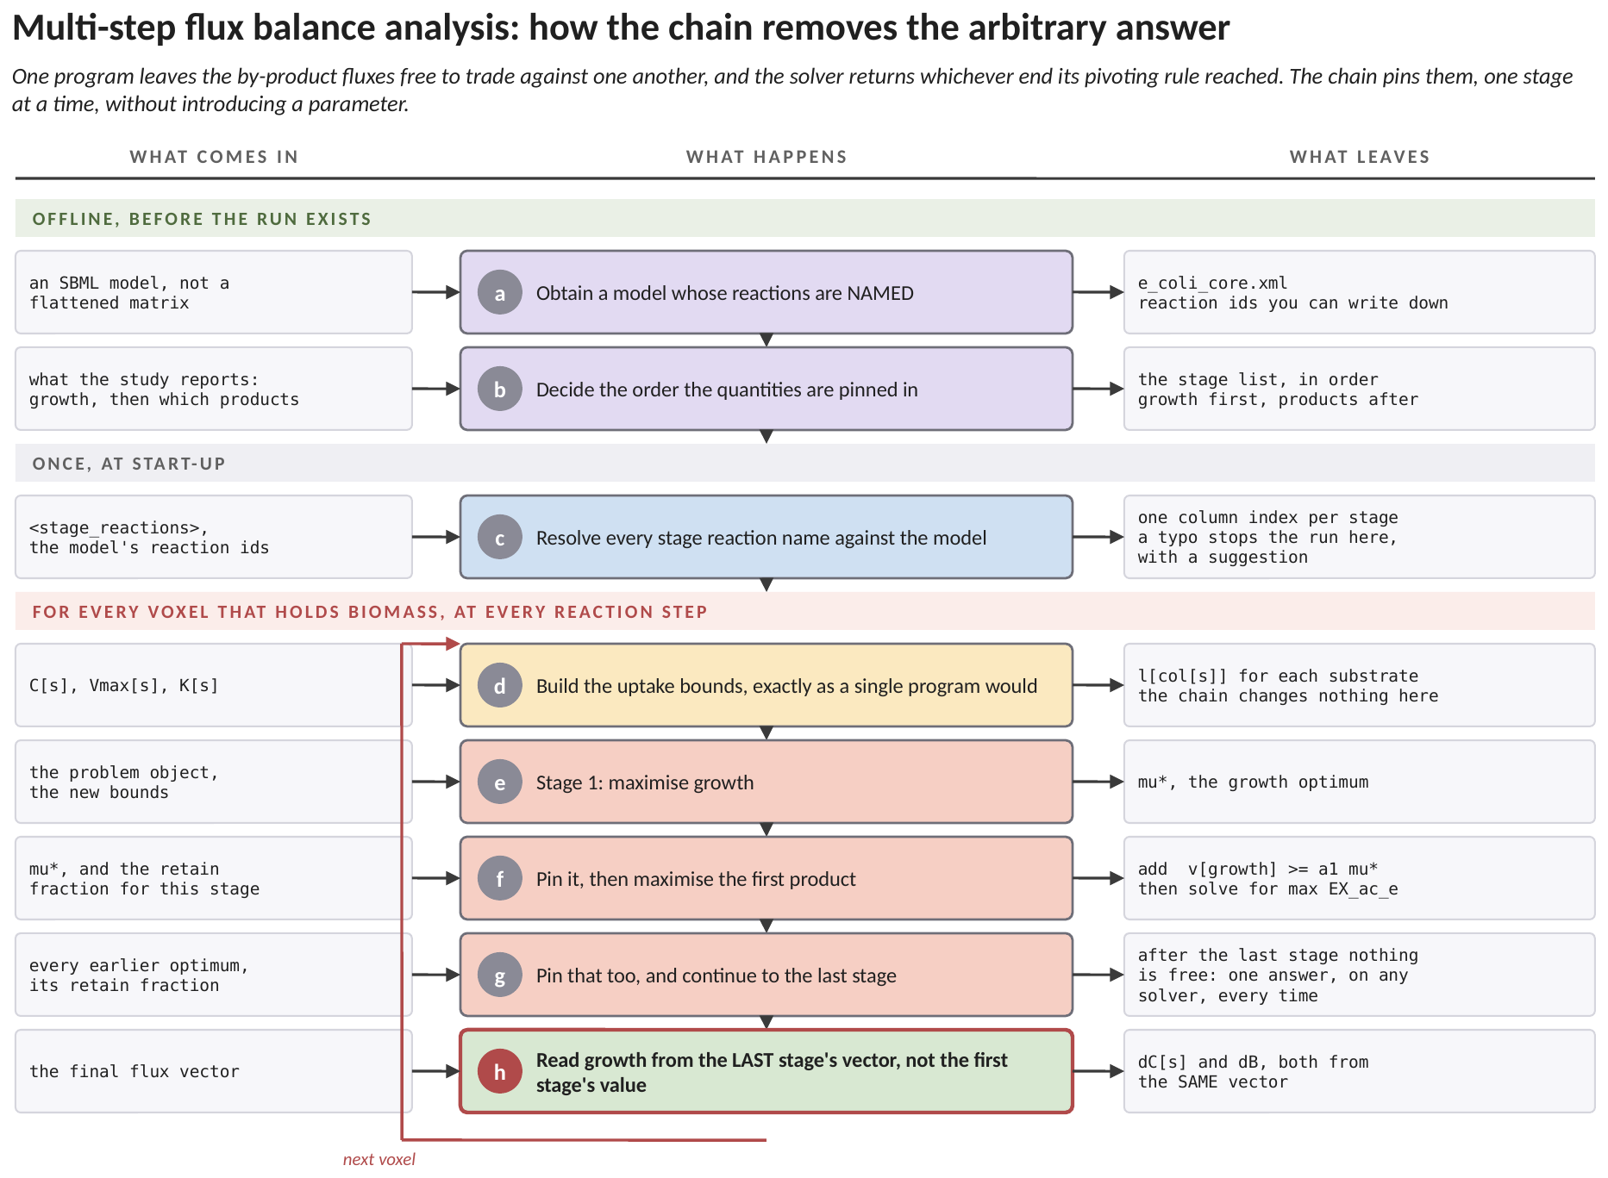
Figure 11. Multi-step flux balance analysis, end to end. The green band is work done before any simulation exists, the grey band is done once at start-up, and the red band runs in every voxel at every reaction step. (a) The chain needs a model whose reactions carry NAMES rather than a flattened matrix, because a stage is identified by the reaction it optimises and a column index stops meaning anything the moment the model file is regenerated. (b) The order is a modelling decision, not a numerical one: growth first, then the products the study actually reports, in the order they matter. (c) At start-up each stage name is resolved against the model. A mistyped name stops the run there with a suggestion, which is the whole reason names are preferred to indices. (d) The loop begins, and this row is identical to a single program: the chain changes nothing about how the local condition enters. (e) Stage 1 maximises growth and returns mu*, exactly as ordinary flux balance analysis would. (f) That optimum is then PINNED as a constraint, v[growth] at least a1 times mu*, and the next stage maximises the first product subject to it. (g) Each further stage pins everything before it. After the last one nothing is free, so the same model at the same bounds returns the same numbers on any solver, every time. That is the point of the method: a single program leaves the by-product fluxes free to trade against one another and the solver returns whichever end its pivoting rule reached. (h) The row in red is the one implementation detail that matters. Growth handed back to transport must be read out of the LAST stage's flux vector, never from the first stage's objective value. With every retain fraction at 1.0 the two are equal, so a version that confuses them passes the obvious test; below 1.0 they diverge by exactly what the calibration gave away.
Turning it on is one block inside the organism, and it needs three lists of the same length. This is what example 21 ships:
<multi_step>
<stage_reactions>
Biomass_Ecoli_core EX_ac_e EX_for_e
</stage_reactions>
<retain_fraction> 1.0 1.0 1.0 </retain_fraction>
<stage_direction> max max max </stage_direction>
</multi_step>
At least two stages are required; with one the block should be omitted, because one stage is ordinary flux balance analysis. <retain_fraction> defaults to 1.0 throughout and <stage_direction> to max, so a strict chain needs only the first list. Every fraction at 1.0 is the recommended starting point: the chain then gives up nothing and introduces no fitted parameter. Lowering the first entry lets the organism trade growth for excretion, which is what real cells do and what a genome-scale model will not do on its own. On the model example 21 ships, growth falls from 0.5591 to 0.5031 to 0.3354 as that fraction goes from 1.0 to 0.9 to 0.6, while acetate export rises from 11.5033 to 12.3529 to 14.9020. A fraction below one is therefore a fitted parameter and belongs in the methods section of whatever the run is reported in.
6.1 The retain fractions are calibration
With every fraction at one the chain gives up nothing and introduces no parameter. That is the default and the recommended starting point.
Below one, the organism is allowed to trade growth for release — which is what real cells do, and what a genome-scale model will not do on its own. Growth falls, release rises, monotonically, and somewhere on that line is the value that matches a measurement. A fraction below one is therefore a FITTED PARAMETER and belongs in the methods section of whatever the run is reported in.
6.2 The one thing to get right
The growth rate handed back to transport must be read out of the LAST stage's flux vector, never from the first stage's objective value.
At a fraction of one those two are equal, so an implementation that confuses them passes the obvious test. Below one they diverge by exactly as much as the calibration gave away — on the small network of Figure 10, at a fraction of 0.8, the first stage says 3.6364 while the vector actually chosen grows at 2.9091. Reporting the first while handing back the second's fluxes would add biomass 25 per cent faster than the fluxes being used. Mass would stop balancing, and nothing in the output would say so.
7. When there is more than one substrate: the competition
An organism offered several substrates it can grow on does not eat them all at once. It grows on the best one available and switches when that one runs out. A preferred donor is consumed while a partially oxidised product accumulates; only when the donor is exhausted does the organism turn round and consume what it made.
Neither of the tools above can produce that. One linear program handed all the substrates will take whichever combination maximises growth, together, from the first step. A rate law cannot do it either, and for a sharper reason: the same compound is a PRODUCT in one regime and a SUBSTRATE in the next, and a concentration alone does not say which.
The answer is to treat the organism as a competition between separate growth options, one per substrate. Solve the model once per substrate with the others shut, score each option by how much of the limiting element it would bring in, and blend the flux vectors:
r_{k} = k_{k} C_{k} / ( K_{k} + C_{k} ) (5)
u_{k} = n_{k} r_{k} / Σ n_{j} r_{j} (6)
v = Σ u_{k} v_{k} (7)
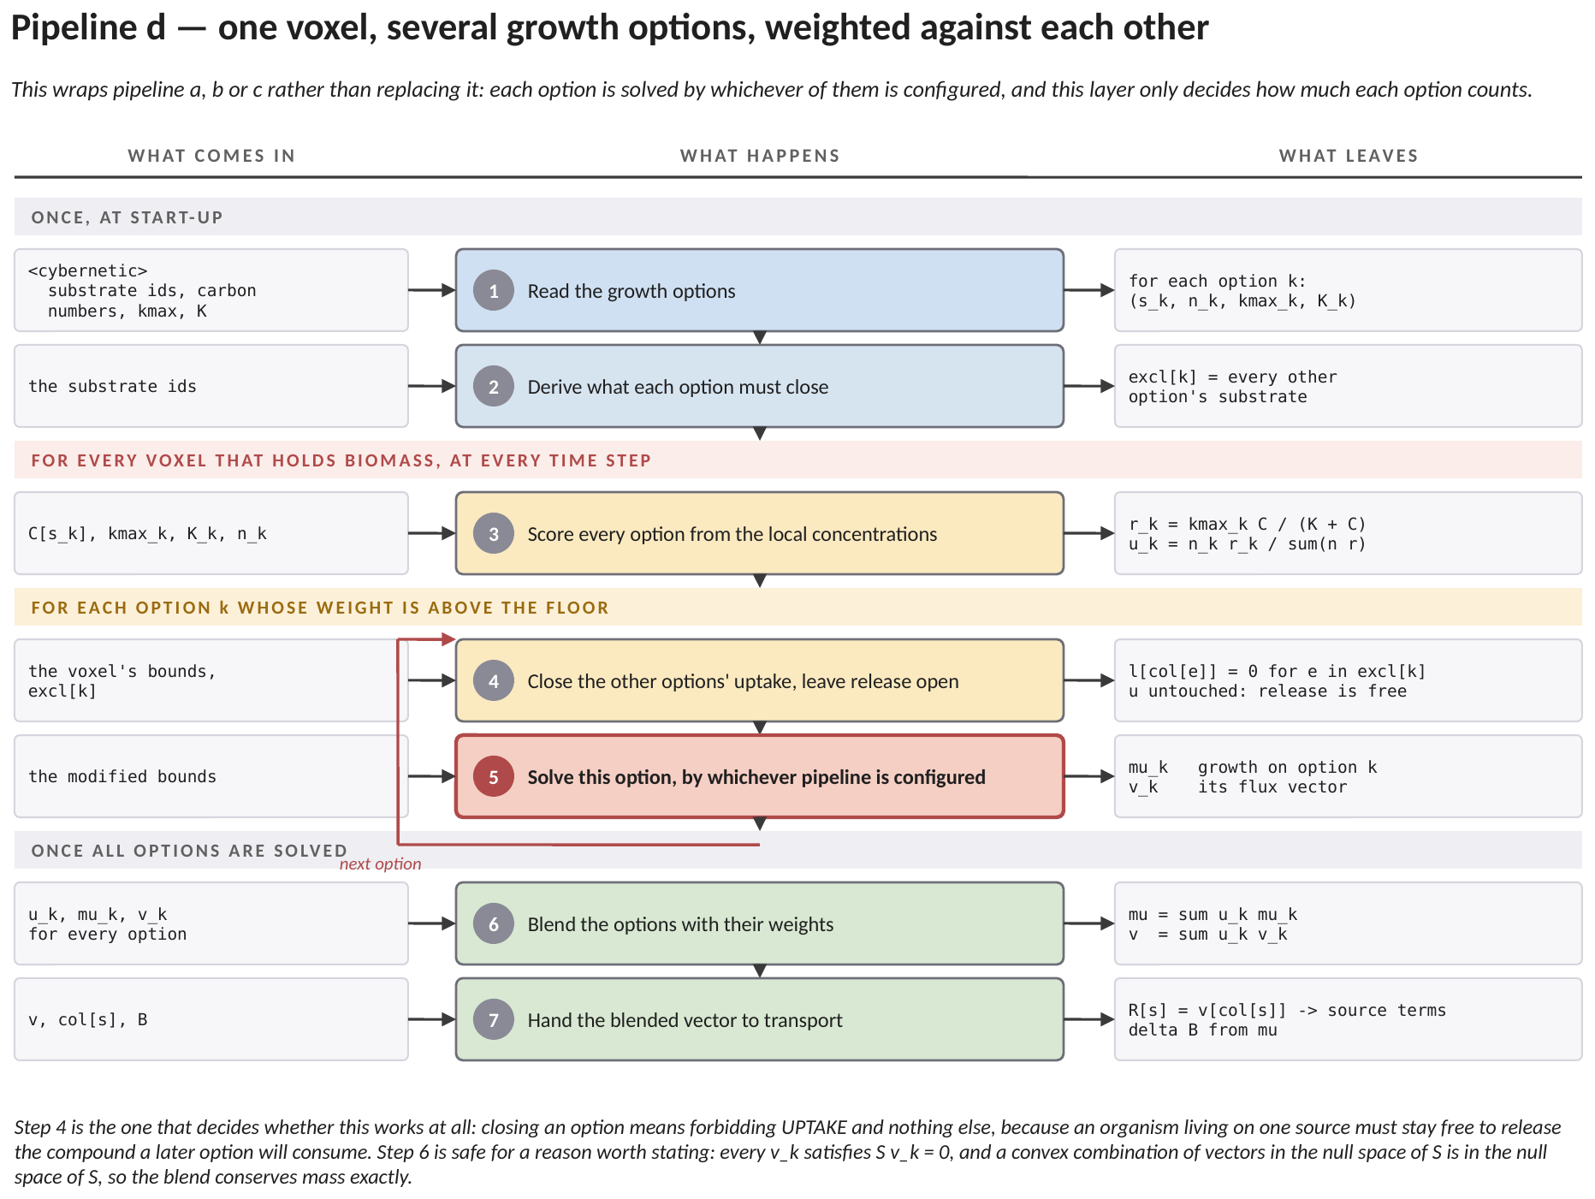
Figure 12. Pipeline d — the competition, step by step. It wraps pipeline a, b or c rather than replacing it: each option is solved by whichever is configured, and this layer only decides how much each option counts.
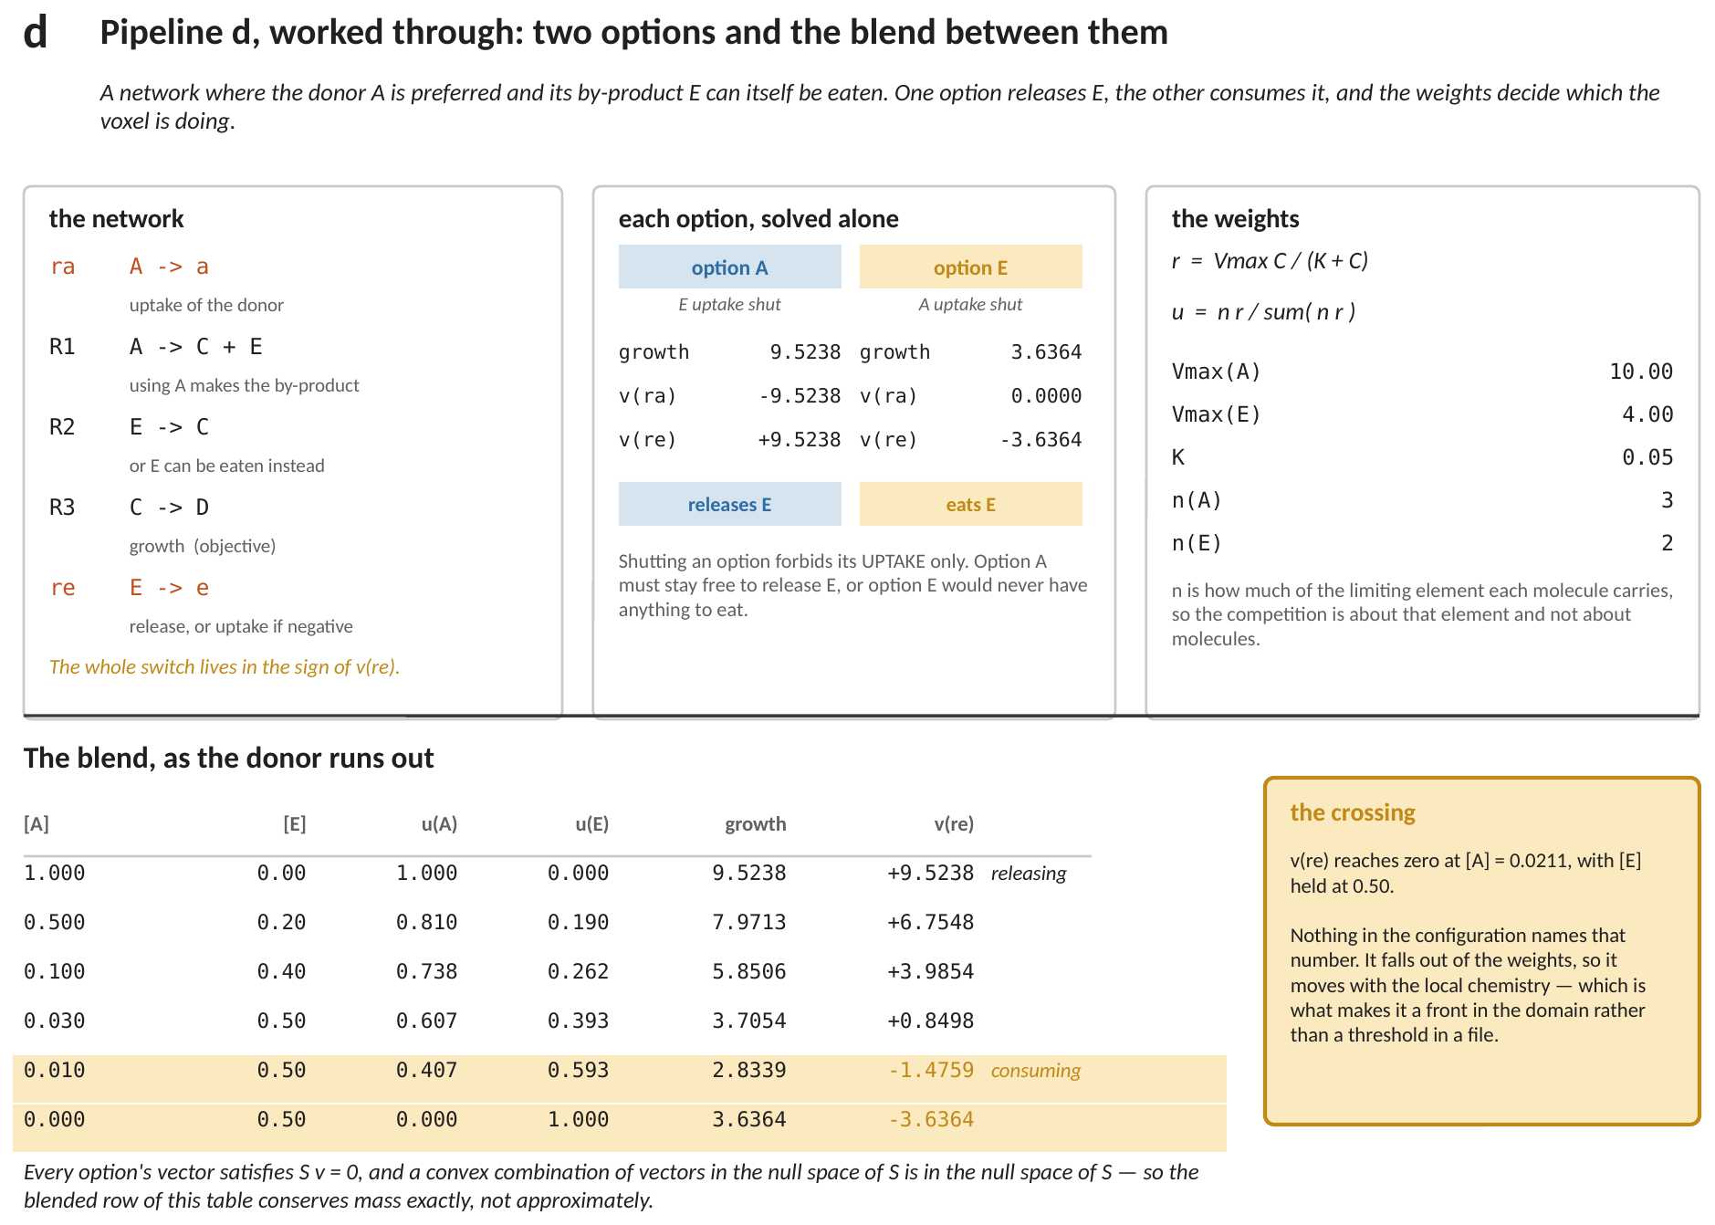
Figure 13. The competition on a network where the donor's by-product can itself be eaten. Top: the network, both options solved alone, and the weights. Below: the blend as the donor runs out, with the release flux changing sign on its own.
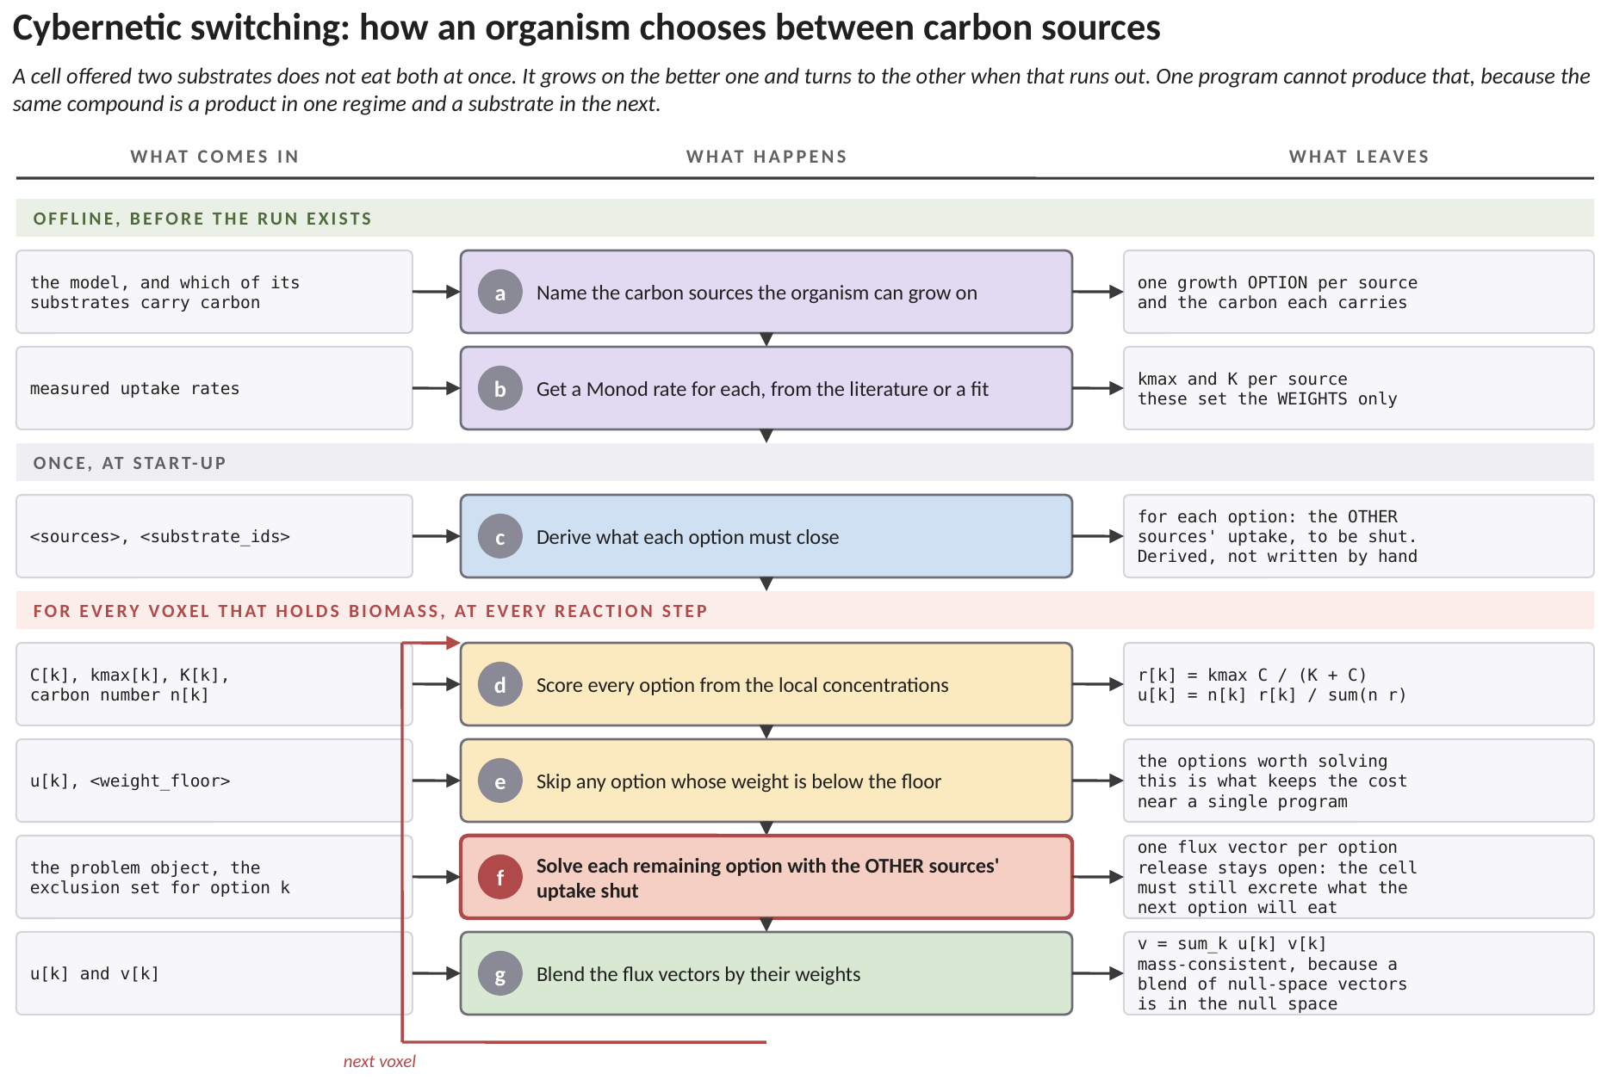
Figure 14. Cybernetic substrate switching, end to end. The bands are the same three. (a) The offline decision is which of the organism's substrates are carbon sources it could live on. Each becomes a growth OPTION, and the carbon each molecule carries is what makes the competition about carbon rather than about molecules: glucose brings six, acetate two. (b) A Monod rate per source sets the WEIGHTS only. The flux actually realised still comes from the model, so these two numbers do not become a hidden rate law. (c) At start-up the exclusion sets are DERIVED rather than written out: for each option, which other sources must be shut. Writing them by hand invites leaving one open, and an open second carbon source destroys the switching silently. (d) The loop begins by scoring every option from the local concentrations. The weight of an option is its carbon uptake as a fraction of the total carbon uptake on offer. (e) An option whose weight falls below the floor is not solved at all. This is what keeps the cost near that of a single program rather than one program per source. (f) Each remaining option is solved with the OTHER sources' uptake shut, in red because the detail is easy to get wrong: shutting a source must forbid its UPTAKE and never its release. An organism growing on glucose has to stay free to excrete the acetate that the other option will later consume, and closing the exchange outright would remove the very thing being switched to. (g) The flux vectors are blended by their weights. That averaging is safe here for a specific reason: each vector satisfies S v = 0, and a convex combination of vectors in the null space of S is itself in that null space, so the blend conserves mass exactly rather than approximately. Averaging model outputs is not usually safe; this is why it is here.
The block that turns it on takes one entry per source, in the same order throughout. This is what example 22 ships:
<cybernetic>
<sources> glucose acetate </sources>
<substrate_ids> 0 2 </substrate_ids>
<carbon_number> 6 2 </carbon_number>
<uptake_kmax> 10.0 4.4 </uptake_kmax>
<uptake_half_saturation> 0.05 0.05 </uptake_half_saturation>
<weight_floor> 1e-3 </weight_floor>
</cybernetic>
<substrate_ids> index this run's own substrate list, which is what ties each growth option to a concentration on the lattice. <weight_floor> defaults to 1e-3; setting it to 0 solves every source every time and is the reference to check against, and it moves the answer in the fourth decimal. At least two sources are required, since with one option there is nothing to switch between. What the method does NOT do is carry any enzyme state between steps, so there is no lag and no diauxic plateau: the weights depend on concentration alone. That is adequate exactly when the switch is fast compared with transport, which is the pore-scale case.
Figure 13 is the whole mechanism on a network small enough to verify. One option grows fast and RELEASES the by-product; the other grows slowly and CONSUMES it. Neither is the organism's behaviour — the blend is, and the blend moves as the donor depletes.
The row to watch is the release flux. It starts strongly positive, falls as the donor's weight falls, and crosses zero when the donor is nearly gone. Nothing in the configuration names the concentration at which that happens; it falls out of the weights. In a pore-scale domain that makes it a FRONT — a surface inside the biofilm where the organism changes what it is living on — rather than a threshold somebody chose.
7.1 Two things that make it work
- Shutting an option forbids its substrate's UPTAKE, never its release. An organism living on one substrate must stay free to release the compound a later option will consume, or the second regime never arrives.
- The blend is over the flux VECTORS. Each satisfies S v = 0, and a convex combination of vectors in the null space of S is in the null space of S, so the blended vector conserves mass exactly rather than approximately. Averaging model outputs is not usually safe; this is why it is safe here.
The cost is m linear programs per organism per voxel per step for m substrates. The programs differ only in which bounds are open, so each warm-starts from the last, and an option whose weight falls below a floor is not solved at all.
8. A worked example: one voxel, step by step
Everything above, on one voxel, with every number written out. The case is the one that ships as examples/09_fba_glpk, and it was chosen for this section because its metabolic model is small enough to solve with a pencil: three metabolites and four reactions. A genome-scale model works exactly the same way and differs only in that nobody can check it by hand.
8.1 Where every number in this example comes from
This is the part that is easy to lose, so it comes first. Some of the numbers below are the modeller's choices and sit in the configuration file. Some are properties of the organism's reaction list. The rest are the state of the simulation at the instant the reaction step begins, and those are the only ones that change from voxel to voxel.
the number | what it is | where it comes from
3 metabolites, 4 reactions | the size of the metabolic model | input/toy_model.xml. A real model has hundreds of each
0.05 mol L⁻¹ | the half-saturation constant of the donor, and of the acceptor | <half_saturation_constants> in CompLaB.xml. A property of the organism's uptake machinery, measured or assumed
10 mmol gDW⁻¹ h⁻¹ | the fastest the organism can take up the donor | <fba_maximum_uptake_flux>, first entry. This is an enzyme capacity, not a supply: it applies however much donor is present
4 mmol gDW⁻¹ h⁻¹ | the same for the acceptor | <fba_maximum_uptake_flux>, second entry
24.6 gDW mol⁻¹ | grams of dry cells per mole of the biomass unit the lattice carries | <biomass_molar_mass>. It exists only to reconcile the units the metabolic model uses with the units the transport solver uses
1.0 mol L⁻¹ donor, 1.0 mol L⁻¹ acceptor | what this voxel holds right now | the transport solver, one step earlier. In this case they are also the starting values, <initial_concentration>
1.0 mol L⁻¹ biomass | the organism present in this voxel | the biomass lattice; here it is the starting value <initial_densities>
0.015 s | how long this reaction step lasts | the solver prints it as [ADE] dt at start-up. It is derived from tau, the voxel size and the donor's diffusivity, not typed in

The last three rows are the simulation. Everything above them is fixed for the whole run. Note that the two uptake capacities are in millimoles per gram of dry cells per hour, which is the unit metabolic models are written in, while the concentrations are in moles per litre of water, which is the unit a transport solver works in. Section 8.5 is where those two meet.
8.2 The model, written out
Four reactions. Three of them move a metabolite across the cell boundary, and the fourth is the one that makes cells:
v0 EX_S S_c -> a negative flux means the donor comes IN
v1 EX_O O_c -> a negative flux means the acceptor comes IN
v2 EX_P P_c -> a positive flux means the product goes OUT
v3 BIO S_c + 0.5 O_c -> P_c the objective: growth
The sign convention is worth pausing on, because it is the one thing in this section that is arbitrary rather than physical. Every exchange reaction is written as metabolite going out, so taking something up is that reaction running backwards, which is a negative flux. The stoichiometry matrix S has one row per metabolite and one column per reaction, and it is simply these four reactions read off vertically:
v0 v1 v2 v3
S_c -1 0 0 -1
O_c 0 -1 0 -0.5
P_c 0 0 -1 +1
8.3 Step 1: turn the concentrations into uptake bounds
The linear program knows nothing about this voxel. The only thing that tells it where it is, is the lower bound on each uptake reaction, and that bound comes from equation (3) applied to what the voxel holds. For the donor, using 10 mmol gDW⁻¹ h⁻¹ from <fba_maximum_uptake_flux>, 0.05 mol L⁻¹ from <half_saturation_constants> and the 1.0 mol L⁻¹ the transport solver delivered:
ℓ_{S} = − 10 × 1.0 / ( 0.05 + 1.0 ) = − 10 × 0.952381 = − 9.523810
and for the acceptor, whose capacity is 4 rather than 10 but whose concentration and half-saturation constant are the same:
ℓ_{O} = − 4 × 1.0 / ( 0.05 + 1.0 ) = − 4 × 0.952381 = − 3.809524
Both in mmol gDW⁻¹ h⁻¹. The factor 0.952381 is the Michaelis-Menten saturation term, and at a concentration twenty times the half-saturation constant it is close to one: this voxel is nearly substrate-replete, and both uptakes run at about their enzyme capacity. The product P has no uptake capacity and none is offered, so its bound stays at zero and it can only leave.
8.4 Step 2: solve the linear program
Steady state inside the cell, equation (1), is three equations, one per row of S. Read them off:
row S_c : -v0 - v3 = 0 -> v0 = -v3
row O_c : -v1 - 0.5 v3 = 0 -> v1 = -0.5 v3
row P_c : -v2 + v3 = 0 -> v2 = +v3
Every flux is now written in terms of the growth flux v3, which is what makes this model solvable by hand. Apply the two bounds from Section 8.3. The donor uptake v0 cannot be more negative than -9.523810, and v0 = -v3, so:
v₃ ≤ 9.523810 from the donor
The acceptor uptake v1 cannot be more negative than -3.809524, and v1 = -0.5 v3, so v3 is bounded by twice that:
v₃ ≤ 2 × 3.809524 = 7.619048 from the acceptor
The objective is to make v3 as large as possible, so the answer is the smaller of the two ceilings:
growth = min ( 9.523810 , 7.619048 ) = 7.619048 mmol gDW⁻¹ h⁻¹
The acceptor limits, and it is worth being clear about why, because it is not simply that 4 is less than 10. Each turnover of the growth reaction needs one donor but only half an acceptor, so a given acceptor uptake supports twice as much growth as the same donor uptake would. The comparison the model actually makes is 9.523810 against 2 x 3.809524, and the factor of two is the 0.5 in the O_c row of S. Change that coefficient and the limiting substrate can change with it.
The remaining fluxes follow from the three relations above:
v0 = -7.619048 donor taken up
v1 = -3.809524 acceptor taken up, exactly half
v2 = +7.619048 product excreted
v3 = +7.619048 growth
8.5 Step 3: turn the fluxes back into what the lattice carries
The linear program has answered in its own units, per gram of dry cells per hour. The transport solver needs a change in concentration in this voxel over this step, in moles per litre. That conversion is the only place the two unit systems meet, and it is three multiplications and two divisions:
ΔC = v × ( B × M ) × Δt / 3.6×10⁶
B is the biomass this voxel holds in mol L⁻¹, M is the biomass molar mass in gDW mol⁻¹, so their product B × M is grams of dry cells per litre of water, which is what turns a per-gram flux into a per-litre one. The 3.6×10⁶ is two conversions at once: 1000 to take millimoles to moles, and 3600 to take hours to seconds. With B = 1.0, M = 24.6 and Δt = 0.015 s:
ΔC_{S} = − 7.619048 × ( 1.0 × 24.6 ) × 0.015 / 3.6×10⁶ = − 7.809524×10⁻⁷ mol L⁻¹
and the same arithmetic on the other two, which differ only in the flux:
dC_acceptor = -3.904762e-7 mol/L exactly half the donor
dC_product = +7.809524e-7 mol/L exactly minus the donor
Those two relations are the check worth doing. The acceptor change is half the donor change because the reaction says 0.5, and the product change is the negative of the donor change because the reaction says one for one. Neither was imposed anywhere in the code: they came out of the linear program, and if they do not hold in your own run then the exchange reactions and the substrates have been paired up wrongly.
8.6 Step 4: grow the biomass
The growth flux is a specific growth rate, per hour. The biomass increment is that rate multiplied by the biomass present and the length of the step, with 3600 to take hours to seconds:
ΔB = 7.619048 × 1.0 × 0.015 / 3600 = 3.174603×10⁻⁵ mol L⁻¹
Set against the donor drawn down in the same step, 7.809524×10⁻⁷ mol L⁻¹, that is about 41 moles of biomass per mole of donor, which is not a yield anyone would recognise. It is not meant to be: this is a toy model whose growth reaction was written to be checkable rather than realistic. In a genome-scale model the same two numbers give a yield that can be compared with a measurement, and that comparison is one of the few end-to-end tests of a coupling like this one.
8.7 The same voxel later, when the donor has run down
Nothing above is specific to this voxel except the two concentrations, so the useful thing is to change one of them and see the answer change character. Take the same voxel after transport has drawn the donor down to 0.02 mol L⁻¹, below its half-saturation constant of 0.05, with the acceptor unchanged. Only the donor bound moves:
ℓ_{S} = − 10 × 0.02 / ( 0.05 + 0.02 ) = − 10 × 0.285714 = − 2.857143
The two ceilings are now 2.857143 from the donor and 7.619048 from the acceptor, so:
growth = min ( 2.857143 , 7.619048 ) = 2.857143 mmol gDW⁻¹ h⁻¹
The donor now limits, growth has fallen by a factor of 2.67, and the acceptor uptake falls with it to -1.428571 rather than staying at its capacity, because the cell has no use for acceptor it cannot pair with donor. That last point is the one a Monod rate law cannot reproduce without being told: the ratio in which the two substrates are consumed is not fixed here, it is an output. Between the two voxels the acceptor to donor consumption ratio stayed at exactly 0.5 because the stoichiometry is fixed, but a model with two ways to use the acceptor would have shifted between them, and the linear program would have reported the shift without anybody calibrating it.
This is also why the limiting substrate is worth printing. A run where every voxel is acceptor-limited and a run where the limit changes hands across the domain look the same in a concentration field and are different simulations.
9. What to check when it has run
symptom | what it usually means | what to do
growth is zero everywhere | the medium is closed: the model needs an exchange the configuration does not open | run the model once in cobrapy with the same bounds
growth is identical in every voxel | the bounds are not being updated; equation (3) is seeing a constant | print ℓ for two voxels with different concentrations
a species goes negative | the shared budget was bypassed, or Δt is beyond the stability limit | check the closing report for the clamp count
infeasible in most voxels | the maintenance demand cannot be met at the supplied bounds | compare the maintenance reaction with the uptake range
results wrong by orders of magnitude | the unit chain: biomass molar mass, or the unit biomass is read in | check one voxel against a hand calculation
GLPK and COBRApy disagree | one of the two couplings, not the solvers: usually an exchange index | print ℓ and the flux vector from both for the same voxel
the answer changes between runs | a flux column the solver was free to choose | add a <multi_step> chain, section 6

10. Where to go next
the full method document | Method 1, long form — the algorithm per voxel, the shared mass budget across organisms, the two back ends in detail, and the published coupling taxonomy
example 09 | flux balance analysis through GLPK, smallest working case
example 10 | the same case through COBRApy, as a cross-check
example 21 | the multi-step chain of section 6
example 22 | the metabolic switching of section 7
config/CompLaB.reference.xml | every tag documented once, including <multi_step> and <cybernetic>

11. References
Orth, J. D., Thiele, I., Palsson, B. O.: What is flux balance analysis? Nature Biotechnology 28, 245–248 (2010). https://doi.org/10.1038/nbt.1614
Scheibe, T. D., Mahadevan, R., Fang, Y., Garg, S., Long, P. E., Lovley, D. R.: Coupling a genome-scale metabolic model with a reactive transport model to describe in situ uranium bioremediation. Microbial Biotechnology 2, 274–286 (2009). https://doi.org/10.1111/j.1751-7915.2009.00087.x
Fang, Y., Scheibe, T. D., Mahadevan, R., Garg, S., Long, P. E., Lovley, D. R.: Direct coupling of a genome-scale microbial in silico model and a groundwater reactive transport model. Journal of Contaminant Hydrology 122, 96–103 (2011). https://doi.org/10.1016/j.jconhyd.2010.11.007
Song, H.-S., Ahamed, F., Lee, J.-Y., Henry, C. S., Edirisinghe, J. N., Nelson, W. C., Chen, X., Moulton, J. D., Scheibe, T. D.: Coupling flux balance analysis with reactive transport modeling through machine learning for rapid and stable simulation of microbial metabolic switching. Scientific Reports 15, 6042 (2025). https://doi.org/10.1038/s41598-025-89997-9
Ramkrishna, D., Song, H.-S.: Dynamic models of metabolism: review of the cybernetic approach. AIChE Journal 58, 986–997 (2012). https://doi.org/10.1002/aic.13734
Jung, H., Song, H.-S., Meile, C.: CompLaB v1.0: a scalable pore-scale model for flow, biogeochemistry, microbial metabolism, and biofilm dynamics. Geoscientific Model Development 16, 1683–1696 (2023). https://doi.org/10.5194/gmd-16-1683-2023

