The Surrogate Network: a reader's guide
replacing the linear program with a fitted function
1. The idea
Method 1 solves a linear program in every voxel at every time step. That is exact and it is valid anywhere, and it is also the most expensive thing in the model. On a domain large enough to be interesting it dominates the run.
The surrogate answers the same question and returns the same quantities, but it never calls a solver while the simulation is running. Instead the linear program is solved a few hundred times before the run starts, across the range of conditions the run will visit, and a small function is fitted to those answers. Inside the time loop that function is evaluated in place of the solver.
The observation this rests on is narrow, and worth stating exactly. Of the several hundred numbers that define the linear program, only a handful change from one voxel to the next: the uptake bounds of the substrates that limit growth. Everything else is a property of the organism and is fixed for the whole run. The solution is therefore a function of two or three numbers, and a function of two or three numbers can be sampled once and interpolated cheaply forever after.
 | Method 1, the linear program | Method 2, the surrogate
what runs in the loop | a simplex solve | a few hundred multiplications
cost per voxel per step | about 0.1 ms | well under a microsecond
what has to be installed | a solver, and the model file | nothing but the weights file
valid where | everywhere | inside the range that was sampled, and nowhere else

The last row is the whole trade, and it is the only assumption the method makes. Everything else in this document is about making that assumption visible and checkable.
2. Where it sits in the solve loop
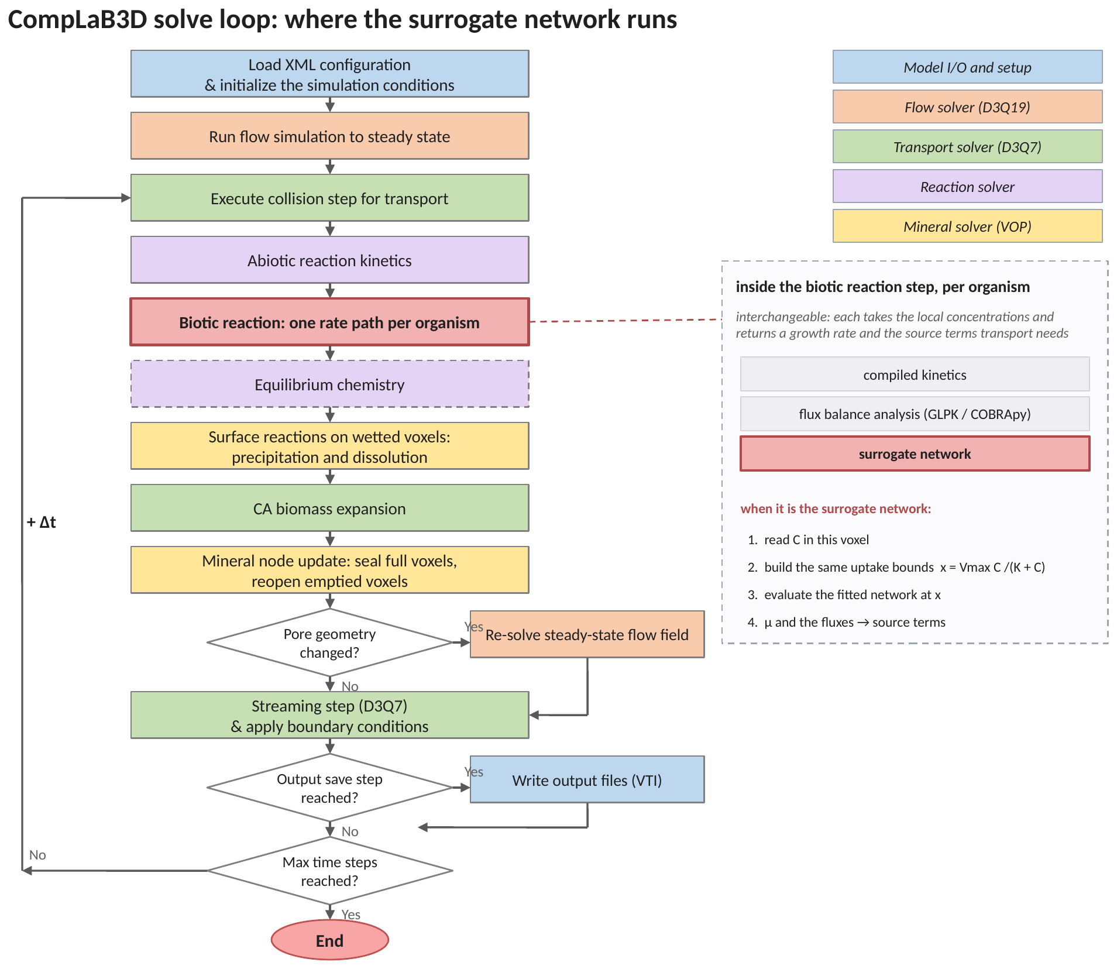
Figure 1. The solve loop, with the surrogate step highlighted. Nothing above or below the biotic reaction step knows which rate path is running, which is what makes the paths interchangeable.
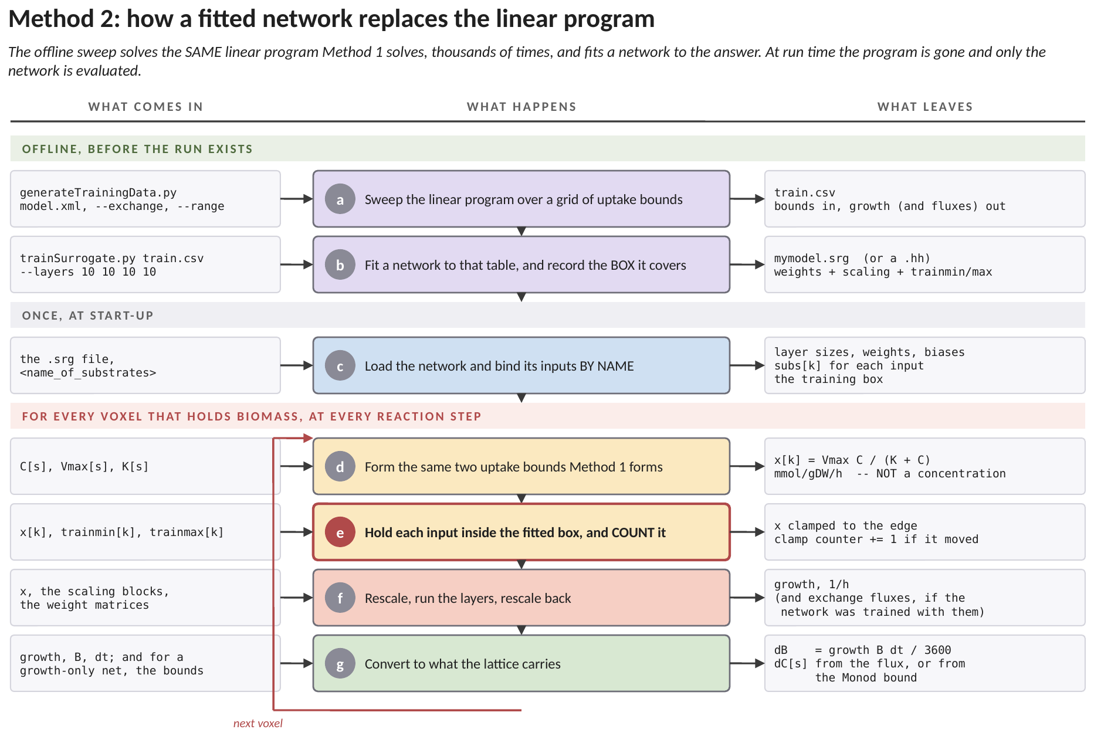
Figure 2. How this method works, end to end, and where each number enters. The green band is work done in Python before any simulation exists, the grey band is work the solver does once at start-up, and the red band is the loop that runs in every voxel at every reaction step. Each row names what arrives, what is done to it, and what leaves. (a) The linear program of Method 1 is solved thousands of times over a grid of uptake bounds. This is the expensive step, and it happens once, offline, with no simulation running. (b) A network is fitted to that table. What is saved is not only the weights: the RANGE of bounds the sweep covered is written into the same file, because a fitted model has no way of knowing it has been asked something outside the data it was shown. (c) At start-up the solver reads the file and matches each network input to a substrate by name, so a network trained on one pair of substrates cannot be fed another pair in the wrong order. (d) The loop begins. The same two Michaelis-Menten uptake bounds Method 1 forms are formed here. This is the single most important row in the figure: the network is fed UPTAKE BOUNDS, in millimoles per gram of dry cells per hour, and not concentrations. (e) Each input is held inside the fitted range, and every time it has to be moved the solver counts it. This row is drawn in red because it is the price of the method: a linear program is valid wherever its bounds are, a network only inside the rectangle it was shown. The count is printed at the end of the run and is the first number to read before believing any result from this path. (f) The inputs are rescaled, passed through the layers, and the answer is rescaled back into a growth rate per hour. (g) The growth rate becomes a biomass increment. Substrate consumption comes from the network too if it was trained with the flux columns; if it was trained on growth alone there is no flux to convert, and the solver falls back on the uptake bound of row (d) as though it were the actual uptake, which overestimates consumption wherever uptake was not the binding constraint.
The surrogate occupies exactly the slot the linear program occupied. It receives the same concentrations, it returns the same quantities, and the code around it is unchanged. Swapping paths is a change to one line of configuration.
3. The two phases
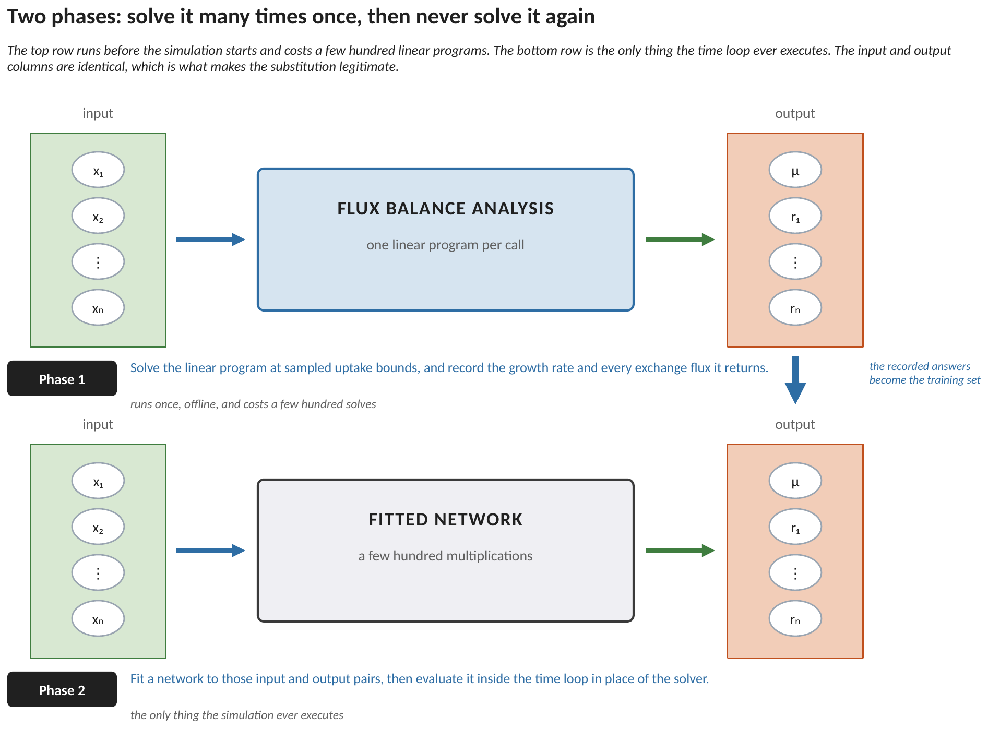
Figure 3. The two phases. The top row runs once, before the simulation starts. The bottom row is the only thing the time loop ever executes. The input and output columns are identical between them, which is what makes the substitution legitimate: the fitted model is asked exactly the question the model it replaces was asked.
Phase 1 is a sweep. Pick the substrates that limit growth, pick a range for each, and solve the linear program at points spread across that range. Record what came back: the growth rate, and every exchange flux. That table is the training set.
Phase 2 fits a function to the table and hands it to the simulation. From that point on the metabolic model, the solver and the sampling code are not needed and do not have to be installed on the machine the simulation runs on. Everything travels in a single text file of weights.
4. What the network is fed, and why
The chain begins exactly as it does in Method 1, because the network is fitted to the uptake bound rather than to the concentration:
x_{k} = V_{max,k} C_{k} / ( K_{k} + C_{k} ) (1)
This is a deliberate choice with a consequence. Equation (1) is exact and costs two floating-point operations. A network fitted from the concentration instead would have to learn that saturation curve from data, would learn it only approximately, and would have to be refitted every time the uptake parameters changed. Fitting from the bound means the network reproduces the linear program and nothing else, so the same weights stay valid when those parameters are edited.
4.1 Rescaling, and what it records
Uptake bounds routinely differ by orders of magnitude between substrates, and a network fed raw values fits badly: the large input dominates and the small one is effectively ignored. Each input is therefore mapped linearly onto the interval from minus one to plus one, using the smallest and largest value seen during training:
a_{j} = ( x_{j} − m_{j} ) g_{j} − 1 , g_{j} = 2 / ( M_{j} − m_{j} ) (2)
The pair of numbers in equation (2) carries more than a numerical convenience. The smallest and largest values are exactly the range over which the network was shown examples, and therefore exactly the range over which it is entitled to be believed. Because they are stored beside the weights, that range can be recovered from any fitted file without the training data. That is what makes the range check in section 7 possible on a network somebody else fitted.
5. Inside the network
Each hidden layer multiplies by a matrix of weights, adds a vector of biases, and applies the same nonlinear function to every element:
a^{(L)} = f ( W^{(L)} a^{(L−1)} + b^{(L)} ) (3)
The nonlinear function is tansig, which is the hyperbolic tangent written in the form MATLAB emits:
f(n) = 2 / ( 1 + e^{−2n} ) − 1 (4)
Three of its properties matter. It is bounded between minus one and plus one, so no single unit can dominate the layer after it. It is smooth, so the fitting problem has derivatives everywhere. And it is odd about the origin, which pairs with equation (2): an input at the centre of its training range arrives at the middle of the responsive part of the curve rather than out on a flat tail where it can barely move the output.
5.1 The last layer, and the only place the two forms differ
The final layer applies weights and biases but no nonlinearity, because a growth rate or a flux has no natural bound:
a^{(out)} = W^{(out)} a^{(L)} + b^{(out)} (5)
and each entry is mapped back into physical units by the inverse of equation (2), with its own pair of constants per output:
o_{k} = ( a^{(out)}_{k} + 1 ) / h_{k} + y_{k} (6)
Everything from equation (1) to equation (5) is identical in both forms of the network. The difference is the number of rows in the final weight matrix, and it propagates to exactly three places.
 | one output | several outputs
final weight matrix | a single row | one row per output
final bias | a scalar | one per output
equation (6) | applied once | applied once per output, each with its own constants
what comes back | the growth rate | growth and the realised exchange fluxes

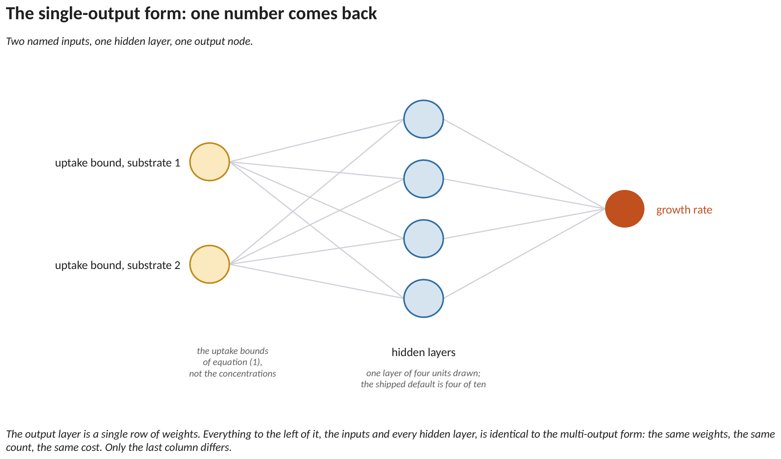
Figure 4. The single-output form. Two named inputs, one hidden layer of four units, one output. The shipped default is four layers of ten; four units are drawn here so every connection is visible. The input labels are the uptake bounds of equation (1), not the concentrations.
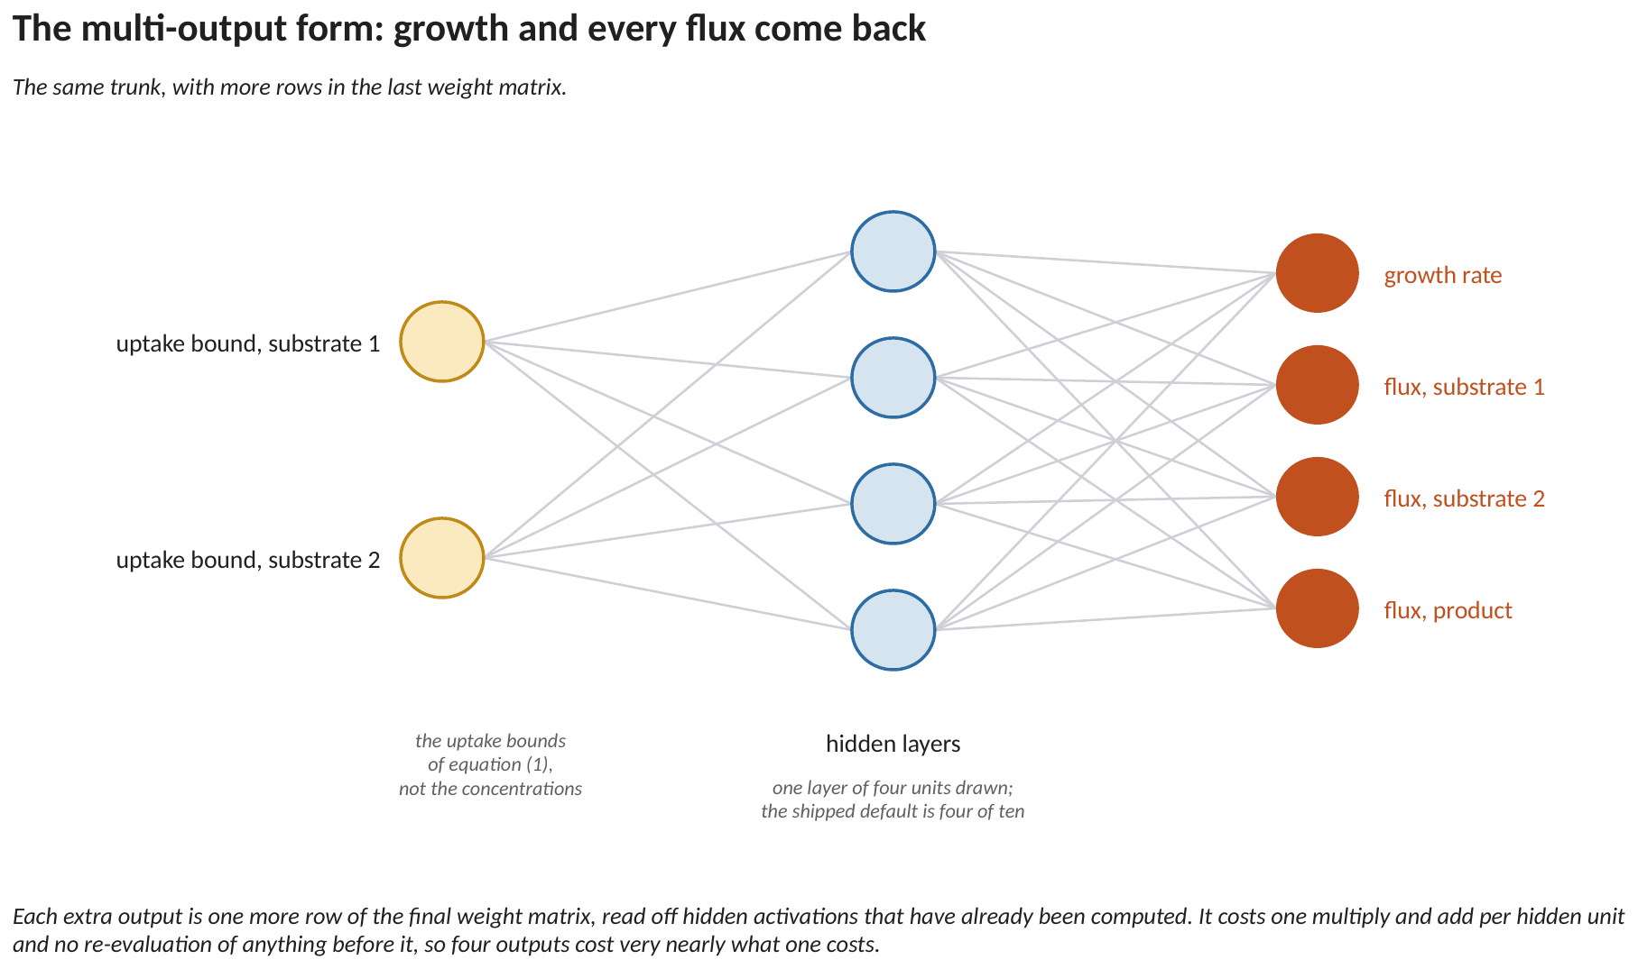
Figure 5. The multi-output form. The inputs and every hidden layer are unchanged: the same weights, the same count, the same cost. Only the output column has grown, and each extra output is one row of the final weight matrix read off activations that have already been computed.
5.2 How to read Figures 3 and 4
Both figures are the same picture with one column changed, and reading them left to right is reading equations (1) to (6) in order.
The two circles on the LEFT are the inputs. They are not concentrations: they are the uptake bounds of equation (1), which is why the labels say bound rather than concentration. One circle per substrate that limits growth, and only those. A substrate the organism is never short of does not need an input, because it never changes what the answer is.
The four circles in the MIDDLE are one hidden layer. Every line reaching one of them is a weight, and the circle itself is the addition of a bias and the application of equation (4). Four units are drawn so that every line is visible; the shipped default is four layers of ten, which is four hundred lines and would be a grey rectangle. Nothing about the method changes with the count.
The circles on the RIGHT are the outputs, and this is the only place the two figures differ. Figure 4 has one, so the final weight matrix is a single row and one number comes back. Figure 5 has four, so the final weight matrix has four rows and four numbers come back.
Look at what is IDENTICAL between them: the two input circles, the four hidden circles, and every line between those two columns. Same weights, same count, same arithmetic. That is the point of drawing them as a pair.
It follows that four outputs cost very nearly what one output costs at run time. The extra work is one multiply and add per hidden unit against a trunk that was going to be evaluated anyway. The cost of the multi-output form is paid in FITTING, where four surfaces have to be learned instead of one, and not in evaluation.
6. Building the network
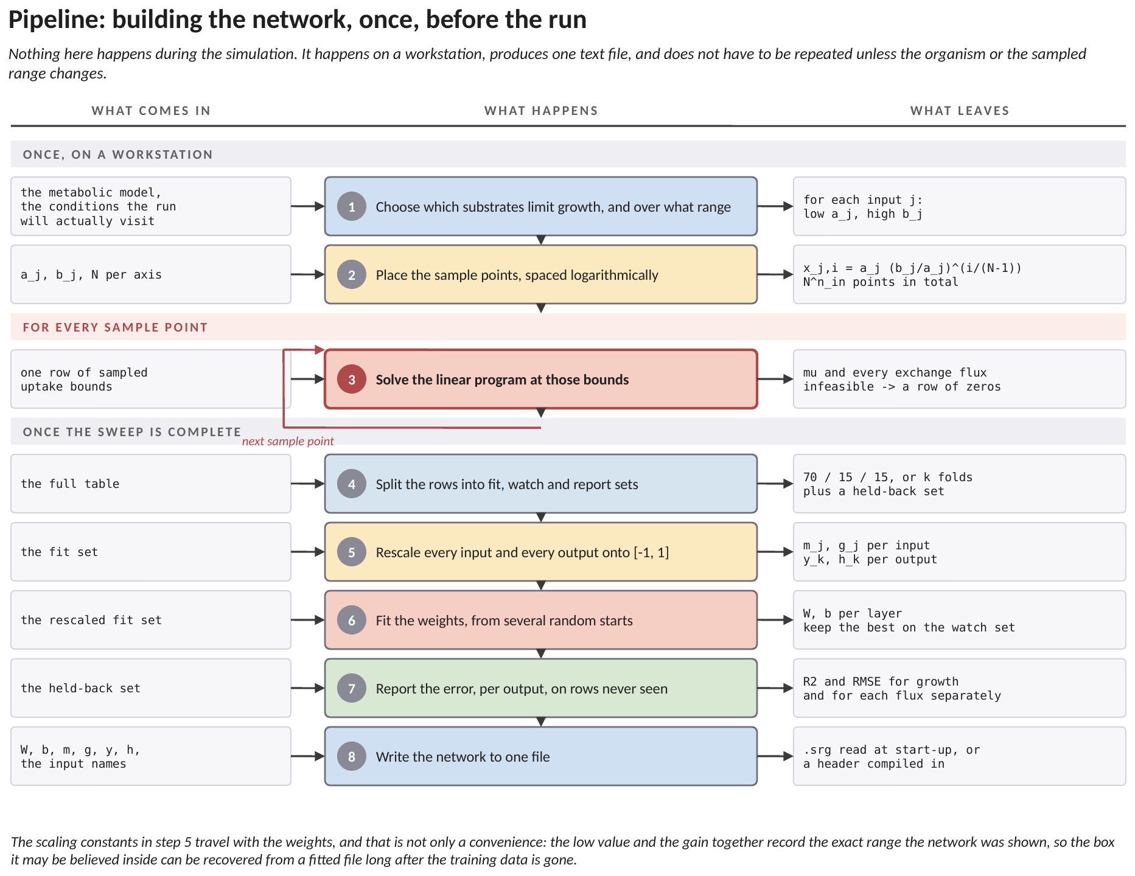
Figure 6. The offline pipeline, step by step: what each stage receives, what it does, and what it leaves for the next. None of this happens during the simulation.
6.1 How to read Figure 6
The chart splits the offline work into three phases: two steps that set the sweep up, one step that repeats for every sample point, and five that run once the sweep is done.
SETTING UP. Step 1 is the only place judgement enters. You choose which substrates limit growth, and over what range each of them will be sampled. That range is the box the finished network may be believed inside, so it should cover the conditions the run will actually visit, with margin. Step 2 places the sample points across it, by equation (7).
THE SWEEP. Step 3 solves the linear program once per sample point, exactly as Method 1 would in a voxel, and records everything that came back. This is where the cost of the path is paid, and it is paid once.
AFTER THE SWEEP. Step 4 divides the rows so that some are never used for fitting. Step 5 computes the rescaling constants of equation (2), for every input and every output. Step 6 fits the weights. Step 7 measures the fit on rows it never saw. Step 8 writes everything to one file.
Notice what step 8 writes: not only the weights and biases, but the rescaling constants from step 5 and the names of the inputs. The constants are what let the training range be recovered later, and the names are what let a reader check the ordering of section 7.2. A weights file without them is a network nobody can verify.
6.2 Where the sample points go
Because uptake bounds span orders of magnitude, the samples are placed logarithmically rather than evenly:
x_{j,i} = a_{j} ( b_{j} / a_{j} )^{i/(N−1)} , i = 0 … N−1 (7)
Equation (7) puts an equal number of points in every decade. Even spacing over the same range would place almost every point in the top decade and leave the low-concentration behaviour, where the organism is supply-limited and the model is most sensitive, essentially unsampled.
Sampling every combination of N values over n inputs costs N to the power n solves: a few hundred for two inputs, a few thousand for three, and close to two hundred thousand for four. Past two or three inputs a Latin hypercube is used instead, which places a fixed number of points so that each axis is evenly covered without taking the full product. Song et al. (2025) use five thousand such samples per model.
A solve that comes back infeasible is recorded as a row of zeros rather than thrown away. An organism that cannot balance at a given supply is a real state of the system, and keeping the row teaches the network where the feasible region ends. Discarding it leaves a hole in the network's domain that it will confidently interpolate across.
6.3 What the fit minimises, and why the outputs are scaled separately
Fitting minimises the mean squared difference between what the network predicts and what the linear program returned, measured on the rescaled values:
E = ( 1 / n q ) Σ ( ô − o )² (8)
What is absent from equation (8) is a weight per output, and that absence is a deliberate consequence of equation (6). Suppose the outputs were not rescaled separately. A growth rate sits near a hundredth of a reciprocal hour while a substrate flux sits near ten millimoles per gram per hour. A one per cent error in the flux then contributes something like five orders of magnitude more to the sum than a one per cent error in growth does. Minimising that sum is, to any practical precision, minimising the flux error alone, and the growth column would come out fitted worse by a multi-output network than by a single-output one, which defeats the purpose of having one.
Rescaling each output first removes the disparity. After equation (6) both quantities occupy the same interval, a one per cent error in either contributes comparably, and equal weighting is then correct rather than a compromise. This is why equation (6) carries its own constants per output, and it is the single design decision that makes the multi-output form workable at all.
6.4 Which number goes in the paper
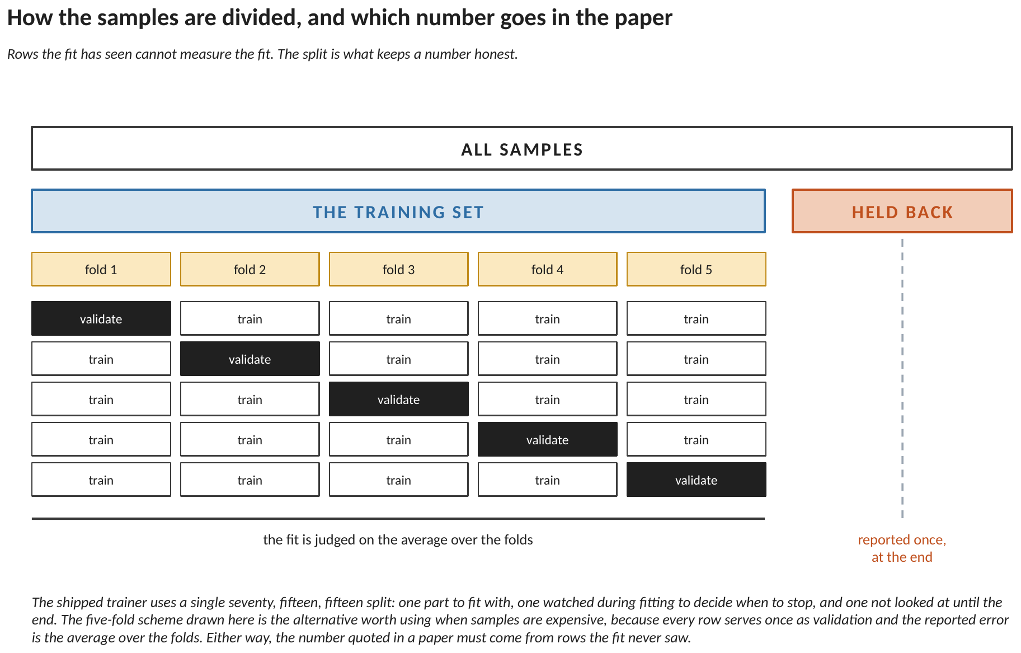
Figure 7. How the samples are divided. Rows the fit has seen cannot measure the fit, so a part of the table is set aside and not looked at until the end.
The fit is repeated from several random starting points, because equation (8) is not convex in the weights and a single attempt can settle in a poor local minimum. The attempt that performs best on the watched set is kept.
The error is then reported on the held-back rows, separately for every output. A single pooled figure is not adequate for a multi-output network, because the outputs are not equally difficult and a pooled number lets a well-fitted growth column conceal a badly fitted flux column.
The asymmetry is structural rather than incidental. Growth is a smooth surface made of a few planar regions. The flux surfaces are piecewise linear with creases wherever the binding constraint changes from one substrate to another, and a smooth interpolant rounds precisely those creases. Song et al. (2025) report the same pattern and name it as the principal difficulty in building their multi-output models.
7. Evaluating the network
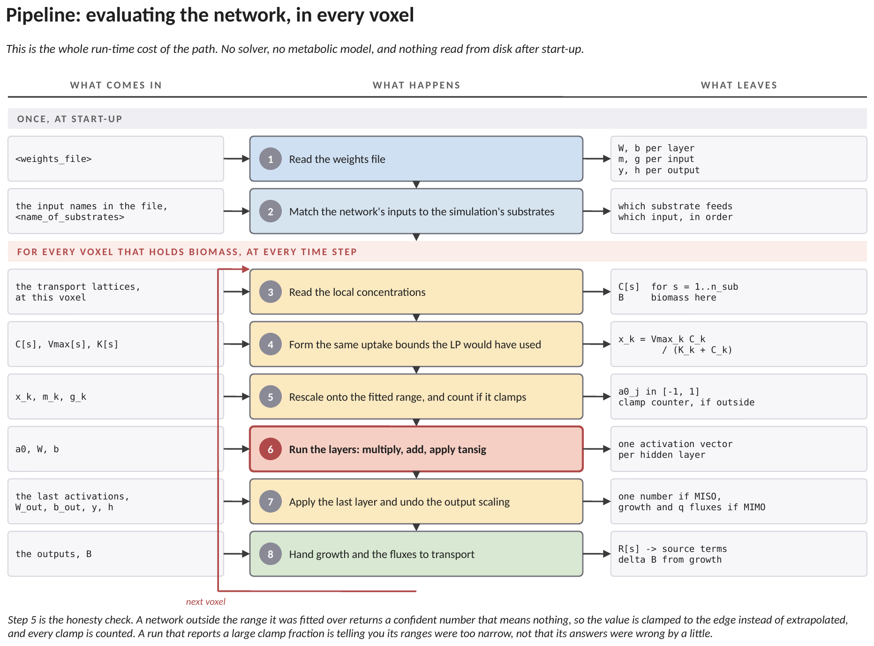
Figure 8. The run-time pipeline, step by step. This is the whole cost of the path: no solver, no metabolic model, and nothing read from disk after start-up.
7.1 How to read Figure 8
Two steps run at start-up and six repeat in every voxel. The two at the top are the whole of the setup: read the weights file, and work out which of the simulation's substrates feeds which of the network's inputs.
Inside the voxel the sequence mirrors the GLPK pipeline of Method 1 as far as step 4. Read the local concentrations. Form the uptake bounds from equation (1), using the same parameters and the same expression the solver would have used. Up to that point the two paths are doing identical arithmetic.
Step 5 is where they part. Instead of handing those bounds to a solver, the surrogate rescales them onto the fitted range by equation (2). Step 6 runs the hidden layers, equations (3) and (4). Step 7 applies the final layer and undoes the output scaling, equations (5) and (6). Step 8 hands the result to transport, exactly as Method 1 does.
There is no loop-back inside a voxel here, unlike the chain in Method 1, because the network is evaluated once and returns everything at once. The only repetition is the outer one: the next voxel.
7.2 The range check
A network asked about conditions outside the range it was fitted over does not fail. It returns a confident number that means nothing, and there is no signal in the output to say so. That is the characteristic failure mode of every fitted method, and it is the reason equation (2) stores its constants beside the weights.
At run time each rescaled input is clamped to the edge of the fitted range rather than extrapolated, and every clamp is counted. Clamping is the conservative choice: at the edge the network returns the answer for a nearby state it actually saw, whereas the extrapolation is unbounded and can go negative or enormous. The closing report gives the clamp fraction, and a run that reports a large one is telling you its ranges were too narrow, not that its answers were slightly off.
7.3 The ordering
The network's outputs are in the order the exchanges were swept during Phase 1. The simulation's substrates are in the order they appear in the configuration. Nothing on the wire between them carries a name.
A transposed pair therefore produces two entirely plausible numbers assigned to the wrong species, with no warning from anything. This is the one silent failure mode of the path, and the only defence is to check the two orders against each other by hand when the network is first configured.
8. The one assumption, and what it costs
The transport step needs two things: the growth rate, and the consumption of every dissolved species. A single-output network supplies only the first.
What the solver does about the second is fill it in before calling the network, using the uptake bound of equation (1), and then let the rate path overwrite it. A multi-output network overwrites it with the fitted flux. A single-output network has nothing to overwrite it with, so the pre-filled value stands:
consumption assumed_{k} = x_{k} = V_{max,k} C_{k} / ( K_{k} + C_{k} ) (9)
In words: a growth-only surrogate assumes the organism consumed everything it was permitted to consume. That is exactly right when the bound on that substrate was the binding constraint of the linear program, and wrong whenever some other substrate ran out first.
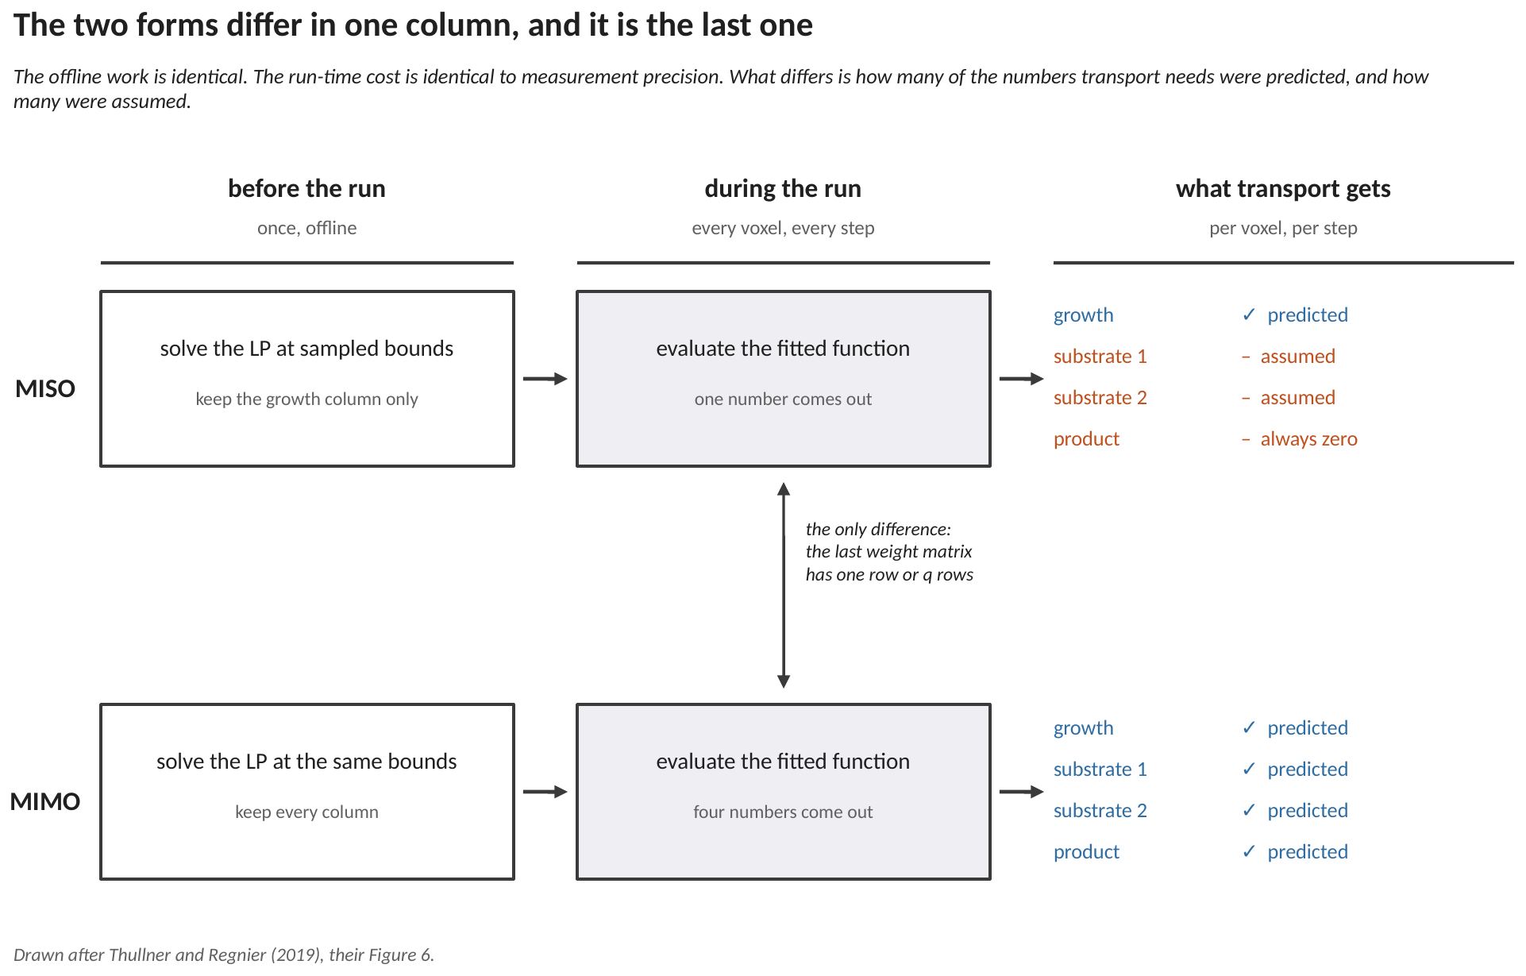
Figure 9. The two forms compared, with the columns carrying the stage of the calculation. The offline work is identical and the run-time work is identical to measurement precision. The difference appears only in the last column: how many of the numbers transport needs were predicted, and how many were assumed. Drawn after Thullner and Regnier (2019), their Figure 7.
8.1 It separates by role, not at random
Whether equation (9) matters is a quantitative question, and it was answered by solving the linear program across the sampled range and comparing the realised flux with the bound. The result separates cleanly, and the separation is chemically interpretable.
For the CARBON SOURCE the assumption is exact everywhere the organism grows. Wherever growth is possible at all the optimum consumes every unit of carbon available, because carbon is what the objective is built from and there is no benefit in leaving any. The realised flux equalled its bound at every sampled point where growth was non-zero.
For the ELECTRON ACCEPTOR the behaviour is different. It is consumed only in proportion to the carbon actually being respired. Where carbon is scarce and the acceptor is plentiful the organism has nothing to respire and leaves most of its permitted acceptor untouched, while equation (9) draws all of it. Across the region where the organism grows, the assumed consumption exceeded the realised one by more than one per cent at about a quarter of the sampled points, by twelve per cent on average, and by up to eighty-seven per cent at worst.
Song et al. (2025) report exactly this asymmetry and give it as their stated reason for storing the realised acceptor uptake in the network alongside growth and the products. A reactive-transport modeller can read the result more directly: where a donor and an acceptor are both supplied, the surrogate must return the acceptor flux, because only the donor flux can be inferred from the bound.
8.2 The second effect is larger
Equation (9) can only ever be negative. An organism that excretes a product cannot be represented by it at all, and this is not a matter of accuracy: there is no output to carry a product and no channel through which the solver could receive one.
On the case that was measured, the organism fermented and excreted over three quarters of the region where it grew. A growth-only network releases none of it, anywhere. If any species the organism produces is consumed by anything else in the domain, that coupling simply does not exist in the run.
8.3 When a growth-only network is still the right choice
None of the above says the multi-output form should always be preferred. A single-output network has fewer parameters to fit for the same amount of data, and one surface to fit rather than several, so it will generally fit growth better. Where the quantity being reported is biomass, and no downstream process depends on a product or on an acceptor budget, the growth-only form is the better instrument and the whole of this section is irrelevant to that study.
The question to ask is therefore not which network is more accurate, but which quantities the study reports. If a mass balance on the electron acceptor is part of the result, or if any species the organism produces is consumed by anything else, the multi-output form is required, and no amount of extra fitting effort on a single-output network will substitute for it.
9. A worked example: one voxel, step by step
Everything above on a single voxel, with every number written out. The network is the one that ships in src/surrogateModel.hh and the voxel is the starting state of examples/11_surrogate. Four hidden layers of ten neurons is 371 fitted numbers, which is too many to print, so this section shows one neuron in full and then gives the rest as the vectors they are. Nothing is hidden: every value below can be reproduced from the header and the configuration file.
9.1 Where every number in this example comes from
The single most important row in the table below is the first one, and it is the thing most easily got wrong about this method: the network is not fed concentrations. It is fed the two Michaelis-Menten uptake bounds, in millimoles per gram of dry cells per hour, which are exactly the numbers that would have been the lower bounds of the linear program had one been solved. The surrogate replaces the program, not the chemistry in front of it.
the number | what it is | where it comes from
the two inputs, in mmol gDW⁻¹ h⁻¹ | the uptake bounds, NOT the concentrations | computed in the solver from the local concentrations, one step before the network is called. Section 4 explains why the bounds rather than the concentrations are the right input
0.05 and 0.01 mol L⁻¹ | the half-saturation constants of acetate and of Fe(III) | <half_saturation_constants> in CompLaB.xml
8.0 and 0.4 mmol gDW⁻¹ h⁻¹ | the largest uptake each substrate can support | <fba_maximum_uptake_flux> in CompLaB.xml
1.0 and 0.5 mol L⁻¹ | the acetate and Fe(III) this voxel holds right now | the transport solver, one step earlier. Here they are also the starting values, <initial_concentration>
1.0 mol L⁻¹ | the biomass in this voxel | the biomass lattice; here the starting value <initial_densities>
0.015 s | how long this reaction step lasts | the solver prints it as [ADE] dt at start-up
8.9016×10⁻⁴ to 9.99793, and 3.51303×10⁻⁵ to 0.499746 | the box of uptake bounds the network was fitted over | recovered by inverting the input scaling in surrogateModel.hh. training/inspectSurrogate.py prints exactly these two lines
x_offset, x_gain, x_ymin | the numbers that map each input onto the range −1 to +1 | the input scaling block of surrogateModel.hh, written there by the trainer
IW1_1, b1, LW2_1 ... b5 | the 371 fitted weights and biases | the fit. They are the output of the training run and mean nothing individually
y_gain 37.9181676275, y_ymin −1 | the numbers that map the network's internal answer back to a growth rate | the output scaling block of surrogateModel.hh

9.2 Step 1: from concentrations to the two uptake bounds
This step happens before the network sees anything, and it is ordinary Michaelis-Menten. Acetate first, with a capacity of 8.0 and a half-saturation constant of 0.05 against the 1.0 the voxel holds:
V_{acetate} = 8.0 × 1.0 / ( 0.05 + 1.0 ) = 8.0 × 0.952381 = 7.619048
and Fe(III), whose capacity is 0.4, whose half-saturation constant is 0.01, and which is present at 0.5:
V_{Fe3} = 0.4 × 0.5 / ( 0.01 + 0.5 ) = 0.4 × 0.980392 = 0.392157
Both in mmol gDW⁻¹ h⁻¹, and both inside the fitted box given in the table above, so neither is clamped and the clamp counter does not move. That matters: a value outside the box would be pulled to the edge and counted, and the count is reported at the end of the run. The whole of Section 7.2 is about why that is preferable to letting the network extrapolate.
9.3 Step 2: rescale the inputs onto the range the network was trained on
A neural network trained by the usual route expects each input on a fixed interval, here −1 to +1, and the mapping is stored with the weights so it travels with them. The form is the one written out in Section 4.1:
x_{p} = ( x − offset ) × gain + y_{min}
With the two offsets and gains from surrogateModel.hh, and y_min = −1:
acetate: (7.619048 - 0.000890159834) * 0.200059307890 - 1 = +0.5240833849
Fe(III): (0.392157 - 0.000035130325) * 4.002315902288 - 1 = +0.5693955946
Both land near the middle of the interval, which is another way of seeing that this voxel sits comfortably inside the fitted box. An input that came back close to −1 or +1 would be at the edge of what the network was shown.
9.4 Step 3: the first hidden layer, one neuron in full
Each neuron in the first layer takes both scaled inputs, multiplies each by its own weight, adds its own bias, and passes the total through a hyperbolic tangent. That is the whole operation, repeated ten times with different weights. Neuron 0, with its two weights and its bias read from IW1_1 and b1:
z = (-2.4353481595 * 0.5240833849) + (1.2453128078 * 0.5693955946) + 0.6779281087
= -1.2763255068 + 0.7090756267 + 0.6779281087
= 0.1106782286
a = tanh(0.1106782286) = 0.1102285081
The hyperbolic tangent is what makes the network able to represent a curve rather than a plane. It is close to linear near zero and flattens towards plus and minus one, so a neuron whose total is large in either direction has effectively saturated and stops responding to its inputs. Several neurons below have done exactly that, and it is not a fault.
The other nine neurons are the same arithmetic with different weights. All ten outputs of layer 1:
a1 = [ 0.110229 0.449506 -0.221237 -0.491672 -0.607776
-0.216422 -0.695360 0.872925 -0.068385 -0.387265 ]
9.5 Step 4: the three remaining hidden layers
Layers 2, 3 and 4 do the same thing, except that each neuron now has ten weights rather than two, because it listens to all ten outputs of the layer before it. Ten multiplications, a bias, and a hyperbolic tangent. The three resulting vectors:
a2 = [-0.899956 -1.000000 0.255442 0.808927 0.420868
0.769281 -0.210953 0.523128 -0.910790 0.298331 ]

a3 = [ 0.597196 0.143377 -0.517805 0.890272 -0.999992
-0.999997 0.129640 -0.991021 -0.928357 0.446156 ]

a4 = [ 0.203767 0.866885 0.285130 -0.999530 0.999769
-1.000000 -0.764104 0.279741 0.795577 -0.073663 ]
Several entries have reached −1.000000 or +0.999769 and are saturated. This is normal in a trained network and is part of how it represents a sharp change in slope. It is also a reason the fitted numbers cannot be interpreted one at a time: no single weight in the four matrices above corresponds to anything chemical.
9.6 Step 5: the output neuron, and back to a growth rate
The last layer is a single neuron and it is LINEAR: ten multiplications and a bias, with no hyperbolic tangent. That is deliberate, and Section 5.1 gives the reason: a hyperbolic tangent here would cap the answer at plus one, and a growth rate has no such cap.
a₅ = b₅ + Σ LW5_4_{j} × a4_{j} = 0.5102869390
That number is on the network's internal scale, not in any physical unit. The output scaling block turns it back into a growth rate, using the same form as the input map run in reverse:
μ = ( a₅ − y_{min} ) / gain = ( 0.5102869390 + 1 ) / 37.9181676275 = 0.0398301667 h⁻¹
About 0.04 per hour, or a doubling time near seventeen hours, which is a reasonable figure for an iron-reducing organism on acetate and is the first sanity check worth making on any surrogate. The fitted range printed by inspectSurrogate.py is 0 to 0.0527 per hour, so this voxel is at roughly three quarters of the fastest growth the network was ever shown.
9.7 Step 6: the increments the transport solver receives
The growth rate is per hour and the biomass increment needs the length of the step in seconds, so the conversion is the same one Method 1 uses:
ΔB = 0.0398301667 × 1.0 × 0.015 / 3600 = 1.659590×10⁻⁷ mol L⁻¹
Substrate consumption is the point at which the shipped network's one limitation becomes visible, and it is worth stating plainly rather than leaving in a footnote. This network has a single output, growth. It returns no exchange fluxes, so there is nothing to convert into a substrate change, and the solver falls back on the only other number it has: the Michaelis-Menten bound from Section 9.2, taken as though it were the actual uptake.
dC_acetate = -7.619048 * (1.0 * 24.6) * 0.015 / 3.6e6 = -7.809524e-7 mol/L
dC_Fe3 = -0.392157 * (1.0 * 24.6) * 0.015 / 3.6e6 = -4.019608e-8 mol/L
The bound is a ceiling, not a rate. The organism is drawing acetate at the fastest rate its uptake machinery allows, which is right only in a voxel where uptake really is the binding constraint, and is an overestimate everywhere else. Section 8 puts the size of that overestimate at around sixty per cent for this organism. It is also why this network cannot excrete anything: there is no flux to excrete.
A network trained with the flux columns as well returns those exchange fluxes directly and both problems disappear. The trainer already records them, so producing one is a matter of asking for them rather than of extra work; Section 8.3 says when the growth-only form is nevertheless the right choice.
9.8 What changes when the voxel changes
Everything in Sections 9.3 to 9.6 is fixed for the whole run. The only numbers that differ between one voxel and the next are the two concentrations, and they enter in exactly one place, Section 9.2. That is the useful thing about this method and the reason it is fast: the expensive part was done once, offline, and what remains per voxel is two Michaelis-Menten expressions, a rescaling, 371 multiplications and a division. There is no solver, nothing to converge, and no possibility of an infeasible answer.
The price is the box. A linear program is valid wherever its bounds are; this network is valid over the rectangle in the table of Section 9.1 and nowhere else. A run that spends much of its time outside that rectangle is reported as such at the end, and that report is the number to look at before any result from this path is believed.
10. Running it
10.1 The offline commands
# 1 sample the linear program
python3 tools/surrogate/generateTrainingData.py model.xml \
--exchange <donor> --range <lo> <hi> --log \
--exchange <acceptor> --range <lo> <hi> --log \
--also <product> --objective <biomass reaction> \
--grid 21 -o train.csv

# 2 fit, and export both formats
python3 tools/surrogate/trainSurrogate.py train.csv \
--layers 10 10 10 10 --restarts 6 --seed 7 \
--name mymodel --srg mymodel.srg -o mymodel_weights.hh

# 3 optional: recover the training box from the fitted file alone
python3 tools/surrogate/inspectSurrogate.py mymodel.srg

Add the growth-only flag to the first command for a single-output network. Drop it, and add one product per extra output, for a multi-output one. The number of outputs is a property of the training set and travels into the weights file, so the solver does not have to be told.
10.2 The two file formats
The same fit is written twice, and both are read by the same code. The text format is read at start-up, so changing network needs no rebuild. The generated header is compiled in, which is the convention inherited from the two-dimensional model and from the networks published with Song et al. (2025), so a network fitted in either toolchain can be read by the other.
10.3 What to put in the configuration
<reaction_type>surrogate</reaction_type>
<enable_surrogate>true</enable_surrogate>
<weights_file>mymodel.srg</weights_file>

<!-- the substrates must be listed in the order they were swept -->
<name_of_substrates>donor acceptor product</name_of_substrates>

That last comment is section 7.3 restated, and it is the thing to check first when a run produces plausible numbers that are nonetheless wrong.
11. Where to go next
Method 1 | the linear program this path replaces, and the reference it is checked against
example 11 | the surrogate path, smallest working case
example 16 | the surrogate inside a complete pipeline
pipelines/B2 | the offline sweep and fit, as a runnable script
tools/surrogate/ | the trainer, the sampler, and the inspector
config/CompLaB.reference.xml | every tag documented once

12. References
Song, H.-S., Ahamed, F., Lee, J.-Y., Henry, C. S., Edirisinghe, J. N., Nelson, W. C., Chen, X., Moulton, J. D., Scheibe, T. D.: Coupling flux balance analysis with reactive transport modeling through machine learning for rapid and stable simulation of microbial metabolic switching. Scientific Reports 15, 6042 (2025). https://doi.org/10.1038/s41598-025-89997-9
Orth, J. D., Thiele, I., Palsson, B. O.: What is flux balance analysis? Nature Biotechnology 28, 245–248 (2010). https://doi.org/10.1038/nbt.1614
Thullner, M., Regnier, P.: Microbial controls on the biogeochemical dynamics in the subsurface. Reviews in Mineralogy and Geochemistry 85, 265–302 (2019). https://doi.org/10.2138/rmg.2019.85.9
Jung, H., Song, H.-S., Meile, C.: CompLaB v1.0: a scalable pore-scale model for flow, biogeochemistry, microbial metabolism, and biofilm dynamics. Geoscientific Model Development 16, 1683–1696 (2023). https://doi.org/10.5194/gmd-16-1683-2023

