Rate Path 3: Symbolic Rate Laws
a formula found by fitting, read from a plain text file at run time
1. What this path is
A symbolic rate law is an ordinary algebraic expression, of the kind a modeller would write by hand, except that the form of the expression was found by fitting rather than chosen in advance. Ordinary fitting starts from a form you picked, a Monod law say, and finds the numbers in it. Symbolic regression searches over the form itself. What it returns is a formula, and the formula is what this path evaluates.
Nothing is trained at run time and nothing is solved. The file is read once at start-up and parsed into a tree of small nodes. Per voxel the tree is walked, the outputs are read straight off in file order, and the rates go to the transport step. There is no solver, no network, and no linear algebra of any kind.
The header does not do the fitting. Genetic programming is slow and its answer depends on the random seed, and neither of those belongs inside a simulation. Fit offline, write the file, run.
2. Where it sits in the time step
One time step of CompLaB3D runs flow, transport, reaction and update in that order. The rate path is the reaction step, and it is the only stage that differs between paths. Everything above and below it is the same code whichever path is selected, which is what makes the six paths interchangeable and comparable.
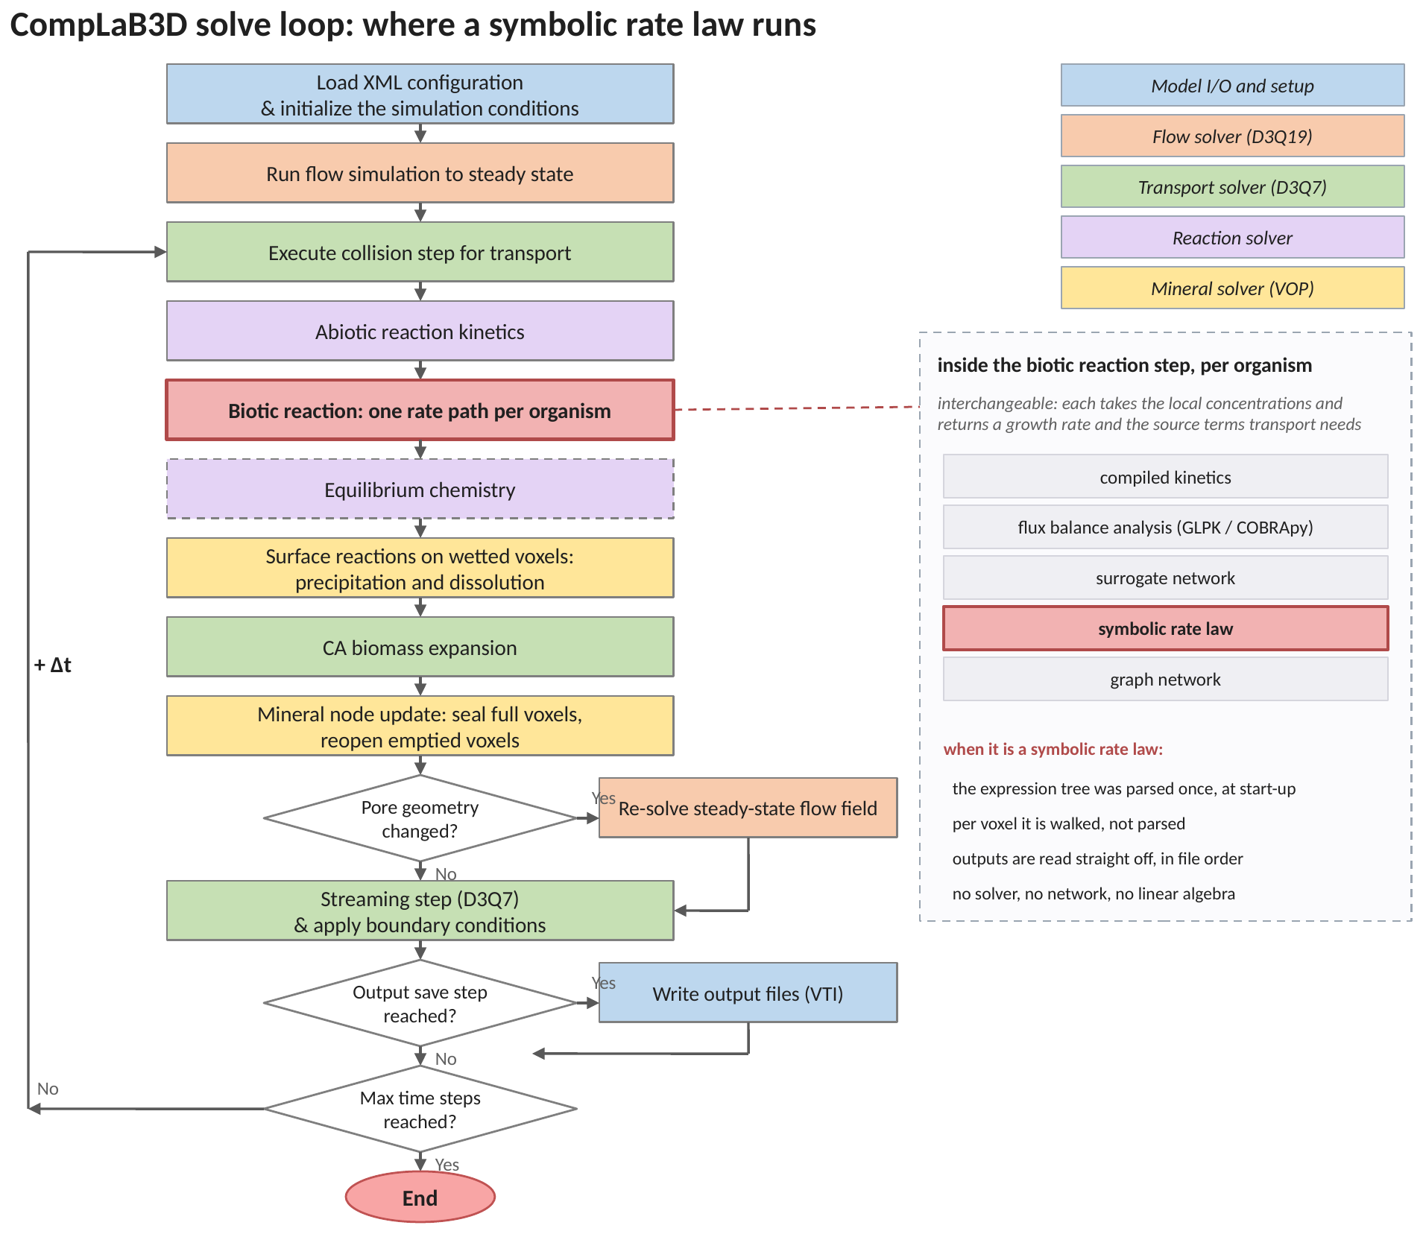
Figure 1. The solve loop, with the symbolic path marked. The biotic reaction step is one of six interchangeable rate paths, each of which takes the local concentrations and returns a growth rate together with the source terms the transport step needs. When the path is a symbolic law, the expression tree was parsed once at start-up, the tree is walked per voxel, and the outputs are read off in file order.
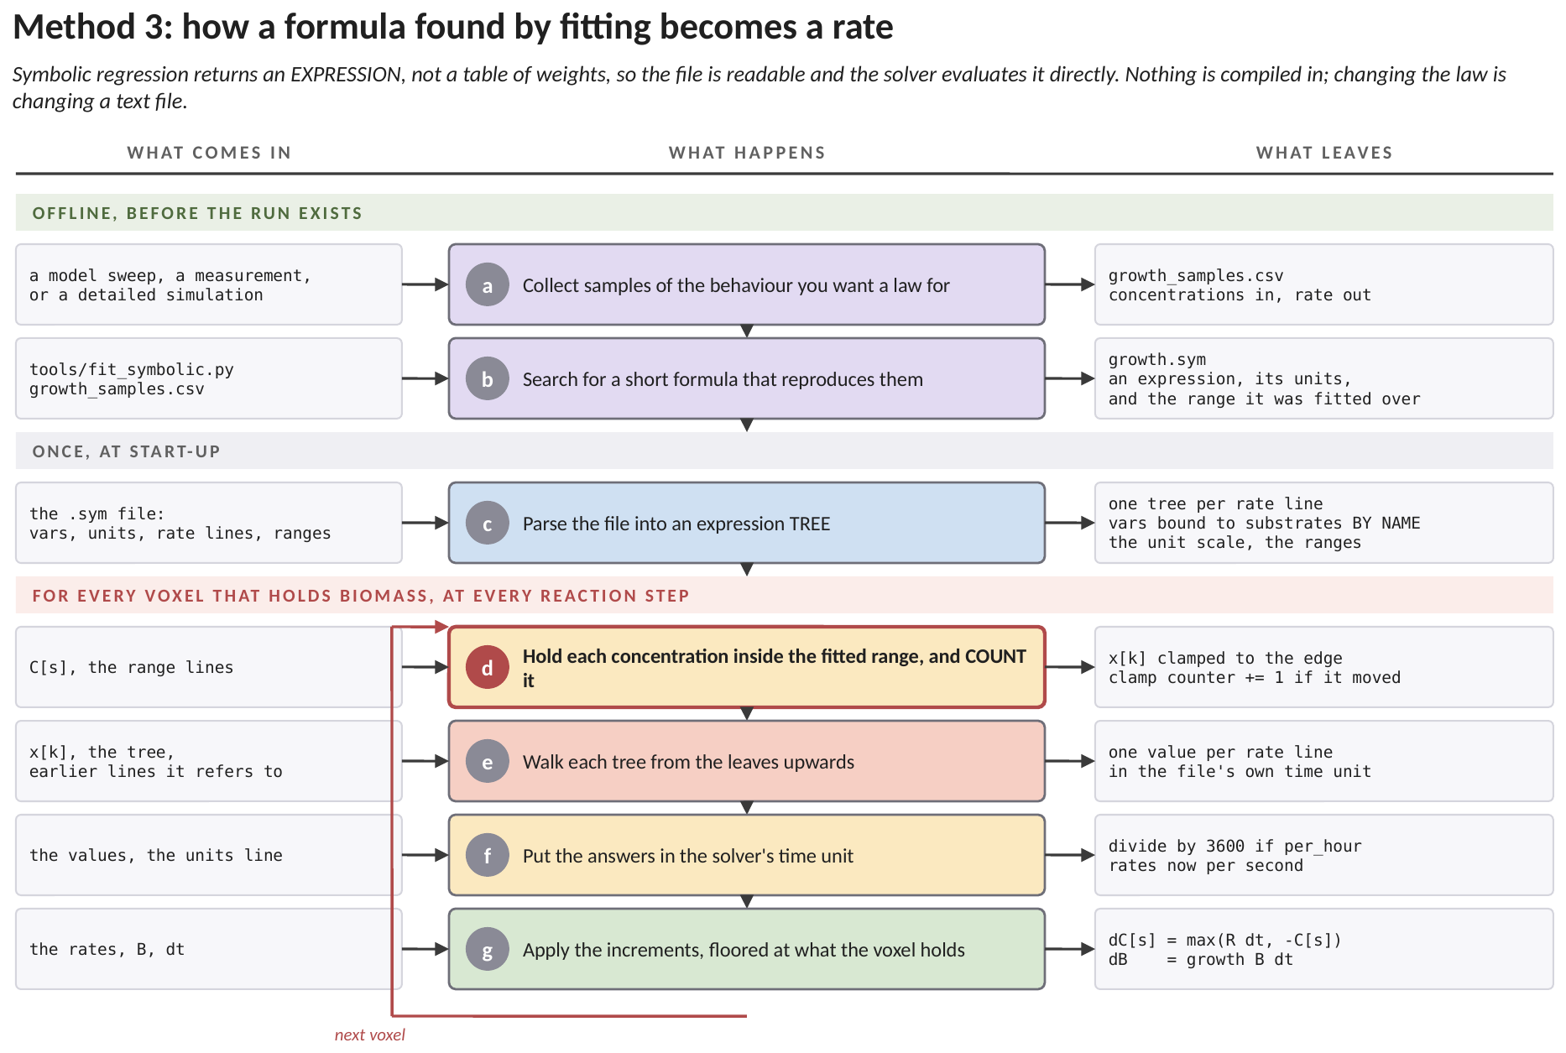
Figure 2. How this method works, end to end, and where each number enters. The green band is work a person does before any simulation exists, the grey band is work the solver does once at start-up, and the red band is the loop that runs in every voxel at every reaction step. Each row names what arrives, what is done to it, and what leaves. (a) Samples of the behaviour you want a law for are collected, from a model sweep, a measurement, or a more detailed simulation. (b) A search is run for a short algebraic formula that reproduces them. What comes out is an expression a reader can look at and argue with, together with the units it was fitted in and the range of concentrations it was shown. All three travel in the same file. (c) At start-up the file is parsed into an expression tree, one per rate line, and the variable names are matched to substrates by name rather than by position. A file written against a different substrate ordering is refused rather than bound to the wrong lattice. (d) The loop begins. Each concentration is held inside the range the fit was shown, and every time one has to be moved the solver counts it. This row is drawn in red because a formula outside its fitted range does not fail, it returns a confident number. (e) Each tree is walked from the leaves upwards. A rate line may refer to an earlier one, so the lines are worked in file order and a growth line can be reused by the substrate lines beneath it. (f) The answers are put in the solver's time unit. If the file says per hour they are divided by 3600. This is a factor that does not announce itself: a run with the wrong unit setting completes, produces smooth fields, and is wrong by three orders of magnitude. (g) The increments are applied, floored at what the voxel actually holds, so a rate law cannot draw a species below zero however aggressive the fit was.
The whole run-time cost of this path is one tree walk per organism per voxel per reaction step, over an expression of a few dozen nodes. That is the reason the parsing is done once rather than per voxel: parsing per voxel would cost more than the linear program this path is standing in for.
3. Two phases, and the line between them
The method has an offline phase and a run-time phase, and the .sym file is the whole handover between them. Nothing on the offline row is inside CompLaB3D.
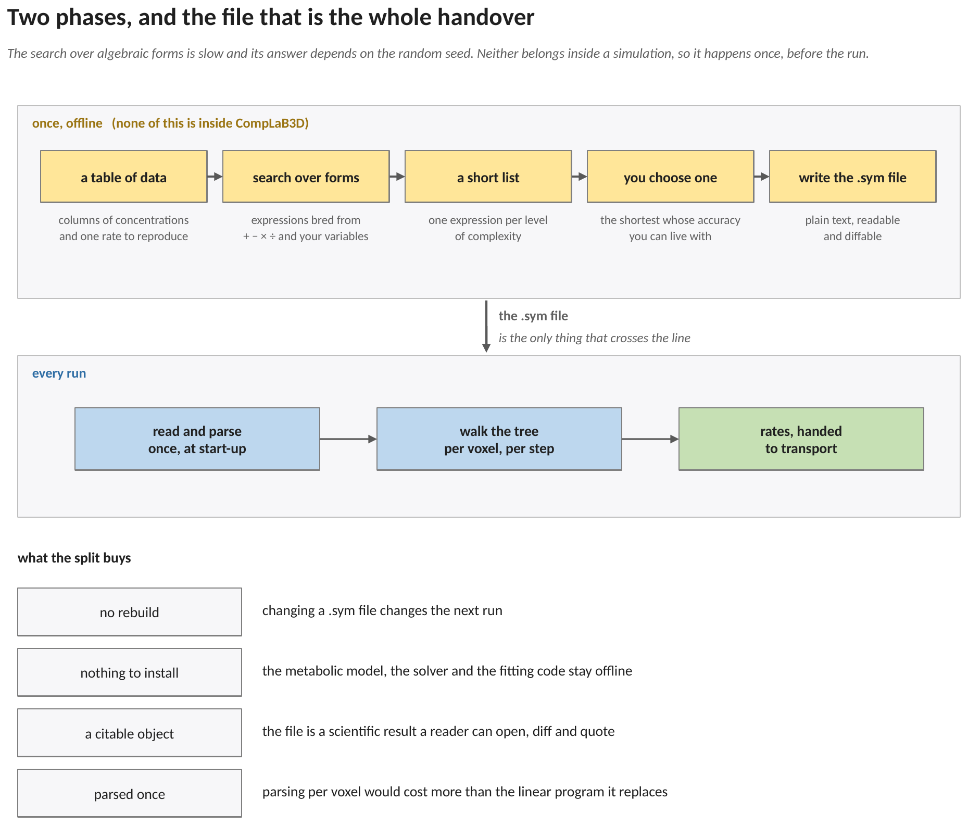
Figure 3. The two phases, and the four things the split buys. Above the line: a table of data, a search over algebraic forms, a short list of candidates, a choice among them, and a file written out. Below the line: the file is read and parsed once at start-up, the tree is walked once per voxel per step, and rates go to transport. The .sym file is the only object that crosses the line.
That last point is the same reasoning that put the surrogate weights of Rate Path 2 in a .srg file rather than in a compiled header. A fitted object is a scientific result, and it should be readable, diffable and citable on its own.
4. What the search returns is a list, not an answer
A symbolic regression run does not return one expression. It returns one expression per level of complexity, together with the error each achieves, and the choice among them is left to the person. That is deliberate: the criterion is not numerical.
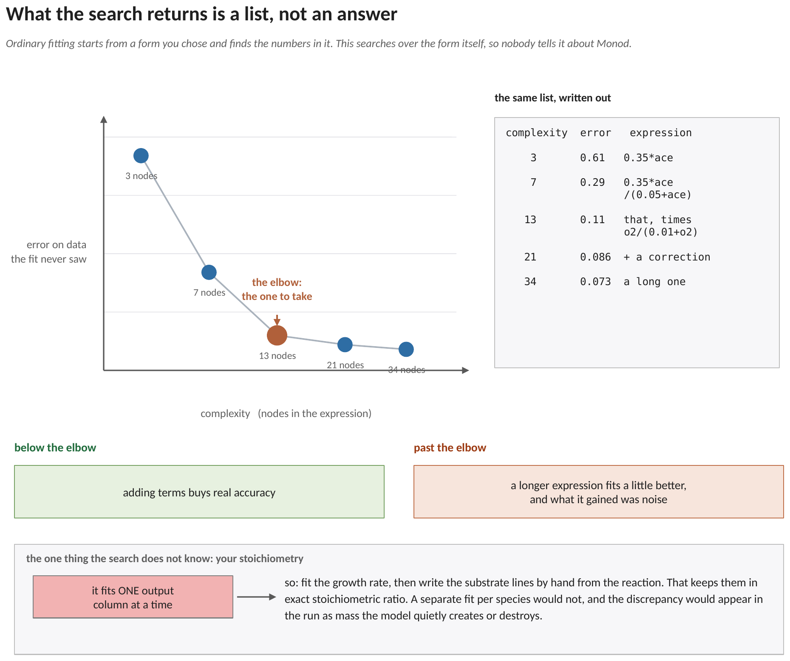
Figure 4. A Pareto set, drawn with complexity on the horizontal axis and error on the vertical, and the same list written out beside it. Complexity is counted in nodes of the expression tree, and the error is measured on data the fit never saw. The elbow is the answer: below it, adding terms buys real accuracy; past it, a longer expression fits a little better and what it gained was noise. The choice among the list is a scientific one rather than a numerical one, which is exactly why the search returns the list instead of picking for you.
One thing the search does not know is the stoichiometry. It fits one output column at a time. The practice that follows is to fit the growth rate, and then write the substrate lines by hand from the reaction, which keeps them in exact stoichiometric ratio. A separate fit per species would not, and the discrepancy would appear in the simulation as mass that the model quietly creates or destroys.
 | compiled kinetics | a symbolic law | the linear program
what you supply | a C++ expression | a text file of expressions | a genome-scale model
what is fixed | the form and the numbers | the form and the numbers | only the stoichiometry
what changes with conditions | the value of the law | the value of the law | which reactions carry flux at all
changing it costs | a rebuild | editing a file | editing a model file
cost per voxel per step | a few operations | one walk of a few dozen nodes | one simplex solve
valid where | wherever you say it is | inside the range lines, and nowhere else | everywhere

The last row is the whole trade. A compiled law is yours and its domain of validity is a claim you are making. A linear program has no fitted range at all, because nothing about it was fitted. A symbolic law sits between the two: it is as readable as the first and as range-limited as any other fitted object.
5. The expression, as the solver holds it
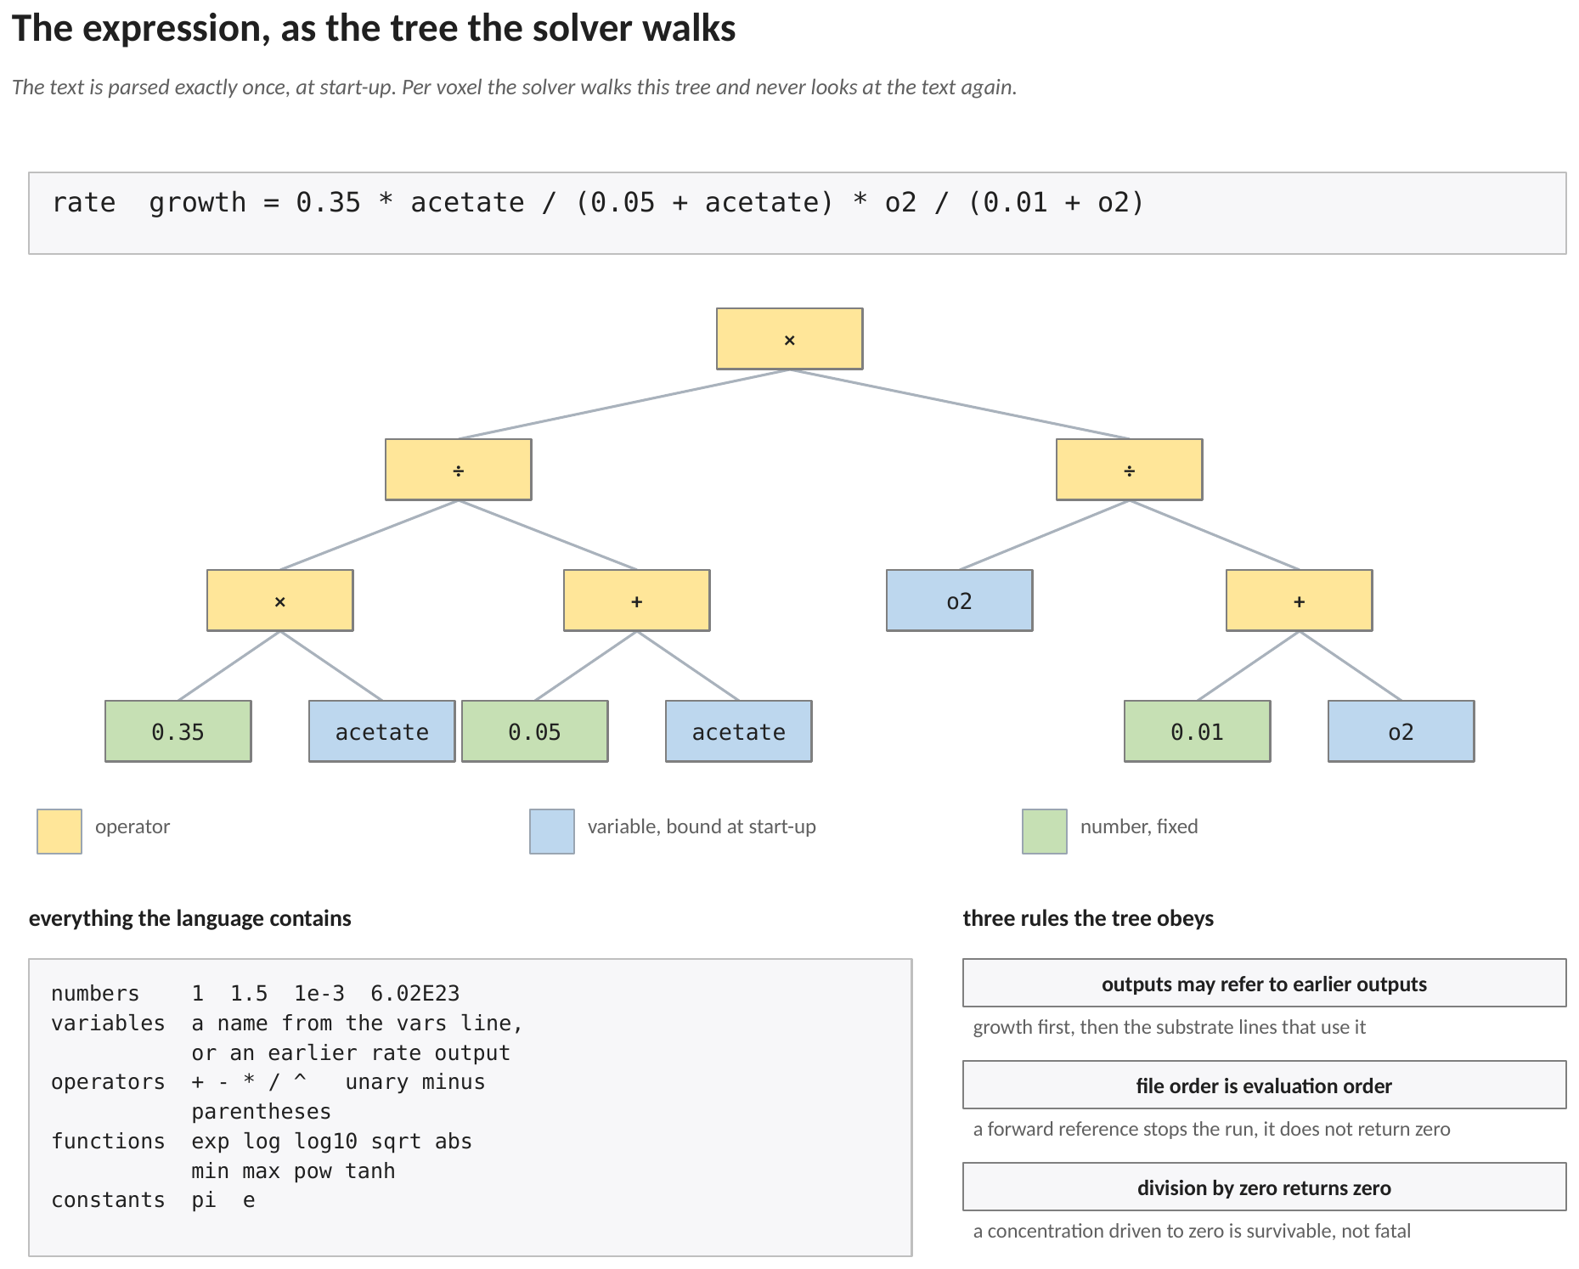
Figure 5. One line of a .sym file, the tree it becomes, the whole of the expression language, and the three rules the tree obeys. Operators are drawn in one shade, variables bound at start-up in another, and fixed numbers in a third. The text is parsed exactly once, at start-up; per voxel the solver walks this tree and never looks at the text again.
5.1 The language
The expression language is deliberately small.

numbers 1 1.5 1e-3 6.02E23
variables any name from the vars line, or an earlier rate output
operators + - * / ^ unary minus parentheses
functions exp log log10 sqrt abs min max pow tanh
constants pi e

Precedence is the usual one: the caret binds tighter than multiplication and division, which bind tighter than addition and subtraction. The caret is right associative, so 2^3^2 is 2^(3^2). Division by zero returns zero rather than an infinity, because a rate law that divides by a concentration the transport solver has driven to zero is a situation the run has to survive rather than a reason to stop.
5.2 Evaluation order, and why a forward reference stops the run
Expressions may refer to outputs defined earlier in the file. In the shipped example the growth rate is defined first and then used on the acetate and oxygen lines, which is how a stoichiometric ratio gets written as one line rather than as a repeated formula. Expressions are evaluated in file order, and a reference to a rate defined later is a hard error at start-up rather than a silent zero.
One detail matters for the units. A chained expression sees the unscaled value of the rate it refers to. The unit scale of Section 6.3 is applied only on the way out, so a line that reads as a pure stoichiometric ratio stays one whichever unit the file declares.
6. The equations
6.1 What is handed in, and the clamp
Each variable named on the vars line is bound at start-up to a lattice: a substrate concentration or a biomass density. Per voxel their current values are gathered, and any variable that carries a range line is clamped to it before the tree is walked:
x_{j} = min( max( C_{j} , lo_{j} ) , hi_{j} ) (1)
where C_{j} the current value of variable j in this voxel; lo_{j}, hi_{j} the low and high end of that variable's range line; x_{j} the value the expression actually sees.
A variable with no range line is not clamped. That is the right default for something like a biomass density, which has no meaningful upper bound and was not a fitted input in the first place.
6.2 The expressions, evaluated in file order
Each rate line is one output. Walking its tree gives
y_{r} = E_{r} ( x₁ ... x_{n} , y₁ ... y_{r−1} ) (2)
where E_{r} the parsed tree of rate line r; y_{r} its value, before the unit scale of equation (3) is applied. The second argument list is what makes a chained expression legal.
Two numerical guards sit on the result. A value that comes back as not-a-number is replaced by zero, and a value larger than 10³⁰⁰ in magnitude is clipped to that magnitude. Both exist so that one pathological voxel cannot poison a whole lattice.
6.3 Units
CompLaB3D works in mol per litre per second, and a growth rate per second, because that is what defineKinetics.hh uses. A formula fitted to flux balance output almost always comes out per hour, because that is the convention metabolic models use. The units line converts:
R_{r} = s_{u} · y_{r} , s_{u} = 1 for units per_second, 1 / 3600 for units per_hour (3)
Getting this wrong is a factor of 3600, which is large enough to look like a modelling result rather than a mistake, so the loaded setting is printed in the log either way.
6.4 Into the transport step
From here the chain is shared with every other rate path. Each output is either a substrate rate or the reserved word growth. The substrate outputs are accumulated over every organism present in the voxel and then applied against what the voxel actually holds; the growth output multiplies that organism's biomass:
ΔC_{k} = max ( Σ_{m} R_{k,m} F_{T,m} Δt , −C_{k} ) (4)
ΔB_{m} = R_{growth,m} F_{T,m} B_{m} Δt (5)
where m an index over the organisms sharing this voxel; B_{m} that organism's biomass density in this voxel; F_{T,m} the thermodynamic factor of the gate described in Method 5, which is exactly one when the gate is off; Δt the reaction time step.
The outer maximum in equation (4) is the substrate budget, and it is applied once for the voxel rather than once per organism, so a symbolic organism and a surrogate organism sharing a voxel obey the same rule. The biomass increment is floored at the biomass present, so a decay term cannot drive a density negative.
7. A worked example: one voxel, step by step
Everything in Sections 5 and 6 on a single voxel, with every number written out.
7.1 Where every number in this example comes from
This comes before any arithmetic, because it is the part that is easiest to lose. Some of the numbers below are the modeller's choice and sit in the rate file; the rest are the state of the simulation at that instant, and those are the only ones that change from voxel to voxel.
the number | what it is | where it comes from
0.35 | the highest growth rate the organism reaches | the symbolic regression fit; it is written on the growth line of the .sym file
0.05 | the acetate half-saturation constant, mol L⁻¹ | the same fit, the same line
0.01 | the oxygen half-saturation constant, mol L⁻¹ | the same fit, the same line
−2.5 | moles of acetate used per mole of biomass made | the reaction, written by hand. The organism makes 0.4 mol of biomass per mol of acetate, and 1 / 0.4 = 2.5
−5.0 | moles of oxygen used per mole of biomass made | the reaction again: two oxygen per acetate, so 2 × 2.5
1×10⁻⁶ to 5.0×10⁻³ | the acetate concentrations the fit was shown | the range line, written when the .sym file was made
1×10⁻⁶ to 2.0×10⁻³ | the oxygen concentrations the fit was shown | the other range line
per_hour | the time unit the formula was fitted in | the units line of the .sym file
1.2 mM | the acetate in this voxel right now | the transport solver, one step earlier
0.6 mM | the oxygen in this voxel right now | the transport solver, one step earlier
2.0×10⁻⁵ | the biomass in this voxel, mol L⁻¹ | the biomass lattice, where the biofilm automaton left it
0.5 s | how long this reaction step lasts | the run's configuration

The first three numbers are what the fitting procedure produced. The next two were written from the reaction by hand. The two ranges say over what water the formula is entitled to be believed. Everything after that is the simulation, and changes from voxel to voxel and from step to step.
7.2 Step 1, equation (1): keep the inputs inside the fitted range
Before the formula is touched, each concentration is compared with the range the fit was shown. If it falls outside, it is pulled back to the nearest end. Here both sit comfortably inside, so nothing changes and nothing is counted:
acetate: 1×10⁻⁶ < 1.2×10⁻³ < 5.0×10⁻³ left as it is
oxygen: 1×10⁻⁶ < 6.0×10⁻⁴ < 2.0×10⁻³ left as it is
Biomass has no range line, so it is used as it stands. That is the right default: a biomass density has no upper bound the fit could have been shown.
7.3 Step 2, equation (2): work the formula out, innermost bracket first
The growth line is evaluated first, because it comes first in the file. It is a dual Monod expression, so it is worked exactly as one: two saturation terms, multiplied together, times the maximum rate.

the acetate saturation term
0.05 is the acetate half-saturation constant, from the growth line of growth.sym
0.0012 is the acetate in this voxel, from the transport solver
bottom of the fraction 0.05 + 0.0012 = 0.0512
the fraction 0.0012 / 0.0512 = 0.023437

the oxygen saturation term
0.01 is the oxygen half-saturation constant, from the same line of growth.sym
0.0006 is the oxygen in this voxel, from the transport solver
bottom of the fraction 0.01 + 0.0006 = 0.0106
the fraction 0.0006 / 0.0106 = 0.056604

the two, times the maximum rate
0.35 is that maximum rate, the leading coefficient of the growth line
0.35 x 0.023437 x 0.056604 = 4.6433e-4 per hour

Both saturation terms are small, 0.023 and 0.057, because the half-saturation constants the fit produced are far larger than the concentrations this voxel holds. The organism is running at about one tenth of one per cent of its maximum, which is what starvation looks like in a Monod law.
The two substrate lines are evaluated next, and both re-use the growth number just computed. That is why the growth line has to come first: an output can be used by a later line but not by an earlier one.
acetate: −2.5 × 4.6433×10⁻⁴ × 2.0×10⁻⁵ = −2.3216×10⁻⁸ mol L⁻¹ h⁻¹
oxygen: −5.0 × 4.6433×10⁻⁴ × 2.0×10⁻⁵ = −4.6433×10⁻⁸ mol L⁻¹ h⁻¹
The oxygen number is exactly twice the acetate number. It has to be, because the two coefficients were written from the reaction rather than fitted separately. That ratio holds in every voxel of the domain, whatever the growth line returns.
7.4 Step 3, equation (3): put the rates in the solver's time unit
The formula was fitted per hour, and CompLaB3D advances the transport step in seconds, so all three numbers are divided by 3600 on their way out:
growth: 4.6433×10⁻⁴ / 3600 = 1.2898×10⁻⁷ s⁻¹
acetate: −2.3216×10⁻⁸ / 3600 = −6.4490×10⁻¹² mol L⁻¹ s⁻¹
oxygen: −4.6433×10⁻⁸ / 3600 = −1.2898×10⁻¹¹ mol L⁻¹ s⁻¹
This is the one line in the whole path where a mistake is invisible. Leave the units line out and all three numbers come out 3600 times larger; the run still finishes, the fields still look smooth, and the reaction is three orders of magnitude too fast.
7.5 Step 4, equations (4) and (5): the change in this voxel over this step
A rate becomes a concentration change by multiplying by the length of the step. One organism sits in this voxel and the thermodynamic gate of Method 5 is switched off, so the factor is one and there is nothing to sum over:
acetate drawn = −6.4490×10⁻¹² × 1 × 0.5 s = −3.2245×10⁻¹² mol L⁻¹
That draw is then checked against what the voxel actually holds. The voxel has 1.2 × 10⁻³ mol L⁻¹ of acetate and the reaction is asking for 3.2 × 10⁻¹² of it, which is about three parts in a billion, so the request goes through unchanged:
ΔC = max ( −3.2245×10⁻¹² , −1.2×10⁻³ ) = −3.2245×10⁻¹²
The second argument only wins in a voxel the reaction has nearly emptied, and it is what stops a concentration going negative however aggressive the fitted formula is.
The biomass grows by the growth rate times the biomass present times the step:
ΔB = 1.2898×10⁻⁷ × 1 × 2.0×10⁻⁵ × 0.5 s = 1.2898×10⁻¹² mol L⁻¹
Those two numbers, one per substrate lattice and one per biomass lattice, are the whole output of the rate path for this voxel at this step. Transport takes them from here.
7.6 The same file in a voxel where the range does bite
Move to a voxel with the same acetate but 3.0 mM oxygen, which is above the 2.0 mM upper end of the oxygen range line. Step 1 now does something:
oxygen: 6.0×10⁻⁴ replaced by 3.0×10⁻³ , which is above 2.0×10⁻³ , so 2.0×10⁻³ is used
and the growth line is worked at the edge of the range rather than at the true value:

using the clamped value 0.0020 / (0.01 + 0.0020) = 0.166667
growth = 0.35 x 0.023437 x 0.166667 = 1.3672e-3 per hour

using the true value 0.0030 / (0.01 + 0.0030) = 0.230769
growth = 0.35 x 0.023437 x 0.230769 = 1.8930e-3 per hour

The two answers differ by a factor of 1.38. The clamped one is the one the solver uses, and that is the right choice: the fitting procedure was never shown a voxel with 3.0 mM oxygen, so 1.8930 × 10⁻³ is an extrapolation and not a result. The evaluation is counted, and at the end of the run the log reports how many evaluations were clamped and what percentage that was, so a reader can judge how much of the domain sat outside the fit.
8. The rate file, line by line
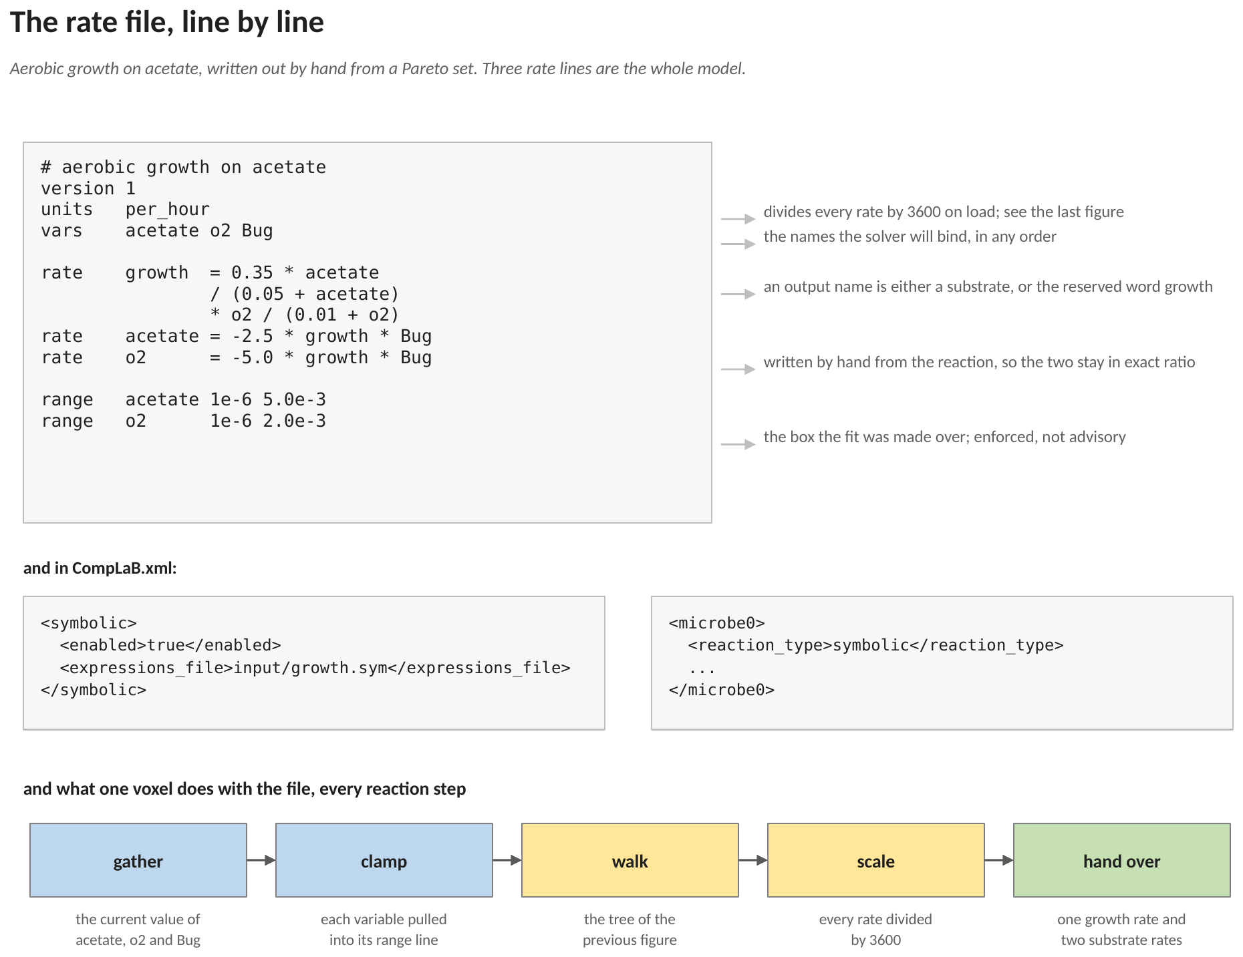
Figure 6. The rate file shipped with example 17, annotated line by line, the two lines it needs in the configuration, and what one voxel does with it at every reaction step. Growth is the fitted line; the two substrate lines are written from the reaction, which is what keeps them in exact stoichiometric ratio.
Every line above is either a declaration or a rate. The declarations name the version, the units and the variables the solver will bind. The rate lines name an output and give an expression. The range lines at the bottom are the box the fit was made over, and Section 8 explains why they are enforced rather than printed.
The names on the vars line are matched against <name_of_substrates> by name, not by position. A file written against a different ordering is refused at start-up rather than bound to the wrong lattice.
9. Two guard rails, both of them enforced
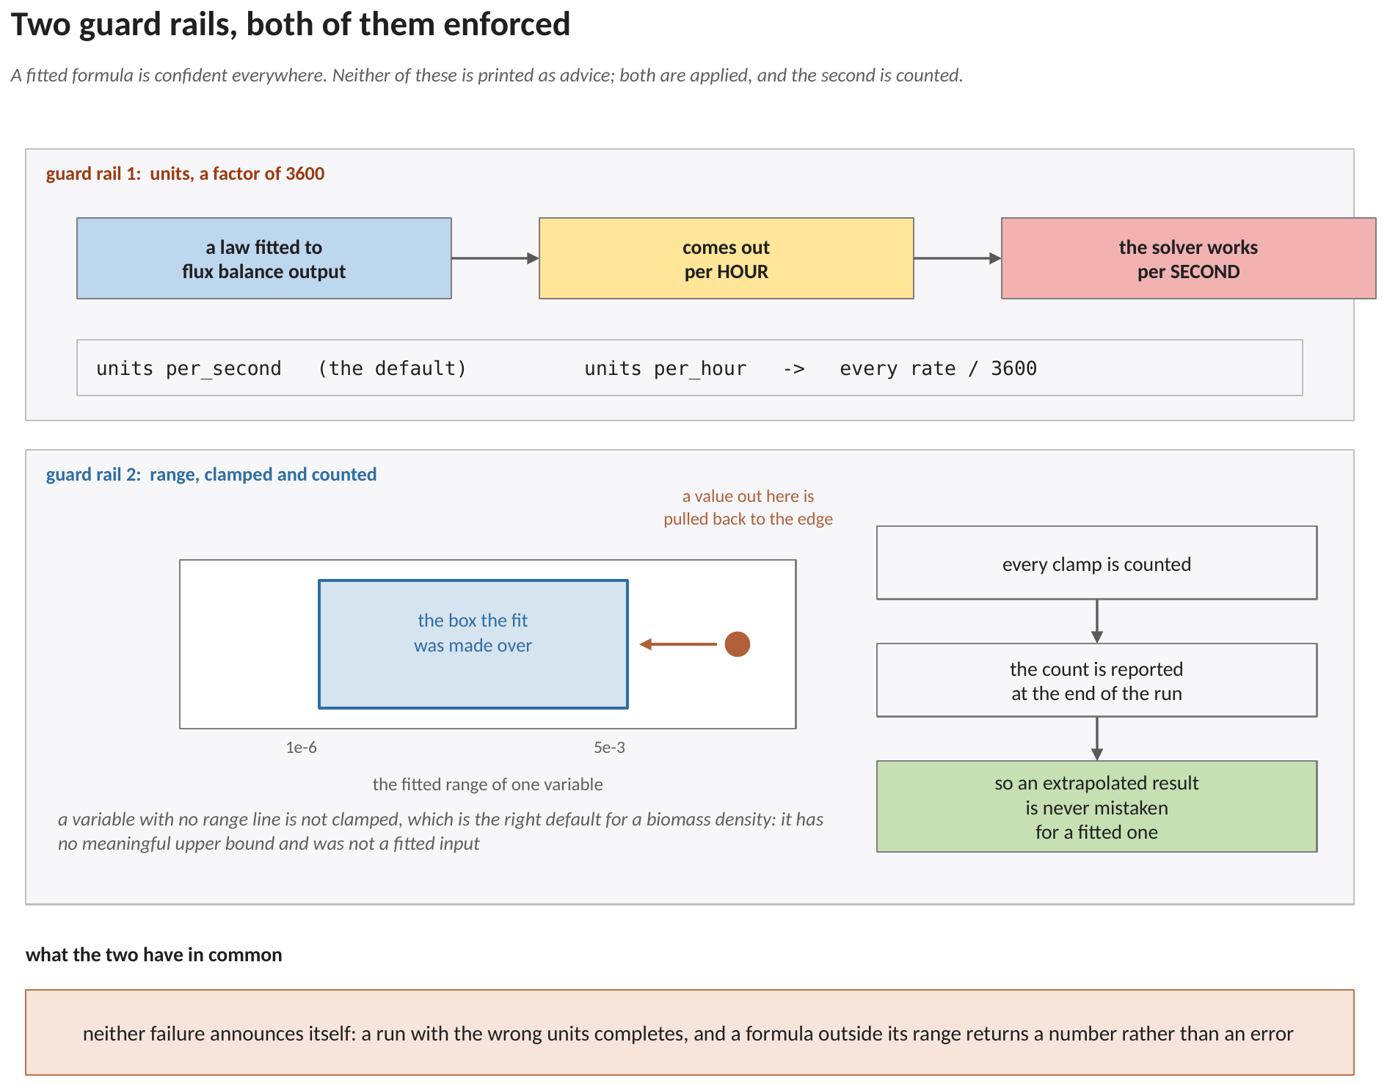
Figure 7. The two ways this path fails silently, and what stops each. Above: a law fitted to flux balance output is per hour and the solver works per second, so the units line divides by 3600 on load. Below: a value arriving from outside the box the fit was made over is pulled back to the edge, the clamp is counted, and the count is reported at the end of the run.
9.1 Units
A factor of 3600 does not announce itself. A run with the wrong units setting completes, produces smooth fields, and gives a reaction rate three orders of magnitude away from the one intended. The default is per_second because that is what defineKinetics.hh uses and a .sym file most often replaces a hand-written law rather than a metabolic model. The loaded setting is printed in the log so the number in a paper carries the convention that produced it.
9.2 Range
A formula fitted between 0.1 and 10 mM is no more valid at 50 mM than a neural network is. Every evaluation is clamped to the box of equation (1) and every clamp is counted; the end of the run reports how often it happened and says so plainly when it happened often. An extrapolated result is therefore never mistaken for a fitted one.
The counter counts evaluations, not variables. Counting once per clamped variable made a two-variable law report up to two hundred per cent of its evaluations as out of range, which is not merely untidy: that percentage is the number a reader uses to decide whether a result is usable, and a value above one hundred makes it unreadable.
10. Running it
10.1 What to put in CompLaB.xml

<symbolic>
<enabled>true</enabled>
<expressions_file>input/growth.sym</expressions_file>
</symbolic>

<microbe0>
<reaction_type>symbolic</reaction_type>
...
</microbe0>

Two lines carry the whole configuration. Everything else about the rate law, including its units and its domain of validity, lives in the file.
10.2 What the log reports
At start-up the log echoes the file, its units setting, and the range of every variable that carries one. At the end of the run it reports the number of expression evaluations and the number and percentage that clamped. Those two numbers are what a reader needs in order to judge whether the run stayed inside the fit.
11. What this path does that the fitted paths do not
Two differences are worth stating, because both change what can be modelled rather than how accurately.
The first is excretion. The COBRApy and surrogate paths end their substrate budget by discarding any net release, so an organism on those paths can consume but cannot excrete. A symbolic law that produces a product has to be able to write it, so the clamp in equation (4) is one-sided in the other direction only: uptake is limited by what the voxel actually holds, and production passes through untouched.
The second is the biomass conversion. There is no biomass molar mass in this path and no conversion through the flux-to-concentration chain the flux balance paths use, because a symbolic rate law is not posed per gram dry weight. What the file says is what the transport step receives.
12. References
Cranmer, M.: Interpretable machine learning for science with PySR and SymbolicRegression.jl. arXiv:2305.01582 (2023). https://doi.org/10.48550/arXiv.2305.01582
Brunton, S. L., Proctor, J. L., Kutz, J. N.: Discovering governing equations from data by sparse identification of nonlinear dynamical systems. Proceedings of the National Academy of Sciences 113, 3932-3937 (2016). https://doi.org/10.1073/pnas.1517384113
Jung, H., Song, H.-S., Meile, C.: CompLaB v1.0: a scalable pore-scale model for flow, biogeochemistry, microbial metabolism, and biofilm dynamics. Geoscientific Model Development 16, 1683-1696 (2023). https://doi.org/10.5194/gmd-16-1683-2023
Song, H.-S., Ahamed, F., Lee, J.-Y., Henry, C. S., Edirisinghe, J. N., Nelson, W. C., Chen, X., Moulton, J. D., Scheibe, T. D.: Coupling flux balance analysis with reactive transport modeling through machine learning for rapid and stable simulation of microbial metabolic switching. Scientific Reports 15, 6042 (2025). https://doi.org/10.1038/s41598-025-89997-9

