Rate Path 4: The Graph Network
the stoichiometric matrix supplied as structure, so the fit does not have to discover it
1. What this path is
The surrogate of Rate Path 2 fits one number, the growth rate, from a handful of uptake bounds. That is the right shape when the objective of the linear program is all the simulation needs, and it is why the surrogate leaves the species rates untouched.
This is the other case. When the rate of every species is needed, the output is a vector rather than a single number, and the entries of that vector are not independent: they are tied together by the stoichiometry. A dense network given four inputs and four outputs has to learn those ties from data. They are information you already have, written down, and exact.
This path supplies them as structure. The stoichiometric matrix becomes the wiring of a graph, and the fitted part of the model rides on that wiring rather than replacing it. Fewer weights are fitted, less data is needed to fit them, and the model cannot invent a coupling the chemistry does not contain.
2. Where it sits in the time step
One time step of CompLaB3D runs flow, transport, reaction and update in that order. The rate path is the reaction step. This path is the symbolic path with the evaluator swapped, so the lattice layout, the biomass gathering, the substrate budget and the deposit are the same code.
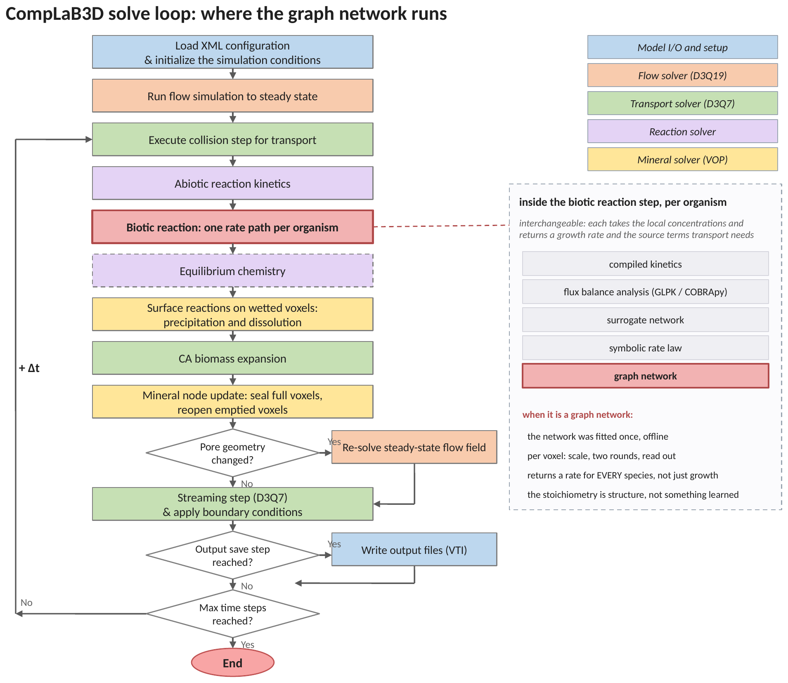
Figure 1. The solve loop, with the graph network marked. The network was fitted once, offline. Per voxel the concentrations are scaled, two rounds of message passing are run, and the rates are read out. Unlike the surrogate, this path returns a rate for every species and not only a growth rate.
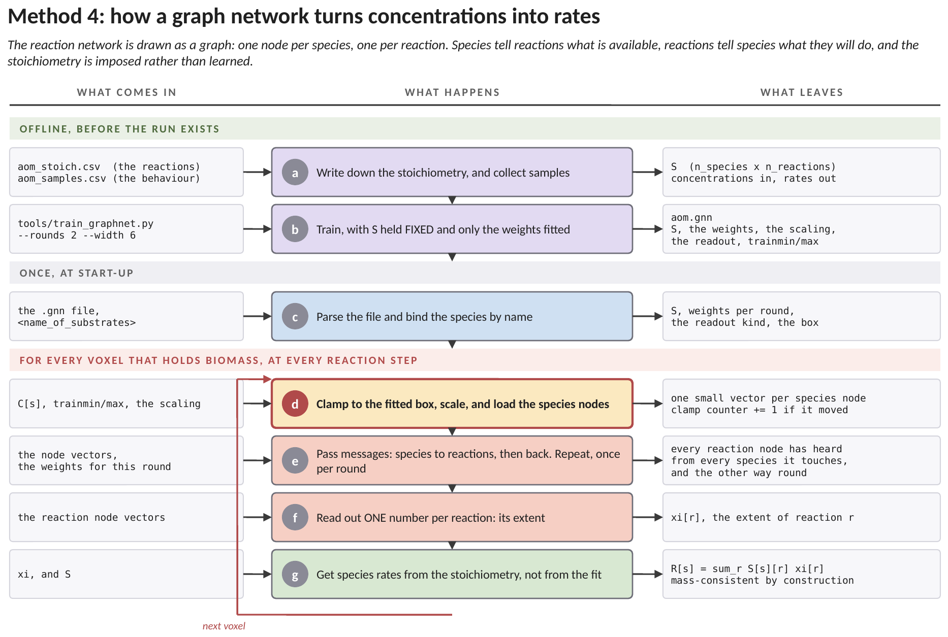
Figure 2. How this method works, end to end, and where each number enters. The green band is the training run, which happens in Python before any simulation exists, the grey band is work the solver does once at start-up, and the red band is the loop that runs in every voxel at every reaction step. Each row names what arrives, what is done to it, and what leaves. (a) Two things are collected: the stoichiometry, meaning how many moles of each species one turnover of each reaction uses or makes, and samples of the behaviour to be reproduced. The stoichiometry is not data to be learned; it is a statement about the chemistry. (b) The network is trained with the stoichiometry held FIXED and only the weights fitted. The fitted numbers, the scaling, the readout choice and the range covered all travel in one file. (c) At start-up the file is parsed and its species are matched to the run's substrates by name. (d) The loop begins. Each concentration is held inside the fitted range and counted if it moved, then scaled and loaded into that species' node. A node is a small vector of numbers attached to one species or one reaction; loading a node means putting this voxel's condition into it. (e) Messages are passed. Every species node tells the reaction nodes it takes part in what is available; every reaction node tells its species what it intends to do. This repeats once per round, so with two rounds a species hears indirectly from species two steps away in the network. (f) One number is read out per reaction: its extent, meaning how far that reaction runs in this voxel at this instant. (g) The species rates are then formed from the extents and the stoichiometry, not from the fit. This is what separates the method from a network that predicts each species separately: because the rates are built as the stoichiometry times the extents, they satisfy the element balance however badly the network was fitted. A poor fit gives a wrong rate, never an unbalanced one.
3. The reaction network, drawn as a graph
Start with the object the network is built on, because it is one you already have. Take the reactions of the case and draw a node for every species and a node for every reaction. Draw an edge wherever a species appears in a reaction, and write that species' stoichiometric coefficient on the edge. No approximation is involved anywhere in that sentence. The graph is the stoichiometric matrix, drawn.
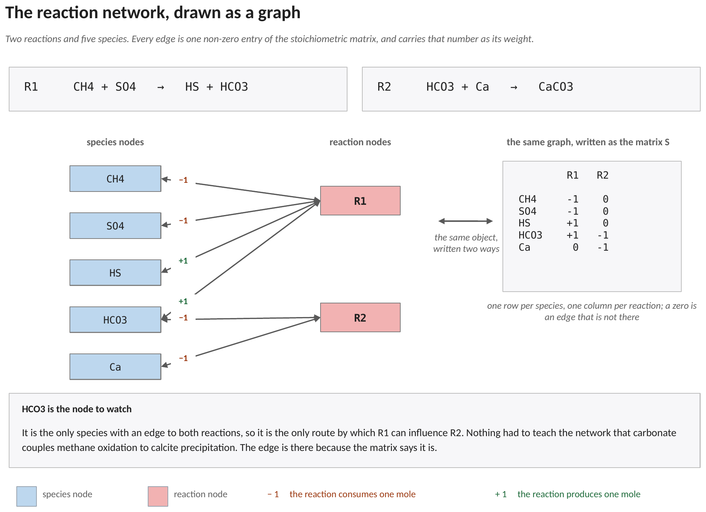
Figure 3. A two-reaction example: anaerobic methane oxidation, and the calcite precipitation its product drives. Left, the graph. Right, the same object as the matrix S, with one row per species and one column per reaction. Bicarbonate is the only species with an edge to both reactions, so it is the only route by which the first reaction can influence the second. Nothing had to teach the network that; the edge is there because the matrix says it is.
Two properties of the drawing carry through into everything below. A species that is not in a reaction has no edge to it, and so can never influence it, at any input, however the network is fitted. And an edge carries a number rather than merely a connection, so a species consumed two moles at a time speaks twice as loudly into that reaction as one consumed a single mole.
 | the surrogate (.srg) | the graph network (.gnn)
what it returns | one number: the growth rate | a rate for every species, and growth
what it is given | the uptake bounds | the concentrations, and the stoichiometric matrix
what it has to learn | one smooth surface | how fast, but not which species couple to which
the ties between outputs | no outputs to tie | given, not learned
checkable against the chemistry | no | yes: a stoichiometric residual
valid where | inside the sampled box, and nowhere else | inside the sampled box, and nowhere else

The last row is the one the two share, and it is the reason Section 8 exists. Supplying the stoichiometry fixes which species talk to which. It does not fix how fast, and how fast is the part still being fitted. A graph network is therefore exactly as range-limited as any other fitted function.
4. How it works
This section is the one to read if graph networks are new. It says what the method does in words first, then in the order the code does it. The equations are Section 5.
4.1 Every node carries a short description of itself
Give every node in the graph a small vector of numbers. In the shipped example it is six numbers long; that length is called the width and it is a setting in the file. Think of it as a short description the node keeps and revises. At the start of an evaluation every species node is given its description from one thing only: its own concentration in this voxel, scaled onto the interval the fit used. It knows nothing yet about any other species.
Reaction nodes start with nothing. Their description is built in the first half of the first round, out of what the species tell them.
4.2 One round: the species speak, then the reactions speak back
In the first half of a round, every reaction node listens. It adds up the descriptions of the species sitting on its edges, each multiplied by that edge's stoichiometric coefficient, adds a number saying how fast transport is relative to reaction, passes the total through a matrix and a smooth squashing function, and keeps the result as its own description. A reaction node now holds a description that depends on every species in it, in the proportions the chemistry uses them.
In the second half, every species node listens. It adds up the descriptions of the reactions it belongs to, again weighted by the coefficient on the edge, keeps a share of its own previous description as well, passes the total through two more matrices and the same squashing function, and replaces its description with the result.
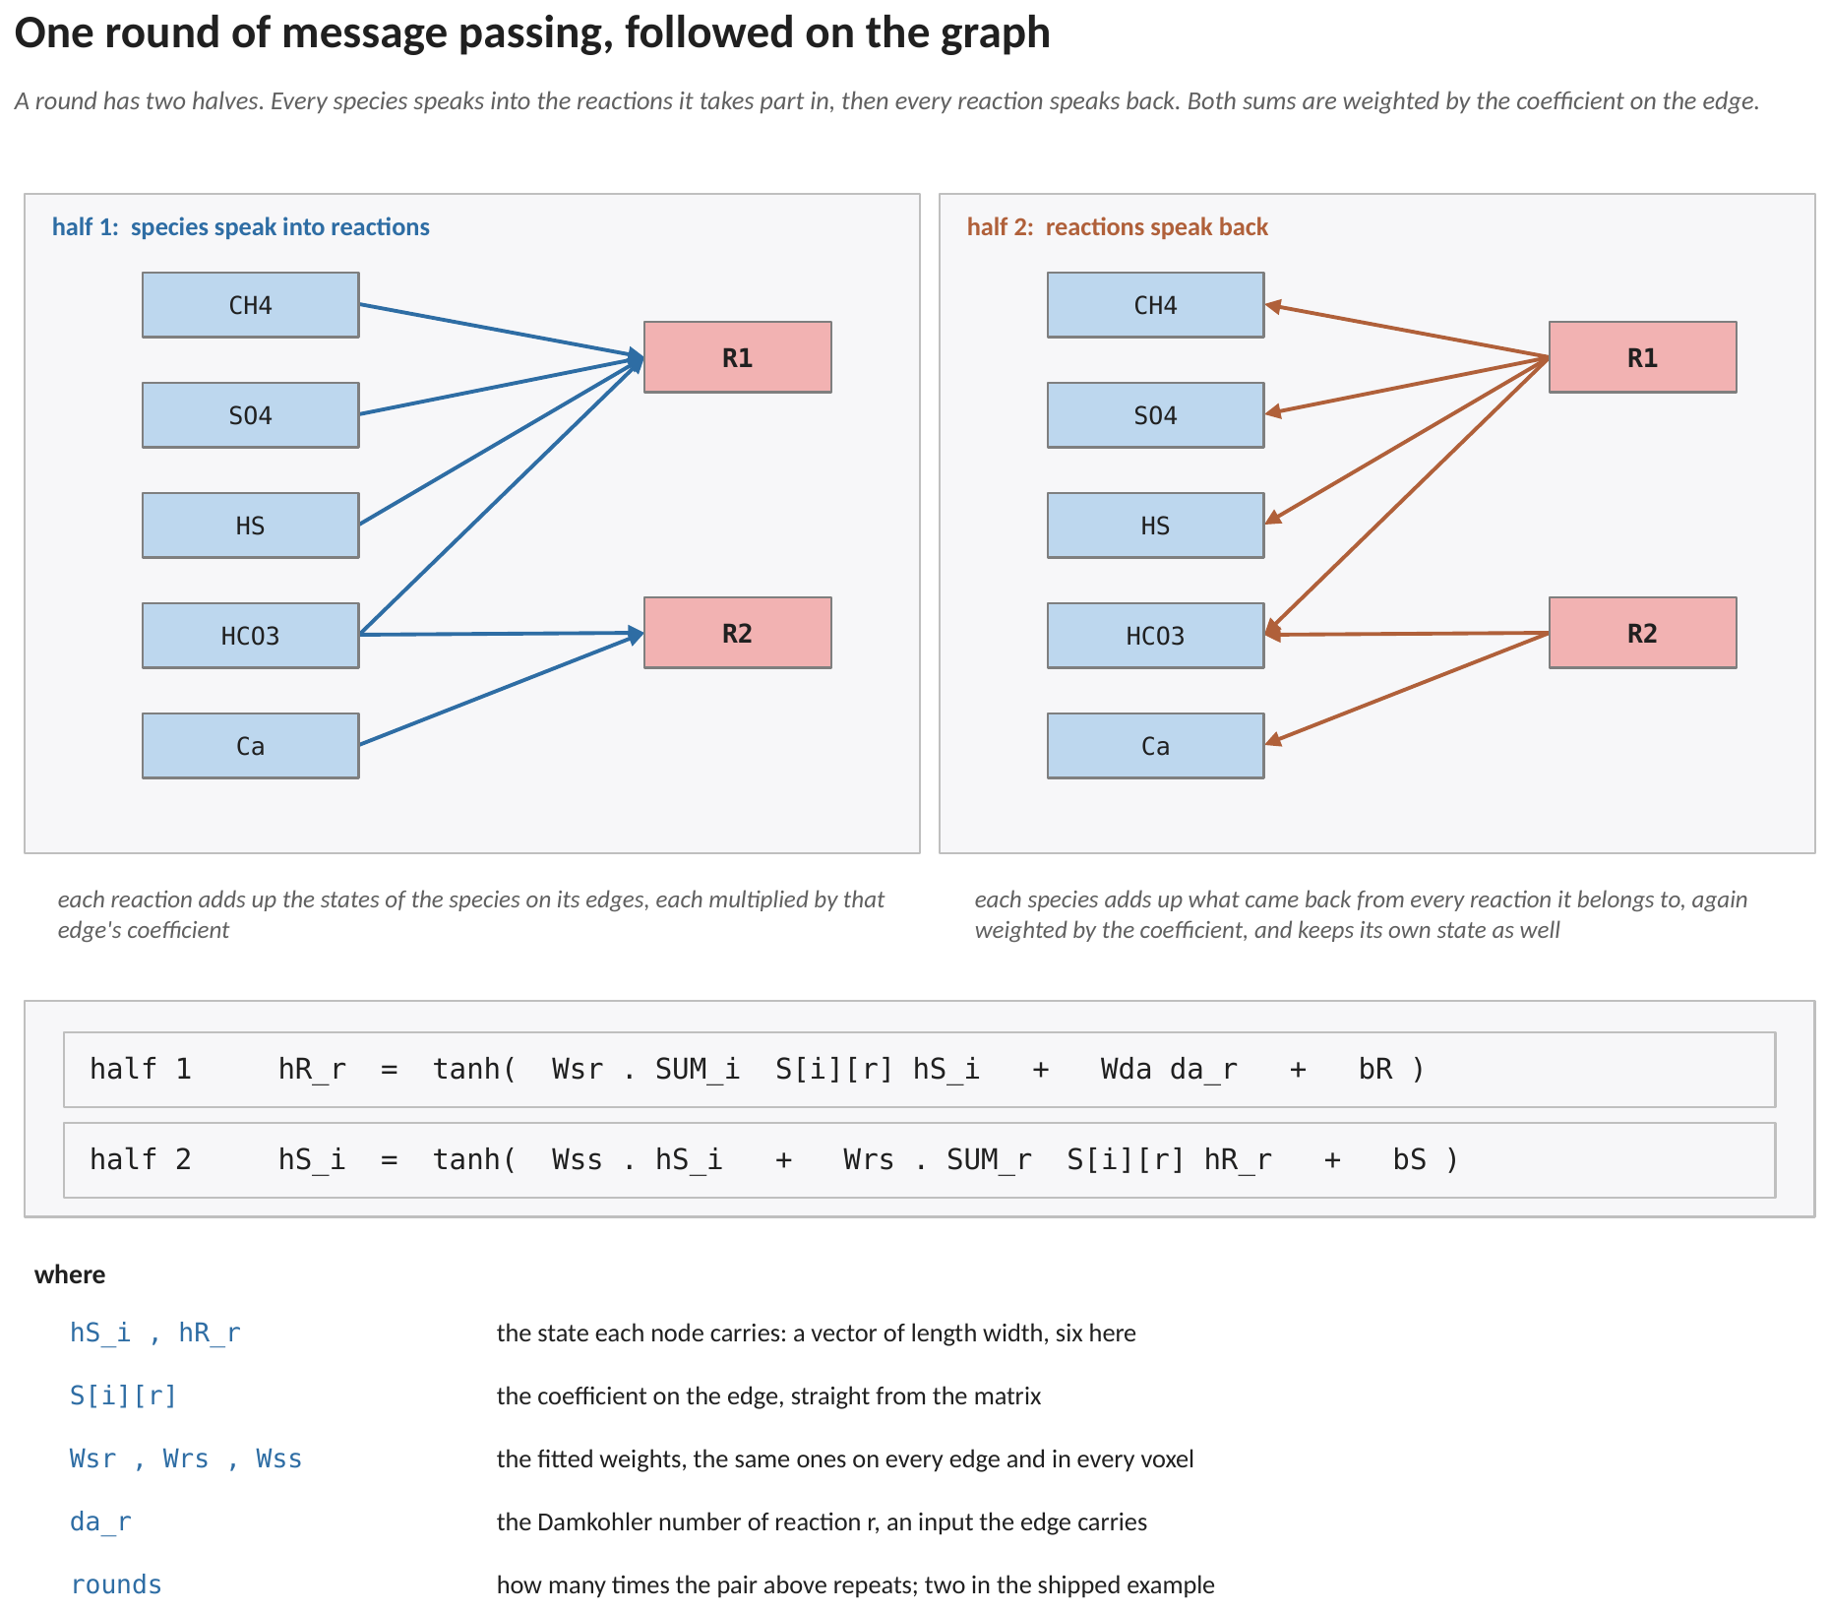
Figure 4. The two halves of one round, drawn on the graph of Figure 3 and written as the two equations they are, with every term named. The arrows are the same edges in both halves; only their direction changes. The shipped example runs two rounds, and each round has its own weight matrices.
The word passing is literal. Nothing is solved, nothing iterates to convergence, and no system of equations is assembled. A round is a fixed sequence of matrix products and one elementwise function, and the number of rounds is a setting in the file rather than something the code decides at run time.
4.3 Why more than one round
After one round a species node has heard from the reactions it belongs to, and those reactions have heard from every species in them. So after one round a species knows about its immediate partners. After two rounds it knows about their partners as well, which for the example of Figure 3 means methane can be influenced by calcium through bicarbonate and the second reaction, even though methane and calcium share no reaction at all.
That is what rounds are for. Each round widens by one step through the graph the neighbourhood a node can be influenced by. Two rounds is what the shipped network uses, because the shipped reaction network is two reactions wide. A larger reaction network may need more.
4.4 Where the fitted numbers actually are
This is the point that makes the method a graph network rather than an ordinary one. The weight matrices of Section 4.2 do not belong to any particular species or to any particular reaction. The same matrices are applied at every node of the graph, and the same ones again in every voxel of the domain. What tells one species apart from another is not a separate set of weights; it is the species' own concentration, its own position in the graph, and the coefficients on its edges.
Two consequences follow. The number of fitted parameters depends on the width and the number of rounds, not on how many species and reactions there are, so a larger reaction network does not need a larger fit. And the network cannot represent a coupling the graph does not contain, because a message can only travel along an edge that exists.
4.5 What one voxel actually does
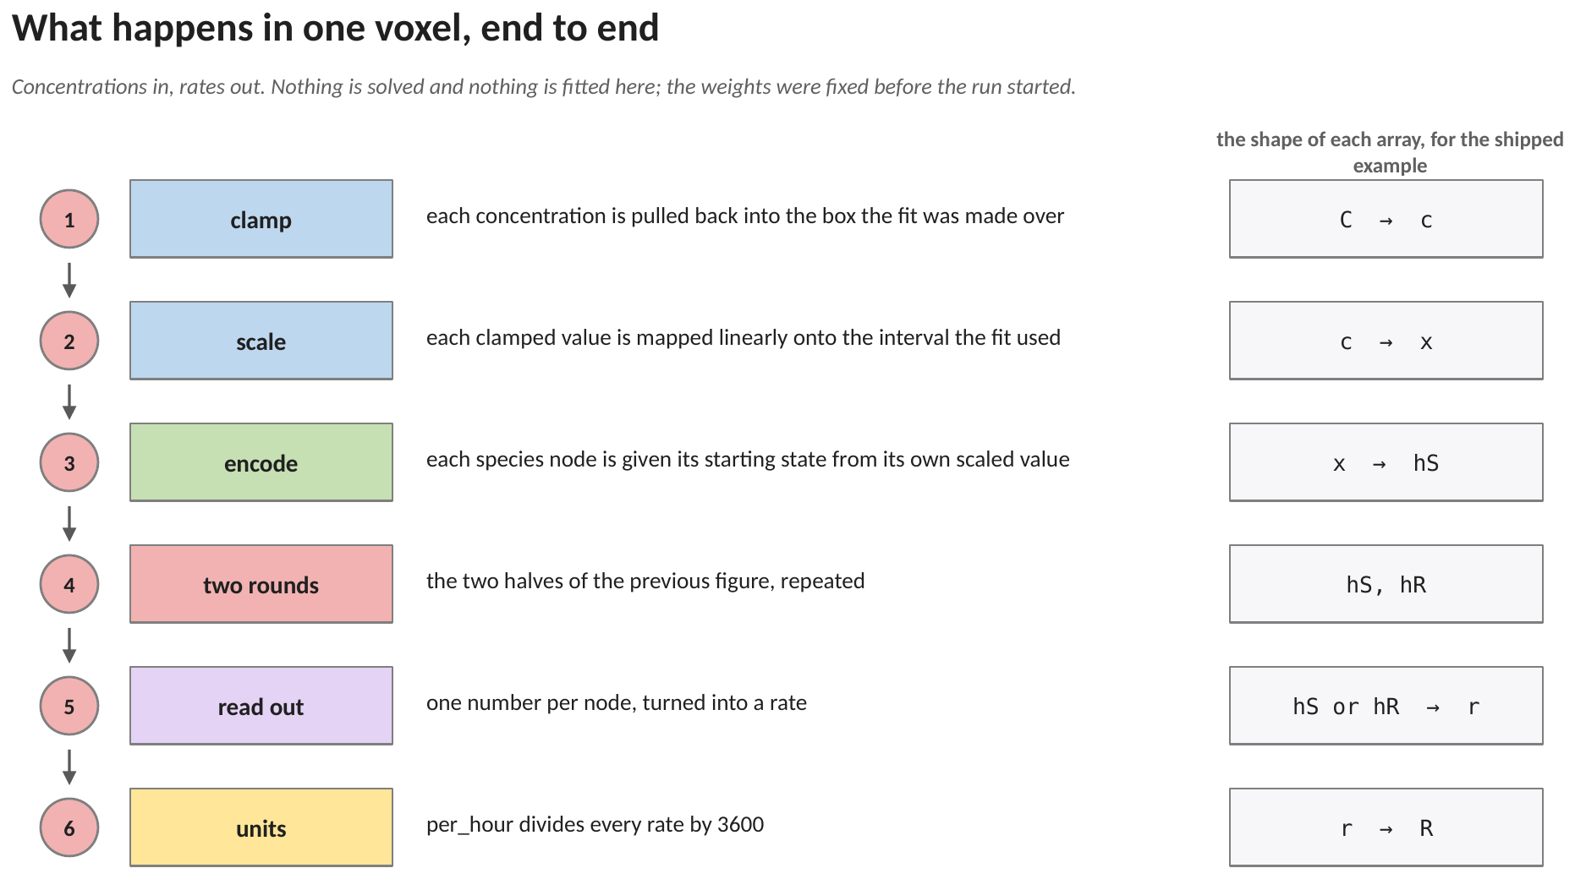
Figure 5. The six steps of one evaluation, with the array each step produces. Steps 1 and 2 are arithmetic on the concentrations, step 3 gives every species node its starting description, step 4 is the two rounds of Figure 4, step 5 turns descriptions into rates, and step 6 puts them in the units the solver works in.
Nothing in that list is fitted at run time and nothing is solved. For the shipped example, five species, two reactions, width six and two rounds, one evaluation is a few hundred multiply-adds. The linear program it stands in for is a simplex solve.
The weights are the same in every voxel: there is one network for the whole domain. What differs from voxel to voxel is the set of concentrations that goes in at step 1, so the rates that come out at step 6 are local even though the model is not.
5. The equations
5.1 The clamp, the scaling and the encoding
Each species node starts from its own concentration in this voxel. That concentration is first clamped to the box the network was fitted over, then mapped linearly onto the interval the fit used, then pushed through a one-column encoder to give the node its starting description:
c_{i} = min( max( C_{i} , trainmin_{i} ) , trainmax_{i} ) (1)
x_{i} = ( c_{i} − xoffset_{i} ) · xgain_{i} + xymin (2)
hS_{i} = tanh ( x_{i} W_{enc} + b_{enc} ) (3)
where C_{i} the concentration of species i in this voxel, mol L⁻¹; xoffset_{i}, xgain_{i} the offset and gain stored in the file for species i; W_{enc}, b_{enc} the encoder, of shape width by one and width by one; hS_{i} the description carried by the species node, of length width.
The encoder has a single column because a species node has a single input. What distinguishes one species from another at this point is only its own scaled concentration; everything else about a species arrives through the edges.
5.2 The two halves of a round
Each round applies its own weight matrices at every node:
hR_{r} = tanh ( W_{sr} Σ_{i} S_{i,r} hS_{i} + W_{da} da_{r} + b_{R} ) (4)
hS_{i} = tanh ( W_{ss} hS_{i} + W_{rs} Σ_{r} S_{i,r} hR_{r} + b_{S} ) (5)
where S_{i,r} the stoichiometric coefficient of species i in reaction r, which is also the weight of that edge; W_{sr}, W_{ss}, W_{rs} square matrices of side width, applied at every node of this round; W_{da} a single column applied to the Damkohler number; da_{r} the Damkohler number of reaction r, an input the edge carries.
The two sums are where the graph enters. Both run over edges, and the coefficient S is both the weight of the edge and the term that makes it vanish when the edge is absent. A species that is not in a reaction contributes nothing to equation (4) for that reaction, and receives nothing back in equation (5).
The Damkohler number is what lets one trained network cover a range of transport regimes rather than a single one. It enters per reaction rather than as another species, so a run in a faster or slower flow field does not need a different network.
5.3 The readout, and the choice that matters
There are two ways to turn the final descriptions into rates, and the difference between them is the most consequential setting in the file.
Species readout. The readout is applied to each species node and gives that species its rate directly:
r_{i} = ( ( w₀ · hS_{i} + b₀ ) − yymin ) / ygain_{i} + yoffset_{i} (6)
The stoichiometric matrix shaped the answer, because it was the weight on every edge of every message. But nothing in the arithmetic of equation (6) forces the returned rates into stoichiometric ratio, and measured on the shipped example they are not: sulfide produced over methane consumed ran between 0.76 and 1.11 where the reaction implies exactly one.
Extent readout. The readout is applied to each reaction node instead, giving one extent per reaction, and the species rates are then formed from the matrix:
ξ_{r} = scale_{r} ( w₀ · hR_{r} + b₀ ) (7)
r_{i} = Σ_{r} S_{i,r} ξ_{r} (8)
where ξ_{r} the extent of reaction r, in the units the file declares; scale_{r} one number per reaction, a pure scale with no offset, because an offset does not commute with the sum in equation (8) and would destroy the exactness the mode exists for.
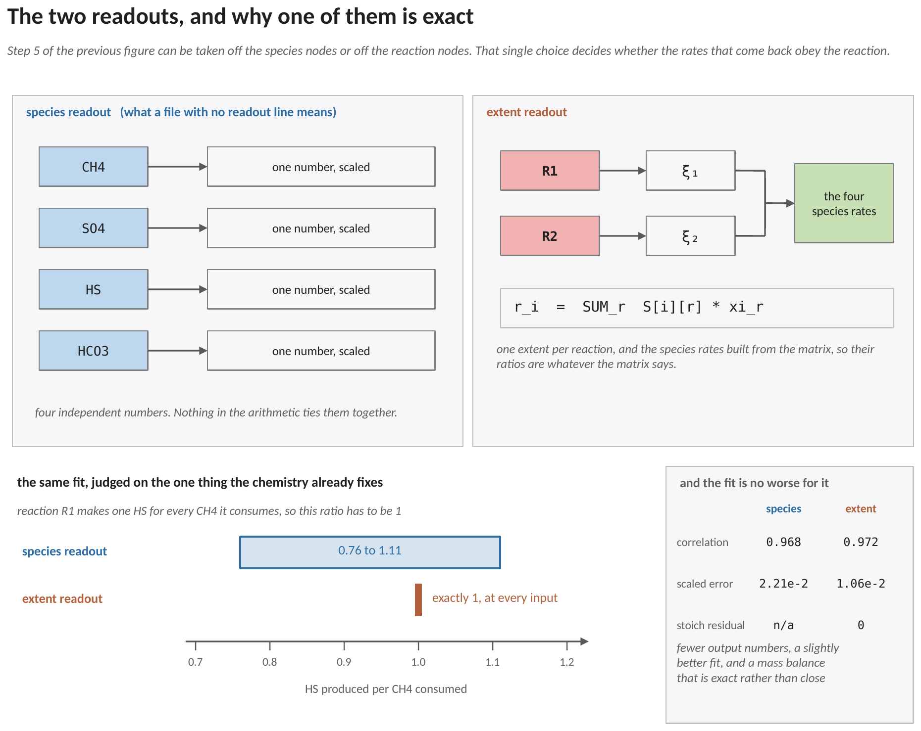
Figure 6. The two readouts drawn side by side, and the single number that separates them. Reaction R1 makes one sulfide for every methane it consumes, so that ratio has to be one. The species readout returns a band; the extent readout returns exactly one at every input, because equation (8) builds the species rates from the matrix rather than fitting them separately. The panel on the right shows that the exactness does not cost accuracy.
Equation (8) is stoichiometrically exact by construction, at every point of the input space including the ones nobody checked. It also uses fewer numbers: one extent per reaction rather than one independently scaled output per species.
What it costs is generality. A rate vector that does not lie in the column space of the matrix cannot be represented at all, which is the point, since such a vector is not a set of reaction rates. The trainer projects the training data onto that space and reports how much of it did not fit, so a data set inconsistent with the declared stoichiometry says so rather than being approximated.
The species readout remains the default only because it is what a file with no readout line means, which keeps older files reading correctly.
5.4 Growth
Growth is read off the mean of the species descriptions rather than off any one node, so it sees the whole graph. It is not a species rate, no stoichiometry constrains it, and it therefore keeps its own offset and gain in both readout modes:
μ = ( ( w₁ · mean_{i} hS_{i} + b₁ ) − yymin ) / ygain_{g} + yoffset_{g} (9)
The readout matrix has one row shared by every species and, when growth is present, a second row for growth. Giving each species its own row would add rows the trainer never touches and would invite a reader to assume row i belongs to species i. It does not.
5.5 Units, and into the transport step
Every returned rate is multiplied by the file's unit scale, which is one for per_second and one over 3600 for per_hour, matching the symbolic path of Method 3. From there the chain is the one shared with every rate path:
ΔC_{k} = max ( Σ_{m} R_{k,m} F_{T,m} Δt , −C_{k} ) (10)
ΔB_{m} = μ_{m} F_{T,m} B_{m} Δt (11)
where m an index over the organisms sharing this voxel; F_{T,m} the thermodynamic factor of Method 5, which is exactly one when the gate is off.
6. A worked example: one voxel, step by step
The shipped network is six numbers wide and runs two rounds, which puts about 150 fitted numbers in the file and makes it impossible to check with a pencil. This example is the same arithmetic on a network small enough to check: three species, one reaction, two numbers per node, one round. Fourteen fitted numbers instead of 150.
The reaction is anaerobic methane oxidation, with the sulfide product kept and the bicarbonate one dropped so the example stays short:

R1 CH4 + SO4 -> HS + ...

the matrix S CH4 -1 SO4 -1 HS +1

6.1 Where every number in this example comes from
This is the part that is easy to lose. Half the numbers below were produced by a fitting procedure and live in the file; the other half are the simulation at that instant.
the number | what it is | where it comes from
−1, −1, +1 | how many moles of each species one turnover of R1 uses or makes | the reaction. Not fitted, not learned, and not adjustable
0.1 to 5.0, 8.0, 2.0 mM | the lowest and highest concentration of each species the fit was shown | the trainmin and trainmax lines of the .gnn file, written when the network was fitted
408.163 etc. | scaling factors that map each species' range onto −1 to +1 | computed from the two lines above; also stored in the file so the range can be recovered from it
Wenc, benc | two numbers each, which turn one scaled concentration into two | the fit. INVENTED HERE so the arithmetic is small. In a real file they are printed to sixteen digits
Wsr, Wda, bR | the weights the reaction node applies to what it hears | the fit. Invented here for the same reason
w0, b0, scale | the numbers that turn a node's two values back into a rate with units | the fit. Invented here
da = 1.0 | the Damkohler number of the reaction: how fast the reaction is relative to transport | supplied when the network was fitted, so one network covers a range of flow conditions
2.0, 4.0, 1.0 mM | the methane, sulfate and sulfide in this voxel right now | the transport solver, one step earlier
0.5 s | how long this reaction step lasts | the run's configuration

The three rows marked as invented are the honest part of this example. Their values do not matter to the argument; what matters is that they are the SAME numbers at every node and in every voxel, which is what Section 4.4 was describing. The last two rows are the only things that differ from voxel to voxel.
6.2 Step 1, equation (1): keep the inputs inside the fitted range
Each concentration is compared with the range the network was fitted over. All three sit inside, so nothing is changed and nothing is counted:

CH4 0.1 mM < 2.0 mM < 5.0 mM left as it is
SO4 0.1 mM < 4.0 mM < 8.0 mM left as it is
HS 0.1 mM < 1.0 mM < 2.0 mM left as it is

Had methane arrived at 6.0 mM it would have been replaced by 5.0, and this evaluation would have been counted as out of range in the end-of-run report.
6.3 Step 2, equation (2): put the three concentrations on one scale
This is the normalisation any regression needs. Methane, sulfate and sulfide span different ranges, and a fitted function works badly on raw values, so each is mapped onto the interval from −1 to +1 using its own range. The scaling factor is 2 divided by the width of that species' range:

CH4 2 / (5.0e-3 - 1.0e-4) = 408.163
SO4 2 / (8.0e-3 - 1.0e-4) = 253.165
HS 2 / (2.0e-3 - 1.0e-4) = 1052.632

Then each concentration has the bottom of its range subtracted, is multiplied by that factor, and has one subtracted so that the bottom of the range lands at −1 and the top at +1:
CH4: ( 2.0×10⁻³ − 1.0×10⁻⁴ ) × 408.163 − 1 = −0.22449
SO4: ( 4.0×10⁻³ − 1.0×10⁻⁴ ) × 253.165 − 1 = −0.01266
HS: ( 1.0×10⁻³ − 1.0×10⁻⁴ ) × 1052.632 − 1 = −0.05263
All three land near the middle of the interval, which is where a fitted function is worth believing. A value sitting at −1 or +1 is on the edge of the box the fit was shown, and anything beyond it was clamped by the previous step.
6.4 Step 3, equation (3): give each species node two numbers instead of one
Each species now has a single scaled value. The next step turns that one number into two, so the node has room to carry more than just its own concentration once the reaction starts talking to it. Two weights and two offsets do the work:

Wenc = [ 0.8 , -0.5 ] benc = [ 0.1 , 0.2 ]

Each of the two values is the scaled concentration times one weight, plus one offset, passed through tanh. The tanh is there only to keep every number between −1 and +1, so that no one node can dominate the sums that follow:
CH4: [ tanh( −0.22449×0.8 + 0.1 ) , tanh( −0.22449×(−0.5) + 0.2 ) ]
= [ tanh( −0.07959 ) , tanh( 0.31224 ) ] = [ −0.07942 , 0.30248 ]
SO4: = [ 0.08963 , 0.20345 ] HS: = [ 0.05783 , 0.22253 ]
At this point no species knows anything about any other. Each of the three pairs is a function of that species' own concentration alone. Calling these numbers a state rather than a concentration is only a naming convention; they carry no units.
6.5 Step 4, equation (4): the reaction adds up what its species tell it
Here the stoichiometry enters, and it enters exactly the way a source term is assembled by hand. The reaction node adds up the three pairs, each multiplied by that species' coefficient in the reaction. Methane and sulfate are consumed, so they carry a minus; sulfide is produced, so it carries a plus:
( −1 )×[ −0.07942 , 0.30248 ] + ( −1 )×[ 0.08963 , 0.20345 ]
+ ( +1 )×[ 0.05783 , 0.22253 ]
= [ 0.04762 , −0.28340 ]
A species with a coefficient of zero would contribute nothing to this sum, which is the formal statement of the point Figure 3 makes: a species not in the reaction cannot influence it, whatever the fit did.
That sum is then combined with the Damkohler number, weighted, offset and squashed, in one line. The weights and offsets are the fitted ones:

Wsr = [ 0.6 -0.3 ] Wda = [ 0.1 ] bR = [ 0.05 ] da = 1.0
[ 0.2 0.7 ] [ -0.2 ] [ -0.10 ]

first value: 0.6×0.04762 − 0.3×(−0.28340) + 0.1×1.0 + 0.05 = 0.26359
second value: 0.2×0.04762 + 0.7×(−0.28340) − 0.2×1.0 − 0.10 = −0.48886
hR = [ tanh( 0.26359 ) , tanh( −0.48886 ) ] = [ 0.25765 , −0.45331 ]
The reaction node now holds two numbers that depend on all three concentrations, in the proportions the reaction uses them. That is the whole content of one half-round.
6.6 Step 5, equations (7) and (8): turn that into rates
Two numbers with no units have to become a rate with units. One weighted sum and one multiplication do it. The three numbers below are fitted, and the last one is what carries the units:

w0 = [ 0.9 , 0.4 ] b0 = 0.05 scale = 1.5e-3 mol/L/h

0.9 × 0.25765 + 0.4 × ( −0.45331 ) + 0.05 = 0.10056
ξ = 1.5×10⁻³ × 0.10056 = 1.5085×10⁻⁴ mol L⁻¹ h⁻¹
That number is the rate of the reaction as written: how many moles of R1 turn over per litre per hour. It is the quantity a reactive-transport modeller would call the reaction rate, and every species rate follows from it and the matrix:
CH4: ( −1 ) × 1.5085×10⁻⁴ = −1.5085×10⁻⁴ mol L⁻¹ h⁻¹
SO4: ( −1 ) × 1.5085×10⁻⁴ = −1.5085×10⁻⁴ mol L⁻¹ h⁻¹
HS: ( +1 ) × 1.5085×10⁻⁴ = +1.5085×10⁻⁴ mol L⁻¹ h⁻¹
This is the ordinary source-term assembly of any reactive-transport model: one rate per reaction, multiplied by the matrix. The only thing the network did was supply the rate. Sulfide made per methane consumed is 1.000000, and sulfate used per methane used is 1.000000, because the matrix says so and nothing else was consulted.
6.7 What the other readout returns instead, on the same voxel
For contrast, finish the round and read the numbers off the species nodes rather than off the reaction node. Each species receives the reaction's two numbers back along the same edge, with the same sign it sent them with, and combines them with what it was already carrying. With the second set of fitted weights,

Wss = [ 0.5 0.1 ] Wrs = [ 0.3 -0.4 ] bS = [ 0.00 ]
[ -0.2 0.6 ] [ 0.5 0.2 ] [ 0.05 ]

the three species end the round carrying

CH4 = [ -0.26184 , 0.20621 ]
SO4 = [ -0.19108 , 0.11546 ]
HS = [ 0.30024 , 0.20708 ]

and equation (6), using the offsets and gains the fit stored for each species separately, turns those into

CH4 = -1.5080e-4 SO4 = -1.2193e-4 HS = +1.6889e-4 mol/L/h

Sulfide made per methane consumed is now 1.120 instead of 1, and sulfate used per methane used is 0.808 instead of 1. Nothing went wrong in the arithmetic. Each species rate was produced by its own scaling, and no step in the chain ever required the three to be in the ratio the reaction demands.
In a run, that discrepancy is mass appearing and disappearing every step in every biomass-bearing voxel. It is exactly what the extent readout removes, at no cost in accuracy, which is why Section 7 recommends it.
6.8 Step 6, equations (10) and (11): the change in this voxel over this step
Take the extent result. The file says per_hour, so every rate is divided by 3600:
CH4: −1.5085×10⁻⁴ / 3600 = −4.1902×10⁻⁸ mol L⁻¹ s⁻¹
One organism, gate off, and a step of 0.5 s. The draw is checked against what the voxel holds, exactly as in the other paths:
methane drawn = −4.1902×10⁻⁸ × 1 × 0.5 s = −2.0951×10⁻⁸ mol L⁻¹
ΔC = max ( −2.0951×10⁻⁸ , −2.0×10⁻³ ) = −2.0951×10⁻⁸
That draw is about one part in a hundred thousand of the methane present, so the check passes it through unchanged. Sulfate is drawn by the same amount and sulfide is added by it, and because all three came from one reaction rate they stay in balance however many steps the run takes.
7. Fitting it offline, and what the file holds
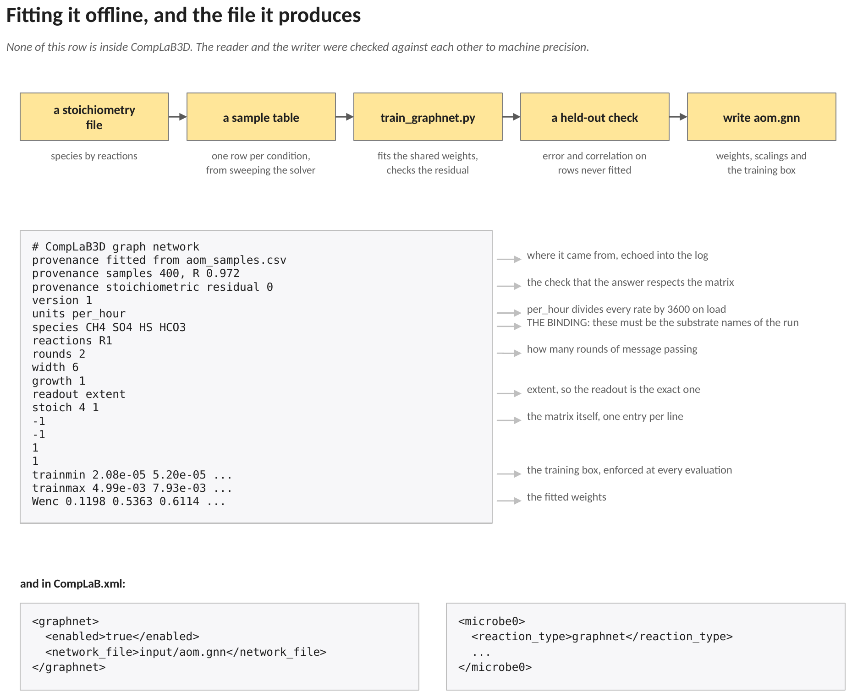
Figure 7. The offline row and the file it produces, annotated line by line, with the two lines the configuration needs. None of the offline row is inside CompLaB3D. The reader and the writer were checked against each other to machine precision, so the format is not a convention anyone has to maintain by hand.
The file is plain text for the same reason the surrogate weights and the symbolic rate laws are: a trained network is a scientific result, and it should be readable, diffable and quotable without a tool. The provenance lines carry where the fit came from, how many samples it used and what error it achieved, and they are echoed into the log so a result carries the network that produced it.
Two fits of the shipped example are worth comparing, because they are the same data and the same architecture with only the readout changed.
 | species readout | extent readout | comment
correlation on the samples | 0.968 | 0.972 | higher is better
scaled mean squared error | 2.21 × 10⁻² | 1.06 × 10⁻² | lower is better
stoichiometric residual | not defined | 0 of the rate norm | exact by construction
sulfide per methane, as returned | 0.76 to 1.11 | exactly 1 | the reaction says 1

The extent readout is not merely tidier here. It fits the data slightly better with fewer output numbers, and it returns a mass balance that is exact rather than approximate.
8. Three guard rails, all of them enforced
All three failures below are silent ones. None of them would stop a run or produce an obviously wrong picture. Each would produce a plausible result that is not the one the chemistry implies, which is why all three are enforced rather than documented as advice.
8.1 The species names are the binding
The file declares its species by name, and the substrates in the configuration carry names of their own. The two are matched by name, not by position. A network fitted against one ordering and applied to a run that uses another stops at start-up naming the offending substrate, rather than silently pairing the wrong column with the wrong species.
8.2 The training box is enforced, not advisory
The trainmin and trainmax lines travel inside the file. Every evaluation is clamped to that box by equation (1), every clamp is counted, and the count is reported at the end of the run. As in Method 3, the counter counts evaluations rather than species: counting once per clamped species made a four-species network able to report four hundred per cent of its evaluations as out of range.
8.3 Units, and the factor of 3600
A network fitted to flux balance output is per hour, because that is the convention metabolic models use; the compiled kinetics convention is per second. Writing per_hour divides every returned rate by 3600 on load. Getting it wrong is a factor of 3600, so the loaded setting is printed in the log.
9. Running it
9.1 Fitting

python tools/train_graphnet.py \
--stoich aom_stoich.csv \
--data aom_samples.csv \
--out aom.gnn \
--width 6 --rounds 2 --epochs 250 --lr 0.03 \
--units per_hour --da 1.0 --readout extent

The stoichiometry file is species by reactions. The sample file is one row per condition, with the concentrations and the rates that were observed or computed there. Dropping --readout extent gives the species readout instead.
9.2 What to put in CompLaB.xml

<graphnet>
<enabled>true</enabled>
<network_file>input/aom.gnn</network_file>
</graphnet>

<microbe0>
<reaction_type>graphnet</reaction_type>
<half_saturation_constants>0 0 0 0</half_saturation_constants>
...
</microbe0>

The half saturation constants are unused on this path and are present only because the block requires them: the network carries its own response to concentration. Everything else about the model, including its units, its readout mode and its domain of validity, lives in the file.
10. References
Battaglia, P. W., Hamrick, J. B., Bapst, V., et al.: Relational inductive biases, deep learning, and graph networks. arXiv:1806.01261 (2018). https://doi.org/10.48550/arXiv.1806.01261
Gilmer, J., Schoenholz, S. S., Riley, P. F., Vinyals, O., Dahl, G. E.: Neural message passing for quantum chemistry. Proceedings of the 34th International Conference on Machine Learning, 1263-1272 (2017).
Jung, H., Song, H.-S., Meile, C.: CompLaB v1.0: a scalable pore-scale model for flow, biogeochemistry, microbial metabolism, and biofilm dynamics. Geoscientific Model Development 16, 1683-1696 (2023). https://doi.org/10.5194/gmd-16-1683-2023
Orth, J. D., Thiele, I., Palsson, B. O.: What is flux balance analysis? Nature Biotechnology 28, 245-248 (2010). https://doi.org/10.1038/nbt.1614
Song, H.-S., Ahamed, F., Lee, J.-Y., Henry, C. S., Edirisinghe, J. N., Nelson, W. C., Chen, X., Moulton, J. D., Scheibe, T. D.: Coupling flux balance analysis with reactive transport modeling through machine learning for rapid and stable simulation of microbial metabolic switching. Scientific Reports 15, 6042 (2025). https://doi.org/10.1038/s41598-025-89997-9

