The Thermodynamic Gate
not a rate path: one factor, computed separately in every biomass-bearing voxel, that multiplies whatever rate a path returned
1. What this is for
Every rate path in CompLaB3D answers the same question: how fast can this organism go, given what is here. None of them asks the other question, which is whether there is enough energy in the reaction, at these local concentrations, for it to run at all.
In a pore-scale domain that second question has a different answer in different voxels. A reaction that is strongly exergonic where the substrate is delivered can be at, or past, its thermodynamic threshold a few voxels further in, once its own products have built up. A Monod law cannot see that. It takes the substrate concentration and returns a positive rate whatever the product concentration is doing. The result is a simulation that keeps a reaction running in a place where no organism could conserve energy from it.
This adds the missing factor. It computes, per voxel, how much energy the reaction actually releases at the local composition, subtracts what the organism must conserve as ATP, and returns a number between zero and one that multiplies the rate the other path produced. Far from the threshold the factor is one and nothing changes. At the threshold it is zero and the reaction stops. Between the two it falls off smoothly.
 | gate off | gate on
what sets the rate | substrate concentrations only | substrates and products together
where the reaction stops | where the substrate runs out | where the energy runs out, which is earlier
what you supply | nothing | one .thm file of cited constants
fitted parameters | none in the gate | none in the gate
cost per voxel per step | nothing | one logarithm and one exponential
which paths it applies to | none | the six biotic paths; the abiotic ones deliberately not

2. Where it sits in the time step
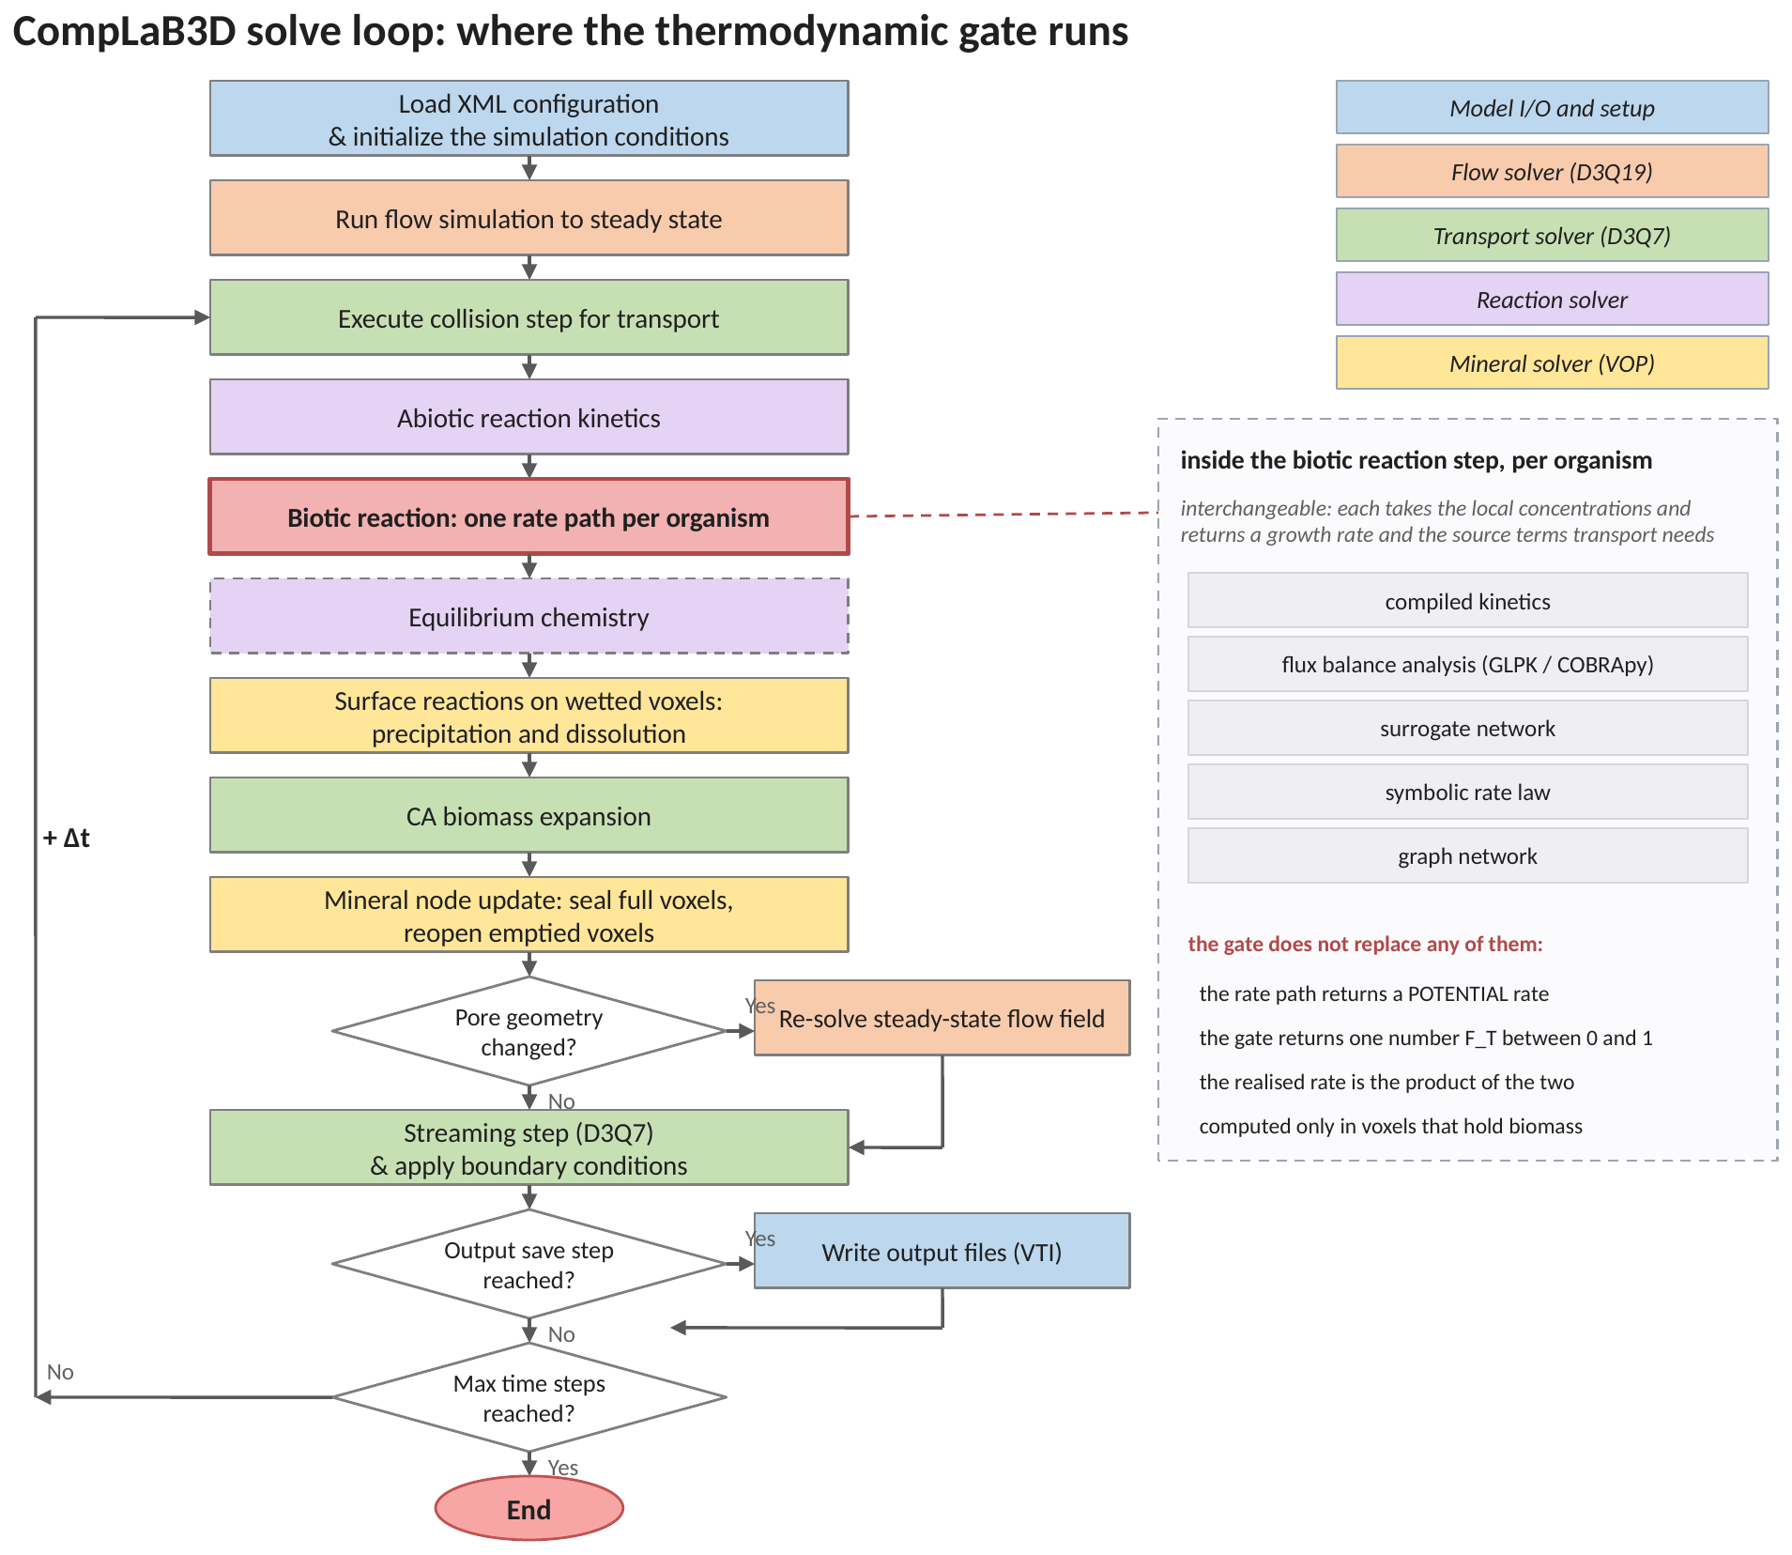
Figure 1. The solve loop, with the gate marked inside the biotic reaction step. The gate does not replace a rate path. It runs after one, on the number that path returned, and only in voxels that hold biomass.
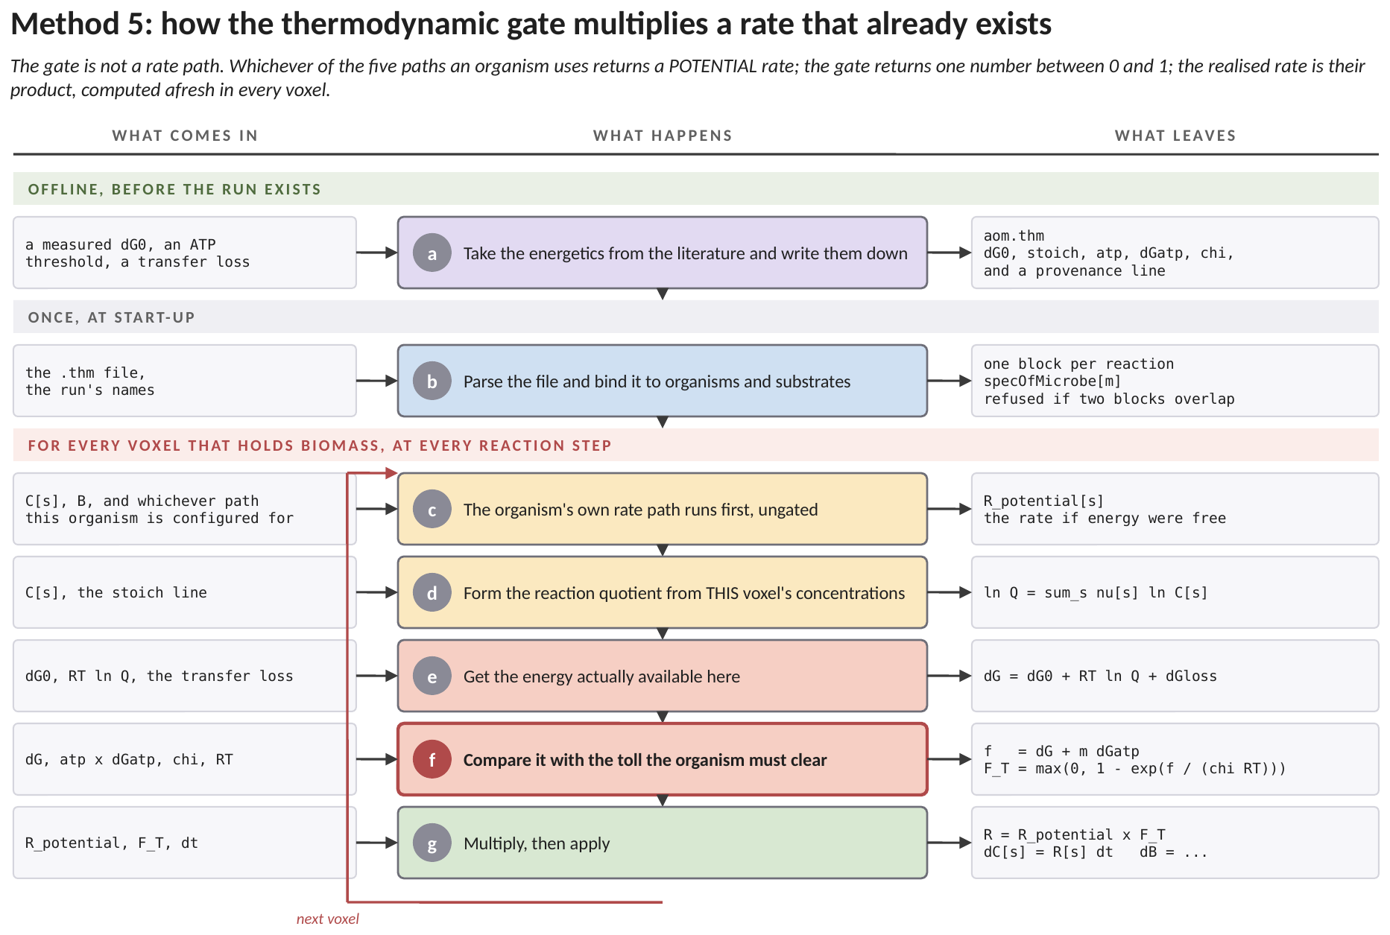
Figure 2. How the gate works, end to end, and where each number enters. The green band is a reading of the literature, the grey band is work the solver does once at start-up, and the red band is the loop that runs in every biomass-bearing voxel at every reaction step. Each row names what arrives, what is done to it, and what leaves. (a) The energetics are taken from published measurements and written into a file: the standard free energy of the reaction, the stoichiometry it belongs to, how much ATP the organism makes per turnover and what one ATP costs in situ. They are scientific claims that get revised and cited, which is why they live in a file a reader can open rather than in a rebuild. (b) At start-up the file is parsed and each block is bound to an organism and to substrates by name. Two blocks that would gate the same organism are refused rather than silently resolved in file order. (c) The loop begins, and the first thing that happens is NOT the gate. Whichever of the rate paths this organism is configured for runs exactly as it would with the gate switched off, and returns a POTENTIAL rate: the rate this voxel would support if energy were free. (d) The reaction quotient is formed from this voxel's own concentrations. It is the product of the concentrations raised to their stoichiometric coefficients, and it is the only place the local chemistry enters the gate. (e) The energy actually available here follows: the standard free energy, plus the correction the quotient makes to it, plus any loss in handing electrons between partners of a consortium. (f) That is compared with the toll the organism has to clear, which is the ATP it makes multiplied by what an ATP costs. The result is F_T, one number between 0 and 1. It is 0 where the reaction cannot pay its way and approaches 1 where energy is abundant. (g) The realised rate is the potential rate multiplied by F_T, and the increments follow from it. F_T is a FIELD, not a setting: one value per voxel per step, discarded and recomputed at the next step, so a voxel whose product has accumulated is throttled while its neighbour, a hundred micrometres away, is not.
3. One gate, every biotic rate path, one multiplication
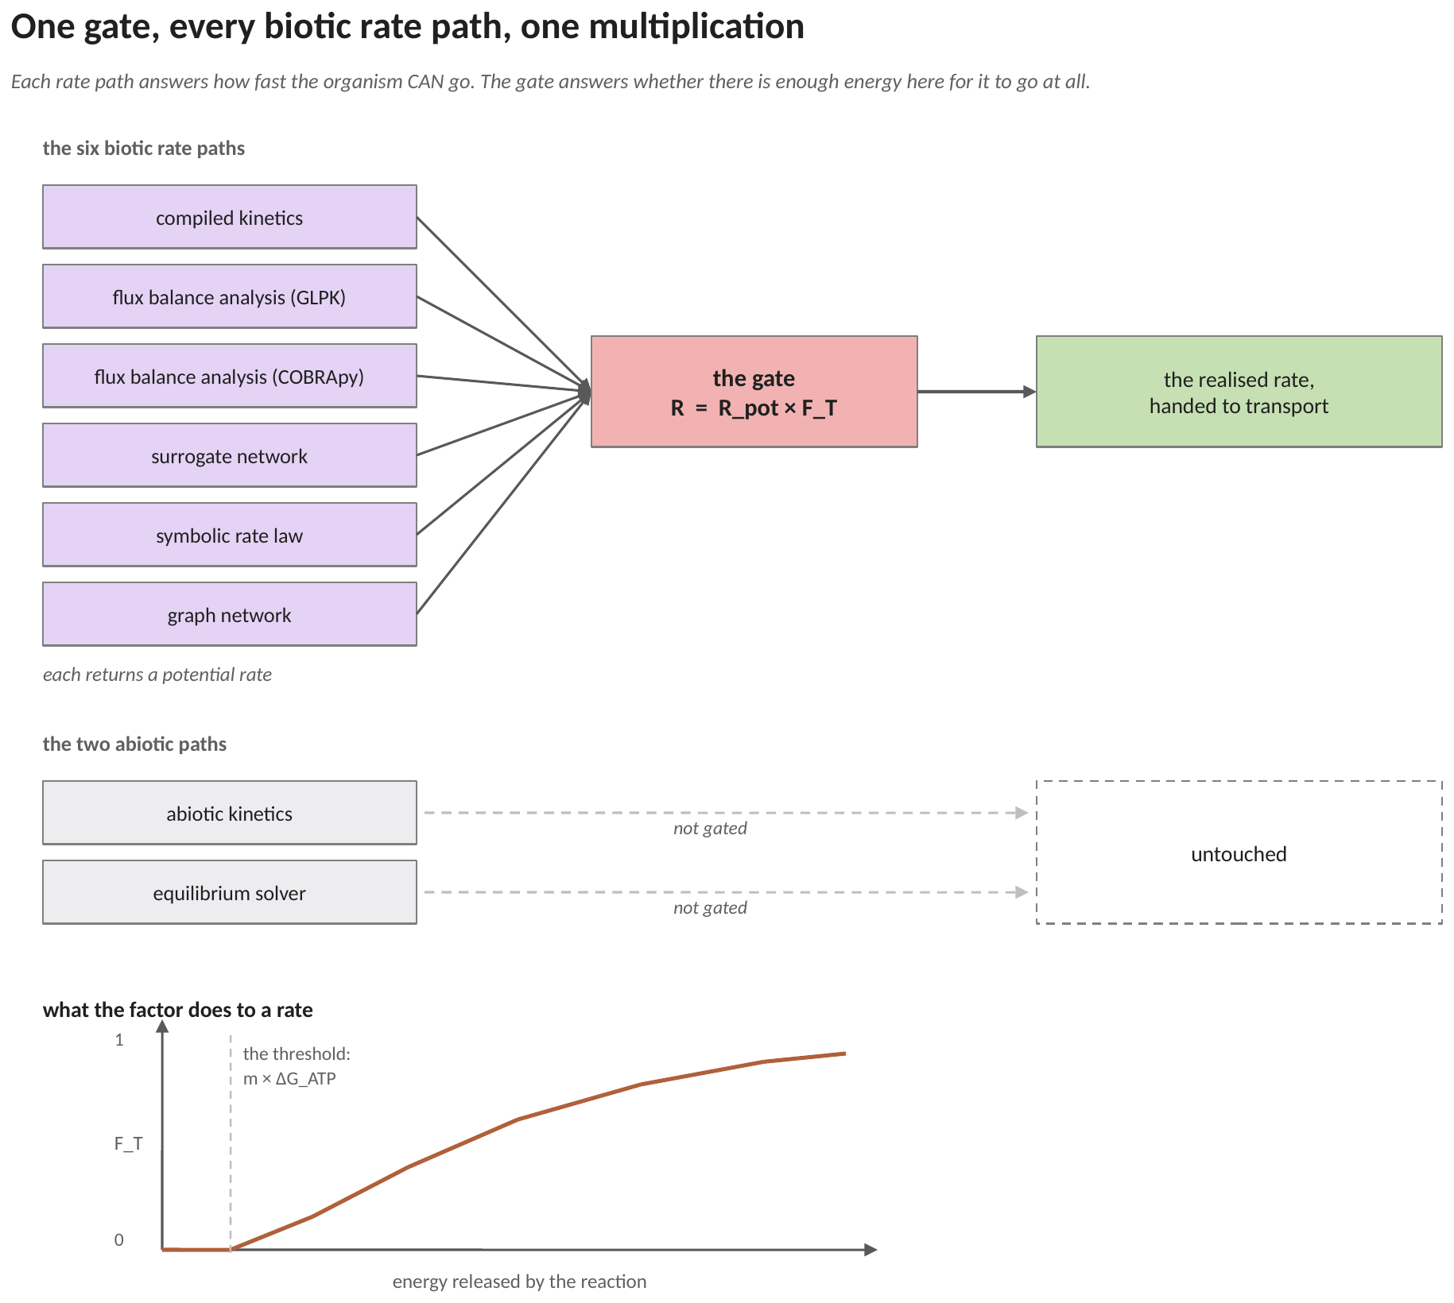
Figure 3. Every biotic rate path returns a potential rate, and the gate turns it into a realised rate by one multiplication. The two abiotic paths pass through untouched. Below, what the factor does to a rate as a function of the energy the reaction releases: one far above the threshold, zero at it, and a smooth fall between.
The gate is applied in exactly one place in each path, on the way from the rate to the increment. Nothing about the rate path itself changes: the same model, the same weights, the same linear program. That is what makes a gate-on and a gate-off run a controlled comparison rather than two different models.
3.1 Why the abiotic paths are left alone
An abiotic kinetic law is one the user wrote. If it needs an energy limit, that limit belongs in the law itself, where the user can see it. An equilibrium is not a rate at all: the equilibrium solver has already answered the same question exactly, by finding the composition at which the free energy is zero. Multiplying either by a factor would be applying the same physics twice.
One caveat applies to the compiled kinetics path. It computes one combined rate vector for every organism in a voxel at once, so two organisms there cannot be given two different gates. A file with more than one reaction block is therefore refused when that path is in use. The other five paths compute rates per organism and have no such restriction.
4. How the factor is applied, and where it lives
This is the question the rest of the document depends on, so it is answered before the equations. There is no single factor for a run, for a domain, or even for an aggregate. The factor is a field.
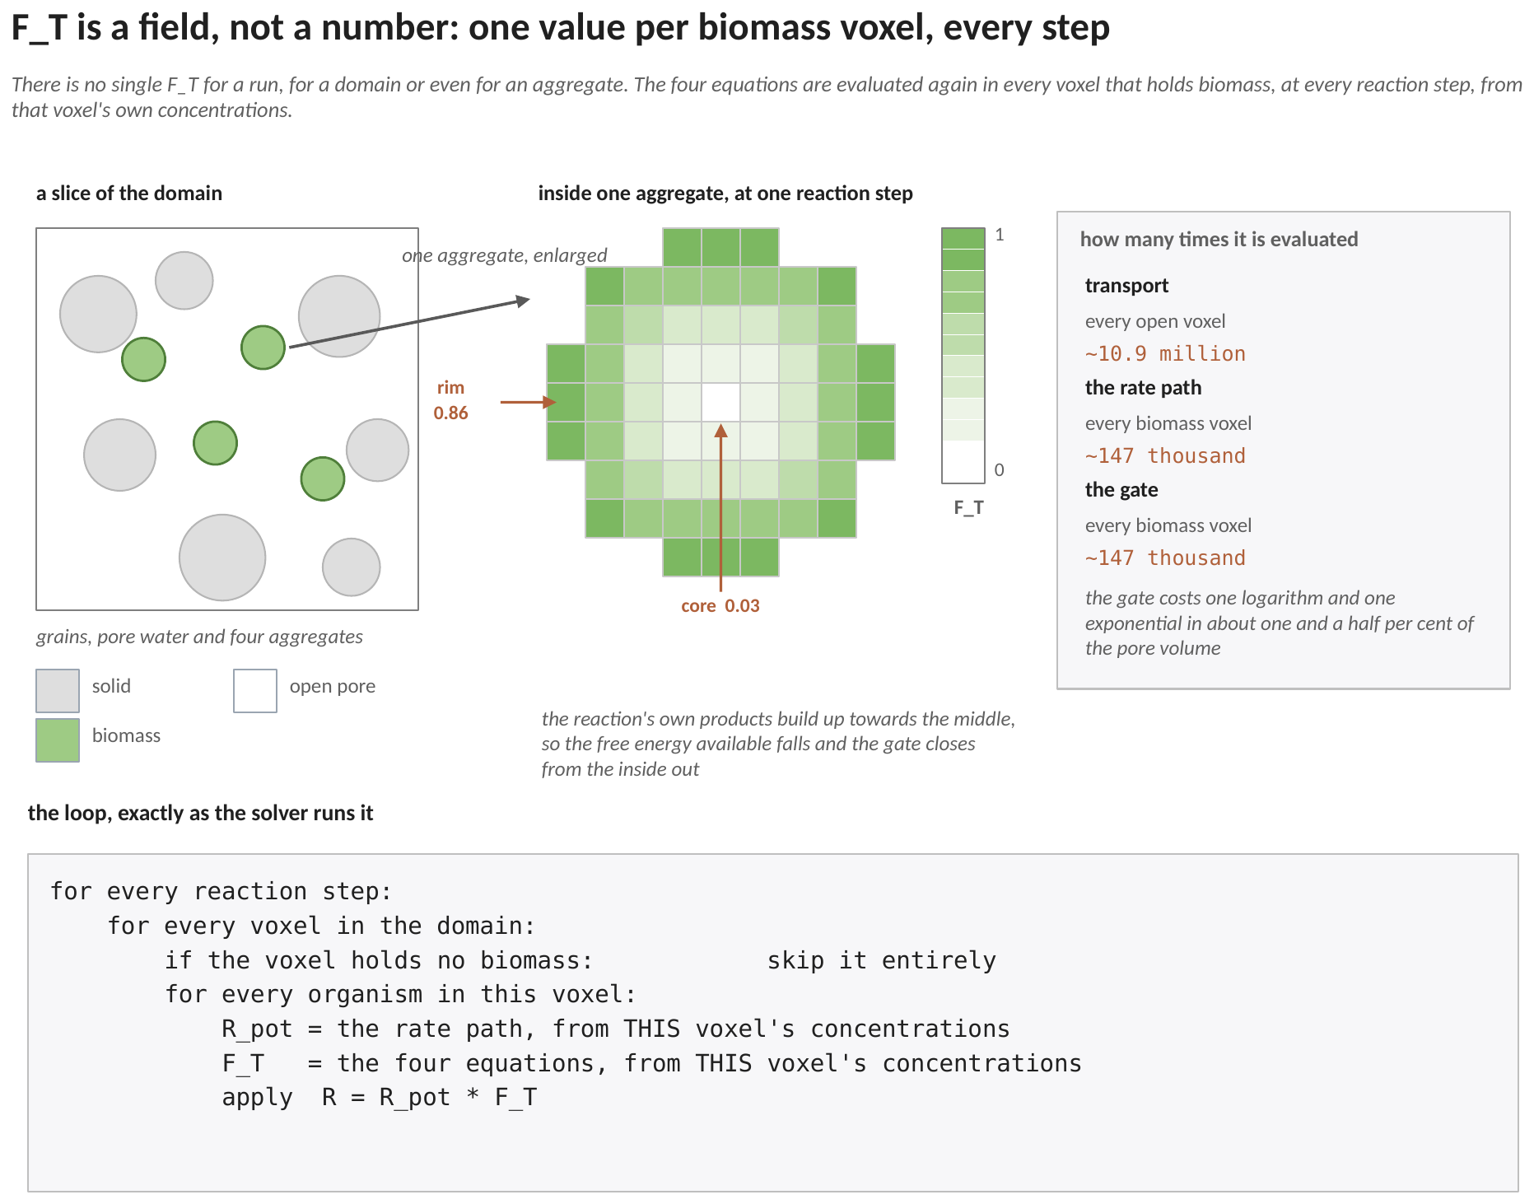
Figure 4. Left, a slice of the domain: grains, pore water, and four aggregates of biomass. Middle, one aggregate enlarged, with every voxel shaded by its own value of the factor at one reaction step. Right, how many times each part of the solver runs. Below, the loop exactly as the code executes it.
4.1 One value per biomass-bearing voxel, per reaction step
At the moment a rate path is about to be applied in a voxel, the gate takes that voxel's own concentrations, evaluates the four equations of Section 5, and returns one number. The next voxel gets its own number from its own concentrations. The whole field is discarded and recomputed at the next reaction step, because transport has moved the concentrations in the meantime.
It is worth being explicit about what the gate does not read. Not a bulk concentration. Not an average over the aggregate. Not a boundary condition. Not a value carried over from the previous step. Only the four numbers sitting in that voxel at that moment.
Because the reaction consumes substrates and makes products, and because transport has to carry both across the aggregate, those four numbers are not the same in the middle of an aggregate as at its rim. Products accumulate towards the middle, the reaction quotient (Q=$\frac{{[C]}^{c}[{D]}^{d}}{{[A]}^{a}{[B]}^{b}}$) rises, the free energy available falls, and the factor falls with it. The middle panel of Figure 4 is that gradient. It is the reason the gate belongs in a pore-scale model rather than in a box model, where the composition is one number and so the factor is one number too.
4.2 Where it is not evaluated
The gate is skipped entirely in any voxel that holds no biomass, which is most of the domain. Transport runs everywhere: in a typical aggregate case that is of order ten million open voxels. The rate path and the gate run only where there is an organism to gate, which in the same case is of order one hundred and fifty thousand voxels, about one and a half per cent of the pore volume.
That is the whole cost argument. The gate adds one logarithm and one exponential per organism per biomass voxel per reaction step, and nothing at all in the other ninety-eight and a half per cent.
4.3 The loop, in the order the code runs it

for every reaction step:
for every voxel in the domain:
if the voxel holds no biomass: skip it entirely
for every organism in this voxel:
R_pot = the rate path, from THIS voxel's concentrations
F_T = the four equations, from THIS voxel's concentrations
apply R = R_pot * F_T

The factor multiplies both of the things the rate path returns. The substrate rates are scaled by it, so a gated organism draws down less of everything, and the growth rate is scaled by it, so it also grows more slowly. Both appear in the increments of Section 5.5.
4.4 What comes out of a run
Because the factor is a field, it is saved with the other output fields and can be plotted like any other. Three quantities are worth reading off it, and none of them exists in a run without the gate.
the volume average of the factor over an aggregate | how much slower the aggregate runs than its substrates alone would allow. This is not the same as the factor evaluated at the bulk composition, and Section 8.3 explains why the difference is the result rather than a rounding error.
the depth at which the factor reaches zero | where inside the aggregate the reaction stops. A box model has no depth and so cannot produce this at all.
the radius past which the core contributes nothing | a size limit on the aggregate, derived by the model rather than assumed. This is the quantity the AOM literature reports as an observed limit on consortium size.

5. The equations
The form is the one of Jin and Bethke (2003, 2005), used for anaerobic oxidation of methane by He et al. (2021) and by Craig (2024, Chapter 3, Equations 3.3 to 3.6). Four lines, evaluated wherever Section 4 says they are. Nothing here is iterative and nothing is solved.
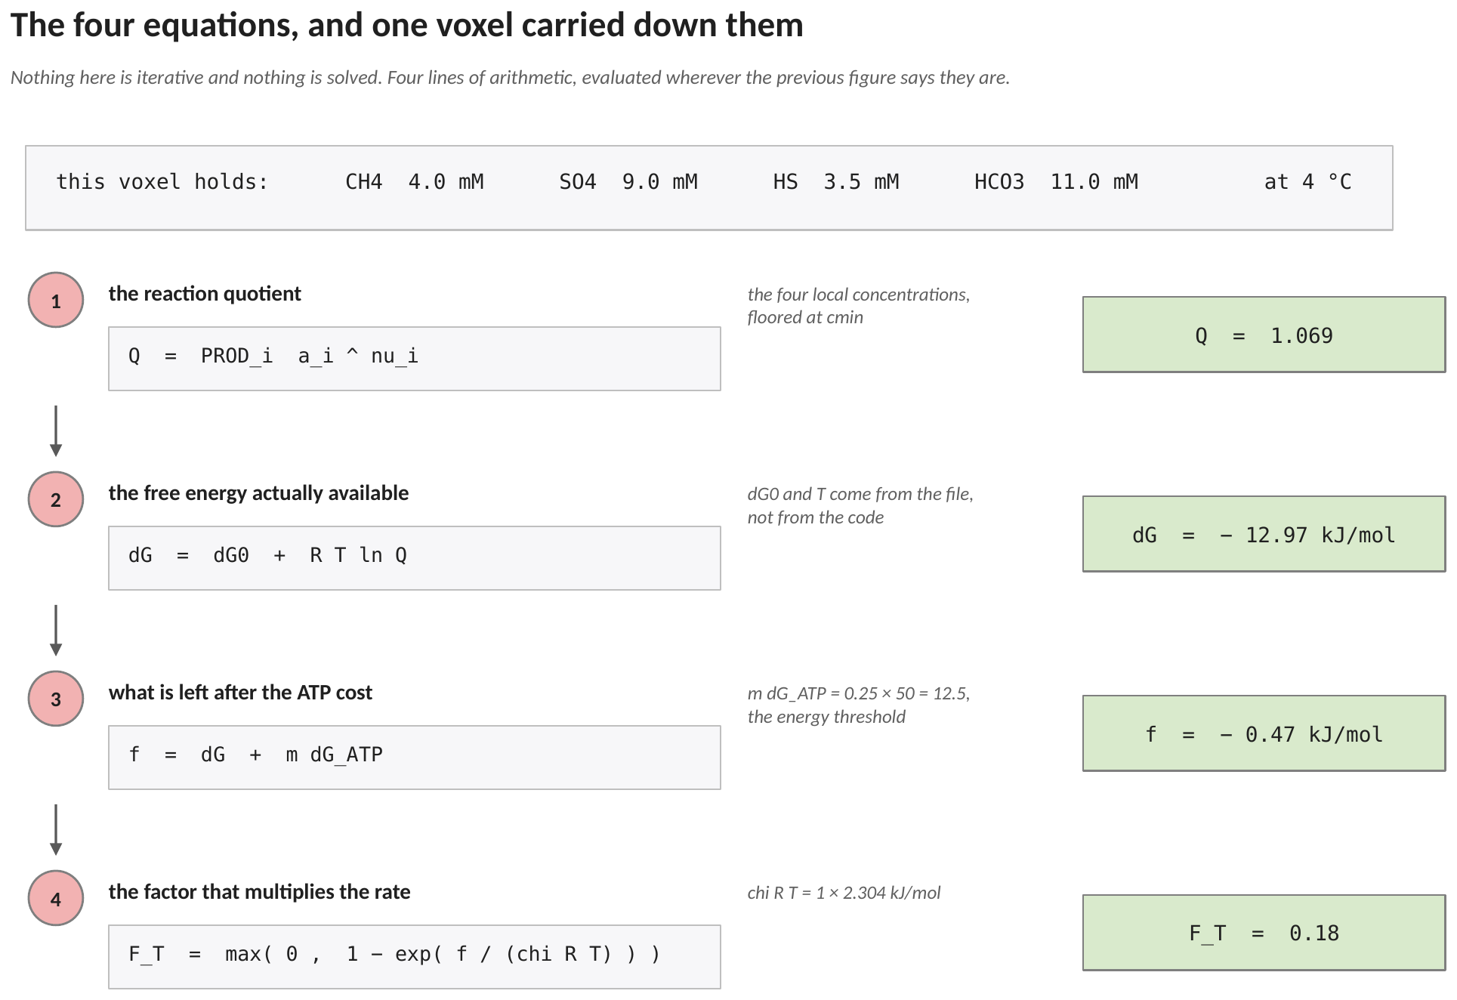
Figure 5. The four equations with one voxel's numbers carried down the right hand column, using the constants of the shipped file including its transfer loss. The composition at the top is what that voxel happens to hold at this reaction step; a voxel one step further into the aggregate would carry different numbers down the same four lines. Section 6 works the arithmetic through in full.
5.1 The reaction quotient
Q = Π_{i} a_{i} ^{νi} (1)
where a_{i} the activity of species i in this voxel, taken as its concentration and floored at cmin; ν_{i} its stoichiometric coefficient, negative for a reactant and positive for a product.
The floor is there because a concentration the transport solver has driven to zero would send the logarithm of Q to minus infinity and make the gate report an energy the system does not have. Using concentrations as activities is the standard pore-scale simplification and is what He et al. (2021) do; in a solution as concentrated as seawater the two differ by an activity coefficient, and any quotient computed this way carries that approximation with it.
5.2 The free energy actually available
ΔG = ΔG⁰ + R T ln Q + ΔG_{loss} (2)
where ΔG⁰ the standard free energy of the reaction at the file's temperature, kJ mol⁻¹; R the gas constant; T the temperature in kelvin; ΔG_{loss} an optional electron-transfer loss, a number that is zero or positive and zero by default. It is added to a free energy that is negative when the reaction is favourable, so it reduces what the reaction has available. See Section 7.1.
The sign convention here is that the free energy is negative when the reaction releases energy, which is the usual chemical convention and lets a printed value be checked against a table. Craig writes the same expression as a positive energy available and carries the minus sign inside the exponential instead. The two are the same expression written twice.
This is the equation that makes the factor local. The standard free energy and the temperature are constants of the file, the same everywhere. The quotient is not: it is built from the four concentrations of this voxel, and those are what transport and the reaction between them have made.
5.3 What is left after the ATP cost
f = ΔG + m ΔG_{ATP} (3)
where m the moles of ATP the organism conserves per mole of reaction; ΔG_{ATP} the free energy of ATP synthesis in situ, kJ per mole of ATP. Their product is the energy threshold.
With m equal to 0.25 and the ATP energy at 50 kJ per mole, the threshold is 12.5 kJ per mole of reaction, which sits inside the 10 to 20 kJ per mole band reported for methanogens and sulfate reducers (Schink 1997; Hoehler et al. 2001).
5.4 The factor
F_{T} = max ( 0 , 1 − exp ( f / ( χ R T ) ) ) (4)
where χ the average stoichiometric number, the number of times the rate-limiting step turns per turnover of the reaction as written. It is one unless a measurement says otherwise (Jin and Bethke 2003).
When f is strongly negative the exponential is near zero and the factor is near one. When f reaches zero the exponential is one and the factor is zero: the reaction has exactly the energy it needs to make its ATP and nothing left to drive it. Past that point the outer maximum holds the factor at zero rather than letting it go negative, which would be a reaction running backwards through a rate law never posed for it.
5.5 Applying it
The factor multiplies both outputs of the rate path, and the products enter the shared chain every path uses:
ΔC_{k} = max ( Σ_{m} R_{k,m} F_{T,m} Δt , −C_{k} ) (5)
ΔB_{m} = μ_{m} F_{T,m} B_{m} Δt (6)
where R_{k,m} the potential rate of species k returned by organism m's rate path; μ_{m} its potential growth rate; F_{T,m} the factor of equation (4) for that organism in this voxel, exactly one when the gate is off; B_{m} that organism's biomass density in this voxel.
Two organisms in one voxel get two factors, because each carries its own reaction block and its own threshold. Equation (5) then sums their gated draws before applying the substrate budget, so a voxel cannot be drawn below zero however many organisms sit in it.
6. A worked example: two voxels, step by step
Everything in Section 5 on two voxels of the same aggregate, at the same reaction step. The two differ in one concentration only, so the arithmetic isolates one cause.
6.1 Where every number in this example comes from
the number | what it is | where it comes from
−33.12 | the free energy the reaction releases under standard conditions, kJ per mole | He et al. (2021), quoted at 4 degrees Celsius, written on the dG0 line of the .thm file
277.15 K | the temperature of the sediment | the temperature line of the .thm file. The free energy above must be quoted at this temperature
8.314×10⁻³ | the gas constant, kJ per mole per kelvin | a constant of nature; the file may override it if it works in joules
0.25 | moles of ATP the organism makes per mole of reaction | the atp line of the .thm file, from the syntroph literature
50.0 | what one mole of ATP costs in situ, kJ | the dGatp line. Their product, 12.5 kJ per mole, is the toll the reaction has to clear
1.0 | how many times the slowest step of the pathway turns per turnover of the reaction as written | the chi line. One unless a measurement says otherwise
25.7 | energy lost getting electrons from one partner of the consortium to the other, kJ per mole | the dGloss line. Not measured directly: it is the one number fixed by the observed growth efficiency, and Section 6.5 shows how
the four concentrations | the methane, sulfate, sulfide and bicarbonate in this voxel right now | the transport solver, one step earlier. These are the only numbers that differ between the two voxels
4.0×10⁻⁸ | the methane consumption the rate path returned before the gate touched it | whichever rate path is in use; a round number is used here so the effect of the gate is easy to see
0.5 s | how long this reaction step lasts | the run's configuration

Only one row of that table changes between the two voxels. Everything else is a property of the reaction, of the organism, or of the run, and is the same in every voxel of the domain.
Two quantities can be worked out once, before either voxel:
R T = 8.314×10⁻³ × 277.15 = 2.3042 kJ per mole
the toll: m ΔG_{ATP} = 0.25 × 50.0 = 12.5 kJ per mole of reaction
The first sets the scale of everything thermal at this temperature. The second is what the reaction has to release before the organism gets anything at all.
6.2 The rim voxel
A voxel near the outside of the aggregate. The reaction has been running there, but transport has carried most of the sulfide and bicarbonate it made away into the pore water, so the products are low: 8.0 mM methane, 12.0 mM sulfate, 0.5 mM sulfide, 9.6 mM bicarbonate.
Equation (1). This is the ordinary reaction quotient: products on top, reactants underneath, each raised to how many moles of it the reaction uses. It is the same quantity that goes into a saturation index.
Q = ( [HS] × [HCO3] ) / ( [CH4] × [SO4] )
= ( 0.5×10⁻³ × 9.6×10⁻³ ) / ( 8.0×10⁻³ × 12.0×10⁻³ )
= 4.80×10⁻⁶ / 9.60×10⁻⁵ = 0.0500
A quotient of 0.05 means the water here holds twenty times more substrate, relative to product, than the standard state assumes. Far from equilibrium, in other words.
Equation (2). That distance from standard is worth an energy, and the logarithm converts it into one. Three terms are then added up.
ln Q = ln 0.0500 = −2.9957
R T ln Q = 2.3042 × ( −2.9957 ) = −6.9028 kJ per mole
ΔG = ( −33.12 ) + ( −6.9028 ) + 25.7 = −14.32 kJ per mole
Read the three terms one at a time.
term | value | what it says
ΔG⁰ | −33.12 | under standard conditions the reaction gives up 33.12 kJ per mole
R T ln Q | −6.90 | this water is richer in substrate than standard, which is worth another 6.90 to the organism
ΔG_{loss} | +25.70 | getting the electrons from the methane oxidiser to the sulfate reducer costs 25.70, so that much never reaches either of them
ΔG | −14.32 | what is actually available to the consortium in this voxel

The sign convention is the chemical one: negative means the reaction releases energy, so a printed value can be checked against a table. A loss makes the number less negative, which is why it is added rather than subtracted.
Equation (3). Take off the toll. What is left is the surplus, and its sign is the whole content of the line.
f = ( −14.32 ) + 12.5 = −1.82 kJ per mole
Negative means the reaction still releases more than the organism must keep, so there is something left over to drive it. Positive would mean the reaction cannot even pay the toll, and equation (4) would return zero.
Equation (4). The surplus is turned into a number between zero and one by comparing it with the thermal scale R T computed above.
f / ( χ R T ) = ( −1.82 ) / ( 1.0 × 2.3042 ) = −0.7911
exp( −0.7911 ) = 0.4533
F_{T} = max ( 0 , 1 − 0.4533 ) = 0.547
So this voxel runs at 54.7 per cent of whatever its rate path returned. Not one, because the surplus of 1.82 is smaller than the thermal scale of 2.30. Not zero, because there is a surplus at all. The comparison of those two numbers is the whole of equation (4): a surplus several times R T gives a factor near one, a surplus near zero gives a factor near zero, and everything in between falls off smoothly.
6.3 The inner voxel: one concentration is different
Now move a few voxels towards the middle of the same aggregate. Diffusion has a longer path to travel from there, so the bicarbonate the reaction makes has not been carried away as effectively and has built up from 9.6 to 20.0 mM. The methane, the sulfate and the sulfide are held at the rim values, so nothing else can be blamed for the result.
Q = ( 0.5×10⁻³ × 20.0×10⁻³ ) / ( 8.0×10⁻³ × 12.0×10⁻³ ) = 0.1042
R T ln Q = 2.3042 × ( −2.2618 ) = −5.2116 kJ per mole
ΔG = ( −33.12 ) + ( −5.2116 ) + 25.7 = −12.63 kJ per mole
f = ( −12.63 ) + 12.5 = −0.13 kJ per mole
F_{T} = max ( 0 , 1 − exp( −0.13 / 2.3042 ) )
= 1 − 0.9445 = 0.056
Compare the two voxels line by line.
 | rim voxel | inner voxel | difference
bicarbonate | 9.6 mM | 20.0 mM | the only input that changed
Q | 0.0500 | 0.1042 | about doubled
R T ln Q | −6.90 | −5.21 | 1.69 kJ/mol less help from the water
ΔG available | −14.32 | −12.63 | 1.69 kJ/mol less energy
surplus after the toll | −1.82 | −0.13 | almost nothing left
F_{T} | 0.547 | 0.056 | a fall of nearly ten times

A loss of 1.69 kJ per mole out of 14 sounds like a detail. It took the rate down by a factor of ten, because the surplus it ate into was only 1.82 to begin with. That is the behaviour the gate exists to capture: once a reaction is close to its threshold, a small further build-up of product costs a large fraction of the remaining rate.
Nothing about the organism differed between the two voxels. The rate path returned the same potential rate in both, because the three substrates were identical. What differed was a product the reaction had made itself and transport had not removed, and that difference exists only in a model that resolves the pore space.
6.4 What the two voxels then do, equations (5) and (6)
Suppose the rate path returned a methane consumption of 4.0 × 10⁻⁸ mol L⁻¹ s⁻¹ and a growth rate of 1.0 × 10⁻⁶ s⁻¹ in both voxels, that the biomass there is 2.0 × 10⁻⁵ mol L⁻¹, and that the reaction step is 0.5 s. The factor multiplies the rate, and the step turns the rate into a change:
rim: ΔC_{CH4} = −4.0×10⁻⁸ × 0.547 × 0.5 s = −1.09×10⁻⁸ mol L⁻¹
inner: ΔC_{CH4} = −4.0×10⁻⁸ × 0.056 × 0.5 s = −1.11×10⁻⁹ mol L⁻¹
The same factor multiplies the growth of the same organism:
rim: ΔB = 1.0×10⁻⁶ × 0.547 × 2.0×10⁻⁵ × 0.5 s = 5.47×10⁻¹² mol L⁻¹
inner: ΔB = 1.0×10⁻⁶ × 0.056 × 2.0×10⁻⁵ × 0.5 s = 5.55×10⁻¹³ mol L⁻¹
Both outputs are scaled by the same number, so a gated organism consumes less and grows more slowly in the same proportion. Repeat that over many steps and the inner voxel falls behind the rim in biomass as well as in rate. That is how an energy limit turns into a limit on how large an aggregate can usefully be.
6.5 The yield, and where the 25.7 came from
The shipped file turns the growth yield on. It answers a different question from the factor: not how fast, but how much biomass one turnover of the reaction pays for.
Equation (7) is a published correlation in two properties of the carbon source alone. Methane has one carbon atom and a degree of reduction of eight, so the correlation returns the same number everywhere in the domain:
( 6 − 1 )^{1.8} = 18.119 18 × 18.119 = 326.15
( 3.8 − 8 )² = 17.64 17.64^{0.16} = 1.5829
3.6 + 0.4 × 1 = 4.0 exp( 1.5829 × 4.0 ) = 561.9
ΔG_{dis} = 200 + 326.15 + 561.9 = 1088.1 kJ per C-mol
That is the energy the cell has to throw away to build one C-mol of biomass at all, over and above the energy the biomass itself contains. Equation (8) divides the energy the voxel actually has by the total cost:
Y = ΔG / −( ΔG_{ana} + ΔG_{dis} )
= ( −14.32 ) / −( −30.0 + 1088.1 ) = 14.32 / 1058.1 = 0.01354
One turnover of the reaction consumes one mole of methane and buys 0.01354 C-mol of biomass. Since one mole of methane is one mole of carbon, that is 1.35 per cent of the methane carbon ending up as cells. The yieldmax line caps the answer at 0.05, so the cap does not bite here.
That percentage is the observational anchor of the whole file, and it is what fixes the transfer loss. Measured growth efficiencies for these consortia are 1.0 to 2.75 per cent of the methane carbon. Set the transfer loss to zero and the free energy at the rim becomes −40.02 instead of −14.32, and the same division returns 3.78 per cent, which is above anything anyone has measured. Raising the loss to 25.7 kJ per mole brings the answer to 1.35 per cent, inside the observed band. One number was fixed that way, once, and everything else in the file is cited from the literature.
6.6 The same arithmetic over a whole aggregate
The two voxels above are two points on a gradient that runs from the outside of the aggregate to its middle. Running the case twice, once with the gate switched off and once with it on, turns that gradient into the difference between two otherwise identical runs.
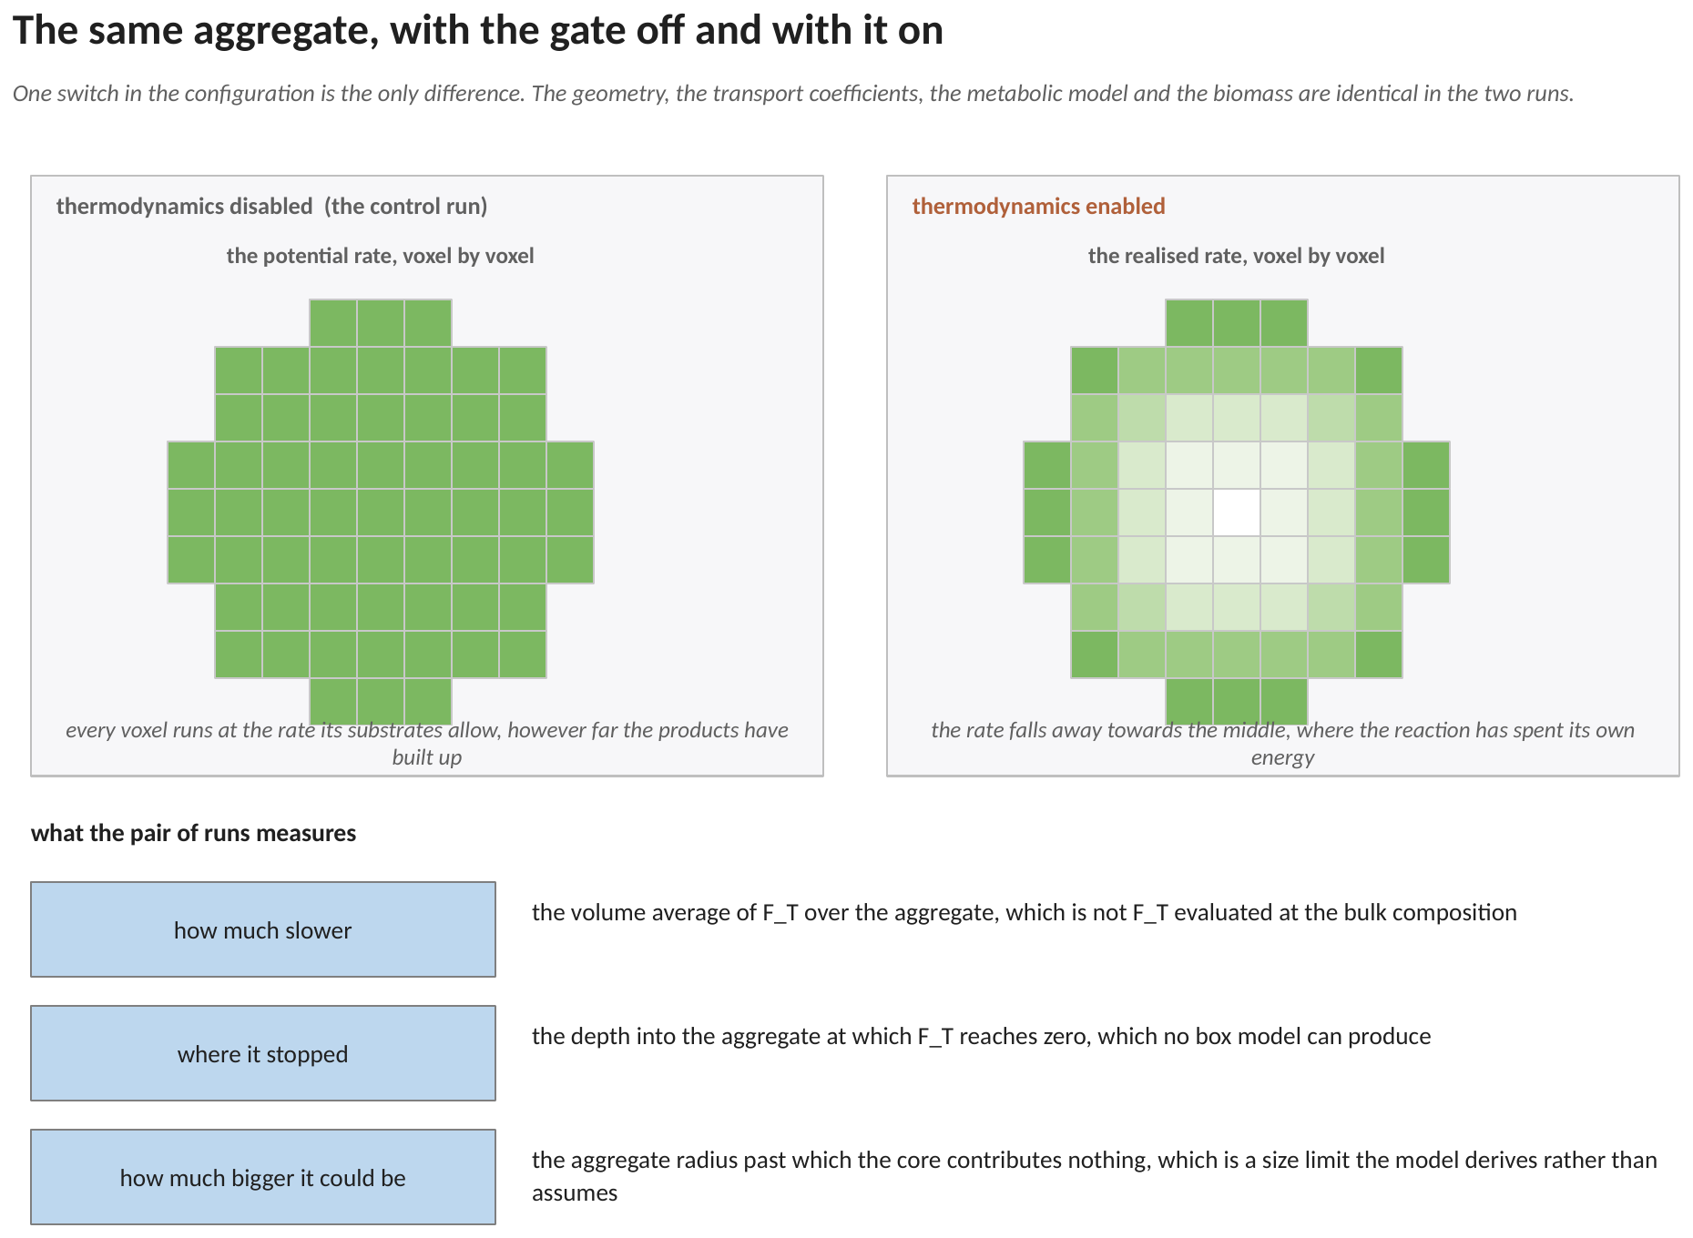
Figure 6. The same aggregate run twice, with the switch off and on. On the left every voxel runs at the rate its substrates allow, however far its own products have built up. On the right the rate falls away towards the middle, where the reaction has spent the energy that drives it. The rim voxel of Section 6.2 and the inner voxel of Section 6.3 are two cells of the right-hand panel. The geometry, the transport coefficients, the metabolic model and the biomass are identical in the two runs; one line in the configuration is the whole difference.
The three quantities of Section 4.4 are read off exactly this pair of runs. Nothing else in the model has to be re-derived to obtain them.
7. The energetics file, line by line
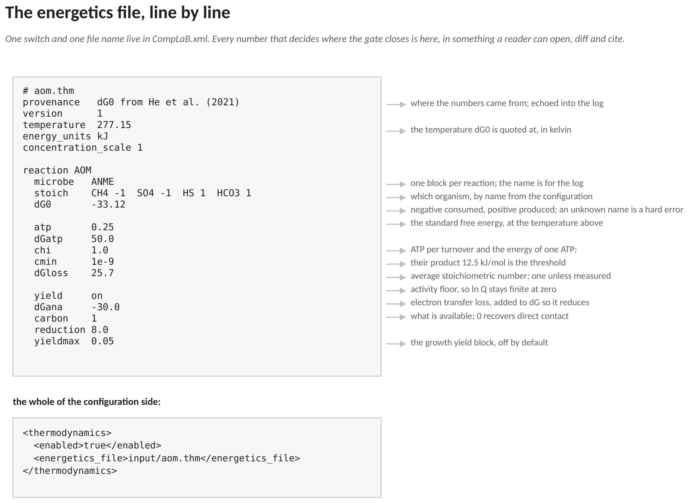
Figure 7. The file shipped with the anaerobic methane oxidation example, annotated, and the whole of the configuration side beneath it. One switch and one file name live in CompLaB.xml; every number that decides where the gate closes is in the file.
A .thm file is read at run time, the same way a symbolic rate law or a graph network is, and for the same reason. The standard free energy of a reaction and its energy threshold are scientific claims that get revised, compared and quoted in a paper. They belong in something a reader can open, diff and cite, not in a rebuild.
The stoich line takes name and number pairs, negative for reactants and positive for products. The names must be substrates of this run, and a name that is not is a hard error rather than a silently dropped term: a missing product is the difference between a gate that closes and one that never does.
The temperature line is not decoration either. The standard free energy on the line below it must be quoted at that temperature, not at 25 degrees Celsius, because the value at 4 degrees is what the sediment these aggregates come from actually offers.
7.1 The electron-transfer loss, and where 25.7 comes from
Craig subtracts activation and ohmic losses along the conductive network between the two partners of a syntrophic consortium, which needs a solver for the cytochrome redox state that CompLaB3D does not have. Setting those losses to zero is the direct-contact assumption. The file format leaves room for the term: the loss line is parsed and added to the free energy of equation (2), which is negative when the reaction is favourable, so a positive loss reduces what is available. Setting it to zero recovers direct contact.
In the shipped example that constant is not a direct measurement. It is fixed by the one observational constraint available: the growth efficiency of these consortia is 1.0 to 2.75 per cent of the methane carbon (Nauhaus et al. 2007; Orphan et al. 2009), and the yield with no transfer loss returns 4.7 per cent at the aggregate rim. The loss that brings it to the top of the observed band is 25.7 kJ per mole. That single number then determines where the gate closes, with nothing further tuned.
7.2 The optional growth yield
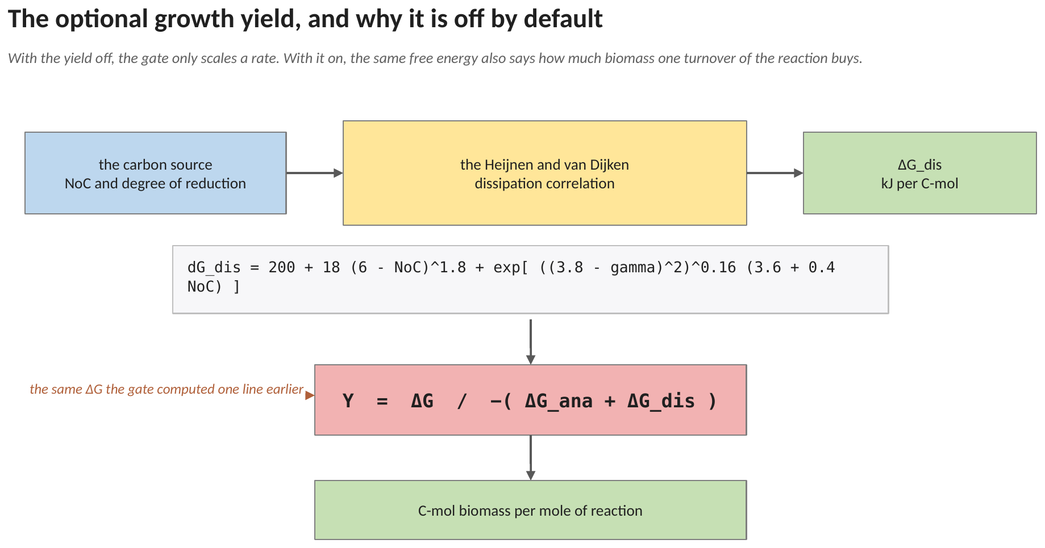
Figure 8. The energy-based growth yield, off by default. The dissipation correlation turns the carbon source into an energy cost per C-mol of biomass, and the same free energy the gate computed one line earlier then says how much biomass one turnover of the reaction buys.
ΔG_{dis} = 200 + 18 ( 6 − NoC )^{1.8} + exp [ ( ( 3.8 − γ )² )^{0.16} ( 3.6 + 0.4 NoC ) ] (7)
Y = ΔG / −( ΔG_{ana} + ΔG_{dis} ) (8)
where NoC the number of carbon atoms in the carbon source; γ its degree of reduction; ΔG_{dis} the dissipation, kJ per C-mol of biomass, a positive number; ΔG_{ana} the free energy of anabolism, kJ per C-mol of biomass; Y the yield, C-mol of biomass per mole of reaction.
The dissipation is positive, the energy the cell must throw away to build biomass at all, so the denominator of equation (8) is negative and the yield comes out positive. The free energy in the numerator is the same number equation (2) produced in this voxel, so the yield is a field too: where the reaction is close to its threshold it buys less biomass per turnover, which is behaviour a fixed yield cannot reproduce.
It is off by default because every rate path already carries a yield of its own. A metabolic model has a biomass reaction, a compiled kinetic law has a yield coefficient, a fitted network learned one from the data. Turning this on replaces that, so it is a deliberate choice rather than a default. The yieldmax line caps the result, because equation (7) is a correlation and a composition far outside the range it was fitted over can return a yield no organism achieves.
8. What the gate does not do, and how to run it
8.1 Three limits
It does not model electron transfer, for the reason given in Section 7.1: the loss is a constant supplied in the file rather than a term the model computes. It uses concentrations as activities, which in a solution as concentrated as seawater differs from the truth by an activity coefficient, so a saturation state or a quotient computed this way carries that approximation with it. And it gates biotic paths only, for the reason given in Section 3.1.
8.2 Running it, and the control run

<thermodynamics>
<enabled>true</enabled>
<energetics_file>input/aom.thm</energetics_file>
</thermodynamics>

Two lines, and one of them is a file name. Switching enabled to false is the control run: the file is not read, the factor is one everywhere, and exactly one multiplication in the whole code changes. Nothing about the geometry, the transport coefficients, the metabolic model or the biomass differs between the two runs, which is what makes the pair a controlled comparison rather than two different models.
At start-up the file is echoed into the log, so a result carries the energetics that produced it, including the provenance line and every constant.
8.3 A note on evaluating the gate at the bulk composition
It is tempting to evaluate the four equations once at the bulk composition and treat the answer as a summary of the run. It is not one. The rate at the bulk composition already includes the factor at the bulk composition, and the quantity a pore-scale run produces which a box model cannot is precisely the difference between that and the volume average of the factor over the aggregate. Reporting the first in place of the second discards exactly the result the model was built to obtain.
8.4 Testing it
The gate needs no Palabos and no solver, so it compiles and checks on its own. The unit test builds the header by itself and verifies the four equations against hand-computed values, including the two limits: a strongly exergonic composition returning a factor indistinguishable from one, and a composition past the threshold returning exactly zero rather than a small negative number.
9. References
Craig, L.: Thermodynamic and metabolic modelling of anaerobic methanotrophic consortia. PhD thesis, Chapter 3 (2024).
He, X., Chadwick, G. L., Kempes, C. P., Orphan, V. J., Meile, C.: Controls on interspecies electron transport and size limitation of anaerobically methane-oxidizing microbial consortia. mBio 12, e03620-20 (2021). https://doi.org/10.1128/mBio.03620-20
Heijnen, J. J., van Dijken, J. P.: In search of a thermodynamic description of biomass yields for the chemotrophic growth of microorganisms. Biotechnology and Bioengineering 39, 833-858 (1992). https://doi.org/10.1002/bit.260390806
Hoehler, T. M., Alperin, M. J., Albert, D. B., Martens, C. S.: Apparent minimum free energy requirements for methanogenic Archaea and sulfate-reducing bacteria in an anoxic marine sediment. FEMS Microbiology Ecology 38, 33-41 (2001). https://doi.org/10.1111/j.1574-6941.2001.tb00879.x
Jin, Q., Bethke, C. M.: A new rate law describing microbial respiration. Applied and Environmental Microbiology 69, 2340-2348 (2003). https://doi.org/10.1128/AEM.69.4.2340-2348.2003
Jin, Q., Bethke, C. M.: Predicting the rate of microbial respiration in geochemical environments. Geochimica et Cosmochimica Acta 69, 1133-1143 (2005). https://doi.org/10.1016/j.gca.2004.08.010
Nauhaus, K., Albrecht, M., Elvert, M., Boetius, A., Widdel, F.: In vitro cell growth of marine archaeal-bacterial consortia during anaerobic oxidation of methane with sulfate. Environmental Microbiology 9, 187-196 (2007). https://doi.org/10.1111/j.1462-2920.2006.01127.x
Orphan, V. J., Turk, K. A., Green, A. M., House, C. H.: Patterns of nitrogen-15 assimilation and growth of methanotrophic ANME-2 archaea and sulfate-reducing bacteria within structured syntrophic consortia revealed by FISH-SIMS. Environmental Microbiology 11, 1777-1791 (2009). https://doi.org/10.1111/j.1462-2920.2009.01903.x
Schink, B.: Energetics of syntrophic cooperation in methanogenic degradation. Microbiology and Molecular Biology Reviews 61, 262-280 (1997). https://doi.org/10.1128/mmbr.61.2.262-280.1997

