In-line Flux Balance Analysis: a reader's guide
what it is, how each solver runs it, and what each pipeline does
1. The idea, for someone who models reactive transport
In a classical reactive-transport model you write the reaction rate yourself. A Monod expression turns the local concentrations into one rate, and fixed yield coefficients turn that rate into a source term for every species. The stoichiometry is baked into those coefficients, and it does not move.
Flux balance analysis replaces that expression with a question put to the organism's whole metabolic network. The network is a list of every reaction the organism can run — hundreds for a core model, thousands for a genome-scale one. The question is: given how much of each substrate is available in this voxel right now, what is the fastest this organism can grow, and what does it consume and release while doing so?
The answer is not looked up and not fitted. It is the solution of a linear program, solved fresh in every voxel that holds biomass, at every time step.

 | a Monod rate law | flux balance analysis
what you supply | a maximum rate, a half-saturation, and a yield per species | the organism's reaction list
what is fixed | the stoichiometry, in the yields | only the reaction list
what can change with conditions | the rate | the rate AND the stoichiometry
cost per voxel per step | a few floating-point operations | one linear program, about 0.1 ms
valid where | wherever the law was calibrated | everywhere: nothing was calibrated

The last row is why this path exists. There is no fitted box outside which the answer stops meaning anything, so it is the reference every cheaper path is checked against. The fourth row is why the other paths exist at all.
2. How flux balance analysis works
2.1 The metabolic model is a matrix
A metabolic model is a list of reactions. Write the metabolites as rows and the reactions as columns, and put each reaction's stoichiometric coefficients down its column, and that list becomes a matrix S.
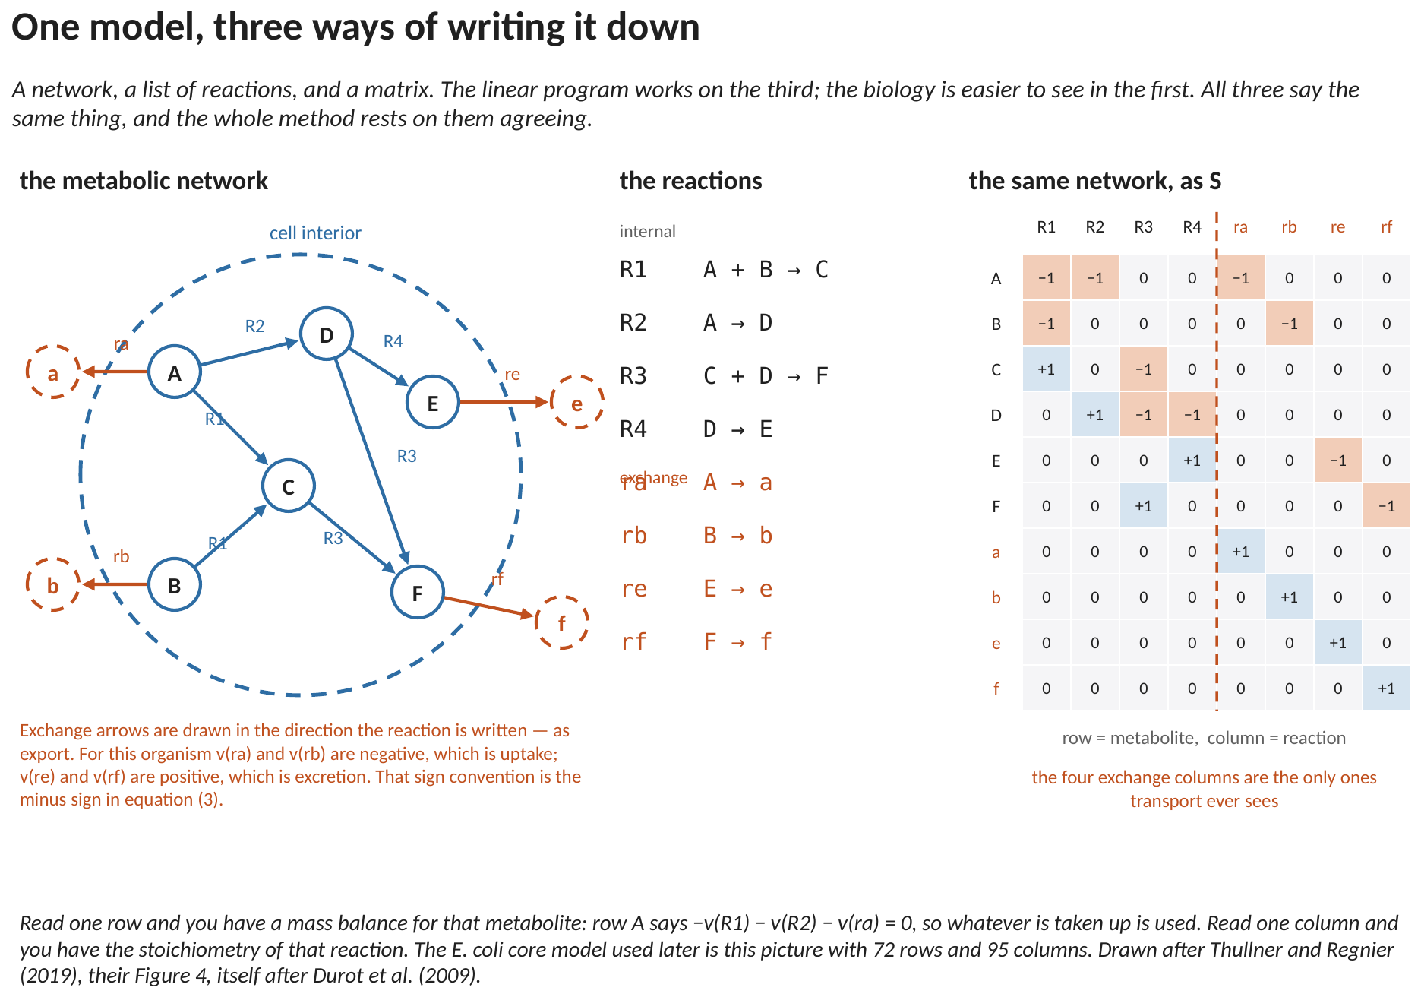
Figure 1. A six-metabolite example, written three ways. The network, the reactions, and the same information as the matrix S. Read one row and you have a mass balance for that metabolite; read one column and you have the stoichiometry of that reaction.
Two kinds of reaction matter differently. INTERNAL reactions happen inside the cell and the transport model never sees them. EXCHANGE reactions cross the cell boundary, and they are the only ones that do: they are where the transport model delivers concentrations and where it collects source terms.
2.2 Three statements and one that is local
The program has four parts. Three are fixed for the whole run; one is rebuilt in every voxel, and that one is the entire coupling between the metabolic model and the transport model.
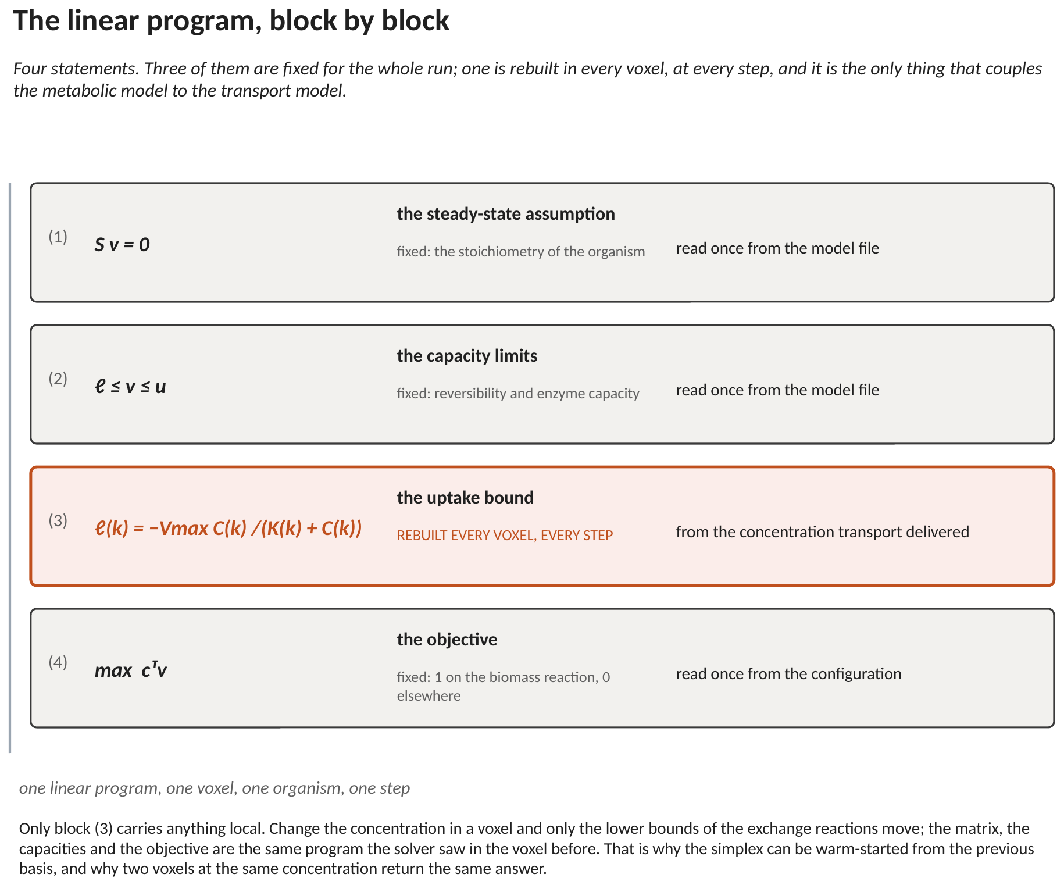
Figure 2. The program, block by block. Only the third block carries anything that changes from one voxel to the next.
The first says every internal metabolite is at steady state:
S v = 0 (1)
Nothing accumulates inside the cell. This is the assumption that makes the problem linear, and it holds because internal pools turn over in seconds while the transport step is minutes or hours.
The second says no reaction may run faster than it can:
ℓ ≤ v ≤ u (2)
The third is the one that carries the local condition. For each substrate the organism can take up, its exchange reaction gets a lower bound built from the concentration transport just delivered:
ℓ_{k} = − V_{max,k} C_{k} / ( K_{k} + C_{k} ) (3)
That is an ordinary Michaelis–Menten expression, and it is doing an ordinary job: it says how fast this substrate CAN enter the cell. The minus sign is a convention — exchange reactions are written as export, so uptake is a negative flux. Nothing else in the program changes from voxel to voxel.
The fourth is what the organism is assumed to be doing:
max cᵀ v (4)
with c one on the biomass reaction and zero elsewhere. The organism grows as fast as its network and its supply allow.
2.3 What comes back
The solver returns one flux for every reaction. Two things are read out of that vector, and nothing else is used:
- The flux on the biomass reaction is the growth rate, which drives the biomass increment.
- The flux on each exchange reaction, scaled by biomass and the time step, is the source term for that species — negative where it was consumed, positive where it was released.
The internal reactions — the several thousand in a real model — are machinery the transport step never sees. It hands concentrations to the cell boundary and receives fluxes back across it.
3. Where it sits in the solve loop
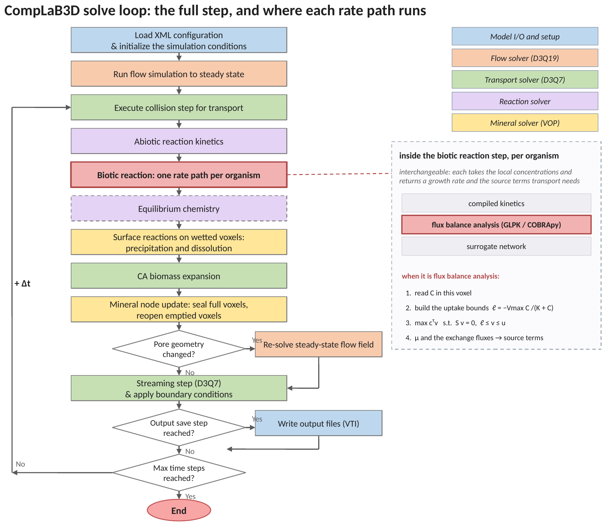
Figure 3. The solve loop. The biotic reaction step is highlighted; flux balance analysis is one of the interchangeable things that step can be.
Nothing above or below the reaction step knows which rate path is running. That is what makes the paths comparable: two runs differing only in the reaction step differ only because of the rate law.
4. How GLPK runs it
GLPK is a linear-programming library linked directly into the executable. Everything stays in one process.
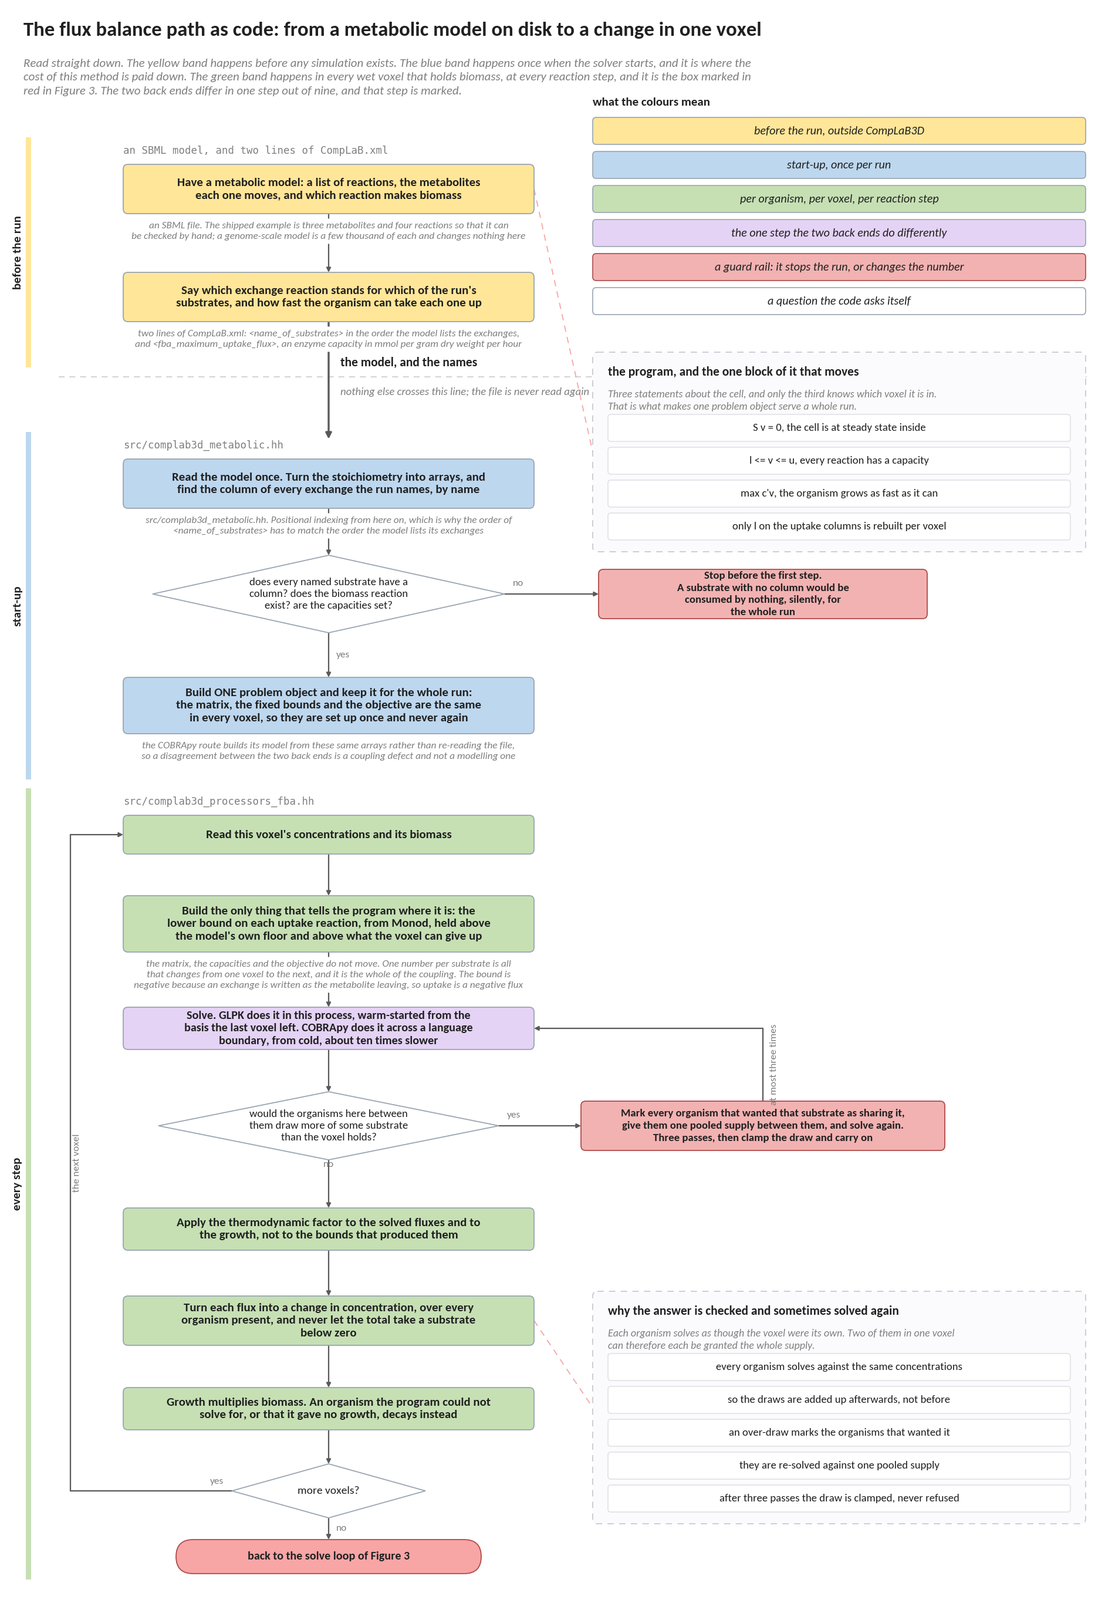
Figure 4. The flux balance path as code, from a metabolic model on disk to a change in one voxel. The side panels open the two steps that are otherwise taken on trust: what the program actually says, and why the answer is sometimes solved again.
The three bands are three different time scales, and the shape of them is the reason this method is affordable at all. The yellow band happens once, before any simulation exists, and none of it is code. The blue band happens once when the solver starts, and it is where the expensive part is paid for: the matrix, the fixed bounds and the objective are the same in every voxel of every step, so they are turned into one problem object that survives the whole run. The green band happens in every wet voxel that holds biomass, at every reaction step, and it is the box drawn in red in Figure 3. What it does to that problem object is small: it moves one number per substrate, solves, and reads two things back. The purple box is the only step where the two back ends differ, and they differ in cost rather than in answer, which is what makes a disagreement between them a defect in one of the couplings rather than a property of either solver. The two boxes drawn in red are the two places where a mistake would otherwise be silent: a substrate the model has no column for would be consumed by nothing for the whole run, and two organisms in one voxel would each be granted the whole supply unless their draws were added up afterwards and checked.
The four start-up steps read the model, turn it into arrays, work out which reaction exchanges which substrate, and build ONE problem object that survives the whole run. That object is the reason the per-voxel work is small.
Per voxel there are only three things to do: read the concentrations, form the uptake bounds from equation (3), and solve. The matrix, the capacities and the objective are the same program the previous voxel solved, so the simplex restarts from the basis it left there and finishes in a handful of pivots — about 0.1 ms.
5. How COBRApy runs it
COBRApy is the standard Python toolbox for metabolic models. CompLaB3D can run the same program through it, in an interpreter embedded in the executable.
The model is built from the SAME arrays the GLPK path uses, not re-read from the file. That is deliberate: it is what makes the two routes comparable rather than two models that happen to share a name.
Per voxel the bounds are packed into a list, sent across the language boundary, solved, and the fluxes unpacked on the way back. No basis is kept between calls, so each solve starts cold: about 1 ms, an order of magnitude more than GLPK.

 | GLPK | COBRApy
per call | about 0.1 ms | about 1 ms
warm start | yes, the previous basis | no
what crosses per voxel | nothing | the bound and flux arrays
XML tag | <reaction_type>glpk</reaction_type> | <reaction_type>cobrapy</reaction_type>
use it for | production runs, MPI domains | model development, checking a GLPK result

Both are exact and neither approximates the other, so a disagreement between them is a defect in one of the two couplings rather than a property of either solver. Running one case through both is the strongest check available on this path, and the only independent one either has.
6. When one program is not enough: the chain
The growth rate a single program returns is almost always unique. The individual exchange fluxes very often are not.
Ask, at that fixed optimal growth, how large the release of one by-product may be, and the answer is usually a RANGE rather than a number: anywhere in it the organism grows exactly as fast, and the products simply trade against one another. The solver returns whichever end its pivoting rule reached. Nothing about that is wrong — it is one member of an optimal set — but it is arbitrary, it need not survive a change of solver, and it cannot be compared against a measured yield.
The fix is to solve a SEQUENCE of programs, each optimising the next quantity while holding every earlier one at the optimum it reached:
LP 1: max v[growth] -> f1
LP 2: max v[product 1], subject to v[growth] >= a1 f1 -> f2
LP 3: max v[product 2], subject to v[growth] >= a1 f1
v[product 1] >= a2 f2
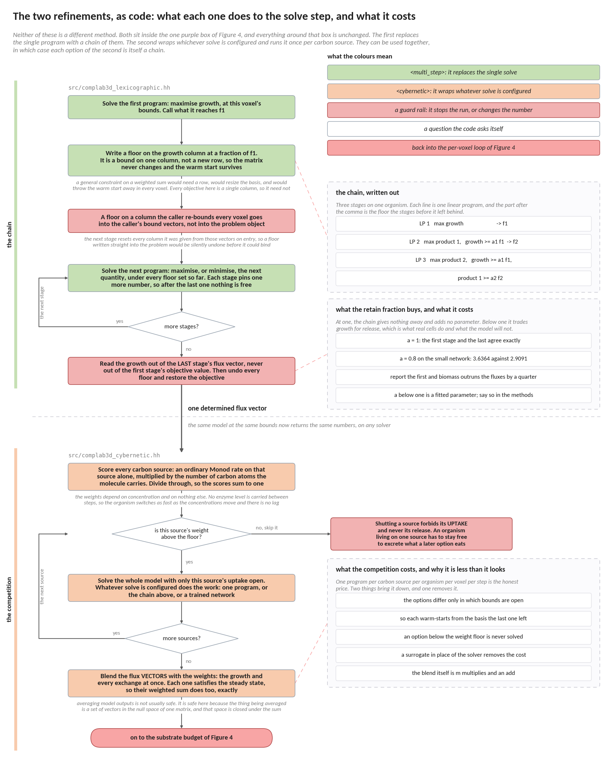
Figure 5. The two refinements of the solve step, as code. Neither replaces the method of Figure 4: the first replaces the single program inside it with a chain, and the second wraps whichever solve is configured and runs it once per carbon source.
They answer two different complaints, and they can be used together. The chain answers the one about reproducibility: a single program pins the growth rate but often leaves the individual exchange fluxes free to trade against one another, and the solver returns whichever member of that set its pivoting rule reached. Each stage of the chain pins one more quantity until nothing is free. The competition answers the one about behaviour: an organism offered several substrates eats the best one and switches when it runs out, which no single program and no rate law will do on its own. The two boxes drawn in red are the places where each one goes quietly wrong. In the chain, the growth rate must be read out of the last stage's flux vector rather than the first stage's optimum, because with any retain fraction below one those two are different numbers and reporting the first while handing back the second's fluxes stops mass balancing. In the competition, shutting an option means forbidding its substrate's uptake and never its release, because the compound one option excretes is what the next option will live on.
Each stage pins one more quantity, so after the last one nothing is free: the same model at the same bounds returns the same numbers, on any solver, every time.
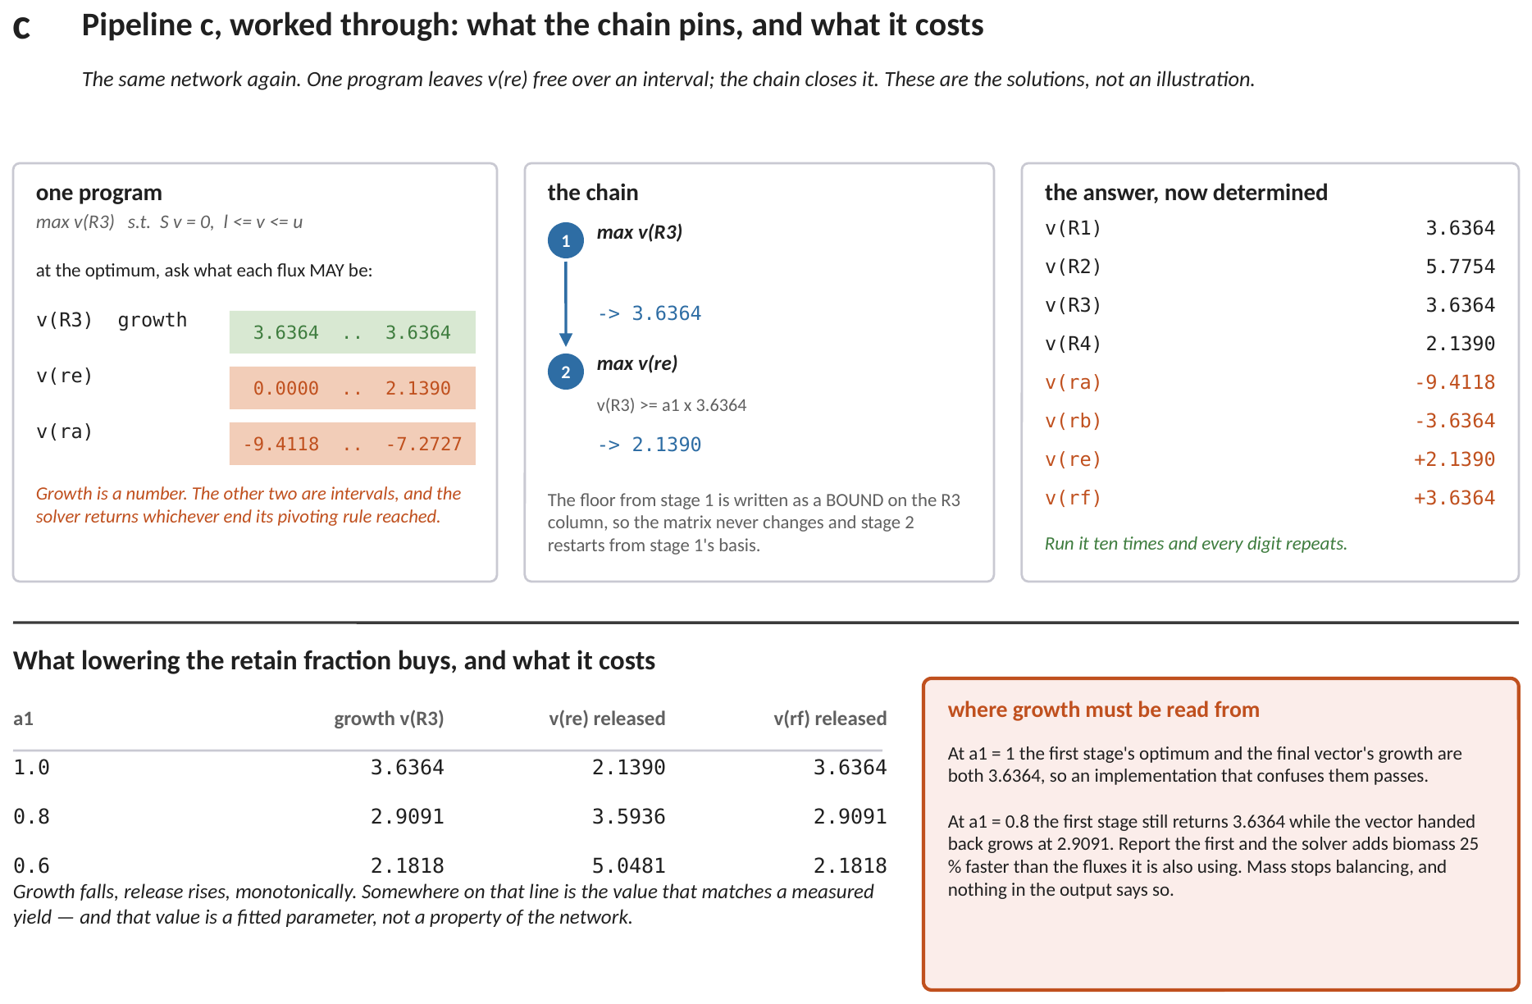
Figure 6. The chain on the network of Figure 1. Top left: what one program leaves free. Top middle: the two stages. Top right: the determined answer. Below: what lowering the retain fraction buys, and where growth must be read from.
Turning it on is one block inside the organism, and it needs three lists of the same length. This is what example 21 ships:
<multi_step>
<stage_reactions>
Biomass_Ecoli_core EX_ac_e EX_for_e
</stage_reactions>
<retain_fraction> 1.0 1.0 1.0 </retain_fraction>
<stage_direction> max max max </stage_direction>
</multi_step>
At least two stages are required; with one the block should be omitted, because one stage is ordinary flux balance analysis. <retain_fraction> defaults to 1.0 throughout and <stage_direction> to max, so a strict chain needs only the first list. Every fraction at 1.0 is the recommended starting point: the chain then gives up nothing and introduces no fitted parameter. Lowering the first entry lets the organism trade growth for excretion, which is what real cells do and what a genome-scale model will not do on its own. On the model example 21 ships, growth falls from 0.5591 to 0.5031 to 0.3354 as that fraction goes from 1.0 to 0.9 to 0.6, while acetate export rises from 11.5033 to 12.3529 to 14.9020. A fraction below one is therefore a fitted parameter and belongs in the methods section of whatever the run is reported in.
6.1 The retain fractions are calibration
With every fraction at one the chain gives up nothing and introduces no parameter. That is the default and the recommended starting point.
Below one, the organism is allowed to trade growth for release — which is what real cells do, and what a genome-scale model will not do on its own. Growth falls, release rises, monotonically, and somewhere on that line is the value that matches a measurement. A fraction below one is therefore a FITTED PARAMETER and belongs in the methods section of whatever the run is reported in.
6.2 The one thing to get right
The growth rate handed back to transport must be read out of the LAST stage's flux vector, never from the first stage's objective value.
At a fraction of one those two are equal, so an implementation that confuses them passes the obvious test. Below one they diverge by exactly as much as the calibration gave away — on the small network of Figure 6, at a fraction of 0.8, the first stage says 3.6364 while the vector actually chosen grows at 2.9091. Reporting the first while handing back the second's fluxes would add biomass 25 per cent faster than the fluxes being used. Mass would stop balancing, and nothing in the output would say so.
7. When there is more than one substrate: the competition
An organism offered several substrates it can grow on does not eat them all at once. It grows on the best one available and switches when that one runs out. A preferred donor is consumed while a partially oxidised product accumulates; only when the donor is exhausted does the organism turn round and consume what it made.
Neither of the tools above can produce that. One linear program handed all the substrates will take whichever combination maximises growth, together, from the first step. A rate law cannot do it either, and for a sharper reason: the same compound is a PRODUCT in one regime and a SUBSTRATE in the next, and a concentration alone does not say which.
The answer is to treat the organism as a competition between separate growth options, one per substrate. Solve the model once per substrate with the others shut, score each option by how much of the limiting element it would bring in, and blend the flux vectors:
r_{k} = k_{k} C_{k} / ( K_{k} + C_{k} ) (5)
u_{k} = n_{k} r_{k} / Σ n_{j} r_{j} (6)
v = Σ u_{k} v_{k} (7)
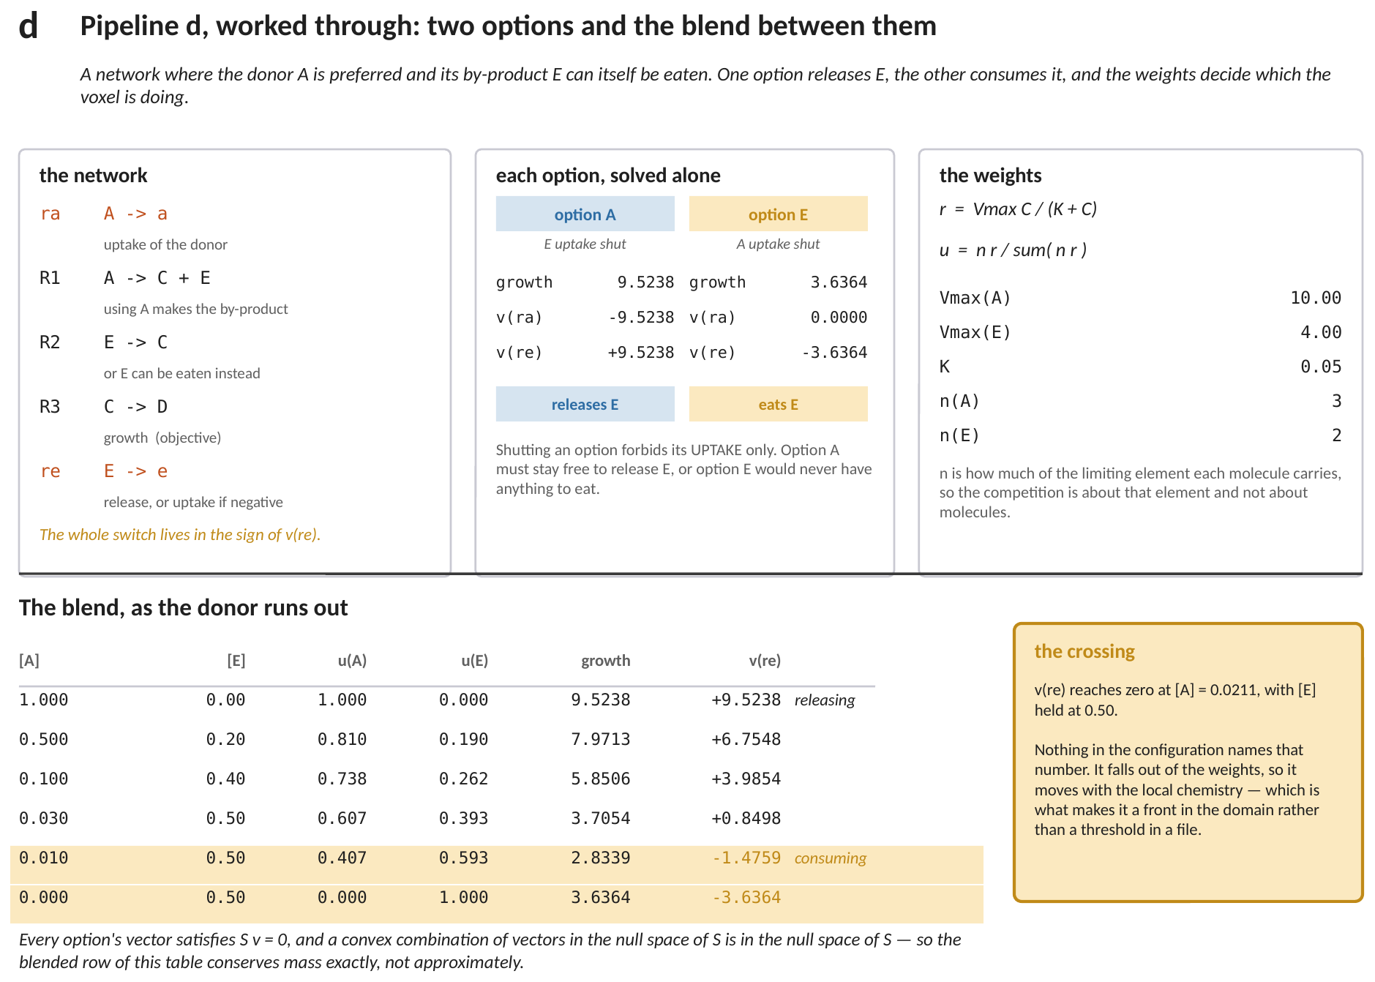
Figure 7. The competition on a network where the donor's by-product can itself be eaten. Top: the network, both options solved alone, and the weights. Below: the blend as the donor runs out, with the release flux changing sign on its own.
The block that turns it on takes one entry per source, in the same order throughout. This is what example 22 ships:
<cybernetic>
<sources> glucose acetate </sources>
<substrate_ids> 0 2 </substrate_ids>
<carbon_number> 6 2 </carbon_number>
<uptake_kmax> 10.0 4.4 </uptake_kmax>
<uptake_half_saturation> 0.05 0.05 </uptake_half_saturation>
<weight_floor> 1e-3 </weight_floor>
</cybernetic>
<substrate_ids> index this run's own substrate list, which is what ties each growth option to a concentration on the lattice. <weight_floor> defaults to 1e-3; setting it to 0 solves every source every time and is the reference to check against, and it moves the answer in the fourth decimal. At least two sources are required, since with one option there is nothing to switch between. What the method does NOT do is carry any enzyme state between steps, so there is no lag and no diauxic plateau: the weights depend on concentration alone. That is adequate exactly when the switch is fast compared with transport, which is the pore-scale case.
Figure 7 is the whole mechanism on a network small enough to verify. One option grows fast and RELEASES the by-product; the other grows slowly and CONSUMES it. Neither is the organism's behaviour — the blend is, and the blend moves as the donor depletes.
The row to watch is the release flux. It starts strongly positive, falls as the donor's weight falls, and crosses zero when the donor is nearly gone. Nothing in the configuration names the concentration at which that happens; it falls out of the weights. In a pore-scale domain that makes it a FRONT — a surface inside the biofilm where the organism changes what it is living on — rather than a threshold somebody chose.
7.1 Two things that make it work
- Shutting an option forbids its substrate's UPTAKE, never its release. An organism living on one substrate must stay free to release the compound a later option will consume, or the second regime never arrives.
- The blend is over the flux VECTORS. Each satisfies S v = 0, and a convex combination of vectors in the null space of S is in the null space of S, so the blended vector conserves mass exactly rather than approximately. Averaging model outputs is not usually safe; this is why it is safe here.
The cost is m linear programs per organism per voxel per step for m substrates. The programs differ only in which bounds are open, so each warm-starts from the last, and an option whose weight falls below a floor is not solved at all.
8. Every equation, in the order the code applies them
8.1 The four equations the sections above do not write down
Equations (1) to (7) describe the program and the competition around it. Four more carry the answer back to the transport solver, and they are the ones a reader is most likely to assume rather than check.
The chain of Section 6 is written there as a list of programs. As an equation it is one inequality per stage, imposed on the stages that come after it:
v_{j} ≥ a_{j} f_{j} , for every stage j already solved (8)
where f_{j} what stage j reached when it was the objective, and a_{j} the fraction of it later stages must preserve. Because every objective in the chain is a single reaction column, this is a bound on a column rather than a constraint on a weighted sum, so no row is added, the matrix never changes, and the warm start survives. That is the whole reason n stages cost about 1.6 single solves rather than n of them.
The fluxes come back in millimoles per gram of dry cells per hour, and the lattice carries moles per litre. One line reconciles them, over every organism present in the voxel:
ΔC_{k} = Δt Σ_{m} v_{m,k} B_{m} M / 3.6 × 10₆ (9)
where B_{m} the biomass of organism m in this voxel and M its biomass molar mass, so their product is grams of dry cells per litre of water, which is what turns a per-gram flux into a per-litre rate. The sum runs over every organism, and the total is checked against what the voxel holds before it is applied: if it overruns, the organisms that wanted that substrate are given one pooled supply and solved again, at most three times, and then the draw is clamped rather than refused.
If the thermodynamic gate of Method 5 is switched on and this organism carries a reaction block, the solved fluxes and the growth are scaled before equation (9) is applied for the last time:
v_{k} ← F_{T} v_{k} , μ ← F_{T} μ (10)
where the factor multiplies the solved answer and not the bounds that produced it. A program asked for a smaller bound would redistribute its whole flux pattern and could return a different set of by-products, which is a modelling change; scaling the solution keeps the metabolic answer and asks only what fraction of it the local energy balance permits. It is also why the budget check above cannot be broken by the gate: scaling can only make the draw smaller.
Last, the growth flux becomes a biomass increment, or, when the program returned none, a loss:
ΔB = μ B Δt / 3600 if μ ≠ 0 , ΔB = − b B Δt if μ = 0 (11)
where b the decay coefficient. The two conversions differ by a factor of a thousand and are easy to confuse: the growth flux is per hour, because that is the unit a metabolic model works in, and the decay coefficient is per second, because that is the unit the transport solver works in. They have separate converters in the code for exactly that reason. An infeasible program takes the decay branch too, and is counted so that the run can say how often it happened.
8.2 The order in which the code applies them
Read down. The shape of this list is the argument for the method: everything that costs anything to build is above the last group, and the last group is the only part that runs more than once.

before the run write or obtain the metabolic model
name each exchange, and set its capacity

once, at start-up 1,2 the matrix and the fixed bounds, once
complab3d_metabolic.hh 4 the objective column, once
the column of every named exchange, by name

per organism, per voxel,
per reaction step 3 the uptake bound Monod allows here
complab3d_processors_ held above the model's floor and the supply
fba.hh 5,6 the weights, if <cybernetic> is on
one solve per source, the others shut
4 maximise growth
8 or a chain, each stage pinning one more
7 blend the options, if <cybernetic> is on
9 what every organism here would draw
if the total overruns, share and re-solve
10 the thermodynamic factor, if the gate is on
9 the draws again, from the gated fluxes
11 growth into biomass, or decay

One matrix, built once. One number per substrate, moved per voxel. Two numbers read back. Everything else in this document is about what happens when that is not quite enough: when the answer is not unique, when the organism has a choice of substrate, when two organisms share a voxel, or when the energy does not add up.
9. A worked example: one voxel, step by step
Everything above, on one voxel, with every number written out. The case is the one that ships as examples/09_fba_glpk, and it was chosen for this section because its metabolic model is small enough to solve with a pencil: three metabolites and four reactions. A genome-scale model works exactly the same way and differs only in that nobody can check it by hand.
9.1 Where every number in this example comes from
This is the part that is easy to lose, so it comes first. Some of the numbers below are the modeller's choices and sit in the configuration file. Some are properties of the organism's reaction list. The rest are the state of the simulation at the instant the reaction step begins, and those are the only ones that change from voxel to voxel.

the number | what it is | where it comes from
3 metabolites, 4 reactions | the size of the metabolic model | input/toy_model.xml. A real model has hundreds of each
0.05 mol L⁻¹ | the half-saturation constant of the donor, and of the acceptor | <half_saturation_constants> in CompLaB.xml. A property of the organism's uptake machinery, measured or assumed
10 mmol gDW⁻¹ h⁻¹ | the fastest the organism can take up the donor | <fba_maximum_uptake_flux>, first entry. This is an enzyme capacity, not a supply: it applies however much donor is present
4 mmol gDW⁻¹ h⁻¹ | the same for the acceptor | <fba_maximum_uptake_flux>, second entry
24.6 gDW mol⁻¹ | grams of dry cells per mole of the biomass unit the lattice carries | <biomass_molar_mass>. It exists only to reconcile the units the metabolic model uses with the units the transport solver uses
1.0 mol L⁻¹ donor, 1.0 mol L⁻¹ acceptor | what this voxel holds right now | the transport solver, one step earlier. In this case they are also the starting values, <initial_concentration>
1.0 mol L⁻¹ biomass | the organism present in this voxel | the biomass lattice; here it is the starting value <initial_densities>
0.015 s | how long this reaction step lasts | the solver prints it as [ADE] dt at start-up. It is derived from tau, the voxel size and the donor's diffusivity, not typed in

The last three rows are the simulation. Everything above them is fixed for the whole run. Note that the two uptake capacities are in millimoles per gram of dry cells per hour, which is the unit metabolic models are written in, while the concentrations are in moles per litre of water, which is the unit a transport solver works in. Section 9.5 is where those two meet.
9.2 The model, written out
Four reactions. Three of them move a metabolite across the cell boundary, and the fourth is the one that makes cells:
v0 EX_S S_c -> a negative flux means the donor comes IN
v1 EX_O O_c -> a negative flux means the acceptor comes IN
v2 EX_P P_c -> a positive flux means the product goes OUT
v3 BIO S_c + 0.5 O_c -> P_c the objective: growth
The sign convention is worth pausing on, because it is the one thing in this section that is arbitrary rather than physical. Every exchange reaction is written as metabolite going out, so taking something up is that reaction running backwards, which is a negative flux. The stoichiometry matrix S has one row per metabolite and one column per reaction, and it is simply these four reactions read off vertically:
v0 v1 v2 v3
S_c -1 0 0 -1
O_c 0 -1 0 -0.5
P_c 0 0 -1 +1
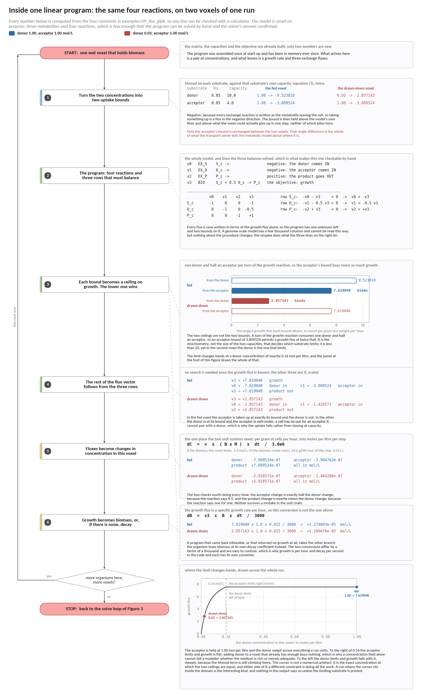
Figure 8. One linear program, drawn, on two voxels of the same run. Every number is computed from the four constants in examples/09_fba_glpk, and the model is small enough that the program can be solved by hand and the solver's answer confirmed.
The two voxels differ in the donor concentration and in nothing else, and that one difference moves which constraint is doing the work. In the fed voxel the acceptor limits, and the reason is stoichiometry rather than size: a turn of the growth reaction consumes one donor and half an acceptor, so an acceptor bound of 3.809524 buys twice as much growth as its own size suggests, and the two ceilings come out at 9.523810 and 7.619048. In the drawn-down voxel the donor's own ceiling has fallen to 2.857143 and it is the donor that binds; the acceptor uptake falls with it rather than staying at its capacity, because a cell has no use for an acceptor it cannot pair with a donor. The panel at the foot of the figure sweeps the donor across the whole range a run visits and shows where the two ceilings cross: at 0.16 moles per litre exactly, with the acceptor limiting above it and the donor below. A run whose domain straddles that concentration is a run in which the limiting substrate changes from one place to another, and nothing in a concentration field says so.
9.3 Step 1: turn the concentrations into uptake bounds
The linear program knows nothing about this voxel. The only thing that tells it where it is, is the lower bound on each uptake reaction, and that bound comes from equation (3) applied to what the voxel holds. For the donor, using 10 mmol gDW⁻¹ h⁻¹ from <fba_maximum_uptake_flux>, 0.05 mol L⁻¹ from <half_saturation_constants> and the 1.0 mol L⁻¹ the transport solver delivered:
ℓ_{S} = − 10 × 1.0 / ( 0.05 + 1.0 ) = − 10 × 0.952381 = − 9.523810
and for the acceptor, whose capacity is 4 rather than 10 but whose concentration and half-saturation constant are the same:
ℓ_{O} = − 4 × 1.0 / ( 0.05 + 1.0 ) = − 4 × 0.952381 = − 3.809524
Both in mmol gDW⁻¹ h⁻¹. The factor 0.952381 is the Michaelis-Menten saturation term, and at a concentration twenty times the half-saturation constant it is close to one: this voxel is nearly substrate-replete, and both uptakes run at about their enzyme capacity. The product P has no uptake capacity and none is offered, so its bound stays at zero and it can only leave.
9.4 Step 2: solve the linear program
Steady state inside the cell, equation (1), is three equations, one per row of S. Read them off:
row S_c : -v0 - v3 = 0 -> v0 = -v3
row O_c : -v1 - 0.5 v3 = 0 -> v1 = -0.5 v3
row P_c : -v2 + v3 = 0 -> v2 = +v3
Every flux is now written in terms of the growth flux v3, which is what makes this model solvable by hand. Apply the two bounds from Section 9.3. The donor uptake v0 cannot be more negative than -9.523810, and v0 = -v3, so:
v₃ ≤ 9.523810 from the donor
The acceptor uptake v1 cannot be more negative than -3.809524, and v1 = -0.5 v3, so v3 is bounded by twice that:
v₃ ≤ 2 × 3.809524 = 7.619048 from the acceptor
The objective is to make v3 as large as possible, so the answer is the smaller of the two ceilings:
growth = min ( 9.523810 , 7.619048 ) = 7.619048 mmol gDW⁻¹ h⁻¹
The acceptor limits, and it is worth being clear about why, because it is not simply that 4 is less than 10. Each turnover of the growth reaction needs one donor but only half an acceptor, so a given acceptor uptake supports twice as much growth as the same donor uptake would. The comparison the model actually makes is 9.523810 against 2 x 3.809524, and the factor of two is the 0.5 in the O_c row of S. Change that coefficient and the limiting substrate can change with it.
The remaining fluxes follow from the three relations above:
v0 = -7.619048 donor taken up
v1 = -3.809524 acceptor taken up, exactly half
v2 = +7.619048 product excreted
v3 = +7.619048 growth
9.5 Step 3: turn the fluxes back into what the lattice carries
The linear program has answered in its own units, per gram of dry cells per hour. The transport solver needs a change in concentration in this voxel over this step, in moles per litre. That conversion is the only place the two unit systems meet, and it is three multiplications and two divisions:
ΔC = v × ( B × M ) × Δt / 3.6×10⁶
B is the biomass this voxel holds in mol L⁻¹, M is the biomass molar mass in gDW mol⁻¹, so their product B × M is grams of dry cells per litre of water, which is what turns a per-gram flux into a per-litre one. The 3.6×10⁶ is two conversions at once: 1000 to take millimoles to moles, and 3600 to take hours to seconds. With B = 1.0, M = 24.6 and Δt = 0.015 s:
ΔC_{S} = − 7.619048 × ( 1.0 × 24.6 ) × 0.015 / 3.6×10⁶ = − 7.809524×10⁻⁷ mol L⁻¹
and the same arithmetic on the other two, which differ only in the flux:
dC_acceptor = -3.904762e-7 mol/L exactly half the donor
dC_product = +7.809524e-7 mol/L exactly minus the donor
Those two relations are the check worth doing. The acceptor change is half the donor change because the reaction says 0.5, and the product change is the negative of the donor change because the reaction says one for one. Neither was imposed anywhere in the code: they came out of the linear program, and if they do not hold in your own run then the exchange reactions and the substrates have been paired up wrongly.
9.6 Step 4: grow the biomass
The growth flux is a specific growth rate, per hour. The biomass increment is that rate multiplied by the biomass present and the length of the step, with 3600 to take hours to seconds:
ΔB = 7.619048 × 1.0 × 0.015 / 3600 = 3.174603×10⁻⁵ mol L⁻¹
Set against the donor drawn down in the same step, 7.809524×10⁻⁷ mol L⁻¹, that is about 41 moles of biomass per mole of donor, which is not a yield anyone would recognise. It is not meant to be: this is a toy model whose growth reaction was written to be checkable rather than realistic. In a genome-scale model the same two numbers give a yield that can be compared with a measurement, and that comparison is one of the few end-to-end tests of a coupling like this one.
9.7 The same voxel later, when the donor has run down
Nothing above is specific to this voxel except the two concentrations, so the useful thing is to change one of them and see the answer change character. Take the same voxel after transport has drawn the donor down to 0.02 mol L⁻¹, below its half-saturation constant of 0.05, with the acceptor unchanged. Only the donor bound moves:
ℓ_{S} = − 10 × 0.02 / ( 0.05 + 0.02 ) = − 10 × 0.285714 = − 2.857143
The two ceilings are now 2.857143 from the donor and 7.619048 from the acceptor, so:
growth = min ( 2.857143 , 7.619048 ) = 2.857143 mmol gDW⁻¹ h⁻¹
The donor now limits, growth has fallen by a factor of 2.67, and the acceptor uptake falls with it to -1.428571 rather than staying at its capacity, because the cell has no use for acceptor it cannot pair with donor. That last point is the one a Monod rate law cannot reproduce without being told: the ratio in which the two substrates are consumed is not fixed here, it is an output. Between the two voxels the acceptor to donor consumption ratio stayed at exactly 0.5 because the stoichiometry is fixed, but a model with two ways to use the acceptor would have shifted between them, and the linear program would have reported the shift without anybody calibrating it.
This is also why the limiting substrate is worth printing. A run where every voxel is acceptor-limited and a run where the limit changes hands across the domain look the same in a concentration field and are different simulations.
10. What to check when it has run

symptom | what it usually means | what to do
growth is zero everywhere | the medium is closed: the model needs an exchange the configuration does not open | run the model once in cobrapy with the same bounds
growth is identical in every voxel | the bounds are not being updated; equation (3) is seeing a constant | print ℓ for two voxels with different concentrations
a species goes negative | the shared budget was bypassed, or Δt is beyond the stability limit | check the closing report for the clamp count
infeasible in most voxels | the maintenance demand cannot be met at the supplied bounds | compare the maintenance reaction with the uptake range
results wrong by orders of magnitude | the unit chain: biomass molar mass, or the unit biomass is read in | check one voxel against a hand calculation
GLPK and COBRApy disagree | one of the two couplings, not the solvers: usually an exchange index | print ℓ and the flux vector from both for the same voxel
the answer changes between runs | a flux column the solver was free to choose | add a <multi_step> chain, section 6

11. References
Orth, J. D., Thiele, I., Palsson, B. O.: What is flux balance analysis? Nature Biotechnology 28, 245–248 (2010). https://doi.org/10.1038/nbt.1614
Scheibe, T. D., Mahadevan, R., Fang, Y., Garg, S., Long, P. E., Lovley, D. R.: Coupling a genome-scale metabolic model with a reactive transport model to describe in situ uranium bioremediation. Microbial Biotechnology 2, 274–286 (2009). https://doi.org/10.1111/j.1751-7915.2009.00087.x
Fang, Y., Scheibe, T. D., Mahadevan, R., Garg, S., Long, P. E., Lovley, D. R.: Direct coupling of a genome-scale microbial in silico model and a groundwater reactive transport model. Journal of Contaminant Hydrology 122, 96–103 (2011). https://doi.org/10.1016/j.jconhyd.2010.11.007
Song, H.-S., Ahamed, F., Lee, J.-Y., Henry, C. S., Edirisinghe, J. N., Nelson, W. C., Chen, X., Moulton, J. D., Scheibe, T. D.: Coupling flux balance analysis with reactive transport modeling through machine learning for rapid and stable simulation of microbial metabolic switching. Scientific Reports 15, 6042 (2025). https://doi.org/10.1038/s41598-025-89997-9
Ramkrishna, D., Song, H.-S.: Dynamic models of metabolism: review of the cybernetic approach. AIChE Journal 58, 986–997 (2012). https://doi.org/10.1002/aic.13734
Jung, H., Song, H.-S., Meile, C.: CompLaB v1.0: a scalable pore-scale model for flow, biogeochemistry, microbial metabolism, and biofilm dynamics. Geoscientific Model Development 16, 1683–1696 (2023). https://doi.org/10.5194/gmd-16-1683-2023

